>Create db meenu_cap;

> set hive.exec.dynamic.partition=true;

>set hive.exec.dynamic.partition.mode=nonstrict;

> CREATE TABLE IF NOT EXISTS meenu_cap.coursedetails_demo (

coursetype string,

courseid string,

title string,

competency string,

complexity string)

ROW FORMAT DELIMITED

FIELDS TERMINATED BY ',';

> load data inpath 'capstone_project/StudentCourseDetails.csv' into table coursedetails_demo;

> CREATE TABLE IF NOT EXISTS meenu_cap.coursedetails (

courseid string,

title string,

competency string,

complexity string)

partitioned by (coursetype string)

row format delimited

fields terminated by ',';

> insert into meenu_cap.coursedetails

partition(coursetype)

select courseid,title,competency,complexity,coursetype from meenu_cap.coursedetails_demo;

> select * from coursedetails limit 10 ;

> create table StudentCourseCompletionStatus_demo (studentsid string, courseid string, examdate string, attendedstatus string, marks int , result string )

row format delimited

fields terminated by ',' ;

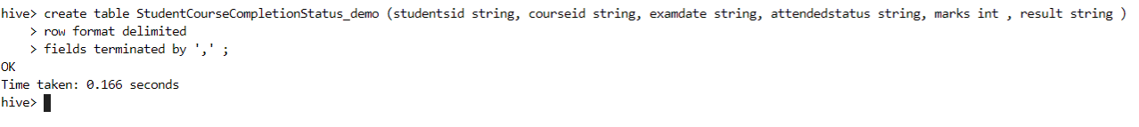

> load data inpath 'capstone_project/StudentCourseCompletionStatus.csv' into table StudentCourseCompletionStatus_demo;

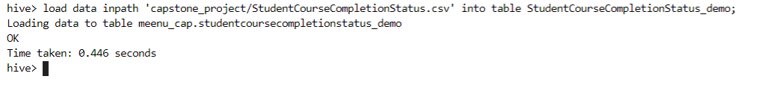

> set hive.enforce.bucketing = true;

> create table StudentCourseCompletionStatus (studentsid string, courseid string, examdate string, attendedstatus string, marks int , result string )

clustered by (marks) into 5 buckets

row format delimited

fields terminated by ',' ;

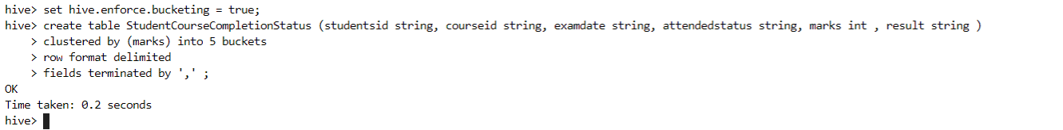

> insert overwrite table StudentCourseCompletionStatus select * from StudentCourseCompletionStatus_demo;

> select * from studentcoursecompletionstatus limit 10 ;

1. List the count of students qualified for various courses

>select count(result) from StudentCourseCompletionStatus where result = 'Qualified' group by result;

2. List the courses available.

>select distinct(coursetype) from coursedetails ;

3. Extract the following fields from both table from HDFS directory and save the following result set to HDFS output directory -

a . StudentID

b. CourseTitle

c. Result

> INSERT OVERWRITE

DIRECTORY 'capstone_project'

ROW FORMAT DELIMITED

FIELDS TERMINATED BY ','

select e1.studentsid, e2.title,e1.result from StudentCourseCompletionStatus e1 left outer join coursedetails e2 on e1.courseid= e2.courseid;

