Project Design Phase-II
Data Flow Diagram & User Stories

Date | 02/10/026
Team ID | SWTID-2026-5414
Project Name | Import Data using Transform Maps (Spreadsheet)
Maximum Marks | 4 Marks

Data Flow Diagrams:
The Data Flow Diagram below shows how employee data moves through ServiceNow during the import. The HR Admin uploads a spreadsheet containing Employee ID, Name, Email, Department, and Location. The data is first stored in an Import Set Table for temporary processing and validation. A Transform Map then maps these fields to the corresponding fields in the target Employee table. Employee ID is used as the unique identifier: if it already exists, the employee record is updated; otherwise, a new record is inserted.
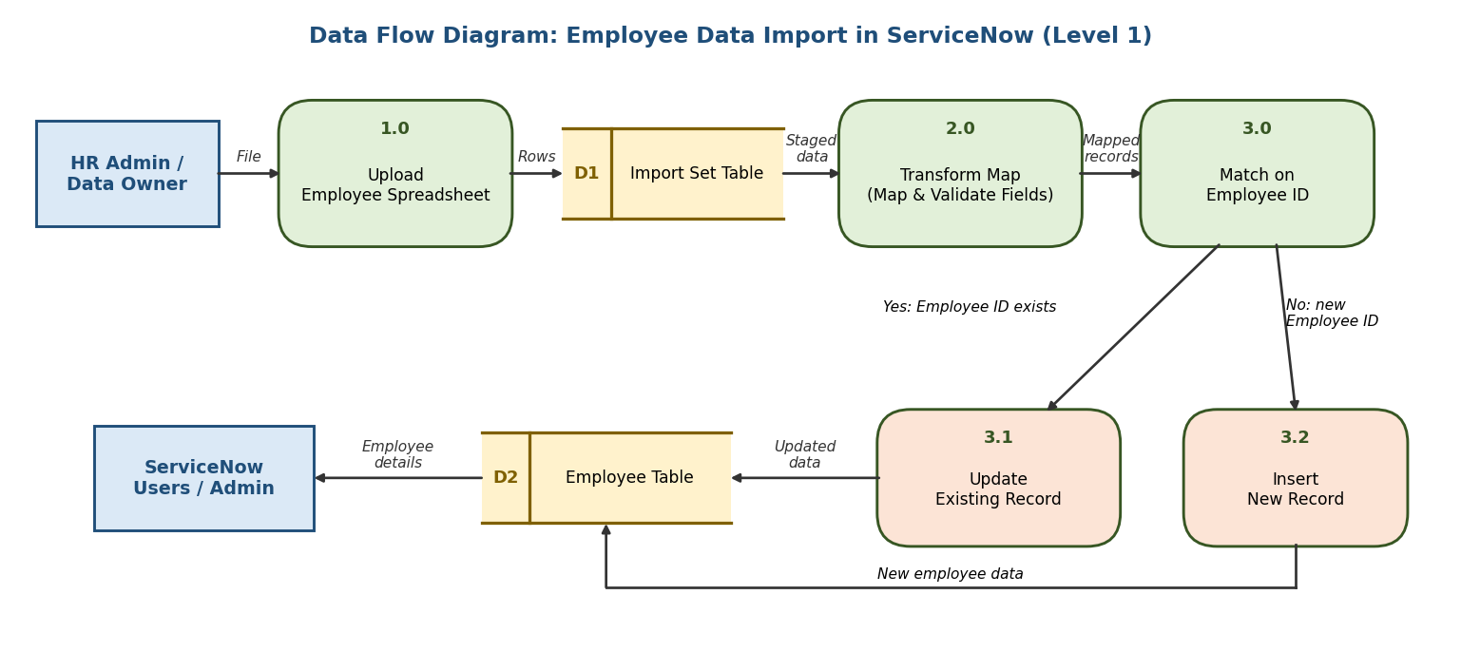
User Stories
User stories for importing employee data into ServiceNow using Import Sets and Transform Maps:
User Type | Functional Requirement (Epic) | User Story Number | User Story / Task | Acceptance criteria | Priority | Release
HR Administrator | Data Upload | USN-1 | As an HR administrator, I can upload a spreadsheet containing Employee ID, Name, Email, Department, and Location so that employee data can be imported into ServiceNow. | The spreadsheet is uploaded and its rows are loaded successfully | High | Sprint-1
HR Administrator | Data Upload | USN-2 | As an HR administrator, I can have the uploaded data stored in an Import Set Table so that it can be temporarily processed and validated. | All spreadsheet rows appear in the Import Set Table | High | Sprint-1
ServiceNow Administrator | Field Mapping | USN-3 | As a ServiceNow administrator, I can create a Transform Map to map the Import Set Table fields to the corresponding fields in the Employee table. | Employee ID, Name, Email, Department, and Location map to the correct Employee table fields | High | Sprint-1
ServiceNow Administrator | Field Mapping | USN-4 | As a ServiceNow administrator, I can use Employee ID as the unique identifier (coalesce field) so that existing employees are identified correctly. | Records with a matching Employee ID are recognised as existing employees | High | Sprint-1
HR Administrator | Data Transformation | USN-5 | As an HR administrator, I can have existing employee records updated when the Employee ID already exists so that employee details stay current. | Existing records are updated with the new values and no duplicate records are created | High | Sprint-2
HR Administrator | Data Transformation | USN-6 | As an HR administrator, I can have new employees inserted as new records so that newly hired employees are available in ServiceNow. | A new record is created in the Employee table for each new Employee ID | High | Sprint-2
ServiceNow Administrator | Import Monitoring | USN-7 | As a ServiceNow administrator, I can review the import results so that I can verify that the data was imported correctly. | The import summary shows the number of inserted, updated, and failed records | Medium | Sprint-2
Employee | Employee Records | USN-8 | As an employee, I can view my up-to-date details such as Department and Location in ServiceNow. | My Department, Location, and Email match the latest imported data | Medium | Sprint-3

