Task-1

1. SELECT Firstname as Workername FROM worker.employee;
2. Select distinct Department from worker.employee;
3. select * from worker.employee order by Empid desc limit 5;

Task-2

1. Select substring(Firstname,1,3) from worker.employee;
2. Select INSTR(Firstname, BINARY'a') from worker.employee;
3. SELECT t.Department,t.Firstname,t.Salary from(SELECT max(Salary) as TotalSalary,Department from worker.employee group by Department) as TempNew

Inner Join worker.employee t on TempNew.Department=t.Department

and TempNew.TotalSalary=t.Salary;

Task-3

1. Select RTRIM(Firstname) from worker.employee;
2. Select distinct length(Department),Department from worker.employee;
3. SELECT distinct Salary from worker.employee a WHERE 1 >= (SELECT count(distinct Salary) from worker.employee b WHERE a.Salary <= b.Salary) order by a.Salary desc;

Task-4

1. Select REPLACE(Firstname,'a','A') from worker.employee;
2. Select * from worker.employee order by Firstname asc, Department desc;
3. SELECT Firstname, Salary from worker.employee WHERE SALARY=(SELECT max(SALARY) from worker.employee);

Task-5

1. Select * from worker.employee where Firstname not in ('Ramesh','Santhosh');
2. Select * from worker.employee where Firstname like '_____h';
3. select * from worker.employee where Email = concat(Firstname,Lastname,'@gmail.com');

Task-6

1. Select * from worker.employee where year(Joindate) = 2021 and month(Joindate) = 3;
2. SELECT Department, COUNT(Department)

FROM worker.employee

GROUP BY Department HAVING COUNT(Department) > 1;

3. DELETE FROM worker.employee WHERE Empid IN(

SELECT Empid FROM (SELECT Empid, ROW_NUMBER()

OVER (PARTITION BY Email ORDER BY Email) AS row_num

FROM worker.employee) AS temp_table WHERE row_num>1);

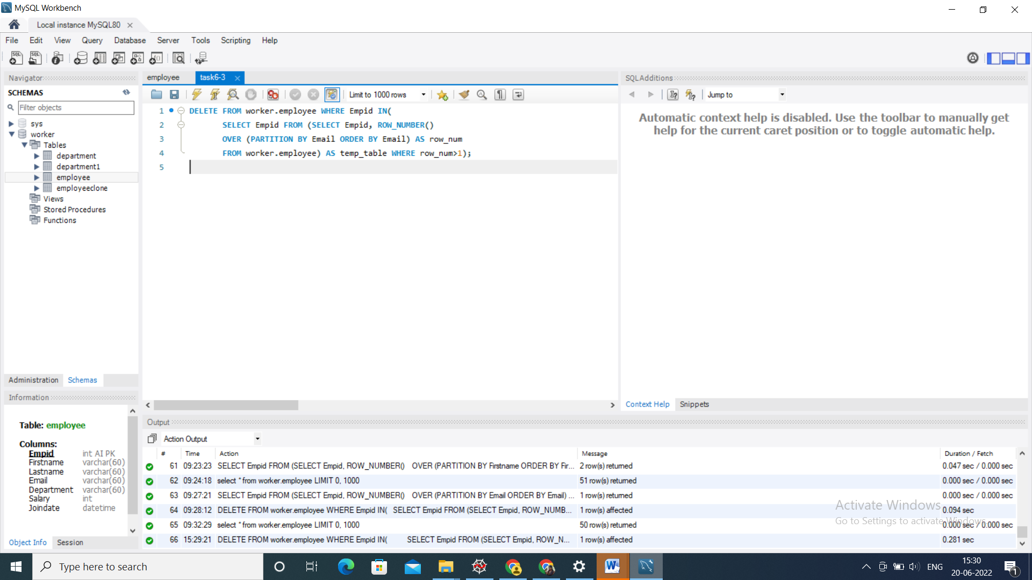

Task-7

1. select * from worker.employee where Empid%2!=0;
2. CREATE TABLE worker.employeeclone LIKE worker.employee;

Task-8

1. SELECT DISTINCT Empid, Firstname, Department, Salary FROM worker.employee

INNER JOIN worker.department USING (Empid);

2. SELECT DISTINCT Empid, Firstname, Department, Salary FROM worker.employee

where Empid not in (select empid from worker.department);

Task-9

1. SELECT * FROM worker.employee order by Empid asc limit 15;
2. SELECT distinct Salary from worker.employee a WHERE 10 = (SELECT count(distinct Salary) from worker.employee b WHERE a.Salary <= b.Salary) order by a.Salary desc

Task-10

1. SELECT distinct Salary from worker.employee a WHERE 8 = (SELECT count(distinct Salary) from worker.employee b WHERE a.Salary <= b.Salary) order by a.Salary desc
2. Select distinct W.Empid, W.Firstname, W.Salary

from worker.employee W, worker.employee W1

where W.Salary = W1.Salary

and W.Empid != W1.Empid;