



Conv2D

Filters:32

Input_shape: 28x28x1

Kernel_size:3x3

Conv2D

Filters:64

MaxPooling2D

MaxPooling2D

Flatten

Dense layer1:

128

Dense layer2:

256

Output layer

Softmax

Num_classes:10

Predicted Class: 1(Apple)



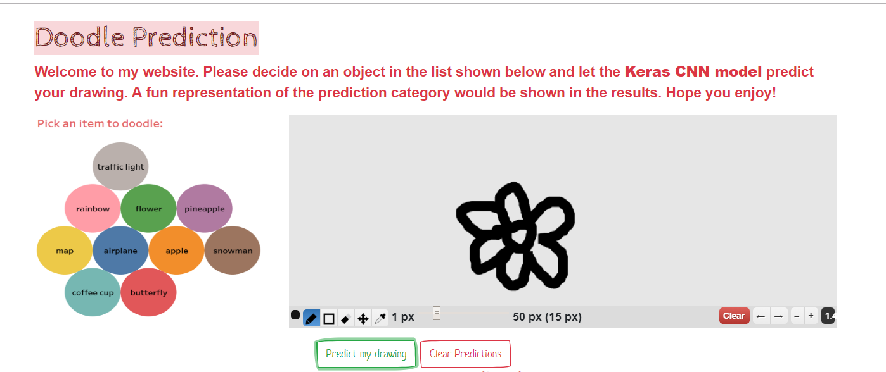

**HTML /CSS**

Crop image from Canvas

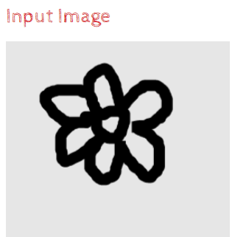

**Keras CNN**

Image Base64 encoded format

D3. json “POST”

Base64 Decode

Download Image

Predicted class:

4 (Flower)

Jsonify

Predicted results



Display a fun image for the predicted class

**JavaScript**

**Python Flask**