1. paper scissors rock.

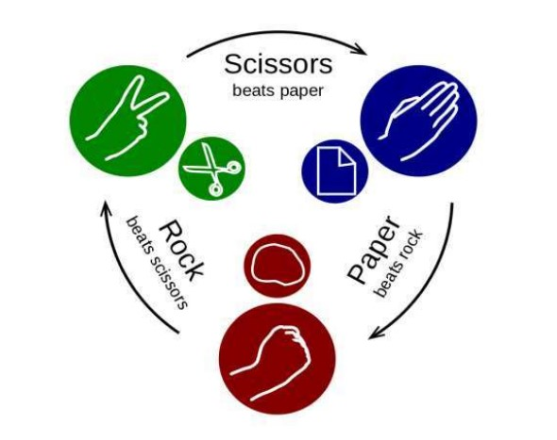

2. graphical dice (shows random numbers from 1 to six like real dice when shaking the micro bit)

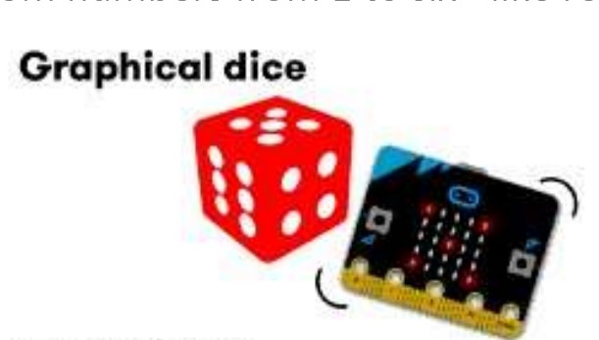

3. clap smile (Supported only in v2 and higher), smile face when claps and a sad face in silence, set sound threshold 200Hz

4. sound logger is simple bar chart display based on sound level.

5. compass (shows all directions and degree of angle when pressing on button A . Generate sound when is at East direction). note: very first time the code runs to fill the screen by tilting it.

6. square of a number from 1 to 25. (Button A= number and Button B= square of a number, Button A and B = reset number as 1)

7. thermometer (shows temp in Celsius when pressing on button A and converted it into Fahrenheit when pressing on B)

8. stopwatch shows lap with sound when touching on logo button. (Works only in v2) alt version shows lap when clicking on the A+B button. (Button A = start timer, Button B Stop timer, and A+B = lap in sec.)

9. send emojis to your friend (shows emojis randomly when clicking on button A and sends them to other group members (group id 105) when shaking the micro bit. (The same thing can do for every member in the group).

10. Is your friend is enjoying themselves? (Button A+B shows the question("HAPPY?”) , shake send a question(HAPPY?), Button A send an answer as "YES" and Button B send an answer as "NO”. Set group ID=110

11. light sensor alarm based on how much light is falling on the led display. Generate alarm and shows an angry face when the light measurement is more than 50. Button A shows a light measurement. Set group ID=115