<Project Name>
<Team Name>

Table of Contents
1. Introduction 4
1.1 Purpose 4
1.2 Scope 4
1.3 Definitions, Acronyms and Abbreviations 4
1.4 References 5
1.5 Technologies to be used 5
1.6 Overview 5
2. Overall Description 6
2.1 Use-Case Model Survey 6
2.2 WEB Architecture diagram 8
2.3 ER Diagram 9
2.4 Architecture diagram 10
2.5 Data Dictionary 11
2.6 Assumptions and Dependencies 15
3. Specific Requirements 166
3.1 Use-Case Reports 12
3.2 Class Diagram 29
3.2 Supplementary Requirements 31

1. Introduction

Purpose
To develop a fully functional and user interactive online tool which can enhance and help various project management users to manage and compile their work efficiently and productively

Scope
- Create different users with varied roles and scopes.
- Confirm each member by providing activation codes.
- Manage all project details like tasks, deadlines, team members and resources.
- Assign different tasks to different members.
- Provide documentation to the members about the tasks being added
- Update all members about new proceedings in the project.
- Bind all the information provided by the team members at one place and show it to all others.
- Maintain start date and end date of each task
- Maintain the overall timeline of the project.

Definitions, Acronyms and Abbreviation

OPM – Online Project Management.
Admin – Administrator.
PM – Project Manager.
HTML – Hyper Text Markup Language.
XHTML – extensible Hypertext Markup Language.
HTTP – Hypertext Transfer Protocol.
JSP – Java Server Pages.
EJB - Enterprise Java Beans.
WAS – Websphere Application Server.
J2EE – Java 2 Enterprise Edition.
DB2 - DB2 Database Management System.
Msg – Messag.
Doc – document.

References

IEEE SRS Format.

TGMC-2008 Sample Synopsis Format.
Problem Definition Provided By TGMC-2008

Technologies to be used

Application Architecture - J2EE

Database Application - DB2

Development tool - Rational System Developer.

Web Deployment Server - WAS.

Designing tool - Rational

Overview
This project is a tool to help in managing projects. It is more useful in current market situation where an organization is not close to a door or a city or a nation. In this case sharing document & data related to project from one corner of the world to another by using internet makes our work for easy. But still it is unmanaged to manage this work we are making this tool Online Project Management System (OPM).

Overall Description

Use-Case Model Survey
Start New Projects
Assign Project Manager
Invite Project Managers
Administrator
View All Details
Project Manager
Invite New Members
Create Messages
Create New Task
Provide Documentation
Update Project Status
Team Members
Update Task Status
Create Messages
Generate Reports
Decide Deadlines

- Administrator: - is responsible for registering with the tool and creating a profile with the company name.

  - Start New Project: - Admin logs into the OPM and create a profile with his company name and initiates a project.

  - Invite Project Manager:- After starting a project the Admin Invites a Project Manager.

  - Assign Project Manager: - When the invited Project Manager agrees to the Admin he/she is being allotted the project initiated.

- Project Manager: - is responsible for dealing with all the proceedings of the project.

  - Invite New Team Member: - After the Project is being allotted a Manager, the PM invites various team members to work on the project as well and sends them invites.

  - Create New Task: - The PM create new tasks and assigns them to the desired members.

  - Create Message: - The PM can create Message for the other team members notifying them about project updates etc.

  - Provide Documentation: - The PM gives documentation for the various tasks.

  - Generate Report: - The PM can generate reports for the various task and project.

  - Decide Deadline: - The PM can decide the time needed for the task to be completed.

  - Update Project Status: - The PM can update the completion status of the project on time-to-time basis.

- Team Members: -

  - Update Task Status: - the members working on the particular task can update the task completion status.

  - Create Message: - the members can also create messages to make aware other members about the task proceedings.

Web Architecture Diagram

HTML CLIENT
(Customer)
HTTP/HTTPS

DB SERVER
WAS

Client Software
(System Users)
TCP/IP

Client Side Application Side DB Server Side
It uses three tier architecture dig where client side application side and DB server are three diff components that improve security in system.

ER Diagram
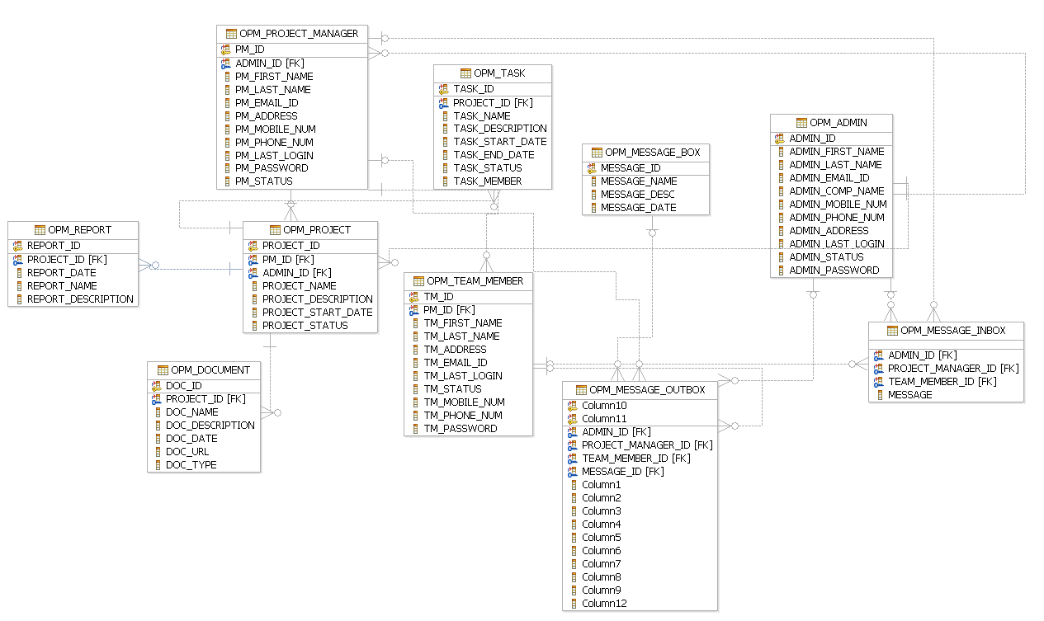

Architecture Diagram

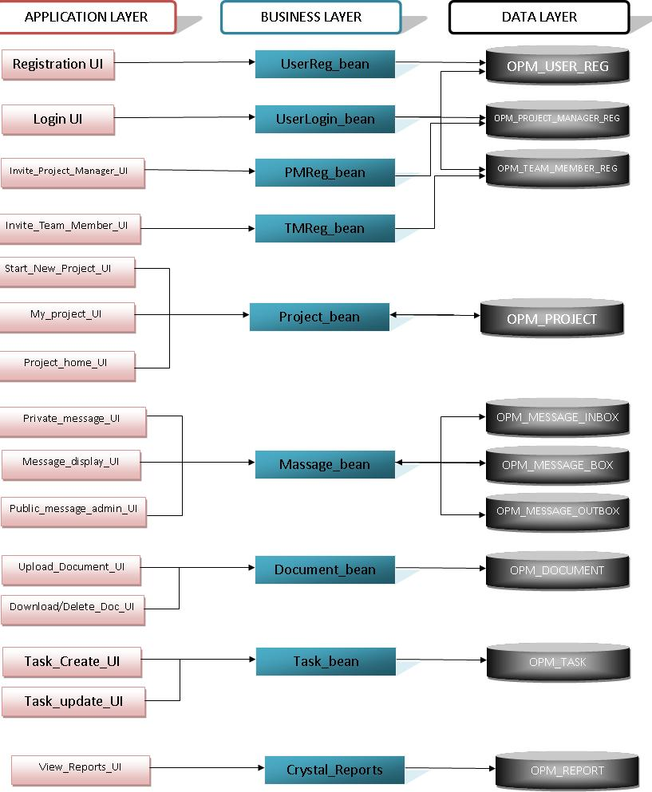

Data Dictionary

All tables used in project

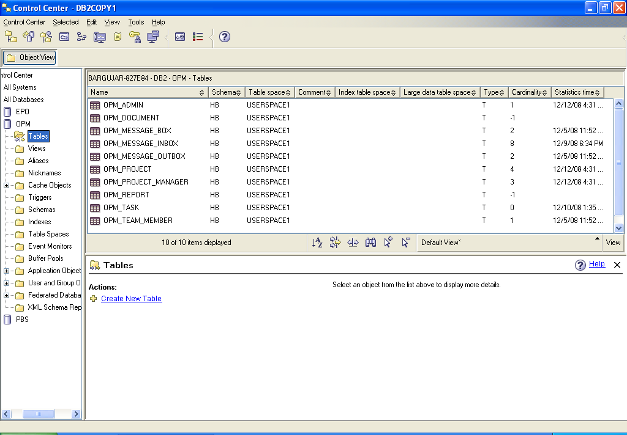

OPM_ADMIN

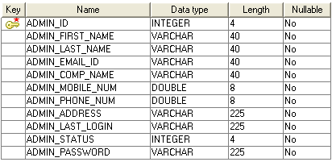

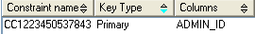

OPM _ PROJECT_MANAGER
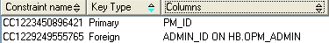
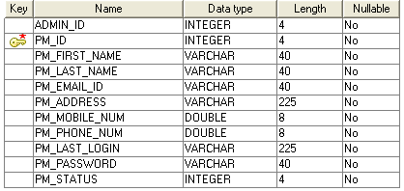

- OPM_TEAM_MEMBER

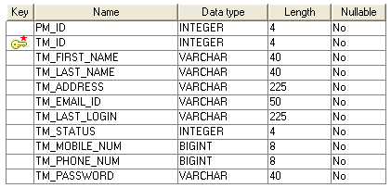

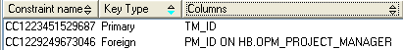

- OPM_PROJECT

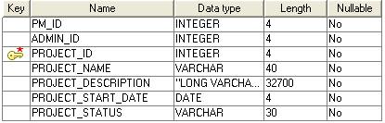

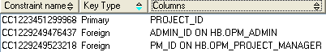

- OPM_TASK

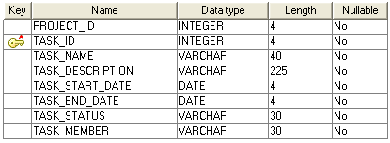

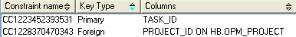

- OPM_DOCUMENTS

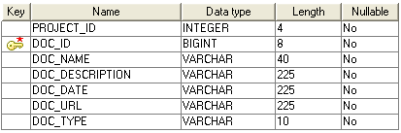

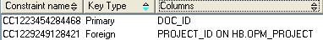
- OPM_MESSAGE_BOX

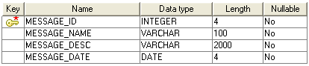

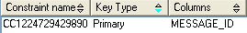

- OPM_MESSAGE_INBOX

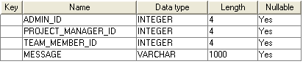

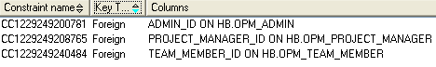

- OPM_MESSAGE_OUTBOX

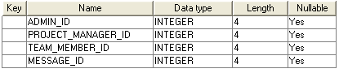

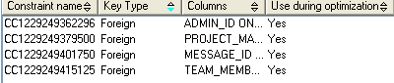

- OPM_REPORTS

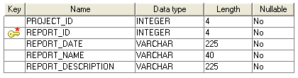

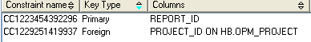

Assumptions and Dependencies

- The Project Manager from same company is not being assigned to two projects.

- Administrator can also be a project manager for a project.

Specific Requirements

Use-Case Reports

- Administrator- is responsible for registering the company and initiating a project, sending invitation mails to the project manager.

  - Start New Project- the admin starts the project which needs to be managed and supervised by the project manager. The Admin provides with the relevant information to the system and initiates a new project.
  - Invite Project Manager- the Admin sends an invitation email to the desired project manager who will be responsible for managing the project so created.

  - Assign Project Manager- the Admin assigns the project manager a particular project on which he/she needs to work.

Name of Use Case - Start New Project.

Description – a new project will be created for the company.

Pre Condition –The Admin should be logged in the system.

Normal Flow of Events –

- A form will open, necessary information will be entered

- A query will be fired to the database.

- An invitation email will be sent to the desired project manager

- Relevant output will be given to the user.

USE CASE DIAGRAM
New Project Details Filled In
Email to Admin for activation

Work Flow Diagram

A new Project details filled in.
An Email is sent to Admin for activation

Name of Use Case – Invite Project Manager.

Description – an invitation email will be sent to project manager for confirmation.

Pre Condition The Admin should be logged in the system.

Normal Flow of Events –

- An invitation email will be sent to Project Manager

- Project Manager will confirm the request.

- Project information will be completed and status will be updated to ready.

USE CASE DIAGRAM

An invitation mail is send to PM
Request confirmation & PM registration
Project Manager
WORK FLOW DIAGRAM

An Invitation Mail is send to PM
PM confirms the Invitation & register to the system

2. Project Manager – is responsible for managing the overall project, it’s tasks, messages, reports, related deadlines and documents

- Invite New Member – the PM is authorized to invite new members for the project and he/she do so by sending them invitation.

- Create New Task – The PM is responsible for creating a new task and assign members to it

- Create Messages – PM can add messages to the project and these messages will be displayed to all the users.

- Provide Documentation - The PM is responsible for providing documentation for the various tasks involved.

- Generate Reports – The PM can generate various types of reports whenever he feels a requirement.

- Update Project Status – The PM can update the project completion status by analyzing the various task completion statuses.

- Decide Deadlines – The PM is responsible for setting project and task deadlines i.e. the start date and the end date.

Name of Use Case – Invite Team Member.

Description – an invitation email will be sent to team member for confirmation.

Pre Condition –

- The Project Manager should be logged in the system.

Normal Flow of Events –

- An invitation email will be sent to Team Member.

- Team Member will confirm the request.

- Project information will be completed and status will be updated to ready.

USE CASE DIAGRAM
Dispatch an Email to invite Team Members
Request confirmation and Registration by Team Member
Project Information will be completed.
Team Member
WORK FLOW DIAGRAM
Dispatch an Email to invite Team Members

Request confirmation and Registration by Team Member

Project Information will be completed

Name of Use Case – Create New Task

Description – PM starts new task and assign team members to it.

Pre Condition –

- The PM should be logged in the system.

Normal Flow of Events –

- A task will be added to the project and timelines will be displayed.

- Team Members will update the task status.

- The Project completion status will also be updated.

USE CASE DIAGRAM
A Task will be added to project
Team Member Update task status
Project Completion status updated
Team Member

WORK FLOW DIAGRAM
Task Is Added to the Project
Team Member updates task status
Project Completion status updated

Name of Use Case – Create New Message.

Description – a new message will be created which will be displayed to all the users.

Pre Condition –

- The PM should be logged in the system.

Normal Flow of Events –

- A Msg will be created by filling in details of the msg.

- This msg will be displayed to all the active users of the project.

USE CASE DIAGRAM

A MSG will be created
Displaying MSG to active user
Team Member

WORK FLOW DIAGRAM
A MSG will be created

Displaying MSG to active user

Name of Use Case – Provide documentation.

Description – a task or project related document will be given to the team members for their guidance

Pre Condition –

- The PM should be logged in the system.

Normal Flow of Events –

- A document will be uploaded to the system.

- Other team members can read the doc.

USE CASE DIAGRAM

Uploading of DOC to system
Accessibility of DOC to other members
Team Member

WORK FLOW DIAGRAM
Uploading of DOC to system

Accessibility of DOC to other members

Name of Use Case – Generate Reports.

Description – a report can be generated by the PM at any instance of time to view the project completion status

Pre Condition –

- The PM should be logged in the system.

Normal Flow of Events –

- A project report will be generated

- A database entry would be made.

USE CASE DIAGRAM
Generation of project report
Enter information to database

WORK FLOW DIAGRAM
Generation of project report

Enter information to database
Name of Use Case – Update Project Status.

Description – a PM can update the project status by looking at the task completion status.

Pre Condition –

- The PM should be logged in the system.

Normal Flow of Events –

- Analyze project tasks.

- Update project completion status.

USE CASE DIAGRAM
Analyze Project task
Update project completion status

WORK FLOW DIAGRAM

Analyze Project task

Update project completion status

Name of Use Case – decide deadlines.

Description – a time line i.e. a start date and an end date would be set for every task.

Pre Condition –

- The PM should be logged in the system.

Normal Flow of Events –

- Set a start date and an end date.

USE CASE DIAGRAM
Set a start date and an end date

WORK FLOW DIAGRAM
Set an start date and an end date

3. Team Member – is responsible for updating task status and completing the task so that the project may not get delayed.

- Update Task Status – the team member is responsible for updating the completion status of the project.

- Create/ update MSG – the team member can create and update the msgs.

Name of Use Case – update task status.

Description – completion status of the task could be updated.

Pre Condition –

- The Team Member should be logged in the system.

Normal Flow of Events –

- Sets the percentage completion status.

USE CASE DIAGRAM
Set the percentage completion status

WORK FLOW DIAGRAM
Set the percentage completion status

Name of Use Case – create/ update MSG.

Description – a new MSG will be created or an already existing MSG will be updated.

Pre Condition –

- The Team Member should be logged in the system.

Normal Flow of Events –

- Create a new msg

- Edit an already existing msg.

USE CASE DIAGRAM
Create a new MSG
Edit an already existing Msg
WORK FLOW DIAGRAM

Create a new Msg

Edit an already existing MSG

Class Diagram
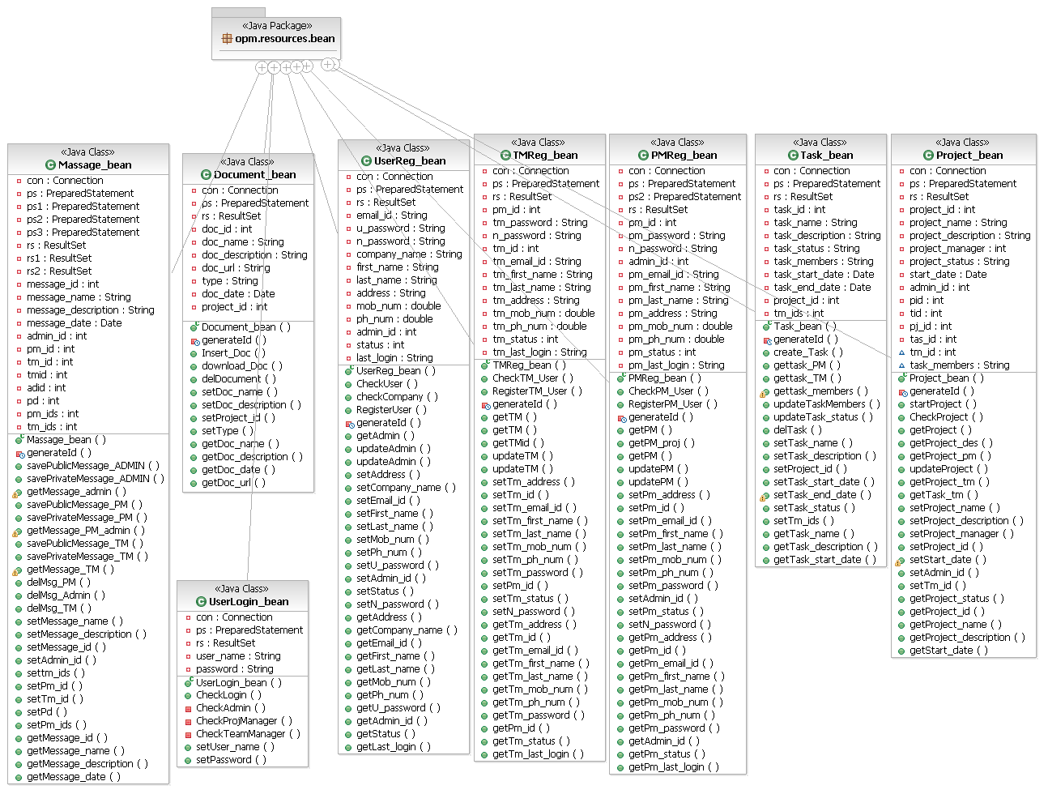

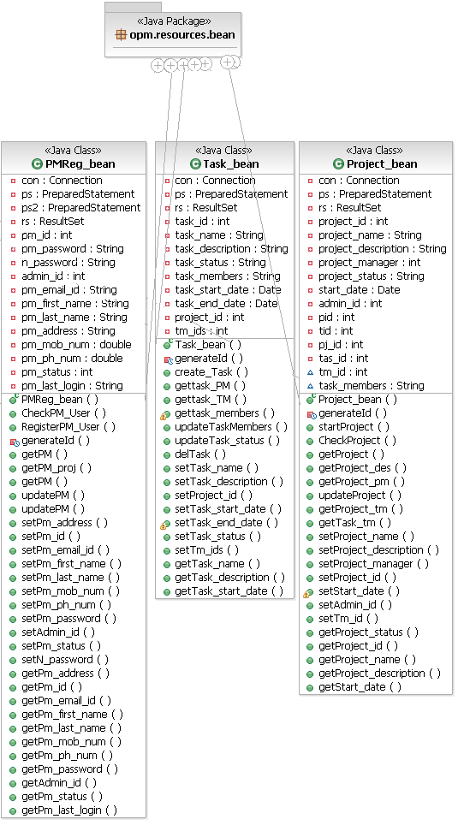

Supplementary Requirements

- Since this a tool which can be used from anywhere and anytime in the world, so the server should be well managed for such kind of requirement.

- The users using this and importing the reports from this tool should have supporting software to run them.

- To use the application in the best possible way please read the tips displayed while using the tool.

