

Customer Support ticket system
8-5-2026

Introduction

This document explains the project structure, components, how to set up development, and how to deploy using Docker, Docker Compose, and Kubernetes. The stack is intended to run on Linux (Docker Engine, Kind).

Content
0.Introduction…………………………………………………………………………………………………2
1. Product overview…………………………………………………………………………………………4
2. Architecture…………………………………………..……………………………………………………5
- 2.1 Microservices (HTTP APIs + MongoDB)……………………………………5
- 2.2 How services communicate…………...……………………………………….5
- 2.3 Docker containerization (images, containers, files)…………………..6
3. Repository structure…………………………………………………………………………………….8
4. Prerequisites………………………………………………………………..……………………………...9
- 4.1 All modes……………………………………………………………………………..9
- 4.2 Docker Compose………………………………………………………..……..….9
- 4.3 Kubernetes (optional path)…………………………………….……..………9
5. Development setup…………………………………………………………………………………….10
- 5.1 Full stack with Docker Compose………………………………………....10
- 5.2 Environment matrix (Compose)………………………...………………...10
- 5.3 MongoDB Compass……………………………..…………………………..….10
6. Building container images manually……………………………………………………………11
7. Deploying with Kubernetes (Kind)…………..…………………………………………………..12
- 7.1 Build images……………………………………………………………………….12
- 7.2 Load into Kind (cluster name cst )……………………………………….12
- 7.3 Apply an overlay………………………………………………………………….12
- 7.4 Verify………………………………………………………………………………….12
- 7.5 Production overlay notes…………………………………………………….12
8. Testing……………………………………………………………………………………………………….13
- 8.1 Frontend unit tests (Vitest via Angular)……………………………………13
- 8.2 Smoke checks (Compose)………………………………………………………13
9. Troubleshooting…………………………………………………………………………………………..14
10. Security reminders…………..………………………………………………………………………..15
11. Quick reference commands……………………………..………………………………………..16

1. Product overview
The system supports:
- Customers: submit tickets, track status, receive notifications from agents.
- Agents: manage tickets (assign, update), log responses, trigger customer notifications.
- DevOps: containerized microservices, multiple isolated environments on one host, and Kubernetes manifests for orchestration.

2. Architecture
2.1 Microservices (HTTP APIs + MongoDB):
Service | Role | Default port (in container)
Frontend | Angular SPA served by nginx; reverse-proxies API paths to backends | 80 (mapped to host per env)
Auth Service | Registration, login, JWT | 5001
Ticket Service | CRUD tickets, status, authorization via JWT/headers | 5000
Support Service | Assignment and response workflow endpoints | 5002
Notification Service | Persist and list notifications for customers | 5003
MongoDB | Data store (separate logical databases per concern) | 27017 (internal)

2.2 How services communicate
- Browser → frontend (nginx) on the published UI port (e.g. 8080).
- Nginx → backends over HTTP inside the Compose/Kubernetes network, using Docker/Kubernetes service DNS names (auth-service, ticket-service, etc.). See docker/nginx/default.conf.
- Backends → MongoDB via MONGODB_URI (Mongo wire protocol on mongo:27017 inside the network).

2.3 Docker containerization (images, containers, files)
This section summarizes what runs in Docker for grading and operations clarity.
- Services in one Compose stack (docker-compose.yml):
# | Compose service name | Runs as container? | Image source
1 | mongo | Yes | Pull: mongo:7.0
2 | auth-service | Yes | Build → cst-auth-service:<tag>
3 | ticket-service | Yes | Build → cst-ticket-service:<tag>
4 | notification-service | Yes | Build → cst-notification-service:<tag>
5 | support-service | Yes | Build → cst-support-service:<tag>
6 | frontend | Yes | Build → cst-frontend:<tag>
- Containers per full stack: 6 (one container per service above).
- Images used by that stack: 6 distinct image references
  - 1 third-party image: mongo:7.0
  - 5 application images built from this repo (each service name + digest differs).
The image tag suffix comes from IMAGE_TAG_SUFFIX in env/*.env (e.g. dev, test, staging, prod), so a running dev stack might use cst-auth-service:dev, etc.
- Custom Dockerfiles (build definitions)
Dockerfile | Builds how many app images | Notes
docker/node-service.Dockerfile | 4 images | Same multi-stage pattern; SERVICE_DIR selects auth-service, ticket-service, notification-service, or support-service
docker/frontend.Dockerfile | 1 image | Multi-stage: Node builds Angular → nginx:1.26-alpine serves static assets + reverse proxy config from docker/nginx/default.conf.
So there are 2 Dockerfile definitions producing 5 custom images (plus pull Mongo as a pre-built image).

Counting distinct image names in one stack (excluding duplicate tags of the same logical app):
- mongo:7.0
- cst-auth-service:*
- cst-ticket-service:*
- cst-notification-service:*
- cst-support-service:*
- cst-frontend:*
That is more than three; replicas of the same image do not apply here (default replica count is 1 per service in Compose).
Multiple environments on one machine
If you start all four env files (development, testing, staging, production) with scripts/compose-up-all-parallels.sh:
- Total running containers: 4 × 6 = 24 (four isolated Compose projects, each with its own 6 containers).
- Named volumes: 4 Mongo data volumes (one per project; name includes COMPOSE_PROJECT_NAME and MONGO_VOLUME_NAME).
Each project has its own Docker network; containers in project A do not share a network with project B (only with the other five services in the same docker-compose project).
- Published host ports (typical):
Only frontend and mongo publish ports to the host in Compose; backends are reached via the nginx gateway or internal DNS.
Exposure | Service | Purpose
FRONTEND_HOST_PORT → 80 | frontend | Browser UI + API proxy paths
MONGO_HOST_PORT → 27017 | mongo | MongoDB Compass / external tools
See env/*.env for the actual numbers (e.g. dev UI 8080, dev Mongo host port 27021).
- Kubernetes (same logical images):
Kubernetes manifests under kubernetes/ reference the same application image names (cst-auth-service:latest, etc.). Build with scripts/k8s-build-images.sh, then load or push those images so the cluster can run one Pod per service (frontend can scale to multiple replicas in the base manifest).

3. Repository structure
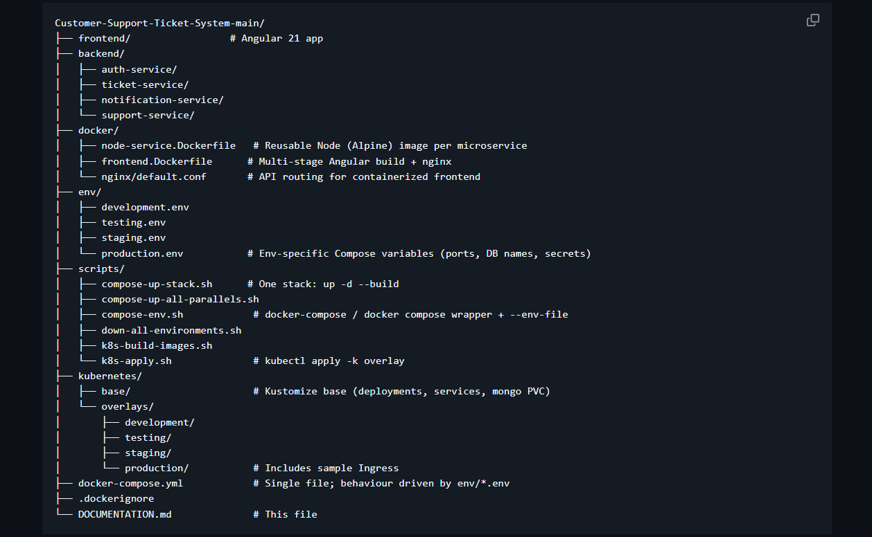
Legacy / reference only (commented, do not use)
- docker-compose.dev.yml, docker-compose.test.yml, docker-compose.prod.yml — historical commented drafts; use instead docker-compose.yml # Single file; behaviour driven by env/*.env
- k8s/*.yaml — old flat manifests; use kubernetes/ with Kustomize.
- scripts/up-all-environments.sh — disabled; use compose-up-all-parallels.sh.

4. Prerequisites
4.1 All modes
- Linux host with Docker (daemon running).
- User in docker group or use sudo with Docker (less convenient).
- Node.js (e.g. 22.x) and npm for local (non-container) frontend dev.

4.2 Docker Compose
- Prefer Docker Compose v2 (docker compose).
- If only v1 is installed, docker-compose is supported by the helper scripts.

4.3 Kubernetes (optional path)
- kubectl (e.g. sudo snap install kubectl --classic).
- A cluster: Kind, Minikube, k3d, or a cloud cluster.
- Cluster must be able to pull or load the images built locally (kind load docker-image, etc.).

5. Development setup
5.1 Full stack with Docker Compose:
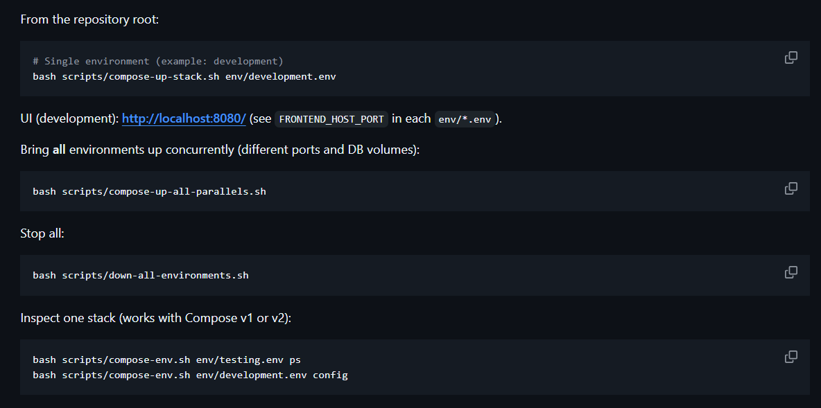
5.2 Environment matrix (Compose):
Environment | UI port | Mongo host port | Compose project name
development | 8080 | 27021 | cst-development
testing | 8081 | 27018 | cst-testing
staging | 8090 | 27019 | cst-staging
production | 8082 | 27020 | cst-production
Each environment uses different Mongo database names (MONGO_DB_* in the env file), different JWT_SECRET, and different image tag suffixes.
5.3 MongoDB Compass:
Connect to the host port for the stack you started, e.g.:
- Development: mongodb://127.0.0.1:27021
Data is split across databases, for example in dev:
- cst_auth_dev → users
- cst_ticket_dev → tickets
- cst_notify_dev → notifications

6. Building container images manually

Images use multi-stage builds for smaller production images.

Produces tags such as:
- cst-auth-service:latest
- cst-ticket-service:latest
- cst-notification-service:latest
- cst-support-service:latest
- cst-frontend:latest

7. Deploying with Kubernetes (Kind)

7.1 Build images:

7.2 Load into Kind (cluster name cst):
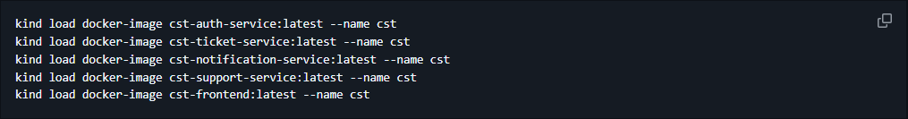

7.3 Apply an overlay:
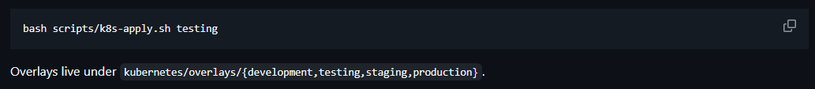

7.4 Verify:
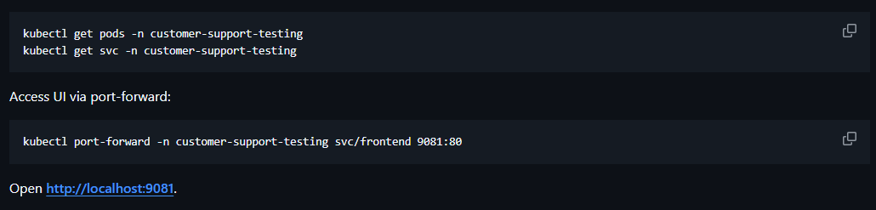

7.5 Production overlay notes:
kubernetes/overlays/production includes an Ingress example (cst-production.local.example). Adjust host and ingressClassName / annotations for your cluster’s ingress controller.

8. Testing

8.1 Frontend unit tests (Vitest via Angular):

8.2 Smoke checks (Compose):
With a stack up:

9. Troubleshooting

Issue | What to try
unknown flag: --env-file for docker compose | Use docker-compose (v1) or bash scripts/compose-env.sh env/....env ...
Docker permission denied on socket | sudo usermod -aG docker $USER then log out/in
docker-compose ContainerConfig KeyError on recreate | Remove stale containers or docker-compose down then up
Mongo port already in use | Change MONGO_HOST_PORT in the matching env/*.env
Kubernetes pods ImagePullBackOff | Load/push images; check image names match manifests
Compass empty DB | Select correct database names (cst_*) not only ticketDB

10. Security reminders

non-production samples:
- Replace JWT_SECRET in every env/*.env before any real deployment.
- Mongo in these samples has no auth; enable authentication and network policies for production.
- The legacy k8s/ tree is disabled; prefer kubernetes/ overlays and sealed secrets / external secret managers in real prod.

11. Quick reference commands
# One env up
bash scripts/compose-up-stack.sh env/development.env

# All envs up
bash scripts/compose-up-all-parallels.sh

# All envs down
bash scripts/down-all-environments.sh

# K8s apply testing overlay
bash scripts/k8s-apply.sh testing

For questions about Angular-only development, see frontend/README.md.

