

Variables, Expressions, and

Statements

Chapter 2

Python for Informatics: Exploring Information www.pythonlearn.com


Constants

- Fixed values such as numbers, letters, and strings are called “constants” because their value does not change

- Numeric constants are as you expect

- String constants use single quotes (') or double quotes (")

- print 123

123

- print 98.6

98.6

- print 'Hello world' Hello world

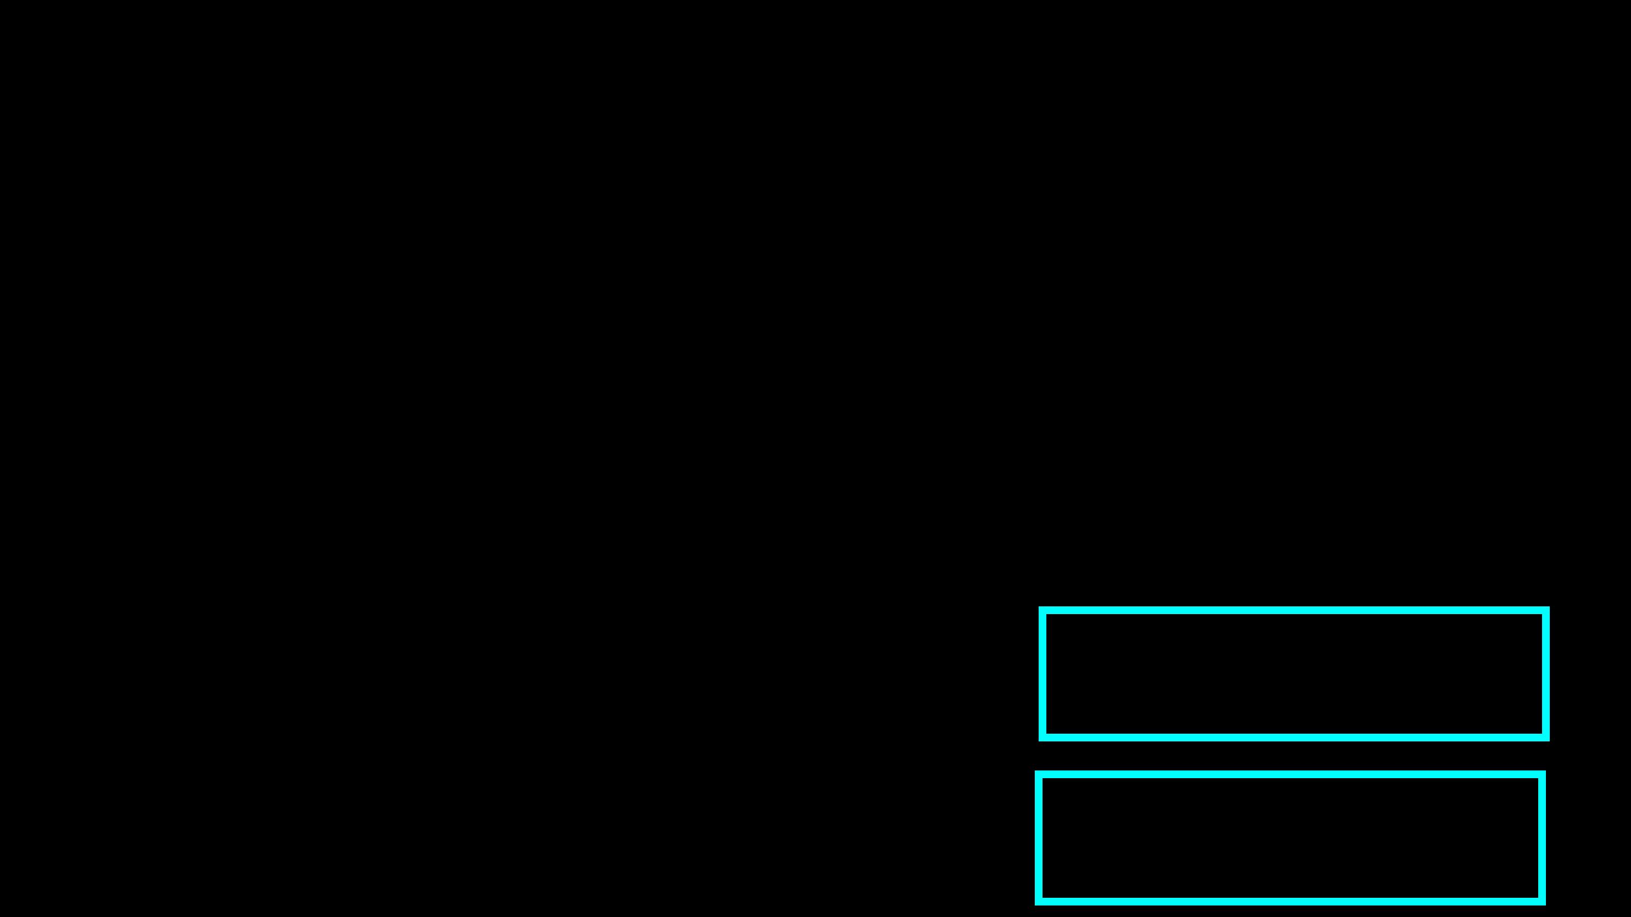
Variables

- A variable is a named place in the memory where a programmer can store data and later retrieve the data using the variable “name”

- Programmers get to choose the names of the variables

- You can change the contents of a variable in a later statement

x = 12.2 y = 14

x

y

12.2

14

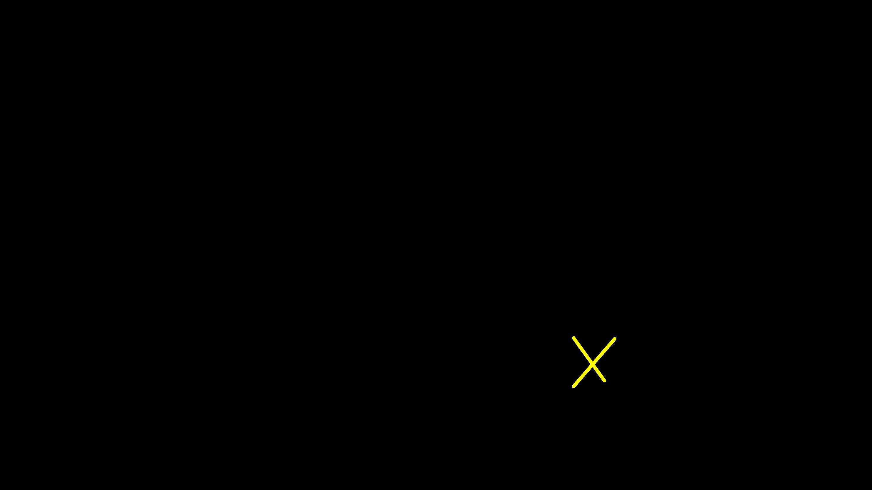
Variables

- A variable is a named place in the memory where a programmer can store data and later retrieve the data using the variable “name”

- Programmers get to choose the names of the variables

- You can change the contents of a variable in a later statement

 |  |  |  |  |  |  |  | 12.2 | 100
x = |  | 12.2 |  |  | x |  |  | 12.2 | 100
y | = | 14
x | = | 100
x | = | 100 |  |  | y |  |  | 14

Python Variable Name Rules

- Must start with a letter or underscore _

- Must consist of letters and numbers and underscores

- Case Sensitive

• Good: |  | spam eggs spam23 _speed
• | Bad: | 23spam | #sign var.12
• | Different: spam |  | Spam SPAM

Reserved Words

• You cannot use reserved words as variable names / identifiers

and del for is raise assert elif from lambda return break else global not try class except if or while continue exec import pass yield def finally in print as with

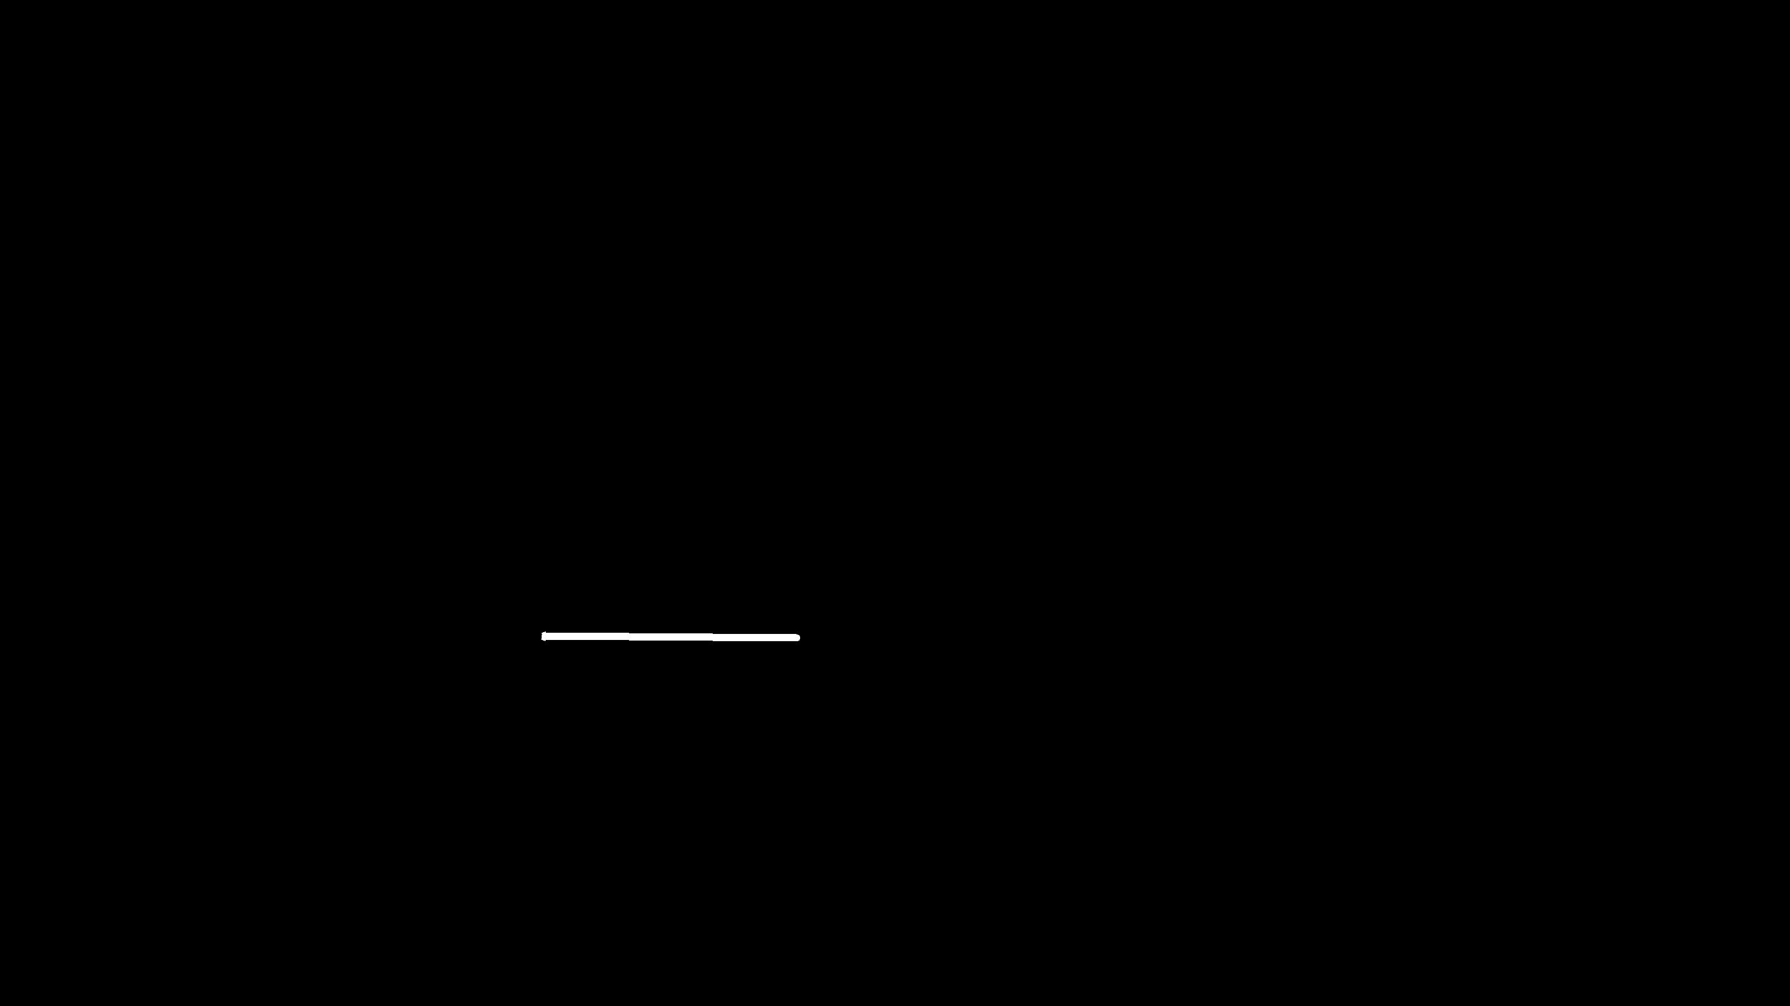
Sentences or Lines

x = 2 x = x + 2 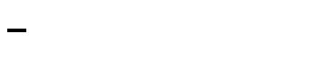 print x

Assignment statement Assignment with expression Print statement

 |  |  |  |  |  | Reserved
 |  |  |  | Constant |  | Reserved
Variable |  | Operator |  | Constant |  | Reserved
Variable |  | Operator |  | Constant |  | Word

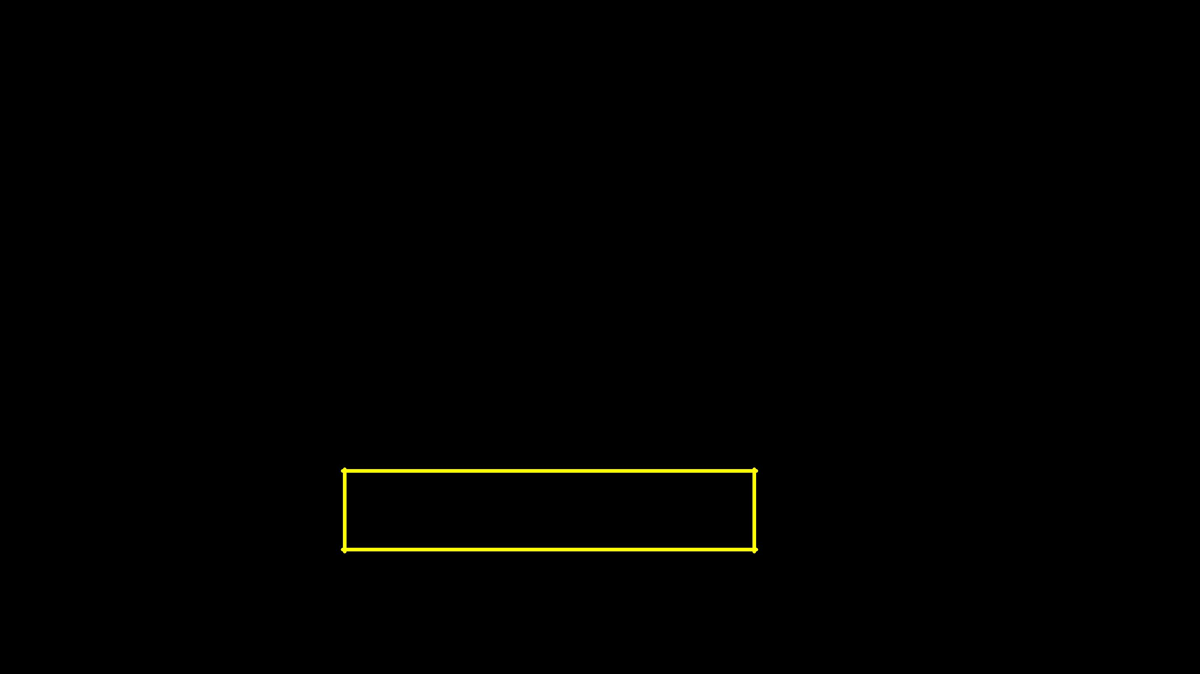
Assignment Statements

- We assign a value to a variable using the assignment statement (=)

- An assignment statement consists of an expression on the right-hand side and a variable to store the result

x =

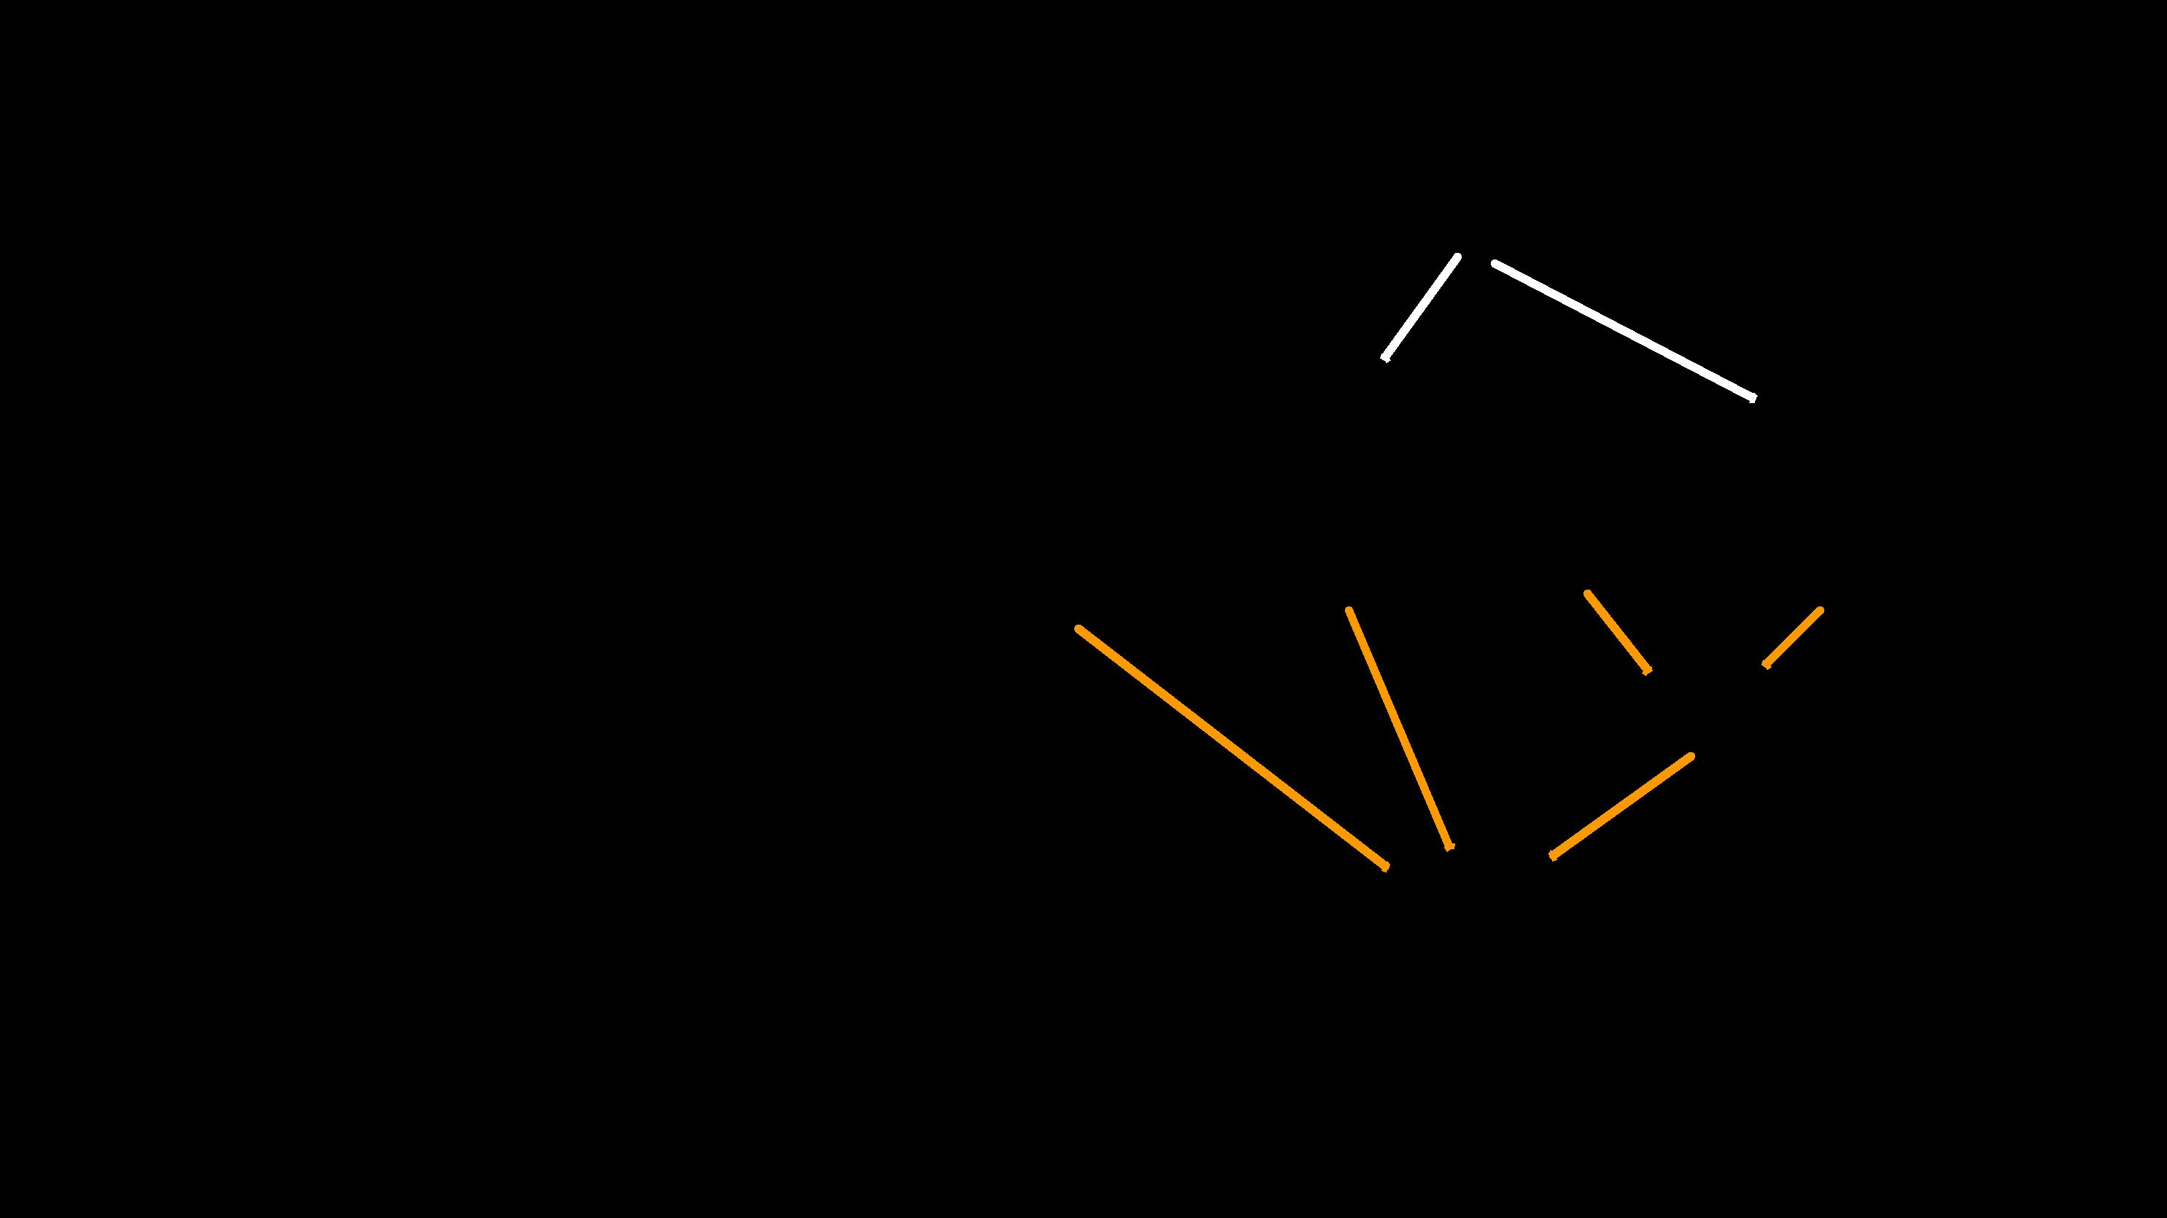
 |  | x |  |  | 0.6
A variable is a memory location |  | x |  |  | 0.6
used to store a value (0.6)

0.6 _{0.6}

x = 3.9 * x * ( 1 - x )

0.4

The right side is an expression.
The right side is an expression. | 0.936
Once the expression is evaluated,
the result is placed in (assigned to) x.

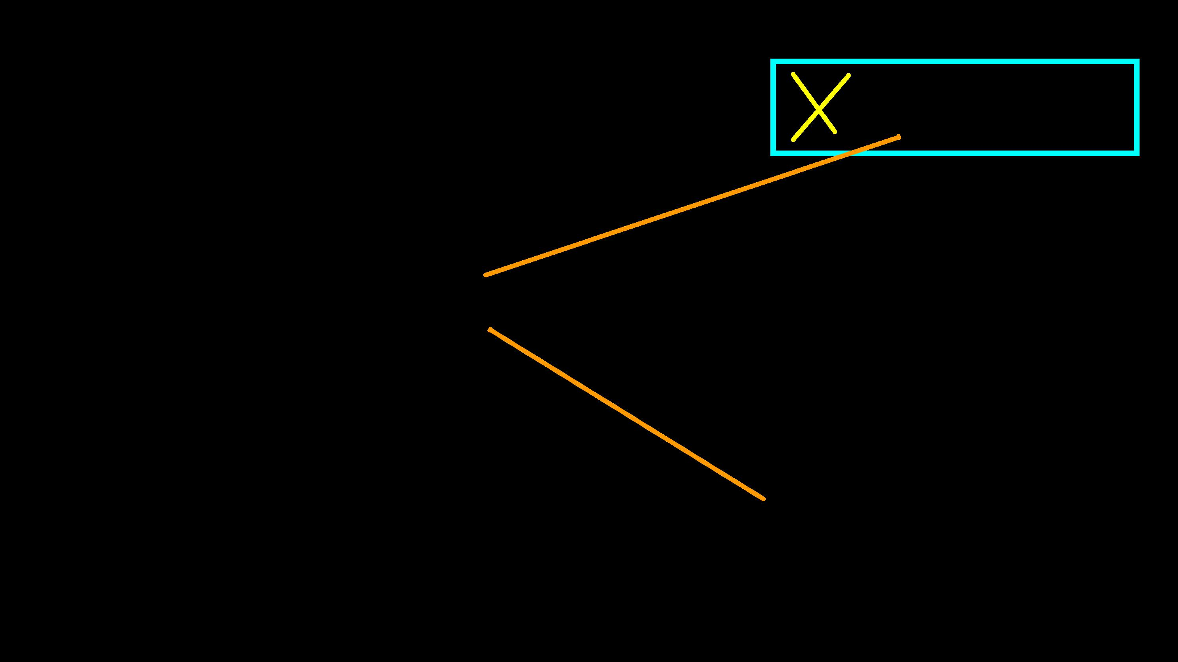
A variable is a memory location used to store a value. The value stored in a variable can be updated by replacing the old value (0.6) with a new value (0.93).

x 0.6 0.93

x = 3.9 * x * ( 1 - x )

The right side is an expression. Once the
expression is evaluated, the result is ^{0.93} placed in (assigned to) the variable on the

left side (i.e., x).

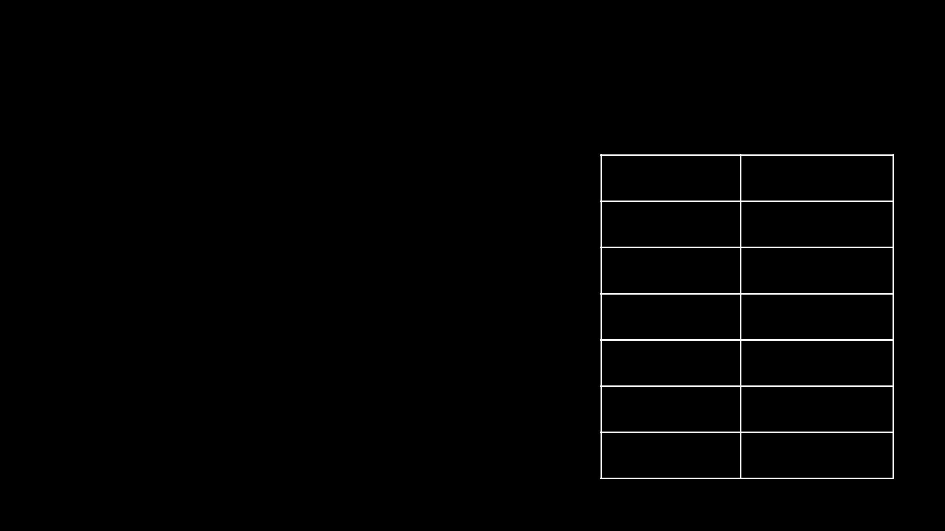
Numeric Expressions

- Because of the lack of mathematical symbols on computer keyboards - we use “computer-speak” to express the classic math operations

- Asterisk is multiplication

- Exponentiation (raise to a power) looks different from in math.

Operator | Operation
+ | Addition
- | Subtraction
* | Multiplication
/ | Division
** | Power
% | Remainder

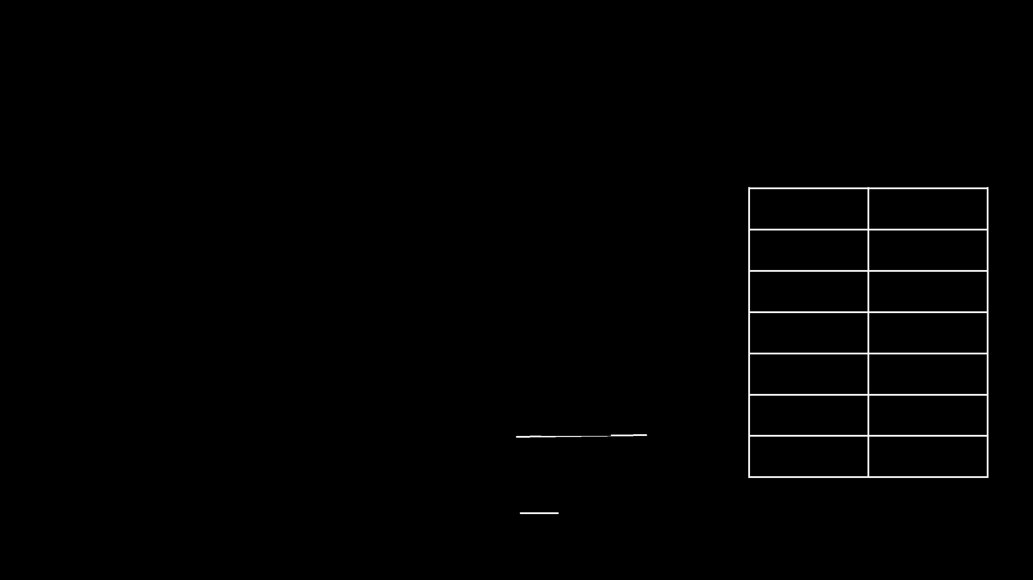
Numeric Expressions

- xx = 2

- xx = xx + 2

- print xx

4

- yy = 440 * 12

- print yy

5280

- zz = yy / 1000

- print zz

5

- jj = 23

- kk = jj % 5

- print kk

3

>>> print 4 ** 3 64

4 R 3
5 23

20

Operator | Operation
+ | Addition
- | Subtraction
* | Multiplication
/ | Division
** | Power
% | Remainder

3

Order of Evaluation

- When we string operators together - Python must know which one to do first

- This is called “operator precedence”

- Which operator “takes precedence” over the others? x = 1 + 2 * 3 - 4 / 5 ** 6

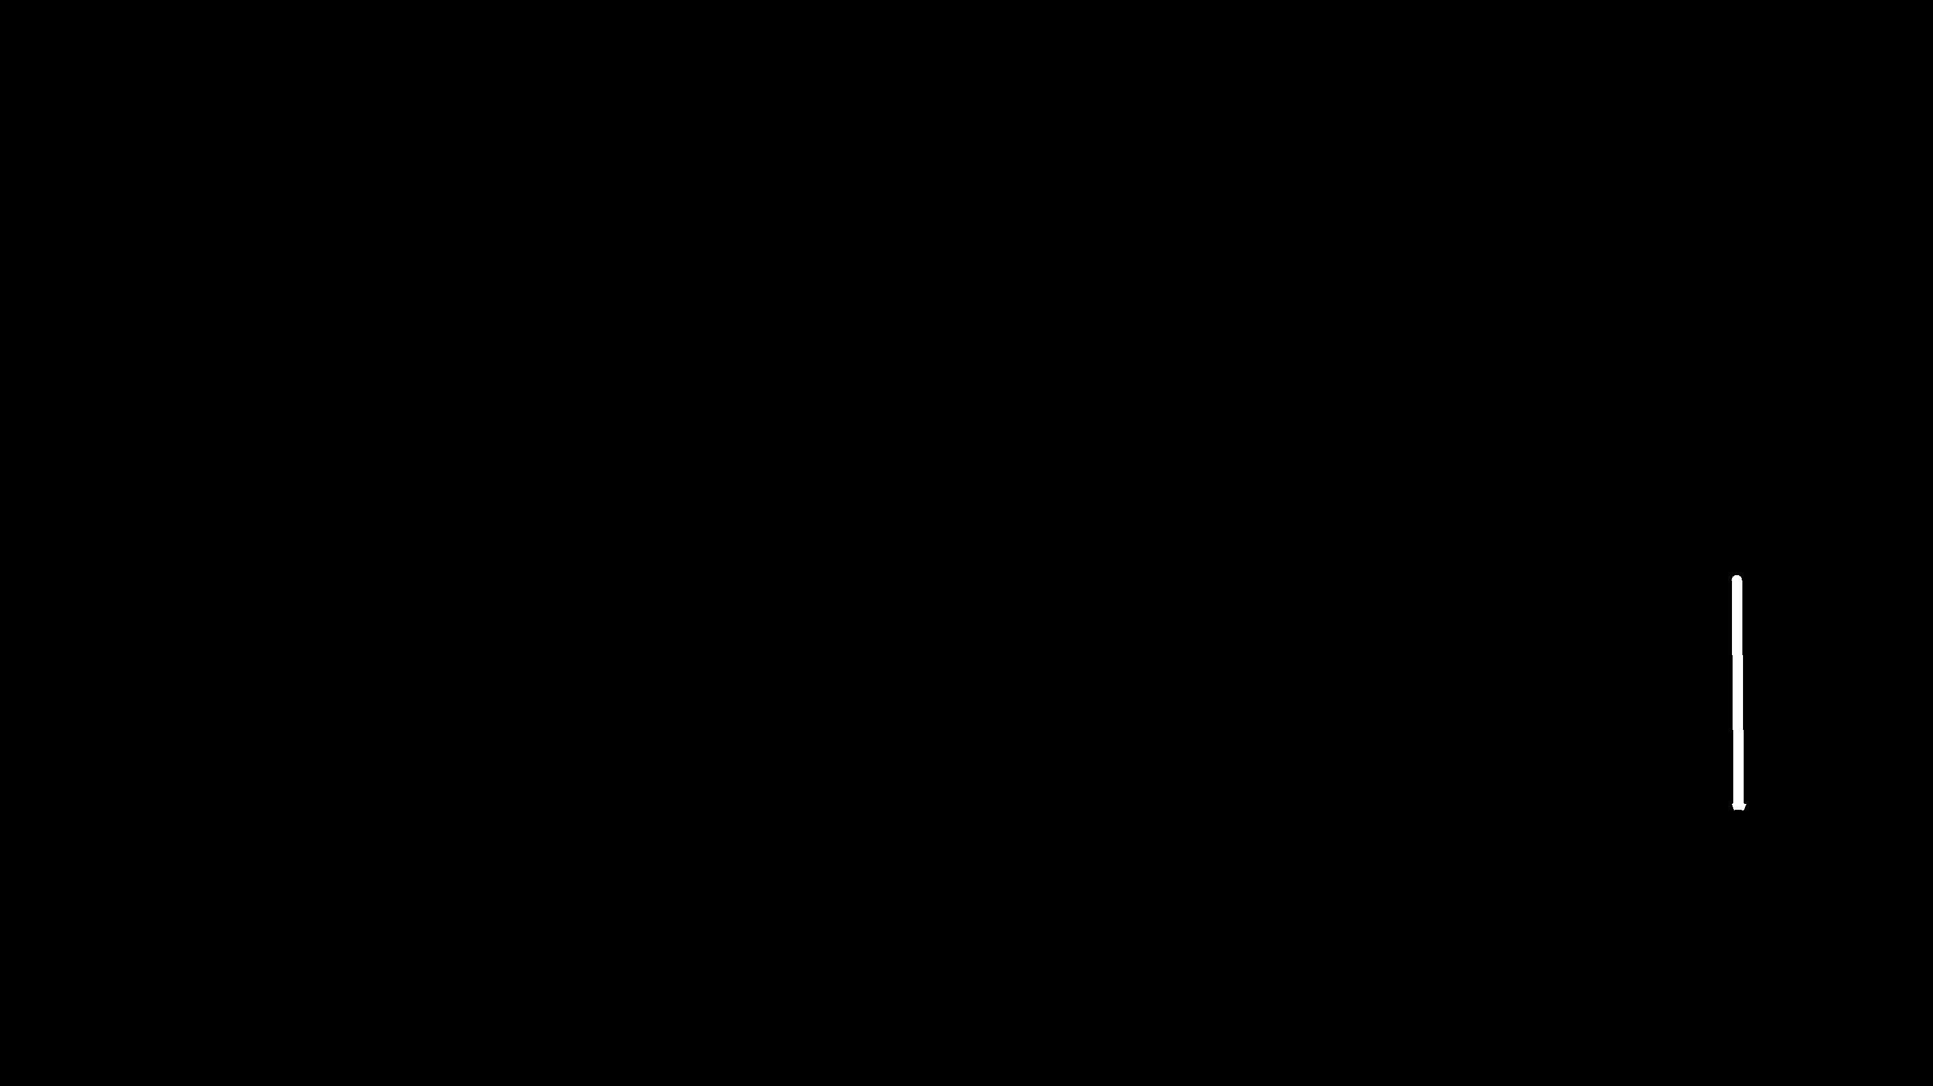
Operator Precedence Rules

Highest precedence rule to lowest precedence rule:
> Parenthesis are always respected
> Exponentiation (raise to a power) | Parenthesis
 | Power
> Multiplication, Division, and Remainder | Multiplication
> Addition and Subtraction | Addition
> Addition and Subtraction | Left to Right
> Left to right

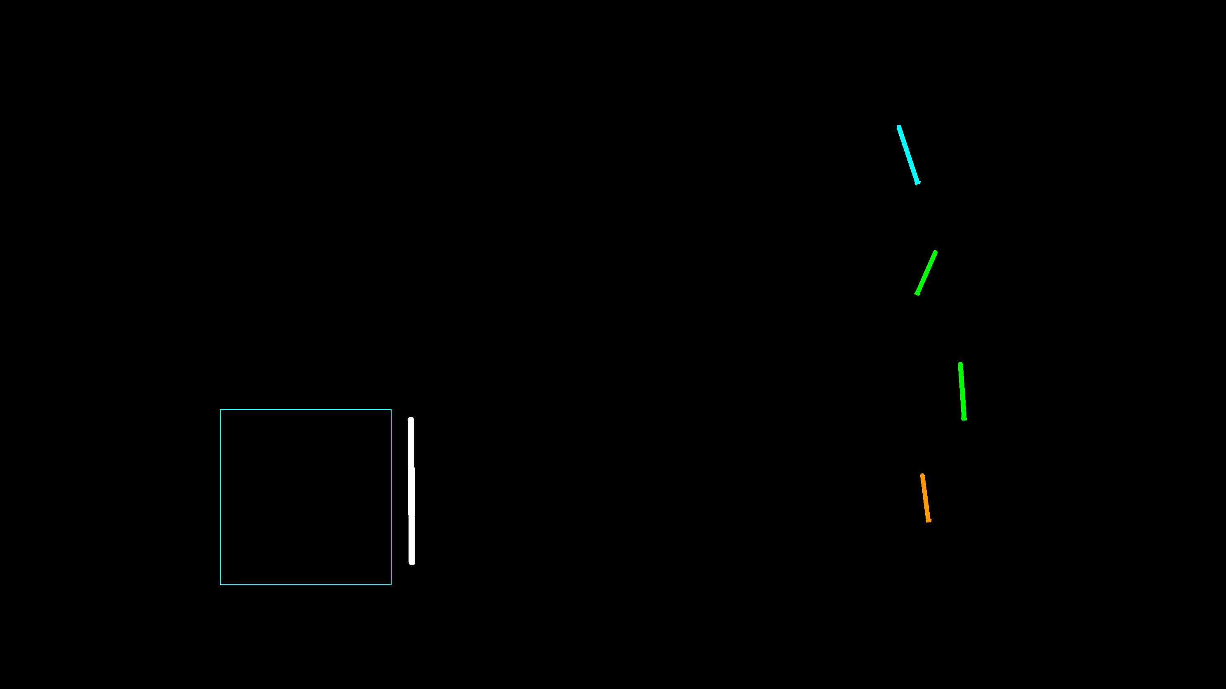

- x = 1 + 2 ** 3 / 4 * 5

- print x

11

>>>

Parenthesis

Power

Multiplication

Addition
Left to Right 

1 + 2 ** 3 / 4 * 5

1 + 8 / 4 * 5

1 + 2 * 5

1 + 10

11

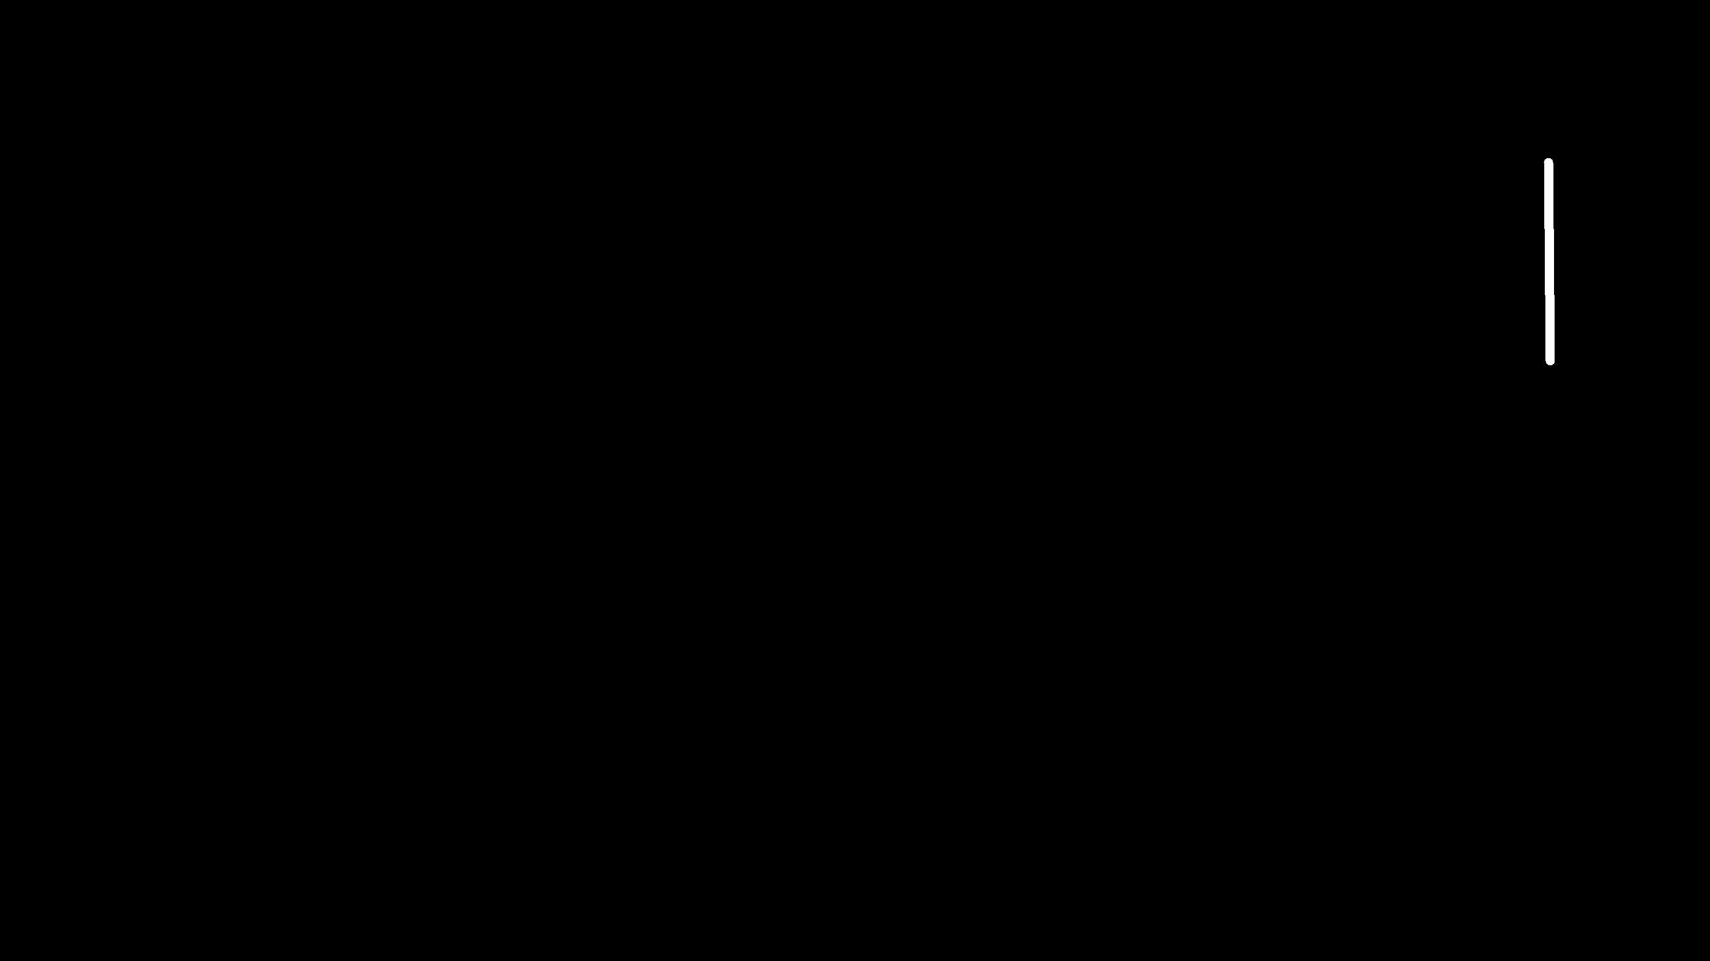
Operator Precedence

• Remember the rules top to bottom

Parenthesis

Power

Multiplication

Addition Left to Right

- When writing code - use parenthesis

- When writing code - keep mathematical expressions simple enough that they are easy to understand

- Break long series of mathematical operations up to make them more clear

Exam Question: x = 1 + 2 * 3 - 4 / 5

Python Integer Division is Weird!

- Integer division truncates

- Floating point division produces floating point numbers

- print 10 / 2

5

- print 9 / 2

4

- print 99 / 100

0

- print 10.0 / 2.0

5.0

- print 99.0 / 100.0

0.99

This changes in Python 3.0

Mixing Integer and Floating

- When you perform an operation where one operand is an integer and the other operand is a floating point, the result is a floating point

- The integer is converted to a floating point before the operation

- print 99 / 100

0

- print 99 / 100.0

0.99

- print 99.0 / 100

0.99

- print 1 + 2 * 3 / 4.0 - 5

-2.5

What does “Type” Mean?

- In Python variables, literals and constants have a “type”

- Python knows the difference between an integer number and a string

- For example “+” means “addition” if something is a number and “concatenate” if something is a string

- ddd = 1 + 4

- print ddd

5

- eee = 'hello ' + 'there'

- print eee

hello there

concatenate = put together

Type Matters

- Python knows what “type” everything is

- Some operations are prohibited

- You cannot “add 1” to a string

- We can ask Python what type something is by using the type() function

- eee = 'hello ' + 'there'

- eee = eee + 1

Traceback (most recent call last): File "<stdin>", line 1, in
<module>

TypeError: cannot concatenate 'str' and 'int' objects

- type(eee)

<type 'str'>

- type('hello') <type 'str'>

- type(1)

<type 'int'>

Several Types of Numbers

- Numbers have two main types

  - Integers are whole numbers: -14, -2, 0, 1, 100, 401233

  - Floating Point Numbers have decimal parts: -2.5 , 0.0, 98.6, 14.0

- There are other number types - they are variations on float and integer

- xx = 1

- type (xx) <type 'int'>
- temp = 98.6

- type(temp) <type 'float'>

- type(1) <type 'int'>

- type(1.0) <type 'float'>

Type Conversions

- When you put an integer and floating point in an expression, the integer is implicitly converted to a float

- You can control this with the built-in functions int() and float()

- print float(99) / 100 0.99

- i = 42

- type(i)

<type 'int'>

- f = float(i)

- print f 42.0

- type(f) <type 'float'>

- print 1 + 2 * float(3) / 4 - 5 -2.5

String

Conversions

- You can also use int() and float() to convert between strings and integers

- You will get an error if the string does not contain numeric characters

>>> sval = '123'
- type(sval) <type 'str'>

- print sval + 1

Traceback (most recent call last): File "<stdin>", line 1, in <module>

TypeError: cannot concatenate 'str' and 'int'

- ival = int(sval)

- type(ival) <type 'int'>

- print ival + 1

124

- nsv = 'hello bob'

- niv = int(nsv)

Traceback (most recent call last):

File "<stdin>", line 1, in <module>

ValueError: invalid literal for int()

User Input

•

•

We can instruct Python

to pause and read data from the user using the raw_input() function

The raw_input() function returns a string

nam = raw_input('Who are you?') print 'Welcome', nam

Who are you? Chuck

Welcome Chuck

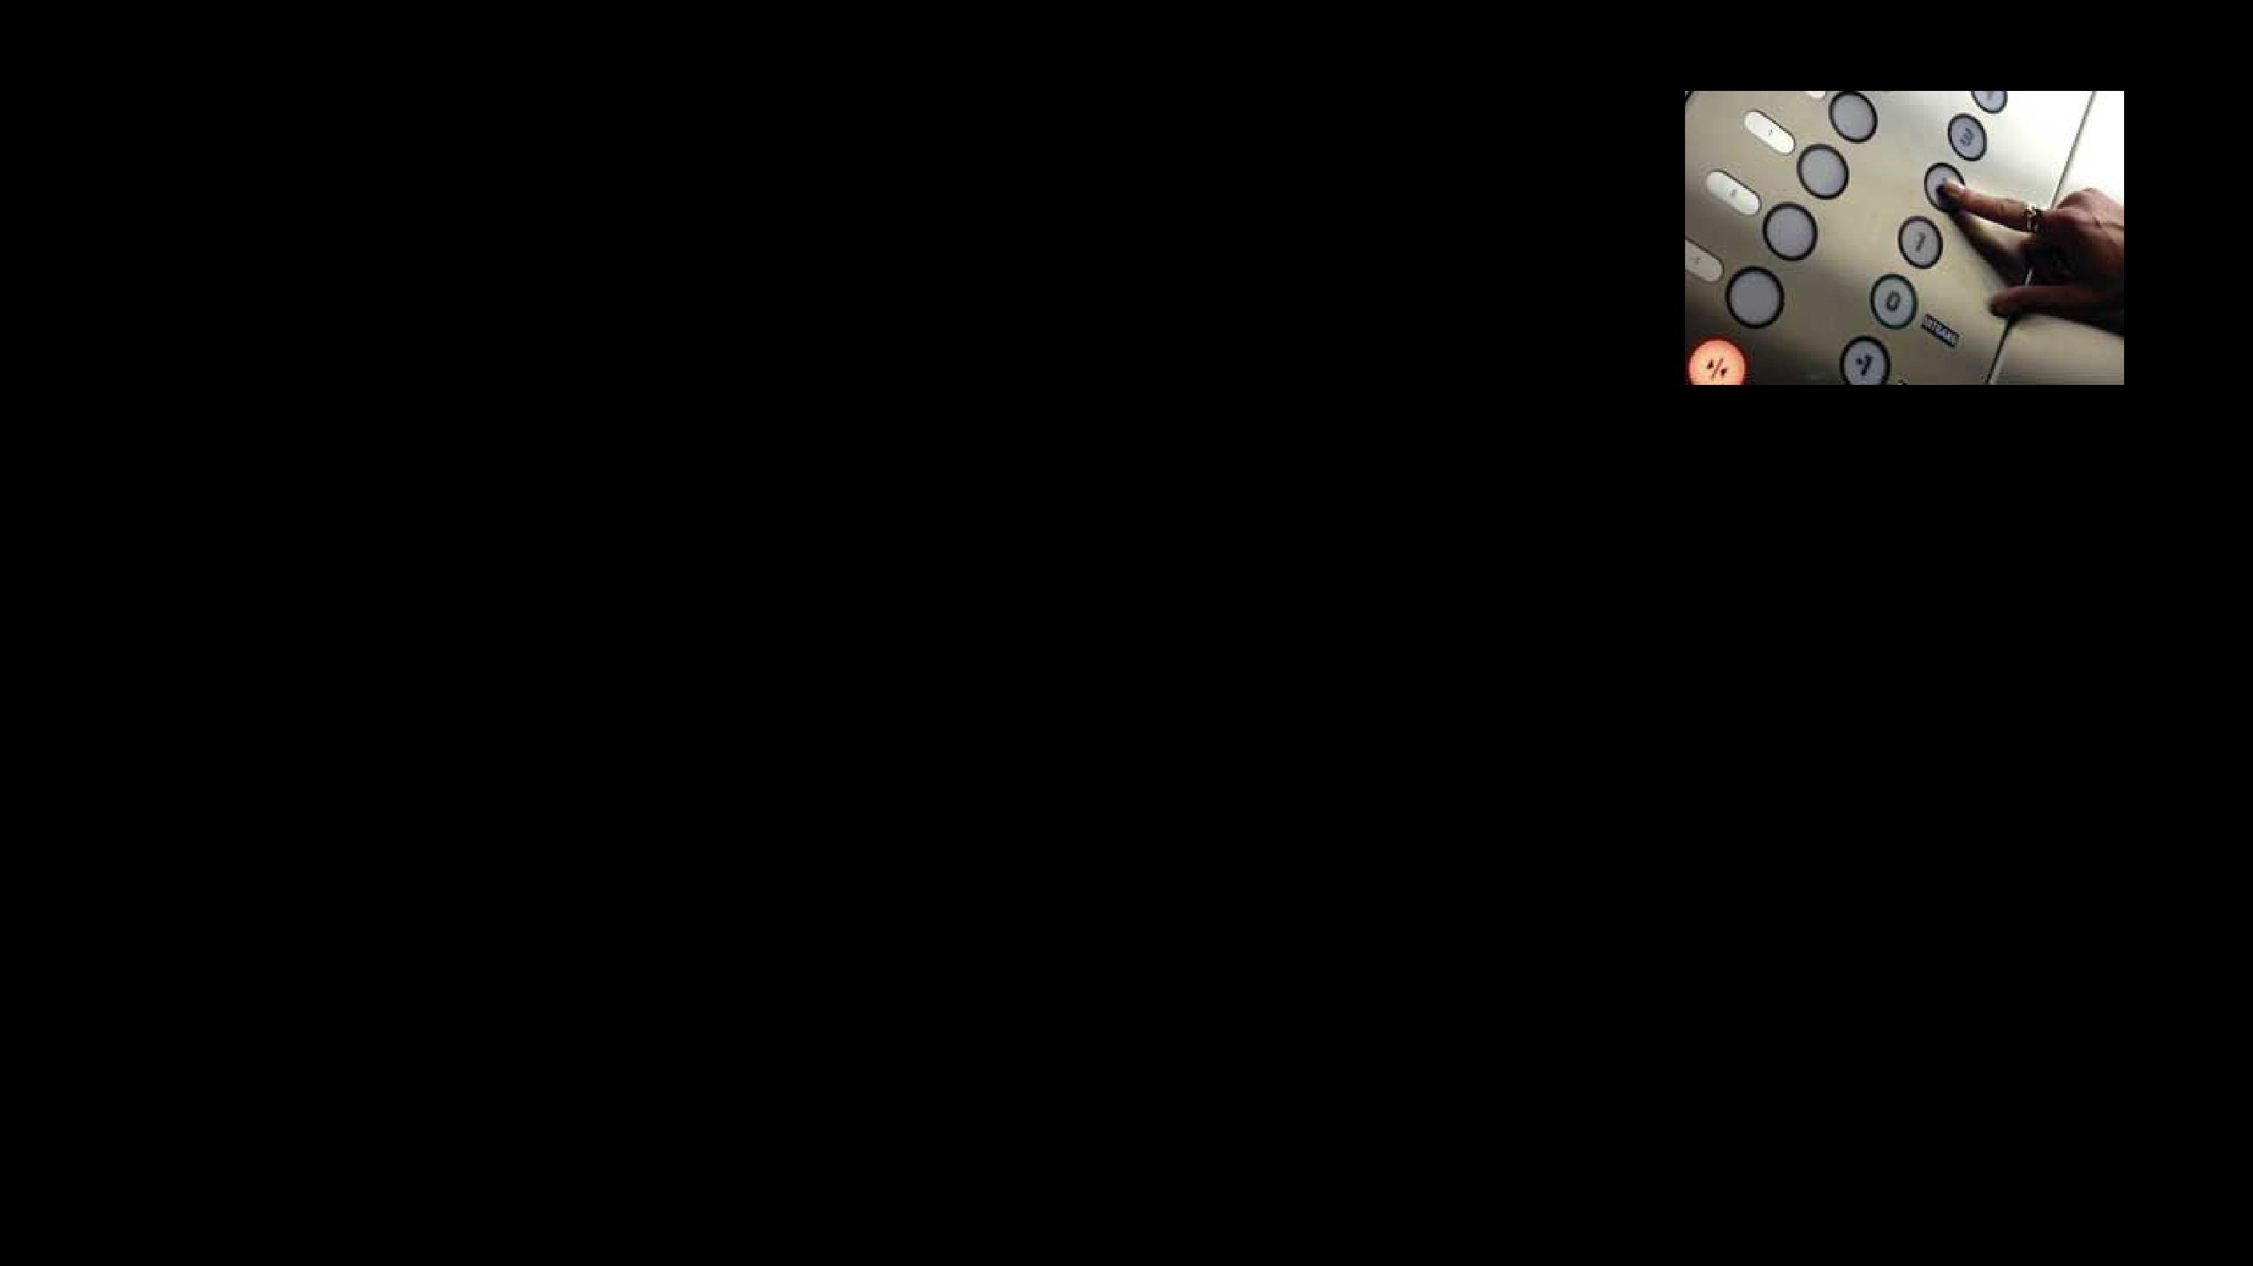
Converting User Input

•

•

If we want to read a

number from the user, we must convert it from a string to a number using a type conversion function

Later we will deal with bad input data

inp = raw_input('Europe floor?') usf = int(inp) + 1

print 'US floor', usf

Europe floor? 0

US floor 1

Comments in Python

- Anything after a # is ignored by Python

- Why comment?

  - Describe what is going to happen in a sequence of code

  - Document who wrote the code or other ancillary information

  - Turn off a line of code - perhaps temporarily

- Get the name of the file and open it name = raw_input('Enter file:') handle = open(name, 'r')

text = handle.read() words = text.split()

- Count word frequency

counts = dict() for word in words:

counts[word] = counts.get(word,0) + 1

- Find the most common word bigcount = None
bigword = None

for word,count in counts.items():

if bigcount is None or count > bigcount: bigword = word
bigcount = count

- All done

print bigword, bigcount


String Operations

- Some operators apply to strings

  - + implies “concatenation”

  - * implies “multiple concatenation”

- Python knows when it is dealing with a string or a number and behaves appropriately

- print 'abc' + '123’ abc123
- print 'Hi' * 5 HiHiHiHiHi

Mnemonic Variable Names

- Since we programmers are given a choice in how we choose our variable names, there is a bit of “best practice”

- We name variables to help us remember what we intend to store in them (“mnemonic” = “memory aid”)

- This can confuse beginning students because well-named variables often “sound” so good that they must be keywords

http://en.wikipedia.org/wiki/Mnemonic

x1q3z9ocd = 35.0 x1q3z9afd = 12.50

x1q3p9afd = x1q3z9ocd * x1q3z9afd print x1q3p9afd

What is this bit of code doing?

x1q3z9ocd = |  | 35.0 |  | a = |  | 35.0
x1q3z9afd | = | 12.50 |  | b | = | 12.50
x1q3p9afd | = | x1q3z9ocd * x1q3z9afd |  | c | = | a | * b
print x1q3p9afd |  |  |  | print |  |  | c

What are these bits of code doing?

x1q3z9ocd = |  | 35.0 |  | a = |  | 35.0
x1q3z9afd | = | 12.50 |  | b | = | 12.50
x1q3p9afd | = | x1q3z9ocd * x1q3z9afd |  | c | = | a | * b
print x1q3p9afd |  |  |  | print |  |  | c

What are these bits of code doing?

hours = 35.0 rate = 12.50

pay = hours * rate print pay

Exercise

Write a program to prompt the user for hours and rate per hour to compute gross pay.

Enter Hours: 35

Enter Rate: 2.75 Pay: 96.25

Summary

• Type |  |  | • Integer Division
• Reserved words |  |  | • Conversion between types
• Variables (mnemonic) |  |  | • User input
• Operators |  |  | • Comments (#)
• Operator precedence


Acknowledgements / Contributions

These slides are Copyright 2010- Charles R. Severance (www. dr-chuck.com) of the University of Michigan School of Information ...
and open.umich.edu and made available under a Creative Commons Attribution 4.0 License. Please maintain this last slide in all copies of the document to comply with the attribution requirements of the license. If you make a change, feel free to add your name and organization to the list of contributors on this page as you republish the materials.

Initial Development: Charles Severance, University of Michigan

School of Information

… Insert new Contributors and Translators here

