Project Setup

1. Install JavaFX and scene builder:

<https://gluonhq.com/products/scene-builder/> --> Note the location of your download.

<https://gluonhq.com/products/javafx/> --> Choose to download SDK and note the location of your download.

1. Add a run configuration like this, but modify the path in the VM options to your JavaFX lib folder (you must add a VM option first from “Modify options”):

Example:

--module-path "C:\Programming-Patterns-Final-Project-main\javafx-sdk-24.0.1\lib" --add-modules javafx.controls,javafx.fxml

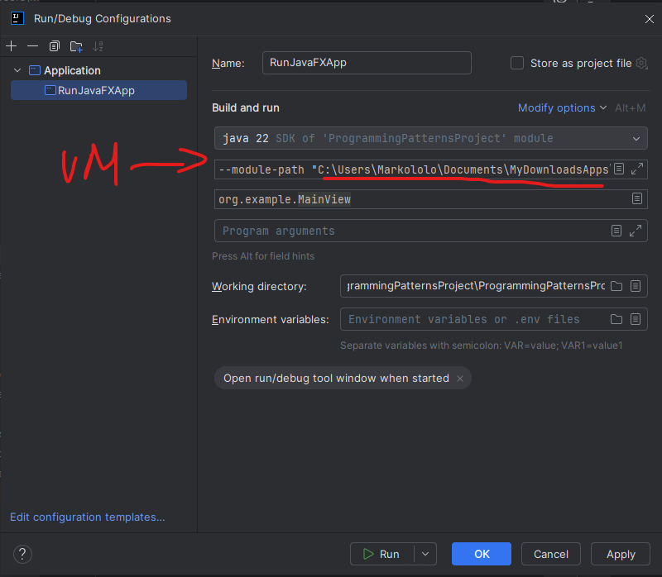

1. Add JavaFX libraries (all the .jar in your JavaFX lib folder):

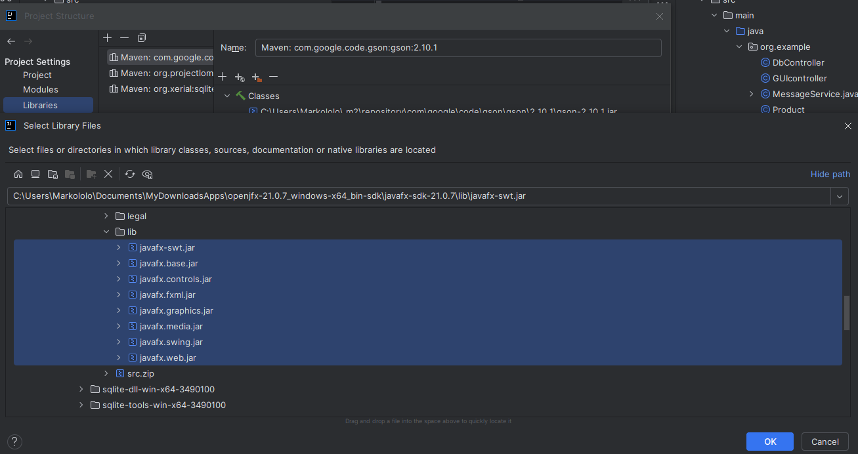

1. Connect to your scene builder (path to your .exe)

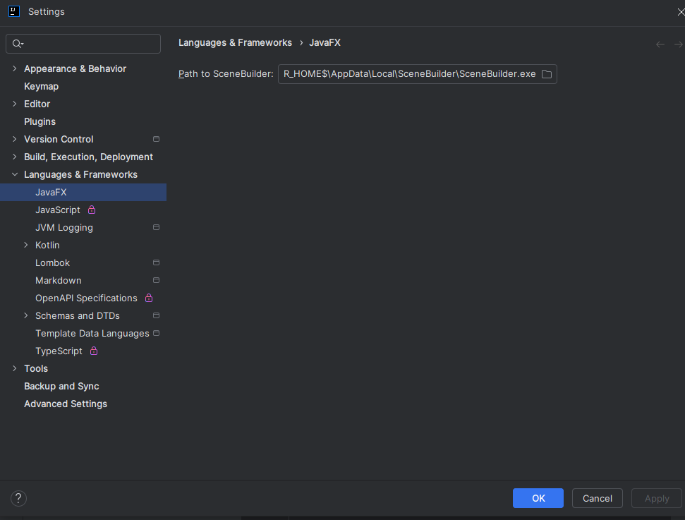

1. Add the Lombok plugin (if not already installed).

