Mehreen Fatima 23F-0611

Meerab Awais 23F-0515

Fatima Nasir 23L-0714

**Database systems-Lab Final project**

**MY GAME STORE APPLICATION**

**MY GAMES STORE APPLICATION**

**Introduction**

The GameStore database project is a simulation of a digital storefront designed to manage the buying and selling of video games. The main purpose of the application is to create a structured, efficient, and scalable system that handles essential operations such as managing game inventory, storing user information, recording purchase transactions, and generating sales reports. This project demonstrates the practical application of relational database concepts in a real-world scenario, reflecting how e-commerce platforms manage large volumes of structured data. Through this project, key database design principles such as entity-relationship modeling, normalization, and query optimization are explored and implemented.

**Objectives**

* To design and implement a relational database system tailored for a video game store.
* To manage core data entities such as users, games, orders, and inventory.
* To apply normalization techniques to reduce redundancy and improve data consistency.
* To enforce data integrity using primary and foreign key constraints.
* To enable efficient querying for common use cases such as product searches, order history, and sales tracking.
* To provide a foundation for further development, such as adding user reviews, shopping carts, or admin analytics.

**Main Codes and Database section:**

**Index.php:**

<!DOCTYPE html>

<html lang="en">

<head>

<title>Techlinked</title>

<style>

body {

margin: 0;

padding: 0;

font-family: 'Arial', sans-serif;

}

header {

background-image: url('Purple_Gaming_Background.png');

background-size: cover;

background-position: center;

color: rgb(255, 255, 255);

text-align: center;

padding: 200px;

}

nav {

background-color: #490e4e;

color: #fff;

padding: 20px;

text-align: center;

}

nav a {

color: #fff;

text-decoration: none;

padding: 20px;

margin: 10px;

font-weight: bold;

}

nav a:hover {

background-color: rgb(192, 7, 230);

}

section {

padding: 20px;

text-align: center;

}

</style>

</head>

<body>

<nav>

<a href="index.php">Home</a>

<a href="products.php">Products</a>

<a href="services.php">Services</a>

<a href="contact.php">Contact</a>

<a href="cart.php">Cart</a>

<a href="tracking.php">Order Tracking</a>

<a href="user_logout.php">Logout</a>

</nav>

<header>

<h1>Welcome to Techlinked Games</h1>

<p>Bringing Exciting Games to you without the middle man</p>

</header>

<section>

<h2>About Us</h2>

<p>

We here at techlinked believe that customers should pay exactly the amount the product costs

and not a penny more. Unfortunately, more and more retailers have started selling games

at a higher price due to low stock and high demand. But worry not — that's where we come in.

We've partnered directly with some of the top game manufacturers to bring you the newest and

latest games at their original prices — even discounted sometimes! You can trust us for

authenticity and quality.

</p>

</section>

</body>

</html>

**Userlogin.php:**

<?php

session_start();

require 'db.php';

if ($_SERVER["REQUEST_METHOD"] == "POST") {

$username = $_POST['email'];

$ad_password = $_POST['password'];

// Use a prepared statement with PDO5

$stmt = $pdo->prepare("SELECT * FROM admins WHERE ad_email = ?");

$stmt->execute([$username]);

$admin = $stmt->fetch();

if ($admin && password_verify($ad_password, $admin['ad_password'])) {

$_SESSION['admin'] = $admin['username']; // Keeps the admin username in the session

$_SESSION['admin_logged_in'] = true; // Set this session variable to indicate logged-in status

header("Location: admin_dashboard.php");

exit();

}

else {

echo "Invalid username or password.";

}

}

?>

<!DOCTYPE html>

<html lang="en">

<head>

<title>Login - Techlinked</title>

<style>

body { font-family: Arial; background-image: url('Purple_Gaming_Background.png'); background-size: cover; text-align: center; padding: 50px; color: white; }

form { background: rgb(191, 41, 237); padding: 20px; display: inline-block; border-radius: 8px; box-shadow: 0 0 10px rgba(0,0,0,0.1); }

input { padding: 5px; margin: 10px 0; width: 100%; }

button { padding: 10px; background: #490e4e; color: white; border: none; cursor: pointer; }

button:hover { background: rgb(205, 41, 237); }

.error { color: yellow; }

</style>

</head>

<body>

<h2>Login</h2>

<?php if (!empty($error)): ?>

<p class="error"><?php echo $error; ?></p>

<?php endif; ?>

<form method="POST" action="">

<input type="email" name="email" placeholder="Email" required><br>

<input type="password" name="password" placeholder="Password" required><br>

<button type="submit">Login</button><br>

<p>Don't have an account? <a href="signup.php">Sign up here</a></p>

</form>

</body>

</html>

**Products.php:**

<?php

session_start();

if (!isset($_SESSION['user_id'])) {

header('Location: user_login.php');

exit();

}

?>

<?php

include 'db.php';

$session_id = session_id();

// Handle Add to Cart

if ($_SERVER['REQUEST_METHOD'] === 'POST' && isset($_POST['add_to_cart'])) {

$name = $_POST['name'];

$price = $_POST['price'];

$image = $_POST['image'];

// Fetch g_id and available quantity

$stmt = $pdo->prepare("SELECT g_id, g_quantity FROM game WHERE g_name = :name");

$stmt->execute(['name' => $name]);

$game = $stmt->fetch();

if ($game && $game['g_quantity'] > 0) {

$g_id = $game['g_id'];

// Update session cart

if (!isset($_SESSION['cart'])) {

$_SESSION['cart'] = [];

}

$found = false;

foreach ($_SESSION['cart'] as &$item) {

if ($item['name'] === $name) {

$item['quantity'] += 1;

$found = true;

break;

}

}

if (!$found) {

$_SESSION['cart'][] = [

'name' => $name,

'price' => $price,

'image' => $image,

'quantity' => 1

];

}

// Update quantity in `game` table

$stmt = $pdo->prepare("UPDATE game SET g_quantity = g_quantity - 1 WHERE g_id = :g_id AND g_quantity > 0");

$stmt->execute(['g_id' => $g_id]);

// Insert into `cart` table or update quantity

$stmt = $pdo->prepare("SELECT * FROM cart WHERE g_id = :g_id AND session_id = :session_id");

$stmt->execute(['g_id' => $g_id, 'session_id' => $session_id]);

$cartItem = $stmt->fetch();

if ($cartItem) {

$stmt = $pdo->prepare("UPDATE cart SET quantity = quantity + 1 WHERE g_id = :g_id AND session_id = :session_id");

} else {

$stmt = $pdo->prepare("INSERT INTO cart (g_id, quantity, session_id) VALUES (:g_id, 1, :session_id)");

}

$stmt->execute(['g_id' => $g_id, 'session_id' => $session_id]);

}

header('Location: products.php');

exit();

}

// Handle Clear Cart

if ($_SERVER['REQUEST_METHOD'] === 'POST' && isset($_POST['clear_cart'])) {

if (isset($_SESSION['cart']) && !empty($_SESSION['cart'])) {

foreach ($_SESSION['cart'] as $item) {

$stmt = $pdo->prepare("SELECT g_id FROM game WHERE g_name = :name");

$stmt->execute(['name' => $item['name']]);

$game = $stmt->fetch();

if ($game) {

$g_id = $game['g_id'];

$stmt = $pdo->prepare("UPDATE game SET g_quantity = g_quantity + :quantity WHERE g_id = :g_id");

$stmt->execute([

'quantity' => $item['quantity'],

'g_id' => $g_id

]);

// Remove from cart table

$stmt = $pdo->prepare("DELETE FROM cart WHERE g_id = :g_id AND session_id = :session_id");

$stmt->execute([

'g_id' => $g_id,

'session_id' => $session_id

]);

}

}

unset($_SESSION['cart']);

}

header('Location: products.php');

exit();

}

// Fetch products

$query = 'SELECT g_id, g_name, g_price, g_image, g_description, g_quantity FROM game';

$stmt = $pdo->query($query);

$products = $stmt->fetchAll();

?>

<!DOCTYPE html>

<html lang="en">

<head>

<title>Techlinked - Products</title>

<link rel="stylesheet" href="css_styling/services.css">

<style>

body {

margin: 0;

padding: 0;

font-family: 'Arial', sans-serif;

background-color: #48114d;

}

header {

background-image: url('Purple_Gaming_Background.png');

background-size: cover;

background-position: center;

color: rgb(255, 255, 255);

text-align: center;

padding: 100px;

}

nav {

background-color: #490e4e;

color: #d62222;

padding: 15px;

text-align: center;

}

nav a {

color: #fff;

text-decoration: none;

padding: 15px;

margin: 0 10px;

font-weight: bold;

}

nav a:hover {

background-color: rgb(205, 41, 237);

}

section {

padding: 20px;

text-align: center;

}

.product {

display: inline-block;

margin: 20px;

text-align: center;

background-color: #f2f2f2;

border-radius: 10px;

padding: 20px;

width: 250px;

box-shadow: 0 4px 8px rgba(0, 0, 0, 0.1);

}

.product img {

max-width: 100%;

border-radius: 10px;

}

.product h2 {

font-size: 1.2em;

margin: 10px 0;

}

.product p {

font-size: 1em;

color: #555;

margin-bottom: 10px;

}

.order-button {

padding: 10px 20px;

background-color: #d62222;

color: #fff;

border: none;

border-radius: 5px;

cursor: pointer;

}

.order-button:hover {

background-color: #b01616;

}

.clear-cart-button {

padding: 10px 20px;

background-color: #28a745;

color: #fff;

border: none;

border-radius: 5px;

cursor: pointer;

}

.clear-cart-button:hover {

background-color: #218838;

}

</style>

</head>

<body>

<nav>

<a href="index.php">Home</a>

<a href="products.php">Product</a>

<a href="services.php">Services</a>

<a href="contact.php">Contact</a>

<a href="cart.php">Cart</a>

<a href="tracking.php">Order Tracking</a>

<a href="user_logout.php">Logout</a>

</nav>

<header>

<h1>Latest Games</h1>

<p>Explore the newest games with exciting features.</p>

</header>

<?php foreach ($products as $product): ?>

<section class="product">

<img src="<?= htmlspecialchars($product['g_image']); ?>" alt="<?= htmlspecialchars($product['g_name']); ?>">

<div class="product-info">

<h2 style="color: black"><?= htmlspecialchars($product['g_name']); ?></h2>

<p><?= htmlspecialchars($product['g_description']); ?></p>

<p>Price: $<?= number_format($product['g_price'], 2); ?></p>

<p>Available Quantity: <?= $product['g_quantity']; ?></p>

<form method="post">

<input type="hidden" name="name" value="<?= htmlspecialchars($product['g_name']); ?>">

<input type="hidden" name="price" value="<?= htmlspecialchars($product['g_price']); ?>">

<input type="hidden" name="image" value="<?= htmlspecialchars($product['g_image']); ?>">

<button class="order-button" type="submit" name="add_to_cart">Add to Cart</button>

</form>

</div>

</section>

<?php endforeach; ?>

<?php if (isset($_SESSION['cart']) && count($_SESSION['cart']) > 0): ?>

<form method="post">

<button class="clear-cart-button" type="submit" name="clear_cart">Clear Cart</button>

</form>

<?php endif; ?>

</body>

</html>

**Database queries section:**

**Tables:**

CREATE TABLE users (

id INT AUTO_INCREMENT PRIMARY KEY,

email VARCHAR(100) UNIQUE NOT NULL,

password VARCHAR(255) NOT NULL,

name VARCHAR(100) NOT NULL,

created_at TIMESTAMP DEFAULT CURRENT_TIMESTAMP

);

CREATE TABLE admins (

id INT AUTO_INCREMENT PRIMARY KEY,

ad_email VARCHAR(100) UNIQUE NOT NULL,

ad_password VARCHAR(255) NOT NULL,

username VARCHAR(100) NOT NULL,

created_at TIMESTAMP DEFAULT CURRENT_TIMESTAMP

);

CREATE TABLE orders (

order_id INT AUTO_INCREMENT PRIMARY KEY,

user_id INT,

order_date DATETIME DEFAULT CURRENT_TIMESTAMP,

total_amount DECIMAL(10, 2),

status VARCHAR(50) DEFAULT 'Pending'

);

CREATE TABLE game (

g_id INT PRIMARY KEY AUTO_INCREMENT,

g_name VARCHAR(100),

g_price DECIMAL(10,2),

g_image VARCHAR(100),

g_description TEXT,

g_quantity INT

);

CREATE TABLE cart (

cart_id INT AUTO_INCREMENT PRIMARY KEY,

g_id INT NOT NULL,

quantity INT NOT NULL DEFAULT 1,

session_id VARCHAR(255),

added_at TIMESTAMP DEFAULT CURRENT_TIMESTAMP,

FOREIGN KEY (g_id) REFERENCES game(g_id)

);

CREATE TABLE payment (

payment_id INT AUTO_INCREMENT PRIMARY KEY,

order_id INT,

payment_date DATETIME DEFAULT CURRENT_TIMESTAMP,

payment_status VARCHAR(50),

payment_method VARCHAR(50),

amount DECIMAL(10, 2)

);

ALTER TABLE payment

ADD COLUMN user_id INT,

ADD COLUMN created_at TIMESTAMP DEFAULT CURRENT_TIMESTAMP;

**Insertion query:**

INSERT INTO game (g_name, g_price, g_image, g_description, g_quantity) VALUES

('GTA V', 999.99, 'gta5.png', 'An open-world action-adventure game where you complete missions and explore a crime-filled city as three different characters.', 25),

('FC 25', 1499.99, 'fc25.png', 'The latest football simulation game offering realistic gameplay, updated teams, and career modes.', 30),

('Forza Horizon 5', 899.99, 'forza.png', 'An open-world racing game set in Mexico with dynamic seasons and a vast variety of cars.', 15),

('Spider Man 2', 899.99, 'sman.png', 'An open-world racing game set in Mexico with dynamic seasons and a vast variety of cars.', 10),

('Tekken 8', 899.99, 'tekken8.png', 'An open-world racing game set in Mexico with dynamic seasons and a vast variety of cars.', 20),

('Tekken 7', 899.99, 'tekken7.png', 'An open-world racing game set in Mexico with dynamic seasons and a vast variety of cars.', 18),

('Call of Duty: Black Ops 6', 999.99, 'cod.png', 'A free-to-play battle royale game set in the Call of Duty universe, offering intense combat and large-scale multiplayer action.', 22),

('Call of Duty: Modern Warfare', 899.99, 'codmw.png', 'An open-world racing game set in Mexico with dynamic seasons and a vast variety of cars.', 16),

('Minecraft', 799.99, 'mine.png', 'A sandbox game where players build and explore virtual worlds made of blocks, with endless possibilities for creativity and survival.', 40),

('Cricket 24', 899.99, 'cri.png', 'An open-world racing game set in Mexico with dynamic seasons and a vast variety of cars.', 14),

('Assassins Creed Valhalla', 1499.99, 'ac.png', 'A historical action RPG that follows the Viking invasion of England, offering open-world exploration and strategic combat.', 13),

('Assasins Creed Odyssey', 899.99, 'aco.png', 'An open-world racing game set in Mexico with dynamic seasons and a vast variety of cars.', 12),

('WWE 2K25', 899.99, 'wwe.png', 'An open-world racing game set in Mexico with dynamic seasons and a vast variety of cars.', 15),

('Valorant', 899.99, 'valo.png', 'An open-world racing game set in Mexico with dynamic seasons and a vast variety of cars.', 17),

('Fortnite', 899.99, 'fort.png', 'An open-world racing game set in Mexico with dynamic seasons and a vast variety of cars.', 21),

('NBA 2K25', 899.99, 'nba.png', 'An open-world racing game set in Mexico with dynamic seasons and a vast variety of cars.', 11),

('Red Dead Redemption 2', 1799.99, 'rdr.png', 'An open-world action-adventure game set in the American Wild West, following a gang of outlaws on their journey through the changing frontier.', 8),

('The Witcher 3: Wild Hunt', 1499.99, 'tw.png', 'An action RPG set in a vast open world, where you play as Geralt of Rivia, a monster hunter, as you embark on a quest to find your adopted daughter.', 9); **Error handling and outputs:**

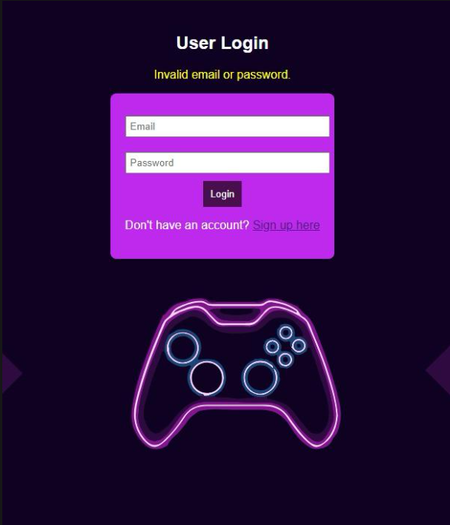

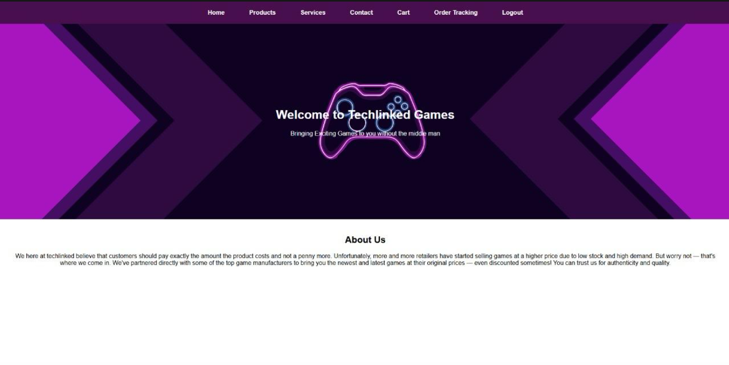

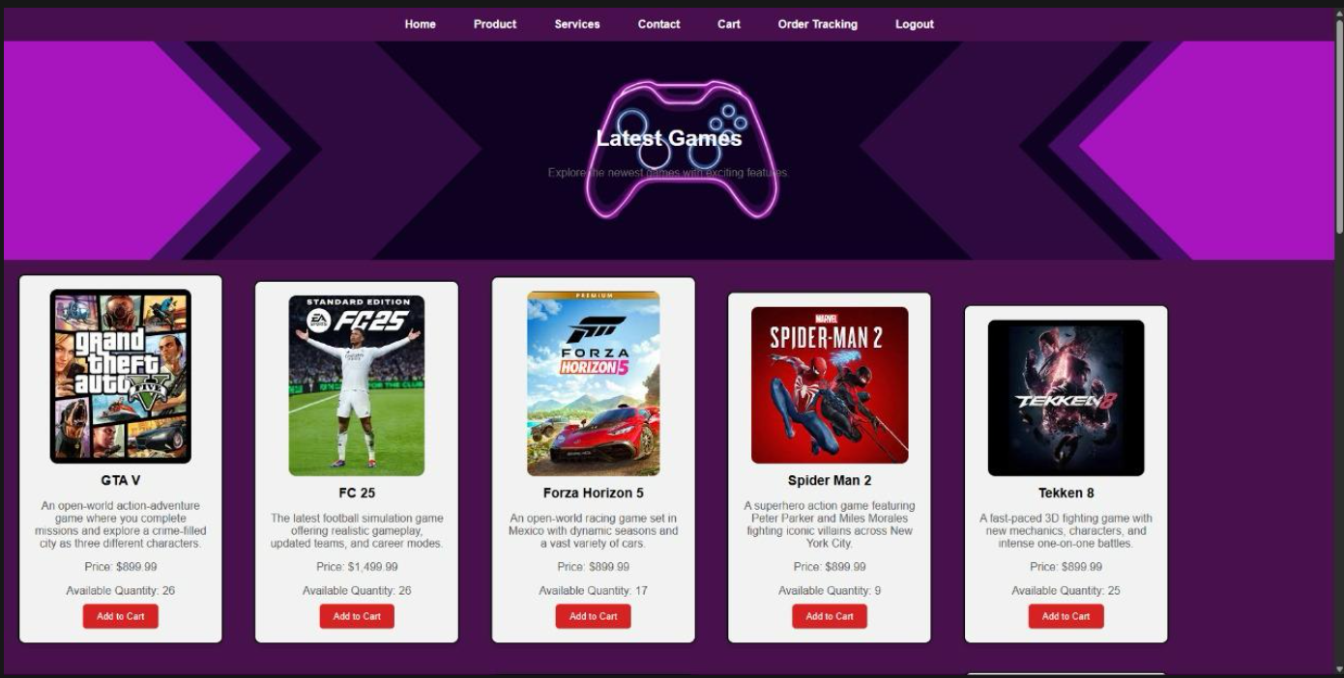

**Database::techlinked**

