**Activity:**

Question No 1:

Open your browser and visit Google.com?

Ans: Done

Question No 2:

In the search box start typing the title of this lecture “Introduction to text analysis”?

Ans: Done.

Question No 3:

Notice as you continue typing a list of suggestion appears?

Ans: Noticed

List of suggestion:

* Introduction to text analysis
* Introduction to text analysis in r
* Introduction to text analysis in r data camp
* Introduction to text analysis with nvivo 11 for windows
* Introduction to text analysis a coursebook
* An introduction to text analytic-with-python-part-3
* Introduction to topology and modern analysis text

Question No 4:

What do you observe in the list of suggestion? Are there any patterns.

Ans: Yes, there was a pattern among the search results. The search engine showed various content related option + all new discoveries and updated content.

Enlisted suggestions were related to computer or computer operating system.

Question No 5:

Repeat step 2 to 4 but this time use duckduckgo.com?

Ans: Done

Duckduckgo.com list of suggestions

* Introduction to text analysis in r

Question No 6:

Repeat step 2 to 4 and this time use bing.com?

Ans: Done

Bing.com list of suggestions

* Introduction to text analysis in r

Question No 7:

Which search engine’s list of suggestion is better and why?

Ans: Google.com is better search engine because there work multiple options regarding to the typed context.

Question No 8:

Observe the list of search results for “Introduction to text analysis” on 3 search engines, google, duckduckgo and bing.

Ans: Done.

Question No 9:

Do all search engines return the same result?

Ans: No, besides the google.com the other search engines like bing and duckduckgo.com showed limited options.

Question No 10:

Which site is listed in the top 5 result of all three search engines?

Ans: List of top 5 search engines

1. Google.com
2. Duckduckgo.com
3. Bing.com

Question No 11:

Do you think that the order of the website in the search result is important?

Ans: Yes, I think that the order of the websites in search result is very important because it shows various other option related to context so people can choose the best and suitable option related to their search easily.

Question No 12:

Try to find which (mechanism/ formula/ algorithms) are being used to order the results?

Ans: Search engines are answer machines they exist to discover, understand and organize the internet’s content in order to often the most relevant results to questions searchers are asking.

The mechanism that a search engine uses are as follow:

1. Crawling
2. Indexing
3. Ranking

Crawling:

Crawling is the discovery process in which search engine send out a team of robots (known as crawlers or spiders) to find new and updated content.

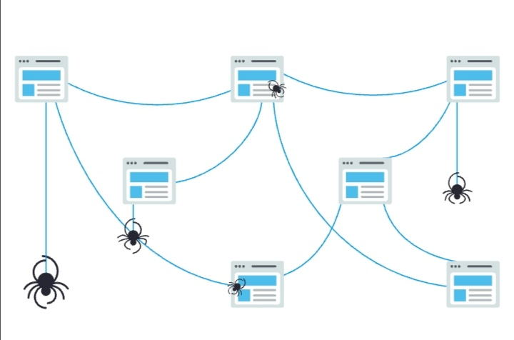

Indexing:

Search engine process and store information they find in an index, a huge database of all the content they’ve discovered and deem good enough to serve up to searchers.

Ranking:

When someone performs a search, search engines scour their index for highly relevant content and then orders that content in the hopes of solving the searchers query. This ordering of search results by relevance is known as ranking. In general, you can assume that the higher a website is ranked, the more relevant the search engine believes that site is to the query.