Yolo-You Only Look once

Before delving into the details of what is yolo? We first need to understand the foundation of what is object detection and how it is relevant to many practical use cases today.

Object Detection:
Object detection is a critical perceptual task that extends beyond mere image classification; it requires a unified approach to both recognizing what objects are present in an image and localizing where they are.
This is formally achieved by predicting precise spatial coordinates, typically represented by bounding boxes, and assigning corresponding class labels for all instances of objects from a predefined set.
The principal challenge lies in developing models that can perform this joint classification and localization accurately and efficiently across vast variations in object appearance, scale, and context, a challenge that traditional multi-stage detection pipelines struggled to overcome in real-time. It is within this context that the YOLO framework introduced its revolutionary single-stage, regression-based paradigm.

What is Yolo?
The "You Only Look Once" (YOLO) model, pioneered by Redmon et al. [1], represents a seminal departure from conventional object detection architectures. Prior two-stage detectors operated by decoupling the process of region proposal from object classification. YOLO, in contrast, reconceptualizes detection as a single regression problem, leveraging a unified neural network to process an entire image and simultaneously output bounding boxes and class probabilities. This end-to-end paradigm is the cornerstone of YOLO's architecture, granting it the exceptional computational speed necessary for real-time performance while preserving competitive detection accuracy.

Why Yolo?
1. Real-Time Performance
YOLO's single-stage architecture processes images in one forward pass, achieving remarkable inference speeds essential for live video analysis and interactive applications.
2. Unified Detection Pipeline
It simplifies object detection into a single regression problem, eliminating complex multi-stage workflows and enabling end-to-end optimization.
3. Global Context Understanding
By processing entire images simultaneously, YOLO leverages contextual information to reduce false positives and improve detection accuracy.

4. Strong Generalization Capability
YOLO demonstrates superior performance across diverse domains, maintaining robustness when applied to unfamiliar data distributions and environments.

Evolution of Yolo:
The following table show the advancement in Yolo since the first base model. Each iteration has brought significant improvements in object detection capabilities, computational efficiency, and versatility in handling various CV tasks.
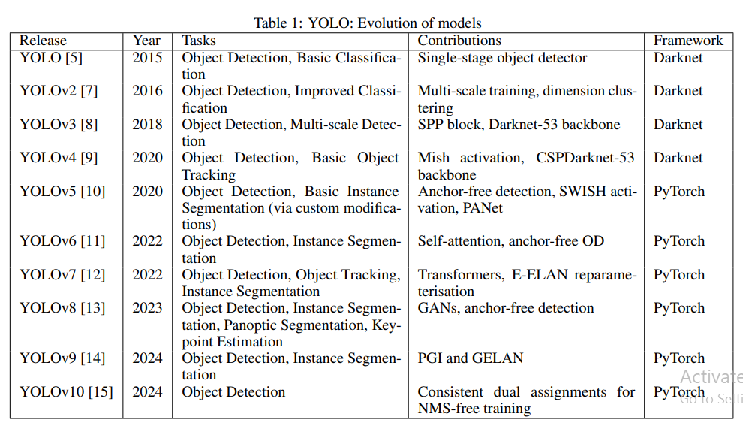
The latest iteration, YOLO11, builds upon this legacy with further enhancements in feature extraction, efficiency, and multi-task capabilities

Foundation: The Original YOLO Architecture:
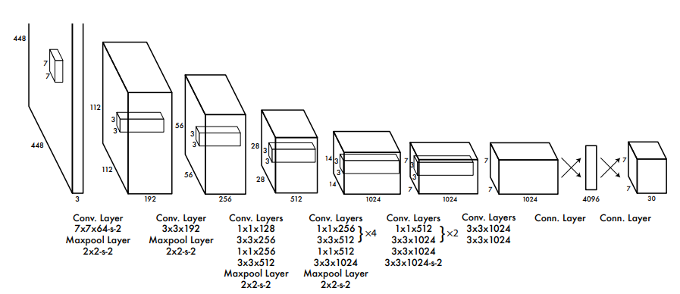

The original YOLO (You Only Look Once) architecture, introduced in 2016, revolutionized object detection by establishing a completely new paradigm that fundamentally differed from existing approaches. Let's break down its core components in detail:
Backbone Network: Feature Extraction Engine
The backbone was a custom, modified GoogLeNet-inspired convolutional neural network that served as the feature extractor:
- 24 Convolutional Layers: These layers progressively learned hierarchical features from the input image
  - Early layers detected simple features like edges and corners
  - Middle layers learned more complex patterns and textures
  - Deeper layers captured high-level semantic information and object parts
- 2 Fully Connected Layers: Positioned at the network's end to perform the final prediction
  - First FC layer: 4096 units for rich feature representation
  - Second FC layer: Produced the final output tensor of size S×S×(B×5 + C)
- Activation Functions: Used leaky ReLU activation for all layers except the final layer, which used linear activation
- Input Processing: Accepted resized images of 448×448 pixels, regardless of original aspect ratio
Grid System: Spatial Organization Framework
The grid system formed the structural foundation for YOLO's detection mechanism:
- S×S Grid Division: The input image was divided into a 7×7 grid (S=7), creating 49 equal cells
- Cell Responsibility: Each grid cell was responsible for detecting objects whose center fell within that cell
- Spatial Localization: The grid maintained spatial information by tying predictions to specific image regions
- Multi-Object Handling: Multiple objects could be detected if their centers fell in different grid cells
Multi-Scale Prediction: Unified Output Mechanism
Each grid cell simultaneously predicted multiple aspects of detection:
Bounding Box Predictions (B boxes per cell):
- Each bounding box contained 5 parameters: (x, y, w, h, confidence)
- (x, y): Box center coordinates relative to the grid cell boundaries (values between 0-1)
- (w, h): Width and height of the box relative to the entire image (values between 0-1)
- Confidence Score: Represented Pr(Object) × IOUᵗʳᵘᵗʰₚᵣₑᵈ
  - Pr(Object): Probability that the box contains any object
  - IOU: Intersection over Union between predicted box and ground truth
Class Predictions:
- C conditional class probabilities: Pr(Classᵢ | Object)
- These probabilities were conditioned on the cell containing an object
- Shared across all B bounding boxes in the same grid cell
Output Tensor: S × S × (B×5 + C)
For the standard configuration (S=7, B=2, C=20 for PASCAL VOC):
- S × S = 7 × 7 = 49 grid cells
- B × 5 = 2 × 5 = 10 values per cell for bounding boxes (2 boxes × 5 parameters each)
- C = 20 class probabilities
- Total per cell: 10 + 20 = 30 values
- Final output tensor: 7 × 7 × 30 = 1,470 values
Training Methodology
Loss Function Components:
- Localization Loss: Mean-squared error for bounding box coordinates (x, y, w, h)
- Confidence Loss: For object presence/absence in each box
- Classification Loss: Softmax loss for class probabilities
Key Training Innovations:
- Coordinate predictions were normalized to stabilize training
- Increased loss weight for bounding box coordinate predictions (λ_coord = 5)
- Decreased loss weight for boxes without objects (λ_noobj = 0.5)
- Used square root of width/height to equally penalize errors in small and large boxes
Architectural Advantages
Speed Benefits:
- Single network evaluation compared to thousands in region proposal methods
- Entire detection pipeline in one forward pass
- No complex post-processing beyond non-maximum suppression
Contextual Understanding:
- Saw the entire image during training and inference
- Learned contextual relationships between objects
- Reduced false positives in background regions
Limitations of Original Design:
- Struggled with small objects and object groups
- Limited to fixed number of detections per grid cell
- Coarse spatial quantization due to 7×7 grid
- Challenging to localize objects of novel aspect ratios
This foundational architecture established the core principles that would guide all subsequent YOLO developments while demonstrating that real-time, high-quality object detection was achievable through a unified, regression-based approach.

Latest Model- YOLOv11:

1. Core Architectural Framework

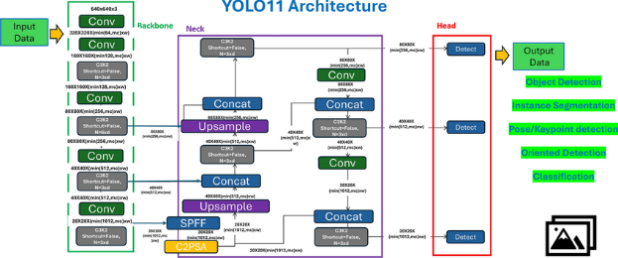

The YOLOv11 architecture represents a sophisticated evolution in the YOLO series, built upon a refined three-component framework that maintains the proven backbone-neck-head structure while introducing significant enhancements. The backbone utilizes an advanced CSPDarknet design featuring C3k2 blocks, which employ two parallel convolution paths for improved feature reuse with reduced parameters. This is complemented by a stem layer with initial convolution and SiLU activation, followed by progressive downsampling that expands channels from 64 to 1024 while maintaining efficient gradient flow through cross-stage partial connections. A key innovation is the C2PSA spatial attention mechanism positioned after the SPPF layer, which generates spatial attention maps to enhance focus on important regions and significantly improves small object detection capabilities.
The neck architecture incorporates an enhanced Feature Pyramid Network with top-down pathways and lateral connections, working in tandem with a Path Aggregation Network that provides bottom-up processing for superior localization. The SPPF block employs sequential max-pooling with kernel sizes of 5×5, 9×9, and 13×13 to capture multi-scale features while maintaining fixed computational costs. The head design features a decoupled structure with separate branches for classification and regression, preventing task conflict while enabling multi-scale prediction across three distinct levels: P3/8 for small objects, P4/16 for medium objects, and P5/32 for large objects. YOLOv11 implements an anchor-free mechanism that predicts object centers directly, eliminating anchor box hyperparameters and simplifying the training pipeline.
Critical components include the detailed C3k2 block specification with its main and shortcut branches, CBS layers ensuring stable training through Conv-BN-SiLU sequences, and the optimized SPPF implementation. The output representation generates detection tensors containing normalized coordinates, objectness scores, and class probabilities, trained using CIoU loss for bounding boxes and focal loss for classification. The model employs compound scaling across depth, width, and resolution, offering variants from nano to xlarge with parameter counts ranging from 2.5M to 94M. Advanced training methodologies incorporate mosaic and mixup augmentation, random affine transformations, and comprehensive color jittering, establishing YOLOv11 as a balanced architecture that optimizes both accuracy and computational efficiency across diverse deployment scenarios.

2. Key Architectural Enhancements
2.1 Backbone Innovations
- C3k2 Block: Replaces the C2f block from YOLOv8, implementing a more efficient Cross Stage Partial bottleneck with kernel size 2
- Enhanced SPPF with C2PSA: Retains Spatial Pyramid Pooling Fast but adds Cross Stage Partial with Spatial Attention for improved focus on relevant regions
- Optimized Convolutional Layers: Improved downsampling layers with better feature preservation

2.2 Neck Improvements
- C3k2 Integration: Replaces C2f blocks throughout the neck for faster feature processing
- Advanced Feature Pyramid: Enhanced multi-scale feature fusion capabilities
- Spatial Attention Mechanisms: Better handling of objects at different scales and positions

2.3 Head Optimizations
- Multi-path C3k2 Processing: Multiple C3k2 blocks process features at different depths
- Flexible Architecture: Configurable C3k parameter (True/False) for varying complexity needs
- CBS Layer Refinements: Improved Convolution-BatchNorm-Silu blocks for feature refinement

3. Performance and Efficiency Gains
3.1 Accuracy Improvements
- Higher mAP Scores: Significant improvements in mean Average Precision on COCO dataset
- Enhanced Small Object Detection: Better performance on small and medium objects
- Improved Orientation Handling: Superior performance on rotated and oriented objects
3.2 Computational Efficiency
- Parameter Reduction: YOLOv11m uses 22% fewer parameters than YOLOv8m
- Faster Inference: Optimized architecture enables higher frames per second
- Better Scaling: More efficient utilization of computational resources across model variants

4. Multi-Task Capabilities
YOLOv11 expands beyond basic object detection to support:
- Instance Segmentation: Pixel-level object separation
- Pose Estimation: Keypoint detection and tracking
- Oriented Object Detection (OBB): Rotation-aware bounding boxes
- Image Classification: Whole-image categorization
- Object Tracking: Real-time object path tracing

5. Model Variants and Deployment
The architecture scales efficiently across multiple variants:
- Nano to XLarge: Catering to edge devices to high-performance systems
- Task-Specialized Models: Dedicated variants for detection, segmentation, pose estimation, and classification
- Deployment Flexibility: Optimized for cloud, edge, and GPU environments

6. Training and Optimization Advances
- Enhanced Data Augmentation: Improved mosaic and mixup strategies
- Better Loss Functions: Optimized for multi-task learning
- Advanced Attention Mechanisms: Spatial attention for focused feature processing
YOLOv11 represents a balanced advancement in the YOLO evolution, offering improved accuracy, reduced computational complexity, and expanded capabilities while maintaining the real-time performance characteristics that define the YOLO series.

The trajectory of YOLO underscores a central theme in modern computer vision: the relentless pursuit of an optimal balance between accuracy and speed. Its enduring legacy lies not only in its widespread adoption across industries from autonomous driving to security but also in its proof that unified, end-to-end learning can achieve state-of-the-art performance in real-time. As computational demands grow and new challenges emerge, the principles established by YOLO will undoubtedly continue to influence the next generation of perceptual models.

