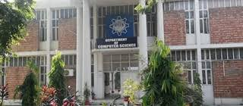
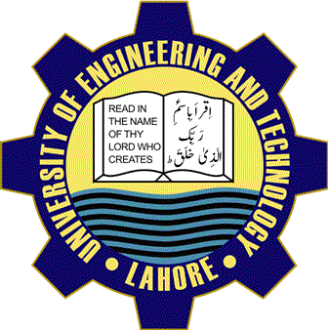
Department of Computer Science
Visit us Online
Lms.uet.edu.pk
Cse.uet.edu.pk
Uet.acm@gamail.com

Internationally
Recognized
UET Graduates are
Eligible to work
Globally, as it is
Associated
To Washington
Accord. Programs
Offered in
Computer science
Department are
Recognized by
Washington accord

