Angular Ahead-of-Time

Before Angular app can run on browser -> components and templates has to be converted into executable JavaScript

Launch Angular App in browser
JiT –> load + generate code (in browser) + launch app
AoT -> load generated code + launch

Launch app faster – pre-compile, inline-template, no compiler

Compilation in angular
Input: Everything that we do in angular go through compiler
directives, components, templates, styles, pipes, ngmodules …
Output: typescript / js - ngFactory
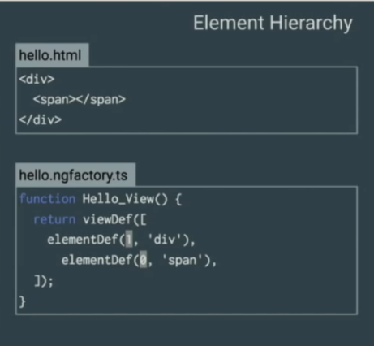

Why do AoT compilation?
- Faster rendering
ngFactory generated in both JiT and AoT
Browser receives pre-compiled application

- Fewer asynchronous requests
Inline external HTML templates and CSS style sheets within the application JavaScript

- Smaller angular framework download size – no angular compiler

“node_modules/.bin/source-map-explorer” aot/dest/build.js

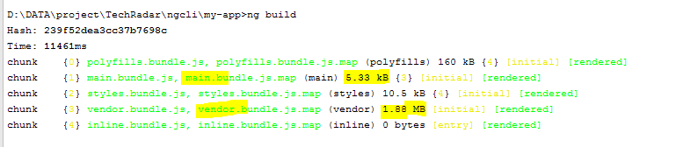

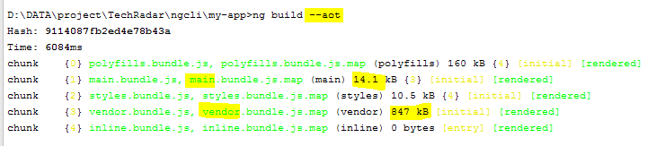

- Detect templates earlier
Ex: invalid modal property error

- Better security

Reduces injection attract
JiT
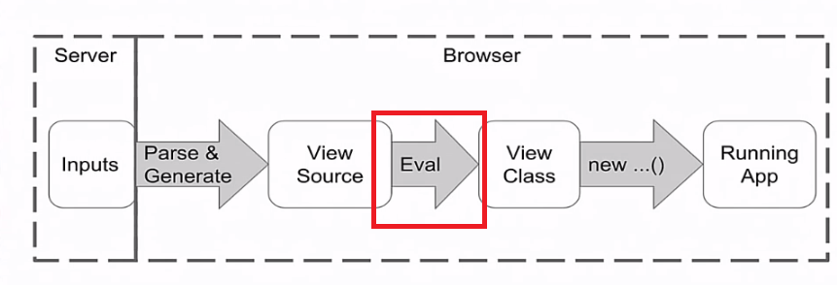
AoT
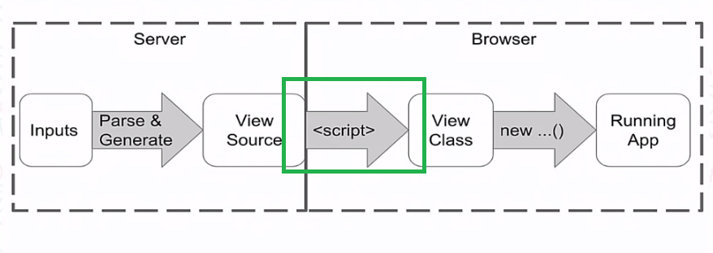
Application does not run eval on client machine -> No risky client-side HTML or JavaScript evaluation
Content-Security-Policy -> blocking the use of eval()
https://developer.mozilla.org/en-US/docs/Web/HTTP/CSP

Preparing for AoT:
- install compiler-cli and platform-server
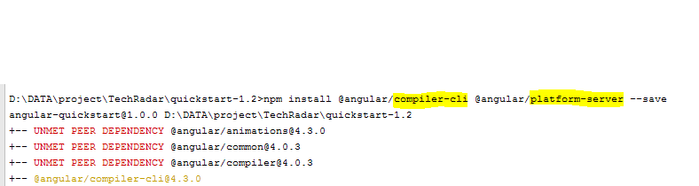

- compiler cli config file with AOT settings -> tsconfig-aot.json

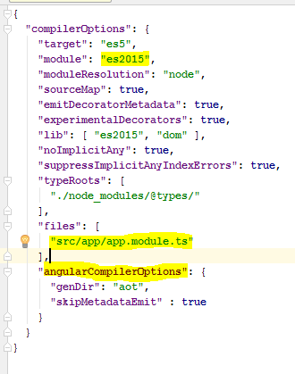

- AoT Compilation

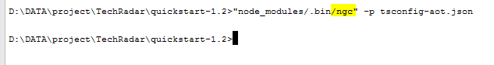

- Bootstrap AppModuleNgFactory – main-aot.ts
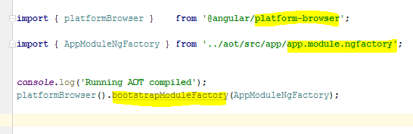

The AoT approach changes application bootstrapping.
- Update tsconfig-aot.json and recompile

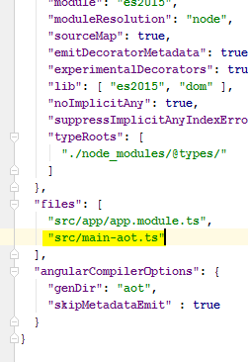

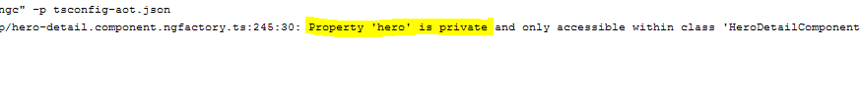
- Install rollup

- roll-up config file
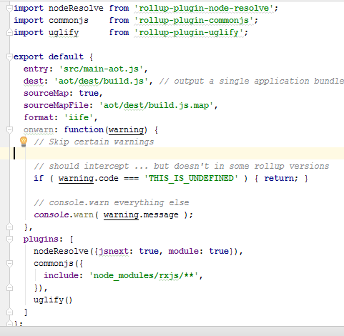

- run rollup
"node_modules/.bin/rollup" -c rollup-config.js

- Copy the AOT distribution files into the aot folder

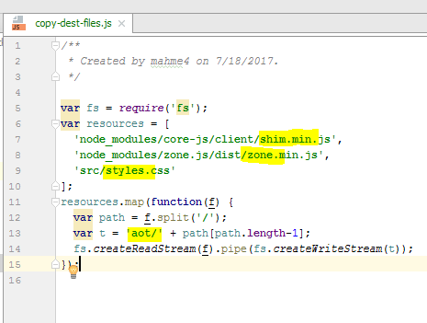

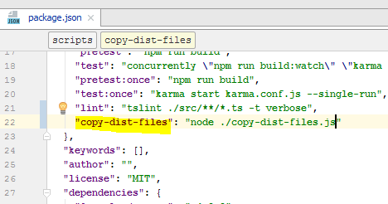

- load the bundle

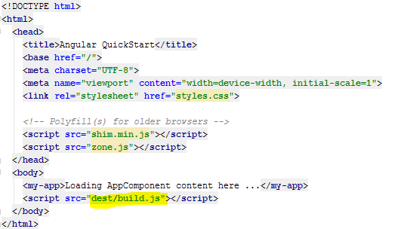

- launch AoT app
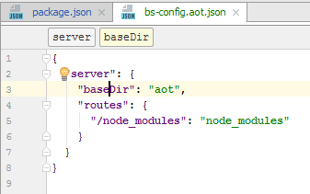

CMD -> lite-server –c bs-config.aot.json

AoT Dos and Don’ts
https://github.com/rangle/angular-2-aot-sandbox

