Task 01:

What are the Advantages of Multi-tier Architecture?

Answer:

Separation of Concerns
- Each tier has a specific responsibility (UI, business logic, data, etc.).
- Easier to develop, test, and maintain because changes in one tier don’t directly affect others (as long as the interfaces remain the same).
Scalability
- You can scale tiers independently.
  - If the database is slow → scale up DB tier.
  - If more users join → scale up the presentation/application tier.
- Supports horizontal scaling (adding more servers) and vertical scaling (increasing server capacity).
Maintainability & Flexibility
- Easier to update or replace a single tier without rewriting the whole system.
- For example, switch from MySQL to PostgreSQL in the Data tier without touching the UI.
Reusability
- Business logic can be reused with different presentation layers (e.g., same backend serving both a web app and a mobile app).
Security
- Each tier can have its own security controls.
- The Data tier is not directly exposed to users — only accessible through the Application tier.
Parallel Development
- Different teams can work on different tiers at the same time.
- For example:
  - Frontend team works on UI.
  - Backend team works on APIs/business logic.
  - Database team works on schema design.
Better Performance with Load Balancing
- Presentation and Application tiers can be distributed across multiple servers.
- Load balancers can direct requests efficiently.
Technology Independence
- Each tier can be built with the best-suited technology.
  - UI in React
  - Backend in Java Spring Boot
  - Database in PostgreSQL
- Allows future tech upgrades without major rewrites.

==================================================================

Home tasks:

Task1:
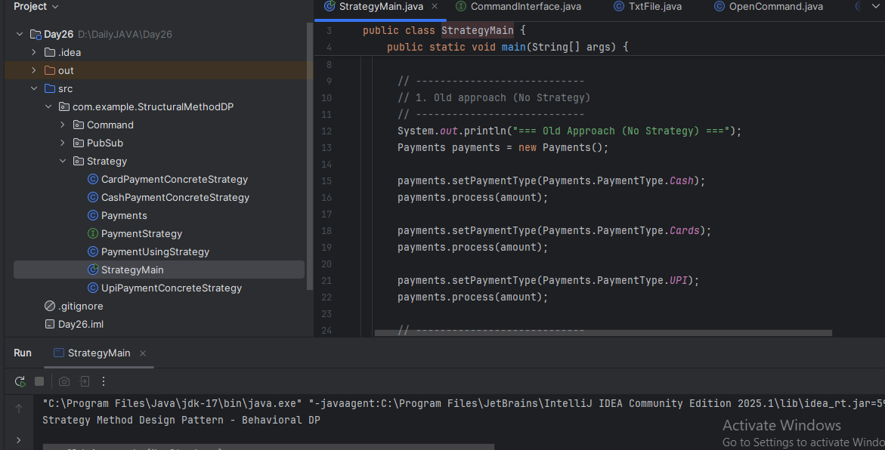

Task2:
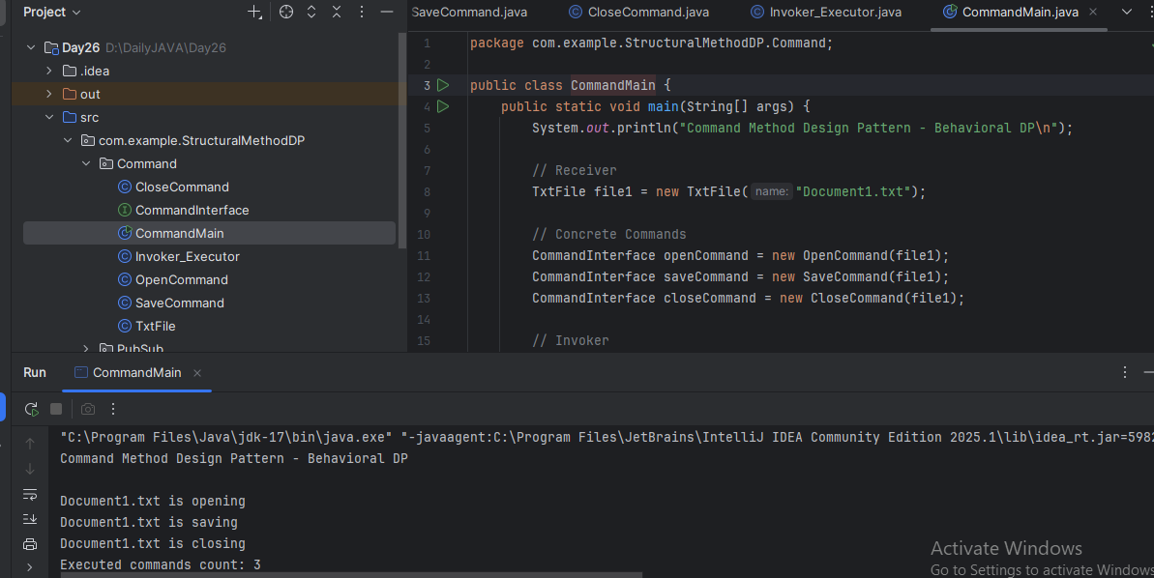

Task3:
Composition
- Symbol: Solid diamond + solid line to another class.
- Meaning: Strong "has-a" relationship where the lifetime of the part depends on the whole.
- Example: House → Room (if House is destroyed, Rooms are destroyed too).
Aggregation
- Symbol: Hollow diamond + solid line to another class.
- Meaning: Weak "has-a" relationship; the part can exist without the whole.
- Example: School → Teacher (teachers exist without a school).
Association
- Symbol: Solid line.
- Meaning: A general connection between classes.
- Example: Student — Course (students enroll in courses).
Directed Association
- Symbol: Solid line with an arrowhead.
- Meaning: One class knows about or uses another.
- Example: Customer → Order.
Usage / Dependency
- Symbol: Dashed line with open arrowhead (often labeled «use»).
- Meaning: A temporary relationship where one class depends on another for some behavior.
- Example: Report Generator uses Printer.
Dependency
- Symbol: Dashed line with open arrowhead (same as usage, label optional).
- Meaning: General dependency between classes.
Generalization
- Symbol: Solid line with hollow arrowhead.
- Meaning: Inheritance (IS-A relationship).
- Example: Dog → Animal.
Realization
- Symbol: Dashed line with hollow arrowhead.
- Meaning: Class implements an interface.
- Example: Car implements Vehicle.

Task4:
package diagram representation of Command Design Pattern code
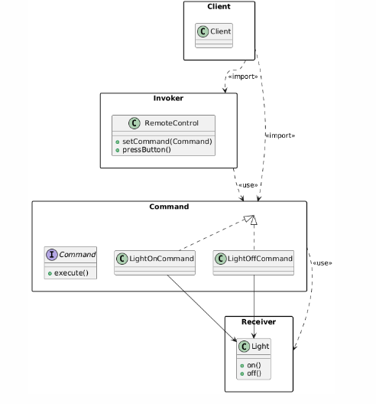
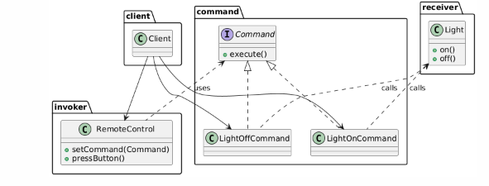
uml diagrams to represent different kinds of relation ships:
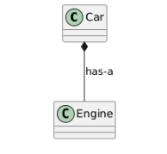
-------------------------------------------------------------------------------------------------------------------------------
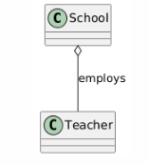
------------------------------------------------------------------------------------------------------------------
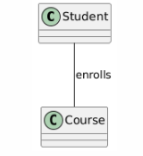
---------------------------------------------------------------------------------------------------------------------
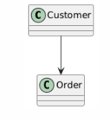
---------------------------------------------------------------------------------------------------------------------
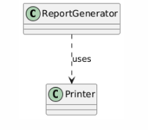
----------------------------------------------------------------------------------------------------------------------------
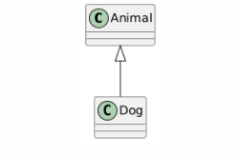
----------------------------------------------------------------------------------------------------------------------------
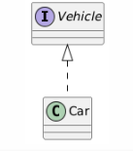
-----------------------------------------------------------------------------------------------------------------------------
Task5:
State notation is part of the UML State Machine Diagrams (or State Diagrams) that represent the states of an object and how it transitions between those states due to events.
Initial State ●: (solid black filled circle) - Represents the starting point of the state machine.
Final State◎: (black filled circle with outer ring) - Represents the end of the object's state transitions

