Intelligent Vehicle Routing & Dynamic Pricing System

FAST-NUCES Karachi: AI Lab Project 2026

Students
- Muhammad Masab (23K-0833)
- Meeran Uz Zaman (23K-0039)

Course
Artificial Intelligence

Instructor
Abdullah Shaikh

1. Introduction

Background
Modern cities like Karachi face two major transportation problems: vehicles wasting time on non-optimal routes, and rental companies pricing services poorly : either losing money or overcharging customers.

Motivation
AI and machine learning can solve both problems. Route planning algorithms can find the shortest path between locations, and ML regression models can learn pricing patterns from data and predict fair prices automatically.

Project Overview
This project is a dual-task AI/ML system that works as follows:
- Task 1 : A* Search Algorithm: Finds the optimal driving route between two locations in Karachi city using an informed search algorithm.
- Task 2 : Dynamic Pricing Prediction: Trains machine learning models on 6,500 rental records to predict the best daily rental price for a vehicle based on conditions like weather, season, day of week, and demand.
Both tasks run through a single Python script (main.py) and their results are displayed in an interactive web dashboard (dashboard.html).

2. Problem Statement & Objectives

Problem Statement

Problem 1: Vehicle Routing
Finding the shortest and most efficient path between two locations in a city is not trivial. A city has many possible routes, and checking all of them (like Dijkstra’s algorithm does blindly) wastes time. We need an algorithm that uses location knowledge to guide its search intelligently.

Problem 2: Dynamic Rental Pricing
Vehicle rental prices change based on many factors : weather, day of week, season, holidays, competitor prices, and how many cars are already rented out (utilization). Setting prices manually is slow and inaccurate. A machine learning model can learn these patterns automatically and predict prices in real time.

3. Methodology / Algorithms

Task 1: A* Search
A* is an informed search algorithm that finds the optimal path in a graph. It is smarter than Dijkstra’s because it uses a heuristic to estimate which direction to search next.

Core Formula
$$f\left(n\right)=g\left(n\right)+h\left(n\right)$$
Term | Meaning
f(n) | Total estimated cost of the path through node n
g(n) | Actual cost from start to current node (in km, along roads)
h(n) | Heuristic: estimated remaining distance from n to goal

Heuristic Function
The heuristic used is the Euclidean (straight-line) distance between two nodes, calculated from their latitude/longitude coordinates:
dlat = (lat2 - lat1) × 111.0 km
dlon = (lon2 - lon1) × 111.0 × cos(lat1) km
h(n) = √(dlat² + dlon²)
This heuristic is admissible (it never overestimates the real road distance) and consistent, which guarantees the algorithm finds the optimal path.

How the Algorithm Works
- Start at the source node, add it to an open heap with f = h(start, goal).
- Pop the node with the lowest f value.
- For each neighbor, compute g_new = g(current) + edge_weight.
- If g_new is better than the known g for that neighbor, update it and push it onto the heap.
- Repeat until the goal is reached. Reconstruct the path by backtracking through came_from.

City Graph
- 18 nodes: major Karachi localities (Clifton, Saddar, DHA, Gulshan, Karachi Airport, etc.)
- 31 bidirectional edges: road connections with real approximate distances in km
- Node positions come from actual geographic coordinates

Task 2 : ML Regression for Dynamic Pricing

Dataset
6,500 synthetic rental records generated with real-world patterns including seasonality, day-of-week effects, weather impact, holiday spikes, and competitor pricing.

Features Used
The model uses 4 categorical and 6 numerical features as input.

Models Trained

Random Forest Regressor
- An ensemble of 200 decision trees
- Each tree is trained on a random subset of data and features
- Final prediction = average of all tree predictions
- Good at handling non-linear relationships and outliers

Gradient Boosting Regressor (Winner)
- Builds trees sequentially : each tree fixes the errors of the previous one
- 200 estimators, learning rate = 0.08, max depth = 5
- Tends to give lower error on structured tabular data

Training Process
- Split data: 80% training (5,200 rows) / 20% testing (1,300 rows)
- Preprocess: One-hot encode categorical features, pass numerical features as-is
- Use sklearn Pipeline to combine preprocessing + model in one step
- Train both models and evaluate on test set
- Run 5-fold cross-validation on training data to check for overfitting
- Save the best model as pricing_model.pkl

4. Dataset Description
The dataset was synthetically generated by generate_dataset.py to simulate real vehicle rental patterns in Karachi over 3 years (2022–2024).
- Total records: 6,500
- Price range: $26 – $220 per day
- Mean price: ~$84.98/day
- Vehicle types: 7 categories (Economy, Compact, Midsize, SUV, Luxury, Minivan, Pickup)

Feature Table
Feature | Type | Description
vehicle_category | Categorical | Type of vehicle (Economy, Luxury, SUV, etc.)
day_of_week | Categorical | Day name (Monday–Sunday)
weather | Categorical | Weather condition (Sunny, Rainy, Snowy, etc.)
season | Categorical | Season (Spring, Summer, Fall, Winter)
month | Numerical | Month number (1–12)
is_weekend | Numerical | 1 if Saturday/Sunday, 0 otherwise
is_holiday | Numerical | 1 if public holiday (Pakistan), 0 otherwise
competitor_base_price | Numerical | Market competitor price for same vehicle type ($) | | `utilization_rate` | Numerical | % of fleet currently rented out (0–100) | | `rental_duration_days` | Numerical | How many days the vehicle is rented | | **`daily_rental_price`** | **Target** | **The price to predict ($/day)**

Pricing Logic (How Prices Were Generated)
price = base_price × season_factor × day_of_week_factor × weather_factor × demand_factor × holiday_factor + noise
- Weekend prices are ~25% higher than weekdays
- Summer and Winter holidays cause a 15–20% price spike
- Sunny weather adds 8%, Snowy adds 15%, Stormy drops 20%
- Holidays multiply price by 1.22

5. System Design / Architecture

Overall Flow
User Input (route + vehicle features)
│
▼
┌────────────────────────────────────────┐
│ main.py (Entry Point) │
│ ┌─────────────┐ ┌────────────────┐ │
│ │ A* Engine │ │ ML Engine │ │
│ │ (Task 1) │ │ (Task 2) │ │
│ └──────┬──────┘ └──────┬─────────┘ │
└─────────│────────────────│────────────┘
│ │
▼ ▼
astar_result.json pricing_results.json
astar_result.png pricing_results.png
pricing_model.pkl
│ │
└────────┬───────┘
▼
dashboard.html
(Interactive UI : no server needed)

Component Descriptions
Component | Role
generate_dataset.py | Creates the 6,500 synthetic rental records
main.py: A* module | Builds Karachi graph, runs A* search, visualizes path
main.py: ML module | Trains models, evaluates, saves best model
dashboard.html | Browser-based UI for interactive A* + pricing demo

Dashboard Features
- A* Tab: Interactive graph canvas. Select any start and goal node, run A* live, watch step-by-step exploration with 220ms frame delay, see the g(n) cost log.
- Pricing Tab: Real-time price prediction : change any feature (vehicle, weather, day) and get instant output. Shows feature importance bars and model comparison table.
- Overview Tab: Project description, architecture diagram, tech stack, sample predictions.
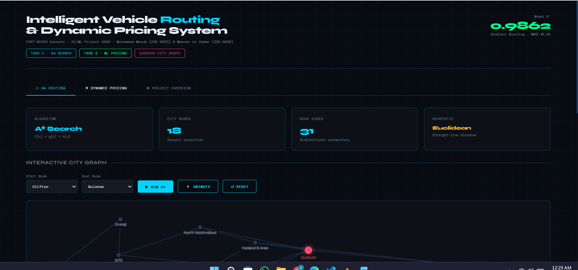

6. Implementation Details

File Structure
File | Purpose
main.py | Main script : runs A* search and ML training end-to-end
generate_dataset.py | Generates 6,500 synthetic rental pricing records
dashboard.html | Interactive web-based visualization dashboard
rental_pricing_dataset.csv | The generated dataset (6,500 rows, 11 columns)
pricing_model.pkl | Saved trained Gradient Boosting pipeline
astar_result.json | JSON output of A* : path, cost, exploration order
astar_result.png | Visual plot of the Karachi city graph with optimal path
pricing_results.json | ML metrics, feature importances, sample predictions
pricing_results.png | Evaluation plots: actual vs predicted, feature importance, model comparison
requirements.txt | Python library dependencies

Libraries Used
Library | Version | Purpose
scikit-learn | ≥1.3 | ML models, pipeline, cross-validation, metrics
pandas | ≥2.0 | Data loading and manipulation
numpy | ≥1.24 | Numerical operations
matplotlib | ≥3.7 | Plotting visualizations
networkx | ≥3.1 | Graph structure for A* visualization

How to Run
# Step 1: Install dependencies
pip install -r requirements.txt
# Step 2: Generate the dataset
python generate_dataset.py
# Step 3: Run both tasks
python main.py
# Step 4: Run with a custom route
python main.py --task astar --src "Clifton" --dst "Karachi Airport"
# Step 5: Open dashboard (Windows)
start dashboard.html

Key Implementation Notes
- A* uses a min-heap (priority queue) via Python’s heapq for efficiency.
- The ML pipeline uses ColumnTransformer to handle categorical and numerical features in one step : no separate preprocessing needed at prediction time.
- The saved pricing_model.pkl includes the full pipeline (preprocessor + model), so it can make predictions on raw input directly.
- All plots are saved with a dark theme (#0D1117 background) for visual clarity.

7. Results & Evaluation

Task 1 : A* Results

Route Tested
Clifton → Gulshan
Metric | Value
Optimal Path | Clifton → Saddar → Gulshan
Total Distance | 15.50 km
Nodes Explored | 3 out of 18
Search Time | 0.243 ms

Exploration Order
Step | Node Visited | g(n) cost
1 | Clifton | 0.00 km
2 | Saddar | 5.80 km
3 | Gulshan ◀ GOAL | 15.50 km
The algorithm only explored 3 nodes out of 18 to find the optimal path : this shows the heuristic is very effective at guiding the search directly toward the goal.
[SCREENSHOT PLACEHOLDER]
Screenshot of astar_result.png : dark-themed Karachi city graph showing all 18 nodes, the optimal path highlighted in cyan from Clifton to Gulshan via Saddar, explored nodes in purple, and stats box showing path cost and nodes explored.

Task 2 : ML Results

Models Compared
Model | MAE | RMSE | CV RMSE | R²
Random Forest | $4.10 | $5.38 | $5.71 | 0.9755
Gradient Boosting ★ | $3.16 | $4.04 | $4.23 | 0.9862
Winner: Gradient Boosting : it predicted rental prices with an average error of only $3.16 and explained 98.62% of all price variation (R² = 0.9862).

Top Feature Importances (Gradient Boosting)
Feature | Importance
competitor_base_price | 76.35%
is_weekend | 4.23%
utilization_rate | 3.04%
vehicle_category_Luxury | 2.80%
weather_Sunny | 2.04%
The dominant feature is competitor price (76.35%), which makes sense : the market price strongly anchors the rental price. Weekend status and vehicle utilization are next.

Sample Predictions
Vehicle | Day | Weather | Predicted Price
Economy | Friday | Sunny | $57.38
Luxury | Monday | Rainy | $146.53
SUV | Saturday | Snowy | $138.96
Compact | Wednesday | Cloudy | $52.08
[SCREENSHOT PLACEHOLDER]
Screenshot of pricing_results.png : three-panel dark-themed plot: (left) Actual vs Predicted scatter plot with R²=0.9862 annotation, (middle) horizontal bar chart of top 15 feature importances, (right) grouped bar chart comparing MAE, RMSE, and CV RMSE for Random Forest vs Gradient Boosting.

8. Conclusion & Future Work

Conclusion
This project successfully built a complete dual-task AI/ML system:
- A* Search was implemented on a realistic 18-node Karachi city graph. The algorithm found the optimal path (Clifton → Gulshan = 15.50 km) by exploring only 3 out of 18 nodes in 0.243 ms : proving the heuristic’s effectiveness. The path is guaranteed to be optimal because the Euclidean heuristic is admissible.
- Dynamic Pricing was solved with a Gradient Boosting regression model trained on 6,500 synthetic records. The model achieved an R² of 0.9862 and an average prediction error of just $3.16, which is excellent performance. Competitor base price turned out to be the most influential pricing factor.
Both algorithms performed well and their results are clearly visualized in the web dashboard.

Future Work
Idea | Description
Real traffic data | Replace synthetic road distances with live traffic data from Google Maps API or OpenStreetMap
Live price APIs | Pull real competitor prices from rental platforms (e.g., Careem, Uber) to make the pricing model self-updating
Deep learning models | Use LSTM or transformer models to capture time-series patterns in pricing data
Mobile application | Build a mobile app (Flutter or React Native) that lets users find optimal routes and predict prices on the go
Larger city graph | Expand to more nodes, covering all of Karachi with hundreds of road intersections
Multi-objective routing | Optimize for both distance and estimated travel time, or factor in fuel cost
These improvements would turn this proof-of-concept into a production-ready intelligent transportation system.

Submitted: May 2026 | FAST-NUCES Karachi

