R3.1 – 3.5, 7, 13, 14, 19, 20, 27, 30

R3.1

1. There should be no “then”
2. There should be no “;”s
3. I don’t think there’s a mistake..?
4. Should be “==”, not “=”
5. If cin failed, there is no value to store in x so y = y + x cannot take place.

R3.2

1. -1
2. 1
3. 1
4. 2 (when doing math ops w/ double it will be at least a little off)

R3.3

R3.4

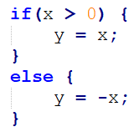

R3.4

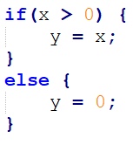

R3.5

Double operations are not exact because computers are binary, and are not well-suited to handle decimals. This means we can only compare differences within a range for doubles.

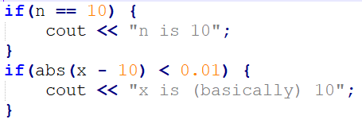

R3.7

|  |  |  |
| --- | --- | --- |
| A, c, e, or g | Odd or even? | Color |
| yes |  |  |
|  | Odd |  |
|  |  | “black” |

R3.13

|  |  |
| --- | --- |
| Test Case | Expected Result |
| Appt 1: 3 – 4 Appt2: 5 - 6 | No |
| Appt 1: 5 - 6 Appt2: 3 - 4 | No |
| Appt 1: 11 – 14 Appt 2: 13 – 15 | Yes |

R3.14

|  |  |
| --- | --- |
| Test Case | Expected Result |
| 1 | Winter |
| 2 | Winter |
| 3 | Spring |
| 4 | Spring |
| 5 | Spring |
| 7 | Summer |
| 9 | Fall |
| 11 | Fall |
| 12 | Winter |

R3.19

In a sequence of else-ifs, if one condition is false, you continue evaluating. In nested if’s, the top if must be true for the other conditions to be evaluated.

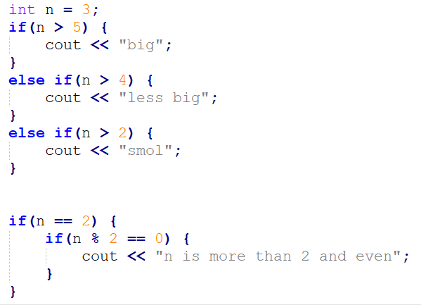

R3.20

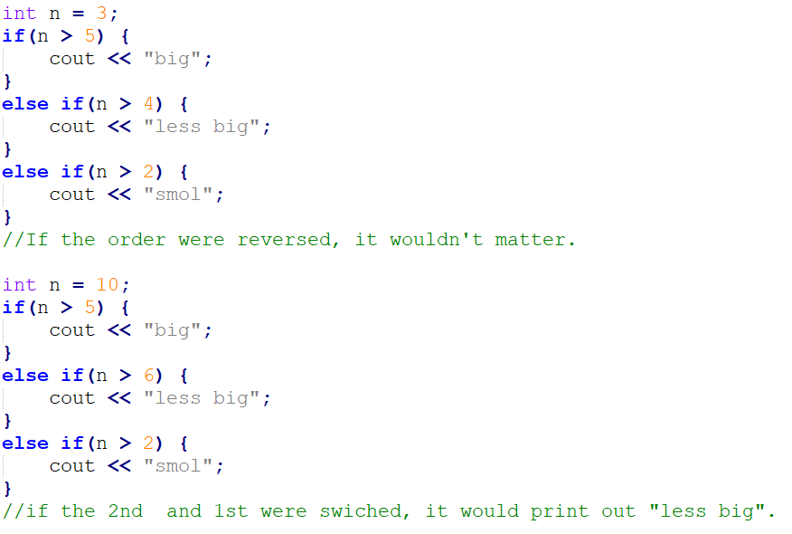

R3.27