**SAP ABAP – WEEK 1**

**SAP – SYSTEMS, APPLICATIONS AND PRODUCTS**

**ERP – ENTERPRISE RESOURCE PLANNING**

**DATA TYPE:**  Data can be of different types, so data types are responsible for defining the type of data of the data object. Data types are crucial for memory optimization in the ABAP programming language.

Data types in ABAP : CHAR, INT, NUMERIC,..

**ABAP CODE:**

REPORT ZDATATYPE.

data LV_a type i value 50.

data LV_b type i value 35.

data LV_c type i.

LV_c = LV_a + LV_b.

write : 'Adding ',LV_c. “Sum of two numbers

**CONTROL STATEMENTS IN ABAP:**

REPORT Z357_CONTROLSTMTS.

PARAMETERS p_a(2) TYPE c.

PARAMETERS : a type i,

b type i.

**IF - STATEMENT**

*IF p_a < 7.

* WRITE 'less than 7'.

*elseif p_a > 7 .

* WRITE 'greater than 7'.

* elseif p_a = 7.

* write 'equal'.

*ENDIF.

**WHILE LOOP- STATEMENT**

*WHILE p_a <= 100.

* WRITE 'Good Luck!'.

* p_a = p_a + 5.

*ENDWHILE.

*

*WHILE p_a < 11.

* DATA(h) = a * p_a.

* WRITE : 'a * ', p_a ,'=', h.

* p_a = p_a + 1. "tables maths

* ENDWHILE.

**DO-STATEMENT**

*do.

* write 'HELLO WORLD'.

* if p_a > 10.

* exit.

* ENDIF.

* p_a = p_a + 1.

* ENDDO.

*while p_a < 100.

* write / a.

* a = a + 3.

* if a = 12.

* CONTINUE.

* ENDIF.

*

* p_a = p_a * 3.

* ENDWHILE.

**CASE STATEMENT**

CASE p_a.

WHEN '+'.

DATA(h) = a + b.

write h .

WHEN '-'.

DATA(t) = a - b.

write t.

WHEN OTHERS.

WRITE 'it is not found'.

ENDCASE.

**INTERNAL TABLES:** Internal tables are temporary tables that are created with runtime object for PROCESSING THE DATA in SAP.

**INTERNAL TABLE 1:**

1. **BASIC INTERNAL TABLE IMPLEMENTATION**

REPORT Z357_ITAB_EX.

*TABLES lfa1.

*TYPES : BEGIN OF i_tab,

* lifnr TYPE lifnr,

* land TYPE land1_gp,

* name1 TYPE NAME1_Gp,

* city TYPE ort01_gp,

* END OF i_tab.

*

*DATA : in_tab TYPE STANDARD TABLE OF i_tab,

* wa_tab TYPE i_tab,

* lv_lifnr TYPE lifnr.

*

*PARAMETERS p_city TYPE land1_gp.

*SELECT-OPTIONS s_lifnr FOR lv_lifnr.

*

*SELECT lifnr land1 name1 ort01 INTO TABLE in_tab FROM lfa1

* WHERE LAND1 = p_city AND lifnr IN s_lifnr.

*

*LOOP AT in_tab INTO wa_tab.

* WRITE : / wa_tab-lifnr,

* wa_tab-land,

* wa_tab-name1,

* wa_tab-city.

*

*ENDLOOP.

1. **BY USING STRUCTURE:**

DATA : in_tab TYPE STANDARD TABLE OF Z357_LT,

wa_tab TYPE Z357_LT,

lv_lifnr TYPE lifnr.

PARAMETERS p_city TYPE land1_gp.

SELECT-OPTIONS s_lifnr FOR lv_lifnr.

SELECT lifnr land1 name1 ort01 INTO TABLE in_tab FROM lfa1

WHERE LAND1 = p_city AND lifnr IN s_lifnr.

LOOP AT in_tab INTO wa_tab.

WRITE : / wa_tab-lifnr,

wa_tab-land1,

wa_tab-name1,

wa_tab-ort01.

ENDLOOP.

1. **INTERNAL TABLE JOIN:**

REPORT ZINTERNAL_TABLE_JOINS NO STANDARD PAGE HEADING.

types : begin of s_tab,

vbeln type VBELN_va,

ERDAT type ERDAT,

ERZET type ERZET,

ERNAM type ERnam,

ANGDT type ANGDT,

POSNR type Posnr,

MATNR type matnr,

MATWA type matwa,

PMATN type pmatn,

end of s_tab.

data : i_tab type STANDARD TABLE OF s_tab,

wa_tab type s_tab.

ULINE.

select-OPTIONS s_vbeln for wa_tab-vbeln.

PARAMETERS p_ernam type ernam.

START-OF-SELECTION.

SELECT vbak~VBELN

vbak~ERDAT vbak~ERZET

vbak~ERNAM

vbak~ANGDT

vbap~POSNR

vbap~MATNR

vbap~MATWA

vbap~PMATN into TABLE i_tab from vbak INNER JOIN vbap

on vbak~vbeln = vbap~vbeln

where vbak~vbeln in s_vbeln and

vbap~ernam eq p_ernam.

skip.

skip.

SORT i_tab by vbeln.

if sy-subrc eq 0.

WRITE : / 'it is working dude' ,sy-dbcnt.

else.

WRITE : / 'it is not working dude'.

ENDIF.

end-of-SELECTION.

ULINE.

FORMAt COLOR COL_GROUP.

LOOP AT i_tab into wa_tab.

WRITE : /

wa_tab-vbeln,

wa_tab-erdat,

wa_tab-erzet,

wa_tab-ernam,

wa_tab-angdt,

wa_tab-POSNR,

wa_tab-MATNR,

wa_tab-MATWA,

wa_tab-PMATN.

ENDLOOP.

FORMAT COLOR off.

uline.

**SELECT STATEMENT AND INTERNAL TABLE IMPLEMENTATION ON MY OWN TABLES:**

1. **SELECT TABLE**

REPORT Z357_STU_TABLE.

TABLES Z357_STU_TABLE.

DATA : lv_collegeid type Z357_STUID,

lv_dept TYPE ZDEPT_DEPNM,

lv_name TYPE ZNAME_STUNM,

lv_phn TYPE ZPHN_STUPH.

PARAMETERS p_colle TYPE Z357_STUID.

select-OPTIONS s_phn for lv_phn.

SELECT STUID DEPID STUNM STUPH into

(lv_collegeid,lv_dept,lv_name,lv_phn) from 357_STU_TABLE

WHERE STUID = p_colle and STUPH in s_phn.

WRITE : / lv_collegeid,lv_dept,lv_name,lv_phn.

ENDSELECT.

1. **SELECT TABLE-2:**

REPORT ZSELECT_MYTABLE2.

TABLES Z357_DEP_TABLE.

DATA : lv_uid TYPE ZUST_UID,

lv_name TYPE ZUST_NAME,

lv_phn TYPE ZUST_PHN,

lv_add TYPE ZUST_ADDRESS,

lv_marks TYPE ZUST_MARKS.

PARAMETERS p_add TYPE ZUST_ADDRESS.

SELECT-OPTIONS s_phn for lv_phn.

SELECT UST_ID UST_CANDI_NAME UST_CANDI_PHN UST_ADDRESS UST_MARKS into

(lv_uid,lv_name,lv_phn,lv_add,lv_marks) from Z357_DEP_TABLE

WHERE UST_ADDRESS = p_add and UST_CANDI_PHN in s_phn.

write :/ lv_uid,lv_name,lv_phn,lv_add,lv_marks.

ENDSELECT.

1. **SELECT STATEMENT-3:**

REPORT ZSELECT_STMT.

TABLES MARA. "MASTER TABLE

DATA : lv_matnr TYPE MATNR,

lv_ersda type ERSDA,

lv_createdAtTime type CREATED_AT_TIME,

lv_ernam type ERNAM,

lv_laeda TYPE LAEDA.

PARAMETERS number TYPE Mara-ERSDA.

SELECT-OPTIONS s_matnr for lv_matnr.

SELECT MATNR ERSDA CREATED_AT_TIME ERNAM LAEDA into (lv_matnr,lv_ersda,

lv_createdAtTime,lv_ernam,lv_laeda) from MARA

where ERSDA eq number AND MATNR in s_matnr.

WRITE : / lv_matnr,lv_ersda,lv_createdAtTime,lv_ernam,lv_laeda.

ENDSELECT.

**STRINGS IN ABAP:** Strings in ABAP are special data objects that are of character datatype. It is a stream of characters combined as a bundle and treated as an entity. We perform several operation on/through strings which are described below show examples of ABAP code.

REPORT zstring_func NO STANDARD PAGE HEADING.

*PARAMETERS : p_a(20) LOWER CASE OBLIGATORY,

* p_b(30) OBLIGATORY.

*TRANSLATE p_a TO UPPER CASE.

*WRITE p_a.

*DATA lv_c(60).

*CONCATENATE p_a p_b into lv_c SEPARATED BY space.

*write lv_c.

*PARAMETERS p_a(60).

*DATA : lv_b(30),

* lv_c(20).

*SPLIT p_a at ',' into lv_b lv_c.

*WRITE : / lv_b,lv_c.

*PARAMETERS p_a(60).

*DATA lv_b(20).

*lv_b = p_a+0(7).

*WRITE lv_b.

*PARAMETERS p_a(60).

*DATA lv_b type i.

*lv_b = strlen( p_a ).

*WRITE lv_b.

*PARAMETERS p_a(60).

*DATA lv_b type i.

*lv_b = strlen( p_a ).

*data m type i.

*while m lt lv_b.

* IF p_a ca ','.

* REPLACE ',' WITH ' ' into p_a.

*else.

* exit.

* ENDIF.

* m = m + 1.

* endwhile.

* WRITE p_a.

*PARAMETERS p_a(20).

*

*SHIFT p_a CIRCULAR.

*WRITE p_a.

**REPORTS:**

1. **CLASSICAL REPORTS:**
2. REPORT z357_r_cl_vbak NO STANDARD PAGE HEADING LINE-COUNT 25(3) LINE-SIZE 500.  
   TYPES : BEGIN OF ls_tab,  
             vbeln TYPE vbeln_va,  
             erdat TYPE erdat,  
             angdt TYPE angdt_v,  
             auart TYPE auart,  
             matnr TYPE matnr,  
             matkl TYPE matkl,  
           END OF ls_tab.  
     
   DATA : i_tab    TYPE STANDARD TABLE OF ls_tab,  
          wa_tab   TYPE ls_tab,  
          lv_vbeln TYPE vbeln_va.  
   SELECT-OPTIONS s_vbeln FOR lv_vbeln OBLIGATORY.  
     
   INITIALIZATION.  
     s_vbeln-low = '1'.  
     s_vbeln-high = '100'.  
     APPEND s_vbeln.  
     CLEAR : i_tab,wa_tab.  
     
   AT SELECTION-SCREEN ON s_vbeln.  
     SELECT SINGLE vbak~vbeln INTO lv_vbeln FROM vbak INNER JOIN vbap  
       ON vbak~vbeln = vbap~vbeln  
       WHERE vbak~vbeln IN S_VBELn.  
     IF sy-subrc EQ 0.  
       MESSAGE s000(z357_class_my_message).  
     ELSE.  
       MESSAGE e001(z357_class_my_message).  
     ENDIF.  
     
   START-OF-SELECTION.  
     SELECT vbak~vbeln vbak~erdat vbak~angdt vbak~auart vbap~matnr vbap~matkl

INTO TABLE i_tab FROM vbak  
    INNER JOIN vbap  
    ON vbak~vbeln = vbap~vbeln  
    WHERE vbak~vbeln IN s_vbeln.  
  
  IF sy-subrc EQ 0.  
    WRITE : 'RECORDS FOUND',sy-dbcnt.  
  ELSE.  
    WRITE 'not found'.  
  ENDIF.  
  
TOP-OF-PAGE.  
  ULINE.  
  FORMAT COLOR COL_POSITIVE.  
  WRITE : 'VBELN',sy-vline,20 'ERDAT',sy-vline,50 'ANGDT',sy-vline,80 'AUART',sy-vline,120 'MATNR',sy-vline,140 'MATKL',sy-vline.  
  FORMAT COLOR OFF.  
  ULINE.  
  
END-OF-PAGE.  
  WRITE : / 'DATE :',sy-datum,'TIME :',sy-uzeit,'PAGENO :',sy-pagno.  
  
END-OF-SELECTION.  
  FORMAT COLOR 1.  
  LOOP AT i_tab INTO wa_tab.  
    WRITE : /  
    sy-vline,  
    wa_tab-vbeln COLOR 4,sy-vline,  
    20 wa_tab-erdat,sy-vline,  
    40 wa_tab-angdt,sy-vline,  
    70 wa_tab-auart,sy-vline,  
    100 wa_tab-matnr,sy-vline,  
   140 wa_tab-matkl,  
    sy-vline.  
  
  ENDLOOP.  
  FORMAT COLOR OFF.

1. **CLASSICAL REPORT - 2**

REPORT ZKALESHA_CLASSIC_REP NO STANDARD PAGE HEADING LINE-COUNT 20(3) LINE-SIZE 500.  
include ZKALESHA_CLASSIC_TD.  
include ZKALESHA_CLASSIC_EVENTS.  
  
PERFORM PRINT.  
  
*&---------------------------------------------------------------------*  
*& Form DEFALUT  
  
FORM defalut .  
s_vbeln-low = '1'.  
s_vbeln-high = '100'.  
APPEND s_vbeln.  
clear :  i_tab,wa_tab.  
ENDFORM.  
*&---------------------------------------------------------------------*  
*& Form SELECTION_SCREEN_VALID  
  
FORM selection_screen_valid .  
SELECT SINGLE vbeln into lv_vbeln from vbak where vbeln in s_vbeln.  
    if sy-subrc eq 0.  
      MESSAGE S000(ZKALESHA_MESSAGE).  
      else.  
        MESSAGE E001(ZKALESHA_MESSAGE).  
       ENDIF.  
ENDFORM.  
*&---------------------------------------------------------------------*  
*& Form SELECT_QUERY  
  
FORM select_query .  
SELECT VBELN ERDAT ERZET ERNAM ANGDT into TABLE i_tab from vbak  
  WHERE VBELN in s_vbeln.  
  
  if sy-subrc eq 0.  
    WRITE : / 'Records are found',sy-dbcnt.  
    else.  
      WRITE : / 'Records are not found'.  
      ENDIF.  
ENDFORM.  
*&---------------------------------------------------------------------*  
*& Form PRINT  
  
FORM print .  
  FORMAT COLOR 1.  
loop at i_tab into wa_tAB.  
 uline.  
  write : / wa_tab-vbeln,sy-vline,  
  20 wa_tab-erdat,sy-vline,  
  40 wa_tab-erzet,sy-vline,  
  60 wa_tab-ernam,sy-vline,  
  100 wa_tab-angdt,sy-vline.  
  
  ENDLOOP.  
ENDFORM.

**TABLES:**

**DATA DICTIONARY (SE11).**

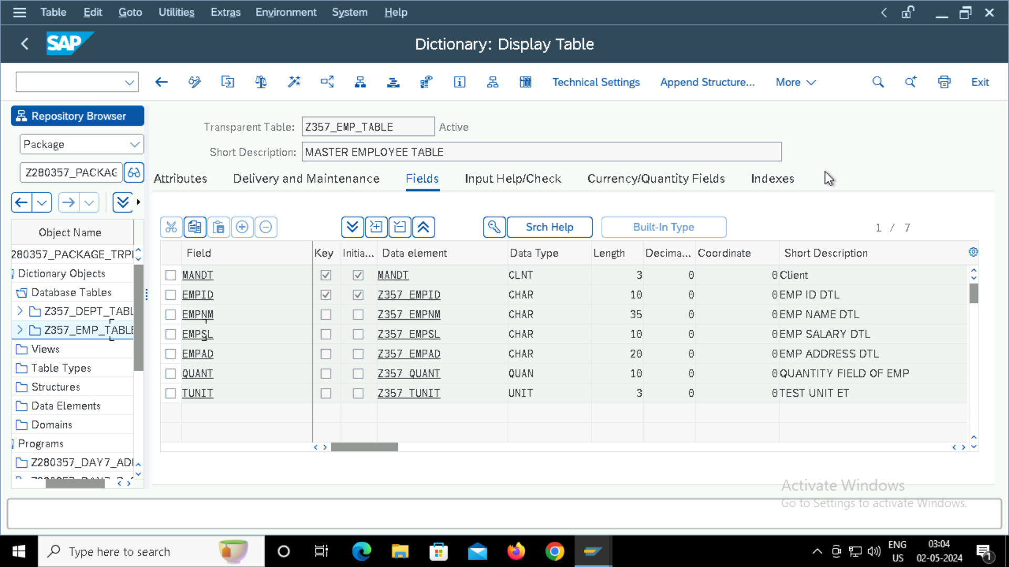

**VIEWS :**

**DATABASE VIEW:**

**PROJECTION VIEW:**

**MAINTENANCE VIEW:**

**STRUCTURE:**

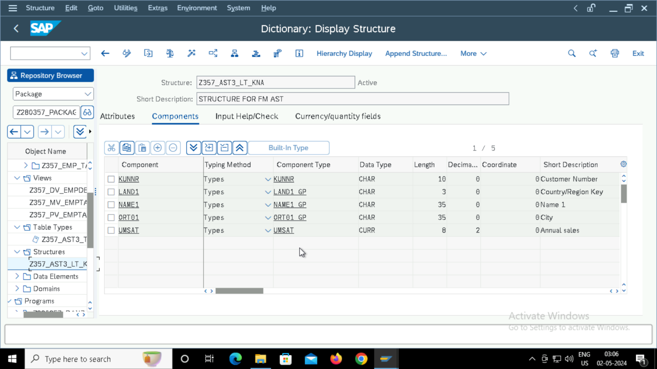

**TABLE TYPE AND LINE TYPE(FLAT STRUCURE):**

**INCLUDE:**

**FUNCTION MODULES:**

