A Project Report on
FreshMart

Undertaken At
BrainyBeam Info-Tech Pvt Ltd

Submitted in fulfillment for the awards of degree in
Master of Computer Applications
[ Batch: 2024-2026]

Submitted by
Miss. Meera M. Vachhani [230823109]

Under the guidance of
Dr. Disha Ganatra [Internal Guide]
Dr. Sagar Jasani [External Guide]

Department Head
Dr. Divyesh Gohel

Submitted to
Atmiya University

Declaration of Authenticity and Originality

The project titled “FreshMart – Online Grocery and Vegetable Shopping System” is a web-based e-commerce platform developed to simplify the process of purchasing groceries, fruits, vegetables, and daily household products through an online system. The platform is designed to provide a convenient and efficient shopping experience for users while also offering administrative tools for managing the system effectively.
The FreshMart system consists of two main modules: the Client (User) Side and the Admin Side. On the client side, users can register and log in to the system, browse different categories of products such as vegetables, fruits, and grocery items, view product details, add products to their cart or wishlist, rate products, and place orders securely. Users can also view their order history, track order status, and manage their shopping activities through an easy-to-use interface.
On the Admin side, the administrator has complete control over the platform. The admin can add, update, or delete products, manage product categories, monitor customer orders, view user details, and track sales through the admin dashboard. The admin panel also provides statistical information such as total products, users, orders, and revenue, helping administrators efficiently manage the online store.
This project has been developed using modern web technologies including MongoDB, Express.js, React.js, and Node.js (MERN Stack) to create a responsive and user-friendly application. The system demonstrates the practical implementation of database management, authentication, product management, order processing, and dashboard analytics.
I hereby declare that the FreshMart project submitted in this report is my original work and has been developed independently as part of my academic requirement for the Master of Computer Applications (MCA) program. The project has not been submitted previously to any other university or institution for the award of any degree or certification. All references and resources used during the development of this project have been properly acknowledged.
This declaration confirms my commitment to maintaining academic honesty, originality, and ethical standards in the completion of this project work.

Meera M. Vachhani [230823109]
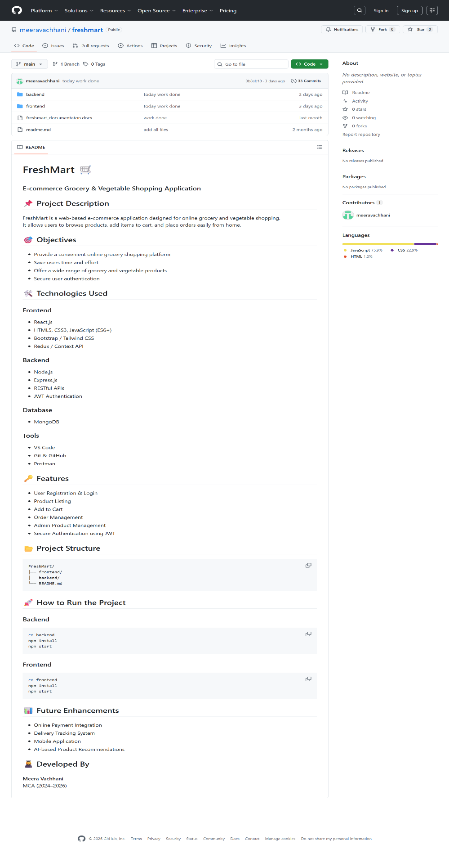

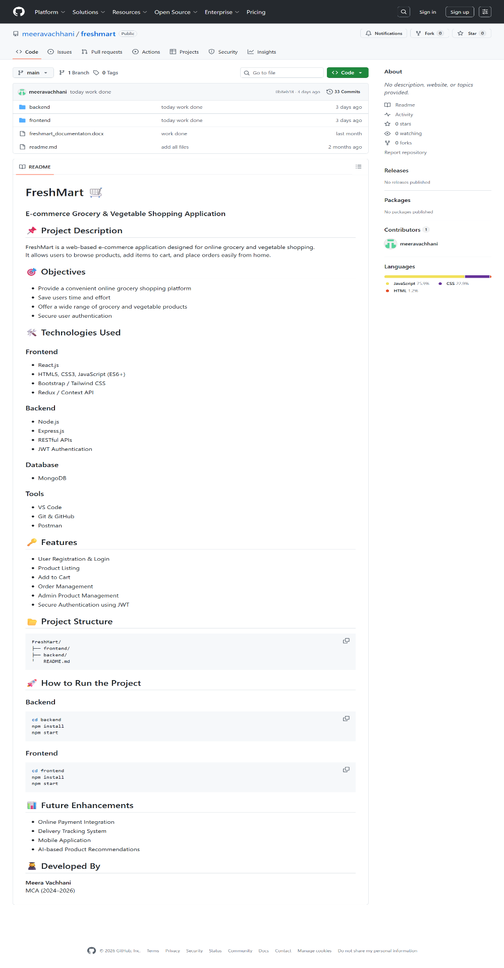

Acknowledgment

I would like to express my sincere gratitude to all those who supported and guided me throughout the development of my project titled “FreshMart – Online Grocery and Vegetable Shopping System.” This project has been a valuable learning experience and an important milestone in my academic journey.
First and foremost, I would like to express my heartfelt thanks to my internal guide, Dr. Disha Ganatra, for her valuable guidance, continuous encouragement, and insightful suggestions throughout the project. Her support and mentorship played a vital role in the successful completion of this work.
I would also like to extend my sincere gratitude to my external guide, Sagar Jasani, for his expert advice, constructive feedback, and technical support which greatly helped in improving the quality of this project.
I am also thankful to Dr. Divyesh Gohel, Head of the Department, for his encouragement and support during the development of this project.
I would like to express my appreciation to the faculty members and staff of Atmiya University for providing the necessary resources, infrastructure, and a supportive academic environment that helped me successfully complete this project.
Finally, I would like to thank my friends and well-wishers who supported and motivated me throughout the project development process. Their encouragement helped me overcome challenges and complete this project successfully.

Meera M. Vachhani [230823109]

ABSTRACT

The rapid growth of digital technology and internet usage has significantly transformed the way people purchase everyday products, including groceries, fruits, and vegetables. Traditional shopping methods often require customers to visit physical stores, which can be time-consuming and inconvenient. To address these challenges, the FreshMart – Online Grocery and Vegetable Shopping System has been developed as a web-based e-commerce platform that allows users to conveniently purchase daily household products from anywhere at any time.
The FreshMart application provides an easy-to-use interface where customers can explore a wide range of products such as vegetables, fruits, and grocery items. Users can register and log in to the system, browse different product categories, view detailed product information, add items to their cart or wishlist, and place orders securely. The platform also enables customers to view their order history, track order status, and rate products, creating a more interactive and user-friendly shopping experience.
In addition to the customer interface, the system includes an admin panel that allows administrators to efficiently manage the entire platform. Through the admin dashboard, administrators can add, update, or remove products, manage product categories, monitor user activity, view customer orders, and track overall sales performance. The dashboard also provides important insights such as the total number of users, products, orders, and revenue, which helps in effective decision-making and store management.
The FreshMart project has been developed using modern web technologies including MongoDB, Express.js, React.js, and Node.js (MERN Stack). These technologies enable the system to deliver a responsive, scalable, and efficient web application capable of handling real-time interactions between users and the system.
In conclusion, the FreshMart platform simplifies the grocery shopping experience by providing a reliable and convenient online solution for customers while also offering powerful management tools for administrators. The system demonstrates the practical implementation of modern web development concepts and highlights the growing importance of e-commerce solutions in today's digital world.

Company Details

Company name | Brainybeam Info-Tech PVT LTD
Address | 7th Floor, Premchand House, Near Old High Court Way / Behind ICICI Bank, Ashram Road, Ahmedabad 380009
Website URL | https://brainybeaminfotech.com/
Company Type | Software Development
Contact Number | +91 96389 37336
Internal Guide/Developer Name | Sagar Jasani

TABLE OF CONTENTS

- Project Profile
1.1 Introduction
1.2 Objectives of the Project
1.3 Gap Analysis
1.4 Project Plan
1.5 Work Breakdown Structure
1.6 Key Impacts and Benefits
1.7 Project Description
1.8 Key Features of FreshMart
- About the Tools and Technologies
2.1 HTML
2.2 CSS
2.3 JavaScript
2.4 React.js
2.5 Node.js
2.6 Express.js
2.7 MongoDB
2.8 Bootstrap
2.9 Visual Studio Code
- System Analysis
3.1 Existing System
3.2 Feasibility Study
3.3 Limitations of Existing System
3.4 Scope of Proposed System
3.5 Limitations of Proposed System
3.6 Target Users
3.7 Project Modules
- System Design
4.1 Use Case Diagram
4.2 Activity Diagram
4.3 Class Diagram
4.4 Sequence Diagram
4.5 Component Diagram
4.6 Deployment Diagram
4.7 Data Flow Diagram (DFD)
4.8 System Screenshots
4.8.1 Login Page
4.8.2 Home Page
4.8.3 Product Listing Page
4.8.4 Product Details Page
4.8.5 Cart Page
4.8.6 Wishlist Page
4.8.7 My Orders Page
4.8.8 Admin Dashboard
4.8.9 Add Product Page
4.8.10 Manage Orders Page
- Agile Documentation
5.1 Project Charter
5.2 Product Roadmap
5.3 User Stories
5.4 Release Plan
5.5 Sprint Backlog
5.6 Agile Test Plan
- Future Enhancements
- Project Timeline
- Bibliography & References
- Project Profile
  - Introduction:

In today’s fast-paced digital world, the use of the internet and online services has become an essential part of everyday life. People increasingly prefer online platforms to perform daily activities such as shopping, banking, education, and communication. Among these activities, online grocery shopping has gained significant popularity because it saves time, provides convenience, and offers access to a wide variety of products. Customers no longer need to visit physical stores or stand in long queues to purchase their daily essentials. Instead, they can easily browse products and place orders from their smartphones or computers.

The FreshMart – Online Grocery and Vegetable Shopping System is designed to provide a simple and efficient online platform where customers can purchase groceries, fruits, vegetables, and other household items conveniently. The main aim of the FreshMart system is to digitize the traditional grocery shopping experience and provide users with a modern, user-friendly interface that makes shopping easier and faster.

FreshMart is developed as a web-based e-commerce application that allows customers to explore different product categories, view product details, add products to their cart or wishlist, and place orders securely. The system is designed to provide a smooth and interactive user experience, enabling customers to quickly find the products they need and complete their purchases in a few simple steps. Additionally, users can track their order history, view order status, and rate products based on their experience.

The system also includes an Admin Panel, which plays an important role in managing the platform. Through the admin dashboard, administrators can add new products, update product information, remove unavailable items, and manage product categories. The admin can also monitor customer orders, view user information, and track overall sales and revenue. This helps ensure efficient management of the online store and improves operational performance.

The FreshMart project has been developed using modern web technologies such as MongoDB, Express.js, React.js, and Node.js (MERN Stack). These technologies allow the application to be dynamic, scalable, and responsive. MongoDB is used for managing the database, Node.js and Express.js handle backend operations and APIs, and React.js is used to create an interactive user interface. The system architecture ensures efficient communication between the client side and the server side.

One of the key goals of FreshMart is to provide convenience, accessibility, and efficiency to users while also offering powerful management tools for administrators. By using this platform, customers can easily purchase fresh groceries and vegetables without leaving their homes, while store managers can efficiently manage inventory and orders through the admin dashboard.

  - Objectives:

- To develop an online platform for buying groceries, fruits, and vegetables easily.
- To allow users to browse products, view details, and purchase items from anywhere.
- To provide a simple and user-friendly interface for customers to search and select products.
- To enable users to add products to cart, wishlist, and place orders securely.
- To allow customers to view their order history and track order status.
- To help administrators manage products, categories, users, and orders efficiently.
- To provide an admin dashboard for monitoring total users, products, orders, and revenue.
- To ensure secure login and authentication for both users and administrators.
- To improve convenience by reducing the need for physical grocery store visits.
- To save time and effort for customers by providing an online shopping solution.
- To maintain proper management of product data and order information in a database.
- To develop the system using modern web technologies such as MongoDB, Express.js, React.js, and Node.js.

  - Gap Analysis:
Gap analysis is used to identify the difference between the existing system and the proposed system. In traditional grocery shopping, customers need to visit physical stores to purchase daily essential items. This process consumes time and effort, especially for people with busy schedules. Additionally, customers may face issues such as limited product availability, long queues at billing counters, and difficulty in comparing different products.
In many small grocery stores, the management process is also manual. Store owners often maintain product records, inventory, and sales information manually, which can lead to errors and inefficiencies. Customers also do not have access to complete product information, reviews, or price comparisons.
The FreshMart Online Grocery and Vegetable Shopping System aims to fill this gap by providing a digital platform where users can easily browse products, check product details, and place orders online. The system improves convenience for customers and provides better management tools for administrators. By implementing an online solution, FreshMart reduces manual work, improves accessibility, and enhances the overall shopping experience.
1.4 Project Plan:
The FreshMart project is developed by following a systematic plan to ensure successful completion of the system. The project begins with understanding the requirements and identifying the main features that the platform should provide. After gathering requirements, the system design is prepared, including database structure, user interface design, and system architecture.
The next step involves the development phase, where the frontend and backend components of the system are implemented using modern technologies. The frontend is developed using React.js to create a dynamic and interactive user interface, while the backend is developed using Node.js and Express.js to handle server-side operations and APIs. MongoDB is used as the database to store product, user, and order information.
After development, the system goes through testing to ensure that all functionalities work correctly. Any bugs or errors found during testing are fixed before deployment. Finally, the system is deployed and made ready for use. This structured project plan helps ensure that the FreshMart platform is developed efficiently and meets the required objectives.

1.5 Work Breakdown Structure:
- Home Page (Front Look): The front page of the FreshMart website displays important information about the platform, including featured products, categories such as fruits, vegetables, and groceries, and promotional offers to attract customers.
- User Login and Registration System: This module manages the authentication process for users and administrators. Customers can create an account, log in securely, and access personalized features such as cart, wishlist, and order history.
- Product Management System: This module allows the admin to add, update, search, and delete product details such as name, price, category, quantity, and product images.
- Cart and Wishlist System: Customers can add products to their cart for purchasing or save products in their wishlist for future reference.
- Order Management System: This module manages the order placement process, order history, and order status updates such as pending, processing, shipped, or delivered.
- Admin Dashboard System: The admin panel provides tools to monitor the system, including managing products, users, and orders, as well as viewing statistics such as total products, users, orders, and revenue.
1.6 Key Impacts and Benefits:
- Better Product Accessibility: Provides a wide range of products with detailed descriptions, prices, and images.
- Efficient Store Management: Helps administrators manage products, users, and orders efficiently through the admin dashboard.
- Digital Data Management: Stores all product, user, and order information in a centralized database for easy access and management.
- Skill Development: Helps developers gain practical experience in full-stack web development using modern technologies.
- Cost-Effective Implementation: Uses open-source technologies which reduce development and implementation costs.
- Real-World Application: Demonstrates how e-commerce systems can be used to simplify daily grocery shopping for customers.

1.7 Description:

Project Title | FreshMart-Online Grocery and Vegetable Shopping System.
Objective | The main objective of the FreshMart project is to develop a web-based e-commerce platform that allows customers to purchase groceries, fruits, vegetables, and other daily essentials online. The system provides a simple and user-friendly interface for customers while also offering efficient management tools for administrators.
Web Link | http://localhoat:3000/
Operating System | Windows 10, Windows 11, Linux
Software’s | Visual Studio Code, MongoDB, Google Crome
Frontend Technologies | Html, Css, JavaScript, React.js
Backend Technologies | Mode.js, Express.js, MongoDB
Project Duration | 3 Month

1.8 Key Features:

- user Registration and Login System: Allows users to create accounts and log in securely to access personalized features.
- Product Browsing and Categories: Users can browse products by categories such as vegetables, fruits, and grocery items.
- Cart Management: Customers can add products to their cart, update quantities, and remove items before placing orders.
- Wishlist Feature: Allows users to save products for future purchases.
- Order Placement and Tracking: Customers can place orders and view order history along with order status.
- Admin Product Management: Administrators can add, update, or delete products and manage product categories.
- Order Management System: Admin can view customer orders and update their status such as pending, shipped, or delivered.
- Dashboard Analytics: Admin dashboard displays important statistics such as total users, products, orders, and revenue for better decision-making.

- About the Tools

  - HTML:

HTML (Hyper Text Markup Language) is the foundation of the web, providing the essential structure for organizing and presenting digital content. It defines the fundamental element sand layout of web pages, ensuring consistency and accessibility across various browsers and devices.

Key Components of HTML:

- Hypertext: HTML enables the creation of hyperlinks, allowing users to navigate seamlessly within and between web pages. Hyperlinks serve as the backbone of the interconnected nature of the World Wide Web, facilitating the exploration of vast amounts of information.
- Markup: HTML utilizes a variety of tags to structure and annotate content for rendering in web browsers. These tags, such as<head>, <title>, <body>, <header>, <footer>, <article>, <section>, <p>, <div>, and more, provide a frame work for organizing text, images, multimedia, and other elements on a web page.
- Semantic Elements: HTML introduces semantic elements that convey the meaning and purpose of content to both browser sand developers. Semantic tags like<nav>, <main>, <aside>, <header>, <footer>, and <article> enhance accessibility, search engine optimization (SEO), and the overall structure of web documents.
- Accessibility Features: HTML supports accessibility features such as alt text for images, labels for form controls, and ARIA (Accessible Rich Internet Applications) attributes, ensuring that web content is inclusive and usable by individuals with disabilities.
- Compatibility and Consistency: HTML's standardized syntax and structure promote compatibility across different web browsers and devices, enabling a consistent user experience regardless of the platform used to access the content.
- Through the use of HTML, developers and content creators are empowered to build cohesive, accessible, and interactive web experiences by leveraging its versatile frame work for structuring and presenting digital content on the World Wide Web.

  - CSS:
CSS (Cascading Style Sheets) is the cornerstone of web design, providing developers with the tools to define the visual presentation and layout of HTML elements. It plays a pivotal role in shaping the aesthetics, usability, and overall user experience of web pages.

Key Features and Capabilities of CSS:
- Styling: CSS empowers developers to customize the appearance of web content by defining properties such as colors, fonts, spacing, borders, backgrounds, and more. This flexibility allows for creative expression and branding consistency across websites and applications.
- Layout: CSS offers powerful layout techniques like flex box and grid, enabling developers to create responsive and adaptive designs that adapt seamlessly to different screen sizes and devices. With CSS, developers can arrange elements in multiple columns, align content horizontally and vertically, and create complex, multi-dimensional layouts.
- Consistency: CSS promotes design consistency across web pages and applications by establishing a unified visual language. By defining global styles and reusable components, developers can ensure a cohesive user experience, fostering familiarity and usability for visitors.
- Accessibility: CSS supports accessibility features that enhance usability for individuals with disabilities. Developers can use CSS to implement high contrast modes, responsive design principles, and accessible typography, making web content more inclusive and user-friendly for all audiences.
- Efficiency: CSS enables developers to write modular and reusable stylesheets, improving code maintainability and reducing development time. By organizing styles logically and leveraging CSS preprocessors like Sass or Less, developers can stream line the styling process and facilitate collaboration within development teams.
- Browser Compatibility: CSS promotes cross-browser compatibility, ensuring that webpages render consistently across different web browsers and platforms. Modern CSS features like vendor prefixes, feature detection, and polyfills help address compatibility challenges and ensure a consistent user experience across diverse environments.
- Through the use of CSS, developers are empowered to create visually appealing, accessible, and responsive web experiences by utilizing its robust set of styling and layout tools. With CSS, developers can transform HTML documents into engaging and interactive websites and applications, thereby elevating the overall quality and usability of digital content on the web.
  - JavaScript:

JavaScript (JS) is a high-level, interpreted programming language used primarily to create dynamic and interactive content on the web. While HTML defines the structure of a page and CSS handles its style, JavaScript is the "magic" third layer that brings a website to life by responding to user actions like clicks, scrolling, and keyboard inputs.
Key Components / Features of JavaScript:
- Client-Side Scripting: JavaScript runs directly in the user's browser, allowing dynamic updates to web pages without reloading the page.
- Event Handling: JavaScript can respond to user actions such as clicks, typing, scrolling, and mouse movements.
- DOM Manipulation: JavaScript can access and modify HTML elements dynamically using the Document Object Model (DOM).
- Asynchronous Programming: JavaScript supports asynchronous operations using callbacks, promises, and async/await, allowing tasks like API calls to run smoothly without blocking the webpage.
- Form Validation: JavaScript can validate user inputs in forms before submitting them to the server, improving data accuracy.
- Integration with APIs: JavaScript can fetch and send data to servers using technologies such as Fetch API and Axios.
- Dynamic Content Update: It allows content to be updated on the page dynamically without refreshing the entire webpage.
- Cross-Platform Support: JavaScript works across different browsers and operating systems, making it widely compatible.
- Server-Side Development: With Node.js, JavaScript can also be used for backend development to build scalable web applications.
- Interactive User Interfaces: JavaScript frameworks and libraries such as React.js help build modern and responsive user interfaces.

  - React.js:
React.js is a popular open-source JavaScript library used for building dynamic and interactive user interfaces, especially for single-page applications. It was developed by Facebook and allows developers to create reusable UI components. React improves application performance by updating only the necessary parts of the webpage using a Virtual DOM.
Key Components / Features of React.js:
- Component-Based Architecture: React applications are built using reusable components that make development easier.
- Virtual DOM: React uses a Virtual DOM to improve performance by updating only the parts of the webpage that change.
- Reusable Components: Developers can reuse components across different parts of the application, reducing development time.
- State Management: React manages data efficiently using state and props to update the user interface dynamically.
- Fast Rendering: React provides faster rendering compared to traditional web applications.
- Strong Community Support: React has a large developer community and many libraries to support application development.

2.5 Node.js:
Node.js is an open-source, server-side runtime environment that allows developers to run JavaScript outside the browser. It is built on Chrome’s V8 JavaScript engine and is widely used for developing scalable network applications and backend services.
Key Components / Features of Node.js:
- Event-Driven Architecture: Node.js uses an event-driven model that makes it efficient for handling multiple requests.
- Non-Blocking I/O: Node.js performs operations asynchronously, improving application performance.
- Fast Execution: Node.js runs on the V8 engine which makes it fast and efficient.
- Scalable Applications: It supports building highly scalable network applications.
- NPM Package Manager: Node.js provides access to thousands of libraries through the Node Package Manager (NPM).

  - Express.js:
Express.js is a lightweight and flexible web application framework built on top of Node.js. It simplifies the development of server-side applications and RESTful APIs by providing powerful tools for handling routing, middleware, and HTTP requests.
Key Components / Features of Express.js:
- Simple Routing System: Express makes it easy to define routes for handling client requests.
- Middleware Support: It allows the use of middleware functions to process requests and responses.
- REST API Development: Express is commonly used to create RESTful APIs for web applications.
- Fast Server Development: It reduces the amount of code required to build server-side applications.
- Easy Integration: Express can easily integrate with databases like MongoDB.

  - MongoDB:
MongoDB is a popular NoSQL database used to store and manage large amounts of data. Unlike traditional relational databases, MongoDB stores data in flexible JSON-like documents, making it easier to manage dynamic data structures.
Key Components / Features of MongoDB:
- Document-Oriented Database: Data is stored in JSON-like documents rather than tables and rows.
- Flexible Schema: MongoDB allows flexible data structures which makes development faster.
- High Performance: It provides fast data retrieval and storage.
- Scalability: MongoDB supports horizontal scaling for large applications.
- Easy Integration: MongoDB integrates easily with Node.js applications.

  - Bootstrap:
Bootstrap is a popular open-source front-end framework used to design responsive and mobile-friendly websites. It provides pre-built CSS classes, UI components, and JavaScript plugins that help developers quickly create professional-looking web interfaces.
Key Components / Features of Bootstrap:
- Responsive Grid System: Bootstrap provides a flexible grid layout that adjusts to different screen sizes.
- Pre-Designed Components: It includes ready-made UI components such as buttons, forms, cards, and navigation bars.
- Mobile-First Design: Bootstrap is designed to work efficiently on mobile devices.
- Cross-Browser Compatibility: Bootstrap works consistently across different browsers.
- Easy Customization: Developers can customize styles according to their project requirements.

2.9 Visual Studio Code:
Visual Studio Code (VS Code) is a powerful and lightweight source code editor developed by Microsoft. It supports multiple programming languages and provides useful features such as debugging, syntax highlighting, and code completion.
Key Components / Features of Visual Studio Code:
- Lightweight and Fast Editor: VS Code is designed to be fast and efficient for coding.
- Multiple Language Support: It supports many programming languages such as JavaScript, HTML, CSS, and Python.
- Extension Marketplace: Developers can install extensions to add additional features.
- Integrated Terminal: VS Code includes a built-in terminal for running commands directly inside the editor.
- Debugging Tools: It provides debugging tools that help developers find and fix errors quickly.

3. System Analysis
3.1 About Existing System:
- In the traditional grocery shopping system, customers need to visit physical stores or supermarkets to purchase daily essential items such as vegetables, fruits, and groceries. This process requires time and effort, especially for people with busy schedules.
- Customers must manually search for products in the store, which second
- sometimes be difficult when products are placed in different sections. Additionally, long queues at billing counters can increase waiting time and create inconvenience for customers.
- In many small grocery shops, product information, inventory management, and sales records are often maintained manually or using basic software. This makes it difficult to track stock availability and manage product data efficiently.
- Customers usually have limited access to product information such as price comparisons, availability, and reviews. They also cannot easily compare products from different categories while shopping in a physical store.
- Store owners or administrators also face challenges in managing product inventory, customer orders, and sales records. Manual record keeping may lead to errors, data loss, or mismanagement of product stock.
- Communication between the store and customers is also limited. Customers may not receive updates about new products, discounts, or offers available in the store.
- Furthermore, many traditional systems do not provide online access to customers. This means customers cannot order groceries from home or track their order history digitally.
- Due to these limitations, the traditional grocery shopping system lacks efficiency, convenience, and accessibility. Therefore, a modern online platform like FreshMart – Online Grocery and Vegetable Shopping System is required to provide a better shopping experience and efficient store management.

3.2 Feasibility Study:
The feasibility study evaluates whether the FreshMart Online Grocery and Vegetable Shopping System can be successfully developed and implemented. It analyzes different factors including technical, economic, operational, legal, and schedule feasibility.
- Technical Feasibility: The FreshMart system is developed using modern web technologies such as React.js, Node.js, Express.js, and MongoDB (MERN Stack). These technologies are widely used for building scalable and efficient web applications. React.js provides a dynamic user interface, while Node.js and Express.js manage backend operations and APIs. MongoDB stores product, user, and order data efficiently. The system can run on common operating systems such as Windows and Linux and can be hosted locally or on cloud servers.
- Economic Feasibility: The FreshMart project is economically feasible because it uses open-source technologies such as React.js, Node.js, Express.js, and MongoDB. These tools are freely available and do not require licensing costs. Development tools such as Visual Studio Code and Git are also free, which reduces the overall development cost.
- Operational Feasibility: The system is designed to be user-friendly and easy to operate for both customers and administrators. Customers can easily browse products, add items to the cart, and place orders. Administrators can manage products, users, and orders through an admin dashboard. The system reduces manual work and improves efficiency in managing the grocery store operations.
- Legal Feasibility: All technologies used in the FreshMart system are open-source and legally safe to use. The system also ensures proper data handling and user authentication to maintain privacy and security. Role-based access control ensures that only authorized users can access specific functionalities.
- Schedule Feasibility: The estimated development time for the FreshMart project is around three to four months. The project follows a structured development process including requirement analysis, system design, development, testing, and deployment. Using modern frameworks helps reduce development time and ensures timely completion of the project.

3.3 Limitations of Existing System:
The existing traditional grocery shopping system has several limitations that affect efficiency and convenience for both customers and store owners.
- Manual Shopping Process: Customers must physically visit the store to purchase products, which takes time and effort.
- Limited Product Information: Customers cannot easily access detailed product information, reviews, or comparisons.
- Long Waiting Time: Billing counters often have long queues, which increases waiting time.
- Manual Inventory Management: Store owners often maintain product stock records manually, which may lead to errors.
- Limited Accessibility: Customers cannot order groceries online or shop from home.
- Poor Communication: Customers may not receive updates about discounts, offers, or new products.
- Difficulty in Order Tracking: Customers cannot track their purchase history or previous orders easily.
- Data Management Issues: Manual record keeping increases the risk of data loss or mismanagement.
These limitations highlight the need for an advanced online grocery shopping platform such as FreshMart, which provides better accessibility, efficient management, and improved user experience through digital technology.

3.4 Scope of Proposed System:
- Online Grocery Shopping: The FreshMart system allows customers to purchase groceries, fruits, and vegetables online without visiting physical stores.
- Product Browsing and Search: Users can easily browse products by categories and search for specific items using the search feature.
- Cart and Wishlist Management: Customers can add products to their cart for purchasing or save products in their wishlist for future shopping.
- Order Placement and Tracking: Users can place orders online and view their order history and order status.
- Admin Product Management: The administrator can add, update, delete, and manage product details such as price, quantity, and product images.
- User Account Management: Customers can register, log in, and manage their personal accounts securely.
- Dashboard and Analytics: The admin dashboard provides insights such as total products, users, orders, and revenue.
- Secure Data Management: All product, user, and order data are stored securely in the database for efficient management.

3.5 Limitations of Proposed System:
- Internet Dependency: The system requires a stable internet connection for customers to access the website and place orders.
- Online Payment Integration: The current system may support limited payment options if payment gateway integration is not implemented.
- Delivery Management: The system may not include a fully automated delivery tracking system.
- Security Risks: Like any online platform, the system must be protected from unauthorized access and cyber threats.
- Limited Mobile Optimization: Some features may require further optimization for mobile devices.

3.6 Target Users:
- Customers: Customers who want to purchase groceries, vegetables, and fruits online quickly and conveniently.
- Administrator: The admin manages the system including product listings, orders, users, and overall system management.
- Store Managers or Staff: Staff members can assist in updating product information and managing orders if required.

3.7 Project Modules:
- User Authentication Module: Handles user registration, login, and authentication for customers and administrators.
- Product Management Module: Allows the admin to add, update, delete, and manage product details and categories.
- Product Display Module: Displays products to customers with details such as name, price, image, and category.
- Cart and Wishlist Module: Allows users to add or remove products from the cart or wishlist.
- Order Management Module: Handles order placement, order history, and order status tracking.
- Admin Dashboard Module: Provides the admin with statistics and management tools for monitoring system activities.
- Database Management Module: Stores and manages all system data including users, products, and orders.

4.System Design
4.1 Use Case Diagram:

