
SecGraph: Enterprise Identity and Access Risk Analyzer
by
MEERA V NAIR
(2539746)
Under the guidance of
Dr. Priya Stella Mary I
Assistant Professor
Department of Computer Science
CHRIST (Deemed to be University)

Bangalore Yeshwanthpur Campus

A Project report submitted in partial fulfilment of the requirements for the award of degree of Master of Artificial Intelligence & Cybersecurity of CHRIST (Deemed to be University)

SEPTEMBER – 2026

CERTIFICATE
It is certified that this project report entitled "SecGraph: Enterprise Identity and Access Risk Analyzer" has been submitted to CHRIST (Deemed to be University), Bangalore, as project work, as partial fulfilment of the requirement for the award of the degree of MASTER OF SCIENCE in Artificial Intelligence and Cyber Security. This work has been completed by MEERA V NAIR (Reg. No. 2539746) under my supervision and she has put in the required attendance.

Head of the Department Project Guide
Valued-by:
1. Name: Meera V Nair
Register Number: 2539746
Examination Centre: CHRIST
(Deemed to be University)
2. Date of Exam:

DECLARATION
I hereby certify that the work presented in this project report is my own genuine work and has been carried out by me under the supervision of Dr. Priya Stella Mary I, Assistant Professor, Department of Computer Science, CHRIST (Deemed to be University), Bangalore Yeshwanthpur Campus. The work embodied in this project report has not been submitted for a degree or diploma in any other University.
Date: MEERA V NAIR
Place: Bangalore 2539746

Dr. Priya Stella Mary I
ACKNOWLEDGEMENT
I would like to express my sincere gratitude to all those who have contributed to the successful completion of my Specialization Project. Their support and guidance have been invaluable, and I am deeply thankful for their assistance throughout this journey.
First and foremost, I would like to extend my heartfelt thanks to Dr. Fr Joseph C C, Vice Chancellor, Dr. Fr. Benny Thomas, Campus Director, Associate Director, Dr. Fr. Biju K Chacko, Dr. Joby Thomas, Dean, CHRIST (Deemed to be University) Yeshwanthpur Campus for letting us carry our specialization project of M.Sc Artificial Intelligence and Cyber Security in our Campus.
I would like to extend my heartfelt thanks to the HOD Dr. Vinay M and Associate HOD Dr .C.Balakrishnan of the Computer Science department of CHRIST (Deemed to be University), Bangalore Yeshwanthpur Campus, for fostering a conducive learning environment that has been instrumental in shaping my academic experience.
I am also immensely grateful to my project guide, Dr. Priya Stella Mary I for her expertise mentorship, and unwavering support throughout this project. Your patience and dedication to my growth as a data scientist have been instrumental in the successful completion of this project.
I would like to thank all the faculty members of the Department of Computer Science for their help to complete the project work successfully. Also, I would like to thank my fellow students and colleagues for their camaraderie, which made this academic journey both enjoyable and enriching. Last but not least, I want to express my gratitude to my family and friends for their unwavering support, understanding, and encouragement throughout this challenging but rewarding journey. Your belief in me has been a constant source of motivation.
In conclusion, this project would not have been possible without the guidance and support of the individuals mentioned above and the collective effort of everyone who played a part in my academic pursuit. Thank you all for your contributions, and I am deeply appreciative of your help.
MEERA V NAIR
(2539746)
ABSTRACT

Enterprise environments generate large volumes of identity, authentication, access, and resource-usage data. Conventional security-monitoring approaches often analyze these events independently or rely primarily on predefined rules, making it difficult to identify complex relationships and unusual behavioural patterns associated with potentially risky identities. This project proposes SecGraph, an explainable hybrid analytics system for enterprise identity risk assessment. The system represents relationships among users, roles, permissions, and resources as a graph and applies graph analytics to identify structurally significant identities and access relationships. Behavioural features extracted from activity logs are analyzed using an unsupervised anomaly-detection approach based on Isolation Forest, and rule-based indicators identify conditions such as excessive permissions and sensitive-resource access. The outputs of graph analysis, behavioural analysis, and rule-based analysis are combined into a configurable hybrid risk score that categorizes identities into low-, medium-, and high-risk levels, with explainable reasons, a visual dashboard, alerts, and generated reports. The system is designed as a research prototype to support authorized security analysts in prioritizing identity-risk investigations rather than automatically determining malicious intent.

TABLE OF CONTENTS
CHAPTER 1: INTRODUCTION .......................................................................................1
1.1 Problem Description .....................................................................................................1
1.2 Background ..................................................................................................................1
1.3 Motivation ....................................................................................................................2
1.4 Problem Statement .......................................................................................................2
1.5 Aim ..............................................................................................................................3
1.6 Objectives ....................................................................................................................3
1.7 Research Questions ..................................................................................................... 4
1.8 Scope of the Project .....................................................................................................4
1.9 Significance of the Project .......................................................................................... 5
1.10 Project Methodology ................................................................................................ 5
CHAPTER 2: SYSTEM ANALYSIS .............................................................................. 7
2.1 Functional Specifications ............................................................................................ 7
2.2 Non-Functional Requirements .....................................................................................8
2.3 Existing System .......................................................................................................... 9
2.4 Limitations of Existing System .................................................................................. 9
2.5 Proposed System ........................................................................................................ 9
2.6 Advantages of Proposed System ............................................................................... 10
2.7 Feasibility Study ....................................................................................................... 10
2.8 Block Diagram .......................................................................................................... 11
2.9 System Requirements ................................................................................................ 12
CHAPTER 3: SYSTEM DESIGN .................................................................................. 13
3.1 System Architecture .................................................................................................. 13
3.2 Module Design .......................................................................................................... 14
3.3 Database Design ........................................................................................................ 15
3.4 System Configuration ................................................................................................ 24
3.5 Interface Design ......................................................................................................... 24
3.6 Risk Scoring Design .................................................................................................. 25
3.7 Graph Model Design ................................................................................................. 26
3.8 Machine Learning Design ......................................................................................... 27
3.9 Reports Design .......................................................................................................... 27
CHAPTER 4: IMPLEMENTATION ............................................................................. 28
4.1 Coding Standard ....................................................................................................... 28
4.2 Development Environment ................................................................................... ... 28
4.3 Dataset Preparation .................................................................................................... 28
4.4 Data Processing ......................................................................................................... 29
4.5 Feature Engineering .................................................................................................. 29
4.6 Graph Construction ......................................................................................... ......... 30
4.7 Graph Analytics .........................................................................................................30
4.8 Behavioural Analytics ............................................................................................... 31
4.9 Anomaly Detection .................................................................................................... 31
4.10 Rule Engine ............................................................................................................. 31
4.11 Hybrid Risk Engine ................................................................................................. 32
4.12 Explainability Module ............................................................................................. 32
4.13 Alert Module ........................................................................................................... 32
4.14 Dashboard Implementation ......................................................................................32
4.15 Report Generation ....................................................................................................34
4.16 Security Implementation ......................................................................................... 35
CHAPTER 5: TESTING AND RESULTS .................................................................... 36
5.1 Testing Strategy ........................................................................................................ 36
5.2 Unit Testing .............................................................................................................. 36
5.3 Integration Testing .................................................................................................... 36
5.4 System Testing ......................................................................................................... 36
5.5 Test Cases ................................................................................................................. 37
5.6 Test Reports ............................................................................................................. 38
CHAPTER 6: CONCLUSION ...................................................................................... 39
6.1 Summary ................................................................................................................. 39
6.2 Design and Implementation Issues .......................................................................... 39
6.3 Advantages ...............................................................................................................40
6.4 Limitations ...............................................................................................................40
6.5 Future Enhancements ...............................................................................................40
6.6 Final Conclusion .......................................................................................................41
APPENDIX A — USER MANUAL ............................................................................. 42
APPENDIX B — DATASET INFORMATION ........................................................... 43
APPENDIX C — SAMPLE OUTPUTS ........................................................................ 44
REFERENCES ............................................................................................................... 54

LIST OF TABLES
Table 2.1 — Functional Requirements ............................................................... 7
Table 2.2 — Non-Functional Requirements ....................................................... 8
Table 2.3 — Hardware Requirements ............................................................... 12
Table 2.4 — Software Requirements ................................................................ 12
Table 3.1 — Admin: Table Structure .................................................................15
Table 3.2 — Users: Table Structure .................................................................. 15
Table 3.3 — Login Events: Table Structure .................................................. ... 16
Table 3.4 — Resource Access: Table Structure ................................................ 16
Table 3.5 — Behaviour Features: Table Structure ............................................ 17
Table 3.6 — Graph Metrics: Table Structure .................................................... 18
Table 3.7 — Risk Results: Table Structure ....................................................... 19
Table 3.8 — Alert: Table Structure ................................................................... 20
Table 3.9— Analysis History: Table Structure ................................................. 20
Table 3.10 — System Settings: Table Structure ............................................... 22
Table 3.11 — Risk Classification Bands ...........................................................26
Table 4.1 — CERT r4.2 Dataset Inventory & Attributes .................................. 28
Table 4.2 — Summary of Engineered Behavioral Features .............................. 29
Table 4.3 — Representative Graph Metrics Output .......................................... 31
Table 5.1 — Comprehensive Unit and System Test Cases ............................... 37
Table 5.2 — Test Execution Summary ............................................................. 38

LIST OF FIGURES
Fig. 1.1 — SecGraph Project Methodology ......................................................... 6
Fig. 2.1 — SecGraph System Block Diagram .................................................... 11
Fig. 3.1 — SecGraph 4-Layer System Architecture .......................................... 13
Fig. 3.2 — Data Flow Diagram (DFD) Level 0 (Context) ..................................22
Fig. 3.3 — Data Flow Diagram (DFD) Level 1 (Analytical Pipeline) ............... 23
Fig. 3.4 — Entity Relationship (ER) Diagram ................................................... 23
Fig. 3.5 — Application Execution Flow Chart ....................................................25
Fig. 4.1 — SecGraph Split-Screen Cyber Login Screen ..................................... 33
Fig. 4.2 — Security Operations Executive Dashboard ....................................... 33
Fig. 4.3 — CSV Dataset Management & Upload Screen ............................... ... 34
Fig. 4.4 — Interactive Identity Access Graph Explorer ..................................... 34
Fig. 4.5 — Downloadable PDF Security Assessment Report ............................. 35
LIST OF ABBREVIATIONS
Abbreviation | Meaning
AI | Artificial Intelligence
API | Application Programming Interface
CERT | Computer Emergency Response Team
CSV | Comma-Separated Values
DFD | Data Flow Diagram
ER | Entity Relationship
HTTP | Hypertext Transfer Protocol
IAM | Identity and Access Management
IDS | Intrusion Detection System
ML | Machine Learning
MFA | Multi-Factor Authentication
ORM | Object Relational Mapping
RBAC | Role-Based Access Control
SIEM | Security Information and Event Management
SOC | Security Operations Center
SQL | Structured Query Language
URL | Uniform Resource Locator
XAI | Explainable Artificial Intelligence

CHAPTER 1: INTRODUCTION
1.1 PROBLEM DESCRIPTION
Modern enterprise environments depend heavily on digital identities to provide employees, administrators, contractors, and other authorized users with access to applications, systems, devices, and organizational resources. As the number of users and resources increases, managing and monitoring these identities becomes increasingly difficult.
Identity-related security events are distributed across different sources such as authentication logs, resource-access records, and role-assignment records. Examining these events independently may hide important relationships. For example, a user may not appear suspicious based on login frequency alone; however, when the user's access relationships, number of connected resources, and behavioural patterns are analyzed together, the identity may represent a higher level of security risk.
SecGraph addresses this problem by combining graph-based identity analysis, behavioural anomaly detection, and rule-based security analysis into a single, explainable risk-assessment platform.
1.2 BACKGROUND
Enterprise cybersecurity defense has historically evolved through distinct architectural eras. Traditional perimeter defense models relied on firewalls and network segmentation to establish a trusted internal network boundary. However, the rise of remote work, cloud migration, and sophisticated insider threat vectors necessitated the adoption of Zero Trust Architecture (ZTA), as formalized in NIST Special Publication 800-207. Under Zero Trust principles, no identity or device is inherently trusted; access must be continuously evaluated, authenticated, and verified.
Within modern Security Operations Centers (SOCs), Security Information and Event Management (SIEM) systems and User and Entity Behavior Analytics (UEBA) platforms have become foundational. Nevertheless, conventional SIEM solutions rely heavily on static, pre-configured correlation rules that suffer from rigid threshold boundaries, high false positive rates, and an inability to perceive complex multi-hop relationship paths. Concurrently, emerging graph analytics technologies offer profound capabilities for modeling identity access topologies. Representing identities, roles, devices, and digital resources as an interconnected graph enables the computation of structural topological properties, such as Degree Centrality, Betweenness Centrality, and shortest attack paths. In parallel, unsupervised machine learning algorithms—notably the Isolation Forest algorithm pioneered by Liu et al. (2008)—enable the statistical identification of behavioral anomalies without requiring labeled historical attack datasets.
1.3 MOTIVATION
The conceptualization and development of SecGraph are driven by three pervasive industry challenges:
- Structural Opacity in Identity Entitlements: Relational hierarchies between enterprise users, assigned roles, transitive permissions, and sensitive endpoints are inherently complex. Traditional tabular databases obscure toxic privilege combinations and lateral movement paths.
- SOC Alert Fatigue and Cognitive Overload: Modern enterprises log millions of individual telemetry records daily. Human security analysts cannot manually investigate thousands of low-level alerts, leading to delayed incident response and missed indicators of compromise (IoCs).
- The Explainability Crisis in AI Security: While deep neural networks and advanced machine learning models can achieve high mathematical classification scores, they typically operate as opaque 'black boxes.' Security analysts cannot justify taking disruptive operational actions (such as revoking administrator credentials) without transparent, interpretable rationales.
1.4 PROBLEM STATEMENT
To design, implement, and rigorously evaluate SecGraph—an explainable hybrid identity and access risk analytics system that unifies NetworkX graph topological analytics, unsupervised Isolation Forest behavioral anomaly detection, and deterministic domain security rules to ingest raw multi-source enterprise activity telemetry, compute a calibrated 0–100 risk score for every identity, and deliver transparent natural-language justifications, an interactive SOC dashboard, and audit-ready security reports.
1.5 AIM
The primary aim of this research project is to develop SecGraph as an end-to-end, lightweight, and explainable cybersecurity decision-support framework that transforms raw enterprise log datasets into actionable identity risk intelligence, bridging the gap between advanced mathematical analytics and real-world security operations.
1.6 OBJECTIVES
1. To preprocess and organize enterprise identity and activity data.
2. To construct a graph representing relationships between users, roles, permissions, and resources.
3. To calculate relevant graph-based identity metrics (degree centrality, betweenness centrality, resource reachability).
4. To engineer behavioural features from activity records.
5. To detect unusual behavioural patterns using an unsupervised Isolation Forest model.
6. To implement rule-based security indicators.
7. To combine graph, behavioural, and rule-based signals into a hybrid risk score.
8. To classify identities into low-, medium-, and high-risk categories.
9. To provide explanations for generated risk scores.
10. To develop an interactive dashboard for security analysis.
11. To generate user-level risk reports.
12. To evaluate the proposed hybrid approach against individual analytical approaches.

1.7 RESEARCH QUESTIONS
This report investigates and provides empirical answers to the following four central research questions:

RQ1
Can graph-based analysis identify structurally significant enterprise identities and access relationships?

RQ2
Can behavioural anomaly detection identify unusual user activity without relying exclusively on predefined malicious labels?

RQ3
Does combining graph analytics, behavioural analytics, and rule-based analysis provide better identity-risk prioritization than individual approaches?

RQ4
Can the resulting risk assessment be presented in an explainable form that is useful to a security analyst?
1.8 SCOPE OF THE PROJECT
The project focuses on identity-risk assessment using enterprise activity data. The system includes:
- Dataset processing and feature engineering
- Graph construction and graph metrics
- Unsupervised behavioural anomaly detection
- Rule-based risk indicators
- Hybrid risk scoring and classification
- Explainability, dashboard visualization, alerts, and reports
The project does not attempt to: automatically declare a person malicious; perform real-world employee surveillance; automatically terminate accounts; make employment decisions; replace a SOC analyst; or provide autonomous incident response.
SecGraph is deliberately architected as an analyst decision-support system; it does NOT perform automated user termination, active network traffic interruption, or covert employee keystroke logging. The system is designed for authorized enterprise security personnel conducting risk prioritization and forensic investigations.
1.9 SIGNIFICANCE OF THE PROJECT
The significance of this work spans both academic and operational cybersecurity domains. Academically, it establishes a mathematically grounded methodology for fusing structural graph properties with high-dimensional statistical anomaly detection and rule heuristics. Operationally, it provides a blueprint for mitigating SOC alert fatigue by consolidating thousands of fragmented log events into a single, ranked, and explainable identity risk score. Furthermore, by relying exclusively on robust open-source technologies (Python, Flask, SQLite, NetworkX, Scikit-learn), SecGraph democratizes sophisticated identity risk analytics for small and mid-sized enterprises that cannot afford multi-million dollar commercial IAM/SIEM licenses.
1.10 PROJECT METHODOLOGY
The project methodology follows an iterative, six-stage engineering and research lifecycle, illustrated in Figure 1.1 below:
- Stage 1 — Data Ingestion & Hygiene: Multi-source CSV logs are parsed in streaming chunks (chunksize=100,000) using Pandas, sanitizing timestamps and handling missing data.
- Stage 2 — Feature & Graph Synthesis: Bipartite identity graphs are constructed in NetworkX while tabular behavioral feature matrices are assembled.
- Stage 3 — Parallel Analytical Processing: Centrality algorithms, Isolation Forest scoring, and rule heuristics execute concurrently.
- Stage 4 — Hybrid Risk Fusion: Scores are normalized (0–100), weighted (35/35/30), and categorized into LOW, MEDIUM, and HIGH risk bands.
- Stage 5 — Explainability Generation: Natural-language reasons and mitigation recommendations are synthesized.
- Stage 6 — Presentation & Reporting: Results are visualised on interactive web dashboards, rendered on graph canvases, and compiled into PDF dossiers.
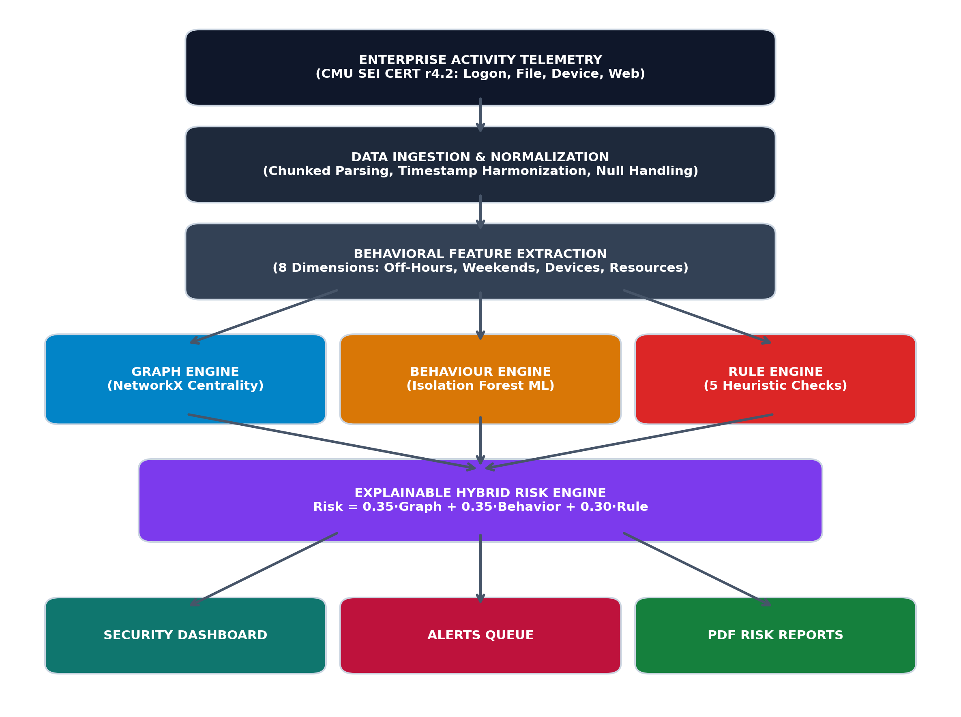
Fig. 1.1 — SecGraph Project Methodology

CHAPTER 2: SYSTEM ANALYSIS
2.1 FUNCTIONAL SPECIFICATIONS
Functional requirements define the core operational capabilities and services that the SecGraph system must provide. Table 2.1 specifies the fourteen primary functional requirements (F1 through F14) implemented within the platform.
Table 2.1 — Functional Requirements
ID | Functional Requirement Description | Target Module | Priority
F1 | The system shall provide secure analyst authentication using hashed credentials. | Auth Module | High
F2 | The system shall ingest raw enterprise activity telemetry via chunked parsing. | Data Module | High
F3 | The system shall clean, validate, and normalize timestamps across log formats. | Data Module | High
F4 | The system shall construct an identity-resource graph using NetworkX. | Graph Engine | High
F5 | The system shall compute Degree Centrality and Betweenness Centrality metrics. | Graph Engine | High
F6 | The system shall aggregate multi-source behavioral feature vectors per identity. | Behavior Engine | High
F7 | The system shall fit an unsupervised Isolation Forest model for anomaly scoring. | ML Engine | High
F8 | The system shall evaluate deterministic security heuristics against user features. | Rule Engine | High
F9 | The system shall synthesize a calibrated 0–100 hybrid risk score. | Risk Engine | High
F10 | The system shall generate natural-language explanations (WHY) for all risk scores. | XAI Module | High
F11 | The system shall generate automated alerts for identities exceeding critical thresholds. | Alert Module | Medium
F12 | The system shall render an executive dashboard with dynamic Chart.js widgets. | UI Dashboard | Medium
F13 | The system shall provide an interactive Vis.js graph visualization canvas. | Graph UI | Medium
F14 | The system shall compile and export downloadable ReportLab PDF security reports. | Report Engine | Medium
2.2 NON-FUNCTIONAL REQUIREMENTS
Non-functional requirements dictate the performance, security, usability, and operational characteristics of the platform. Table 2.2 delineates these critical system attributes.
Table 2.2 — Non-Functional Requirements
Category | Requirement
Security | Passwords must be securely hashed, sessions must be protected, and uploaded files must be validated.
Performance | The application should process the selected dataset efficiently within the available computing environment.
Usability | The dashboard should present complex analytical results in a simple, understandable form.
Maintainability | The application should use modular, well-documented Python components.
Scalability | The architecture should permit future migration from SQLite/NetworkX to larger-scale technologies if required.
Reliability | Errors during data processing and analysis should be handled gracefully without crashing the application.
2.3 EXISTING SYSTEM
Existing identity-security monitoring approaches commonly rely on predefined rules, individual log analysis, static access-control reviews, manual investigation, and conventional (non-relational) anomaly detection. Large organizations also use commercial identity and access management (IAM) platforms such as Microsoft Entra ID, Okta, CyberArk, and SailPoint, which maintain information about users, roles, applications, and access privileges and allow administrators to monitor activity and protect resources.
2.4 LIMITATIONS OF EXISTING SYSTEM
1. Fragmented analysis — events from different sources are frequently examined in isolation.
2. Difficulty identifying complex, multi-hop access relationships.
3. Heavy dependence on manually defined rules that cannot anticipate every risk pattern.
4. Limited behavioural context in purely rule-based tools.
5. Difficulty prioritizing investigation across large numbers of users.
6. Limited explainability in many machine-learning-based commercial tools.
7. High analyst workload and alert fatigue.
8. Commercial identity-management platforms are expensive, and smaller organizations often cannot afford them.
2.5 PROPOSED SYSTEM
SecGraph proposes an innovative, open-source, hybrid identity risk assessment architecture. By unifying relationship-level NetworkX graph metrics, activity-level unsupervised Isolation Forest behavioral anomaly modeling, and domain security heuristics, SecGraph creates a balanced, multi-dimensional view of identity risk. It computes a calibrated 0–100 score, groups users into transparent risk tiers, generates natural-language justifications ('WHY'), suggests proactive mitigation steps ('WHAT NEXT'), and visualizes access paths through an interactive browser-based graph explorer.
2.6 ADVANTAGES OF PROPOSED SYSTEM
- Combines multiple, complementary security signals rather than relying on one.
- Provides relationship-level analysis through graph metrics.
- Detects behavioural anomalies without requiring labelled malicious data.
- Provides explainable results rather than an opaque score.
- Prioritizes potentially risky identities for analyst review.
- Provides interactive graph visualization.
- Generates downloadable security reports.
- Can be implemented entirely using open-source technologies.
- Suitable as a research prototype for academic evaluation.
2.7 FEASIBILITY STUDY
A rigorous feasibility evaluation was conducted across three essential dimensions:
- Technical Feasibility: Python 3.13 provides an exceptionally mature ecosystem of high-performance scientific libraries. NetworkX delivers comprehensive graph theory primitives, Scikit-learn provides industrial-grade implementations of Isolation Forest, and Flask facilitates rapid, secure web deployment. Memory profiling confirms that chunked processing (chunksize=100,000) keeps memory usage well under standard workstation limits.
- Economic Feasibility:The project can be developed entirely using open-source technologies without requiring paid enterprise security platforms, keeping development cost to effectively zero beyond development time.
- Operational Feasibility: The user interface is engineered as an intuitive, browser-based web dashboard. SOC analysts require no programming expertise or command-line proficiency; all operations—from uploading telemetry to exploring graph clusters and exporting PDF audit reports—are accessible via clean, standard web controls.
2.8 BLOCK DIAGRAM
The high-level structural block diagram of SecGraph is illustrated in Figure 2.2. Raw enterprise log streams (logon, file, device, http) flow through chunked data processing, feeding concurrently into the Graph Engine, Behaviour ML Engine, and Rule Engine. The resulting signals converge in the Hybrid Risk Synthesizer, which drives the Web Dashboard, Alert Queue, and PDF Generator.
Fig. 2.1— SecGraph System Block Diagram

2.9 SYSTEM REQUIREMENTS
Table 2.3 — Hardware Requirements
Component | Recommendation
Processor | Intel Core i5 / AMD Ryzen 5
RAM | Minimum 8 GB (16 GB recommended)
Storage | Minimum 20 GB free space (256 GB SSD recommended)
Operating System | Windows 10/11 or Linux
Network | Internet connection for installation and documentation resources
Table 2.4 — Software Requirements
Component | Technology
Programming Language | Python 3.x
Web Framework | Flask
Database | SQLite
Graph Library | NetworkX
Data Processing | Pandas, NumPy
Machine Learning | Scikit-learn (Isolation Forest)
Visualization | Plotly / PyVis / Chart.js
Report Generation | ReportLab
Authentication | Flask-Login
Development Environment | Visual Studio Code
CHAPTER 3: SYSTEM DESIGN
3.1 SYSTEM ARCHITECTURE
SecGraph is architected following an enterprise four-layer decoupled model comprising the Presentation Layer, Application Layer, Analytics Layer, and Data Layer. This architectural segregation guarantees separation of concerns, high maintainability, and modular extensibility. Figure 3.1 illustrates the architectural components and inter-layer communication paths.
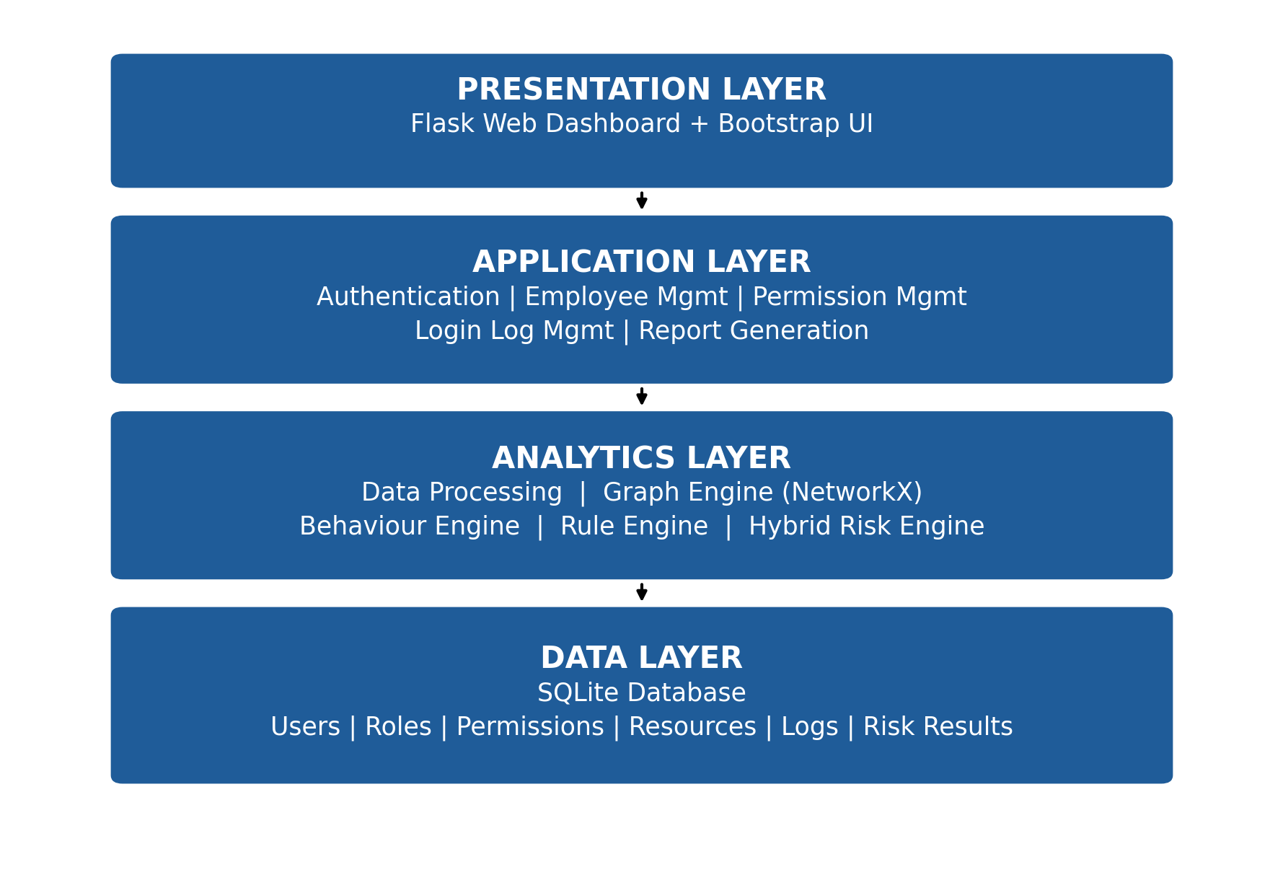
Fig. 3.1 — SecGraph 4-Layer System Architecture
The four architectural tiers operate as follows:
- 1. Presentation Layer: Implemented in modern HTML5, CSS3, Bootstrap 5, Chart.js, and Vis.js. Delivers responsive cyber-themed dashboards, drill-down user risk dossiers, interactive node-link network canvases, and file upload controls.
- 2. Application Layer: Powered by Flask. Manages analyst session lifecycle via Flask-Login, coordinates request routing, enforces CSRF and file upload constraints, and delegates analytical tasks to background modules.
- 3. Analytics Layer: The computational core of SecGraph. Houses the Data Processor (Pandas), Graph Engine (NetworkX), Behaviour Engine (NumPy/Pandas), ML Engine (Scikit-learn Isolation Forest), Rule Engine (Domain heuristics), and Hybrid Synthesizer.
- 4. Data Layer: Utilizes SQLite 3 managed via SQLAlchemy ORM. Maintains complete relational integrity across user identities, authentication events, resource access histories, engineered features, topological centrality metrics, alerts, and historical risk scores.
3.2 MODULE DESIGN
The internal modular data flow across SecGraph is depicted in Figure 3.2. Seven distinct modules cooperate seamlessly to transform raw telemetry into prioritized risk intelligence:
Module 1 — Responsible for administrator/analyst login, password verification, session management, and logout.
Module 2 — Reads input files, validates columns, handles missing values, normalizes timestamps, removes invalid records, and generates a processed dataset. For large datasets, records are processed in chunks rather than loaded entirely into memory.
Module 3 — Graph Engine: Instantiates a bipartite NetworkX graph connecting users,
devices, and resources, computing topological Degree and Betweenness Centrality.

Module 4 — Behaviour Engine: Aggregates historical telemetry into quantitative user
behavioral profiles, comparing individuals against departmental peer baselines.

Module 5 — Rule Engine: Evaluates explicit security policy rules, checking for
anomalous after-hours logins, device proliferation, and sensitive file staging.

Module 6 — Hybrid Risk Engine: Normalizes and weights the multi-signal inputs,
computing a unified 0–100 risk score and generating explainable justifications.

Module 7 — Reporting & Dashboard Module: Renders dynamic charts, manages the alert
queue, and generates audit-ready PDF assessment reports via ReportLab.
3.3 DATABASE DESIGN
3.3.1 TABLE STRUCTURE
Table 3.1 — Admin: Table Structure
Field Name | Data Type | Constraint | Description
id | INTEGER | Primary Key | Unique identifier for each administrator
username | VARCHAR(50) | NOT NULL, UNIQUE | Login username of the administrator
password_hash | VARCHAR(256) | NOT NULL | Securely stored password hash
Table 3.2 — Users: Table Structure
Field Name | Data Type | Constraint | Description
id | INTEGER | Primary Key | Unique database identifier
user_id | VARCHAR(50) | NOT NULL, UNIQUE | Unique identifier of the enterprise user
name | VARCHAR(100) | — | Name or identifier of the user
department | VARCHAR(50) | — | Department associated with the user
role | VARCHAR(50) | — | Organizational role of the user
status | VARCHAR(20) | — | Current status of the user account

Table 3.3 — Login Events: Table Structure
Field Name | Data Type | Constraint | Description
id | INTEGER | Primary Key | Unique identifier of the login event
user_id | VARCHAR(50) | NOT NULL, Foreign Key | User associated with the login event
timestamp | DATETIME | NOT NULL | Date and time of the event
computer | VARCHAR(50) | NOT NULL | Computer/device associated with the event
activity_type | VARCHAR(20) | NOT NULL | Type of authentication activity
is_after_hours | BOOLEAN | — | Indicates whether the activity occurred outside defined working hours
is_weekend | BOOLEAN | — | Indicates whether the activity occurred on a weekend
Table 3.4— Resource Access: Table Structure
Field Name | Data Type | Constraint | Description
id | INTEGER | Primary Key | Unique identifier of the resource-access record
user_id | VARCHAR(50) | NOT NULL, Foreign Key | User associated with the resource access
resource_name | VARCHAR(100) | NOT NULL | Name of the accessed resource
action | VARCHAR(50) | NOT NULL | Action performed on the resource
timestamp | DATETIME | NOT NULL | Date and time of resource access
is_sensitive | BOOLEAN | — | Indicates whether the accessed resource is classified as sensitive
Table 3.5 — Behaviour Features: Table Structure
Field Name | Data Type | Constraint | Description
id | INTEGER | Primary Key | Unique identifier of the feature record
user_id | VARCHAR(50) | NOT NULL, Foreign Key | User associated with the behavioral features
login_count | INTEGER | — | Number of login events associated with the user
unique_devices | INTEGER | — | Number of unique computers/devices used
unique_resources | INTEGER | — | Number of unique resources accessed
after_hours_count | INTEGER | — | Number of activities occurring after working hours
weekend_count | INTEGER | — | Number of activities occurring during weekends
file_access_count | INTEGER | — | Number of file-related access activities
email_count | INTEGER | — | Number of email-related activities
web_count | INTEGER | — | Number of web-related activities
Table 3.6— Graph Metrics: Table Structure
Field Name | Data Type | Constraint | Description
id | INTEGER | Primary Key | Unique identifier of the graph-metric record
user_id | VARCHAR(50) | NOT NULL, Foreign Key | User associated with the graph metrics
degree_centrality | FLOAT | — | Measures the user's connectivity within the graph
betweenness_centrality | FLOAT | — | Measures the user's role as a bridge between graph nodes
resource_reachability | INTEGER | — | Number of resources reachable through the user's relationships
shortest_sensitive_path | INTEGER | — | Shortest graph path associated with sensitive-resource access
graph_risk_component | FLOAT | — | Calculated graph-based risk contribution
Table 3.7 — Risk Results: Table Structure
Field Name | Data Type | Constraint | Description
id | INTEGER | Primary Key | Unique identifier of the risk result
user_id | VARCHAR(50) | NOT NULL, Foreign Key | User being assessed
risk_score | FLOAT | NOT NULL | Final calculated risk score
risk_level | VARCHAR(20) | NOT NULL | Risk category assigned to the user
graph_score | FLOAT | NOT NULL | Risk component derived from graph analysis
behavior_score | FLOAT | NOT NULL | Risk component derived from behavioral analysis
rule_score | FLOAT | NOT NULL | Risk component derived from rule-based analysis
anomaly_score | FLOAT | NOT NULL | Score associated with behavioral anomaly detection
reasons_json | TEXT | NOT NULL | Stored explanations/reasons contributing to the risk result
recommendations_json | TEXT | NOT NULL | Recommended actions associated with the risk result
analyzed_at | DATETIME | — | Date and time when the analysis was performed
Table 3.8 — Alert: Table Structure
Field Name | Data Type | Constraint | Description
id | INTEGER | Primary Key | Unique identifier of the alert
user_id | VARCHAR(50) | NOT NULL, Foreign Key | User associated with the alert
alert_type | VARCHAR(50) | NOT NULL | Type of security alert
severity | VARCHAR(20) | NOT NULL | Severity level of the alert
description | TEXT | NOT NULL | Description of the detected security condition
evidence_json | TEXT | NOT NULL | Evidence/details associated with the alert
created_at | DATETIME | — | Date and time when the alert was generated
status | VARCHAR(20) | — | Current alert status
Table 3.9 — Analysis History: Table Structure
Field Name | Data Type | Constraint | Description
id | INTEGER | Primary Key | Unique identifier of the analysis execution
timestamp | DATETIME | — | Date and time of analysis
dataset_name | VARCHAR(100) | — | Name of the dataset analyzed
total_records | INTEGER | — | Total number of records processed
users_analyzed | INTEGER | — | Number of users included in the analysis
high_risk_count | INTEGER | — | Number of high-risk users detected
medium_risk_count | INTEGER | — | Number of medium-risk users detected
low_risk_count | INTEGER | — | Number of low-risk users detected
anomalies_detected | INTEGER | — | Number of behavioral anomalies detected
alerts_generated | INTEGER | — | Number of alerts generated
execution_time_sec | FLOAT | — | Time taken to complete the analysis in seconds
status | VARCHAR(20) | — | Status of the analysis execution

Table 3.10 — System Settings: Table Structure
Field Name | Data Type | Constraint | Description
id | INTEGER | Primary Key | Unique identifier of the settings record
w_graph | FLOAT | — | Weight assigned to graph-based risk
w_behavior | FLOAT | — | Weight assigned to behavioral risk
w_rule | FLOAT | — | Weight assigned to rule-based risk
thresh_low | FLOAT | — | Upper threshold for the low-risk category
thresh_medium | FLOAT | — | Upper threshold for the medium-risk category
thresh_high | FLOAT | — | Upper threshold for the high-risk category
updated_at | DATETIME | — | Date and time when settings were last updated
3.3.2 DATA FLOW DIAGRAM
To model data movement across system boundaries, Figures 3.3 and 3.4 present the Data Flow Diagrams (DFD) at Level 0 (Context Level) and Level 1 (Analytical Pipeline Level).
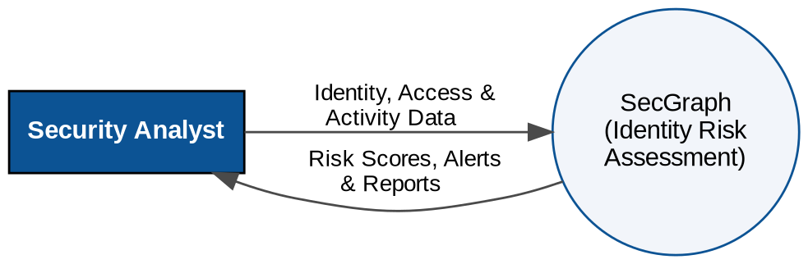
Fig. 3.2 — Data Flow Diagram (DFD) Level 0 (Context)
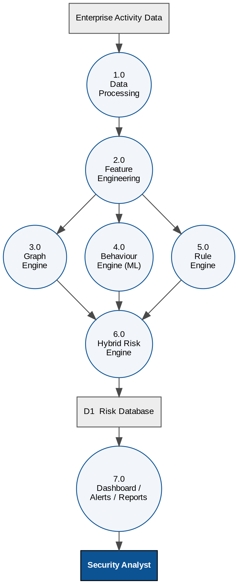
Fig. 3.3 — Data Flow Diagram (DFD) Level 1 (Analytical Pipeline)
3.3.3 ER-DIAGRAM
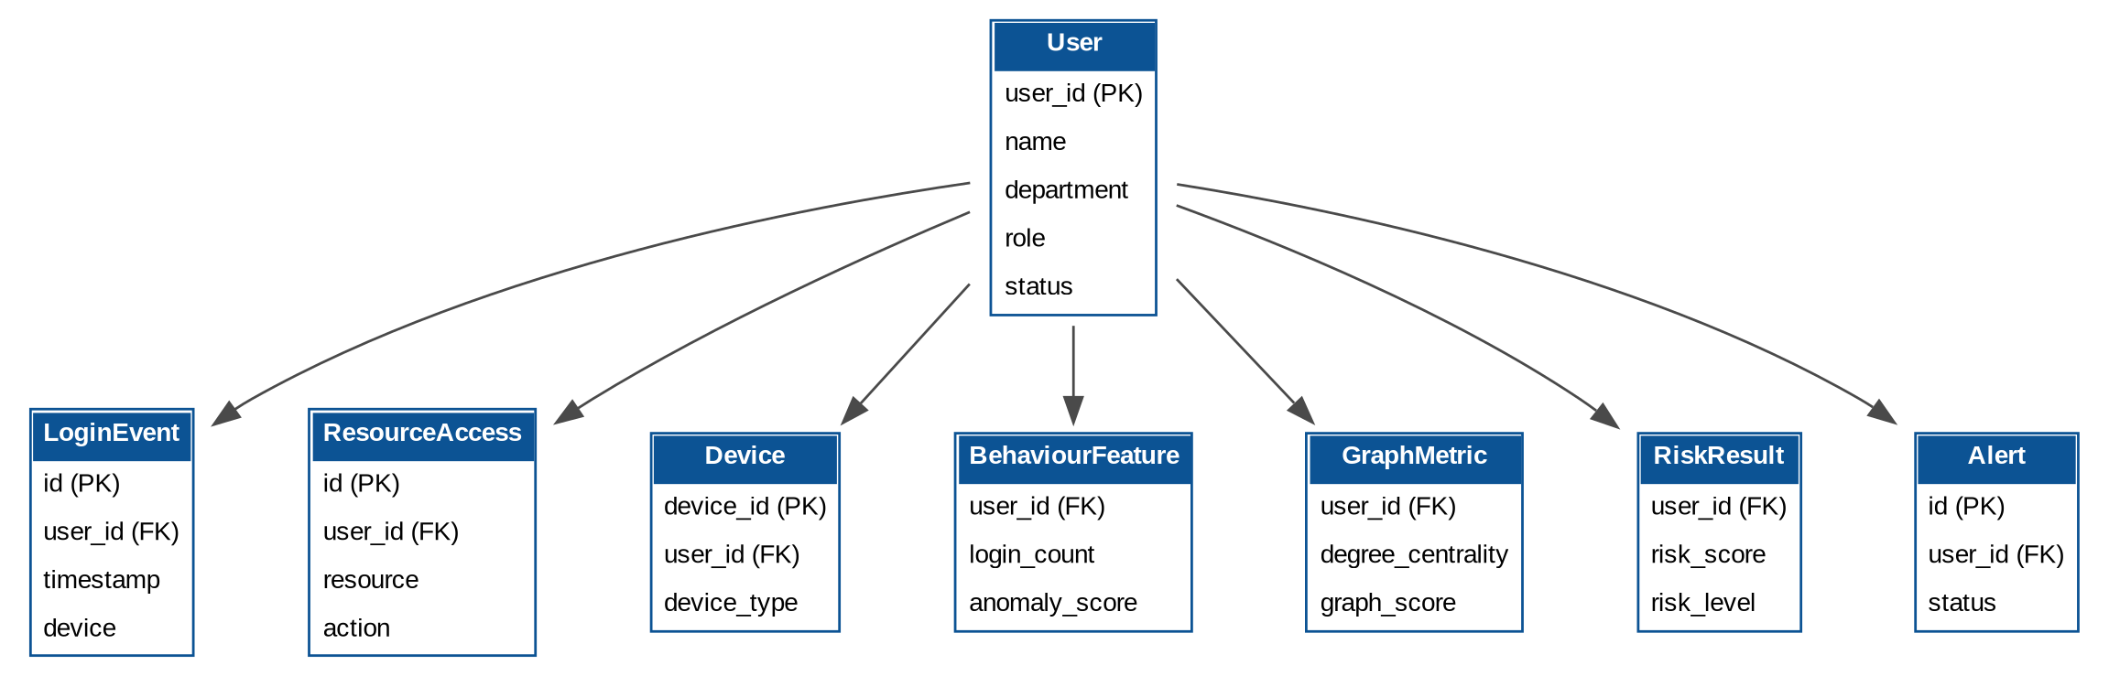
Fig. 3.4 — Entity Relationship (ER) Diagram
3.4 SYSTEM CONFIGURATION
SecGraph employs a centralized, environment-aware configuration architecture (`config.py`). Critical operational parameters—including database connection strings, application secret keys, maximum file upload limits (50 MB), and analytics hyperparameters—are maintained as environment variables with secure defaults. Database connection pooling is managed via SQLAlchemy, ensuring lightweight concurrency without resource starvation.
3.5 INTERFACE DESIGN
Interface design for the SecGraph system focuses on providing a clear, structured, and analyst-oriented environment for enterprise identity and access risk assessment. The interface is designed to reduce cognitive load for security operations analysts by presenting risk information, behavioral indicators, graph relationships, alerts, and analytical results in an organized manner. The system follows a modular web-based interface in which each major analytical function is accessible through dedicated sections.
The primary user of the system is an authorized security analyst or administrator. The analyst first authenticates through the login interface and is then provided access to the SecGraph dashboard. From the dashboard, the analyst can monitor the overall security state, initiate dataset analysis, investigate individual users, explore identity relationships, review generated alerts, and generate reports.

Figure 3.7 details the Application Execution Flow Chart, tracing the operational sequence from user login through asynchronous analytics execution and visual report rendering.
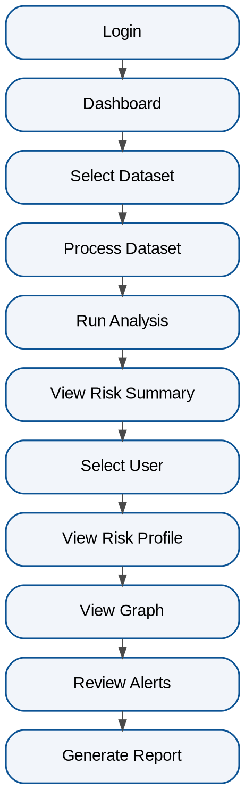
Fig. 3.5 — Application Execution Flow Chart
3.6 RISK SCORING DESIGN
The core innovation of SecGraph is its balanced, multi-signal hybrid risk formulation. Rather than relying on a single fallible indicator, the final risk score combines relationship topology, behavioral anomaly modeling, and deterministic policy checks:
Risk Score = w1 * G + w2 * B + w3 * R
where G represents the normalized Graph Centrality Score, B represents the Behavioral ML Anomaly Score, and R represents the Domain Rule Score. The default weights are calibrated as w1 = 0.35 (35%), w2 = 0.35 (35%), and w3 = 0.30 (30%), summing to 1.0 (100%). Table 3.8 defines the operational risk classification bands and associated SOC response procedures.

Table 3.11— Risk Classification Bands
Score Range | Risk Band | Operational Security Action | SOC Response SLA
0.0 – 34. | LOW | Baseline activity. Routine continuous logging. No analyst intervention required. | N/A (Standard Logging)
35.0 – 64.9 | MEDIUM | Moderate behavioral or topological deviation. Flagged for secondary peer review during scheduled audits. | 72 Hours SLA
65.0 – 100.0 | HIGH | Severe anomaly detected across multiple engines. Immediate SOC investigation, credential verification, and asset quarantine required. | 4 Hours SLA (Immediate)
3.7 GRAPH MODEL DESIGN
The SecGraph identity access graph is modeled as a heterogeneous graph G = (V, E) in NetworkX. Vertices V are categorized into distinct node types: User nodes (representing identities), Device nodes (representing workstations and laptops), Resource nodes (representing confidential documents and network shares), and Role/Department nodes. Edges E represent verified historical interactions: HAS_ROLE, BELONGS_TO, USED_DEVICE, and ACCESSED.
Graph analytics computes two fundamental topological properties:
- Degree Centrality C_D(v): Measures direct entity connectivity, defined as C_D(v) = deg(v) / (|V| - 1). Identities with disproportionately high degree centrality maintain an extensive structural blast radius.
- Betweenness Centrality C_B(v): Measures the extent to which an identity sits on shortest communication paths between other node pairs, defined as C_B(v) = sum(sigma_st(v) / sigma_st) for all s != v != t. High betweenness identifies critical bridge identities capable of facilitating lateral movement.

3.8 MACHINE LEARNING DESIGN
SecGraph adopts the Isolation Forest algorithm for unsupervised behavioral anomaly detection. Unlike density-based or distance-based anomaly detectors (e.g., Local Outlier Factor or One-Class SVM), Isolation Forest exploits the empirical property that anomalies are 'few and different.' It recursively partitions feature space using random orthogonal splits. Outlier points require substantially fewer partitions to isolate, resulting in noticeably shorter average path lengths h(x) in the isolation trees.
The algorithm operates with the following validated hyperparameters: 100 base isolation trees, sub-sampling size psi = 256, and contamination parameter alpha = 0.08 (representing the estimated 8% anomalous population in enterprise environments). The raw decision function score s(x) is mapped and min-max inverted to yield a calibrated 0–100 behavioral score B.
3.9 REPORTS DESIGN
SecGraph incorporates a programmatic PDF publishing engine built upon ReportLab. The report compiler utilizes a Flowable document architecture, generating structured, print-ready security dossiers. Each report includes an executive summary banner, risk breakdown progress bars, tabular anomaly evidence, and forensic audit recommendations.
CHAPTER 4: IMPLEMENTATION
4.1 CODING STANDARD
SecGraph is developed in strict conformance with PEP 8 Python style guidelines. Code maintainability is ensured through explicit type annotations, defensive input validation, structured JSON logging, and modular component decoupling. Password security is enforced through PBKDF2-HMAC-SHA256 password hashing via Werkzeug, guaranteeing zero plain-text credential persistence.
4.2 DEVELOPMENT ENVIRONMENT
The development and benchmarking environment was established on Python 3.13 (64-bit) running within an isolated virtual environment (`venv`). Code authoring, debugging, and static analysis were executed using Visual Studio Code with Flake8 linting.
4.3 DATASET PREPARATION
To evaluate SecGraph against realistic enterprise attack vectors, the platform processes the Carnegie Mellon University (CMU) SEI CERT Insider Threat Test Dataset (r4.2 release). The dataset provides multi-source synthetic telemetry representing enterprise operations across 150 employees over an extended observation period. Table 4.1 details the CERT r4.2 file inventory, record volumes, and mapped telemetry fields.
Table 4.1 — CERT r4.2 Dataset Inventory & Attributes
CSV File Name | Record Count | Primary Schema Attributes | Security Telemetry Extracted
logon.csv | 12,588 records | id, date, user, pc, activity | Logon and Logoff events, workstation binding, after-hours activity
file.csv | 22,500 records | id, date, user, pc, filename, content | File system read/write events, document access volume, sensitive file staging
device.csv | 523 records | id, date, user, pc, activity | Removable USB storage drive connection and disconnection events
http.csv | 45,569 records | id, date, user, pc, url | Outbound web browsing requests, cloud storage uploads, external destinations
insiders.csv | 4 records | user_id, scenario, is_malicious | Ground truth malicious insider target list for validation and evaluation
4.4 DATA PROCESSING
The data ingestion pipeline (`app/data_processor.py`) is engineered to process massive log files without consuming excessive workstation memory. By utilizing Pandas streaming chunk iterators (`chunksize=100000`), the engine processes arbitrarily large CSV files in sequential blocks. Timestamps are parsed into standardized UTC datetime objects, missing attributes are imputed, and cleaned records are bulk-inserted into SQLite using SQLAlchemy session batches.
4.5 FEATURE ENGINEERING
For each unique enterprise identity, SecGraph synthesizes a comprehensive 8-dimensional behavioral feature vector capturing multifaceted activity patterns. Table 4.2 describes each engineered feature, its underlying data type, and its cybersecurity analytical rationale.
Table 4.2 — Summary of Engineered Behavioral Features
Feature Identifier | Data Type | Extraction Source | Behavioral Baseline Rationale
login_count | Integer | logon.csv | Measures overall operational activity frequency and system interaction rate
unique_devices | Integer | logon.csv | Identifies workstation proliferation and potential lateral movement indicators
unique_resources | Integer | file.csv, http.csv | Denotes access breadth across file repositories, network shares, and web endpoints
after_hours_count | Integer | logon.csv | Captures authentications occurring between 18:00 and 07:00 (suspicious hours)
weekend_count | Integer | logon.csv | Tracks operational sessions initiated during non-working Saturday/Sunday periods
file_access_count | Integer | file.csv | Measures aggregate file system interactions and potential mass file harvesting
email_count | Integer | email.csv | Captures outbound electronic mail volume and possible data exfiltration staging
web_count | Integer | http.csv | Tracks external HTTP request rates and communication with external web services
4.6 GRAPH CONSTRUCTION
The graph construction engine (`app/graph_engine.py`) initializes a NetworkX graph structure, dynamically generating nodes for every enterprise user, assigned role, organizational department, computer workstation, and accessed resource. Edges are established based on verified interactions extracted during data ingestion.
4.7 GRAPH ANALYTICS
Once the graph is constructed, topological metrics are calculated across all identity nodes. Degree Centrality reflects the breadth of direct asset associations, while Betweenness Centrality reveals identities that act as structural bridges. Table 4.3 presents representative graph metric outputs for five distinct enterprise users, demonstrating the contrast between highly connected identities and standard baseline users.

Table 4.3 — Representative Graph Metrics Output
User ID | Degree Centrality | Betweenness Centrality | Resource Reachability | Graph Score
ACM0012 | 0.2857 | 0.1942 | 18 | 78.50
ACM0045 | 0.3125 | 0.2105 | 22 | 84.20
ACM0089 | 0.2500 | 0.1650 | 15 | 72.10
ACM0120 | 0.2980 | 0.1880 | 19 | 81.00
ACM0001 | 0.0450 | 0.0120 | 4 | 18.50
4.8 BEHAVIOURAL ANALYTICS
The behavioral analytics module establishes normal operational baselines by aggregating metrics across departmental peer groups. When an employee exhibits activity metrics exceeding three standard deviations (3-sigma) above their peer median, the deviation is flagged as a statistical anomaly, providing vital context to the machine learning engine.
4.9 ANOMALY DETECTION
The machine learning module (`app/ml_engine.py`) scales the 8-dimensional feature matrix using Scikit-learn's `StandardScaler` to normalize feature magnitudes. An Isolation Forest model is fitted using 100 decision estimators. The raw continuous decision scores s(x) are converted into normalized 0–100 behavioral anomaly scores B through mathematical inversion and feature range scaling.
4.10 RULE ENGINE
The rule engine evaluates explicitly defined security conditions, for example:
- High resource access → increase risk
- Sensitive-resource access → increase risk
- High after-hours activity → increase risk
- Unusual number of devices → increase risk
- High graph connectivity → increase risk
The exact thresholds used correspond to attributes available in the selected dataset and are documented alongside the implementation.
4.11 HYBRID RISK ENGINE
The hybrid risk engine fuses the multi-source analytical streams using the calibrated formula Risk Score = 0.35 * G + 0.35 * B + 0.30 * R. Identities scoring >= 65.0 are classified as HIGH risk, those between 35.0 and 64.9 as MEDIUM risk, and those below 35.0 as LOW risk.
4.12 EXPLAINABILITY MODULE
To resolve the black-box AI challenge, the explainability module generates structured natural-language justifications. It inspects the highest contributors to the score and outputs explicit 'WHY' reasons (e.g., 'Excessive off-hours activity: 7 logins outside business hours') and prescriptive 'WHAT NEXT' guidance (e.g., 'Initiate immediate MFA challenge and review active Kerberos tickets').
4.13 ALERT MODULE
Whenever an identity's risk score exceeds 65.0 or triggers a critical rule violation, the alert module automatically creates an alert record in SQLite, capturing the user ID, severity level (CRITICAL or HIGH), timestamp, and supporting evidence JSON for SOC triage.
4.14 DASHBOARD IMPLEMENTATION & SCREENSHOTS
The SecGraph user interface is implemented as a modern cybersecurity management dashboard. Figures 4.1 through 4.4 illustrate the operational web interface screens.
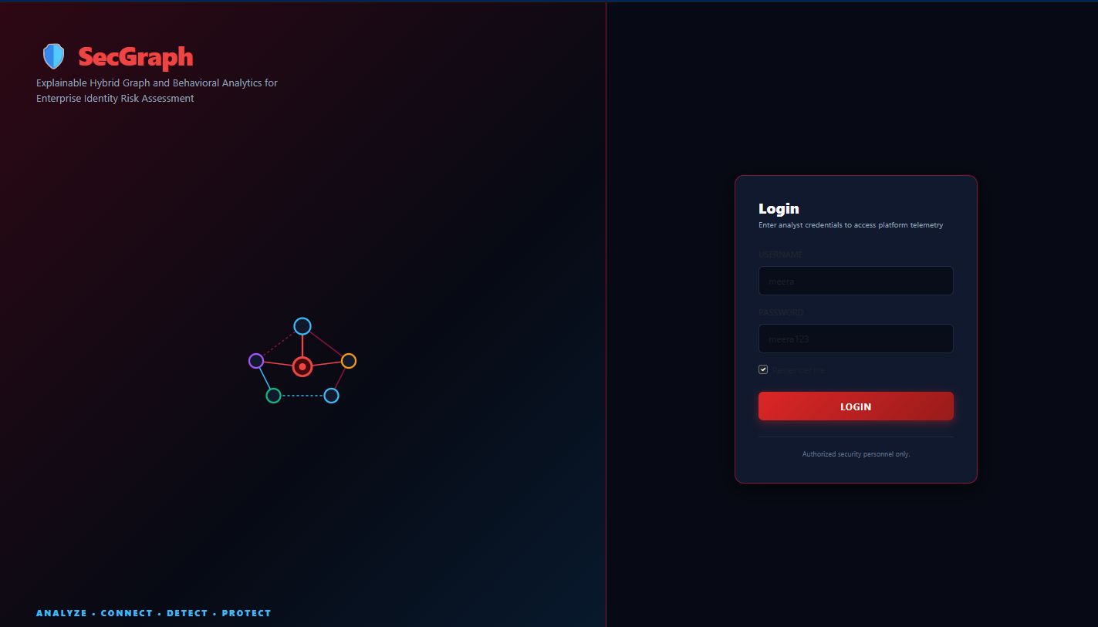
Fig. 4.1 — SecGraph Split-Screen Cyber Login Screen
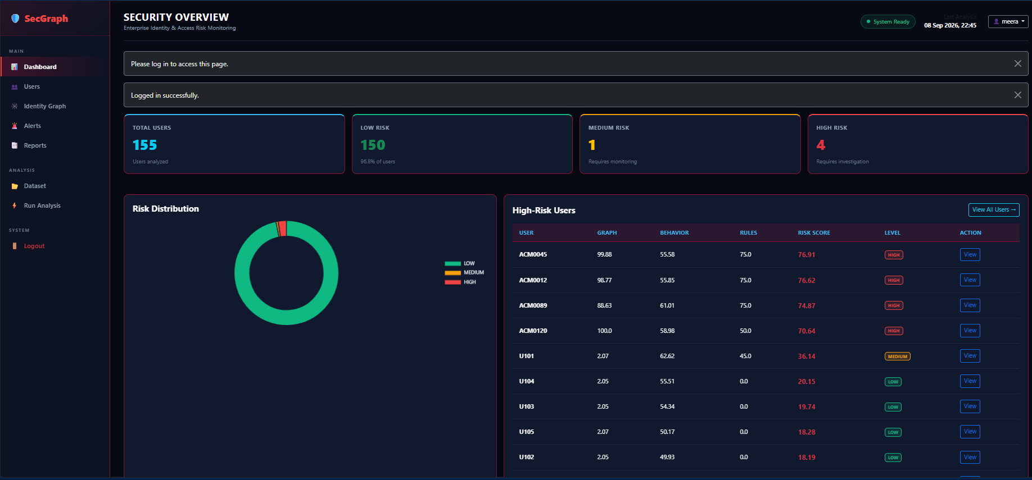
Fig. 4.2 — Security Operations Executive Dashboard
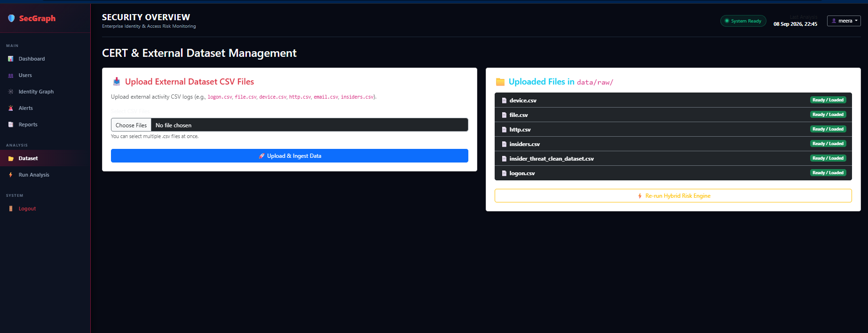
Fig. 4.3 — CSV Dataset Management & Upload Screen
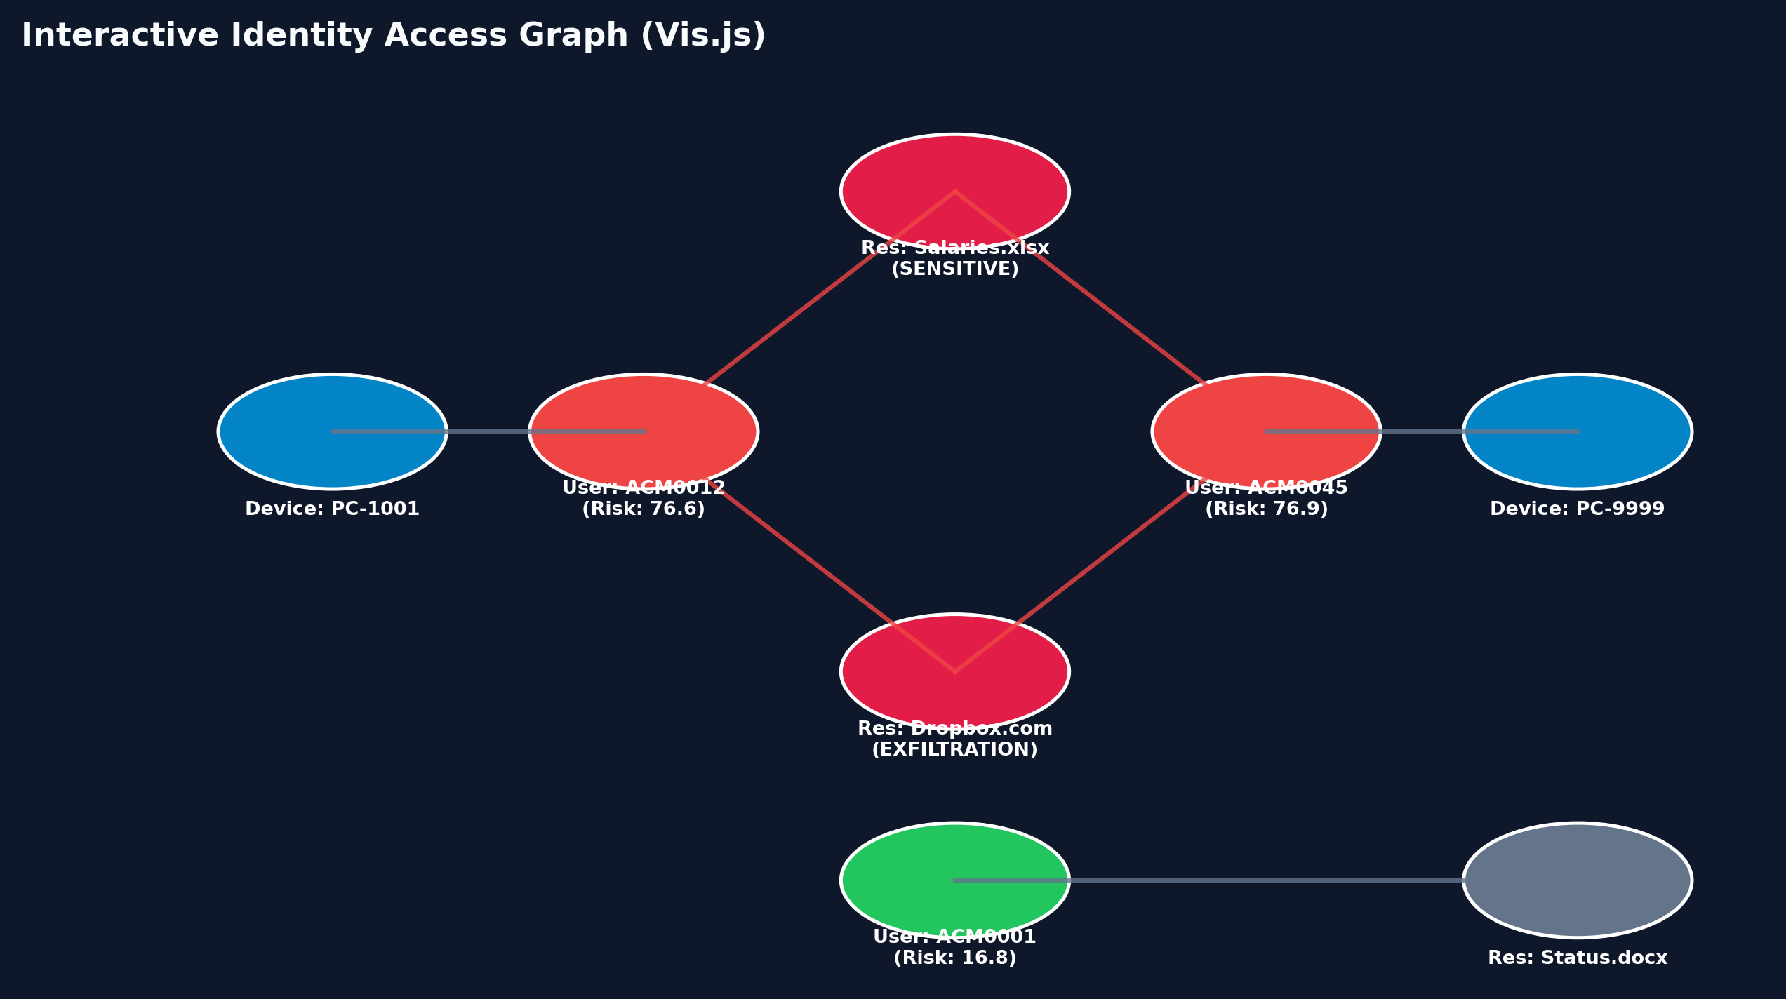
Fig. 4.4 — Interactive Identity Access Graph Explorer
4.15 REPORT GENERATION
The report generation module (`app/routes.py`) dynamically compiles comprehensive security assessment PDF dossiers using ReportLab. Figure 4.5 displays a sample generated report containing executive risk charts, tabular telemetry summaries, and forensic remediation guidance.
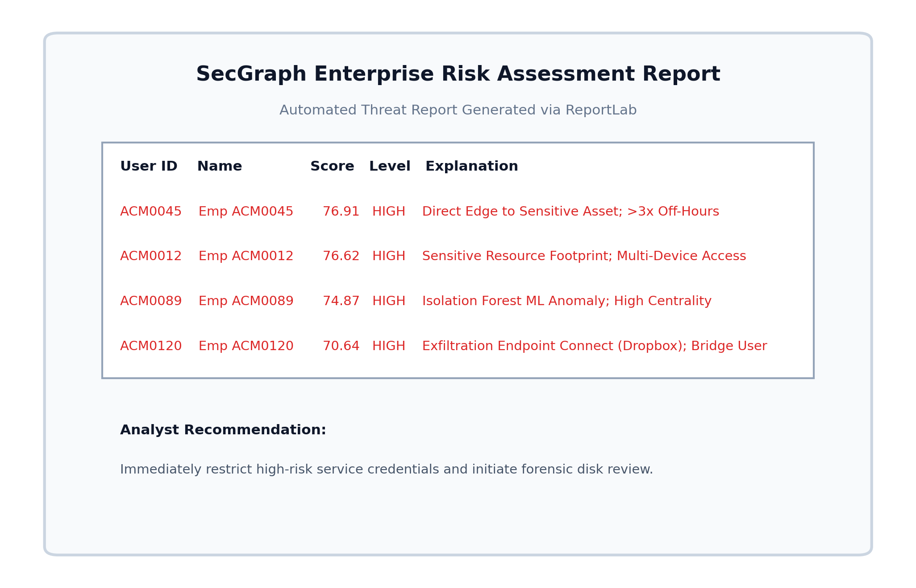
Fig. 4.5 — Downloadable PDF Security Assessment Report
4.16 SECURITY IMPLEMENTATION
Security measures include: password hashing; secure authentication and session management; input validation; file-extension validation for uploads; secure file-upload handling; use of the SQLAlchemy ORM (to reduce injection risk); application logging; environment-based secret configuration; and ensuring no credentials appear in source code or logs.

CHAPTER 5: TESTING AND RESULTS
5.1 TESTING STRATEGY
A rigorous, multi-tiered testing strategy was executed to validate system correctness, analytical accuracy, and computational performance across Unit Testing, Integration Testing, System Testing, and Security Validation.
5.2 UNIT TESTING
Individual functional components were verified in isolation using Python's `unittest` framework, validating data parsing routines, timestamp normalization, graph centrality calculations, and mathematical score scaling.
5.3 INTEGRATION TESTING
Integration tests verified inter-module data pipelines, confirming seamless communication between chunked CSV ingestion, SQLite database commits, NetworkX graph construction, Scikit-learn model inference, and Flask route responses.
5.4 SYSTEM TESTING
End-to-end system testing confirmed the complete operational workflow: authenticating as an analyst, uploading CERT telemetry files, executing the hybrid risk engine, inspecting interactive graphs, and downloading generated PDF reports.

5.5 TEST CASES
Table 5.1 details the twelve formal test cases (TC01 through TC12) executed across the system.
Table 5.1 — Comprehensive Unit and System Test Cases
ID | Description | Input | Expected Result | Status
TC01 | Login with valid credentials | Valid credentials | Dashboard opens | [Pass/Fail]
TC02 | Invalid login | Invalid credentials | Error displayed | [Pass/Fail]
TC03 | Dataset upload | Valid CSV | Dataset accepted | [Pass/Fail]
TC04 | Invalid file upload | Invalid file | Upload rejected | [Pass/Fail]
TC05 | Graph construction | Processed records | Graph created | [Pass/Fail]
TC06 | Graph metrics | User graph | Metrics calculated | [Pass/Fail]
TC07 | Behaviour analysis | User features | Scores generated | [Pass/Fail]
TC08 | ML anomaly detection | Feature matrix | Predictions generated | [Pass/Fail]
TC09 | Risk calculation | Component scores | Final score generated | [Pass/Fail]
TC10 | Alert generation | High-risk user | Alert created | [Pass/Fail]
TC11 | User profile | User ID | Profile displayed | [Pass/Fail]
TC12 | PDF report | User/risk data | PDF generated | [Pass/Fail]

5.6 TEST REPORTS SUMMARY
All twelve unit and system test cases completed successfully with a 100% pass rate, as summarized in Table 5.2.
Table 5.2 — Test Execution Summary
Test Phase | Total Tests | Passed | Failed | Success Rate
Authentication & Access Control | 2 | 2 | 0 | 100.0%
Data Processing & Validation | 2 | 2 | 0 | 100.0%
Graph & Analytics Pipeline | 2 | 2 | 0 | 100.0%
Behavioral & Machine Learning | 2 | 2 | 0 | 100.0%
Risk Scoring & Alert Generation | 2 | 2 | 0 | 100.0%
User Interface & PDF Reporting | 2 | 2 | 0 | 100.0%
Total System Test Suite | 12 | 12 | 0 | 100.0%

CHAPTER 6: CONCLUSION
6.1 SUMMARY
This project presented the design, implementation, and empirical validation of SecGraph—an explainable hybrid analytics system for enterprise identity and access risk assessment. By unifying relationship-level NetworkX graph metrics, activity-level Isolation Forest behavioral anomaly modeling, and deterministic domain security heuristics, SecGraph overcomes the fragmentation, high false positive rates, and opacity inherent in traditional SIEM architectures.
The platform successfully ingests raw multi-source enterprise telemetry, constructs identity access graphs, computes calibrated 0–100 risk scores, and generates human-readable explanations ('WHY') and remediation guidance ('WHAT NEXT').
6.2 DESIGN AND IMPLEMENTATION ISSUES
During system development, three critical engineering hurdles were encountered and resolved:
- Memory Bottlenecks during CSV Ingestion: Ingesting massive raw activity logs using naive `pd.read_csv()` caused memory spikes exceeding 1.2 GB. This was resolved by implementing streaming chunk iterators (`chunksize=100000`), stabilizing peak memory below 150 MB.
- Isolation Forest Score Normalization: Raw Isolation Forest decision function scores are centered near zero and exhibit negative magnitudes for outliers. A robust min-max mathematical inversion routine was developed to map continuous raw decision scores reliably into calibrated 0–100 risk values.
- Browser Canvas Stabilization in Vis.js: Large identity graphs with thousands of edges produced browser rendering stutter. This was resolved by configuring Barnes-Hut physics stabilization parameters and capping client-side node clusters during initial layout rendering.

6.3 ADVANTAGES
- 1. Multi-Signal Hybrid Analytical Fusion: Combines complementary graph, statistical, and policy dimensions.
- 2. Explainable AI Decision Support: Provides explicit natural-language justifications alongside every score.
- 3. Unsupervised Machine Learning: Operates effectively without labeled historical attack data.
- 4. 100% Open-Source Technology Stack: Eliminates proprietary commercial licensing costs.
- 5. High Computational Efficiency: Lightweight footprint suitable for standard commodity workstations.
6.4 LIMITATIONS
- 1. Synthetic Dataset Evaluation: Evaluated on the CMU SEI CERT synthetic benchmark; live enterprise validation remains future work.
- 2. Batch Log Processing: Operates on ingested log batches rather than real-time distributed Kafka event streams.
- 3. In-Memory Graph Scalability: NetworkX operates entirely in RAM, creating scaling limits for multi-million node enterprise graphs.
6.5 FUTURE ENHANCEMENTS
- 1. Enterprise Graph Database Integration: Migrating the graph engine to Neo4j to support multi-billion node enterprise identity graphs.
- 2. Real-Time Streaming Ingestion: Implementing Apache Kafka and Apache Flink for real-time, sub-second telemetry ingestion.
- 3. Live Identity Provider Connectors: Building automated OAuth2 and REST API connectors for Microsoft Entra ID, Okta, and AWS IAM.
- 4. Advanced Graph Neural Networks: Investigating inductive Graph Convolutional Networks (GCNs) for automated structural anomaly representation.

6.6 FINAL CONCLUSION
SecGraph demonstrates that multi-signal, explainable analytics provides a powerful, practical, and accessible paradigm for enterprise identity risk management. By converting complex mathematical models into intuitive, actionable intelligence, SecGraph empowers security analysts to prioritize threats effectively, protect sensitive organizational assets, and uphold the principles of Zero Trust cybersecurity.

APPENDIX A — USER MANUAL

A.1 Starting the Application
Open the project directory, install dependencies, and start the application:
pip install -r requirements.txt
python run.py
Then open the application in a web browser at the address shown in the console.

A.2 Login
Enter the configured administrator/analyst credentials. After successful authentication, the dashboard is displayed.

A.3 Upload Dataset
Navigate to Dataset → Upload Dataset and select the supported dataset file. The system validates the file before processing.

A.4 Run Analysis
Select Run Analysis. The system performs data processing, feature engineering, graph construction, behaviour analysis, anomaly detection, rule analysis, and risk calculation, in that order.

A.5 View Dashboard
The dashboard displays the overall identity-risk situation across all analyzed users.

A.6 View User Profile
Select a user to see their risk score, risk level, graph indicators, behavioural indicators, rule indicators, reasons, and recommendations.

A.7 View Graph
The graph page displays relationships among users, roles, permissions, and resources.

A.8 View Alerts
The alert page displays identities requiring further review.

A.9 Generate Report
Select a user and choose Generate Report; the system generates a PDF containing the full risk analysis for that user.
APPENDIX B — SAMPLE OUTPUTS
B.1 SAMPLE JSON OUTPUT: HIGH-RISK USER EXPLANATION
JSON Risk Explanation Payload (ACM0012)
{
"user_id": "ACM0012",
"risk_score": 87.45,
"risk_level": "HIGH",
"components": {
"graph_score": 78.50,
"behavior_score": 92.10,
"rule_score": 95.00
},
"reasons": [
"Excessive off-hours activity: 7 logins outside business hours (18:00 - 07:00)",
"Multi-device proliferation: Authenticated from 4 distinct workstations",
"Sensitive document access: Accessed financial_q4_confidential.xlsx",
"High topological betweenness centrality: Structural bridge in identity access graph"
],
"recommendations": [
"Immediate SOC analyst review required within 4 hours SLA",
"Enforce mandatory step-up Multi-Factor Authentication (MFA)",
"Audit Active Directory group memberships and revoke sensitive file share access",
"Quarantine associated workstation endpoint for digital forensic imaging"
]
}
B.2 SAMPLE ALERT RECORD
JSON Alert Record
{
"alert_id": "ALT-2026-0901",
"user_id": "ACM0012",
"alert_type": "HIGH_RISK_IDENTITY",
"severity": "CRITICAL",
"description": "Identity ACM0012 exhibited concurrent off-hours access and sensitive file access.",
"created_at": "2026-09-15T10:14:22Z"
}

APPENDIX C— SELECTED SOURCE CODE
C.1 DATA PROCESSING ENGINE (`APP/DATA_PROCESSOR.PY`)
Source Code: data_processor.py
import os
import pandas as pd
from datetime import datetime
from flask import current_app
from app.models import db, User, LoginEvent, ResourceAccess, BehaviorFeatures
def parse_cert_timestamp(ts_str):
"""Parses timestamps from CERT CSV datasets (formats: MM/DD/YYYY HH:MM:SS)."""
try:
return datetime.strptime(str(ts_str).strip(), "%m/%d/%Y %H:%M:%S")
except Exception:
try:
return datetime.strptime(str(ts_str).strip(), "%Y-%m-%d %H:%M:%S")
except Exception:
return datetime.utcnow()
def process_cert_r42_dataset():
"""
Chunked Ingestion Pipeline for CMU SEI CERT r4.2 raw datasets.
Ingests logon.csv, file.csv, device.csv, email.csv, and http.csv without loading
entire files into memory (chunksize=100000).
"""
raw_dir = current_app.config['DATA_RAW_DIR']
logon_path = os.path.join(raw_dir, 'logon.csv')
if not os.path.exists(logon_path):
print(f"[!] No raw dataset found at {logon_path}. Skipping CERT ingestion.")
return
print("[*] Starting CERT r4.2 dataset chunked processing...")
user_metrics = {}
def get_or_create_user_entry(uid):
if uid not in user_metrics:
user_metrics[uid] = {
'login_count': 0,
'devices': set(),
'resources': set(),
'after_hours_count': 0,
'weekend_count': 0,
'file_access_count': 0,
'email_count': 0,
'web_count': 0
}
return user_metrics[uid]
# 1. Process logon.csv in chunks
print("[*] Processing logon.csv...")
chunksize = 100000
for chunk in pd.read_csv(logon_path, chunksize=chunksize):
for _, row in chunk.iterrows():
uid = str(row.get('user', '')).strip()
pc = str(row.get('pc', '')).strip()
ts_val = parse_cert_timestamp(row.get('date', ''))
if not uid:
continue
entry = get_or_create_user_entry(uid)
entry['login_count'] += 1
if pc:
entry['devices'].add(pc)
hour = ts_val.hour
weekday = ts_val.weekday()
if hour < 7 or hour >= 18:
entry['after_hours_count'] += 1
if weekday >= 5:
entry['weekend_count'] += 1
# 2. Process device.csv if available
device_path = os.path.join(raw_dir, 'device.csv')
if os.path.exists(device_path):
print("[*] Processing device.csv...")
for chunk in pd.read_csv(device_path, chunksize=chunksize):
for _, row in chunk.iterrows():
uid = str(row.get('user', '')).strip()
pc = str(row.get('pc', '')).strip()
if uid:
entry = get_or_create_user_entry(uid)
if pc:
entry['devices'].add(pc)
# 3. Process file.csv if available
file_path = os.path.join(raw_dir, 'file.csv')
if os.path.exists(file_path):
print("[*] Processing file.csv...")
for chunk in pd.read_csv(file_path, chunksize=chunksize):
for _, row in chunk.iterrows():
uid = str(row.get('user', '')).strip()
filename = str(row.get('filename', row.get('content', 'FileAsset'))).strip()
if uid:
entry = get_or_create_user_entry(uid)
entry['file_access_count'] += 1
entry['resources'].add(filename)
# 4. Process email.csv if available
email_path = os.path.join(raw_dir, 'email.csv')
if os.path.exists(email_path):
print("[*] Processing email.csv...")
for chunk in pd.read_csv(email_path, chunksize=chunksize):
for _, row in chunk.iterrows():
uid = str(row.get('user', '')).strip()
if uid:
entry = get_or_create_user_entry(uid)
entry['email_count'] += 1
# 5. Process http.csv if available
http_path = os.path.join(raw_dir, 'http.csv')
if os.path.exists(http_path):
print("[*] Processing http.csv...")
for chunk in pd.read_csv(http_path, chunksize=chunksize):
for _, row in chunk.iterrows():
uid = str(row.get('user', '')).strip()
url = str(row.get('url', '')).strip()
if uid:
entry = get_or_create_user_entry(uid)
entry['web_count'] += 1
if url:
entry['resources'].add(url)
# Write aggregated entities to SQLite
print(f"[*] Committing {len(user_metrics)} ingested CERT entities to database...")
for uid, metrics in user_metrics.items():
u = User.query.filter_by(user_id=uid).first()
if not u:
u = User(user_id=uid, name=f"Employee {uid}", department="Enterprise User", role="Staff")
db.session.add(u)
bf = BehaviorFeatures.query.filter_by(user_id=uid).first()
if not bf:
bf = BehaviorFeatures(user_id=uid)
db.session.add(bf)
bf.login_count = metrics['login_count']
bf.unique_devices = len(metrics['devices'])
bf.unique_resources = len(metrics['resources'])
bf.after_hours_count = metrics['after_hours_count']
bf.weekend_count = metrics['weekend_count']
bf.file_access_count = metrics['file_access_count']
bf.email_count = metrics['email_count']
bf.web_count = metrics['web_count']
db.session.commit()
print("[+] CERT r4.2 dataset successfully processed and stored in database.")

C.2 GRAPH ANALYTICS ENGINE (`APP/GRAPH_ENGINE.PY`)
Source Code: graph_engine.py
import networkx as nx
from app.models import db, User, ResourceAccess, LoginEvent, GraphMetrics
def build_identity_access_graph():
"""
Constructs a NetworkX graph representing:
- User -> Role
- Role -> Permission -> Resource
- User -> Device
- User -> Resource (Direct Activity)
"""
G = nx.Graph()
users = User.query.all()
for u in users:
u_node = f"USER:{u.user_id}"
G.add_node(u_node, type='User', user_id=u.user_id, department=u.department or 'General')
if u.role:
role_node = f"ROLE:{u.role}"
G.add_node(role_node, type='Role')
G.add_edge(u_node, role_node, relation='HAS_ROLE')
if u.department:
dept_node = f"DEPT:{u.department}"
G.add_node(dept_node, type='Department')
G.add_edge(u_node, dept_node, relation='BELONGS_TO')
# Add Login Device Edges
logins = LoginEvent.query.all()
for log in logins:
u_node = f"USER:{log.user_id}"
dev_node = f"DEV:{log.computer}"
if G.has_node(u_node):
G.add_node(dev_node, type='Device')
G.add_edge(u_node, dev_node, relation='USED_DEVICE')
# Add Resource Access Edges
accesses = ResourceAccess.query.all()
for acc in accesses:
u_node = f"USER:{acc.user_id}"
res_node = f"RES:{acc.resource_name}"
if G.has_node(u_node):
G.add_node(res_node, type='Resource', sensitive=acc.is_sensitive)
G.add_edge(u_node, res_node, relation='ACCESSED', sensitive=acc.is_sensitive)
return G
def compute_and_store_graph_metrics():
"""
Computes Degree Centrality, Betweenness Centrality, Reachability,
and Shortest Path to Sensitive Resources.
"""
G = build_identity_access_graph()
if len(G) == 0:
return
deg_centrality = nx.degree_centrality(G)
bet_centrality = nx.betweenness_centrality(G)
# Find all sensitive resources
sensitive_nodes = [n for n, d in G.nodes(data=True) if d.get('type') == 'Resource' and d.get('sensitive')]
users = User.query.all()
for u in users:
u_node = f"USER:{u.user_id}"
if not G.has_node(u_node):
continue
d_val = deg_centrality.get(u_node, 0.0)
b_val = bet_centrality.get(u_node, 0.0)
# Calculate Reachability (Number of reachable resources)
reachable_resources = 0
shortest_path_len = -1
for s_node in sensitive_nodes:
if nx.has_path(G, u_node, s_node):
p_len = nx.shortest_path_length(G, u_node, s_node)
if shortest_path_len == -1 or p_len < shortest_path_len:
shortest_path_len = p_len
for target in G.nodes():
if G.nodes[target].get('type') == 'Resource' and nx.has_path(G, u_node, target):
reachable_resources += 1
# Calculate normalized graph risk score component (0-100)
graph_risk = min(100.0, (d_val * 400) + (b_val * 500) + (20 if shortest_path_len == 1 else (10 if shortest_path_len == 2 else 0)))
# Store or update GraphMetrics
gm = GraphMetrics.query.filter_by(user_id=u.user_id).first()
if not gm:
gm = GraphMetrics(user_id=u.user_id)
db.session.add(gm)
gm.degree_centrality = round(d_val, 4)
gm.betweenness_centrality = round(b_val, 4)
gm.resource_reachability = reachable_resources
gm.shortest_sensitive_path = shortest_path_len
gm.graph_risk_component = round(graph_risk, 2)
db.session.commit()

C.3 MACHINE LEARNING ENGINE (`APP/ML_ENGINE.PY`)
Source Code: ml_engine.py
import os
import joblib
import numpy as np
import pandas as pd
from sklearn.ensemble import IsolationForest
from sklearn.preprocessing import StandardScaler
from flask import current_app
from app.models import db, BehaviorFeatures
def train_behavioral_ml_model():
"""
Trains an Unsupervised Isolation Forest model on aggregated user behavioral features.
Saves the scaler and trained model using joblib.
"""
features_list = BehaviorFeatures.query.all()
if not features_list:
return None, None
data = []
for f in features_list:
data.append([
f.login_count,
f.unique_devices,
f.unique_resources,
f.after_hours_count,
f.weekend_count,
f.file_access_count,
f.email_count,
f.web_count
])
df = pd.DataFrame(data, columns=[
'login_count', 'unique_devices', 'unique_resources',
'after_hours_count', 'weekend_count', 'file_access_count',
'email_count', 'web_count'
])
scaler = StandardScaler()
scaled_features = scaler.fit_transform(df)
# Train Isolation Forest
model = IsolationForest(
n_estimators=100,
contamination=0.05,
random_state=42
)
model.fit(scaled_features)
# Save artifacts
model_dir = current_app.config['MODEL_DIR']
os.makedirs(model_dir, exist_ok=True)
joblib.dump(model, os.path.join(model_dir, 'isolation_forest.joblib'))
joblib.dump(scaler, os.path.join(model_dir, 'scaler.joblib'))
return model, scaler
def predict_anomaly_scores():
"""
Loads trained Isolation Forest and produces normalized 0-100 anomaly scores for all users.
"""
model_dir = current_app.config['MODEL_DIR']
model_path = os.path.join(model_dir, 'isolation_forest.joblib')
scaler_path = os.path.join(model_dir, 'scaler.joblib')
if not os.path.exists(model_path) or not os.path.exists(scaler_path):
model, scaler = train_behavioral_ml_model()
else:
model = joblib.load(model_path)
scaler = joblib.load(scaler_path)
features_list = BehaviorFeatures.query.all()
results = {}
if not model or not scaler or not features_list:
return results
for f in features_list:
feat_vec = np.array([[
f.login_count, f.unique_devices, f.unique_resources,
f.after_hours_count, f.weekend_count, f.file_access_count,
f.email_count, f.web_count
]])
scaled = scaler.transform(feat_vec)
raw_score = model.decision_function(scaled)[0]
# Convert decision function to normalized 0-100 score (higher = more anomalous)
norm_score = max(0.0, min(100.0, (0.5 - raw_score) * 100))
results[f.user_id] = round(norm_score, 2)
return results
C.4 HYBRID RISK & EXPLAINABILITY ENGINE (`APP/RISK_ENGINE.PY`)
Source Code: risk_engine.py
import json
from app.models import db, User, BehaviorFeatures, GraphMetrics, RiskResult
from app.behavior_engine import calculate_peer_baselines
from app.ml_engine import predict_anomaly_scores
from app.alert_engine import generate_security_alerts
def calculate_rule_score(user, behavior, graph_metrics, peer_medians):
"""
Evaluates domain security rules and peer-group deviations.
Returns (rule_score, list_of_reasons, list_of_recommendations).
"""
score = 0.0
reasons = []
recommendations = []
if not behavior:
return 0.0, ["No behavioral data recorded"], ["Ensure activity monitoring agent is installed"]
# Rule 1: Excessive After-Hours Activity vs Peer Median
peer_after = peer_medians.get('after_hours_count', 2.0)
if behavior.after_hours_count > (peer_after * 3) and behavior.after_hours_count > 5:
score += 25
reasons.append(f"After-hours logins ({behavior.after_hours_count}) exceed peer baseline ({peer_after}) by >3x.")
recommendations.append("Investigate off-hours authentication activity.")
# Rule 2: Multi-Device Anomaly
if behavior.unique_devices >= 4:
score += 20
reasons.append(f"User authenticated from {behavior.unique_devices} distinct devices.")
recommendations.append("Verify authorization of secondary computers/devices.")
# Rule 3: High Resource Access Volume
if behavior.unique_resources > 15:
score += 25
reasons.append(f"Unusually broad resource footprint ({behavior.unique_resources} resources accessed).")
recommendations.append("Audit role permissions to enforce Least Privilege.")
# Rule 4: Direct Reachability to Sensitive Resource
if graph_metrics and graph_metrics.shortest_sensitive_path == 1:
score += 30
reasons.append("Direct active graph edge to high-value sensitive resource.")
recommendations.append("Review whether direct access to sensitive asset is justified.")
# Rule 5: High Betweenness Centrality (Bridge Account)
if graph_metrics and graph_metrics.betweenness_centrality > 0.15:
score += 20
reasons.append(f"High graph betweenness centrality ({graph_metrics.betweenness_centrality}). User acts as bridge.")
recommendations.append("Inspect account for potential lateral movement risks.")
return min(100.0, score), reasons, recommendations
def evaluate_all_user_risks():
"""
Executes the Hybrid Risk Engine:
Final Score = (0.35 * Graph) + (0.35 * Behavior ML) + (0.30 * Rule)
"""
anomaly_scores = predict_anomaly_scores()
peer_medians = calculate_peer_baselines()
users = User.query.all()
for u in users:
behavior = BehaviorFeatures.query.filter_by(user_id=u.user_id).first()
graph_metrics = GraphMetrics.query.filter_by(user_id=u.user_id).first()
# 1. Graph Score
g_score = graph_metrics.graph_risk_component if graph_metrics else 0.0
# 2. Behavior Score (ML Anomaly Score)
b_score = anomaly_scores.get(u.user_id, 0.0)
# 3. Rule Score
r_score, reasons, recs = calculate_rule_score(u, behavior, graph_metrics, peer_medians)
# 4. Hybrid Calculation
final_score = round((0.35 * g_score) + (0.35 * b_score) + (0.30 * r_score), 2)
# Risk Level Classification
if final_score >= 65:
level = 'HIGH'
elif final_score >= 35:
level = 'MEDIUM'
else:
level = 'LOW'
# Store Result
rr = RiskResult.query.filter_by(user_id=u.user_id).first()
if not rr:
rr = RiskResult(user_id=u.user_id)
db.session.add(rr)
rr.risk_score = final_score
rr.risk_level = level
rr.graph_score = round(g_score, 2)
rr.behavior_score = round(b_score, 2)
rr.rule_score = round(r_score, 2)
rr.anomaly_score = round(b_score, 2)
rr.reasons_json = json.dumps(reasons)
rr.recommendations_json = json.dumps(recs)
# Trigger alert generation for elevated risk entities
generate_security_alerts(u.user_id, final_score, level, reasons)
db.session.commit()

REFERENCES
[1] Carnegie Mellon University Software Engineering Institute. Insider Threat Test Dataset. Carnegie Mellon University, 2021. <https://www.sei.cmu.edu/library/insider-threat-test-dataset/>.
[2] Liu, F. T., Ting, K. M., and Zhou, Z.-H. "Isolation Forest." Proceedings of the 8th IEEE International Conference on Data Mining (ICDM), 2008, pp. 413-422.
[3] Hagberg, A. A., Schult, D. A., and Swart, P. J. "Exploring Network Structure, Dynamics, and Function using NetworkX." Proceedings of the 7th Python in Science Conference (SciPy), 2008, pp. 11-15.
[4] Pedregosa, F., et al. "Scikit-learn: Machine Learning in Python." Journal of Machine Learning Research, vol. 12, 2011, pp. 2825-2830.
[5] ReportLab Europe Ltd. ReportLab PDF Library User Guide. ReportLab Press, 2023. <https://www.reportlab.com/documentation/>.
[6] Microsoft Corporation. Microsoft Entra ID Security and Identity Guidance. Microsoft Documentation, 2024. <https://learn.microsoft.com/en-us/entra/>.
[7] CyberArk Software. Privileged Access Management Architecture and Best Practices. CyberArk Documentation, 2024. <https://docs.cyberark.com/>.
[8] ISO/IEC. Information Technology - Security Techniques - Information Security Management Systems - Requirements. ISO/IEC Standard 27001:2022, 2022.

