1. **Find all the information about each product**

{}

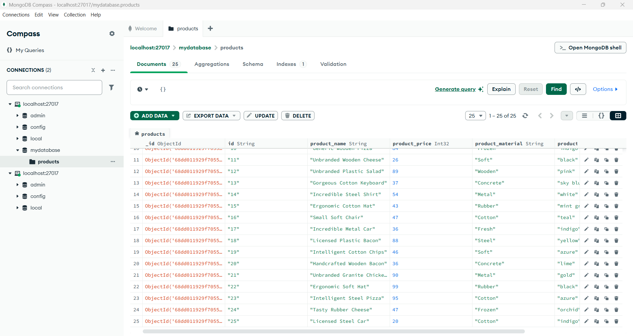

**2.Find the product price which are between 400 to 800**

{ product_price: { $gte: 400, $lte: 800 }

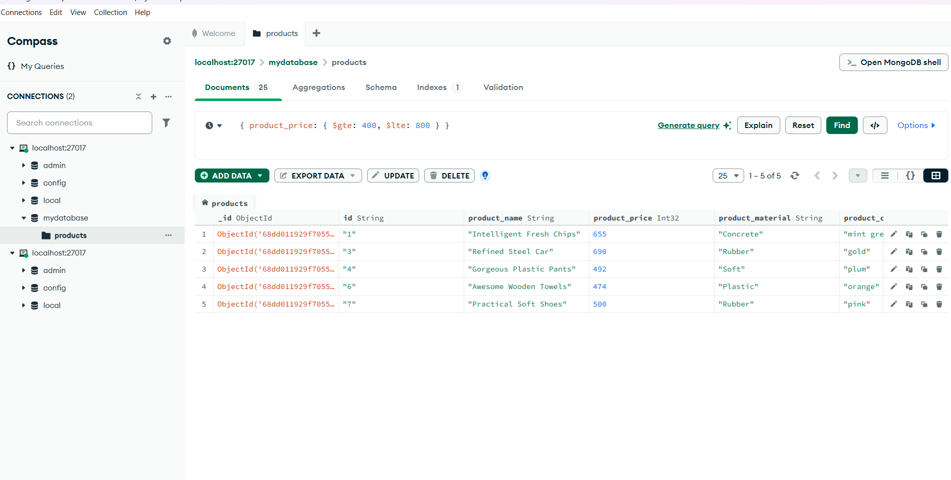

**3.Find the product price which are not between 400 to 600**

{ product_price: { $not: { $gte: 400, $lte: 600 } } }

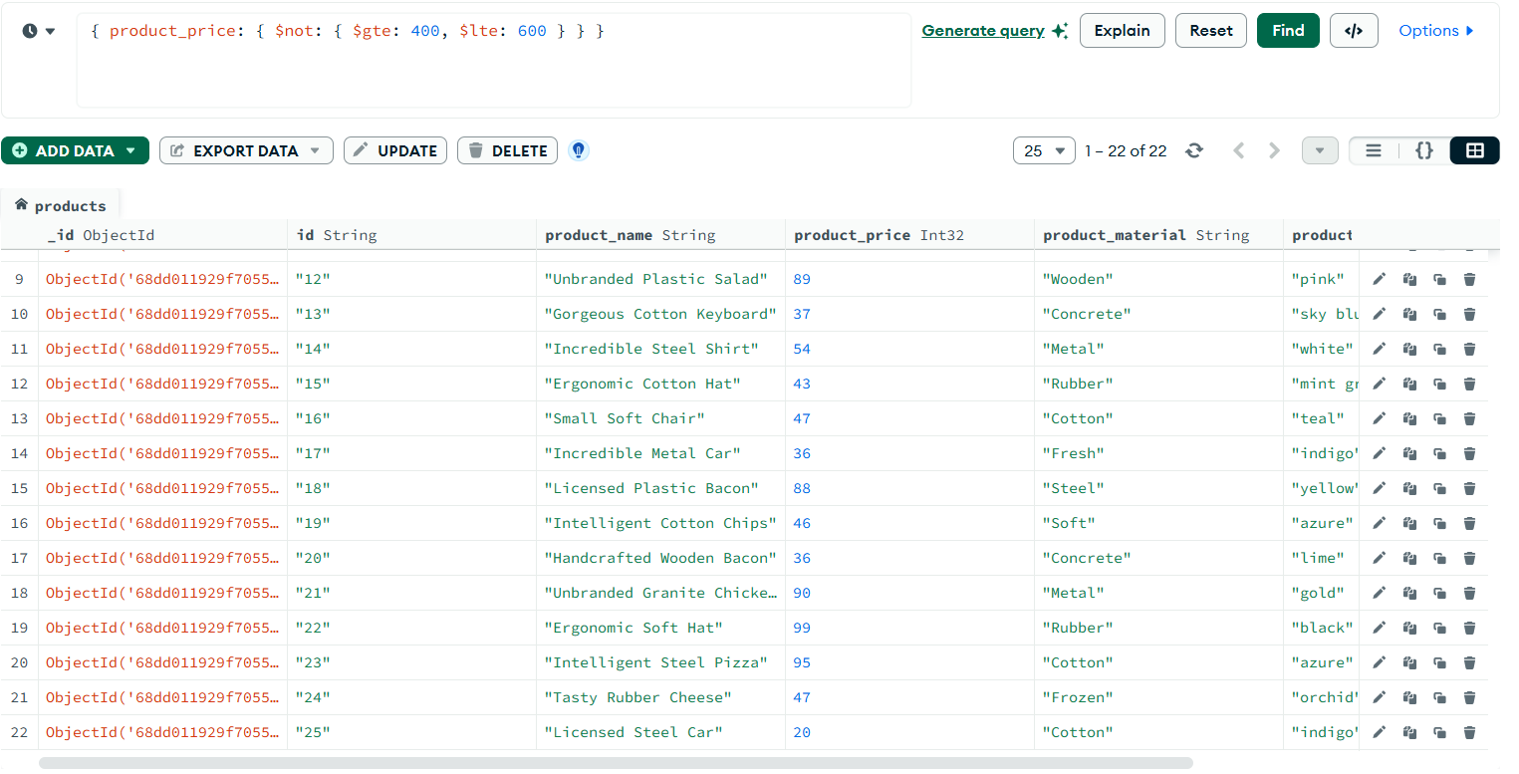

4. **List the four products which are greater than 500 in price**

{ product_price: { $gt: 500 } }

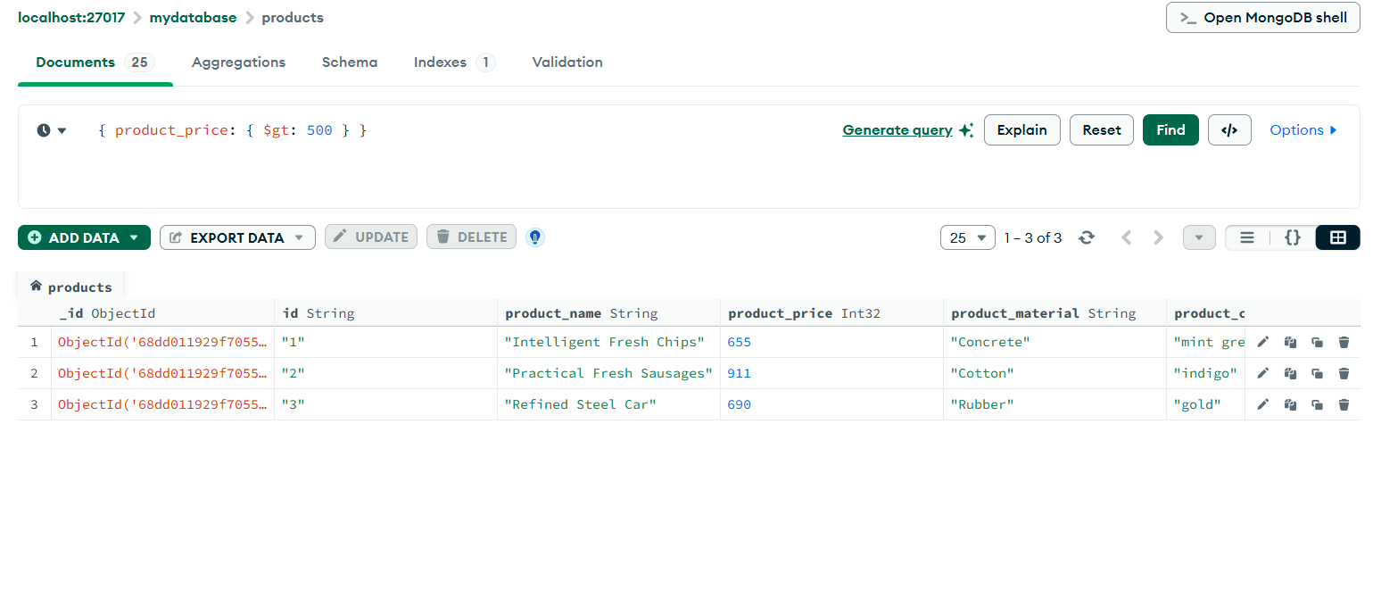

**5. Find the product name and product material of each product**

* **Filter:**

**{}**

* **Project:**

**{ product_name: 1, product_material: 1, _id: 0 }**

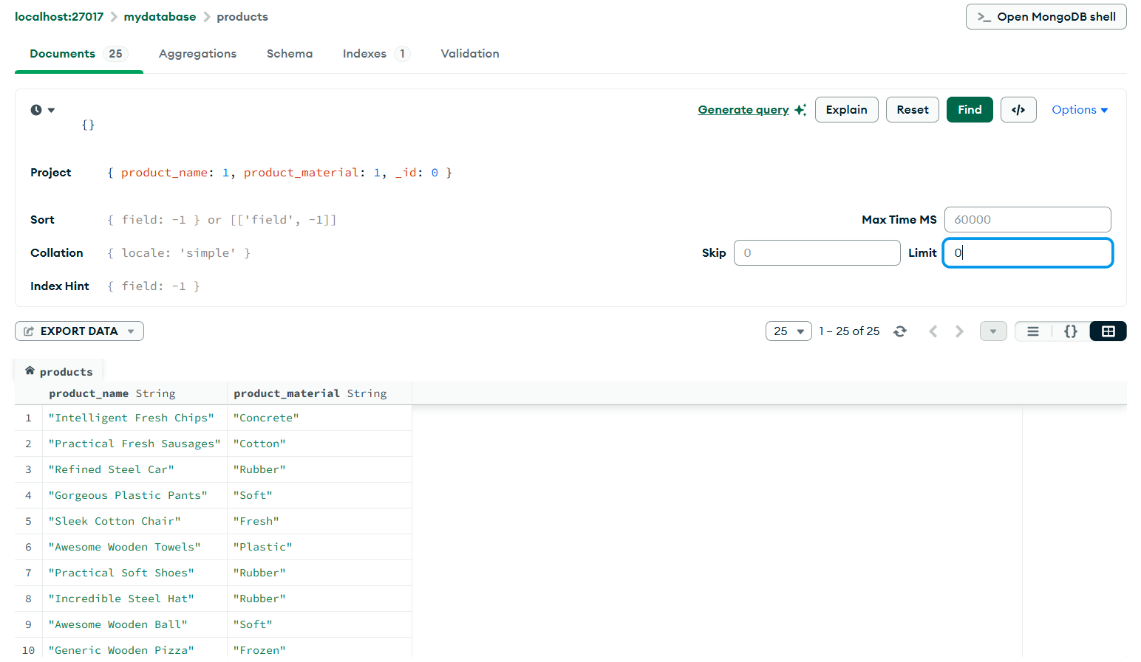

**6. Find the product with a row id of 10**

**{ id: "10" }**

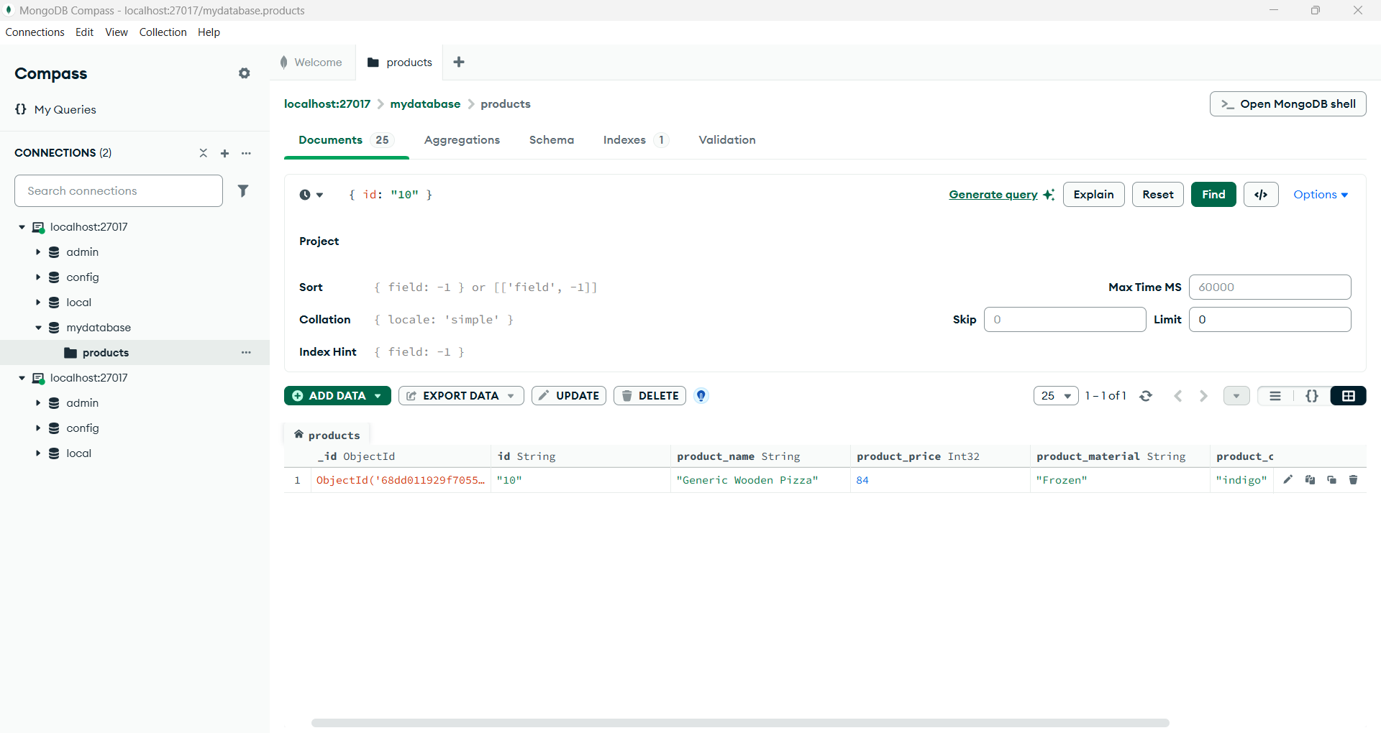

**7. Find only the product name and product material**

**{}**

**Project tab:**

**{ product_name: 1, product_material: 1, _id: 0 }**

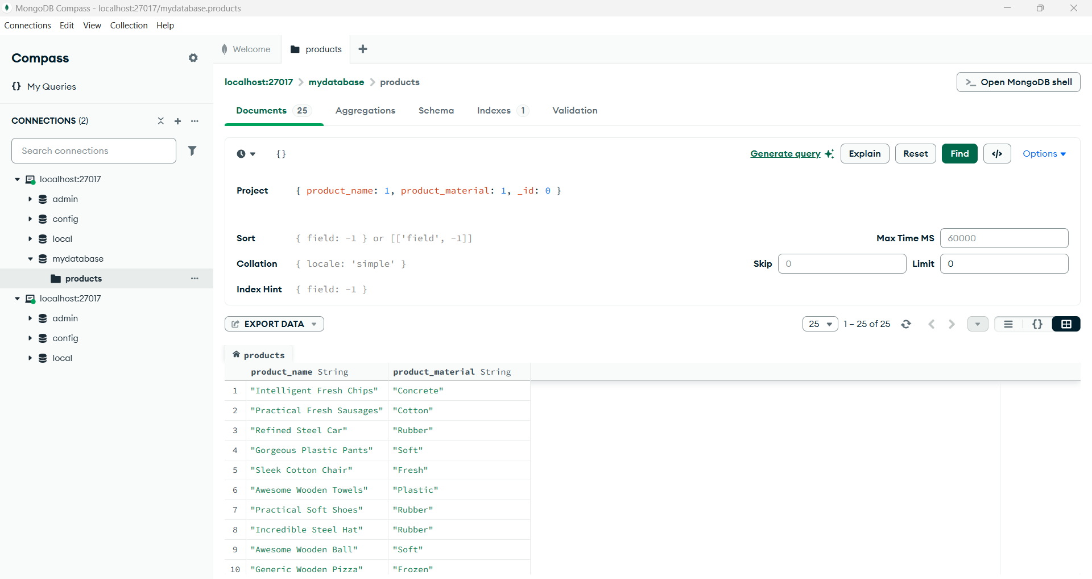

**8. Find all products which contain the value of "soft" in product material**

**{ product_material: { $regex: "soft", $options: "i" } }**

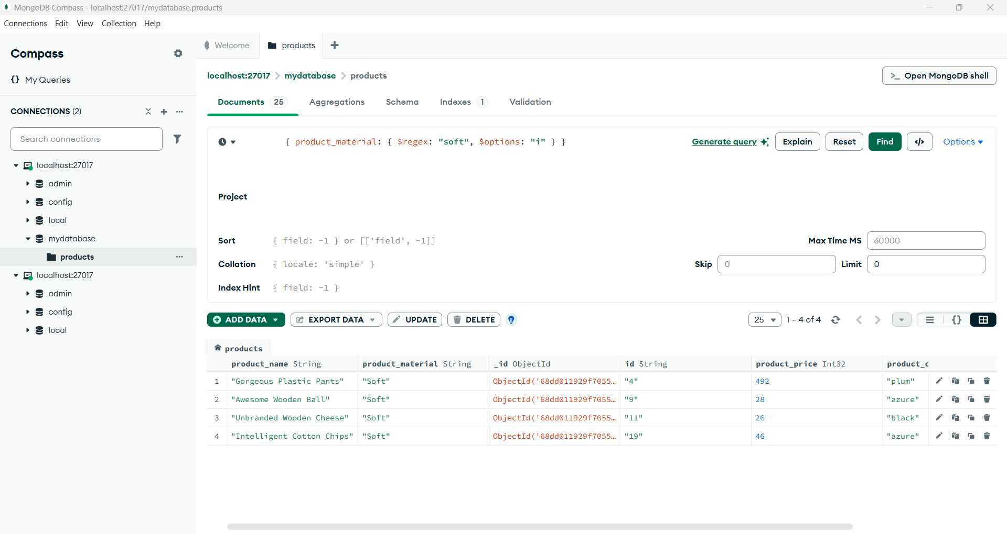

**9. Find products which contain product color "indigo" and product price 492.00**

**{ product_color: "indigo", product_price: 492 }**

**10. Delete the products which product price value are 28**

**{ product_price: 28 }**