Vendor Invoice Intelligence and Payment Monitoring System
Detailed project report
Core Python with AI Integrated Development
Saurav Kumar Jaiswal | Two member capstone team
Report date 22 September 2026

Abstract
This project implements a local desktop application for an organization to record vendor invoices, track payments and identify outstanding obligations. Vendors benefit indirectly from clearer payment tracking and fewer processing errors; the application itself is operated by the paying organization rather than being a vendor self-service portal. The solution addresses fragmented spreadsheet records, partial payments, duplicate submissions, inconsistent invoice details, overdue balances and the difficulty of comparing amounts across currencies.
The interface is written entirely in Python using Tkinter. SQLite persists suppliers, invoices, payments, exchange rates and audit events. Manual forms and CSV or Excel imports share the same validation and service logic. Invoice objects calculate balances and statuses; separate payments preserve payment history. Decimal arithmetic and exact text storage support fractional source amounts, including fractional JPY, without forcing currency-specific rounding at entry.
Published reference rates and manually entered dated rates support INR reporting equivalents. Overdue alerts operate while the application is open. Search, filters, sortable tables, CSV exports and password-guarded clearing make the workflow suitable for a classroom demonstration. The latest recorded automated test run passed 40 tests, including the complete 200-record sample import and migration of legacy amount storage.

Project boundary
The application monitors and reports payments. It does not execute bank transfers, authenticate suppliers, provide a production accounting ledger or extract data from scanned invoices. These boundaries keep the capstone focused on demonstrable Python design, validation, persistence, reporting and testing.

Report contents
The report is organized around the final implementation. Sections distinguish source facts, calculated results, design decisions, test evidence and future work. Heading styles support navigation through Word’s Navigation Pane.
1 Business context and vendor challenges
2 Objectives and requirements
3 Dataset profile and input contract
4 Validation and import behavior
5 Functional flow diagram
6 Architecture and module responsibilities
7 Object oriented design and data structures
8 Database relationships
9 Database fields and integrity
10 Monetary calculations and worked examples
11 Payment lifecycle and reporting dates
12 Exchange rate workflow
13 Alerts sorting and interface behavior
14 User operating guide
15 Deletion and correction flow
16 Installation and environment setup
17 Reports logs and audit evidence
18 Testing strategy and results
19 Implementation challenges and resolutions
20 Team allocation and evaluation mapping
21 Limitations and future improvements
22 Demonstration plan and troubleshooting
23 References and submission inventory

1 Business context and vendor challenges

Why invoice monitoring matters
A vendor may deliver goods or services before receiving full payment. When invoice details are missing, approval is delayed, or several partial payments are recorded in different places, the vendor may have difficulty determining what remains unpaid. This can make short-term planning harder. The paying organization also needs a consistent record of its obligations to avoid duplicate processing and unclear follow-up.
The project treats the invoice as the main record and payments as related transactions. A single place for invoice identity, due dates, original currency and payment history lets the operator identify which obligations are settled, which are partially paid and which are overdue. This is an operational tracking benefit; the project does not claim measured reductions in payment delays because it has not been evaluated in a live organization.
Challenge | Implemented response
Delayed or missed payments | Due dates, remaining balances, overdue-day calculations and visible alerts.
Unclear partial payments | Separate payment entries accumulated into a total paid amount.
Duplicate invoice submissions | Unique invoice IDs and supplier-ID/invoice-number combinations.
Incomplete or inconsistent records | Shared validation for forms and imported rows; issue reports explain failures.
Amounts in several currencies | Original currency preserved; dated rates provide comparable INR equivalents.
Time spent finding records | Search, status filters, read-only details and sortable columns.
Correction without traceability | Confirmed individual deletions retain audit snapshots before replacement.

Stakeholders and responsibility
The primary user is a staff member tracking vendor invoices on one local PC. The two student developers maintain the code and explain its behavior during evaluation. Vendors are the counterparties represented by supplier records. No supplier-facing login or messaging channel is implemented; follow-up action remains the responsibility of the operator.

2 Objectives and requirements

Primary objective
Develop a Python-only desktop application that turns invoice records and payment entries into reliable outstanding-balance reports, due-date indicators and vendor summaries. The application must preserve source amounts and make failed validation or missing conversion data visible rather than quietly producing incomplete results.
Area | Implemented requirement
Entry and import | Manually enter invoice details or load CSV and XLSX files using shared rules.
Persistence | Store records in a local SQLite file and recover them after restart.
Payments | Record additional payments, reject overpayment and calculate balances.
Reporting | Show payment status, overdue days, paid-late history and vendor totals.
Exchange rates | Load defaults, fetch latest published rates and retain dated manual updates.
Interface | Provide five tabs, useful errors, searchable tables and header-click sorting.
Alerts | Check today’s overdue balances at startup and periodically while open.
Corrections | Keep saved invoice/payment facts read-only; delete and replace with confirmation.
Full reset | Require exact password Delete, clear database rows and restore default rates.
Evidence | Provide tests, input data, outputs, documentation and AI-assistance notes.

Quality requirements
Monetary values should be computed with Decimal rather than ordinary binary float arithmetic. SQL values should use placeholders. Related writes should be transactional, so a rejected operation does not leave partial records. Network requests should not block the desktop interface. Tests should use temporary storage rather than the operational database.

What changed from the initial proposal
The original outline considered a CLI, a single currency and subtotal-plus-tax validation. The delivered application uses Tkinter, multiple currencies and invoice/payment arithmetic. The chosen dataset has neither subtotal nor tax fields, so tax-total verification was not implemented. Pandas is not required: the project uses the csv module, openpyxl for Excel, SQLite and standard-library data structures.

3 Dataset profile and input contract
The supplied file is supplier-invoice-payment-timelines.csv, downloaded by the user from the GoMask dataset page. It contains synthetic supplier invoice records. Profiling found 200 rows, 19 columns, 106 distinct supplier IDs and nine currencies. Invoice dates range from 20 November 2023 to 15 May 2024. These describe the original source file, not the contents of a user-modified database.
Stored source status | Records
paid | 94
pending | 50
overdue | 28
cancelled | 20
partial | 8

Currency | Records
USD | 99
EUR | 26
GBP | 16
INR | 16
CAD | 13
SEK | 12
BRL | 9
JPY | 5
CNY | 4

Required input columns
invoice_id, supplier_id, supplier_name, invoice_number, invoice_date, invoice_due_date, invoice_amount and currency are required. Identifiers should be stored as text in Excel so leading zeroes are not lost. Dates use YYYY-MM-DD in CSV; native Excel date cells are supported. Numeric input should omit currency symbols and thousands separators.

Optional and source columns
supplier_tax_id, invoice_submission_date, payment_date, payment_amount, payment_method, payment_reference, payment_status, days_to_payment, is_overdue, created_at and updated_at complete the supplied schema. Blank submission date defaults to invoice date. A positive payment requires a payment date. Original source creation/update timestamps remain available in the unchanged source file; database timestamps describe local entry.

4 Validation and import behavior

Shared rules
Manual entry and file import both call InvoiceService.add_invoice. This prevents one input route from bypassing business rules. Required strings are stripped and checked. Currency codes are normalized to uppercase and checked against the supported set. Invoice and submission dates cannot be future dates. Due and submission dates cannot precede the invoice date. Due dates may be future dates.
Amounts must be finite and non-negative, with at most 12 decimal places and a scaled-value ceiling of 10 to the power 15. An active invoice must have a positive amount. A cancelled source invoice may have a zero amount, but it cannot have a recorded payment. Payment dates must fall between invoice date and today. An initial payment cannot exceed invoice amount.

Identity and status consistency
Invoice ID is unique, and supplier ID plus invoice number is unique. An existing supplier ID must retain the same supplier name and tax ID; identical names under different IDs are not automatically merged. Source status paid requires full payment. Partial requires a payment strictly between zero and invoice total. Pending cannot coexist with a payment. The stored overdue label is not used as the authority for current overdue calculations.

CSV and Excel mechanics
CSV uses DictReader with UTF-8 BOM support. Excel reads the first worksheet with openpyxl in read-only mode. The first row must contain unique, non-empty column names. Blank Excel rows are skipped, formula cells are rejected, and native dates are converted to ISO dates. Legacy XLS files must first be saved as XLSX. Malformed rows are reported with a row number and reason.

Partial success and source anomalies
Each valid row is committed separately. Invalid rows are excluded from financial summaries while other rows continue. An imported aggregate payment becomes one payment entry; the application does not invent earlier transactions. The source record INV-00010 states 34 days to payment, while the submission and payment dates produce 35 days. It is imported with a warning. The fractional JPY amount in INV-00375 is now accepted and retained. A fresh import accepts all 200 source records with one warning.
Reimport is not an update operation. Existing invoice keys are rejected as duplicates. The issue CSV is written when an import has issues; an issue-free import does not delete an older issue file. The result dialog identifies the current import outcome.

5 Functional flow diagram
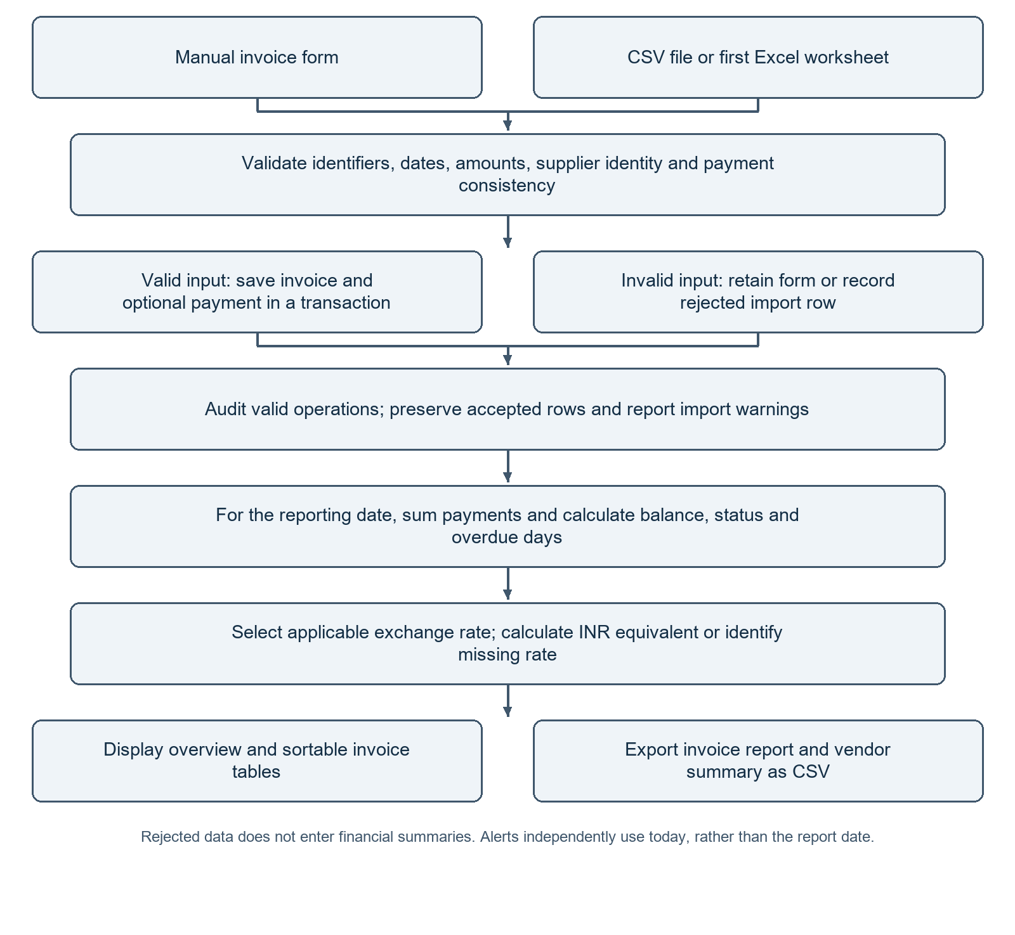
Figure 1. Invoice entry, validation, persistence, calculation and reporting flow.
The form and file readers are input adapters. They converge on shared service rules. Valid invoices contribute to reports; rejected invoices do not. A warning about a source-derived value can coexist with a successfully imported invoice when the payment facts themselves remain valid.

6 Architecture and module responsibilities
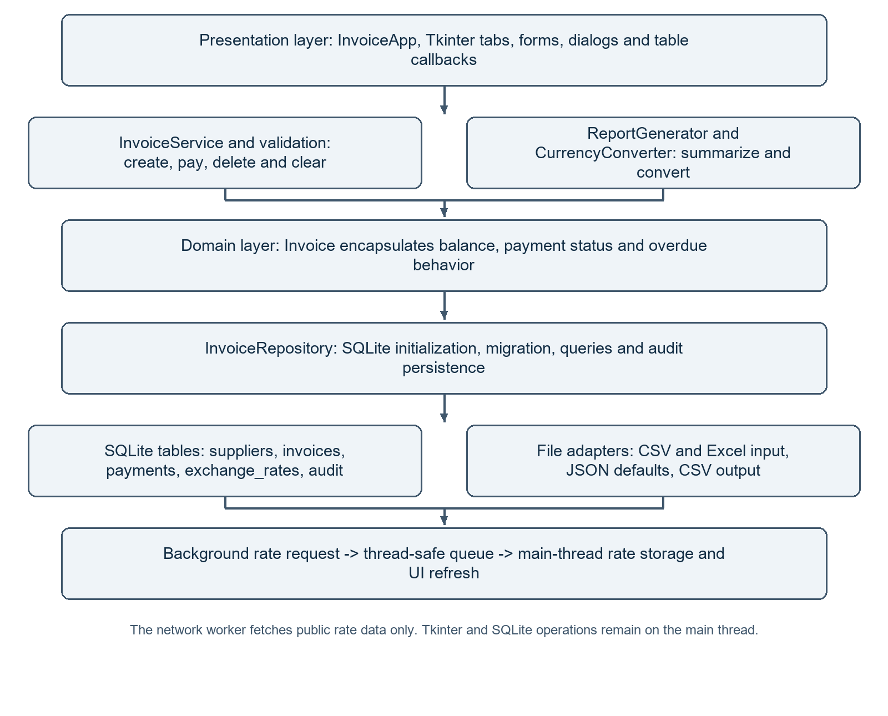
Figure 2. Presentation, service, domain, persistence and adapter responsibilities.
Module | Primary responsibility
main.py | Tkinter views, callbacks, rate worker coordination and alert scheduling.
models.py and validation.py | Invoice behavior, payment value type and reusable field checks.
database.py and invoice_service.py | SQLite schema/migration, queries and transactional operations.
currency.py and reports.py | Dated rate selection, INR conversion and grouped output.
csv_handler.py and ui_helpers.py | File import/export, type-aware sorting and overdue summaries.

7 Object oriented design and data structures

Domain objects and encapsulation
Invoice is a frozen dataclass holding invoice identity, supplier details, dates, currency, amount, paid amount and cancellation state. It exposes balance_minor, status, days_overdue and amount conversion behavior. Keeping these rules together gives the rest of the application one definition of invoice state. Payment is a frozen payment value type; current persistence methods pass validated payment fields directly rather than constructing it for every database operation.

Services repositories and composition
InvoiceService receives an InvoiceRepository and uses it for validated writes and audit entries. CurrencyConverter uses the repository for rate history. ReportGenerator combines repository query results with currency conversion. This is composition: separate objects collaborate without forcing every responsibility into the UI. SQL details remain in persistence/service code while Tkinter callbacks gather input and show results.

Inheritance and immutability
InvoiceApp extends tkinter.Tk to provide the root window and event loop. The business domain does not require an artificial hierarchy of paid and unpaid invoice subclasses because payment state changes through recorded transactions. Frozen dataclasses discourage accidental in-memory modification; the service controls changes through additions and deletion/replacement operations.
Structure | Use and reason
List | Ordered query results, report records and import issues.
Dictionary | CSV field mappings, payment totals and vendor summary accumulators.
Tuple | Supplier/currency grouping keys and immutable alert signatures.
Set | Required-header comparison and missing-currency detection.
Decimal | Amounts, exchange rates and exact payment accumulation.
date and datetime | ISO date parsing, overdue differences and source date handling.
Queue and worker thread | Transfer network results safely to Tkinter’s main thread.

Readability and reuse
Classes reflect real responsibilities, not merely evaluation keywords. The same calculation logic supports UI views, exports and tests. Validation errors are raised as understandable exceptions, and the UI converts expected failures into messages rather than exposing raw tracebacks to users.

8 Database relationships
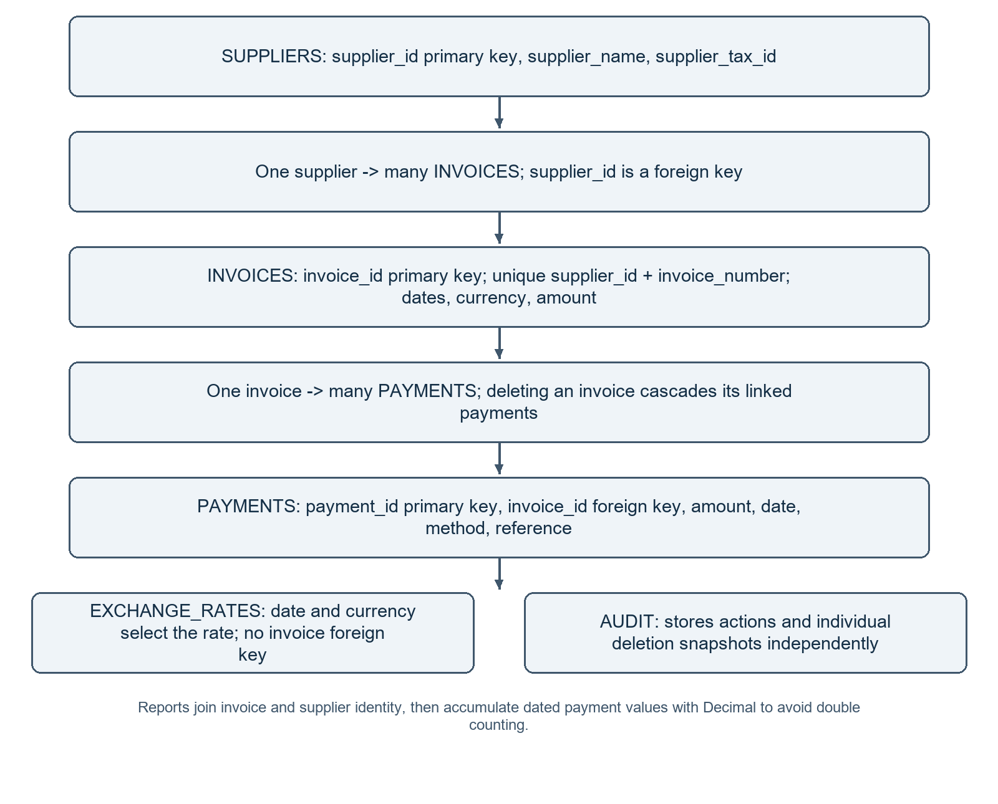
Figure 3. Core relational entities and the independent rate/audit stores.
The database is a local file under files/vendor_invoices.db. It requires no database server. Foreign-key enforcement is enabled for each connection. Deleting an invoice cascades its payments; removing a single payment leaves its invoice intact. Supplier rows without remaining invoices are removed during individual invoice deletion. Rate history is looked up by currency and effective date, not through an invoice foreign key.

9 Database fields and integrity
Table | Key fields and purpose
suppliers | supplier_id primary key; supplier_name; supplier_tax_id.
invoices | invoice_id primary key; supplier_id foreign key; invoice_number; invoice_date; invoice_due_date; invoice_submission_date; currency; amount_minor; cancelled; source_status; source_days; source_overdue; created_at; updated_at.
payments | payment_id integer primary key; invoice_id foreign key; amount_minor; payment_date; payment_method; payment_reference.
exchange_rates | rate_id integer primary key; currency; rate_date; inr_per_unit; source; created_at.
audit | audit_id integer primary key; timestamp; action; details.

Keys and transactions
A unique constraint on supplier_id and invoice_number prevents duplicate processing within the same supplier. Invoice ID remains separately unique. An invoice creation transaction may include a new supplier, an invoice, an initial payment and an audit event. If a constraint fails, the transaction rolls back so a failed invoice cannot leave an orphan supplier from that operation.

Exact storage and migration
The original implementation used integer minor units. The final implementation stores amount_minor as decimal text, retaining the existing scale: 100 for supported non-JPY currencies and 1 for JPY. This preserves previous values while allowing fractional scaled values. Application code converts stored text into Decimal and accumulates it in Python instead of using SQLite SUM, which could introduce floating-point conversion.
When an older database is opened, the repository detects INTEGER amount columns, rebuilds the affected tables in a transaction, copies their values, checks foreign-key consistency and restores enforcement. Failure rolls back the migration. The migration was tested using temporary legacy databases; monetary values and relationships remained unchanged.

Audit boundaries
Individual additions and deletions create audit records. A deleted invoice snapshot includes its linked payments. The full database-clear action intentionally removes database audit rows as well, while the external log records that clearing occurred. The audit store is a classroom traceability feature, not a tamper-proof financial archive.

10 Monetary calculations and worked examples
Result | Rule
Total paid | Sum eligible payment amounts through the selected reporting date.
Outstanding | Invoice amount minus total paid; payable balance zero when cancelled.
Unpaid | Positive invoice total and zero paid.
Partially paid | Paid amount greater than zero but below invoice total.
Paid | Paid amount exactly equals invoice total.
Overdue | Positive balance, not cancelled, and report date later than due date.
Days overdue | Maximum of zero and report date minus due date.
Paid late | For fully paid invoices, final recorded settlement date minus due date, minimum zero.
INR equivalent | Original-currency balance multiplied by applicable INR-per-unit rate.

Example A partial payment
An INR 10,000 invoice receives INR 3,000 and INR 2,000. Total paid is INR 5,000 and outstanding is INR 5,000. If the due date is 10 October and the reporting date is 15 October, it is partially paid and five days overdue. If viewed on 10 October, it is not yet overdue. Paid status and overdue state are separate dimensions.

Example B fractional source values
A JPY 135.50123 invoice receives payments of JPY 0.10001 and JPY 0.20002. Total paid is JPY 0.30003 and the remaining amount is JPY 135.20120. The entry is not rounded to whole JPY. A final payment of JPY 135.20120 settles the invoice. This behavior supports the user’s source-data requirement rather than imposing real-world cash denomination rules.

Example C INR reporting conversion
A USD 100 invoice with USD 40 paid has USD 60 outstanding. At an illustrative rate of INR 85 per USD, its reporting equivalent is INR 5,100.00. The original USD values remain unchanged. This demonstration rate is not a claim about a current exchange rate. Conversion is rounded half-up to two decimal places.

11 Payment lifecycle and reporting dates

Adding payments
The operator selects an invoice and enters only the new payment amount. The service checks that the invoice exists, is not cancelled, and has sufficient remaining balance. The payment must be positive, and its date must be no earlier than the invoice date and no later than today. Payment method and reference are retained for review. Existing payments are not overwritten.
For example, when an invoice totals 100 and 40 has been paid, the final new payment entry is 60. Entering 100 as the new payment would exceed the balance and is rejected. A correction to an incorrect payment uses deletion of that payment followed by a new entry, so the original invoice need not be recreated.

Historical report date
The report date selects invoices issued on or before that date and payments made on or before it. A payment received later must not reduce an earlier outstanding balance. The repository accumulates eligible payment values once per invoice, preventing multiple payment rows from duplicating invoice totals in a join.
Event | Balance seen in the example
1 January: USD 100 invoice issued | USD 100 outstanding.
20 January: USD 40 payment | USD 60 outstanding from this date.
31 January: invoice due | USD 60 outstanding, zero days overdue on the due date.
3 February: USD 60 payment | Fully paid; final settlement was three days late.
Report as of 31 January after all entries exist | Still shows USD 60 outstanding because February payment is excluded.

Cancellation and unavailable history
Cancelled invoices are visible but excluded from financial summaries and carry no payable balance. Cancellation is a flag rather than a dated event history. The source dataset also provides an aggregate recorded payment rather than every original transaction. Consequently, exact historical cancellation states and unprovided payment events cannot be reconstructed. A fully dated accounting ledger would need a richer event model.

Reporting versus alerts
Historical reports follow the selected date. Operational alerts independently use the PC’s current date. Selecting an old report therefore does not suppress a warning about an invoice that remains overdue today.

12 Exchange rate workflow

Defaults and online retrieval
The project includes default_rates.json containing a reference snapshot dated 21 September 2026. On launch, the application loads eligible defaults and starts a background request to the Frankfurter latest endpoint with INR as the base. The snapshot is dated fallback data, not a permanently current rate. The UI displays the latest provider date or a saved-rate fallback message when the request fails.
The endpoint returns foreign-currency units per INR. For each supported foreign currency, the application calculates INR per unit as one divided by that returned rate. It checks the base, date, presence and positivity of supported rates before insertion. The network request sends no invoice or supplier information and uses a timeout. A queue carries the payload back to the main thread for database writes and UI refresh.

Manual overrides and precedence
The manual form requires a supported currency, positive finite rate, effective date and source. INR must equal 1. Rates are appended, preserving earlier entries. Reports select the greatest effective date on or before the report date; the newest entry wins if dates match. Automatic loading skips a currency when a stored same-date or newer setting exists, preserving manual settings under that rule.
Situation | Behavior
Successful fetch with no newer eligible data | Show latest published date and Added 0; saved settings remain.
Network failure | Keep dated saved rates; allow manual entry and later retry.
Historical report without an applicable rate | Show Rate missing and an incomplete INR subtotal.
Manual rate entered for same date | Latest manual entry takes precedence over earlier entries.
Future-dated manual rate | Stored, but not selected before its effective date.

Interpretation limits
Rates are daily published references, not streaming trading quotes or the exact rate charged by a bank. Displayed rate values are shortened to six decimals, while stored values are retained for calculations. INR totals represent reporting-date equivalents, not realized exchange gains/losses, settlement fees or historical cash conversion accounting.

13 Alerts sorting and interface behavior

Overdue detection and notification
The alert helper examines today’s invoice report and includes rows with days_overdue greater than zero. It adds outstanding amounts separately for each original currency rather than combining unlike units. Its signature contains invoice ID, outstanding amount and overdue days. A different signature triggers a warning and sound, so an unchanged refresh does not repeatedly display the same popup.
Checks occur at startup and every 60 seconds while the Tkinter event loop is running. Relevant record changes also refresh alert state. The Overview message remains visible, and Open overdue invoices selects today’s reporting date, clears the search and applies the Overdue filter. Closing the application ends monitoring; there is no external scheduler, email or SMS service.

Sorting behavior
Every table heading is clickable. The first click sorts ascending; another click on the same column reverses the direction. Numeric amounts, counts, payment IDs and rates use Decimal keys. ISO dates sort chronologically as text. Names and other text use case-insensitive order. Missing numeric values remain last in either direction. Header arrows indicate the selected order, which is reapplied when records refresh.

Interface choices
UI choice | Reason
Five task-based tabs | Separate entry, review, rates and file operations without multiple programs.
Read-only tables and detail dialog | Avoid accidental changes to saved financial facts.
Currency and due date near balance/status | Help the operator interpret the amount and urgency together.
Colored paid and overdue rows | Provide a visual aid alongside explicit text labels.
Horizontal and vertical scrollbars | Keep all columns accessible when the window cannot show them at once.
Windows DPI-awareness setup | Reduce scaling mismatch on high-resolution displays.

The design is intended for a desktop screen. It is not a responsive mobile application. Sound availability depends on the operating system and device settings; the textual alert remains the primary visible signal.

14 User operating guide
Tab | Actions and expected result
Overview | Read counts, vendor totals, INR coverage and today’s overdue alert. Open overdue invoices for follow-up.
Add invoice | Enter required fields; optionally record an initial payment. Save manually or select Import CSV or Excel beside the Save button.
Invoices and payments | Search and filter; select an invoice to view details or add a payment. Inspect dated payments and use confirmed deletion for corrections.
Exchange rates | Review publication dates and sources, fetch online rates, or save a manual dated override.
Import and export | Import the supplied sample or another file, export reports, and access password-guarded database clearing.

A normal operating sequence
- Launch main.py and allow the default-rate check to finish. Review the displayed rate date before using converted totals.
- Import the supplied sample or enter a new invoice. Check the import result and issue file before assuming every row was accepted.
- Select a reporting date and refresh. Use original-currency vendor totals to inspect obligations, and INR equivalents when applicable rates exist.
- Record each additional payment separately. Confirm its amount, original currency and date, then check the new balance.
- Use the overdue view for follow-up, sort by balance or date, and export a report for the selected reporting date.

Correction discipline
Saved invoice and payment facts cannot be edited in place. Select the incorrect record, read the deletion confirmation, then add its corrected replacement. Deleting an invoice deletes every linked payment, not only those visible in a historical report. A user who only needs to fix one payment should delete that payment instead.

Export scope
The invoice and vendor exports contain all eligible report records for the chosen date. Screen search and status filters affect the table view only; they do not restrict exported rows. Choose an appropriate filename and avoid overwriting a file that is currently open in Excel.

15 Deletion and correction flow
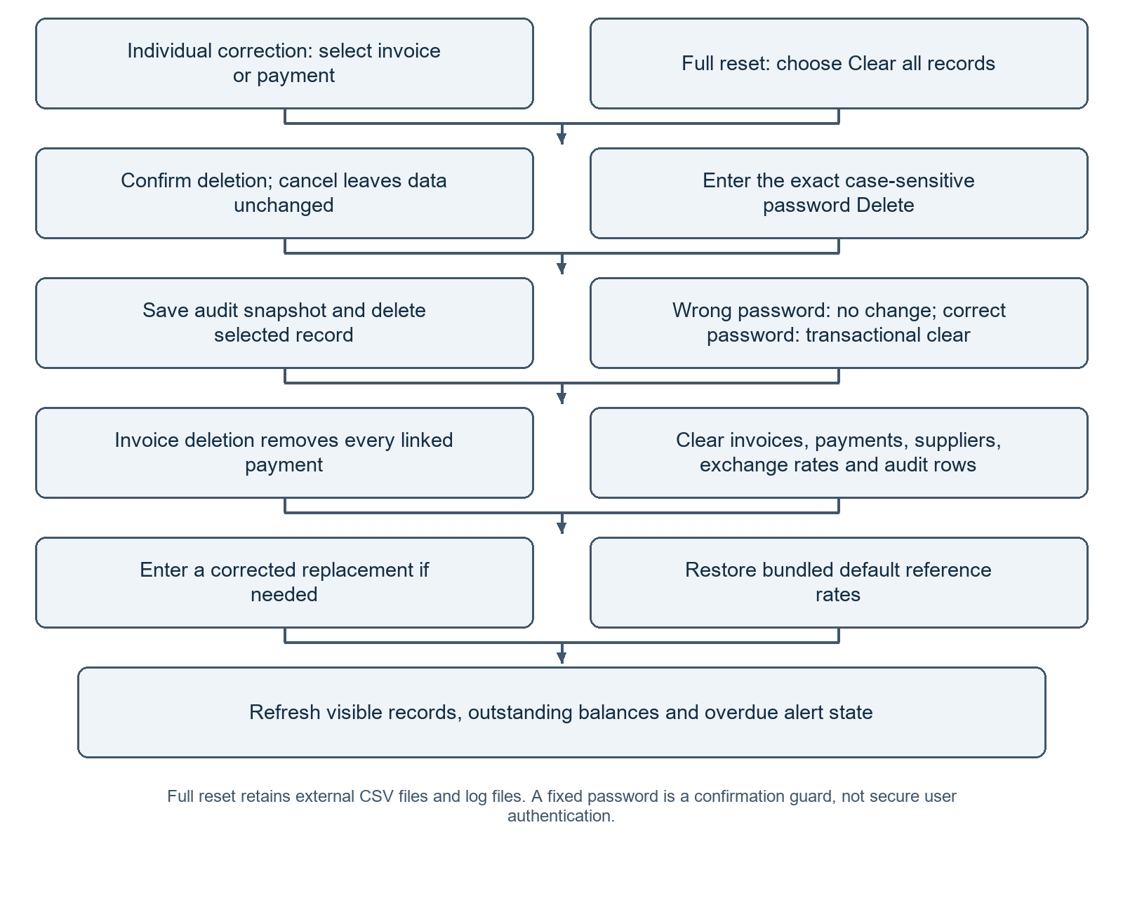
Figure 4. Individual correction and full database reset are different operations.
The full-clear password is exactly Delete, including the capital D. A cancelled dialog or wrong password leaves records untouched. Correct entry clears all five database tables in a transaction and then reloads default rates. This is an accidental-deletion guard, not an encrypted password or a security boundary. Close the app and copy vendor_invoices.db before clearing records that must be retained.

16 Installation and environment setup

Prerequisites
Use Python 3.10 or newer on Windows with Tcl/Tk support. The application was tested with Python 3.12. The standard Windows installer should include Tcl/Tk and IDLE and add Python to PATH. Reopen PowerShell after installation. SQLite is part of Python and requires no separate database server. Internet is required for installing dependencies and fetching newer rates, not for reading saved records.

Create and use a virtual environment
cd "C:\Users\NullVoid\Desktop\Cisco-pythonGenAI\Saurav_Kumar_Jaiswal"
python -m venv .venv
.\.venv\Scripts\python.exe -m pip install -r requirement.txt
.\.venv\Scripts\python.exe main.py
Adjust the folder path on another PC. If python is unavailable but the launcher is installed, use py -m venv .venv. The filename is requirement.txt, singular. The submission does not include a virtual environment; recreate it locally rather than copying one between PCs.

Optional activation and PowerShell policy
.\.venv\Scripts\Activate.ps1
python -m pip install -r requirement.txt
python main.py
If PowerShell blocks activation scripts, use the direct interpreter commands above. Alternatively, allow scripts for the current terminal session only, then activate:
Set-ExecutionPolicy -Scope Process -ExecutionPolicy Bypass
.\.venv\Scripts\Activate.ps1

Dependencies and subsequent runs
Dependency | Purpose
openpyxl >=3.1 and <4 | Read Excel XLSX input. Version 3.1.5 was used during verification.
pytest >=8 and <10 | Run tests. Version 9.1.1 was used during verification.

Tkinter, sqlite3, csv, Decimal, date/time, pathlib, logging, threading, queue, json, urllib, dataclasses, collections, re, sys and Windows ctypes are standard-library components. Do not pip-install them. On later occasions, run the same virtual-environment python.exe main.py command. Restart the app after source updates. Use deactivate when finished with an activated shell.

17 Reports logs and audit evidence

Invoice report
The invoice CSV includes invoice ID, supplier ID and name, invoice number, currency, original amount, paid amount, outstanding balance, due date, calculated status, days overdue, paid-late days, outstanding INR equivalent and reporting date. A missing applicable rate appears as text rather than a false zero. Cancelled rows remain identifiable in invoice-level output.

Vendor summary
The vendor summary contains supplier ID/name, currency, total invoiced, total paid, outstanding and overdue amount. Cancelled invoices are excluded. Values are grouped by original currency, so USD and INR are not added as if they were the same unit. The dashboard’s INR aggregate is computed separately using eligible conversion rates.

Import exception report
import_issues.csv records the input line, invoice ID, whether the row was rejected or imported with a warning, and the reason. It is written when an import has issues. A later issue-free import does not remove an older issue file. Operators should use the current dialog counts and know which input file was processed before interpreting an existing issue report.

Application log and database audit
application.log records informational operations and expected errors through Python logging. Database audit rows record additions, rate operations and individual deletion snapshots. These mechanisms support explanation and debugging but are not a secure accounting journal. Clearing the database removes its audit rows and records a clear event in the external log.

Output handling
CSV exports use UTF-8 with a BOM for common spreadsheet compatibility. Text beginning with formula-triggering characters is prefixed so opening the exported file does not execute it as a spreadsheet formula. Source invoice files are not overwritten by import. The user chooses export paths and filenames through a Save dialog.

Backup and portability
The database and routine files are resolved relative to main.py. Moving the entire project folder retains this layout. Close all application instances before copying the database for a simple backup. The system is designed for one local operator; sharing the database file through a cloud-synchronized folder is not the intended deployment model.

18 Testing strategy and results
The latest recorded functional test run completed with 40 passed. The tests are in test_main.py and use pytest fixtures with temporary databases. Fixed dates and test rates make results repeatable. Live network availability is not a dependency of the unit suite. Desktop UI checks and a provider request were performed separately during development.
Test group | Behavior verified
Balances and reporting | Partial payments, due-date boundary, historical payment filtering and no invoice double counting.
Validation | Missing/invalid fields, unsupported currency, negative/non-finite/excess-precision amounts and inconsistent source statuses.
Persistence | Unique keys, rollback, database reopening, individual payment deletion and cascading invoice deletion.
Cancellation and overpayment | Cancelled balances excluded; payments to cancelled invoices and excess payments rejected.
Rates | Historical selection, same-date overrides, missing rates, valid defaults and atomic rejection of invalid provider data.
Files | CSV partial success, Excel dates/blanks/bad rows, required headers and safe formula-like export text.
UI helpers and clearing | Numeric sorting, overdue summaries and exact password protection against unintended clearing.
Fractional amounts and migration | Exact fractional calculations for JPY/INR/USD, full 200-row import and legacy integer database migration.

Commands and representative expectations
.\.venv\Scripts\python.exe -m pytest -q
.\.venv\Scripts\python.exe -m pytest -v
A USD 100 invoice with USD 40 paid must report USD 60 outstanding. It must not be overdue on its due date, but must be overdue on the following day if unpaid. A payment after the selected reporting date must not reduce the earlier balance. A failed duplicate insert must not leave extra suppliers. A wrong clear password must leave records intact.

Evidence limits
A passing test suite supports the implemented rules, not production readiness. There has been no large-scale performance study, formal security audit or live supplier pilot. Tests of clearing and migration used temporary storage. The operational database was not cleared as part of those development checks.

19 Implementation challenges and resolutions

From static CSV status to calculated state
The dataset stores statuses from earlier dates. Reusing those labels as today’s truth would misclassify unpaid invoices. The solution preserves source labels for reference but calculates payment state from amounts and overdue state from the chosen date. Alerts use today independently. This explains why historical pending records can appear overdue in the current view.

Fractional currency values and precision
An initial currency-specific rule rejected fractional JPY. The user required all valid source amounts to be accepted, so the rule changed to up to 12 decimal places for every supported currency. Integer-only storage was then insufficient. Decimal text storage and a migration path preserved old values while supporting fractional payments. Migration tests exposed a fallback INTEGER column case; the migration replacement was corrected and the full suite passed.

Duplicate and supplier identity ambiguity
The source has names occurring under multiple supplier IDs. Automatically merging by name could join unrelated suppliers. The implementation groups by supplier ID and currency and checks consistent identity within an ID. Duplicate invoice keys are rejected rather than silently updating saved facts. This favors explicit operator review.

UI responsiveness and operating environment
A rate request on the GUI thread would pause the interface. The final design performs only the network fetch on a worker thread and uses a queue for the result. SQLite writes and widgets remain on the main thread. Windows scaling required a DPI-awareness adjustment, and table/action placement was reviewed so important controls remain accessible. PowerShell activation restrictions were addressed through direct virtual-environment interpreter commands.

Safe correction and report consistency
The user requested no in-place editing. Separate payment records make it possible to correct one payment without replacing the invoice. Individual deletion preserves an audit snapshot, while full reset has a clearly stated broader scope and exact confirmation password. Report aggregation was kept invoice-based to avoid double-counting invoice amounts when several payment rows exist.

Scope control
The original subtotal/tax idea was removed from the implemented scope because those fields are absent from the source. PDF extraction, live trading prices and actual payment processing were not added. This preserved a comprehensible Core Python project instead of implying unsupported functionality.

20 Team allocation and evaluation mapping
Participant 1 | Participant 2
Define invoice/payment models and validation rules. | Design the Tkinter tabs, forms and readable status displays.
Implement SQLite schema, queries and migration. | Implement rate selection, conversion and online refresh handling.
Implement invoice/payment operations and file import. | Implement reporting, sorting and alert summaries.
Test data integrity, duplicates and payment calculations. | Test rate behavior, reports, UI helpers and import presentation.
Review service interfaces and failure cases jointly. | Prepare report, README and demonstration jointly.

This is a suggested allocation for the two-member team, not a claim about work personally completed by an unnamed participant. Both members should understand the complete data flow, run tests, review generated code and demonstrate the result.
Evaluation dimension | Evidence in the project
Core correctness | Invoice entry, balance/status calculations and due-date rules.
OOP and data structures | Domain behavior, repository/service composition and standard collections.
Input and validation | CSV/Excel import, date and amount checks, duplicate prevention and issue reporting.
Exception handling and logging | User-facing errors, transactional rollback, application log and audit entries.
Reporting | Vendor/currency summaries, invoice reports and explicit missing-rate handling.
Testing and documentation | 40-case recorded test run, README, Word report and sample data/output.
AI-assisted development | Prompt and contribution evidence in AI_ASSISTANCE.md, with team verification responsibilities.
Demonstration | A reproducible sequence covering import, entry, payment, rates, alerts and exports.

No new percentage weights are assigned here: the source capstone document uses different weights for its different problem statements. The mapping demonstrates coverage without inventing an official grading rubric for this new project.

21 Limitations and future improvements

Current limitations
- Single-user local desktop application; no authenticated roles, shared server or encrypted user account system.
- The fixed Delete password prevents casual accidental clearing but is visible in code and is not a security boundary.
- Daily reference rates provide reporting equivalents, not guaranteed bank transaction prices, charges or FX accounting entries.
- Payments must use the invoice currency; refunds, credit notes and cross-currency settlement are not modeled.
- No subtotal/tax fields, tax-law compliance checks, scanned invoice OCR or PDF extraction.
- No background monitoring after closing the app and no automated email/SMS notifications.
- Imported aggregates cannot reconstruct missing payment history or dated cancellation events.
- Display formatting may show fewer decimals than stored amounts in some summaries; full original values remain in invoice records and reports.

Prioritized future improvements
Priority | Potential enhancement | Why it would help
First | Dated cancellation and adjustment events | Make historical reports more faithful to past invoice state.
First | Supplier selection and better import mapping | Reduce repeated identity entry and header-format errors.
Next | Automated local backups and restore workflow | Make recovery easier before destructive operations.
Next | Selected-filter export and report metadata | Match export scope to a chosen review and record exact rate provenance.
Later | Role-based multi-user architecture | Support a real team using a central service and appropriate database.
Later | OCR, tax fields and approval workflow | Extend invoice capture after foundational validation is stable.

Conclusion
The final project provides a working basis for local vendor invoice monitoring with explicit calculation rules, persistent records, useful reports and repeatable tests. Its educational value lies in connecting Python data structures, OOP, file handling, SQL, GUI events, exceptions, network access and testing into one understandable business workflow. Further production features should be added only with revised requirements and additional verification.

22 Demonstration plan and troubleshooting

Suggested demonstration sequence
- Introduce the vendor payment problem, the local-user scope and the module/class design.
- Import the 200-row sample into a clean demonstration database and explain the one non-blocking duration warning.
- Create a new invoice, add a partial payment and verify the outstanding balance manually.
- Show due dates, the overdue filter, alert behavior and ascending/descending sorting.
- Review rate dates and sources; enter a labelled demonstration override and explain INR conversion.
- Export invoice and vendor reports and explain that exports use the report date rather than screen filters.
- Delete and replace a demonstration record. Explain full-clear scope without deleting needed submission data.
- Run pytest and describe the difference between automated rule checks and manual UI review.
Symptom | Resolution
Python opens Microsoft Store | Install standard Python with PATH enabled, reopen PowerShell, or use py.
Activation script is blocked | Use the direct .venv interpreter or the process-only policy command.
openpyxl or pytest missing | Install requirement.txt with the same interpreter used to run the application.
Tkinter missing | Modify Python installation to include Tcl/Tk; pip is not the installer for this component.
Duplicate import rejection | The invoice already exists; imports intentionally do not overwrite it.
Rate missing in old report | Provide a historical rate effective on/before that report date.
Online refresh adds zero rows | Same-date/newer settings already exist and were retained.
Database locked or CSV cannot be saved | Close competing app/database sessions or the destination file in Excel.

23 References and submission inventory

Project evidence
The source modules are the authority for implementation behavior. README.md contains installation commands and detailed Mermaid diagrams. test_main.py contains the automated checks. AI_ASSISTANCE.md records the actual prompt themes, generated contributions and verification expectations. The supplied original CSV is retained unchanged.

Reference resources
Dataset: GoMask Supplier Invoice Payment Timelines — https://gomask.ai/marketplace/datasets/supplier-invoice-payment-timelines
Exchange-rate provider: Frankfurter — https://frankfurter.dev/
Current implementation endpoint — https://api.frankfurter.dev/v1/latest?base=INR
Python standard-library documentation — https://docs.python.org/3/library/
Tkinter reference — https://docs.python.org/3/library/tkinter.html
SQLite Python reference — https://docs.python.org/3/library/sqlite3.html
Decimal reference — https://docs.python.org/3/library/decimal.html
Pytest documentation — https://docs.pytest.org/
openpyxl documentation — https://openpyxl.readthedocs.io/

Submission contents
Deliverable | Location or description
Application modules | main.py, models.py, database.py, invoice_service.py, validation.py, currency.py, reports.py, csv_handler.py, ui_helpers.py and __init__.py.
Setup and testing | requirement.txt, README.md and test_main.py.
Reports and evidence | project.docx and AI_ASSISTANCE.md.
Data and outputs | files directory: source CSV, default rate JSON, saved database, log, import issues and user-exported reports.

Virtual environments, development screenshots, caches and temporary generation scripts are not part of the submission. The evaluator creates a virtual environment locally. Exported outputs reflect the reporting date and database state at the time of export; they should not be interpreted as a permanent count of all possible future records.

