1. f1 is not injective because there are (a) and (b), for example a = 1, b = -1, such that (a =/= b), and   
   (a, b ϵ Df), and f(a) = f(1) = 2 = f(-1) = f(b).   
   f1 is not surjective because if f(x) = x2 + 1 -> So, for x ϵ R - > y > 0 (x2 >= 0). Therefore, Rf = [1, +ꚙ) =/= co-Df.
2. f2 is not injective because there are (a) and (b), for example a = 1, b = -1, such that (a =/= b), and   
   (a, b ϵ Df), and f(a) = f(1) = 2 = f(-1) = f(b).   
   f2 is surjective because if f(x) = x2 + 1 -> So, for xϵ R -> y > 0. Therefore, Rf = [1, +ꚙ) = co-Df.
3. f3 is injective because if f(a) = f(b) -> a3 = b3 -> a = b.   
   f3 is surjective because if f(x) = x3 -> So, for x ϵ R -> y ϵ R. Therefore, Rf = R = co-Df.

f4 is injective because if there are (a) and (b), such that (a, b ϵ Df) and f(a) = f(b), then f(a) = 2a + 3 = f(b) = 2b + 3 -> 2a + 3 = 2b + 3 -> 2a = 2b -> a = b.   
Also, f4 is surjective because if f(x) = 2x + 3 -> So, for x ϵ R -> y ϵ R. Therefore, Rf = R = co-Df.

F5 is injective because if there are (a) and (b), such that (a =/= b), and (a, b ϵ Df), it means f(a) =/= f(b).  
Also, f5 is surjective because if f(x) = 2x + 3 -> So, for x ϵ Z - > y ϵ Z. Therefore, Rf = Z = co-Df.

1. If f(a) = f(b), ea + 1 = eb + 1 -> ea = eb -> a = b. Therefore, f(x) is injective function.
2. f(x) = ex + 1 -> So for x ϵ R -> y > 1 (ex > 0) -> Rf = (1, +ꚙ) = co-Df. Therefore, f(x) is surjective.
3. f-1(x): If y = ex + 1 -> y – 1 = ex -> x = ln(y-1) -> y-1 = ln(x – 1)
4. Graph 1

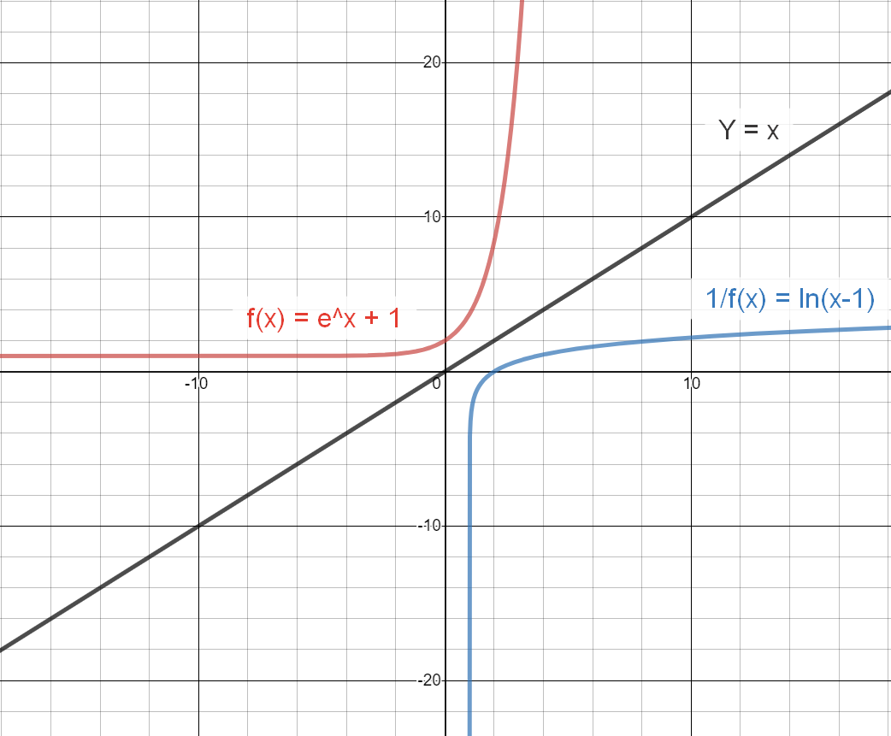

1. Curves of f(x) and f-1(x) are the same with only difference being that the roles of x and y has been reversed (they are inversed around y = x).