SLE-3: Architectural Design (Full C4 Model)
Course: 02AML204 – Introduction to Artificial Intelligence
PRN: 25UAM129
Name: Meet Shah
Division: B
Date: 04 October 2026
GitHub Link: https://github.com/meet-3826/first-repository

1. System Title & Short Description
System: 8-Puzzle Solver using BFS and A*
The 8-Puzzle Solver is a search-based AI system for a 3×3 sliding-tile puzzle. The user provides an initial puzzle configuration and selects BFS or A*. BFS explores states level by level, while A* uses Manhattan Distance to guide the search. The system reports the result, solution depth, and states explored.

2. Context Diagram (Level 1)
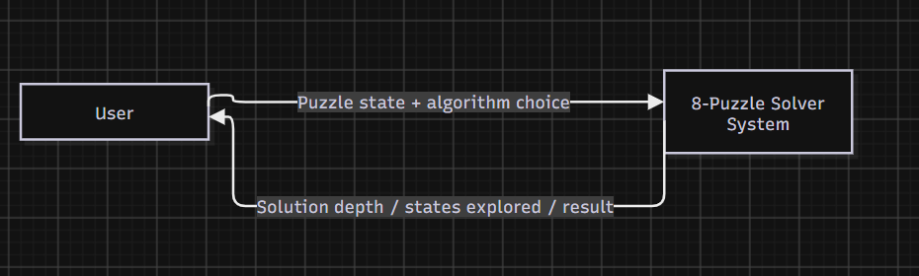
The user provides the puzzle state and algorithm choice. The solver processes the input and returns the result, solution depth, and states explored.

3. Container Diagram (Level 2)
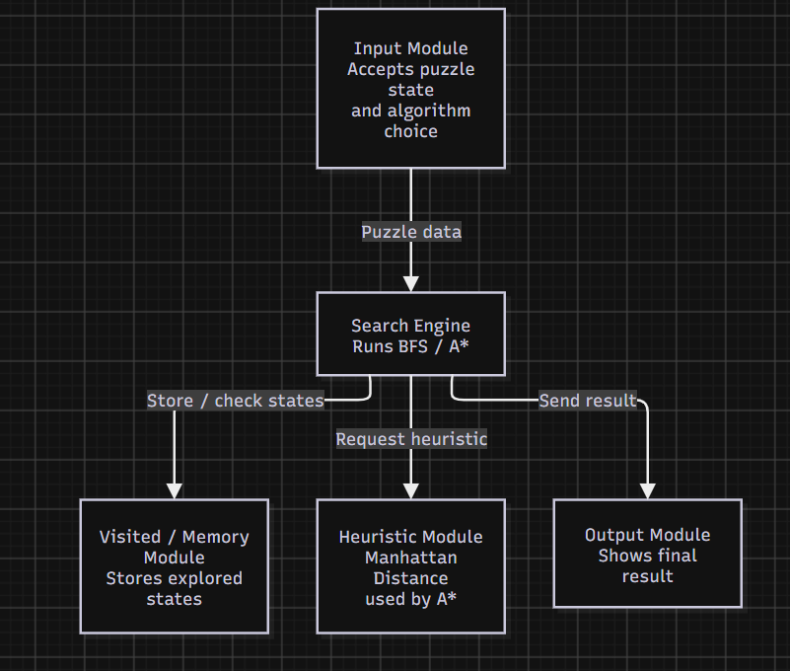
• Input Module: Accepts the puzzle state and algorithm choice.
• Search Engine: Runs BFS or A*.
• Visited / Memory Module: Stores explored states and avoids repeats.
• Heuristic Module: Calculates Manhattan Distance for A*.
• Output Module: Displays the final result.
The five modules separate input, search processing, memory, heuristic calculation, and output, making the system easier to understand and modify.

4. Component Diagram (Level 3) – Search Engine
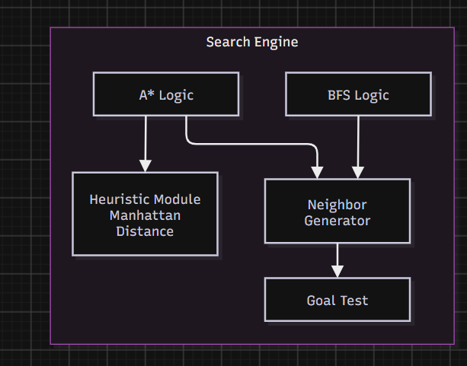
• BFS Logic: Performs Breadth-First Search.
• A* Logic: Performs A* Search using heuristic guidance.
• Neighbor Generator: Generates valid next puzzle states.
• Goal Test: Checks whether the goal state is reached.
• Heuristic Module: Uses Manhattan Distance for A*.
BFS and A* use the Neighbor Generator to create valid next states. The Goal Test checks the target state, while the Heuristic Module supports A*.

5. Code Level Overview (Level 4)
• get_neighbors() – Generates valid next puzzle states.
• bfs() – Solves the puzzle using Breadth-First Search.
• manhattan_distance() – Calculates the heuristic value used by A*.
• astar() – Solves the puzzle using A* Search.
• run_bfs() – Runs BFS and displays the result.
• run_astar() – Runs A* and displays the result.
• main() – Selects and starts the required search algorithm.

6. Design Decisions
The architecture separates input, search logic, memory, heuristic calculation, and output. BFS and A* share the same puzzle representation and neighbor-generation logic, while Manhattan Distance is separate because it is used only by A*. This modular structure makes testing and modification easier.

7. AI Contribution Note
• AI tool used: ChatGPT.
• What AI helped with: Understanding the C4 Model, organizing the architecture levels, suggesting diagram structure, and improving explanations.
• What I did myself: Used my existing 8-puzzle project, reviewed the functions, created the diagrams in draw.io, checked the architecture, and prepared the submission.

8. Conclusion
This SLE helped me understand the same system at different levels of detail. The Context level shows user interaction, the Container level shows major modules, the Component level explains the Search Engine, and the Code level connects the design to actual functions. The C4 Model makes the 8-Puzzle Solver easier to understand, explain, test, and modify.

