1. **Project Analysis**

* The main objective of this project is to provide customer’s best quality of facilities of the entire system of provide the goods products.
* The main purpose of this website is to make it interactive and its ease of use,

it would be viewing and selection of a product easier by help of gallery and

product section respectively.

* User can also view the product reviews and also write their own reviews by

helping of feedback section and also the live location of the shop with location control.

* Customer can also see the in brief detail of product and direct contact with the seller of the product by helping of the contact and also know the history of shop using about us.
* Customer detail saves securely in database of the system.

1. **Feasibility Study**

* Feasibility Analysis is the process of determination of whether of not a project is worth doing.
* Feasibility studies are undertaken within tight time constraints and normally culminate in a written and oral feasibility report.
* A feasibility study is a detailed analysis that considers all of the critical aspects of a proposed in order to determine the likelihood of it succeeding.
* A feasibility study is simply an assessment of the practically of a proposed project plan or method. The study is done in three phases
  1. Operational Feasibility
  2. Technical Feasibility
  3. Economic Feasibility

**2.1 Operational Feasibility**

* Operational feasibility is also known as behavioural feasibility due to its nature of study is basically concerned with the end-user and how he reacts or responds to the new system.
* The purpose o the operational feasibility study is to determine whether the new system will be used if it is developed and installed. And whether there will be resistance from users that will undermine the possible application benefit.
* There was no difficulty in implemented the software and proposed system is so effective, user friendly, functionally reliable so that the users in the shop will find that the new system reduces the hard steps.
  1. **Technical Feasibility**
* Technical feasibility study of online webstore covered the hardware as well as the software requirements.
* Here the targeted users of the system are the general public. It is therefore necessary to determine whether the users are able to work with our project and not at technical level.
* We believe a quick tutorial and overview of our system is enough for any of our targeted user to learn to use the system.
* The development risk considered the factors like whether the system can implement using existing technology and the design of the system can run on the real environment.
  1. **Economic Feasibility**
* The feasibility determines whether there are sufficient benefits in creating to make the cost acceptable, or is the cost of the system too high.
* The software using to develop the online dops selling system are cost efficient. HTML, CSS and PHP tools are available for free and open source.

1. **Tools Used**

**3.1 PHP**

* PHP is a server-side scripting language that is used for building dynamic, interactive websites. Today, PHP has been a real success in many aspects.
* PHP script runs on a web server. PHP stands for hypertext pre-processor.

PHP programs runs on webserver, and web pages to visitor on request.

* One of the key features of PHP that you can embed PHP code within HTML web pages, makings it’s very easy for you to create dynamic web content quickly.
* PHP is a scripting language originally designed for producing dynamic web pages. It has evolved to include a command line interface capability and can be used in standalone graphical websites.

**Common uses of PHP:**

* PHP performs system functions, i.e. from files on a system it can create, open, read, write, and close them.
* PHP can handle forms, i.e. gather data from files, save data to a file, through email you can send data, return data to the user.
* You add, delete, and modify elements within your database through PHP access cookies variables and set cookies.

**3.2 HTML**

* HTML is the standard mark-up language for creating webpages.
* HTML stands for Hyper Text Mark-up Language.
* HTML describes the structure of web pages using mark-up.
* The default character encoding in HTML is UTF-8.

**HTML Overview:**

* HTML 3.0 builds upon HTML 2.0 and provides full backwards combability.
* Tables have been one of the most requested features, with text flow around figures and math as runners up.
* The level of support is compatible with most word processing software and avoids the drawbacks from having to convert math to inline image.
* HTML is trying to get a particular effect, as well as from explicit demand for new features.

**3.3 MySQL**

* MySQL is an open-source relational database management system (RDBMS). It is the most popular database system used with PHP. MySQL is developed, distributed and supported by oracle corporation.
* MySQL is a database system that runs on a server.
* MySQL is ideal for both small and large websites.
* MySQL is very fast, reliable, and easy to use database system. It uses standard SQL.
* MySQL compiles on a number of platforms.

**Features of MySQL:**

* Storage Engines.
* Easy to use.
* It is secure.
* It is scalable.
* Speedy.
* Server Architecture.

**3.4 CSS**

* Cascading style sheets, fondly referred to as CSS, is a simply designed language intended to simplify the process of making webpages presentable. CSS allows you to apply styles to webpages. More importantly, CSS enables you to do this independent of the HTML that makes up each web page.

**3.5 JQUARY**

* jQuery is a lightweight, “write less, do more”, and java script library.
* jQuery takes a lot of common tasks that require many lines of java script code to accomplish, and wraps them into methods that you can call with a single line of code.

**Features of jQuery:**

* jQuery is a fast, small, and feature-rich java script library. It makes things like HTML document traversal and manipulation, event handling, animation, and Ajax much simpler with an easy-to-use API that works across a multitude of browsers.

1. **Data Dictionary**

**Introduction:**

* A data dictionary is a file or a set of files that contains a database’s metadata. The data dictionary contains records about other objects in the database, such as data ownership, data relationships to other objects, and other data.
* In a relational database, the metadata in the data dictionary includes the following.
* Names of all tables in the database and their owners.
* Constraints defined on tables, including primary keys, foreign key relationship to other tables, and not-null constraints.
  1. **Table Name: Login**

**Table description**: This table contains the login information of user.

|  |  |  |  |  |  |
| --- | --- | --- | --- | --- | --- |
| **Serial No** | **Col_Name** | **Datatype** | **Size** | **Constraints** | **Description** |
| 1 | Name | Varchar | 20 | Not null | Name of user |
| 2 | Id | Int | 5 | Primary key | Unique id of user |
| 3 | Phone_no | Int | 10 | Not null | Phone of user |
| 4 | Email | Varchar | 50 | Not null | Email of user |
| 5 | password | text | 16 | -- | Password of user |

* 1. **Table Name: Admin Login**

**Table description:** This table contains access of admin.

|  |  |  |  |  |  |
| --- | --- | --- | --- | --- | --- |
| **Serial No** | **Col_Name** | **Datatype** | **Size** | **Constraints** | **Description** |
| 1 | Name | Varchar | 20 | Not Null | Name of admin |
| 2 | Id | Int | 5 | Primary Key | Id of admin |
| 3 | Password | text | 16 | -- | Password of admin |

* 1. **Table Name: Product**

**Table description:** This table contains information of product like id, name

And cost.

|  |  |  |  |  |  |
| --- | --- | --- | --- | --- | --- |
| **Serial No** | **Col_Name** | **Datatype** | **Size** | **Constraints** | **Description** |
| 1 | Id | Int | 5 | Primary Key | Id of product |
| 2 | Name | Varchar | 20 | Not Null | Name of product |
| 3 | Cost | Int | 5 | Not Null | Cost of product |

* 1. **Table Name: Order**

**Table description:** This table contains information of product which customer

ordered.

|  |  |  |  |  |  |
| --- | --- | --- | --- | --- | --- |
| **SerialNo** | **Col_Name** | **Datatype** | **Size** | **Constraints** | **Description** |
| 1 | Uid | Int | 5 | Foreign Key | Id of user |
| 2 | Pro_id | Int | 5 | Foreign Key | Id of product |
| 3 | Pro_Name | Varchar | 20 | Not Null | Name of product |
| 4 | Quantity | Int | 5 | Not Null | Quantity of product |
| 5 | Cost | Int | 5 | Not Null | Cost of product |
| 6 | Total | Int | 10 | Not Null | Total amount of product ordered |
| 7 | Date-Time | Datetime | -- | Not Null | Date and time when User ordered |

* 1. **Table Name: Feedback**

**Table description:** Using this table user’s feedback can easily store.

|  |  |  |  |  |  |
| --- | --- | --- | --- | --- | --- |
| **Serial No** | **Col_Name** | **Datatype** | **Size** | **Constraints** | **Description** |
| 1 | Uid | Int | 5 | Foreign Key | Id of user |
| 2 | Uname | Varchar | 20 | Not Null | Name of user |
| 3 | Message | Text | -- | Not Null | Message from user |

* 1. **Table Name: Payment**

**Table description:** This table shows the record of payment with some user

information.

|  |  |  |  |  |  |
| --- | --- | --- | --- | --- | --- |
| **Serial_No** | **Col_Name** | **Datatype** | **Size** | **Constraints** | **Description** |
| 1 | Uid | Int | 5 | Foreign Key | Id of user |
| 2 | Pro_id | Int | 5 | Foreign Key | Id od product |
| 3 | Cost | Int | 5 | Not Null | Cost of product |
| 4 | Quantity | Int | 5 | Not Null | Quantity of product ordered |
| 5 | Total | Int | 6 | Not Null | Toal amount |
| 6 | Date-Time | Datetime | -- | Not Null | Order time-date |

1. **Data Flow Diagram (DFD)**

**5.1 Introduction:**

* A picture is worth a thousand words. A data flow diagram is traditional visual representation of the information flows within a system. A neat and clear DFD can depict good amount of the system requirements graphically.
* DFD describes the processes that are involved in a system to transfer data from the input to the file storage and reports generation. Data flow diagram can be divided into logical and physical.

**5.2 Data Flow Diagram Symbols:**

|  |  |
| --- | --- |
| **Symbol** | **Description** |
|  | **Data Flow:** Data Flow are pipelines through the packets of information flow. |
|  | **Process:** A process or task performed by the system/ |
|  | **Entity:** Entity is an object of the system. A source or destination data of a system. |
|  | **Data Store:** A place where data of the table is stored. |

** Rules for Draw DFD:**

* Process must have at least one input and an output.
* Data store must have at least one data flow in one data flow out.
* Data stored must go through a process.
* Process is a data flow diagram go to another process or a data store.

**5.2.1 Context Level DFD 0 Level**

* The context level data flow diagram is describing the whole system.
* The (0) level DFD describe the all-user module who used the system.
* Below data flow diagram of online selling diamond dops shows the user gives request for dops order and admin gives the confirmation of dops order and shows the whole process.

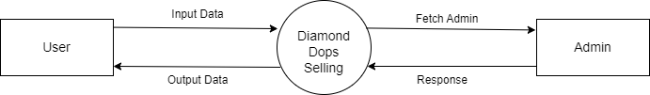

**5.2.2 Admin 1 level DFD**

* Admin zero level DFD shows for the when admin want to update their website or want to some changes in their website at that time admin can login into website threw their name, username and password.

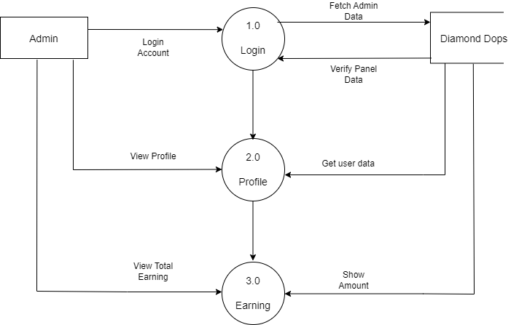

**5.2.3 First Level DFD**

* Here, in 1st level DFD user must need to login for giving the order at that time user must fill up detail of login page and this detail is stored in login database.

After the process of login user can giving the order of product in which they are interested also the user selection of product is stored in product order database.

* User can give the feedback of their experience about website and their feedback also stored in database. Payment details is also stored in database.

