**Project:** Hash_Cracker — A Python-based Password Hash Analysis & Cracking Tool

**Student / Intern:** Meet Pandit

**Internship:** [Inlighn Tech]

**Abstract**

Hash_Cracker is a Python-based tool designed to demonstrate password hash analysis and controlled brute-force / dictionary-based cracking techniques for educational and defensive security testing. The project emphasizes responsible use, shows how attackers may recover weak passwords, and demonstrates how to harden password storage using modern key-derivation functions. The tool is intended for lab/educational environments only.

**Objective:**

The objective of this project is to develop a Python-based tool that attempts to crack hashed passwords using either a wordlist or brute-force techniques. This project will help students understand cryptographic hash functions, password security vulnerabilities, and multi-threading in Python.

**Project Overview:**

Passwords stored as hashes are commonly used in authentication systems. This project demonstrates how attackers attempt to break hashed passwords using dictionary attacks and brute-force methods. The script allows users to input a hash, specify a hash algorithm (e.g., MD5, SHA-256), and choose between using a wordlist or generating passwords dynamically.

**How the Project Works:**

* **Input Handling: The user provides a hashed password, hash type, and optional parameters such as a wordlist or password length range.**
* **Dictionary Attack: If a wordlist is provided, the script reads it and checks if any word matches the target hash.**
* **Brute Force Attack: If no wordlist is used, the script generates password combinations using letters, digits, or custom character sets.**
* **Hash Matching: The script hashes each password attempt and compares it with the target hash.**
* **Multi-threading: The script utilizes multiple threads to speed up the cracking process.**
* **Output Result: If a match is found, the cracked password is displayed; otherwise, the script reports failure.**

**Key Concepts Covered:**

● Cryptographic hash functions (MD5, SHA-1, SHA-256, etc.)

● Dictionary attacks and brute-force techniques

● Multi-threading for performance optimization

● Handling command-line arguments in Python

● Using external libraries like hashlib and itertools

* **Step-by-Step Implementation:**

1. Install required Python libraries if not already installed.

2. Create a Python script that accepts command-line inputs for hash, hash type, and optional parameters.

3. Implement a function to check if a generated password matches the target hash.

4. Implement the dictionary attack by reading words from a given wordlist.

5. Implement the brute-force attack to generate passwords within a specified length range.

6. Utilize multi-threading to accelerate password attempts.

7. Display the cracked password if found, or a failure message if not.

**OUTPUT**

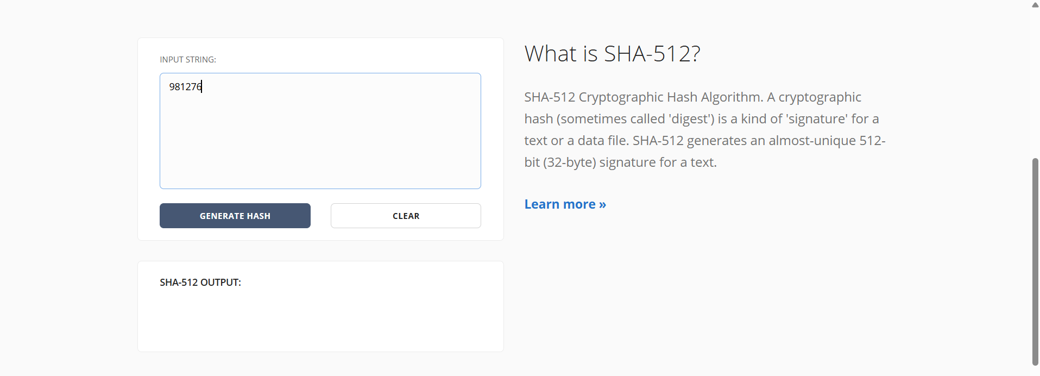

Open SHA512.online website to create hash value

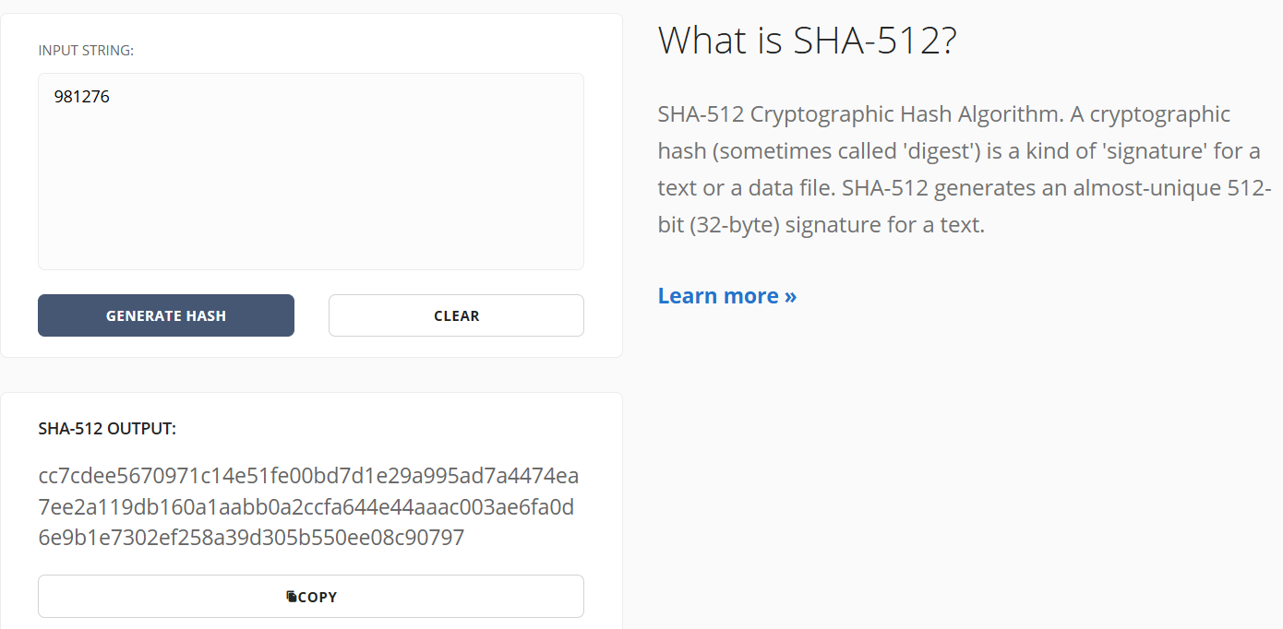

Create hash value for that number

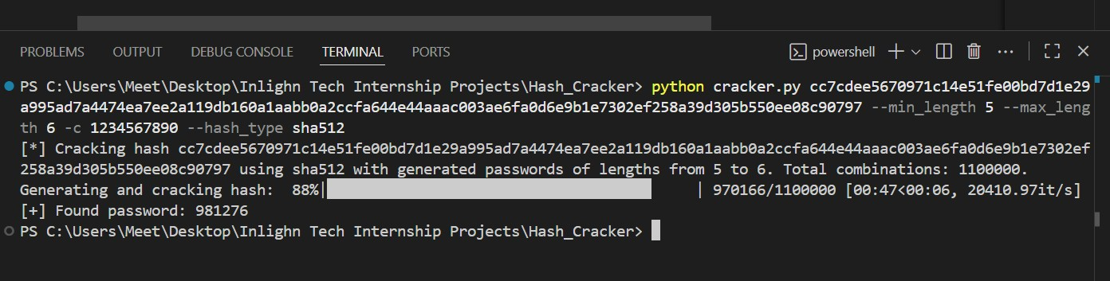

Successfully Hash value is cracked