**USE CASE STUDY REPORT**

**Group No**.: Group 6

**Student Names**: Meet Vasani and Harshil Modi

**Executive Summary:**

Every college candidate wants to explore every possible corners of their interests and they actually need something which can actually guide them so that they can gain as much, a college has numerous resources available which are available for the students use, but students miss out as there is so much of information available, they get confused. A recommendation system is to be built to give students multiple options based on their needs and interests, with this students can also connect with new fellows who does have similar thinking and can have different views and perspectives. With that, recommendations are as follows.

**LIBBRAIN**: Based on the genre selected by the student while entering the application, the system will recommend book names to the students and their ratings.

**CLUBCONNECT**: Based on the interests and likings, the system will recommend different clubs, timing and description where in students can join and connect with new students and listen about various views and perspectives.

**CHILLZONE**: Based on the games a student is interested in, the system will recommend them the games which are available at the university, also the location where the setup of that particular game is available at the campus.

**JIM**: Based on the interests of a particular candidate, like which workouts students like, recommendations of exercises will be provided and which equipment are available.

**FUNFOODS**: Food recommendations based on the likes of student personal preferences, where to find particular delicacies, on and off campus both.

1. **Introduction**

In United States itself, there are more than 5000 universities, which does pack a lot of students. Each and every students has a different background, some of them are international students and some of them are natives. There are multiple interests which a student hold and want to get involve in the things except academic work. There are resources available online which can fulfil the needs of students with the information they want for particular tasks. But the Internet has a lot of information and sometimes students do miss out the particular aspects they are looking for. University websites do have some content which do support but are not particular on the things which the students are looking for.

We combined all the aspects and information, any students crave for and made a single substitute which serves everything. Let us suppose a student wants to try out any particular cuisine in a particular area, they can find that out easily, a student can also access which books are available in the library with all the possible genres and the location of each library, a student can access various different clubs which are there on campus and see which of them serves which type of purpose, all the details are provided under one hood, so that a student will not have a hard time searching out for the information.

This makes the daily routine of students much easier, especially for the international students who just came here and are adjusting with all the new environment around. Everything around is new to them and are not able to cope up with the extracurricular which indirectly affect their focus and state of mind. With this concept every bit of information is accessible to them at every instant and makes everything much easier to sustain.

1. **Conceptual Data Modelling**
2. EER Diagram

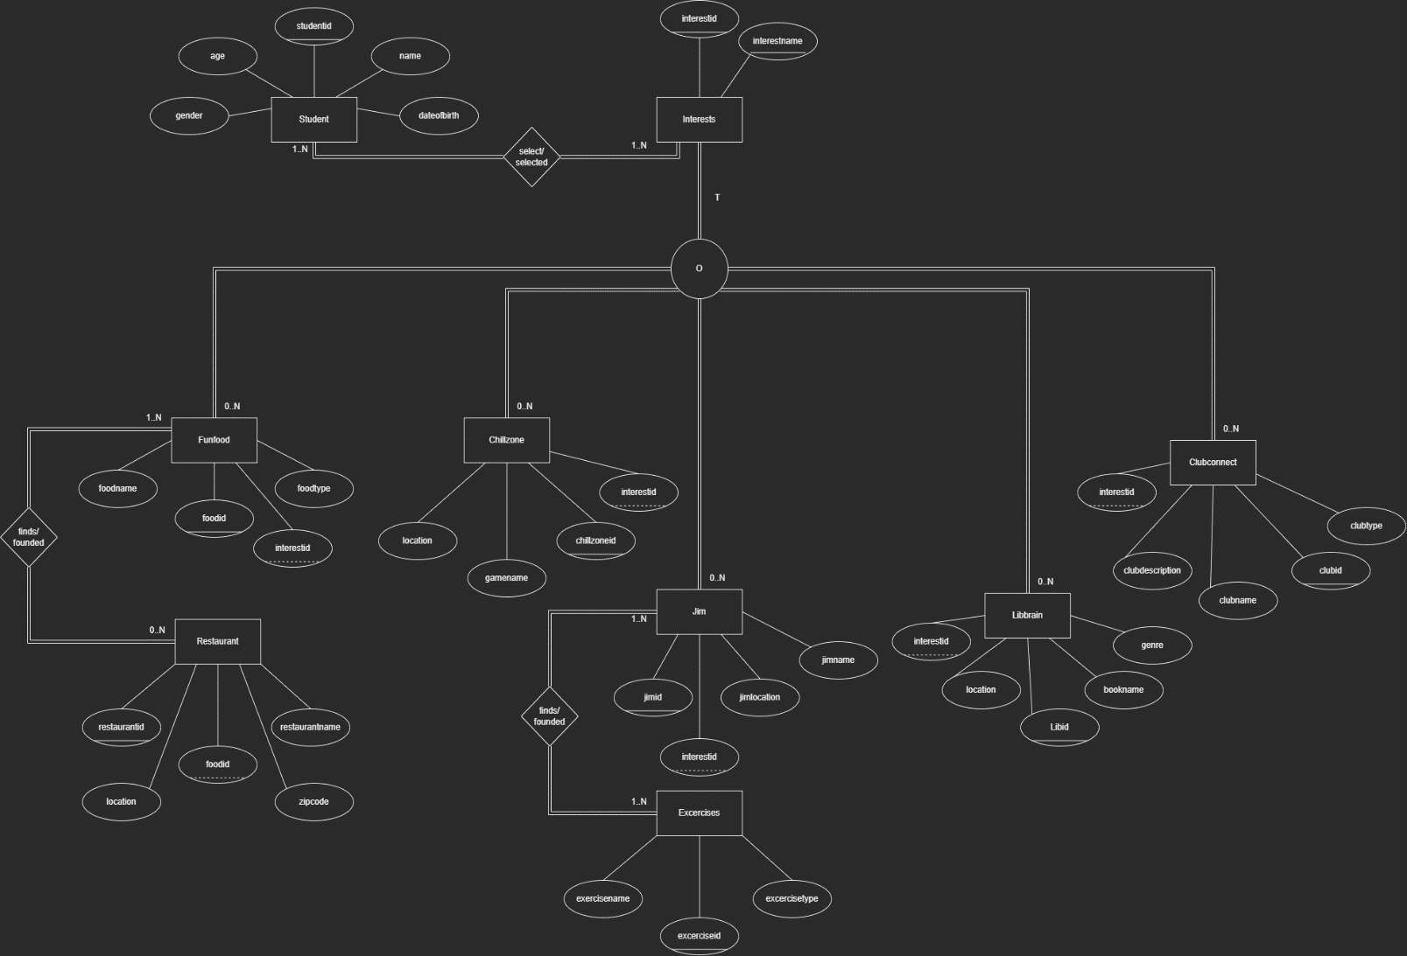

1. UML Diagram

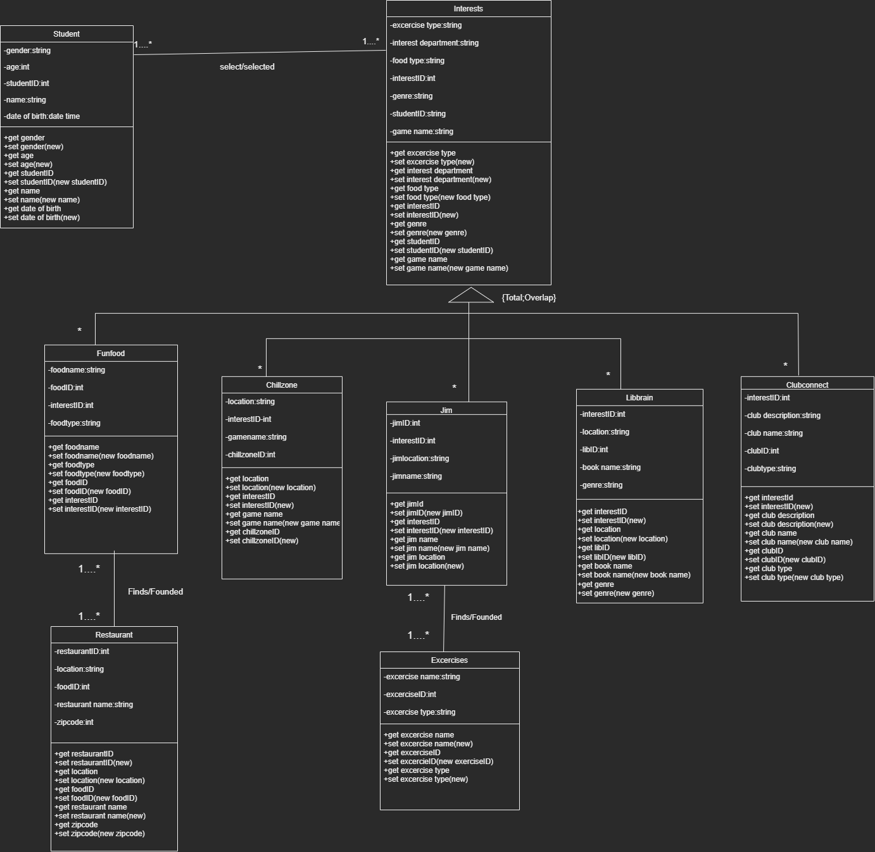

1. **Mapping Conceptual model to Relational Model**

**Primary Key – Underlined**

**Foreign Key – Dotted Line**

* Student (studentid, name, age, gender, dateofbirth)
* Selects_Interest (studentid, interestid)
* Interests (interestid, interestname)
* Funfood (foodid, studentid, interestid, foodtype, foodname)
* Funfoodfinds (foodid, restaurantid)
* Restaurant (restaurantid, foodid, restaurantname, location, zipcode)
* Chillzone (chillzoneid, studentid, interestid, gamename, location)
* Jim (jimid, interestid, studentid, jimlocation, jimname)
* Jimfinds (jimid, excerciseid)
* Excercises (excerciseid, jimid, excercisename, excercisetype)
* Libbrain (libid, interestid, studentid, location, bookname, genre)
* Clubconnect (clubid, studentid, interestid, clubname, clubdescription, clubtype)

1. **Implementation of Relational Model via MySQL and NoSQL**

**MySQL Implementation:**

The data was manually inserted into an Excel file and then was imported to MySQL through building the schema and following Queries were performed:

**Query 1: Fetching all the exercisetype which have more than 3 excercises.**

SELECT excercisetype

FROM madeezy.excercise

GROUP BY excercisetype

HAVING COUNT (excercisetype) > 3**;**

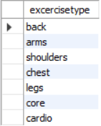

**Query 2: Fetching all the restaurants with its location and various foodname.**

SELECT f.foodname, r.restaurantname, r.location

FROM madeezy.food AS f

INNER JOIN madeezy.food_restaurant AS fr

ON f.foodid = fr.foodid

INNER JOIN madeezy.restaurant as r

ON fr.restaurantid = r.restaurantid;

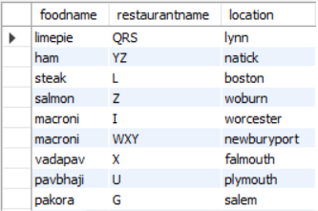

**Query 3: Fetching all the exercise of “cardio” with jimname and location.**

SELECT excercisename, excercisetype, jimname, jimlocation

FROM madeezy.jim as j

INNER JOIN madeezy.jim_excercise as je

ON j.jimid = je.jimid

INNER JOIN madeezy.excercise as e

ON je.excerciseid = e.excerciseid

WHERE excercisetype = "cardio";

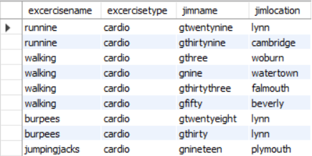

**Query 4: Fetching club name having clubtype = “literature”.**

SELECT clubtype, clubname

FROM madeezy.clubconnect

WHERE clubid IN (

SELECT clubid

FROM madeezy.clubconnect

WHERE clubtype = "literature");

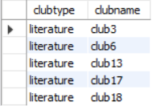

**Query 5: Fetching all the restaurantname with zipcode 2116, 2117, 2118.**

SELECT restaurantname, location

FROM madeezy.restaurant

WHERE EXISTS (

SELECT restaurantname

FROM madeezy.restaurant

WHERE zipcode IN ('2116', '2117', '2118'));

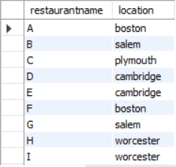

**Query 6: Fetching student details whose age is below 25.**

SELECT studentid, name, age, gender

FROM madeezy.student

WHERE age <= ANY (

SELECT age

FROM madeezy.student

WHERE age <= 25);

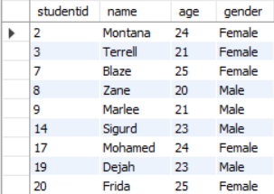

**Query 7: Fetching all the chillzoneid except the highest one.**

SELECT chillzoneid, gamename, location

FROM madeezy.chillzone

WHERE chillzoneid < ANY (

SELECT chillzoneid

FROM madeezy.chillzone

ORDER BY chillzoneid DESC)

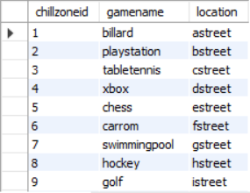

**NoSQL Implementation:**

**Query 1: Fetching Students who are Female and are less than 25 years old**

db.students.find( {gender: “Female”, age: {$lt:25}} ).pretty()

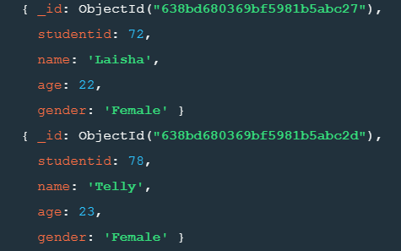

**Query 2: Finding average age of all the gender which are available**

db.students.aggregrate( [ { $group: { _id: “$gender”, total: { $avg: “$age} } } ] )

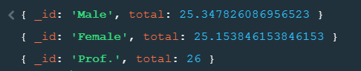

1. **Database Access via Python**

**Graph 1: Comparing Interest with age of students**

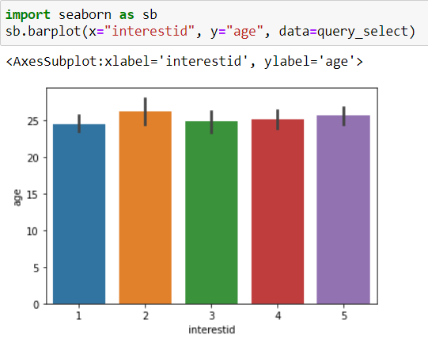

**Graph 2: Getting Food at different location**

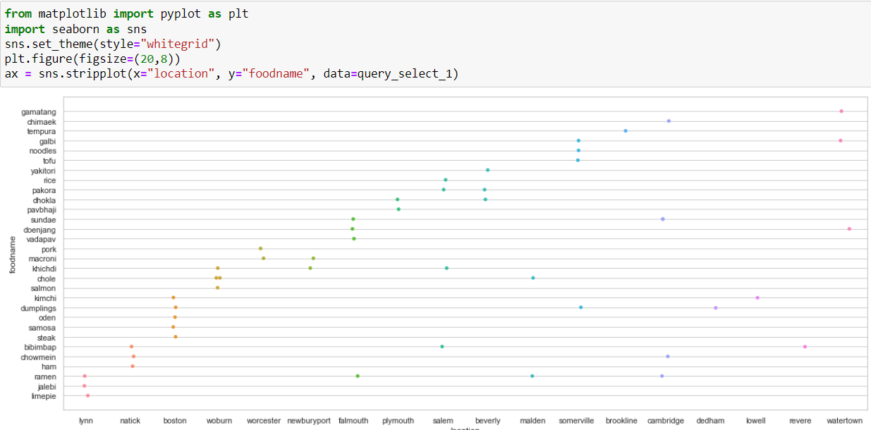

**Graph 3: No. of Genres in the Library**

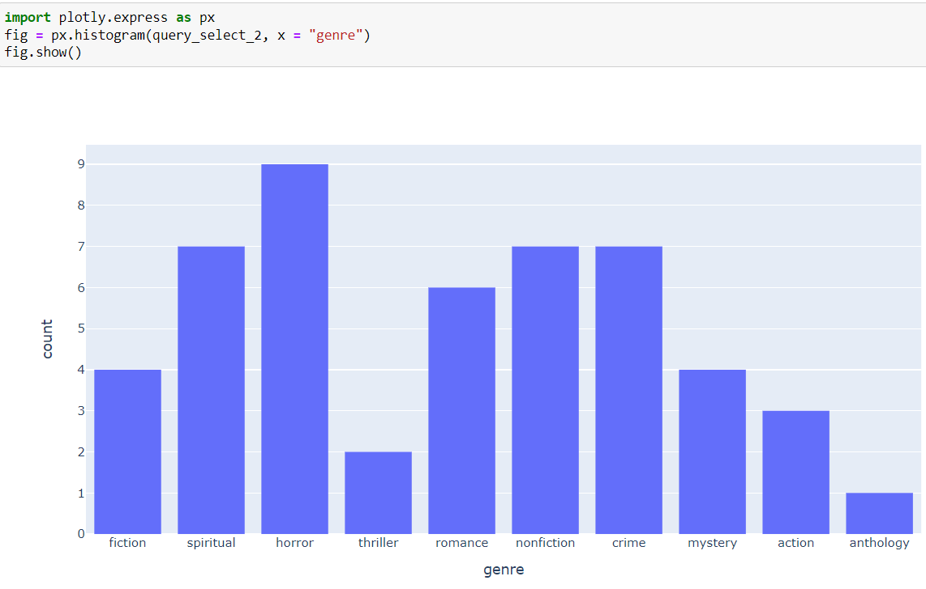

**Graph 4: Exercise in gym particularly for Cardio sessions**

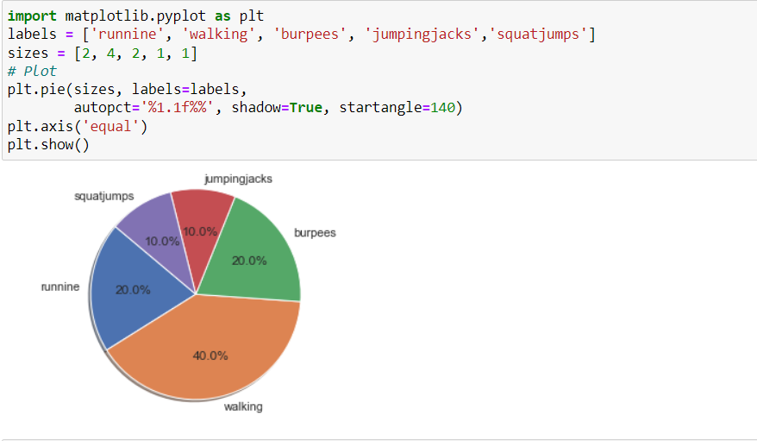

**Graph 5: Finding students and their age who does have same interests**

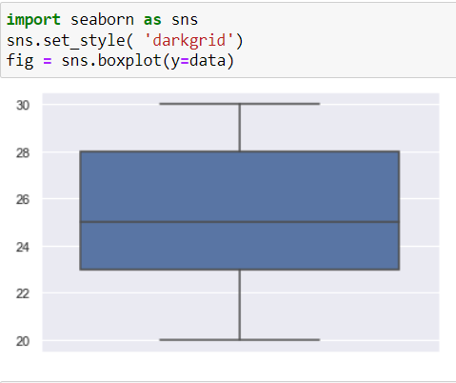

1. **Summary and Recommendation**

This concept can be implemented in all universities across the globe and this will one or the other way benefit the students who are struggling right now to get that proper guidance and direction they need. This is a basic concept right now and can be taken to a whole another level by adding more and more attributes and other areas where the students find it struggling, this will make the backend more and more complex but will take whole educational industry to another level.

Front end can be developed to make it more interactive and lively. The Database is too short right now and can be extended further. With all the front end being generated there will be live tracking of data, which in the longer run can be used for Data Analysis and Insights.