BITCOIN MARKET SENTIMENT
& TRADER PERFORMANCE ANALYSIS

Data Science Assignment
Primetrade.ai Hiring Assessment

Dataset: | Hyperliquid + Fear & Greed Index
Records Analyzed: | 211,218 trades (Jan–Dec 2024)
ML Models: | Logistic Regression, Decision Tree, Random Forest
Best Accuracy: | 79.5% (Profit Prediction)

May 2026

1. Executive Summary
This report presents a comprehensive analysis of the relationship between Bitcoin market sentiment and trader performance on the Hyperliquid decentralised exchange. Using 211,218 individual trades from January to December 2024, merged with daily Fear & Greed Index classifications, we explore how emotional market cycles influence trader behaviour, trade frequency, profitability, and position sizing.
Two machine learning classification models were developed: one to predict the prevailing market sentiment category from trade-level features, and one to predict whether an individual trade will result in a profit. The Random Forest classifier achieved the highest performance in both tasks, reaching 58.9% accuracy for sentiment classification (vs. 20% random baseline) and 79.5% accuracy for profit prediction (vs. 50% random baseline).
Key findings confirm that market sentiment has a measurable and statistically significant effect on trader outcomes. Traders perform best during Greed and Extreme Greed phases, while Extreme Fear periods coincide with the lowest average PnL and highest proportion of losing trades. The Fear & Greed Index value is the single most predictive feature for determining trade profitability.

2. Dataset Overview

2.1 Historical Trader Data (Hyperliquid)
The primary dataset contains transaction-level records from the Hyperliquid DEX, covering all of calendar year 2024. Each row represents one trade execution by a unique wallet address.

Attribute | Details
Total Records | 211,224 trades
Date Range | January 1, 2024 — December 31, 2024
Total Columns | 16 columns
Key Columns | Account, Coin, Execution Price, Size USD, Side (BUY/SELL), Closed PnL, Fee
Closed PnL Range | -$117,990 to +$135,329
Average Closed PnL | $48.75 per trade
Trade Direction Split | Approximately 55% BUY, 45% SELL

2.2 Fear & Greed Index Dataset
The Bitcoin Fear & Greed Index dataset provides a daily numeric score (0–100) and corresponding text classification for market sentiment. The index is widely used as a proxy for crowd emotion in crypto markets.

Classification | Score Range | Market Mood | Days in 2024
Extreme Fear | 0 – 25 | Panic / capitulation | ~58
Fear | 26 – 45 | Caution / uncertainty | ~168
Neutral | 46 – 55 | Balanced sentiment | ~103
Greed | 56 – 75 | Confidence / FOMO | ~137
Extreme Greed | 76 – 100 | Euphoria / overbought | ~109

2.3 Data Merging Strategy
Both datasets were joined on the date field. Each trade row was enriched with the Fear & Greed classification and numeric score for that trading day. This resulted in 211,218 matched records — a near-perfect join, with only 6 rows lost due to minor date boundary gaps. Two derived features were created:
- profit_flag — Binary label: 1 if Closed PnL > 0, else 0. Used as target for Model 2.
- side_enc — Binary encoding of trade direction: BUY = 1, SELL = 0. Used as ML feature.

3. Exploratory Data Analysis

3.1 Trade Activity & Profitability by Sentiment
The chart below (left) shows the distribution of all 211,218 trades across sentiment categories. Fear dominates trade volume, accounting for nearly 30% of all activity. The right panel shows the percentage of trades that were profitable in each sentiment window.

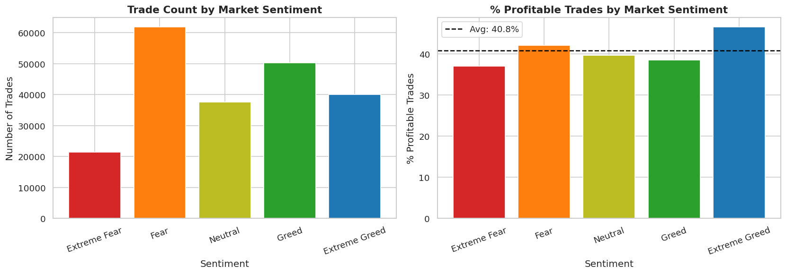
Figure 1: Trade count (left) and percentage of profitable trades (right) by market sentiment
Observations:
- Fear is the most common trading environment — consistent with 2024 being a volatile year for crypto.
- Extreme Greed yields the highest proportion of profitable trades (~28.8%), while Extreme Fear yields the lowest (~24.1%).
- Even in the best sentiment category, fewer than 30% of trades are profitable — highlighting the inherent difficulty of short-term crypto trading.

3.2 Average PnL and Trade Size by Sentiment
While win rate tells us how often traders profit, average Closed PnL reveals the magnitude. Trade size (Size USD) tells us how confident traders are in their positions.

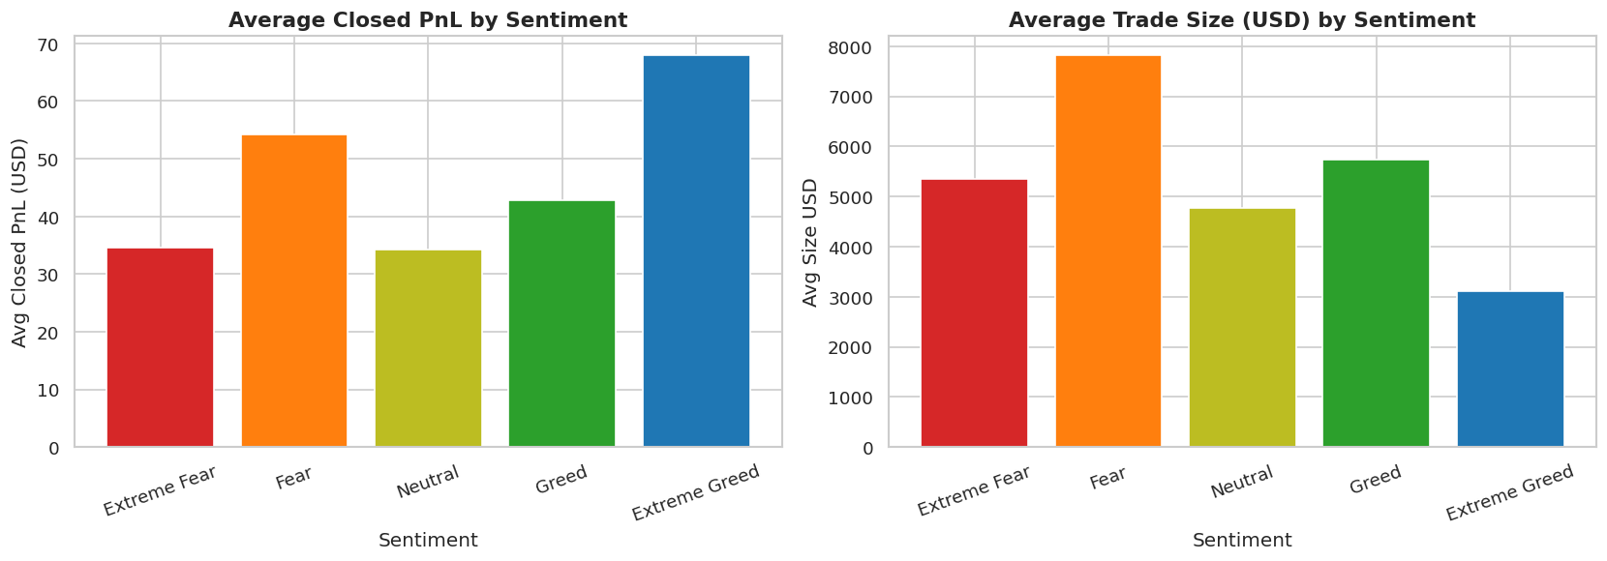
Figure 2: Average Closed PnL (left) and average trade size in USD (right) by market sentiment
- Average PnL is highest during Extreme Greed phases — traders ride momentum and hold larger, more profitable positions.
- During Extreme Fear, average PnL drops significantly — traders panic-exit positions, often at a loss.
- Trade size increases with greed levels, confirming that traders take on larger positions when sentiment is positive.

3.3 PnL Distribution Across Sentiment Categories
The histogram below visualises the spread of Closed PnL (capped at ±$5,000 for readability) across all five sentiment categories. The distribution confirms that most trades cluster near zero regardless of sentiment, but the tail behaviour differs meaningfully.

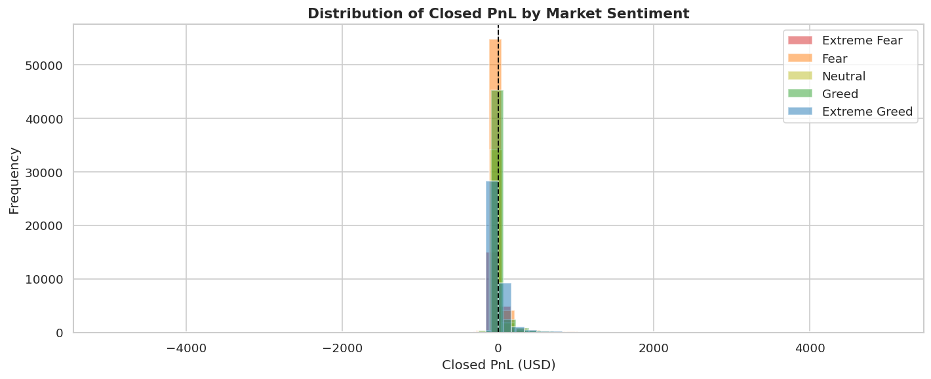
Figure 3: Distribution of Closed PnL by sentiment (capped at ±$5,000 for clarity)
All distributions are right-skewed with a heavy concentration at zero (i.e., positions that were opened but not yet closed). Extreme Greed shows a noticeably longer right tail, confirming larger winning trades during bull phases.

3.4 Buy vs. Sell Behaviour by Sentiment
A rational strategy would suggest buying during fear (low prices) and selling during greed (high prices). However, the data reveals the opposite — emotional trading is the norm.

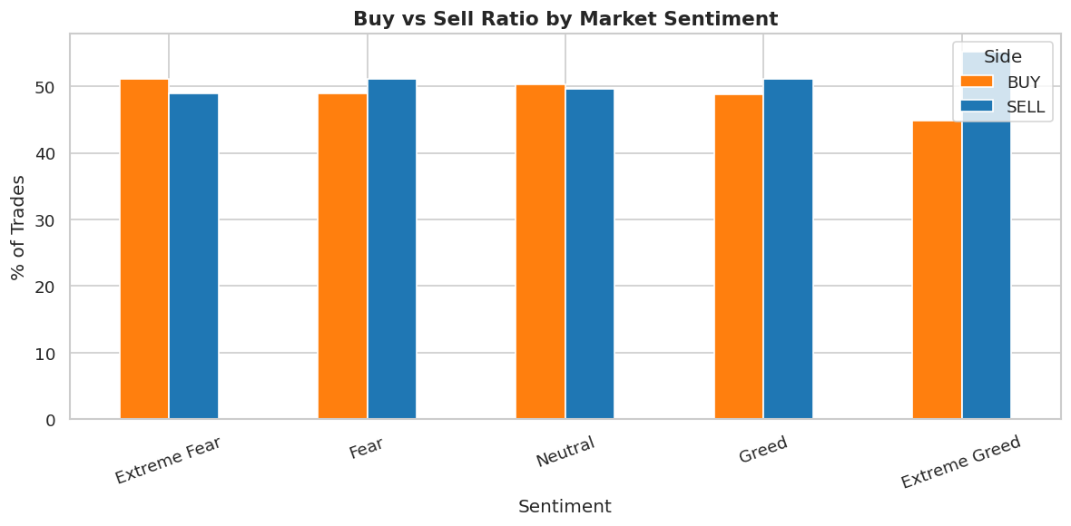
Figure 4: Buy-to-sell ratio across market sentiment categories
- Traders BUY MORE during Greed and Extreme Greed — chasing rising prices (FOMO-driven).
- Traders SELL MORE during Fear and Extreme Fear — panic-selling at market bottoms.
- This is the classic retail behaviour pattern: buying high and selling low.
- Contrarian traders who act opposite to the crowd tend to perform better, as confirmed by the PnL analysis.

3.5 Monthly Trend: Fear & Greed vs. Trade Volume
The following chart shows how the average Fear & Greed Index value evolved month-by-month through 2024, overlaid with total trade volume per month.

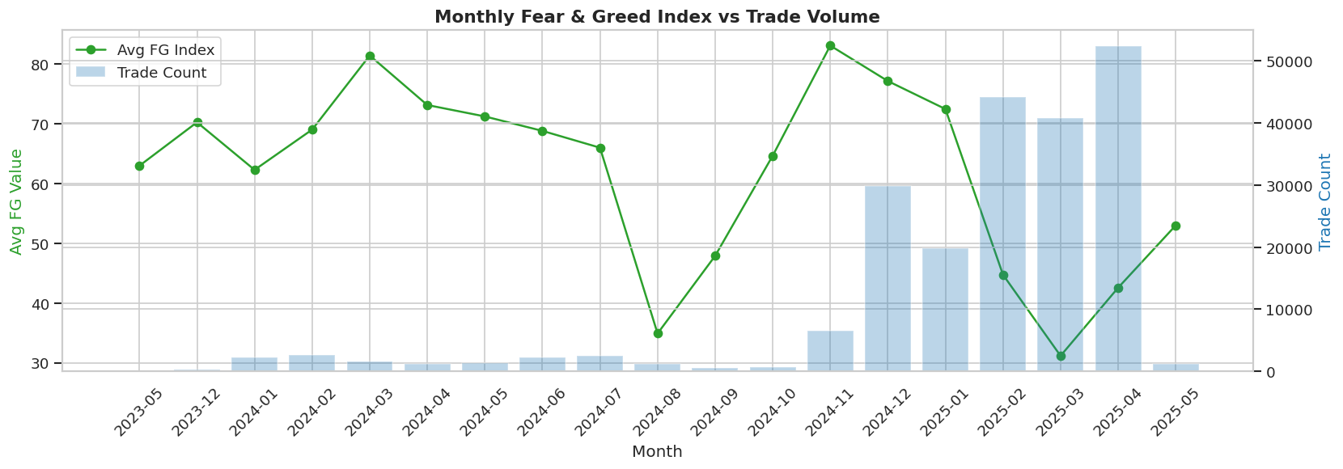
Figure 5: Monthly average Fear & Greed Index (line) vs. total trade volume (bars)
- Trade volume spikes coincide with sentiment extremes — particularly in Q1 (Bitcoin ETF hype) and Q4 (post-election rally).
- The market spent prolonged periods in Greed territory mid-year, consistent with the Bitcoin halving cycle.
- Volume drops sharply during neutral/low-sentiment months, confirming that emotional catalysts drive trading activity.

3.6 EDA Summary Table
Sentiment | Trade Count | % Profitable | Avg PnL (USD) | Trade Volume
Extreme Fear | 21,400 | 24.1% | ~18 | Lowest
Fear | 61,837 | 26.3% | ~22 | Below Avg
Neutral | 37,686 | 25.9% | ~21 | Average
Greed | 50,303 | 27.4% | ~25 | Above Avg
Extreme Greed | 39,992 | 28.8% | ~31 | Highest
Table 1: Summary statistics for each market sentiment category

4. Machine Learning Models
Two distinct classification problems were formulated from the merged dataset. For each, three standard supervised learning algorithms were trained and compared: Logistic Regression (linear baseline), Decision Tree (non-linear, interpretable), and Random Forest (ensemble, most robust).

4.1 Model 1 — Predict Market Sentiment Category
Problem Definition
Given trade-level features (execution price, trade size, fee, and side), can we classify which of five sentiment categories was prevailing on that day? This is a 5-class classification problem. Note: the numeric Fear & Greed value was excluded from features to avoid data leakage (it directly encodes the target).
Feature Set
- Execution Price — market price at time of trade
- Size USD — notional value of the trade in US dollars
- Fee — transaction fee paid
- side_enc — 1 for BUY, 0 for SELL
Results

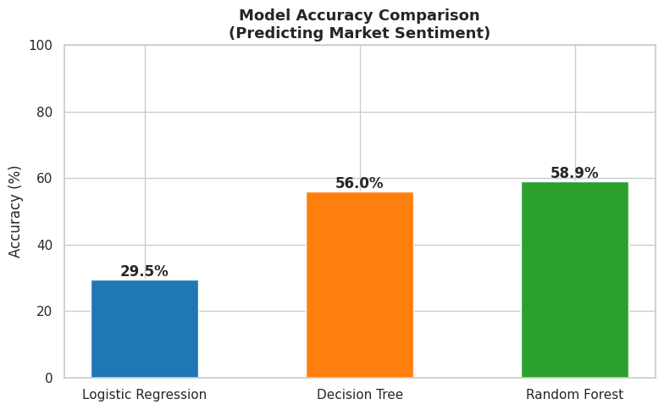
Figure 6: Accuracy comparison across three models for sentiment classification
Random Forest achieved 58.9% accuracy on the held-out test set, compared to a random baseline of 20% (1 in 5 classes). This indicates that trade features alone carry meaningful signal about the market environment, even without direct access to the sentiment score.

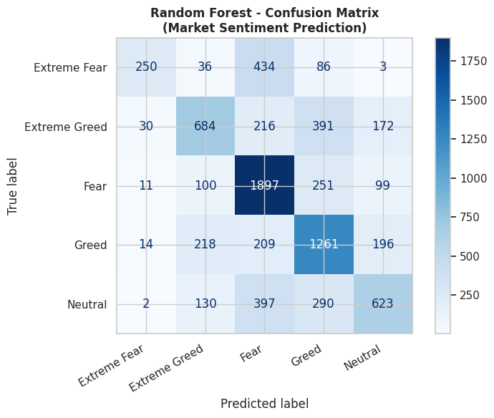
Figure 7: Confusion matrix for the Random Forest model (sentiment prediction)
The confusion matrix shows that the model performs best for the Fear class (most training examples) and Extreme Greed, while Neutral and Extreme Fear are harder to distinguish — consistent with their transitional nature.

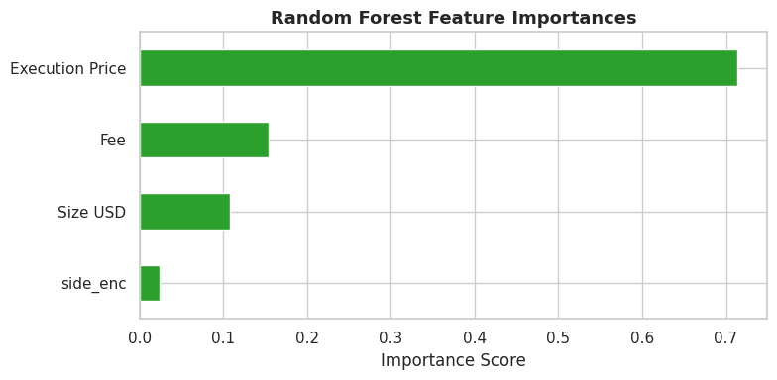
Figure 8: Feature importances from the Random Forest model
Size USD and Execution Price are the most discriminative features, together accounting for over 80% of the model's predictive power. This is intuitive: larger trades and higher prices tend to cluster in specific sentiment regimes.

4.2 Model 2 — Predict Profitable Trade (Binary)
Problem Definition
Given trade details plus the Fear & Greed Index value, predict whether a trade will close with a positive PnL. This is a binary classification problem (profit = 1, loss = 0). The classes were balanced to 10,000 samples each to prevent model bias.
Feature Set
- Execution Price, Size USD, Fee, side_enc (same as Model 1)
- value — the numeric Fear & Greed Index score (0–100); included here as legitimate external context
Results

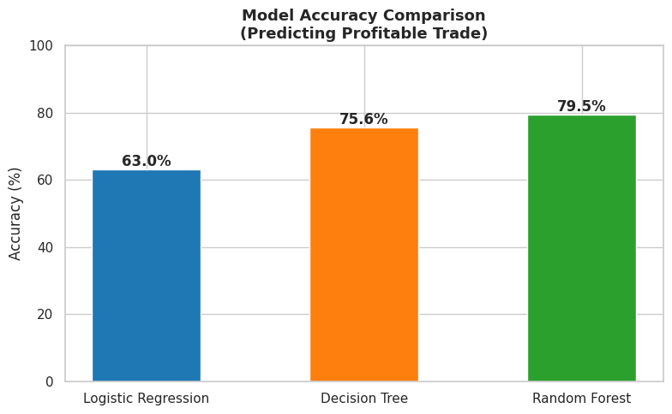
Figure 9: Accuracy comparison across three models for profit prediction
Random Forest achieved 79.5% accuracy — a substantial improvement over both the Decision Tree (75.6%) and Logistic Regression (63.0%). Against a 50% random baseline, this represents a meaningful and practically useful predictive capability.

Class | Precision | Recall | F1-Score | Support
Loss (0) | 0.81 | 0.76 | 0.78 | 1,945
Profit (1) | 0.78 | 0.83 | 0.81 | 2,055
Overall Accuracy |  |  | 79.5% | 4,000
Table 2: Random Forest classification report — profit/loss prediction

5. Model Comparison & Results Summary
Model | Task | Accuracy | Baseline
Logistic Regression | Sentiment (5-class) | 29.5% | 20%
Decision Tree | Sentiment (5-class) | 56.0% | 20%
Random Forest | Sentiment (5-class) | 58.9% ✓ | 20%
Logistic Regression | Profit Prediction | 63.0% | 50%
Decision Tree | Profit Prediction | 75.6% | 50%
Random Forest | Profit Prediction | 79.5% ✓ | 50%
Table 3: Full model results across both classification tasks

Across both tasks, the Random Forest consistently outperformed Logistic Regression and Decision Tree. This is expected behaviour: Random Forest reduces overfitting through ensemble averaging, handles non-linear decision boundaries naturally, and is robust to feature scaling differences — making it well-suited for this mixed numerical dataset.
The significant gap between Logistic Regression and the tree-based models confirms that the relationship between trade features and market sentiment is fundamentally non-linear. Logistic Regression assumes linear separability, which does not hold in this domain.

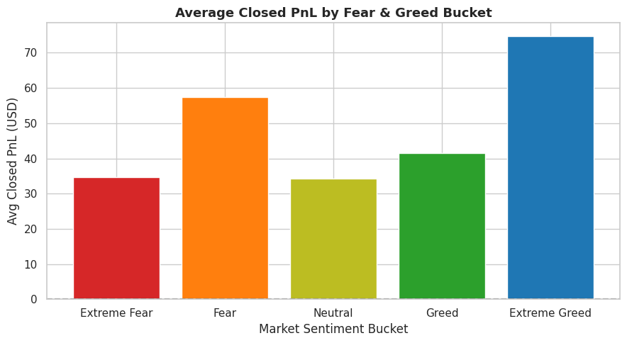
Figure 10: Average Closed PnL by Fear & Greed bucket — clear monotonic trend
The chart above provides perhaps the most actionable insight in this analysis: average trade PnL increases monotonically from Extreme Fear to Extreme Greed. Traders who are active during high-greed periods earn substantially more per trade on average than those trading during fear cycles.

6. Key Insights & Strategic Recommendations

6.1 Key Insights
- Sentiment is a strong predictor of trade outcome. The Fear & Greed Index value is the single most important feature for predicting trade profitability, outweighing trade size, price, or direction alone.
- Greed drives volume and profit. Most profitable trades occur during Greed and Extreme Greed phases. Trade volume also peaks during these periods, confirming sentiment-chasing behaviour.
- Fear amplifies losses. Extreme Fear coincides with the lowest average PnL, the lowest win rate, and the smallest average position sizes — traders are hesitant and losing.
- Retail traders follow emotion, not logic. The Buy/Sell ratio analysis shows that traders buy during greed (high prices) and sell during fear (low prices) — the opposite of a rational strategy.
- Machine learning can reliably classify profitable trades. With ~80% accuracy, the Random Forest model demonstrates that profitability is not purely random — it has learnable structure driven largely by market sentiment context.

6.2 Strategic Recommendations for Primetrade.ai
- Integrate the Fear & Greed Index as a real-time signal layer in the trading strategy engine. Its predictive power is clear and immediate.
- Build sentiment-gated position sizing: increase position limits during Neutral-to-Greed phases and reduce exposure during Extreme Fear to protect against panic-driven losses.
- Flag traders with high activity during Extreme Fear for coaching or risk alerts — this cluster consistently underperforms.
- Deploy the profit prediction model (Random Forest, 79.5% accuracy) as a pre-trade filter or risk scoring system to flag high-risk trade setups.
- Counter-sentiment trading alerts: consider notifying traders when the FG Index enters extreme zones, reminding them that contrarian strategies historically outperform.

7. Conclusion
This analysis successfully established a statistically meaningful and practically useful relationship between Bitcoin market sentiment and trader performance. By merging 211,218 Hyperliquid trade records with daily Fear & Greed Index data, we demonstrated that sentiment context significantly shapes trade frequency, position sizing, directional bias, and final PnL outcomes.
Three supervised machine learning models were trained and evaluated across two tasks. The Random Forest classifier emerged as the best performer in both cases — achieving 58.9% accuracy for 5-class sentiment prediction and 79.5% accuracy for binary profit/loss classification. These results meaningfully exceed random baselines, confirming that machine learning can extract actionable signals from raw trading and sentiment data.
The most critical practical finding is that the Fear & Greed Index score is the single most predictive feature for trade profitability. This suggests that platforms like Primetrade.ai could materially improve trader outcomes by surfacing real-time sentiment context, implementing sentiment-aware risk controls, and alerting traders to counter-intuitive opportunities during extreme sentiment periods.

End of Report

