Experiment no 3:Evaluation of postfix Expression using stack ADT

Aim: Implementation of Evaluation of Postfix Expression using stack ADT

Objective:

1) Understand the use of stack

2) Understand importing an ADT in an application program

3) Understand the instantiation of stack ADT in an application Program

4) Understand how the member function of an ADT are accessed in an application program

Theory: If the element encountered is an operand, push it into the stack. If the element encountered is an operator, pop two operands a and b from the stack, apply the operator (b operator a) and push the result back into the stack.

Algorithm:

**Step 1:** If a character is an operand push it to Stack  
**Step 2:** If the character is an operator  
Pop two elements from the Stack.  
Operate on these elements according to the operator, and push the result back to the Stack  
**Step 3:** Step 1 and 2 will be repeated until the end has reached.  
**Step 4:** The Result is stored at the top of the Stack,  
return it  
**Step 5**: End

Code :

#include<stdio.h>;

int stack[20];

int top = -1;

void push(int x)

{

stack[++top] = x;

}

int pop()

{

return stack[top--];

}

int main()

{

char exp[20];

char *e;

int n1,n2,n3,num;

printf(“Enter the expression :”);

scanf(“%s”,&exp);

e = exp;

while(*e != ‘\0’)

{

if(isdigit(*e))

{

num = *e - 48;

push(num);

}

else

{

n1 = pop();

n2 = pop();

switch(*e)

{

case ‘+’ :

{

n3 = n1 + n2;

break;

}

case ‘-’ :

{

n3 = n2 - n1;

break;

}

case ‘*’ :

{

n3 = n1 * n2;

break;

}

case ‘/’ :

{

n3 = n2 / n1;

break;

}

}

push(n3);

}

e++;

}

printf(“\nThe result of expression %s = %d\n”,exp,pop());

getch();

return 0;

}

OUTPUT:

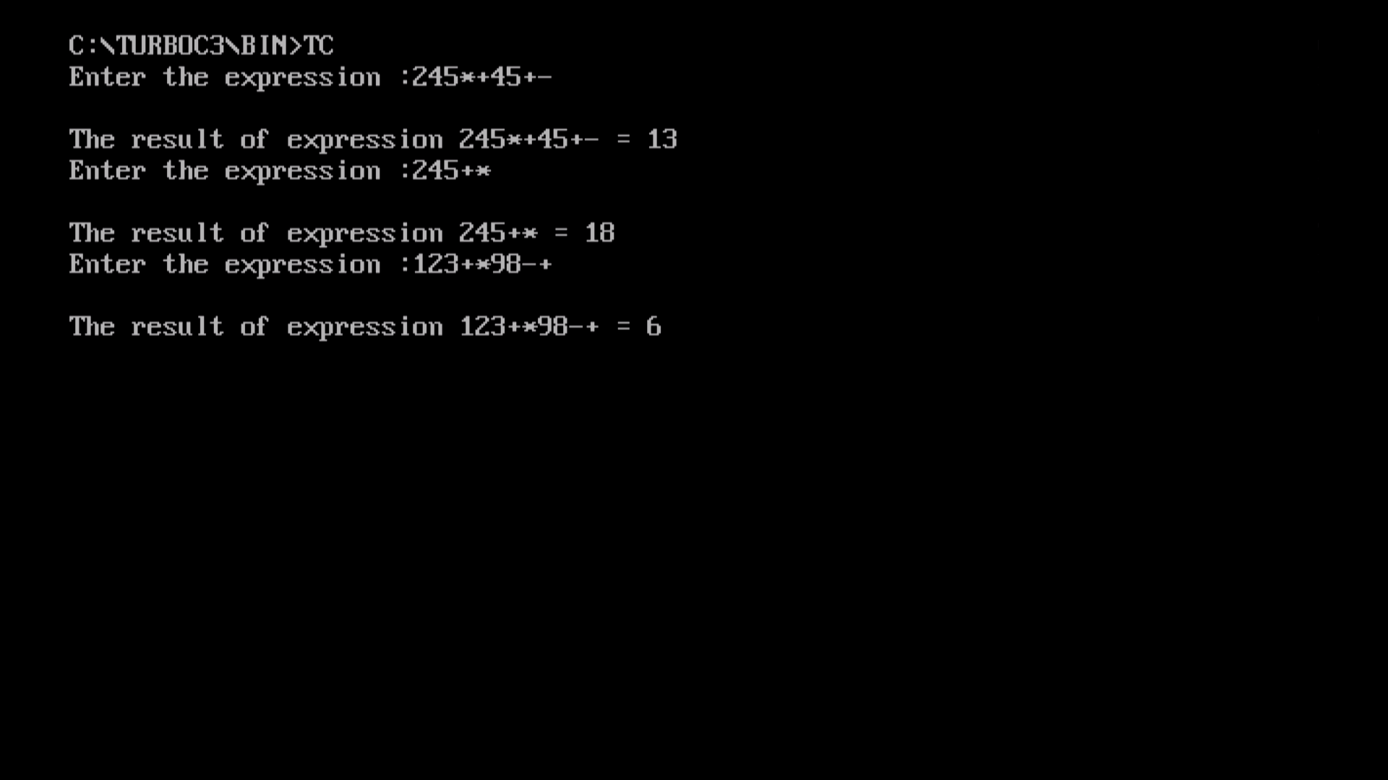

Conclusion :

To evaluate a postfix expression we can use a stack. Iterate the expression from left to right and keep on storing the operands into a stack. Once an operator is received, pop the two topmost elements and evaluate them and push the result in the stack again.