Smart City Traffic Pattern Recognization

Meet Amit Gandhi

Smart City Traffic Pattern Recognization

I have decided to work on smart city traffic pattern. In these project , the major focus will on the function where traffic is more and with these project it will help the government to focus on the mandatory infrastructure and will lead to less traffic. These project will be providing proper visualization which will be easy for the end use to understand as it is difficult for the end user to study the raw data and understand it properly and these many cause error in decision.

# Work done till now

As the further part of the EDA(Exploratory Data Analysis) heatmap was ploted to check the co-relation between each and every variable.

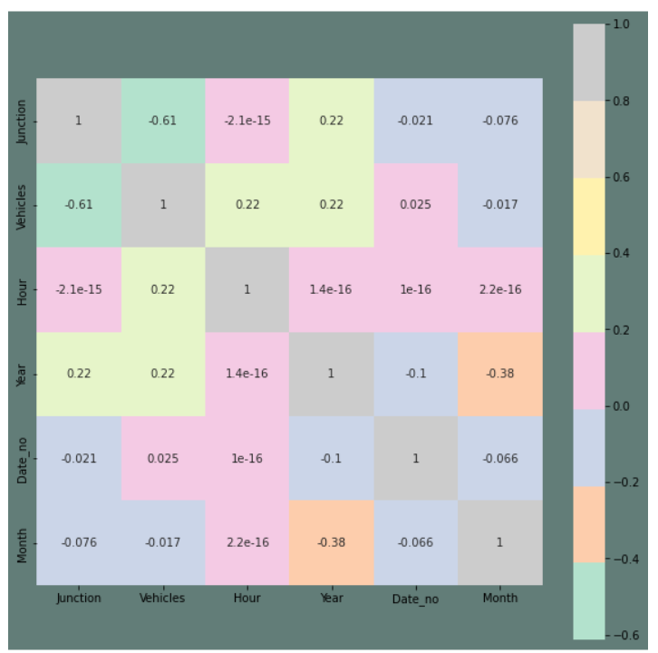

From the het map we can predict that the variable Junction and Year , Vehicles and Year , Vehicles and Hour are highly dependent on each other.

After plotting the HeatMap next Step is to Normalize the data , for which there is need of separate junction dataframe with the vehicles as attribute and DateTime as key attribute.

As, we have less data for the Junction 4, we need to remove the null values from the dataframe that may effect the our ML model.

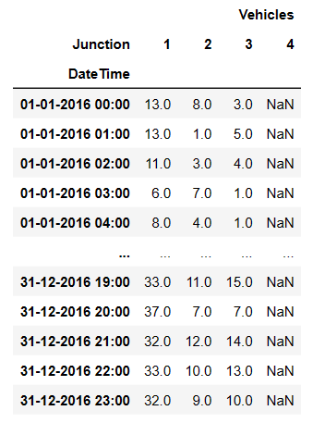

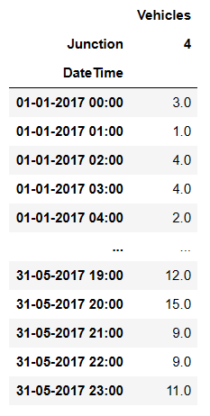

## What will be doing next?

Next step will be normalizing the data and doing the further research in training the model to predict the model. Use of Tensorflow library and seaborm library will be there.

**Challenges Faced**

As these is my first time working with tensorflow and also using time series , I have to do bit more research and go through all the materials from the online again and again.

And again the time which is the greater challenge for as I have to manage between college work and internship work.