Smart City Traffic Control

Meet Amit Gandhi

Smart City Traffic Control

I have decided to work on smart city traffic pattern. In these project , the major focus will on the function where traffic is more and with these project it will help the government to focus on the mandatory infrastructure and will lead to less traffic. These project will be providing proper visualization which will be easy for the end use to understand as it is difficult for the end user to study the raw data and understand it properly and these many cause error in decision.

# Work done till now

In these week test for checking whether the data is stationay or noy was made.

To check that we used Dicker-Fuller Test which gives ADF statistics and p-value of the data as per the junction.

First of all , data was normalize to centelize the data to 0 and differencing was used to remove the trends from the data if any.

Below output is of the Data before normalization and Differencing.

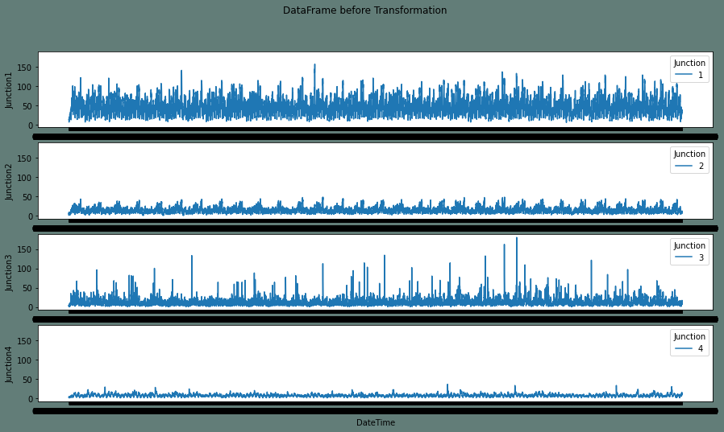

And the output Shown below is after the Data is being Transformed.

For Data to Transform a separate function was made to Normalize the data and apply differencing.

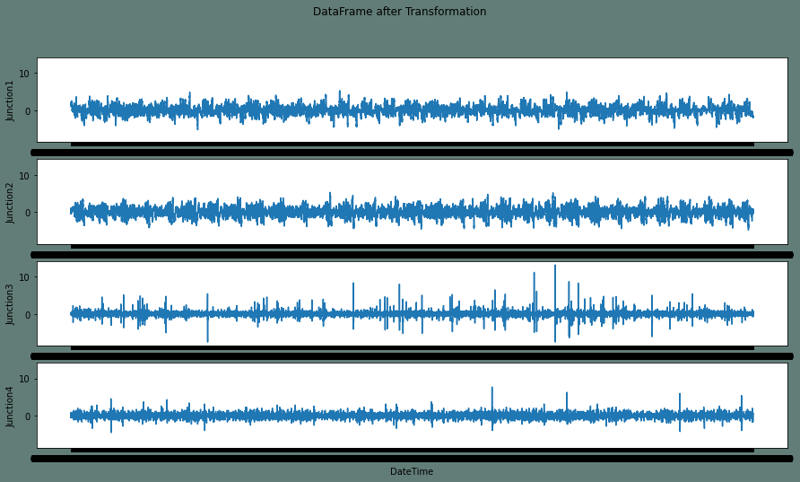

After the Data is being transform , Dicker Fuller Test is applied which provides the following data and from the Data it is clear that the data is stationary as p-value of all the four dataset are near to 0.

ADF Statistic: -10.949577330172252

p-value: 8.867666034151526e-20

Critical Values:

1%: -3.431

5%: -2.862

10%: -2.567

Time Series is Stationary

ADF Statistic: -20.062610290296895

p-value: 0.0

Critical Values:

1%: -3.431

5%: -2.862

10%: -2.567

Time Series is Stationary

ADF Statistic: -33.85306408558853

p-value: 0.0

Critical Values:

1%: -3.431

5%: -2.862

10%: -2.567

Time Series is Stationary

ADF Statistic: -15.649812888416328

p-value: 1.6016794321006325e-28

Critical Values:

1%: -3.432

5%: -2.862

10%: -2.567

Time Series is Stationary

**Challenges Faced**

As these is my first time working with tensorflow and also using time series , I have to do bit more research and go through all the materials from the online again and again.

And again the time which is the greater challenge for as I have to manage between college work and internship work.