Smart City Traffic Pattern

Meet Amit Gandhi

Smart City Traffic Pattern

I have decided to work on smart city traffic pattern. In these project , the major focus will on the function where traffic is more and with these project it will help the government to focus on the mandatory infrastructure and will lead to less traffic. These project will be providing proper visualization which will be easy for the end use to understand as it is difficult for the end user to study the raw data and understand it properly and these many cause error in decision.

# Work done till now

These week main goal was to get the insight the data. EDA(Exploratory Data Analysis) was used to gain the data insight of the data and it is easlier to work with data.

Firstly, the ‘Month’ , ’Year’ , ‘Date’ , ‘Day’ were obtained from the date attribute given and the ‘id’ attribute which was of no use was dropped from the data to reduce the redundancy.

Dataframe after removing the ‘ID’ column.

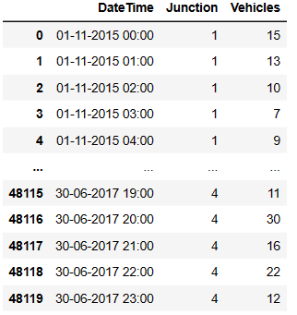

New Dataframe obtained after the splitting the Date and Time into ‘Month’, ’Day’, ’Time’, ’Date’ and ‘Year’. These attributes can be used to analyse the traffic on the Weekdays , Festivals , also in office hours.

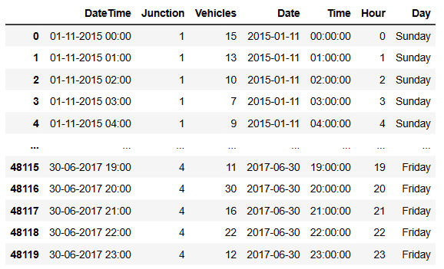

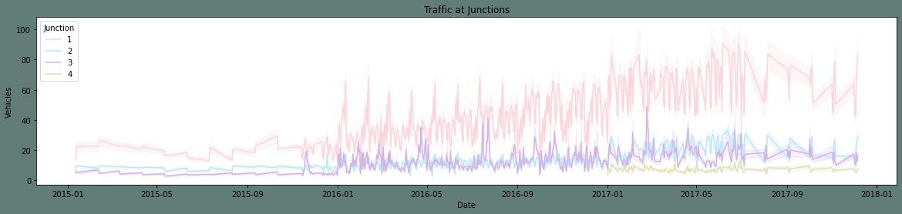

These is the line graph plotted on the current dataframe. From these graph we can see that we have Junction 1 is highly loaded with traffic all these year whereas in Junction 4 we have data starting from 2017.

The Graph shown below is the is plotted between year and vehicles at the Particular Junction.

From these graph we can analyse the traffic the particular Junction faces per year.

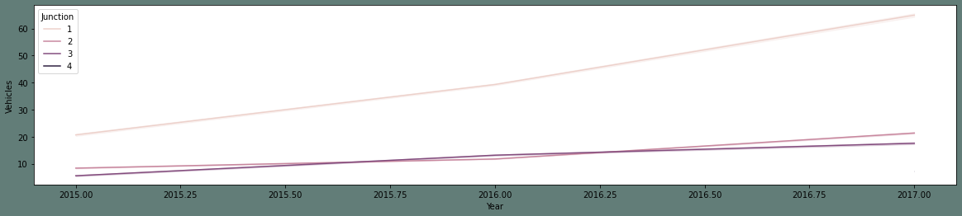

The Graph shown below is the is plotted between Month and vehicles at the Particular Junction.

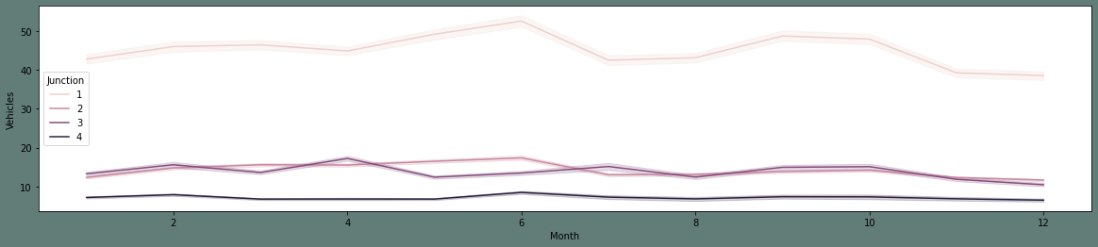

The Graph shown below is the is plotted between Hour and vehicles at the Particular Junction.

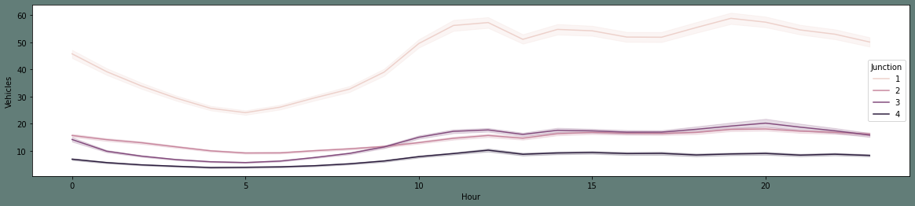

The Graph shown below is the is plotted between Day and vehicles at the Particular Junction to analyse the Traffic at the junction on that day.

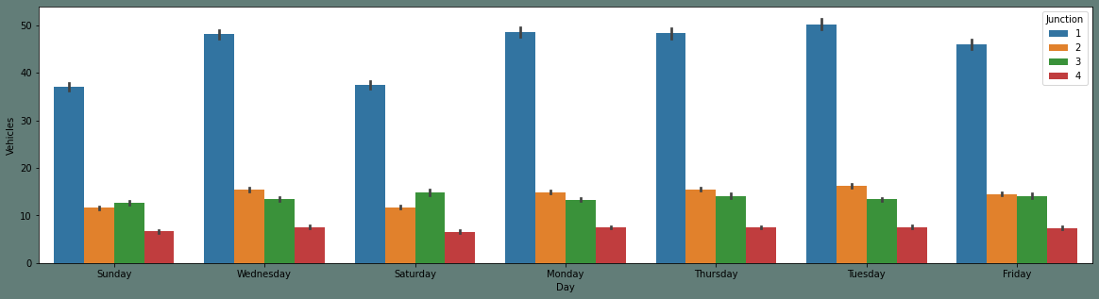

These the final graph which shows the that the number of the vehicles have increased from 2015 to 2016 and there is the drastic decrease in the number of the vehicles till 2017.

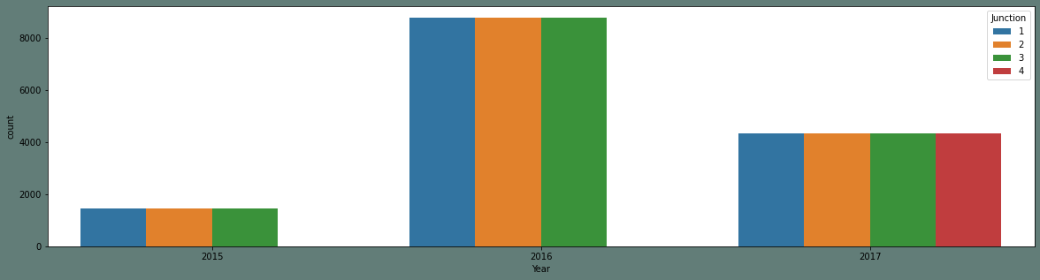

## What will be doing next?

Next step will be normalizing the data and doing the further research in training the model to predict the model.