Project name: Medicine

Page 1: [www.root-directory.com/forms/check-request/](http://www.root-directory.com/forms/check-request/)

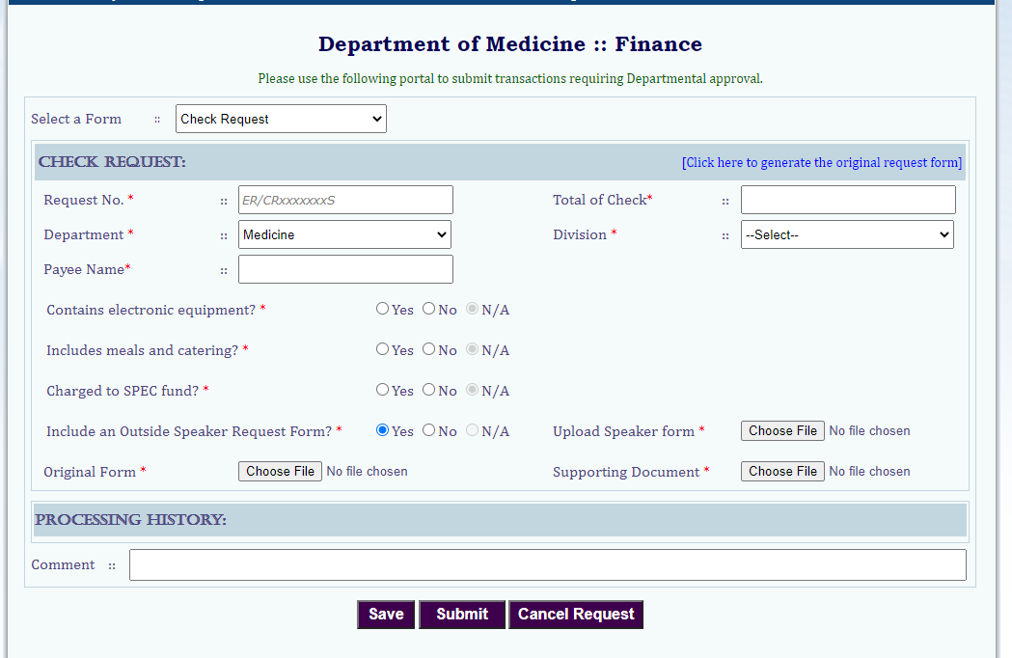

On the top “Select a form” is NOT required.

Fields in * are required.

For Department and Division dropdown, use db table Z_Department and Z_Division.

Once a Dept is selected, corresponding division will be loaded in division dropdown. E.g. when DeptCode 11 is selected, 001,002,003,004 will be loaded in division dropdown. Refer the data in the Z_Department/ Z_Division table. Add an extra item “—Select--” in the dropdown list.

Radio button Yes or No only, Don’t need N/A as showing above.

When ‘Yes’ is selected in “Include an Outside Speaker Request Form”, file upload button “Upload Speaker Form” will show-up, otherwise hidden.

Allowed file type – docs, xlsx, pdf, png and jpg

Save will data in sql table ‘TransactionInfo’. Use store procedure ‘sp_Save_TransactionInfo’. Modify the scripts if require.

Scripts attached -