**Data Flow Diagram**

**Emergency Help Service**

* ***Context Diagram***

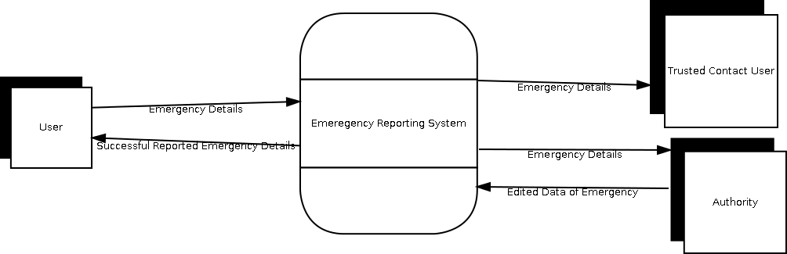

* ***Level - 0 Data Flow Diagram***

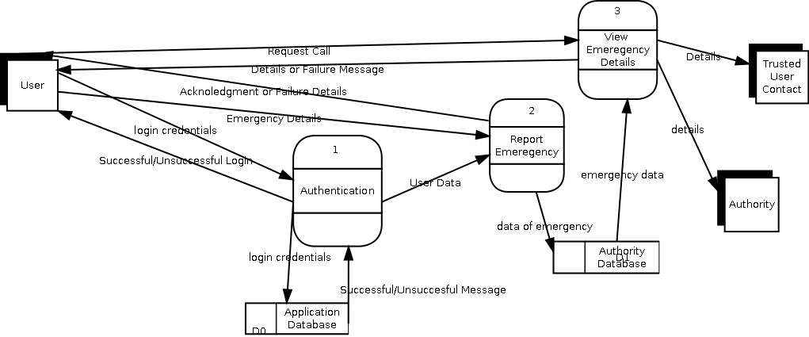

* ***Level-1 DFD for Process - 1 : Authentication***

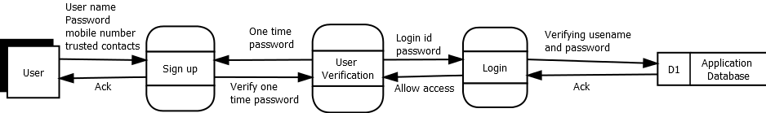

* ***Level-1 DFD for Process - 2 : Report Emergency***

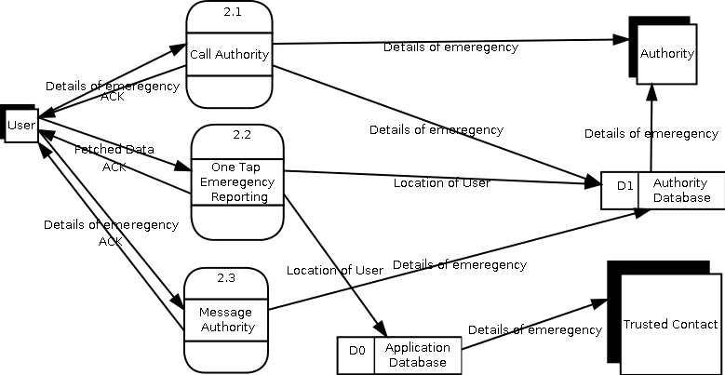

* ***Level-1 DFD for Process - 3 : View Emergency Details***

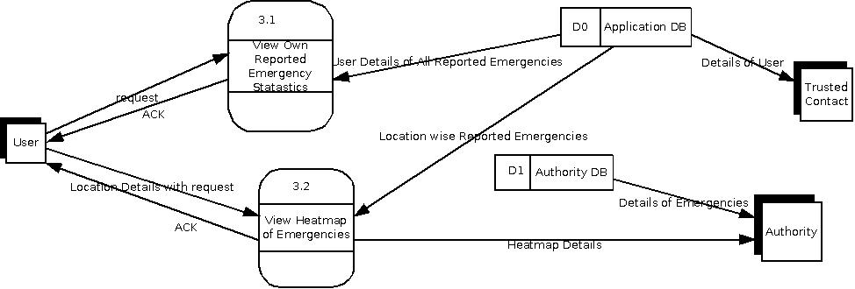

* ***Level-2 DFD for Report Emergency -> One Tap Emergency Reporting***

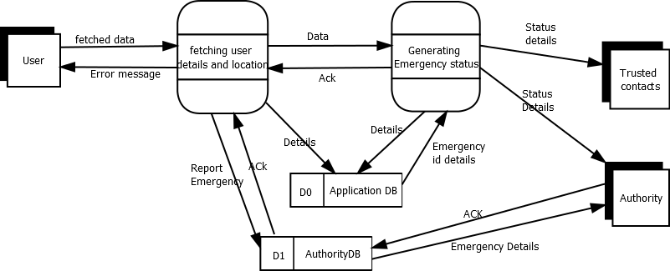

* ***Level-2 DFD for Report Emergency -> Message Authority***

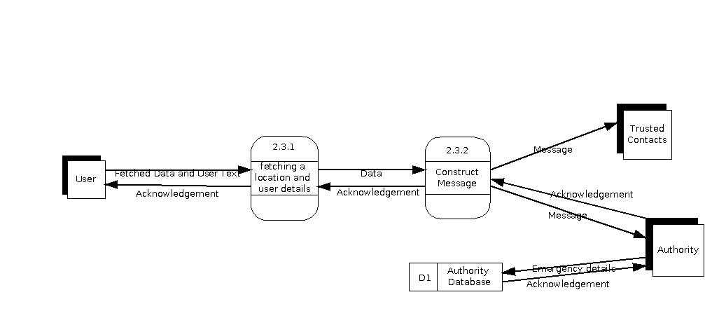

* ***Level-3 DFD for Report Emergency -> One Tap Emergency Reporting -> Generate Emergency status***

