Comprehensive Data Analysis Report

1. Executive Summary

Dataset Overview
- Total Records: 100
- Total Columns: 3
- Total Missing Values: 0
- Overall Missing Percentage: 0.00%

Key Insights
- Insight 1
- Insight 2

2. Statistical Summary
Column | Mean | Min | Max
A | 0.5 | 0 | 1
B | 50 | 0 | 100

3. Univariate Analysis
Analysis of all variables (Numeric & Categorical):

Variable: A
A is a positively skewed numeric variable with an average of 0.50.
The variable 'A' contains 100 observations. It ranges from a minimum of 0.00 to a maximum of 1.00, with a standard deviation of 0.00. The average value is 0.50, while the median is 0.00. The mean is higher than the median, indicating a right-skewed distribution with potential high-value outliers. The data is relatively consistent (CV: 0.0%).
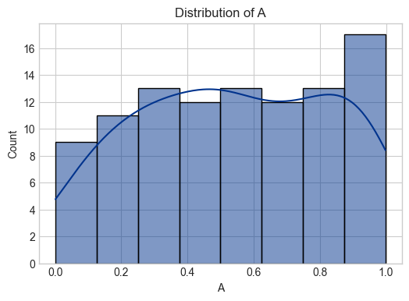

Variable: B
B is a positively skewed numeric variable with an average of 50.00.
The variable 'B' contains 100 observations. It ranges from a minimum of 0.00 to a maximum of 100.00, with a standard deviation of 0.00. The average value is 50.00, while the median is 0.00. The mean is higher than the median, indicating a right-skewed distribution with potential high-value outliers. The data is relatively consistent (CV: 0.0%).
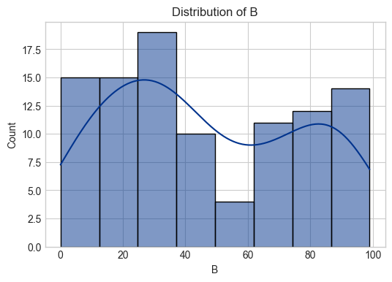

Variable: C
C is a categorical variable with 3 unique values, dominated by 'X'.
The categorical variable 'C' has 3 distinct categories across 100 records. The most frequent category is 'X', appearing 40 times, which accounts for 40.0% of the data. With fewer than 5 unique values, this variable is suitable for use as a grouping dimension in analysis.
Frequency Table:
Category | Count | Percentage
X | 40 | 40.0%
Y | 33 | 33.0%
Z | 27 | 27.0%

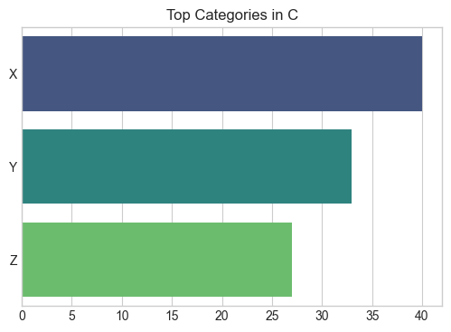
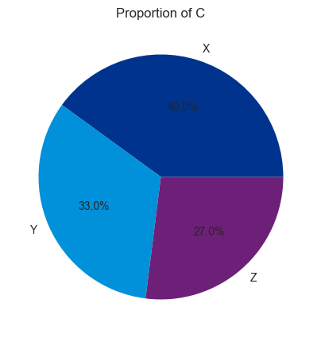

4. Multivariate Analysis
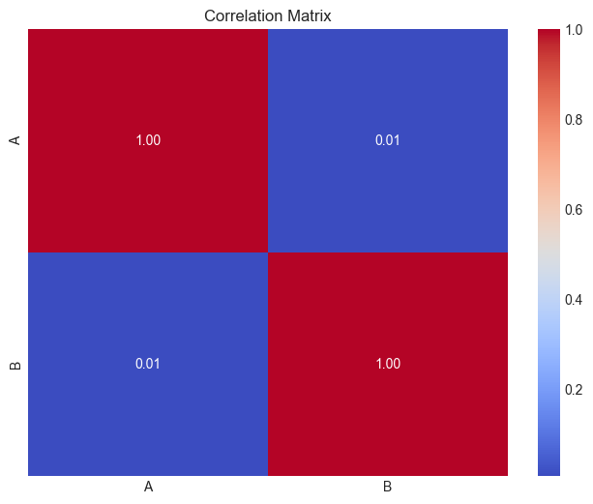

5. Key Relationships (Bivariate)
