Comprehensive Data Analysis Report

1. Executive Summary

Dataset Overview
- Total Records: 100
- Total Columns: 4
- Total Missing Values: 0
- Overall Missing Percentage: 0.00%

Key Insights
- Data distribution suggests a potential correlation between numeric variables.
- Recommendation: Visualize the distribution of key metrics to identify skewness.

2. Statistical Summary

Data Quality Overview
Column | Missing % | Unique Values | Data Type
id | 0.0% | 100 | int64
category | 0.0% | 2 | object
value | 0.0% | 83 | int64
group | 0.0% | 2 | object

Numeric Variables Summary
Column | Mean | Min | Max
id | 49.5 | 0.0 | 99.0
value | 61.25 | 0.0 | 147.0

3. Univariate Analysis
Analysis of all variables (Numeric & Categorical):

Variable: id
This variable is identified as an identifier (High cardinality or ID-like name).
Unique Values: 100 | Missing Values: 0

Variable: category
category is a categorical variable with 2 unique values, dominated by 'A'.
The categorical variable 'category' has 2 distinct categories across 100 records. The most frequent category is 'A', appearing 50 times, which accounts for 50.0% of the data. With fewer than 5 unique values, this variable is suitable for use as a grouping dimension in analysis.
Frequency Table:
Category | Count | Percentage
A | 50 | 50.0%
B | 50 | 50.0%

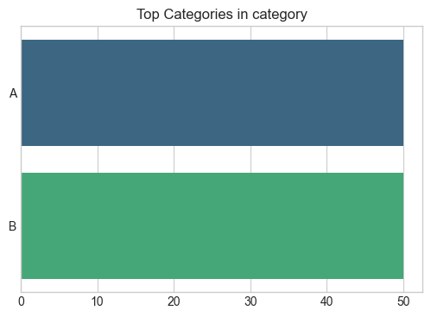
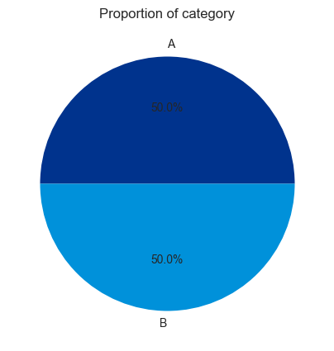

Variable: value
value is a normally distributed numeric variable with an average of 61.25.
The variable 'value' contains 100 observations. It ranges from a minimum of 0.00 to a maximum of 147.00, with a standard deviation of 38.97. The average value is 61.25, while the median is 59.00. The close proximity of the mean and median suggests a symmetrical, bell-shaped distribution. The data shows high variability (CV: 63.6%), suggesting significant spread in the values.
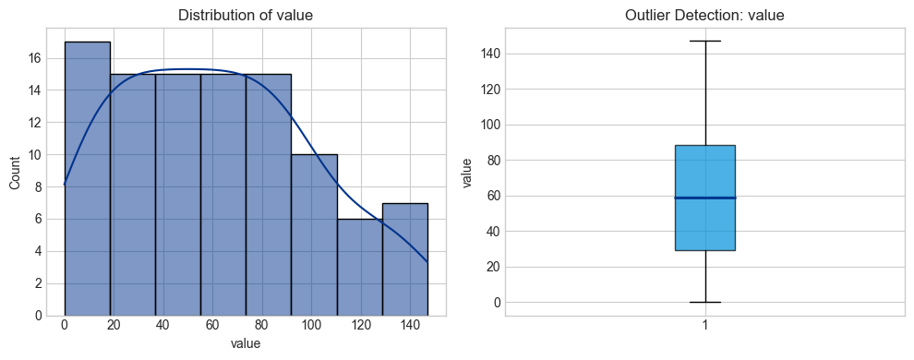

Variable: group
group is a categorical variable with 2 unique values, dominated by 'X'.
The categorical variable 'group' has 2 distinct categories across 100 records. The most frequent category is 'X', appearing 50 times, which accounts for 50.0% of the data. With fewer than 5 unique values, this variable is suitable for use as a grouping dimension in analysis.
Frequency Table:
Category | Count | Percentage
X | 50 | 50.0%
Y | 50 | 50.0%

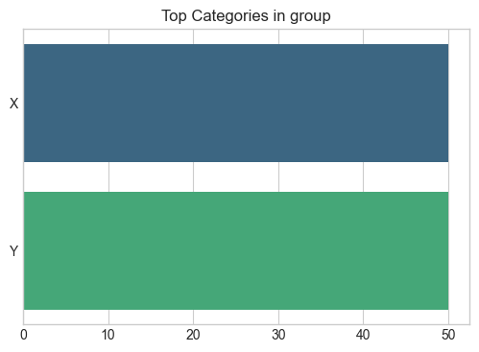
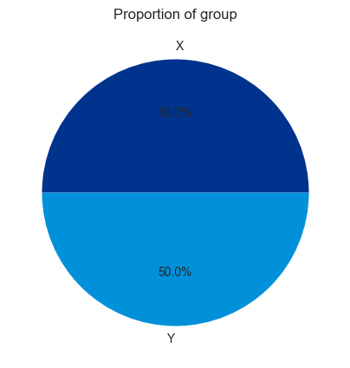

4. Multivariate Analysis
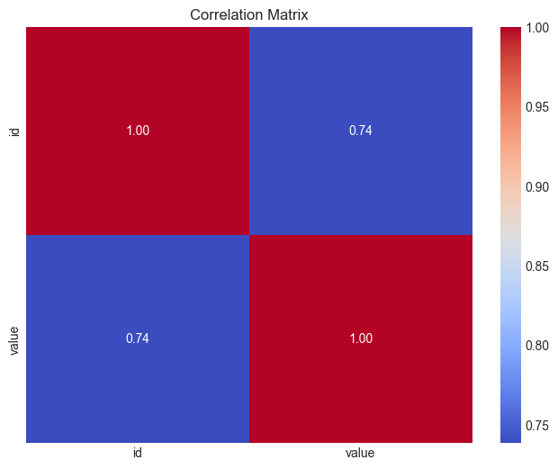

5. Key Relationships (Bivariate)

Numeric Correlations
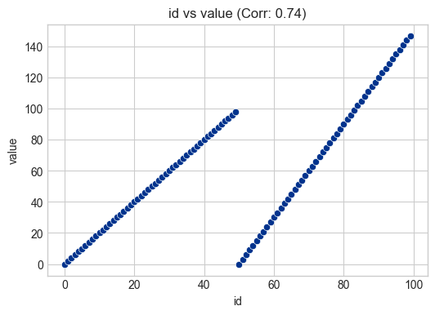

Categorical vs Numeric Analysis
