**free5gmano NM manager**

[](https://camo.githubusercontent.com/1d9254610b5896359b211cd73c482805780a584a/68747470733a2f2f692e696d6775722e636f6d2f736961547056372e706e67)

**Table of Contents**

* [free5gmano](https://github.com/free5gmano/free5gmano#What-is-free5gmano?)
* [Features](https://github.com/free5gmano/free5gmano#Features)
* [Dependencies](https://github.com/free5gmano/free5gmano#Dependencies)
* [Getting started](https://github.com/free5gmano/free5gmano#Getting-started)
  + [Install NFV-MANO](https://github.com/free5gmano/free5gmano#Install-NFV-MANO)
  + [Install NM](https://github.com/free5gmano/free5gmano#Install-NM)
* [Apply a NSSI (Network Slice Subnet Instance)](https://github.com/free5gmano/free5gmano#Apply-a-NSSI-(Network-Slice-Subnet-Instance))
  + [Install the nmctl client](https://github.com/free5gmano/free5gmano#Install-the-nmctl-client)
* [Release Note](https://github.com/free5gmano/free5gmano#Release-Note)

**What is free5gmano?**

This is a 5G MANO (Management and Network Orchestration) project developed that refer to 3GPP TS 28.531, TS 28.532 Release 15 (R15). The purpose is to achieve the management and scheduling of 5G network slices. Please refer to [Features](https://github.com/free5gmano/free5gmano#Features) for the functions of release. This project is collaborating with [free5GC.org](https://free5gc.org). Hence, it can provide as a MANO platform for deploying network slice subnet instances (NSSIs) of free5GC VNFs.

Currently, the major contributors of this project are Department of Computer Science and Information Engineering (Dept. of CSIE) and Center of Infomormation Technology Innovation Services (CITIS), National Taichung University of Science and Technology (NTCUST)

Note: Thank you very much for your interest in free5gmano. The license of Stage 2 free5gmano follows [Apache 2.0](http://www.apache.org/licenses/LICENSE-2.0). That is, anyone can use free5gmano for commercial purposes for free. We will not charge any license fee.

This project is initiated by: [https://camo.githubusercontent.com/667f1cd3de7fc5d1eb6a12763a79d2d74be9ef24/68747470733a2f2f692e696d6775722e636f6d2f37485536505a752e706e67](https://www.moea.gov.tw/)[https://camo.githubusercontent.com/11667e2c8e907627ab1b7fbf01f621605e62590f/68747470733a2f2f692e696d6775722e636f6d2f6b4e496d566f462e706e67](https://www.edu.tw/)

**Architecture**

[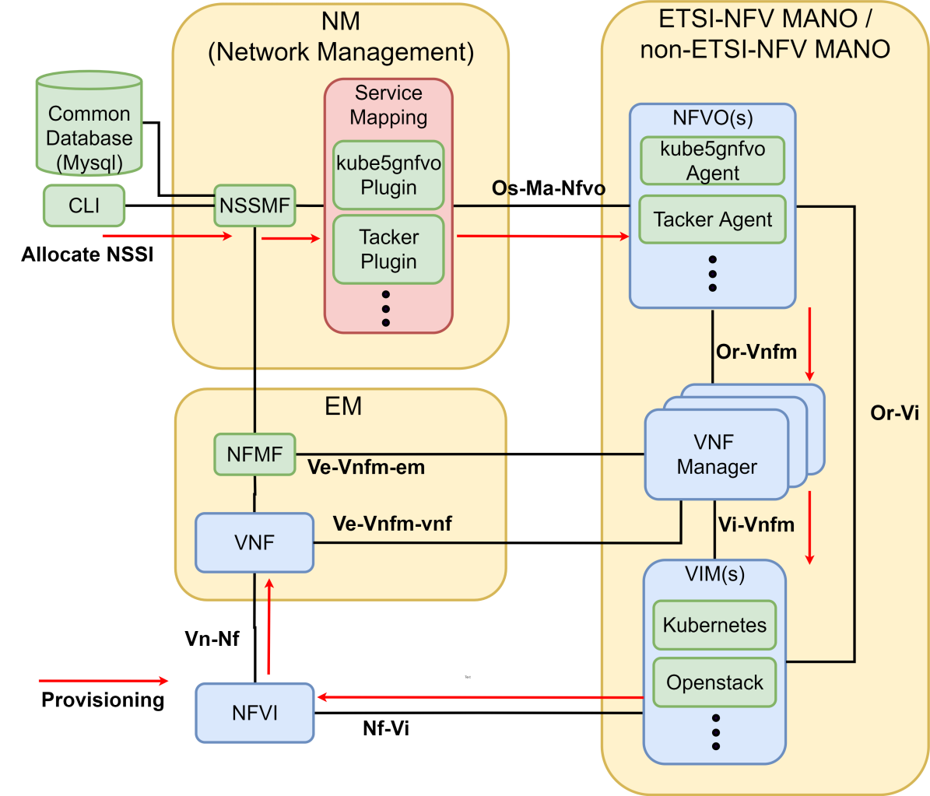](https://camo.githubusercontent.com/7401ba3776e683d473570c7d67871fcc23408329/68747470733a2f2f692e696d6775722e636f6d2f785552785131342e706e67)

It's refer to [ETSI GS NFV-MAN 001 V1.1.1](https://www.etsi.org/deliver/etsi_gs/NFV-MAN/001_099/001/01.01.01_60/gs_NFV-MAN001v010101p.pdf)

**Features**

* Allocation Nssi API is implemented in Network Slice Subnet Management Function that refer to 3GPP TS 28.531 (R15). It can create a Network Slice Subnet Instance (NSSI) by calling os-ma-nfvo interface, which is the basis of network slicing.
* A Service Mapping Plugin framework is designed to deploy the Network Slice Subnet Instance (NSSI) via os-ma-nfvo APIs and provide the selection of the open source NFV Orchestrators, e.g. Kubernetes-based [Kube5gnfvo](https://github.com/free5gmano/kube5gnfvo) (default), [OpenStack-based Tacker](https://wiki.openstack.org/wiki/Tacker) etc.
* Network Slice Subnet Template can assist users to provide ETSI MANO NFVO required information, e.g. VNF Package, Network Service Descriptor

**Dependencies**

The following packages are required:

* git
* python3
* pip3
* mysql
* NFV-MANO

**Getting started**

**Install NFV-MANO**

**Option1 - install kube5gnfvo**

Please refer to [kube5gnfvo](https://github.com/free5gmano/kube5gnfvo) Installation Guide to install kube5gnfvo.

**Option2 - install OpenStack Tacker**

Please refer to [OpenStack Tacker](https://github.com/free5gmano/tacker-example-plugin) Installation Guide to install OpenStack Tacker.

**Install NM**

1. Install the required packages

sudo apt -y update

sudo apt install -y python3 python3-pip git libmysqlclient-dev mysql-server

sudo service mysql start

1. Alias python3 to python

sudo alias python=python3

sudo alias pip=pip3

1. Clone nm_manager project

git clone https://github.com/free5gmano/free5gmano.git

cd free5gmano

1. Install python dependencies

pip install -r requirements.txt

1. Apply environment variable

echo 'export FREE5GMANO_MYSQL_USER=<your mysql user>' >> ~/.bashrc

echo 'export FREE5GMANO_MYSQL_PASSWORD=<your mysql password>' >> ~/.bashrc

echo 'export FREE5GMANO_MYSQL_HOST=<your mysql host ip>' >> ~/.bashrc

echo 'export FREE5GMANO_MYSQL_PORT=<your mysql port>' >> ~/.bashrc

echo 'export FREE5GMANO_NM=127.0.0.1:8000' >> ~/.bashrc

echo 'export FREE5GMANO_NFVO=<your nfvo ip>:<your nfvo port>' >> ~/.bashrc

source ~/.bashrc

1. Create a database

mysql -h $FREE5GMANO_MYSQL_HOST -u $FREE5GMANO_MYSQL_USER -p$FREE5GMANO_MYSQL_PASSWORD

CREATE DATABASE free5gmano

1. Database migrate

python manage.py makemigrations nssmf

python manage.py migrate

1. Run the Django server

python manage.py runserver 0.0.0.0:8000

**Apply a NSSI (Network Slice Subnet Instance)**

**Install the nmctl client**

Please refer to [free5gmano-cli](https://github.com/free5gmano/free5gmano-cli) Installation Guide to install free5gmano-cli.

1. Clone simpleexampleplugin project

git clone https://github.com/free5gmano/simpleexampleplugin.git

1. Register a service mapping plugin

nmctl register plugin kube5gnfvo -f simpleexampleplugin/

1. Check service mapping plugin is registered

nmctl get plugin

name allocate_nssi deallocate_nssi

kube5gnfvo allocate/main.py deallocate/main.py

1. Create a VNF Template

nmctl create template -t VNF -n kube5gnfvo

Do you want to download example? [y/N]: y

OperationSucceeded

Template Id: 00936c28-ba30-4604-a134-4f4302acaea7

1. Onboard the VNF Template

nmctl onboard template 00936c28-ba30-4604-a134-4f4302acaea7 -f VNF/

1. Create a NSD Template

nmctl create template -t NSD -n kube5gnfvo

Do you want to download example? [y/N]: y

OperationSucceeded

Template Id: 31e7f5ad-9259-4b9b-97b6-d3ff78996aec

1. Onboard the NSD Template

nmctl onboard template 31e7f5ad-9259-4b9b-97b6-d3ff78996aec -f NSD/

1. Combined the VNF and NSD Template to Network Slice Subnet Template (NSST)

nmctl create nsst -n kube5gnfvo 00936c28-ba30-4604-a134-4f4302acaea7 31e7f5ad-9259-4b9b-97b6-d3ff78996aec

OperationSucceeded, NSST is combined.

NSST Id:: 66ff6b6f-6c54-4498-bc1e-411382c80bc5

1. Apply a NSSI

nmctl allocate nssi 66ff6b6f-6c54-4498-bc1e-411382c80bc5

**Docker Repository**

[free5gmano](https://hub.docker.com/repository/docker/free5gmano/free5gmano) [free5gc-stage-1](https://hub.docker.com/repository/docker/free5gmano/free5gc-base) [free5gc-stage-2(control plane)](https://hub.docker.com/repository/docker/free5gmano/free5gc-control-plane) [free5gc-stage-2(user plane)](https://hub.docker.com/repository/docker/free5gmano/free5gc-user-plane)

**Contributors**

**National Taichung University of Science and Technology:** Cheng-En Wu, Sheng-Tang Hsu, Yi-Chieh Hsu, Wen-Sheng Li, Meng-Ze Li, Yi-Xin Lin, Hung-Ming Chen, Yung-Feng Lu

**Release Note**

* Allocate a Network Slice Subnet Instance(NSSI) and deploy [free5GC](https://www.free5gc.org/)

©Copyright January 2020 All rights reserved.

Contact: [free5gmano@gmail.com](mailto:free5gmano@gmail.com)