ng Commands

ng help -- get all the commands

new -- create new angular project
generate -- to generate a new files as per project artifacts
run -- run app
serve -- as soon as make code changes, it will reflected
lint -- checks the code against the std. Uses "tslint.js" file for config.
build -- build the app and create the executable "dist" folder which we can directly put in web server.
test -- similar to junit. Config and Test cases are defined in karma.conf.js (config for test runner) and app.component.spec.ts ( test cases defined).
e2e -- end to end test. They are much more than unit test. Here we launch entire angular app and run tests related to this. Here chrome driver was used to perform selenium tests. Protractor is the tool used to perform selenium tests on angular code. All the code is present under "e2e" directory.

"angular.json" is the file which decides what to happen when a user runs different ng commands. ( like build,serve,e2e etc..)

"Project Structure"

src-->app : This is where all angular code will be put ( components and modules).
assets--> all the images.
environments--> similar to properties files.

tsconfig.json --> typescript will get converted into javascript. This file specifies the config for the same.
package.json --> It is like a "pom.xml". All the package, tools , frameworks are mentioned in this file. We need to specify the dependencies in the file and npm (like mvn) will download.
index.html, main.ts --> These two files are loaded up when we boot the application.
polyfills.ts --> takes care of browser compatibilities.
styles.css--> specifies the global application styles.
test.js--> this file will be used when we use "ng test". This is the starting file to run unit tests.
App.modules.ts → contains all the modules and components entry.
App-routing-module.ts → defines the routing of the different components.

"Angular Component"

- This is basic construct in angular.
- @component is a “Decorator”. It is similar to annotations in Java.
- @compoent:
  - Selector : The tag name of the component.
  - TemplateUrl: Where is the location of html template.
  - StyleUrls: Where is the location of css template.
- We can create member variable in the compoenet. We can do interpolation ({{ variable}} )and use that member variable in the html template.
- We bind those variable in the component and use them in html templates.

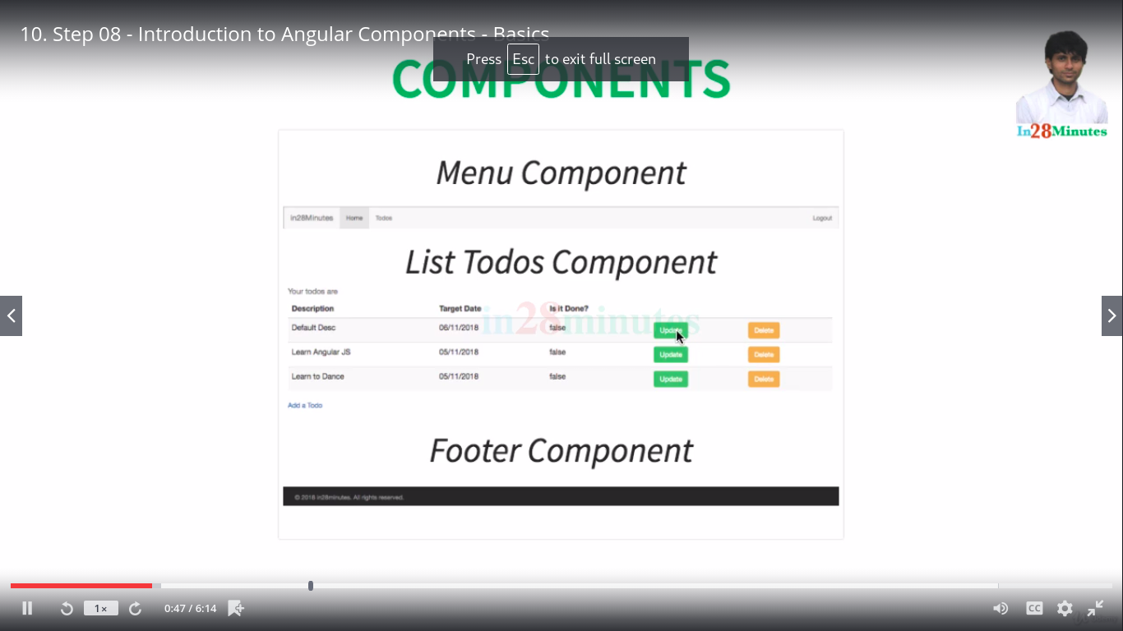
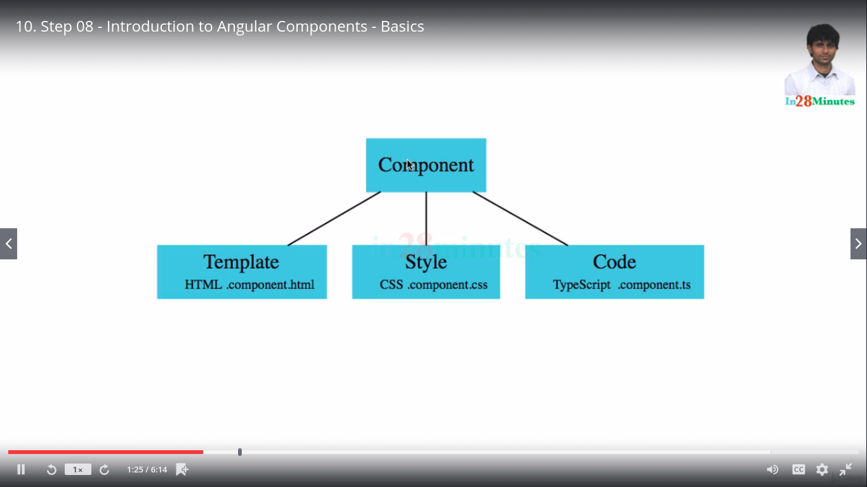
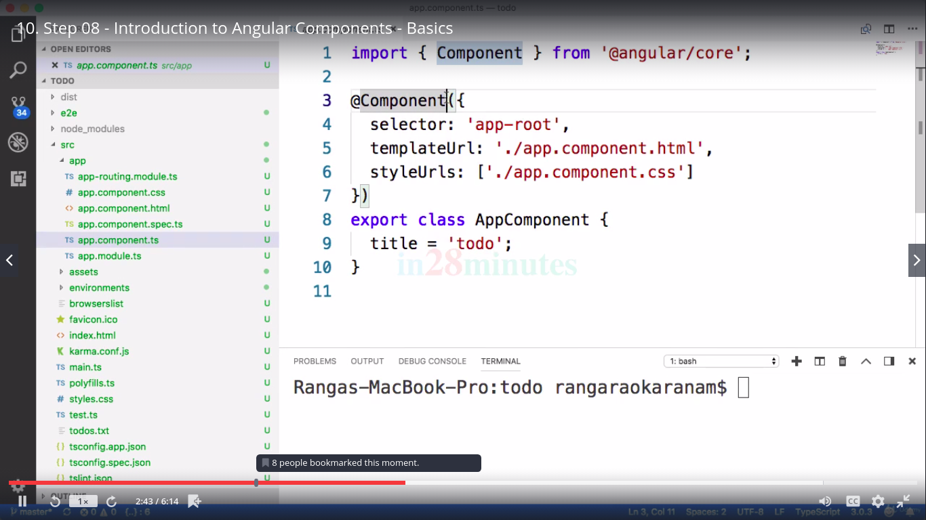
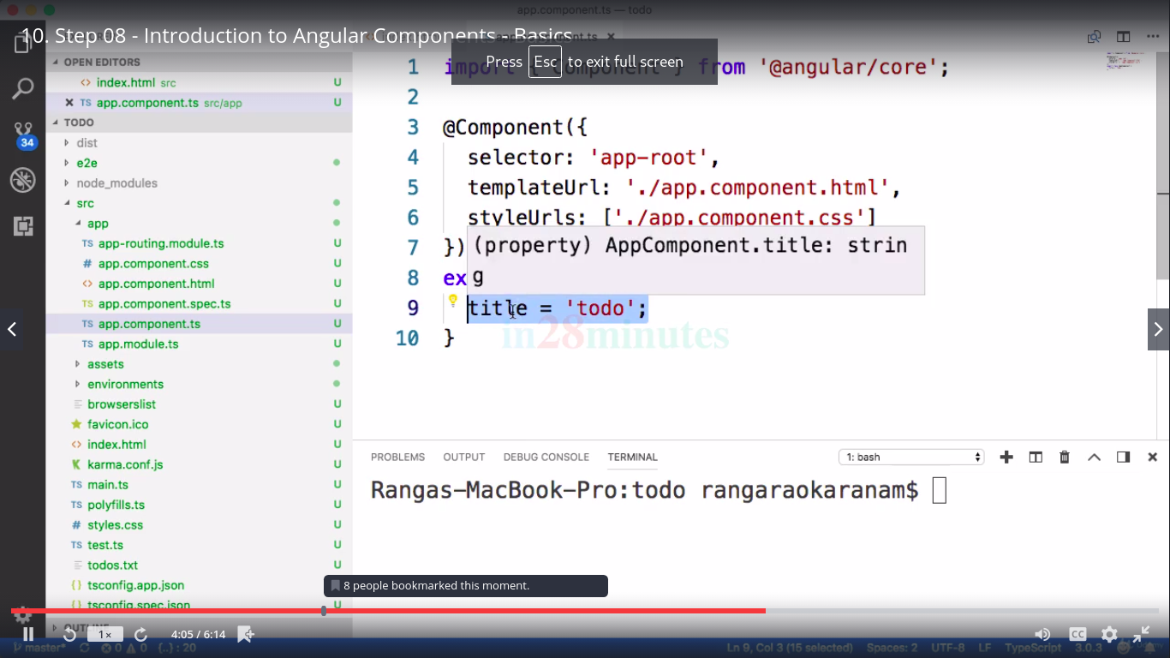
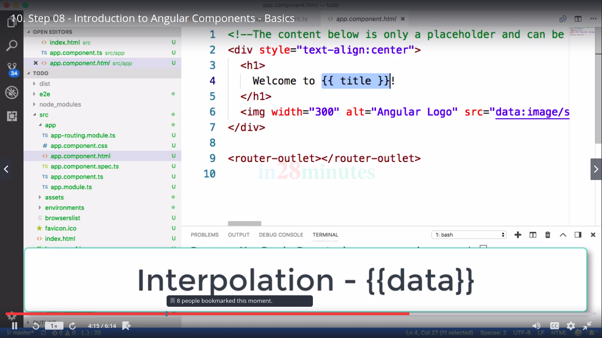

- To generate new component: ng generate component <component_name>

Data Binding

- Interpolation ( e.g {{ username}} – here we binding the component variable/property “username” to the view and showed its value it in view (html).
- Event Binding : Here we are binding a component event method to the view. Calling javascript method (defined in the component) for the fulfillment.
e.g <button (click)=handleLogin()>Login</button>
- 2 way Binding (Banana in the box [()] ) : In addition to the interpolation, we bind the input from the view with the component variable/property.
e.g UserName: <input type="text" name="username" [(ngModel)] = "username">

Note: We need to import new angular directive/library called “FormsModule” in app.module.ts.

- We usually add error component to map unknown url to this component. Refer app-routing,module.ts, added new routing path for error component in case of unkown url.
- Order of the routes are very imp in app-routing.modle.ts.
- In order to route one component to another we need to use router class.
e.g // routing to welcome component
this.router.navigate(['welcome']);
- We can pass and receive Path params
e.g constructor(private route: ActivatedRoute) { }

  - this.username = this.route.snapshot.params['username'];

Angular Module

- Anything starts with “Ng” is an angular module.
- Whenever we think of an angular application, they have been build using a no of angular modules.
- Some modules are build in e.g BrowserModule, NgModule, FormModule (in app.module.ts).
- We should always import corresponding built in module in app.module.ts based on your use case.
- Each component which we create are always associated with some angular module.
- One module can be used in other. We just need to import the concerned module and start using the respective component.

Bootstrapping Root Module and Component

- In main.ts file, we define that “AppModule” is the bootstrap module. AppModule is pointing to app.module.ts. We call it as root module.
- In app.module.ts, we define AppComponent as the bootstrap component. This is how all the ts,html and css files associated to AppComponent is getting loaded as a part of bootstrap process.

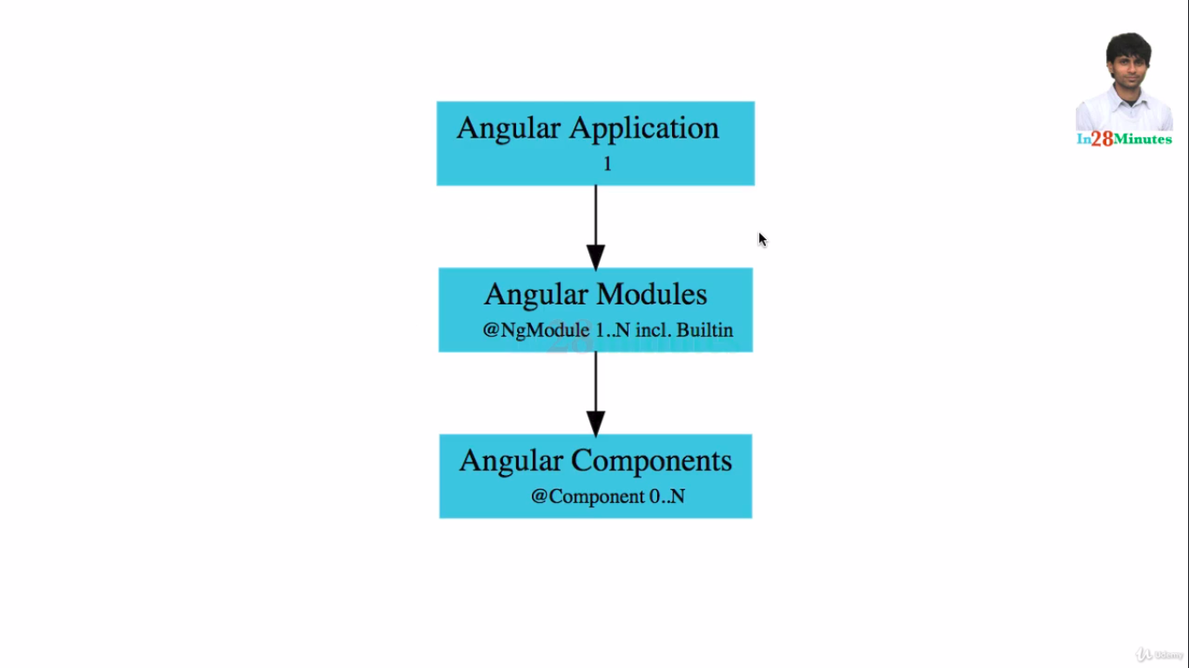
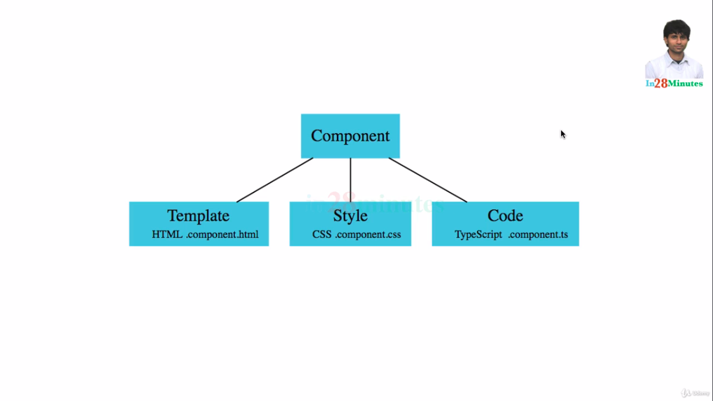

Spring Boot

Web Service:

- Designed for machine-to-machine interaction
- Interoperable (Platform Independent)
- Should allow communication over internet.

- Dispatcher Servlet
- @RestController ( has @ResponseBody)
- Auto Configuration

