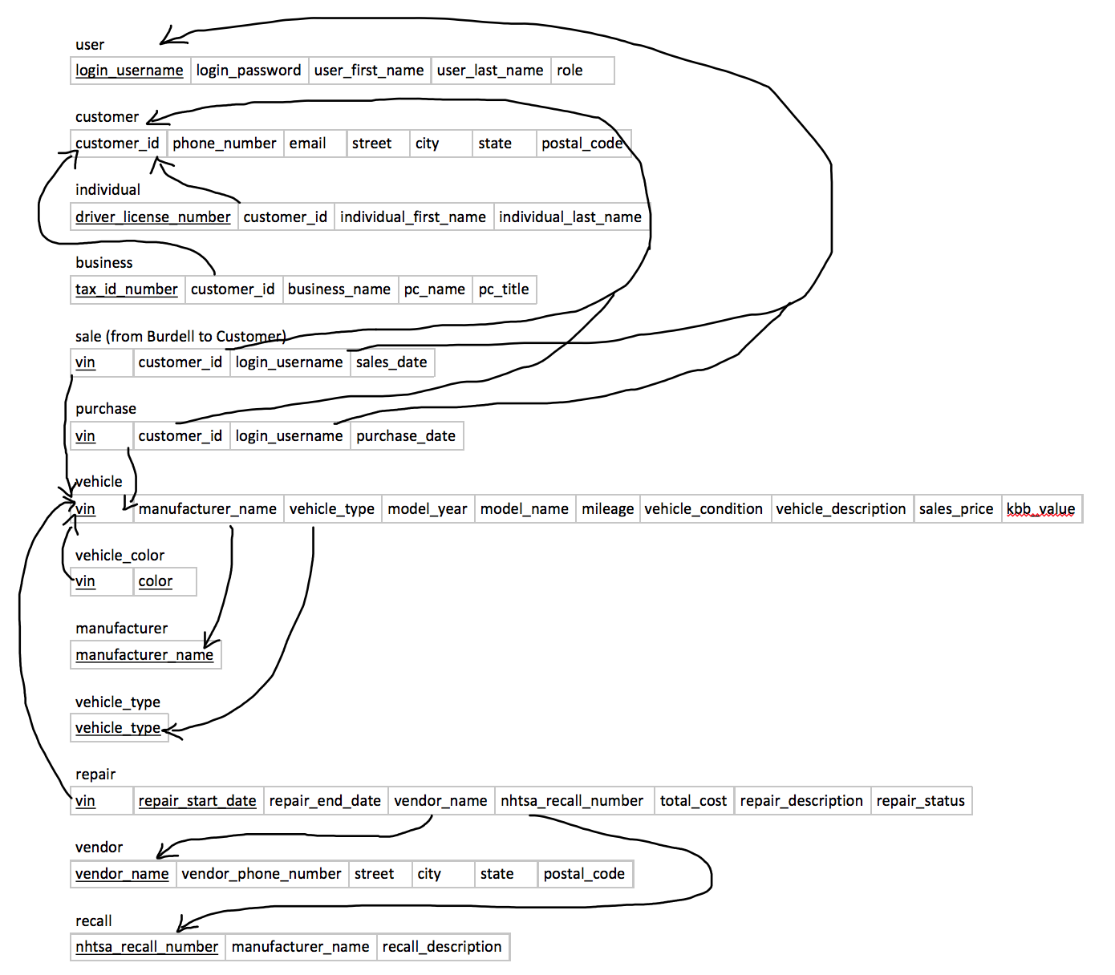

user

|  |  |  |  |  |
| --- | --- | --- | --- | --- |
| login_username | login_password | user_first_name | user_last_name | role |

customer

|  |  |  |  |  |  |  |
| --- | --- | --- | --- | --- | --- | --- |
| customer_id | phone_number | email | street | city | state | postal_code |

individual

|  |  |  |  |
| --- | --- | --- | --- |
| driver_license_number | customer_id | individual_first_name | individual_last_name |

business

|  |  |  |  |  |
| --- | --- | --- | --- | --- |
| tax_id_number | customer_id | business_name | pc_name | pc_title |

sale (from Burdell to Customer)

|  |  |  |  |
| --- | --- | --- | --- |
| vin | customer_id | login_username | sales_date |

purchase

|  |  |  |  |
| --- | --- | --- | --- |
| vin | customer_id | login_username | purchase_date |

vehicle

|  |  |  |  |  |  |  |  |  |  |
| --- | --- | --- | --- | --- | --- | --- | --- | --- | --- |
| vin | manufacturer_name | vehicle_type | model_year | model_name | mileage | vehicle_condition | vehicle_description | sales_price | kbb_value |

vehicle_color

|  |  |
| --- | --- |
| vin | color |

manufacturer

|  |
| --- |
| manufacturer_name |

vehicle_type

|  |
| --- |
| vehicle_type |

repair

|  |  |  |  |  |  |  |  |
| --- | --- | --- | --- | --- | --- | --- | --- |
| vin | repair_start_date | repair_end_date | vendor_name | nhtsa_recall_number | total_cost | repair_description | repair_status |

vendor

|  |  |  |  |  |  |
| --- | --- | --- | --- | --- | --- |
| vendor_name | vendor_phone_number | street | city | state | postal_code |

recall

|  |  |  |
| --- | --- | --- |
| nhtsa_recall_number | manufacturer_name | recall_description |