Chapter 1

Introduction

This chapter gives a brief overview about the background and the scope of the project.

1.1 Overview

The idea of “Electricity generation using Dynamo” is based on the concepts of Rural Electrification. The basic aim of this project or basic objective of our project is just to electrify the rural areas ,so that after riding the bicycle for 2 hours they can lighten their house by an LED bulb. So in todays world , electrification is such an important factor ,our project provides solution to this problem.

Rural electrification in many nations is insufficient, incomplete and discontinuous and this is mainly due to technical constraints or practical difficulty in transmitting the electrical power to remote rural areas through grid connectivity.Generally it is seen that the basic mode of transport in the villages is the bicycle. So the idea is to convert mechanical energy to electrical energy. This concept of our project is an efficient way to increase human awareness regarding energy conversion, energy consumption and energy loss through energy transmission.

Our system which will be fitted onto the rear wheel of the bicycle has much lower installation cost. Also, it is far easier to implement and does not have any constraints such as requirement of large area for installation.

1

Chapter 2

Literature Survey
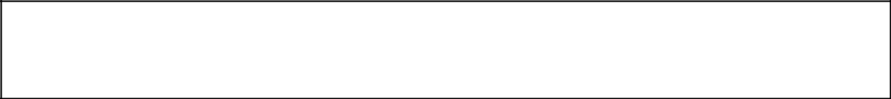

This chapter gives a brief idea of the methodological contribution and the substantial findings forming a concrete background required for the project.

Rural communities are suffering from colossal market failures as the national grids fall short of their demand for electricity. Rural electrification is the process of bringing electrical power to rural and remote areas. Electrification typically begins in cities and towns and gradually extends to rural areas, however, this process often runs into road blocks in developing nations.So in this current scenario where electrification is such an important factor ,our project provides solution to this problem.

Normally we see that the basic mode of transport in the villages is the bicycle. So the idea is to convert mechanical energy to electrical energy is the main aim of our project.

Literature survey done on electricity generation shows that a lot of work is been done in this field. The idea of electricity generation using bicycle was bought into realization by students as their academic projects as well as some small companies who have designed or manufactured this product.

Students of University of Dhaka have proposed power generation using gymnasium bicycle. The main concept of their research was to utilize those type of kinetic energy which are wasted in gymnasium through exercise bicycle and produce electricity. Many people in the country use riding cycle for their fitness. AS a result mechanical energy is fully released. To rescue this energy we can convert it as electrical energy. The Kinetic energy, generated by pedaling is converted into rotational energy through the use of gear system turning a fly wheel. An alternator connected with the fly

2

wheel through a coupling belt. AC generator convert this rotational energy into electrical energy. System construction is as follows:

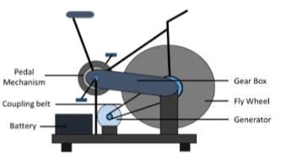

Figure 2.1: Exercycle mechanism

Faculty of the science and mathematics also proposed the same project. They tried making electric bicycles using solar panels. The paper analysed the use of the PV systems as auxiliary power generators for hybrid and electric vehicles and especially foe electric bicycles and normally electric scooters. It also represented a solution to integrate PV systems in large cities. The incorporation of PV systems into the charging systems of electric bicycles and electric scooters, as an alternative of using a car daily helps to reduce the overall amount of fuel consumed. Also in addition, PV systems are light, noise free and maintenance free . The basic block diagram is as follows:

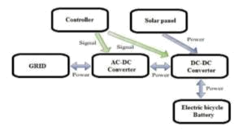

Figure 2.2: Electric bicyle using solar panel

3

Chapter 2

PROJECT DESIGN
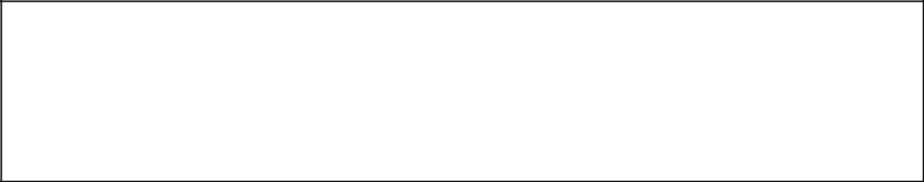

This chapter gives a description about the project design giving detailed specifications of all the hardware components used throughout the project. It also gives an in depth information of the software used extensively in the project. It is
intended to cover only that part of the software that holds relevance to the
undertaken project. | CHAPTER 3

3.1 HARDWARE REQUIREMENTS

3.1.1 Arduino nano

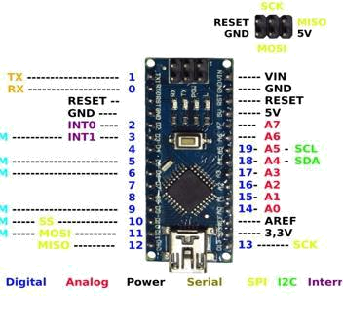

Figure 3.2 Arduino pinout

4

- The Arduino Nano is a small, complete, and breadboard -friendly board based on the ATmega328P[4].

- it is small in size as compared to Arduino UNO but it provides same functionality [4].

- Normally the input voltage of arduino nano can vary from 7v to 12v,but its specified operating voltage is 5v[4].

- In total there are 14 digital pins,8 analog pins ,6 power pins and 2 reset pins[4].

- To interface sensors with arduino analog pins act as input pin while digital pins are used to drive the output load[4]. Example - analogread() is used to control analog pins and digitalwrite() to control digital pins.

- It has an builtin crystal oscillator with a frequency of 16 MHz[4].

- Atmega168 comes with 16KB of flash memory while Atmega328 comes with a flash memory of 32KB[4].

3.1.2 Buck convertor design

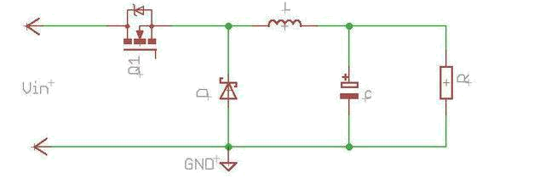

Figure 3.2 Buck convertor

Buck Converter is basically known as step down converter. It is used in the circuit where DC output voltage needs to be less than DC input voltage. It is a DC-DC step down converter that steps down the voltage from its input to its output.

5

CASE 1: MOSFET is ON

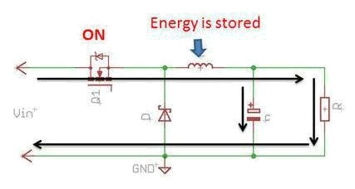

Figure 3.3 M0SFET is ON

When the MOSFET is ON, current flows through the inductor (L) , load (R) and the output capacitor (C ) as shown in the fig. In this condition the diode is reverse biased.So no current flows through it. During the ON state magnetic energy is stored in the inductor and electrical energy is stored in the output capacitor.

CASE 2: MOSFET is OFF

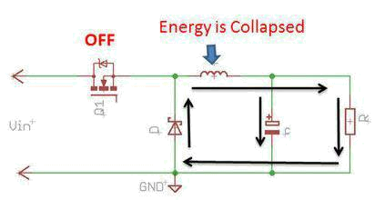

Figure 3.4 MOSFET is OFF

6

When the MOSFET is off, stored Energy in the Inductor is collapsed and current complete its path through the diode ( forward biased) as shown in fig.When stored energy in the inductor vanishes, stored energy in the capacitor is supplied to load to maintain the current.

Selecting the frequency: The switching frequency is inversely proportional to the size of the inductor and capacitor and directly proportional to the switching losses in MOSFETs. So higher the frequency, lower the size of the inductor and capacitor but higher switching losses.So a mutual trade off between cost of the components and efficiency is needed to select the appropriate switching frequency.

Keeping this constraints in to consideration the selected frequency is 50KHz.

We are designing for a 6W solar panel and 6V battery

Input voltage (Vin) =15V

Output Voltage (Vout)=6V

Output current (Iout) =6W/6V =4.16A = 1A

Switching Frequency (Fsw)=50 KHz

Duty Cycle (D) =Vout/Vin= 6/15 =0.4 or 40%

Calculation

L= ( Vin-Vout ) x D x 1/Fsw x 1/ dI

Where dI is Ripple current

For a good design typical value of ripple current is in between 30 to 40 % of load current.

7

Let dI =35% of rated current

dI=35% of 4.2=0.35 x 1=0.35A

So L= (15.0-6) x 0.4 x (1/50k) x (1/0.35) = 205.2uH =220uH (approx)

MOSFET

MOSFET stands for metal-oxide semiconductor field-effect transistor. It is a special type of field-effect transistor (FET).It is a voltage controlled device.The three terminals which a MOSFET contains are gate, drain, source .Due to a voltage controlled device ,it has a very high input impedance.The main aim of the MOSFET is just to control the current flow and the voltage flow between the source and the drain.The working of MOSFET mainly depends on MOS capacitor.

There are so many MOSFET available in market.To select the appropriate MOSFET for the project here are few basic parameter that we have used

1.Voltage Rating : Vds of MOSFET should be greater than 20% or more than the rated voltage.

2.Current Rating: Ids of MOSFET should be greater than 20% or more than the rated current.

3.ON Resistance (Rds on) : Select a MOSFET with low ON Resistance (Ron)

4.Conduction Loss : It depends on Rds(ON) and duty cycle.Keep the conduction loss minimum.

5.Switching Loss: Switching loss occurs during the transition phase.It depends on switching frequency,voltage ,current etc.Try to keep it minimum.

8

In our design the maximum voltage is nearly 15 to 25V and maximum load current is 5A.

So we have chosen IRFZ44N MOSFET. The Vds and Ids value have enough margin as well as it has low Rds(On) value.

MOSFET Driver

A Mosfet driver allows a low current digital output signal from a Microcontroller to drive the gate of a Mosfet. A 5 volt digital signal can switch a high voltage mosfet using the driver.A MOSFET has a gate capacitance that you need to charge so that the MOSFET can turn on and discharge it to switch off,the more current you can provide to the gate the faster you switching on/off the mosfet, that is why you use a driver.

There are dedicated chip available in the market for MOSFET driving but it is costly and also it requires 15-20V at the VCC pin which degrades the efficiency.So we used a simple MOSFET driver by using a NPN general purpose transistor 2N2222.

3.1.3 Voltage sensors

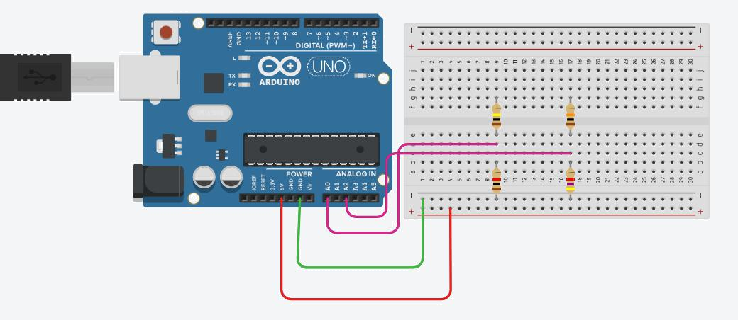

Figure 3.5 Voltage sensor with arduino

9

The voltage sensors is implemented by using a voltage divider arrangement.It will sense voltage coming from dynamo and the battery voltage.

The ARDUINO analog pin input voltage is restricted to 5V, so the voltage divider is designed in such a way that the output voltage from it should be less than 5V.We have used dynamo with open circuit voltage of 12V and a 6V and 4.2Ah SLA battery for storing the power .

So we used R1=100K,R2 =10K for sensing dynamo voltage and R3=10K,R4=4.7K for sensing the battery voltage.

Sensor calibration

For Dynamo - Actual volt/divider output= 11

4.47V = ADC value 1024 => 1 ADC value = (4.47/1024)V= 0.004365V

DYN_VOLTS_SCALE = 0.004365*11=0.048017578

dyn_volts = read_adc(DYN_VOLTS_CHAN) * DYN_VOLTS_SCALE

For Battery - Actual volt/divider output= 3.127

BAT_VOLTS_SCALE = 0.004365*3.127= 0.01363

bat_volts = read_adc(BAT_VOLTS_CHAN) * BAT_VOLTS_SCALE

10

3.1.4 Diode(IN4007)

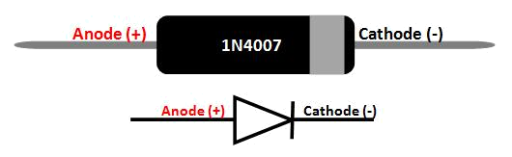

Figure 3.6 Diode symbol

A diode is a device which allows current flow through only one direction. That is the current should always flow from the Anode to cathode. The cathode terminal can be identified by using a grey bar as shown in the picture above.

For 1N4007 Diode, the maximum current carrying capacity is 1A it with stand peaks up to 30A and also it can withstand Reverse voltage up to 1000V.

Features:

- Average forward current is 1A

- Non-repetitive Peak current is 30A

- Reverse current is 5uA.

- Peak repetitive Reverse voltage is 1000V

- Power dissipation 3W

- Available in DO-41 Package

11

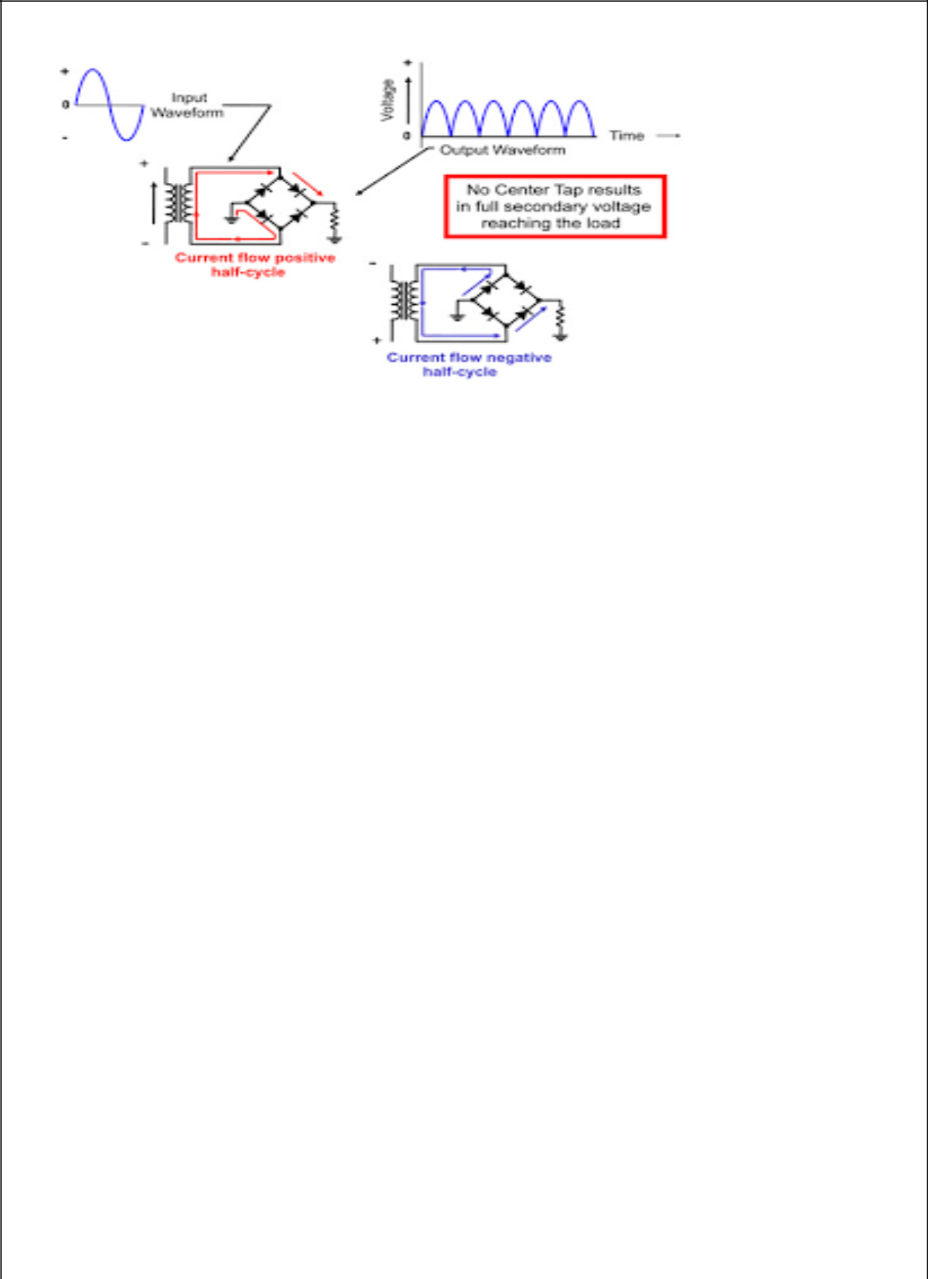

Figure 3.7 Bridge rectifier

Voltage produced by dynamo is in form of AC.To convert from AC into DC we used bridge rectifier consisting of diodes. Depending on the load current requirements, a proper bridge rectifier is selected. Components’ ratings and specifications, breakdown voltage, temperature ranges, transient current rating, forward current rating, mounting requirements and other considerations are taken into account while selecting a rectifier power supply for an appropriate electronic circuit’s application.

3.1.5 Speedometer

To measure the speed and the distance covered while riding the bicycle we have made speedometer using magnetic reed switch. The Arduino calculates the kmph, and send this information out to the LCD screen . It is compatible with any kind of cycle, simply enter the radius of the wheel to calibrate speed and distance covered.

12

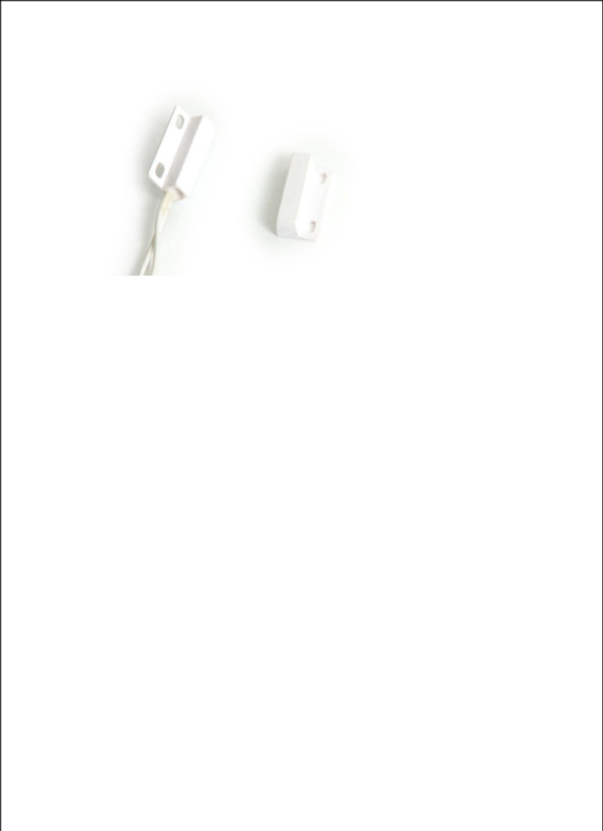

Figure 3.8 Reed switch and magnetic contanct

We have used normally open reed switch in which switch is normally open and whenever a magnetic field comes near the switch, the contacts will be closed.

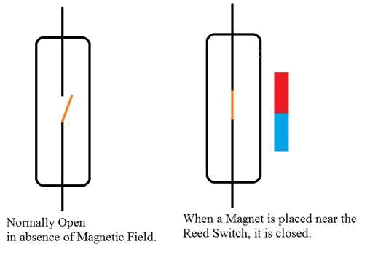

Figure 3.9 Reed switch working

13

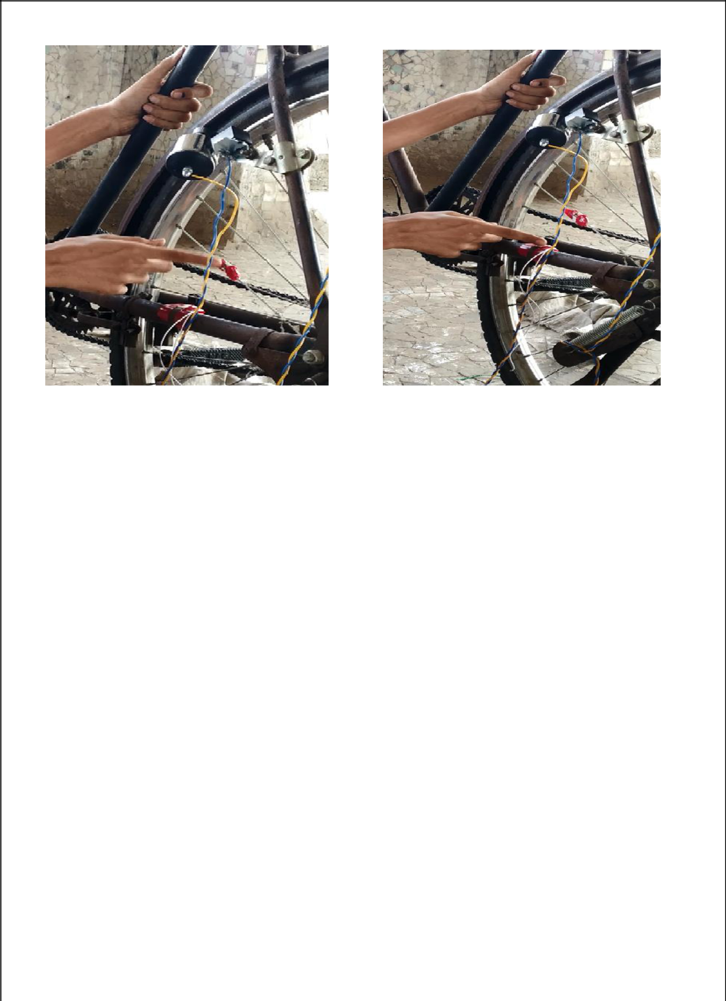

Figure 3.10 Magnet Figure 3.11 Reed switch

The magnetic reed switch is attached on the side frame of cycle and the magnet is attached to the tire spoke as shown in the above figure.When cycle wheel rotates the magnet will pass through the reed switch.

Calculations

Raduis of cycle is measured as 13.5 inches

Converting inch to diameter we get

radius = 0.00034

circumference = 2 * 3.14 * radius

velocity = circumference/(float(time)/1000/3600)

distance = distance + circumference

14

3.2 SOFTWARE REQUIREMENTS

3.2.1 Arduino IDE

The Arduino Integrated Development Environment - or Arduino Software (IDE) - contains a text editor for writing code, a message area, a text console, a toolbar with buttons for common functions and a series of menus. It connects to the Arduino and Genuino hardware to upload programs and communicate with them.

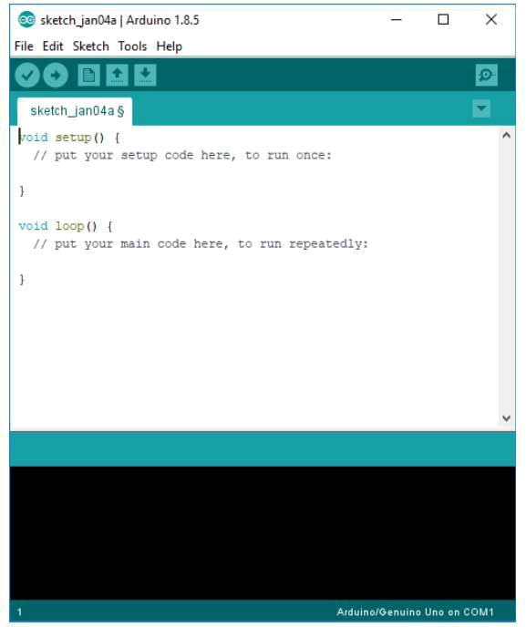

Figure 3.10 Arduino IDE

Programs written using Arduino Software (IDE) are called sketches. These sketches are written in the text editor and are saved with the file extension .ino

15

Verify – Checks the code for errors.

Upload – Compiles your code and uploads to the configured board.

New – Creates a new sketch.

Open – Presents a menu of all the sketches in your sketchbook.

Save – Saves your sketch.

Serial monitor – Opens the serial monitor.

Uploading

Before uploading your sketch, you need to select the correct items from the Tools > Board and Tools > Port menus. On Windows, it's probably COM1 or COM2 (for a serial board) or COM4, COM5, COM7, or higher (for a USB board) - to find out, you look for USB serial device in the ports section of the Windows Device Manager.Once you've selected the correct serial port and board, press the upload button in the toolbar or select the Upload item from the Sketch menu.The Arduino Software (IDE) will display a message when the upload is complete, or show an error.

When you upload a sketch, you're using the Arduino bootloader, a small program that has been loaded on to the microcontroller on your board. It allows you to upload code without using any additional hardware. The bootloader is active for a few seconds when the board resets; then it starts whichever sketch was most recently uploaded to the microcontroller.

Libraries

Libraries provide extra functionality for use in sketches, e.g. working with hardware or manipulating data. To use a library in a sketch, select it from the Sketch > Import Library menu. This will insert one or more #include statements at the top of the sketch

16

and compile the library with your sketch. Because libraries are uploaded to the board with your sketch, they increase the amount of space it takes up. If a sketch no longer needs a library, simply delete its #includestatements from the top of your code.

Serial Monitor

This displays serial sent from the Arduino or Genuino board over USB or serial connector. To send data to the board, enter text and click on the "send" button or press enter. Choose the baud rate from the drop-down menu that matches the rate passed to Serial.begin in your sketch.

3.3 Dynamo

Dynamo is basically an generator which produces current by converting mechanical energy to electrical energy when subjected to rotation[1]. When dynamo is subjected to rotation , a magnetic field is created[1]. Due to this EMF is induced in the coil[1]. This EMF leads to flow of current inside the coil and through the external circuit connected to the coil.[1]

There are two types of Dynamos –

1)Bottle dynamo

2)Hub dynamo.

- Bottle Dynamo:- Bottle dynamo is also known as sidewall dynamo[2]. A bottle dynamo or sidewall dynamo is a small electrical generator for bicycles employed to power a bicycle's lights[2]. It is also used to charge the rechargeable batteries. It is attached on the sidewall of the rear wheel.

17

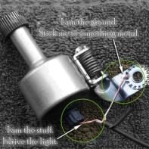

Figure 3.11 Bottle dynamo

- Hub Dynamo:- Hub Dynamo is attached inside the hub of the bicycle[3]. It is also an electrical generator used in the bicycles to power a bicycles lights[3]. It is also used to charge the rechargeable batteries.

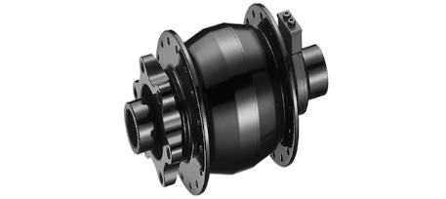

Figure 3.12 Hub dynamo

In our project, we have used Bottle Dynamo over Hub Dynamo due to following reasons:-

18

- Bottle Dynamo is more cost effective then Hub Dynamo and also it is nearly as efficient as hub dynamo.

- Bottle dynamo is more easy to fit into a bicycle. While hub dynamo is difficult to install inside bicycle as it has to be fitted inside the hub of the wheel.

3.4 Lead acid battery

The lead–acid battery was invented in 1859 by French physicist Gasto Planté and is the earliest, yet still most widely used, type of rechargeable battery.

As they are inexpensive compared to newer technologies, lead–acid batteries are widely used even when surge current is not important and other designs could provide higher energy densities. Large-format lead–acid designs are widely used for storage in backup power supplies in cell phone towers, high-availability settings like hospitals, and stand-alone power systems. For these roles, modified versions of the standard cell may be used to improve storage times and reduce maintenance requirements. The electrical energy produced by a discharging lead–acid battery can be attributed to the energy released when the strong chemical bonds of water (H₂O) molecules are formed from H⁺ ions of the acid and O²⁻ ions of PbO₂. Conversely, during charging the battery acts as a water-splitting device, and in the charged state the chemical energy of the battery is mostly stored in the acid.

19

Nominal cell voltage | 2.1V
Charge/discharge efficiency | 50-95%
Charge temperature interval | Min. -35 degree Celsius
 | Max. 45 degree Celsius
Self- discharge rate | 3-20% per month
Specific power | 180/kg

Table 3.1 Battery specifications

Lead-acid battery selection and use

It is important to understand the advantages and limitations of the different lead-acid battery designs available and their performance characteristics. Battery performance is highly dependent on matching the appropriate battery design to the battery application. Lead-acid batteries are designed for engine starting, lighting, and ignition (SLI), deep-cycle (motive power), stationary float service (uninterruptable power supplies or UPS), and energy storage systems. Usually the deep-cycle batteries provide the best performance because they have a high cycle-life.

Specifications

Voltage

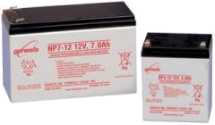

Battery voltage refers to the electric potential difference between the positive and

negative terminal. Manufacturers typically specify the battery's nominal voltage, although

its actual discharge voltage can vary depending on the battery's charge and current. For

20

example, a battery cell with a nominal voltage of 2 V actually discharges between 1.7 and 2.0 volts at a given time. Most round consumer batteries carry a nominal voltage of 1.5 V, while a car battery is typically 12 volts. Depending on the battery materials and application, voltage can range from a fraction of a volt to several kilovolts

Capacity

The amount of charge a battery can store is known as its capacity. Charge is typically measured in amp-hours or milliamp-hours (Ah or mAh). Most manufacturers specify capacity as the constant current that a new battery can supply for 20 hours. For example, a battery rated at 200 Ah can supply 10 A over a 20 hour period at room temperature. If the current supply to the same battery is increased, the capacity will then decrease.

Reserve Capacity

Reserve capacity describes a fully-charged battery's ability to maintain a useful voltage under a 25 amp discharge. Batteries with higher reserve capacities can operate for a longer period without recharging. When discussing deep cycle batteries, reserve capacity in minutes is a more realistic representation of battery performance than capacity expressed in amp-hours.

Applications

Batteries are manufactured for use in numerous applications.

- Consumer batteries
- Energy batteries
- Industrial batteries
- Medical batteries
- Military batteries
- Transportation batteries
- Stand-by/UPS batteries

Advantages

- Inexpensive and simple to manufacture; low cost per watt-hour
- Low self-discharge; lowest among rechargeable batteries
- High specific power, capable of high discharge currents

21

- Good low and high temperature performance

Limitations

- Low specific energy; poor weight-to-energy ratio
- Must be stored in charged condition to prevent sulfation
- Limited cycle life; repeated deep-cycling reduces battery.

Chapter 4

IMPLEMENTATION AND EXPERIMENTATION

4.1 Block Diagram

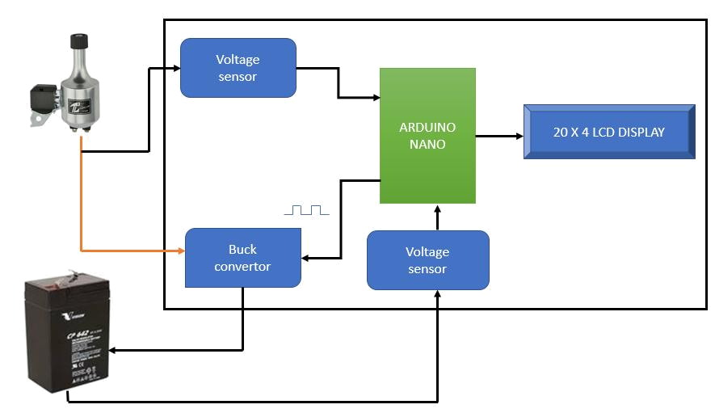

Figure 4.1 Block Diagram

22

ENERGY GENERATION

When the person is riding the cycle the mechanical energy generated is converted into electrical energy by the dynamo which is connected to rear wheel of the bicycle.In this project two dynamo of 12V 6W each are attached to rear wheel of bicycle on both sides of the wheel.The electrical energy generated by dynamo is AC and hence it is converted to DC by bridge rectifier.One bridge rectifier is used for one dynamo and second bridge rectifier is used for other dynamo.This both bridge rectifier are connected in parallel to achieve more current output and make charging more efficient.

BATTERY UNIT

The energy generated by the dynamo is stored in lead acid battery.The battery type,size

depends upon the usage of electricity in household.Lead acid batteries are economical,robust and ruged choice as compared to lithium ion battery.

CHARGE CONTROLLER MODULE

This is the heart of our project.Maximum power point tracking(MPPT) based charge controller is used.It will convert the output of dynamo in suitable format for charging the battery.

The battery charger can be in one of the following four states:

On State

Bulk State

Float State

Off State

23

4.2 Working

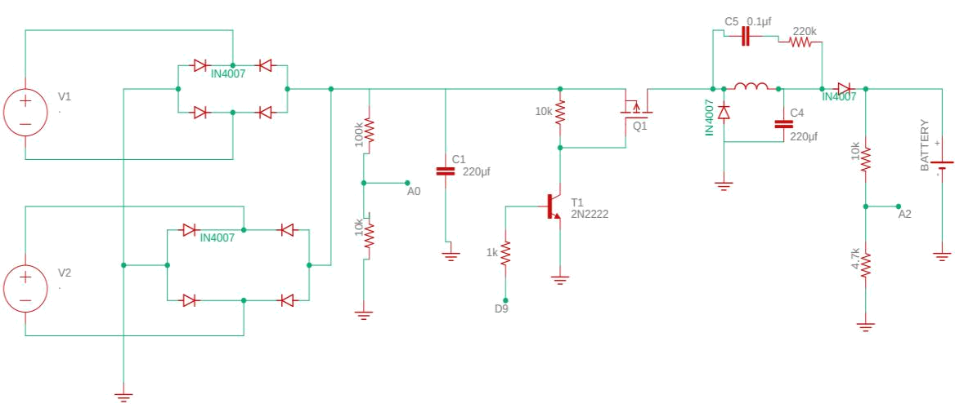

Figure 4.2 Circuit Diagram

The input power from dynamo is rectified by the bridge rectifier consisting of IN4007 diodes.The buck converter is made up of the MOSFET switches Q1 and the energy storage devices inductor L and capacitor C4 and a 1N4007 diode. The inductor smooths the switching current and along with Capacitor C4 it smooths the output voltage.Capacitor C5 and 220K resistor are a snubber network,used to cut down on the ringing of the inductor voltage generated by the switching current in the inductor.

The 2N222 is a MOSFET gate driver. It drives the MOSFET Q1 using the PWM signal from the Arduino (Pin -D9) . The software keeps track of the PWM duty cycle and never allows 100% or always on. It allows the PWM duty cycle at 99.9% to keep the charge pump working.

24

There are two voltage divider circuits( R1=100K,R2=10K and R3=10K,R4=4.7K) to measure the dynamo and battery voltages.The output from the dividers is read by Analog pin-0 and Analog pin-2.

4.3 Component Interfacing

4.3.1 Interfacing LCD

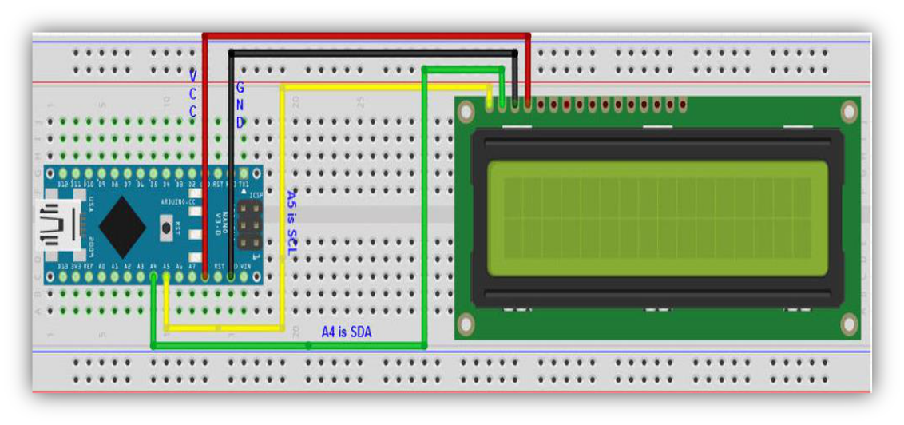

Figure 4.3 LCD interfacing

A 20X4 char LCD is used for monitoring dynamo voltage, battery voltage,battery charging status,speed of cycle and distance covered by the cycle.For simplicity a I2C LCD display is chosen.It needs only 4 wires to interface with the Arduino.

- VCC of LCD > 5V of Arduino nano

- GND of LCD >GND of Arduino nano

- SDA of LCD >A4 of Arduino nano

- SCL of LCD >A5 of Arduino nano

25

4.4 Design Analysis

Schematic includes bridge rectifier,resisitors divider network,capacitors,2N222 transisitor used as mosfet driver.Buck convertor which consists of IRFZ44N power mosfet,220uh inductor,IN4007 diode ,220uf capacitor and a snubber circuit(resistor,capacitor).Microcontroller used is Arduino uno. The interfacing diagram for the whole system and the pin connections are shown below:

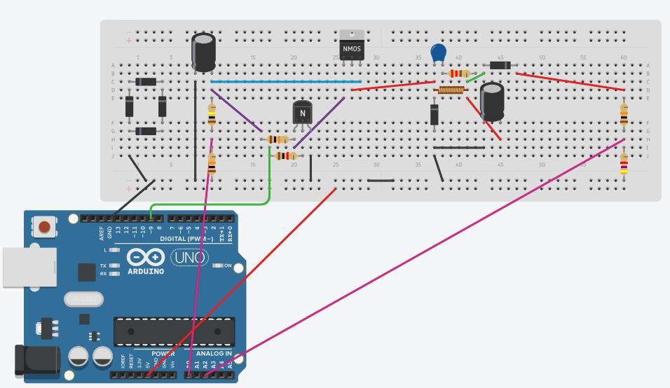

Figure 4.4 Prototype schematic

26

4.5 Implementation Algorithm

The project working algorithm is mentioned below:

- Power-up the system.

- Initialize LCD

- Initially charger state is off

- Voltage sensors sense the voltage of dynamo and battery

- ADC pin reads and averages analog inputs like voltage of battery and dynamo

- PWM duty cycle is set using Timer1 function

- Run charger – Charger goes to each case as follows

- On State - This is charger state for 5 < dynamo volts < 7. In this state the dynamo input is too low for the bulk charging state but not low enough to go into the off state.In this state we just set the pwm = 99.9% to get the most of low amount of power available.

- Bulk State - This is charger state for dynamo volts > 7. This is where we do the bulk of the battery charging and where we run the Peak Power Tracking algorithm. In this state we try and run the maximum amount of current that the dynamos are generating into the battery.

- Float State - As the battery charges it's voltage rises. When it gets to the maximum battery volts we are done with the bulk battery charging and enter the battery float state. In this state we try and keep the battery voltage at max battery volts by adjusting the pwm value.

- Off State - This is state that the charger enters when dynamo volts < 5. The charger goes into this state when there is no more power being generated by the dynamo. The MOSFETs are turned off in this state so that power from the battery doesn't leak back.

- Display parameters on LCD.

27

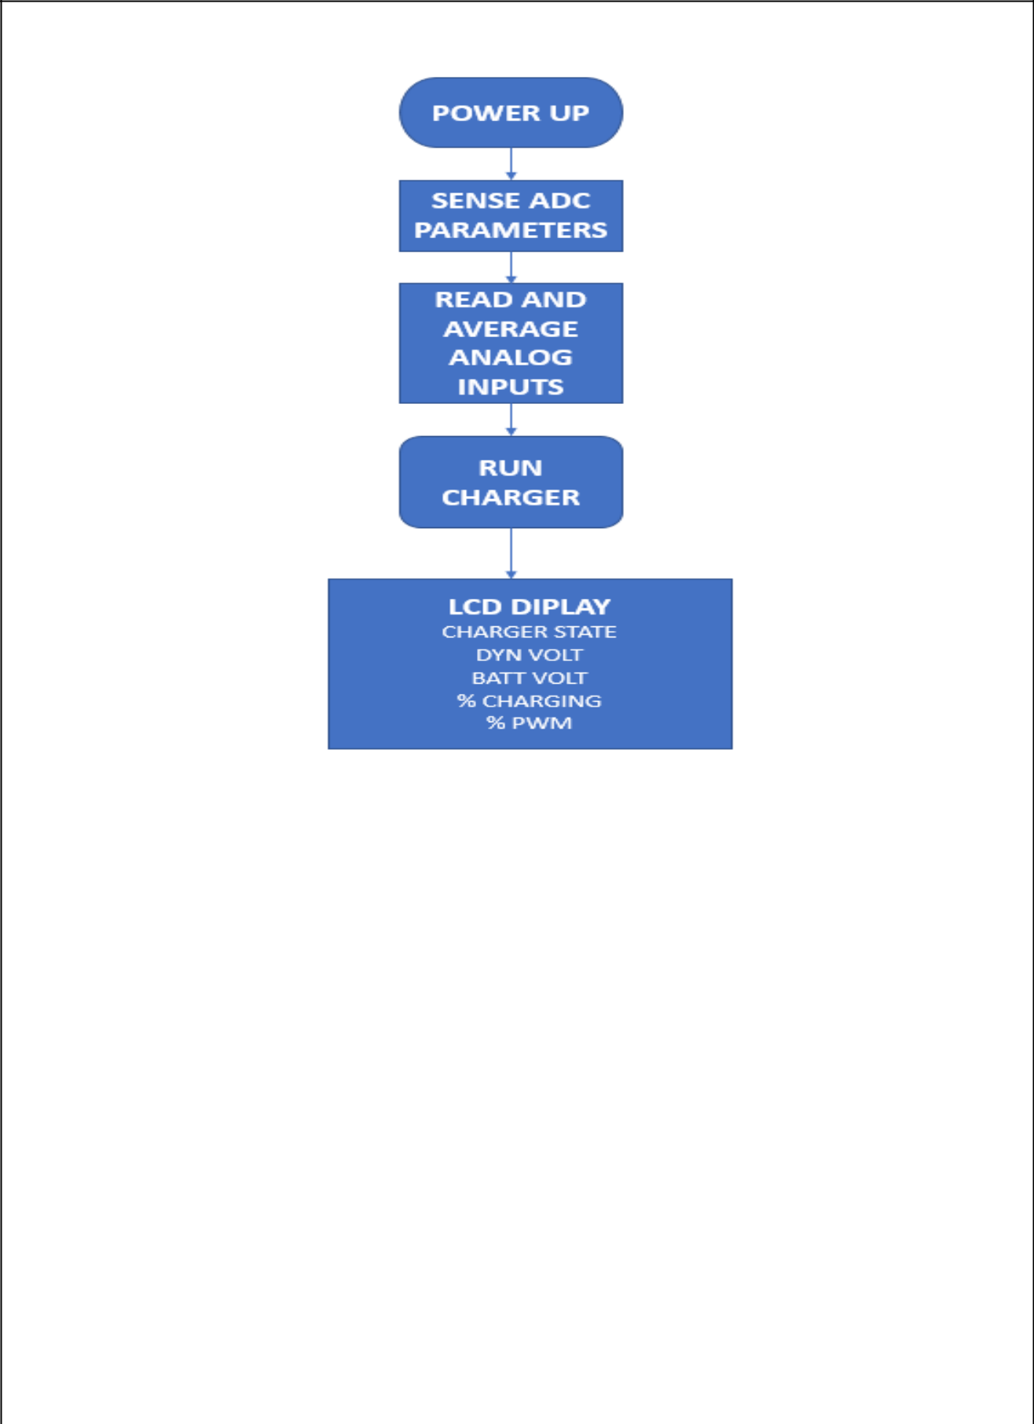

Figure 4.5 Flowchart

28

CHAPTER 5

RESULTS
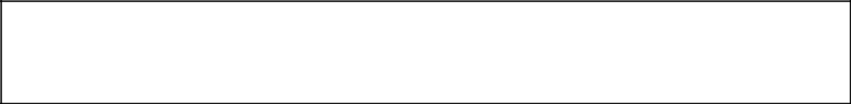

This chapter gives concise information of the block diagram designed by us and followed by the results of the project.

When the cycle is moving dynamo generates the voltage as per the speed of the cycle as we can see in the fig below

When cycle speed is slow dynamo voltage is 2.63V and battery is 33% charged

When cycle speed increases dynamo voltage increases to 8.94V and riding the cycle continuously increases the charged percent of battery to 41% and then to 58% as displayed on LCD
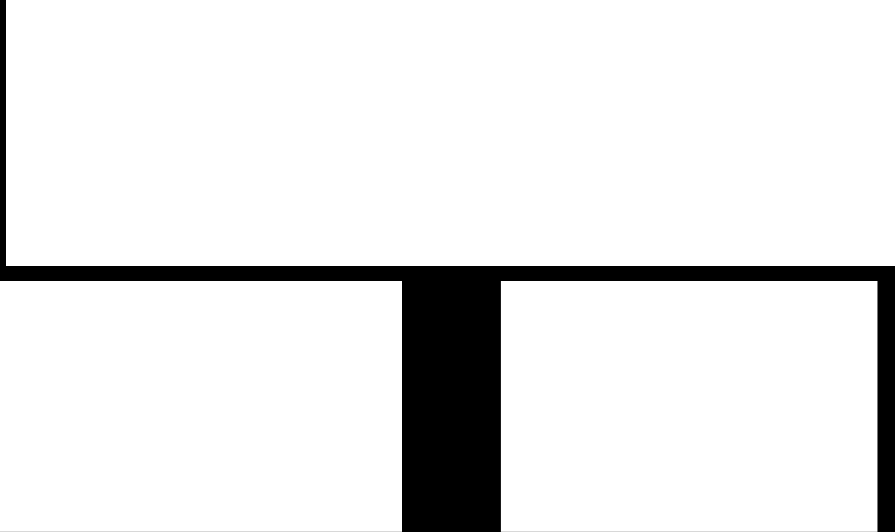
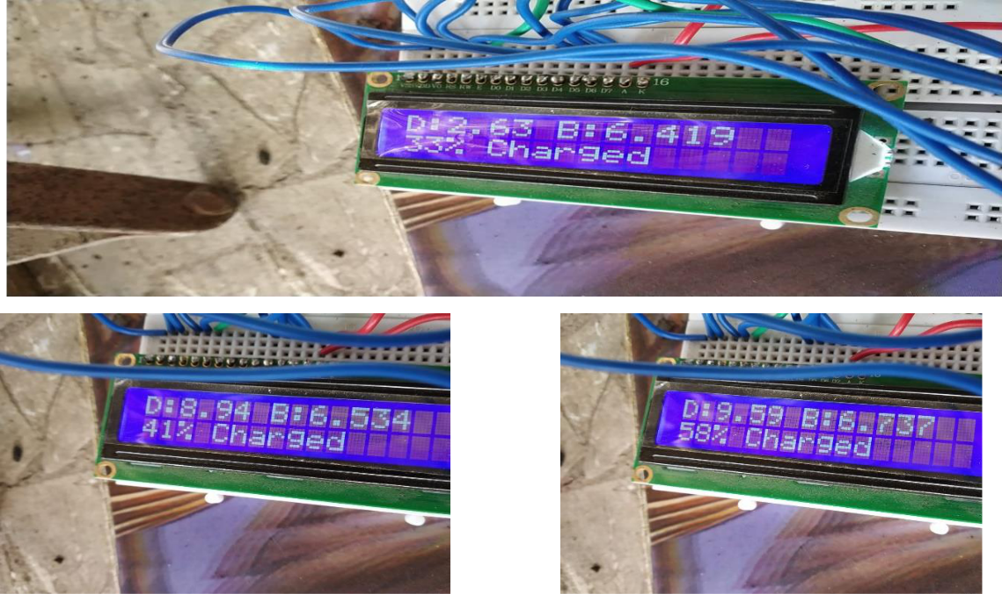

Figure 5.1 Result

29

Chapter 6

Future Scope

This chapter elaborates on the further applications of the project.

1)Better efficiency :

In the future we would like to improve the efficiency of the system to harness more power by modifying the design to integrate multiple battery or single battery with higher capacity.

We can use waterproof disconnects to lower the loss due to transmission of current through the medium. Waterproofing will help in prevention of the system from any water contact leading to short circuiting and damaging the circuit.

Solar panels is also a way to increase the efficiency of the output as solar energy is not a new concept to us and its installation and maintenance is not that difficult.

2)Similar mechanical apparatus:

We will try to implement this concept on other similar mechanical apparatus which are commonly used in villages and modify our design according to it.

Like Sewing machine application the dynamo circuit can be attached to the rotating wheel of the machine similarly the way it works with the bicycle.

3) Electric bike:-

The energy generated from the dynamo circuit can be used to drive the bicycle using a dc electric motor fitted at the front wheel of the cycle. E-bike are becoming the next big change in the world of machines due it benefits over the already present vehicles in the market and without the use of non-renewable resources. This concept will also make the

30

bike more efficient as while the bike is using the stored energy to accelerate at the same time the dynamo circuit is generating the energy constantly.

4) Gymnasium:-

Dynamos or alternator can be attached to the gym equipments like spinning bike.This machine without difficulty converts existing equipment into electricity producing machines so that when we step on and start cycling we will be able to produce DC energy that can be stored into battery.This charged battery than can be used to power gym lightings and other purposes by converting DC energy into AC energy using inverter circuit.

31

Chapter 7

Conclusion

In the present situation where the Indian government is trying hard to meet the electricity demand of the country,providing atleast the bare minimum lighting for a rural house will be great comfort for its inhabitants as it will aid them in many of their daily activities.Towards achieving this goal we have successfully designed the project power generation using bicycle.this generated power can be used in many application where electric power is required. Due to easy and simplified circuit it provides a low cost and easy installation on the bicycle which is used as common mode of transport in villagesWe meet our goal to help the people of rural area by using our prototype on their bicycle and it will play an important role in development and empowering rural areas.

32

BIBLIOGRAPHY

- https://en.wikipedia.org/wiki/Dynamo

- https://en.wikipedia.org/wiki/Bottle_dynamo

- https://en.wikipedia.org/wiki/Hub_dynamo

- https://store.arduino.cc/usa/arduino-nano

- Sci-Hub | Pedalite: Lighting up Lives in Un-electrified Villages |

10.1109/GHTC.2012.61

- Sci-Hub | Turning sweat into watts | 10.1109/MSPEC.2011.5910449.

- Design_of_a_Bicycle-_and_Solar-

Powered_Lighting_System_for_Rural_Vietnamese_Students.pdf

- Battery Charging Tutorial | ChargingChargers.com

- Energydrive.com/pwm vs mppt charge controller.

- http://www.appropedia.org/Rowan%27s_portable_pedal_power_generator

  - http://www.los-gatos.ca.us/davidbu/pedgen.html

  - http://www.lowtechmagazine.com/2011/05/bike-poweredelectricity-generators.html

  - http://scienceshareware.com/bicycle-generator-faq.html

  - http://www.alternative-energy-news.info/technology/humanpowered/pedal-power/

  - Tom Gibson, “These Exercise Machines Turn Sweat into Electricity”, IEEE

Spectrum, July 2011.

33

ACKNOWLEDGEMENT

We would like to express our gratitude firstly to our college K. J. Somaiya College Of Engineering and the Electronics And Telecommunication (EXTC) Dept. for allowing us to embark on this opportunity. We would like to express our sincere gratitude to our internal guide Mrs. Jyoti Varavadekar for her endless support throughout our course of project. We would like to thank her for valuable suggestions regarding the project and report.

Finally , we would like to thank the Head of Department Dr.Ameya Naik and all the faculty as well as non-teaching staff. Without their co-operation, it wouldn’t have been possible to have gain the knowledge we have acquired throughout the engineering course. Such opportunities really enrich our knowledge and experience about the industry even before entering in the professional world.

34

