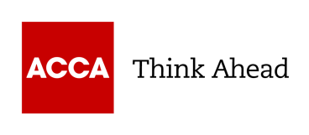
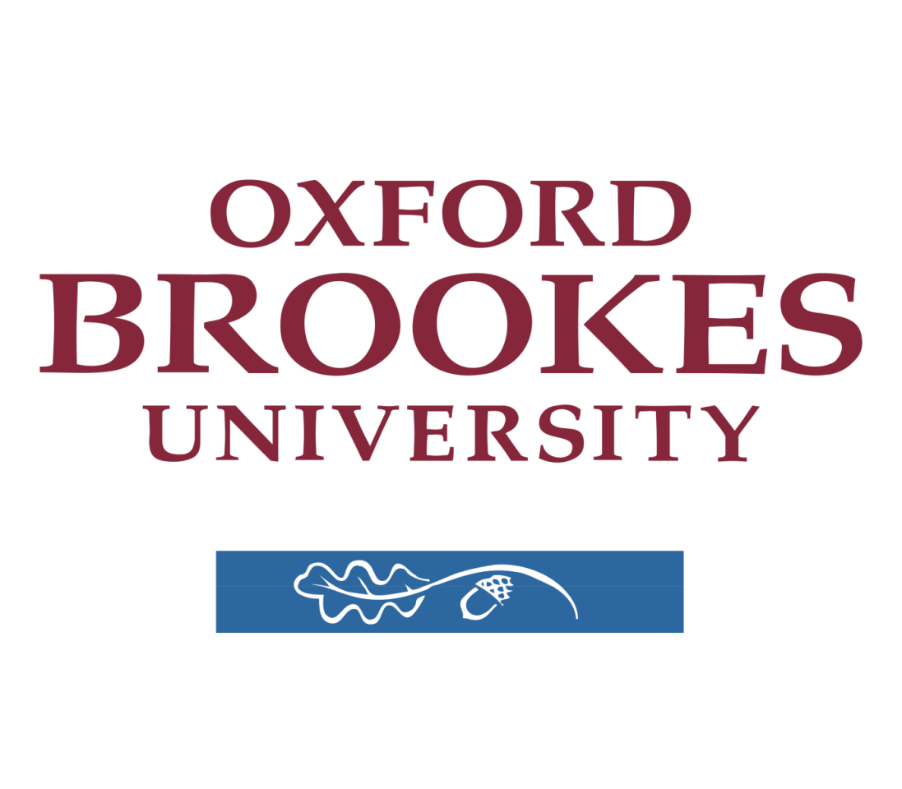

ACCA Registration number: 5593364
Submission period: 51
Word count: 1925

Sills and Learning Statement

Q1. How have you developed, personally and professionally, as a result of undertaking the research and analysis project?

- What new skills you acquired and how you developed them?

- Data interpretation skills - I began the project in 2024, but I had to postpone it until 2025 submissions because of my unfortunate ACCA exam results. I nearly finished my RAP in March, and after my second attempt at the exams, I realised that the data interpretation skills I had acquired through Rap had helped me ace my ACCA exams, including SBL and ATX. This skill also helped me in my trading journey by enabling me to analyse the fundamentals and publicly available information of various listed companies.

- Software abilities - Before I began working on this OBU project, I had a basic understanding of Microsoft Word, Excel, and PowerPoint; but, as I progressed through the program, I gained a significant amount of knowledge about it. Due to the fact that Microsoft Excel is an essential tool in the auditing and financial industries, this was beneficial to me in my ACCA professional tests and will continue to be beneficial to me in my future job.

- Reflective and emotional Awareness - Before commencing the project, I was anxious and uncertain about the results. However, the discipline, grit, and consistency required to complete the project convinced me that the process was more significant than the outcome, and that worrying about the outcome was causing me anxiety and apprehension. This ability proved advantageous in my subsequent academic and trading activities, as it enabled me to more effectively manage my emotions and increase my self-assurance.

- Business Competencies - Prior to commencing the project, I was unaware of the global operations, management, and presentation of major corporations like PepsiCo and Coca Cola. However, I acquired a wealth of information about the operations of these companies as soon as I began the assignment and conducted research on the numerous ratios and their history. Additionally, I acquired a wealth of new terminology. I have always been intrigued by the manner in which their expenses are allocated and how they achieve profitability or loss. However, upon finishing the assignment, I acquired a wealth of new knowledge.

- The challenges you faced and how you overcame them?

  - Skill challenge - I did not seek any guidance or mentorship when I initiated this project. However, upon reflection, I came to the realisation that my format was not in accordance with the format recommended by OBU. I made numerous attempts to improve it, but I was unable to do so. This presented a challenge for me, but I was able to overcome it by hiring an OBU-certified mentor who provided me with subtle guidance that enabled me to comprehend the format. I also adhered to the project's guidelines and prescribed formats.

  - Over detailing - By the time I had finished my assignment for the first time, I had gone over the word limit for the rap. I looked to all of the publications that were available on the internet that explained the rise or reduction in ratio. There were a lot of papers with this explanation. However, when I noticed that my word limit had been increased, and my mentor also guided me regarding the same, I realised that referring to all of the articles that explain the same point will not only hinder the word limit, but it will also not add any new value to the project. As a result, I decided to keep the information that is prudent to the project, and this helped me overcome the challenge of over-detailing or elaborating.

  - Balancing priorities- I was unable to devote the necessary time to research reporting when I commenced the OBU project, as I was preoccupied with my family business, my ACCA examinations, and trading. I was unable to devote a full amount of time to OBU, which resulted in the creation of invalid points and the reliance on unreliable sources of information. However, upon the completion of the submissions, I came to the realisation that I needed to priorities tasks in order to ensure the project's success and success on the first attempt. Consequently, I temporarily abstained from my business and trading activities and redirected my attention to ACCA and OBU. This approach not only enabled me to complete the project on time, but also enabled me to discuss any insights I gained from my mentor.

  - Lack of Relevant Data - During the preparation of the ratios for the companies I selected for the research report, I encountered no obstacles; however, the process of clarifying on them and locating references to assist in their explanation or analysis was a significant challenge for me. A significant number of websites on the internet are clickbait websites, which display incomplete or unverifiable information in order to either generate controversy for companies or require a monetary subscription to access the full information. I encountered difficulty in locating pertinent data for references and analysing the company. However, I was fortunate to acquire a wealth of knowledge on ratio analysis during my preparation for the SBR exam, as I conducted numerous ratio analyses for numerous companies. Consequently, I was able to overcome this challenge by leveraging prior knowledge to identify which websites on the internet were providing information that was either valid or logical.

Q2. How will the experience of the RAP help you in the future?

- Made you more employable and capable.

  - Consistency - While working on the project, I observed a pattern in which I was only able to allocate time to it when I was motivated. This was not a positive factor, as there were only a few days when I was motivated, and I would only conduct research on those days. I was wasting my time on the other days. However, I came to the realisation that motivation was not as important as discipline, and I continued to conduct research and report on the project every day until it was completed. In my opinion, the realisation that discipline and consistency are more important than motivation will be beneficial to me in both my business and trading ventures.

  - Mental Toughness - As previously stated in the first section of SLS, I initiated this project in 2024. However, the unfortunate results of my ACCA exams necessitated that I postpone the project until 2025. This left me feeling somewhat disheartened and demotivated, as I was required to begin and modify certain aspects of the report, which was akin to re-starting the project. The task of leaving all of the previous work and refocusing on the project was challenging. However, once I shifted my attention from the negative to the positive, I realised that growth is not constant and that everyone must experience both highs and lows. This was the first significant disappointment of my life, and it served as a psychological strengthener. I believe that life is too vast, and in the future, if I encounter any obstacles associated with my employment, I will be emotionally mature enough to comprehend them and avoid becoming demotivated and lowering my spirits.

  - Business Knowledge - I discovered a number of new expenses and tax-saving strategies during the assignment, as well as new and varied procedures used by the businesses I studied. I also gained knowledge about how large corporations operate. This was interesting for me since it would help me grasp the technical aspects of many companies whose shares I will trade on the public market in the future. Additionally, the various procedures I learnt throughout my study will help me develop those kinds of insights in my firm and automate it.

  - Social Skills - Before commencing the OBU project, I was puzzled and uncertain about whether or not to pursue it. However, I ultimately resolved to consult with a classmate of mine who is a platinum-certified member of the ACCA institute. Subsequently, I sought the advice of individuals who had previously submitted the project on LinkedIn. They provided me with valuable insights regarding the advantages of this specific program and how it had benefited them in an array of roles. I have always aspired to become a CFA, and the CFA program necessitates a bachelor's degree. Therefore, I believe that this will be extremely beneficial.

- Might influence your future plans in the short and longer term.

  - Data-Backup - My initial experience with the OBU project was disappointing. While completing my Excel file, my laptop collapsed, resulting in the complete formatting of my MS Excel file. I was compelled to begin the project from beginning, which was not a pleasant experience. After that, I conducted daily backups of my entire project. I was also concerned that my other files, which relate to trading algorithms and business, were susceptible to this type of risk. Consequently, I took a data backup of all the files and stored them on the cloud.

  - Positive feedback - I initially made numerous errors when I began my project, and I ignored feedback from my mentor due to my innate nature. However, her positive outlook and natural feedback style helped me realise that these errors were consuming a significant amount of my time. As a result of this project, I have acquired the ability to provide and receive constructive criticism. This will enable me to subtly influence my subordinates in my business, and it will provide me with positive feedback that will be beneficial for my personal development if I choose to pursue a position in the future.

- Vocabulary- During the preparation of this OBU project, I acquired the ability to effectively communicate and utilise professional jargon. This will allow me to more effectively communicate with my colleagues, and my keen interest in private equity will enable me to establish professional relationships and seek professional assistance.

- Tax Planning - The tax savings also led to their higher ratio as deferred tax asset/liability was influenced, and lower taxes led to greater profit margins for both firms. When I first started performing research reports, I saw that both companies were legally able to save money on taxes by doing straightforward things. In my capacity as a businessperson and a part-time trader, this will be of great use to me in terms of my long-term income tax obligations. I will be able to comprehend the ways in which I may adjust some aspects of my income in order to avoid having to pay substantial taxes, and it will also assist me in the process of tax planning.

- Emotional Stability I was not following the structure for the reference report when I started this project, and I also screwed up the word limit for both the Sls and the RAP. When I realised that I had done this, I became nervous. However, when I realised that I could make it better and that I should not let my mind to fool me into not enhancing the project, I gradually began to regulate my emotions and I developed a steady relationship with them. In the event that my transaction does not go as planned or if my seasonal profitability is decreased, this will be of assistance to me in my business. When it comes to trading, this will also be of great use to me, as it will assist me in avoiding taking risks that are both foolish and unnecessary.

