CHAROTAR UNIVERSITY OF SCIENCE & TECHNOLOGY
DEVANG PATEL INSTITUTE OF ADVANCE TECHNOLOGY & RESEARCH
Department of Computer Engineering
Subject Name:Web Development Framework
Semester: III
Subject Code: ITEU204
Academic year: 2025-26 [ODD]

Practical File
No. | Aim of the Practical
1&2. | Problem Definition:1  Initiate the “Project Title” by defining scope, key pages (min. 10), and layout  with HTML skeletons.  Problem Definition:2  Design a fully responsive layout for the portal home, about, and registration  pages using CSS and Flexbox/Grid.  PROGRAM CODE :  <!DOCTYPE html>  <html lang="en">  <head>  <meta charset="UTF-8" />  <meta name="viewport" content="width=device-width, initial-scale=1.0"/>  <title>Home page</title>  <link rel="stylesheet" href="index.css">  <style>  body {  font-family: Arial, sans-serif;  margin: 0;  padding: 0;  background-color: #f5f7fa;  }  .container {  display: flex;  justify-content: space-between;  padding: 30px;  }  .column {  width: 30%;  }  .left-buttons,  .right-buttons {  display: flex;  flex-direction: column;  gap: 15px;  }  .left-buttons p,  .right-buttons p {  margin: 0;  }  .button-box {  background-color: #2286c3;  color: white;  padding: 15px;  text-align: center;  font-weight: bold;  border-radius: 6px;  transition: background 0.3s;  cursor: pointer;  }  .button-box:hover {  background-color: #1769aa;  }  .center-panel {  background-color: white;  border-radius: 6px;  padding: 15px;  box-shadow: 0 2px 8px rgba(0,0,0,0.1);  }  .center-panel h3 {  margin-top: 0;  background-color: #0054a6;  color: white;  padding: 10px;  border-radius: 4px;  font-size: 18px;  }  .tabs {  display: flex;  justify-content: space-around;  margin: 15px 0;  font-weight: bold;  }  .tabs label {  cursor: pointer;  color: #0054a6;  }  .news-list {  border: 1px solid #ddd;  border-radius: 4px;  padding: 10px;  font-size: 14px;  }  .news-list option {  padding: 5px;  }  .view-all a {  color: white;  text-decoration: none;  }  .view-all {  background-color: #0054a6;  padding: 15px;  text-align: center;  font-weight: bold;  border-radius: 6px;  margin-top: 10px;  }  .view-all:hover {  background-color: #004080;  }  .partner-logos-section {  background-color: #f4f4f4;  padding: 20px 0;  text-align: center;  }  .logo-bar {  display: flex;  justify-content: center;  align-items: center;  flex-wrap: wrap;  gap: 40px;  }  .logo-bar img {  width: 117px;  max-height: 65px;  object-fit: contain;  }  .logo-bar img:hover {  transform: scale(1.05);  }  .apply-section {  display: flex;  flex-wrap: wrap;  justify-content: center;  gap: 20px;  background-color: #f5f5f5;  padding: 40px 20px;  }  .apply-card {  width: 230px;  background-color: white;  border-radius: 12px;  padding: 20px;  text-align: center;  color: black;  font-family: Arial, sans-serif;  box-shadow: 0 4px 12px rgba(0, 0, 0, 0.1);  position: relative;  transition: transform 0.3s ease;  }  .apply-card img {  width: 50px;  height: 50px;  margin-bottom: 10px;  }  .apply-card h3 {  font-size: 18px;  margin-bottom: 10px;  }  .apply-card p {  font-size: 14px;  margin-bottom: 15px;  color: #fff;  }  .apply-card a {  background-color: white;  color: inherit;  text-decoration: none;  font-weight: bold;  padding: 8px 14px;  border-radius: 5px;  display: inline-block;  transition: background 0.3s;  }  .apply-card a:hover {  background-color: #e6e6e6;  }  .apply-card.migration {  background-color: #03A9F4;  }  .apply-card.duplicate {  background-color: #8BC34A;  }  .apply-card.equivalent {  background-color: #673AB7;  }  .apply-card.nri {  background-color: #F44336;  }  .apply-card:hover {  transform: translateY(-5px);  }  </style>  </head>  <body>  <div class="top-header">  <div class="logo-area">  <img src="headimg.png" alt="Logo" />  <h2>Gujarat Secondary and Higher Secondary Education Board<br><small>Education Department - Official Site</small></h2>  </div>  <div class="top-right">  <div>  Skip to main content | Screen Reader Access <br />  <a href="#">Home</a> |  <a href="#">Feedback</a> |  <a href="faq.html">FAQ</a> |  <a href="#">Sitemap</a>  </div>  <div class="font-size-controls">  <button>A-</button>  <button>A</button>  <button>A+</button>  <span>English</span> |  <span>ગુજરાતી</span>  </div>  <div class="login-register">  <a href="login.html">🔓Login</a> |  <a href="register.html">➕Register Now</a>  </div>  </div>  </div>  <nav>  <div class="nav-item"><a href="index.html">Home</a></div>  <div class="nav-item">  <select onchange="location = this.value;">  <option value="">About Board</option>  <option value="OrganizationStructure.html">Organization Structure</option>  <option value="Contact.html">Contact</option>  <option value="Branches.html">Branches</option>  </select>  </div>  <div class="nav-item">  <select onchange="location = this.value;">  <option value="">School</option>  <option value="StaticalData.html">Statical Data</option>  <option value="SchoolRegistration.html">School Registration</option>  <option value="NewSchoolApplication.html">New School Application</option>  <option value="NewClassApplication.html">New Class Application</option>  </select>  </div>  <div class="nav-item">  <select onchange="location = this.value;">  <option value="">Students</option>  <option value="10QuestionPaper.html">10 Question Paper</option>  <option value="12QuestionPaper.html">12 Question Papers</option>  </select>  </div>  <div class="nav-item">  <select onchange="location = this.value;">  <option value="">Teachers</option>  <option value="Teachers.html">Teacher Info</option>  </select>  </div>  <div class="nav-item">  <a href="Result.html">Result</a>  </div>  <div class="nav-item">  <select onchange="location = this.value;">  <option value="">E-Citizen</option>  <option value="right-to-information.html">Right To Information</option>  <option value="act-rules.html">Act & Rules</option>  <option value="government-resolutions.html">Govt Resolutions</option>  <option value="tenders.html">Tenders</option>  <option value="Gallery.html">Gallery</option>  <option value="circulars.html">Circulars</option>  </select>  </div>  <div class="nav-item"><a href="ImportantLinks.html">Important Links</a></div>  <div class="nav-item"><a href="matdaryadi.html">Matdar Yadi</a></div>  <div class="nav-item calendar-icon">📅</div>  </nav>  <div class="container">  <div class="column left-buttons">  <p><strong>Board Website Links</strong></p>  <div class="button-box">Board Website</div>  <div class="button-box">School Registration</div>  <div class="button-box">Teacher Registration</div>  <div class="button-box">Online Student Exam Registration 10th (SSC)</div>  <div class="button-box">Online Student Exam Registration 12th (HSC Science)</div>  </div>  <div class="column center-panel">  <h3> News Highlights</h3>  <div class="tabs">  <label>ALL</label>  <label>DEO</label>  <label>STUDENT</label>  <label>SCHOOL</label>  <label>MEDIA</label>  </div>  <div class="news-list">  <select size="15" style="width: 100%; border: none;">  <option>>ધોરણ-૯થી૧૨નાવિદ્યાર્થીઓમાટેBISAG નામાધ્યમથીશૈક્ષણિકકાર્યક્રમોપ્રસારિતકરવાબાબત. (June-2025)</option>  <option>>બોર્ડનીધોરણ-10 અનેધોરણ-12નીપૂરકપરીક્ષાતા.03/07/2025નાહાજર-ગેરહાજરવિગત</option>  <option>>બોર્ડનીધોરણ-10 અનેધોરણ-12નીપૂરકપરીક્ષાતા.02/07/2025નાહાજર-ગેરહાજરવિગત</option>  <option>>બોર્ડનીધોરણ-10 અનેધોરણ-12નીપૂરકપરીક્ષાતા.01/07/2025નાહાજર-ગેરહાજરવિગત</option>  <option>>બોર્ડનીધોરણ-10 અનેધોરણ-12નીપૂરકપરીક્ષાતા.30/06/2025નાહાજર-ગેરહાજરવિગત</option>  <option>>બોર્ડનીધોરણ-10 અનેધોરણ-12નીપૂરકપરીક્ષાતા.28/06/2025નાહાજર-ગેરહાજરવિગત</option>  <option>>બોર્ડનીધોરણ-10 અનેધોરણ-12નીપૂરકપરીક્ષાતા.24/06/2025નાહાજર-ગેરહાજરવિગત</option>  <option>>બોર્ડનીધોરણ-10 અનેધોરણ-12નીપૂરકપરીક્ષાતા.23/06/2025નાહાજર-ગેરહાજરવિગત</option>  <option>>ધોરણ-૧૨સામાન્યપ્રવાહનાંઅંગ્રેજીવિષયનીITI નાંવિદ્યાર્થીઓનીપૂરકપરીક્ષાહોલટિકિટ</option>  <option>>ધોરણ-૧૨સામાન્યપ્રવાહપૂરકપરીક્ષામાટેનુંહોલટિકિટતથાનિમણૂકપત્ર</option>  <option>> Not Approved New School Application 10.02.2025</option>  <option>> Provisional Approved New School Application 10.02.2025</option>  <option>>ધોરણ-૧૨સામાન્યપ્રવાહનાઆંતરિકમૂલ્યાંકનાગુણઅંગેસૂચના</option>  <option>>ધોરણ-૧૨વિજ્ઞાનપ્રવાહનાઆંતરિકમૂલ્યાંકનાગુણઅંગેસૂચના</option>  <option>> Action Plan February-2025 Examination</option>  <option>>ધોરણ-૧૦નાઆંતરિકમૂલ્યાંકનાગુણઅંગેસૂચના</option>  <option>>ધોરણ-૧૨વિજ્ઞાનપ્રવાહપ્રાયોગિકપરીક્ષાગુણઅંગેસૂચના</option>  </select>  </div>  </div>  <div class="column right-buttons">  <div class="button-box">Online Student Exam Registration 12th (HSC General)</div>  <div class="button-box">Migration Certificate</div>  <div class="button-box">Duplicate Marksheet</div>  <div class="button-box">Equivalent Certificate</div>  <div class="view-all"><a href="#">View All Links >>></a></div>  </div>  </div>  <section class="apply-section">  <div class="apply-card migration">  <img src="D:\web\home222.png" alt="Migration Icon" />  <h3>Migration Certificate</h3>  <p>Apply online for 10<sup>th</sup>–12<sup>th</sup> Migration Certificate</p>  <a href="migration.html">APPLY NOW</a>  </div>  <div class="apply-card duplicate">  <img src="D:\web\home111.png" alt="Duplicate Marksheet Icon" />  <h3>Duplicate Marksheet</h3>  <p>Apply for 10<sup>th</sup>–12<sup>th</sup> Duplicate Marksheet/Certificate</p>  <a href="duplicate.html">APPLY NOW</a>  </div>  <div class="apply-card equivalent">  <img src="D:\web\home333.png" alt="Equivalent Certificate Icon" />  <h3>Equivalent Certificate</h3>  <p>Apply for 10<sup>th</sup> and 12<sup>th</sup> Equivalent Certificate</p>  <a href="equivalent.html">APPLY NOW</a>  </div>  <div class="apply-card nri">  <img src="D:\web\home444.png" alt="NRI Icon" />  <h3>Admission Eligibility</h3>  <p>For NRI</p>  <a href="nri.html">APPLY NOW</a>  </div>  </section>  <div class="partner-logos-section">  <div class="logo-bar">  <img src="D:\web\11home.png" alt="Logo 1" />  <img src="D:\web\0home.png" alt="Logo 2" />  <img src="D:\web\1home.png" alt="Logo 3" />  <img src="D:\web\2home.png" alt="Logo 4" />  <img src="D:\web\3home.png" alt="Logo 5" />  <img src="D:\web\4home.jpg" alt="Logo 6" />  </div>  </div>  <footer class="last-heading"><center>  <p>Education Department | Commissionerate Mid Day Meal & Schools | Commissionerate of Higher Education</p>  <p>Gujarat Institute of Educational Technology | Director of Literacy & Continuing Education | Commissionerate of Technical Education</p>  <p>Directorate of Primary Education | National Cadet Corps | Sarva Shiksha Abhiyan</p>  <p>Gujarat Secondary and Higher Secondary Education Board | State Examination Board</p>  <p>Gujarat State Board of School Textbooks | State Board of Technical Examinations Gujarat</p>  <p>Gujarat Council of Educational Research and Training</p>  <p><a href="index.html">Home Page</a></p>  <p>Privacy Policy | Terms of Use | Disclaimer</p>  </center>  </footer>  </body>  </html>  Home page css code:  body {  margin: 0;  font-family: Arial, sans-serif;  }  .top-header {  display: flex;  justify-content: space-between;  align-items: flex-start;  padding: 10px 20px;  }  .logo-area {  display: flex;  align-items: center;  }  .logo-area img {  width: 80px;  height: auto;  }  .logo-area h2 {  margin: 0 0 0 10px;  font-size: 18px;  line-height: 1.2;  color: #1a237e;  }  .top-right {  font-size: 13px;  text-align: right;  }  .top-right a {  text-decoration: none;  color: #333;  margin-left: 10px;  }  .top-right a:hover {  text-decoration: underline;  }  .font-size-controls button {  margin: 0 2px;  }  nav {  background-color: #114a7e;  display: flex;  flex-wrap: wrap;  justify-content: flex-start;  }  nav a, nav select {  color: white;  padding: 14px 16px;  text-decoration: none;  background: none;  border: none;  font-size: 14px;  cursor: pointer;  }  nav a:hover,  nav select:hover {  background-color: #0a3960;  }  nav select {  background-color: #114a7e;  color: white;  }  nav select option {  color: black;  }  nav .nav-item {  position: relative;  display: flex;  align-items: center;  border-left: 1px solid #0a3960;  }  nav .nav-item:first-child {  border-left: none;  }  .calendar-icon {  font-size: 18px;  padding: 14px;  }  .login-register {  margin-top: 5px;  }  .last-heading{  background-color: black;  color: aliceblue;  }  footer {  margin-top: 60px;  padding: 20px;  background-color: #f1f1f1;  color: #555;  }  footer a {  color: #007bff;  text-decoration: none;  }  footer a:hover {  text-decoration: underline;  }  OUTPUT:  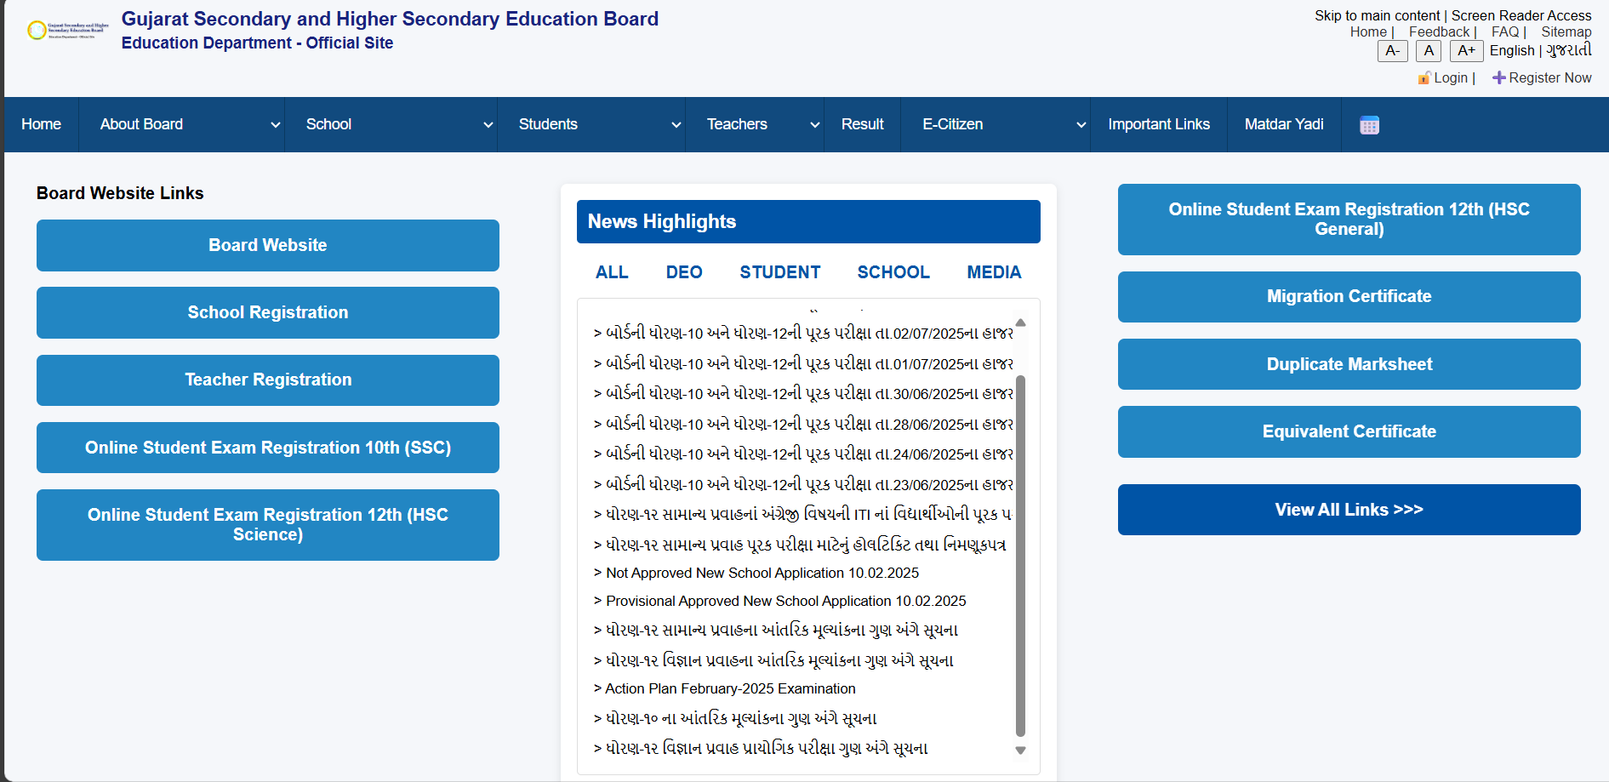    Figure:1 Home page  PROGRAM CODE :  <!DOCTYPE html>  <html lang="en">  <head>  <meta charset="UTF-8">  <meta name="viewport" content="width=device-width, initial-scale=1.0">  <title>matdaryadi</title>  <link rel="stylesheet" href="index.css">  <style>  table {  margin: 0 auto 30px auto;  border-collapse: separate;  border-spacing: 10px;  }  th {  background-color: #21865c;  color: white;  font-size: 18px;  padding: 12px;  border-radius: 6px;  }  td {  background-color: #1976d2;  color: white;  font-weight: bold;  padding: 10px 16px;  border-radius: 6px;  cursor: pointer;  min-width: 120px;  transition: background 0.3s ease;  }  td:hover {  background-color: #1565c0;  }  /* Responsive Layout */  @media screen and (max-width: 768px) {  table, td, th {  font-size: 14px;  padding: 6px;  min-width: auto;  }  }  </style>  </head>  <body>  <div class="top-header">  <div class="logo-area">  <img src="headimg.png" alt="Logo" />  <h2>Gujarat Secondary and Higher Secondary Education Board<br><small>Education Department - Official Site</small></h2>  </div>  <div class="top-right">  <div>  Skip to main content | Screen Reader Access <br />  <a href="#">Home</a> |  <a href="#">Feedback</a> |  <a href="faq.html">FAQ</a> |  <a href="#">Sitemap</a>  </div>  <div class="font-size-controls">  <button>A-</button>  <button>A</button>  <button>A+</button>  <span>English</span> |  <span>ગુજરાતી</span>  </div>  <div class="login-register">  <a href="login.html">🔓Login</a> |  <a href="register.html">➕Register Now</a>  </div>  </div>  </div>  <nav>  <div class="nav-item"><a href="index.html">Home</a></div>  <div class="nav-item">  <select onchange="location = this.value;">  <option value="">About Board</option>  <option value="OrganizationStructure.html">Organization Structure</option>  <option value="Contact.html">Contact</option>  <option value="Branches.html">Branches</option>  </select>  </div>  <div class="nav-item">  <select onchange="location = this.value;">  <option value="">School</option>  <option value="StaticalData.html">Statical Data</option>  <option value="SchoolRegistration.html">School Registration</option>  <option value="NewSchoolApplication.html">New School Application</option>  <option value="NewClassApplication.html">New Class Application</option>  </select>  </div>  <div class="nav-item">  <select onchange="location = this.value;">  <option value="">Students</option>  <option value="10QuestionPaper.html">10 Question Paper</option>  <option value="12QuestionPaper.html">12 Question Papers</option>  </select>  </div>  <div class="nav-item">  <select onchange="location = this.value;">  <option value="">Teachers</option>  <option value="Teachers.html">Teacher Info</option>  </select>  </div>  <div class="nav-item">  <a href="Result.html">Result</a>  </div>  <div class="nav-item">  <select onchange="location = this.value;">  <option value="">E-Citizen</option>  <option value="right-to-information.html">Right To Information</option>  <option value="act-rules.html">Act & Rules</option>  <option value="government-resolutions.html">Govt Resolutions</option>  <option value="tenders.html">Tenders</option>  <option value="Gallery.html">Gallery</option>  <option value="circulars.html">Circulars</option>  </select>  </div>  <div class="nav-item"><a href="ImportantLinks.html">Important Links</a></div>  <div class="nav-item"><a href="matdaryadi.html">Matdar Yadi</a></div>  <div class="nav-item calendar-icon">📅</div>  </nav>  <table border="0">  <tr>  <th colspan="6">ગુજરાતમાધ્યમિકઅનેઉચ્ચતરમાધ્યમિકશિક્ષણબોર્ડનીસામાન્યચૂંટણી-૨૦૨૪માટેનીજિલ્લાનાસંવર્ગવારજિલ્લામાંનોંધાયેલામતદારોનીમતદારયાદી</th>  </tr>  <tr>  <td>અમદાવાદગ્રામ્ય</td><td>અમદાવાદશહેર</td><td>અમરેલી</td><td>અરવલ્લી</td><td>આણંદ</td><td>કચ્છ</td>  </tr>  <tr>  <td>ખેડા</td><td>ગાંધીનગર</td><td>ગીરસોમનાથ</td><td>છોટાઉદેપુર</td><td>જામનગર</td><td>જૂનાગઢ</td>  </tr>  <tr>  <td>ડાંગ</td><td>તાપી</td><td>દાહોદ</td><td>દેવભૂમિદ્વારકા</td><td>નર્મદા</td><td>નવસારી</td>  </tr>  <tr>  <td>પંચમહાલ</td><td>પાટણ</td><td>પોરબંદર</td><td>બનાસકાંઠા</td><td>બોટાદ</td><td>ભરૂચ</td>  </tr>  <tr>  <td>ભાવનગર</td><td>મહીસાગર</td><td>મહેસાણા</td><td>મોરબી</td><td>રાજકોટ</td><td>વડોદરા</td>  </tr>  <tr>  <td>વલસાડ</td><td>સાબરકાંઠા</td><td>સુરત</td><td>સુરેન્દ્રનગર</td>  </tr>  </table>  <!-- Second Table -->  <table border="0">  <tr>  <th colspan="6">બોર્ડનીસામાન્યચુંટણી-2024 માઉમેદવારીકરવામાટેનાઅગત્યનાઆદેશો, સૂચનાઓઅનેઅન્યનમૂનાઓ</th>  </tr>  <tr>  <td>પરિશિષ્ટ-1</td><td>પરિશિષ્ટ-2</td><td>મતવિભાજનનીવિગત</td><td>ઉમેદવારોનીસૂચનાઓ</td><td>નમૂનો - S</td>  </tr>  <tr>  <td>પરિશિષ્ટ-અ(૧૪૭)</td><td>નમૂનો - C</td><td>નમૂનો - A</td><td>નમૂનો - B</td>  </tr>  <tr>  <td colspan="2">ઉમેદવારોએરૂઝકરવાનીજાહેરાતનુંપત્રક</td>  <td colspan="2">ઉમેદવારીપરતખેંચવાનુંપત્રક</td>  </tr>  </table>  <footer class="last-heading"><center>  <p>Education Department | Commissionerate Mid Day Meal & Schools | Commissionerate of Higher Education</p>  <p>Gujarat Institute of Educational Technology | Director of Literacy & Continuing Education | Commissionerate of Technical Education</p>  <p>Directorate of Primary Education | National Cadet Corps | Sarva Shiksha Abhiyan</p>  <p>Gujarat Secondary and Higher Secondary Education Board | State Examination Board</p>  <p>Gujarat State Board of School Textbooks | State Board of Technical Examinations Gujarat</p>  <p>Gujarat Council of Educational Research and Training</p>  <p><a href="index.html">Home Page</a></p>  <p>Privacy Policy | Terms of Use | Disclaimer</p>  </center>  </footer>  </body>  </html>  OUTPUT:  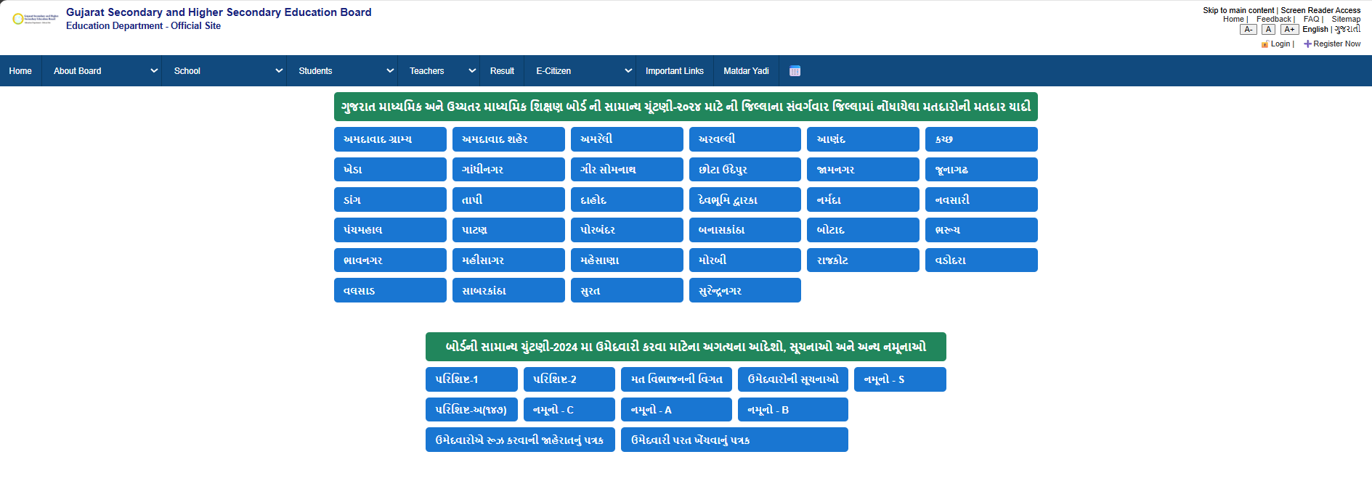    Figure:2Matdar yadi page  PROGRAM CODE :  <!DOCTYPE html>  <html lang="en">  <head>  <meta charset="UTF-8" />  <meta name="viewport" content="width=device-width, initial-scale=1.0"/>  <title>Teacher Info</title>  <link rel="stylesheet" href="index.css" />  </head>  <body>  <!-- TOP HEADER -->  <div class="top-header">  <div class="logo-area">  <img src="headimg.png" alt="Logo" />  <h2>Gujarat Secondary and Higher Secondary Education Board<br>  <small>Education Department - Official Site</small>  </h2>  </div>  <div class="top-right">  <div>  Skip to main content | Screen Reader Access <br />  <a href="#">Home</a> |  <a href="#">Feedback</a> |  <a href="faq.html">FAQ</a> |  <a href="#">Sitemap</a>  </div>  <div class="font-size-controls">  <button>A-</button>  <button>A</button>  <button>A+</button>  <span>English</span> |  <span>ગુજરાતી</span>  </div>  <div class="login-register">  <a href="login.html">🔓Login</a> |  <a href="register.html">➕Register Now</a>  </div>  </div>  </div>  <!-- NAVIGATION -->  <nav>  <div class="nav-item"><a href="index.html">Home</a></div>  <div class="nav-item">  <select onchange="location = this.value;">  <option value="">About Board</option>  <option value="OrganizationStructure.html">Organization Structure</option>  <option value="Contact.html">Contact</option>  <option value="Branches.html">Branches</option>  </select>  </div>  <div class="nav-item">  <select onchange="location = this.value;">  <option value="">School</option>  <option value="StaticalData.html">Statical Data</option>  <option value="SchoolRegistration.html">School Registration</option>  <option value="NewSchoolApplication.html">New School Application</option>  <option value="NewClassApplication.html">New Class Application</option>  </select>  </div>  <div class="nav-item">  <select onchange="location = this.value;">  <option value="">Students</option>  <option value="10QuestionPaper.html">10 Question Paper</option>  <option value="12QuestionPaper.html">12 Question Papers</option>  </select>  </div>  <div class="nav-item">  <select onchange="location = this.value;">  <option value="">Teachers</option>  <option value="Teachers.html">Teacher Info</option>  </select>  </div>  <div class="nav-item"><a href="Result.html">Result</a></div>  <div class="nav-item">  <select onchange="location = this.value;">  <option value="">E-Citizen</option>  <option value="right-to-information.html">Right To Information</option>  <option value="act-rules.html">Act & Rules</option>  <option value="government-resolutions.html">Govt Resolutions</option>  <option value="tenders.html">Tenders</option>  <option value="Gallery.html">Gallery</option>  <option value="circulars.html">Circulars</option>  </select>  </div>  <div class="nav-item"><a href="ImportantLinks.html">Important Links</a></div>  <div class="nav-item"><a href="matdaryadi.html">Matdar Yadi</a></div>  <div class="nav-item calendar-icon">📅</div>  </nav>  <!-- MAIN TEACHER CONTENT -->  <div class="main-content">  <h2>👨‍🏫 Teacher Information and Resources</h2>  <p>This section provides key resources and tools for school teachers under GSEB. Below you will find downloadable model papers and useful links for academic development and administration.</p>  <h3>📄 Download Model Papers</h3>  <ul class="model-paper-links">  <li><a href="10QuestionPaper.html">Class 10 Model Paper</a></li>  <li><a href="12QuestionPaper.html">Class 12 Model Paper</a></li>  </ul>  <h3 style="margin-top: 40px;">🔗 Useful Links</h3>  <ul class="useful-links">  <li><a href="training.html">Teacher Training Resources</a></li>  <li><a href="teaching-guidelines.html">Teaching Guidelines (PDF)</a></li>  <li><a href="evaluation-policy.html">Evaluation Policy</a></li>  <li><a href="circulars.html">Latest Circulars</a></li>  <li><a href="http://ssagujarat.org" target="_blank">SSA Gujarat Website</a></li>  </ul>  </div>  <!-- FOOTER -->  <footer class="last-heading">  <center>  <p>Education Department | Commissionerate Mid Day Meal & Schools | Commissionerate of Higher Education</p>  <p>Gujarat Institute of Educational Technology | Director of Literacy & Continuing Education | Commissionerate of Technical Education</p>  <p>Directorate of Primary Education | National Cadet Corps | Sarva Shiksha Abhiyan</p>  <p>Gujarat Secondary and Higher Secondary Education Board | State Examination Board</p>  <p>Gujarat State Board of School Textbooks | State Board of Technical Examinations Gujarat</p>  <p>Gujarat Council of Educational Research and Training</p>  <p><a href="index.html">Home Page</a></p>  <p>Privacy Policy | Terms of Use | Disclaimer</p>  </center>  </footer>  </body>  </html>  OUTPUT:  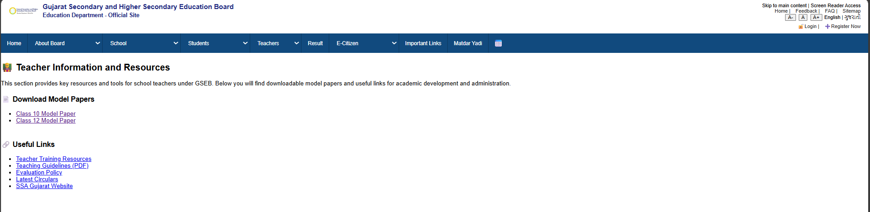    Figure:3 Teacher inform page  PROGRAM CODE :  <!DOCTYPE html>  <html lang="en">  <head>  <meta charset="UTF-8">  <meta name="viewport" content="width=device-width, initial-scale=1.0">  <title>ImportantLinks</title>  <link rel="stylesheet" href="index.css">  <style>  body {  margin: 0;  padding: 0;  font-family: 'Segoe UI', sans-serif;  background: linear-gradient(to right, #f2f9ff, #e6f7ff);  }  .page-container {  height: 500px;  max-width: 600px;  margin: 100px auto;  text-align: center;  padding: 40px;  background: #ffffffaa;  border-radius: 20px;  box-shadow: 0 4px 20px rgba(0, 0, 0, 0.1);  }  .page-container h2 {  font-size: 28px;  color: #004080;  margin-bottom: 30px;  }  .styled-select {  width: 100%;  padding: 12px 20px;  font-size: 16px;  border: 2px solid #007acc;  border-radius: 8px;  background-color: #ffffff;  color: #004080;  cursor: pointer;  box-shadow: 0 2px 5px rgba(0, 0, 0, 0.1);  }  .styled-select:focus {  outline: none;  border-color: #005fa3;  box-shadow: 0 0 6px #90cfff;  }  </style>  </head>  <body>  <div class="top-header">  <div class="logo-area">  <img src="headimg.png" alt="Logo" />  <h2>Gujarat Secondary and Higher Secondary Education Board<br><small>Education Department - Official Site</small></h2>  </div>  <div class="top-right">  <div>  Skip to main content | Screen Reader Access <br />  <a href="#">Home</a> |  <a href="#">Feedback</a> |  <a href="faq.html">FAQ</a> |  <a href="#">Sitemap</a>  </div>  <div class="font-size-controls">  <button>A-</button>  <button>A</button>  <button>A+</button>  <span>English</span> |  <span>ગુજરાતી</span>  </div>  <div class="login-register">  <a href="login.html">🔓Login</a> |  <a href="register.html">➕Register Now</a>  </div>  </div>  </div>  <nav>  <div class="nav-item"><a href="index.html">Home</a></div>  <div class="nav-item">  <select onchange="location = this.value;">  <option value="">About Board</option>  <option value="OrganizationStructure.html">Organization Structure</option>  <option value="Contact.html">Contact</option>  <option value="Branches.html">Branches</option>  </select>  </div>  <div class="nav-item">  <select onchange="location = this.value;">  <option value="">School</option>  <option value="StaticalData.html">Statical Data</option>  <option value="SchoolRegistration.html">School Registration</option>  <option value="NewSchoolApplication.html">New School Application</option>  <option value="NewClassApplication.html">New Class Application</option>  </select>  </div>  <div class="nav-item">  <select onchange="location = this.value;">  <option value="">Students</option>  <option value="10QuestionPaper.html">10 Question Paper</option>  <option value="12QuestionPaper.html">12 Question Papers</option>  </select>  </div>  <div class="nav-item">  <select onchange="location = this.value;">  <option value="">Teachers</option>  <option value="Teachers.html">Teacher Info</option>  </select>  </div>  <div class="nav-item">  <a href="Result.html">Result</a>  </div>  <div class="nav-item">  <select onchange="location = this.value;">  <option value="">E-Citizen</option>  <option value="right-to-information.html">Right To Information</option>  <option value="act-rules.html">Act & Rules</option>  <option value="government-resolutions.html">Govt Resolutions</option>  <option value="tenders.html">Tenders</option>  <option value="Gallery.html">Gallery</option>  <option value="circulars.html">Circulars</option>  </select>  </div>  <div class="nav-item"><a href="ImportantLinks.html">Important Links</a></div>  <div class="nav-item"><a href="matdaryadi.html">Matdar Yadi</a></div>  <div class="nav-item calendar-icon">📅</div>  </nav>  <div class="page-container">  <h2>🔗 Important Links</h2>  <select name="important links" class="styled-select">  <option value="">-- Select an Option --</option>  <option value="Official Website Of Gujarat Govt.">Official Website Of Gujarat Govt.</option>  <option value="GSWAN">GSWAN</option>  <option value="National Portal">National Portal</option>  <option value="All Universities Of Gujarat">All Universities Of Gujarat</option>  <option value="Affiliated Schools">Affiliated Schools</option>  <option value="Lavajam">Lavajam</option>  <option value="CBSE School NOC Application">CBSE School NOC Application</option>  </select>  </div>  <footer class="last-heading"><center>  <p>Education Department | Commissionerate Mid Day Meal & Schools | Commissionerate of Higher Education</p>  <p>Gujarat Institute of Educational Technology | Director of Literacy & Continuing Education | Commissionerate of Technical Education</p>  <p>Directorate of Primary Education | National Cadet Corps | Sarva Shiksha Abhiyan</p>  <p>Gujarat Secondary and Higher Secondary Education Board | State Examination Board</p>  <p>Gujarat State Board of School Textbooks | State Board of Technical Examinations Gujarat</p>  <p>Gujarat Council of Educational Research and Training</p>  <p><a href="index.html">Home Page</a></p>  <p>Privacy Policy | Terms of Use | Disclaimer</p>  </center>  </footer>  </body>  </html>  OUTPUT:  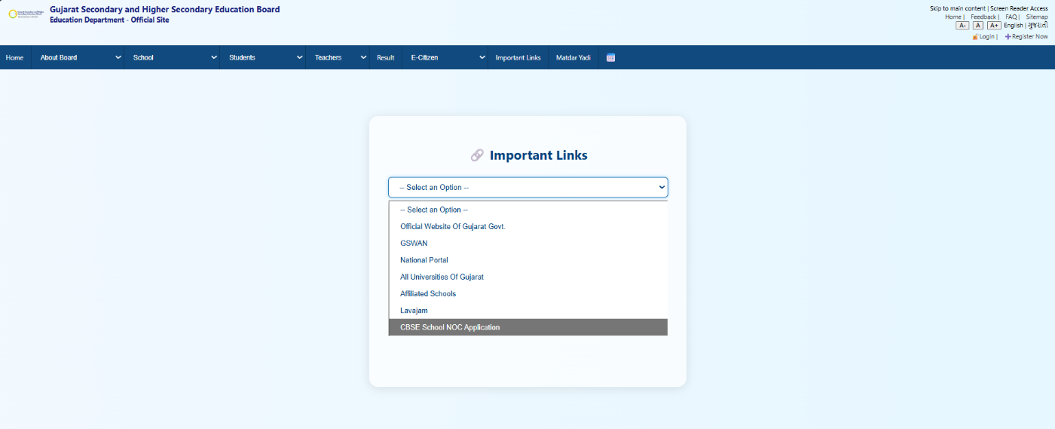    Figure:4Important Links page  PROGRAM CODE :  <!DOCTYPE html>  <html lang="en">  <head>  <meta charset="UTF-8">  <meta name="viewport" content="width=device-width, initial-scale=1.0">  <title>Result</title>  <link rel="stylesheet" href="index.css">  <style>  <style>  body {  font-family: 'Segoe UI', Tahoma, Geneva, Verdana, sans-serif;  background: linear-gradient(to right, #f8f9fa, #e3f2fd);  margin: 0;  padding: 0;  }  .hell {  text-align: center;  color: #2c3e50;  margin-top: 40px;  }  form {  width: 60%;  max-width: 500px;  margin: 40px auto;  padding: 30px;  background-color: #ffffff;  border-radius: 12px;  box-shadow: 0 8px 16px rgba(0, 0, 0, 0.1);  }  label, input {  display: block;  width: 100%;  margin-bottom: 15px;  font-size: 1rem;  }  input[type="text"],  input[type="password"] {  padding: 10px;  border: 1px solid #ccc;  border-radius: 6px;  }  input[type="submit"] {  background-color: #007bff;  color: white;  padding: 10px;  font-size: 1rem;  border: none;  border-radius: 6px;  cursor: pointer;  transition: background-color 0.3s ease;  }  input[type="submit"]:hover {  background-color: #0056b3;  }  .captcha-box {  display: flex;  justify-content: space-between;  align-items: center;  }  .captcha-text {  font-size: 1.2rem;  font-weight: bold;  color: #444;  background-color: #f1f1f1;  padding: 6px 12px;  border-radius: 6px;  letter-spacing: 3px;  }  footer {  margin-top: 60px;  padding: 20px;  background-color: #f1f1f1;  color: #555;  }  footer a {  color: #007bff;  text-decoration: none;  }  footer a:hover {  text-decoration: underline;  }  </style>  </style>  </head>  <body>  <div class="top-header">  <div class="logo-area">  <img src="headimg.png" alt="Logo" />  <h2>Gujarat Secondary and Higher Secondary Education Board<br><small>Education Department - Official Site</small></h2>  </div>  <div class="top-right">  <div>  Skip to main content | Screen Reader Access <br />  <a href="#">Home</a> |  <a href="#">Feedback</a> |  <a href="faq.html">FAQ</a> |  <a href="#">Sitemap</a>  </div>  <div class="font-size-controls">  <button>A-</button>  <button>A</button>  <button>A+</button>  <span>English</span> |  <span>ગુજરાતી</span>  </div>  <div class="login-register">  <a href="login.html">🔓Login</a> |  <a href="register.html">➕Register Now</a>  </div>  </div>  </div>  <nav>  <div class="nav-item"><a href="index.html">Home</a></div>  <div class="nav-item">  <select onchange="location = this.value;">  <option value="">About Board</option>  <option value="OrganizationStructure.html">Organization Structure</option>  <option value="Contact.html">Contact</option>  <option value="Branches.html">Branches</option>  </select>  </div>  <div class="nav-item">  <select onchange="location = this.value;">  <option value="">School</option>  <option value="StaticalData.html">Statical Data</option>  <option value="SchoolRegistration.html">School Registration</option>  <option value="NewSchoolApplication.html">New School Application</option>  <option value="NewClassApplication.html">New Class Application</option>  </select>  </div>  <div class="nav-item">  <select onchange="location = this.value;">  <option value="">Students</option>  <option value="10QuestionPaper.html">10 Question Paper</option>  <option value="12QuestionPaper.html">12 Question Papers</option>  </select>  </div>  <div class="nav-item">  <select onchange="location = this.value;">  <option value="">Teachers</option>  <option value="Teachers.html">Teacher Info</option>  </select>  </div>  <div class="nav-item">  <a href="Result.html">Result</a>  </div>  <div class="nav-item">  <select onchange="location = this.value;">  <option value="">E-Citizen</option>  <option value="right-to-information.html">Right To Information</option>  <option value="act-rules.html">Act & Rules</option>  <option value="government-resolutions.html">Govt Resolutions</option>  <option value="tenders.html">Tenders</option>  <option value="Gallery.html">Gallery</option>  <option value="circulars.html">Circulars</option>  </select>  </div>  <div class="nav-item"><a href="ImportantLinks.html">Important Links</a></div>  <div class="nav-item"><a href="matdaryadi.html">Matdar Yadi</a></div>  <div class="nav-item calendar-icon">📅</div>  </nav>  <h2 class="hell">Board Examination Results - 2025</h2>  <form onsubmit="validateForm(event)">  <label for="rollno">Enter Roll Number:</label>  <input type="text" id="rollno" name="rollno" required>  <label for="password">Enter Password:</label>  <input type="password" id="password" name="password" required>  <div class="captcha-box">  <span class="captcha-text" id="captcha-code"></span>  <input type="hidden" id="hidden-captcha">  </div>  <label for="captcha-input">Enter Captcha:</label>  <input type="text" id="captcha-input" required>  <input type="submit" value="Get Result">  </form>  </form>  <footer class="last-heading"><center>  <p>Education Department | Commissionerate Mid Day Meal & Schools | Commissionerate of Higher Education</p>  <p>Gujarat Institute of Educational Technology | Director of Literacy & Continuing Education | Commissionerate of Technical Education</p>  <p>Directorate of Primary Education | National Cadet Corps | Sarva Shiksha Abhiyan</p>  <p>Gujarat Secondary and Higher Secondary Education Board | State Examination Board</p>  <p>Gujarat State Board of School Textbooks | State Board of Technical Examinations Gujarat</p>  <p>Gujarat Council of Educational Research and Training</p>  <p><a href="index.html">Home Page</a></p>  <p>Privacy Policy | Terms of Use | Disclaimer</p>  </center>  </footer>  </body>  </html>  OUTPUT:  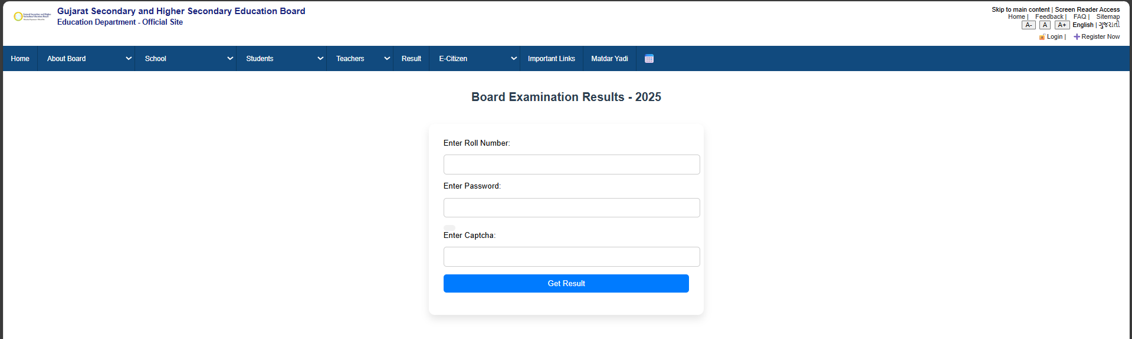    Figure:5Result of board page  PROGRAM CODE :  <!DOCTYPE html>  <html lang="en">  <head>  <meta charset="UTF-8">  <meta name="viewport" content="width=device-width, initial-scale=1.0">  <title>Static data</title>  <link rel="stylesheet" href="index.css">  <link rel="stylesheet" href="QuestionPapers.css">  <style>  .static-data-section {  max-width: 1000px;  margin: 40px auto;  padding: 20px;  font-family: Arial, sans-serif;  }  .static-data-section h1 {  text-align: center;  font-size: 28px;  margin-bottom: 30px;  color: #0054a6;  border-bottom: 2px solid #0054a6;  padding-bottom: 10px;  }  .booklet-list {  display: grid;  grid-template-columns: repeat(auto-fit, minmax(260px, 1fr));  gap: 20px;  }  .booklet-card {  background-color: #f1f8ff;  padding: 15px 20px;  border-left: 5px solid #0054a6;  border-radius: 6px;  box-shadow: 0 4px 8px rgba(0, 0, 0, 0.05);  transition: transform 0.2s ease, background-color 0.2s ease;  font-size: 16px;  color: #333;  }  .booklet-card:hover {  transform: translateY(-5px);  background-color: #e6f0ff;  }  </style>  </head>  <body>  <div class="top-header">  <div class="logo-area">  <img src="headimg.png" alt="Logo" />  <h2>Gujarat Secondary and Higher Secondary Education Board<br><small>Education Department - Official Site</small></h2>  </div>  <div class="top-right">  <div>  Skip to main content | Screen Reader Access <br />  <a href="#">Home</a> |  <a href="#">Feedback</a> |  <a href="faq.html">FAQ</a> |  <a href="#">Sitemap</a>  </div>  <div class="font-size-controls">  <button>A-</button>  <button>A</button>  <button>A+</button>  <span>English</span> |  <span>ગુજરાતી</span>  </div>  <div class="login-register">  <a href="login.html">🔓Login</a> |  <a href="register.html">➕Register Now</a>  </div>  </div>  </div>  <nav>  <div class="nav-item"><a href="index.html">Home</a></div>  <div class="nav-item">  <select onchange="location = this.value;">  <option value="">About Board</option>  <option value="OrganizationStructure.html">Organization Structure</option>  <option value="Contact.html">Contact</option>  <option value="Branches.html">Branches</option>  </select>  </div>  <div class="nav-item">  <select onchange="location = this.value;">  <option value="">School</option>  <option value="StaticalData.html">Statical Data</option>  <option value="SchoolRegistration.html">School Registration</option>  <option value="NewSchoolApplication.html">New School Application</option>  <option value="NewClassApplication.html">New Class Application</option>  </select>  </div>  <div class="nav-item">  <select onchange="location = this.value;">  <option value="">Students</option>  <option value="10QuestionPaper.html">10 Question Paper</option>  <option value="12QuestionPaper.html">12 Question Papers</option>  </select>  </div>  <div class="nav-item">  <select onchange="location = this.value;">  <option value="">Teachers</option>  <option value="Teachers.html">Teacher Info</option>  </select>  </div>  <div class="nav-item">  <a href="Result.html">Result</a>  </div>  <div class="nav-item">  <select onchange="location = this.value;">  <option value="">E-Citizen</option>  <option value="right-to-information.html">Right To Information</option>  <option value="act-rules.html">Act & Rules</option>  <option value="government-resolutions.html">Govt Resolutions</option>  <option value="tenders.html">Tenders</option>  <option value="Gallery.html">Gallery</option>  <option value="circulars.html">Circulars</option>  </select>  </div>  <div class="nav-item"><a href="ImportantLinks.html">Important Links</a></div>  <div class="nav-item"><a href="matdaryadi.html">Matdar Yadi</a></div>  <div class="nav-item calendar-icon">📅</div>  </nav>  <section class="static-data-section">  <h1>Statistical Data Booklets</h1>  <div class="booklet-list">  <div class="booklet-card">1. SSC Booklet - 2019</div>  <div class="booklet-card">2. HSC General Booklet - 2019</div>  <div class="booklet-card">3. HSC Science Booklet - 2019</div>  <div class="booklet-card">4. SSC Booklet - 2020</div>  <div class="booklet-card">5. HSC Science Booklet - 2020</div>  <div class="booklet-card">6. HSC General Booklet - 2020</div>  <div class="booklet-card">7. HSC Science Booklet - 2022</div>  <div class="booklet-card">8. SSC Booklet - 2022</div>  <div class="booklet-card">9. HSC General Booklet - 2022</div>  <div class="booklet-card">10. HSC General Booklet - 2023</div>  <div class="booklet-card">11. SSC Result Booklet - 2023</div>  <div class="booklet-card">12. Science & GUJCET Booklet - 2023</div>  <div class="booklet-card">13. SSC Result Booklet - 2024</div>  <div class="booklet-card">14. HSC General Result Booklet - 2024</div>  <div class="booklet-card">15. HSC Science & GUJCET Result Booklet - 2024</div>  </div>  </section>  <footer class="last-heading"><center>  <p>Education Department | Commissionerate Mid Day Meal & Schools | Commissionerate of Higher Education</p>  <p>Gujarat Institute of Educational Technology | Director of Literacy & Continuing Education | Commissionerate of Technical Education</p>  <p>Directorate of Primary Education | National Cadet Corps | Sarva Shiksha Abhiyan</p>  <p>Gujarat Secondary and Higher Secondary Education Board | State Examination Board</p>  <p>Gujarat State Board of School Textbooks | State Board of Technical Examinations Gujarat</p>  <p>Gujarat Council of Educational Research and Training</p>  <p><a href="index.html">Home Page</a></p>  <p>Privacy Policy | Terms of Use | Disclaimer</p>  </center>  </footer>  </body>  </html>  Css code(3 page ):  ul {  max-width: 900px;  margin: 30px auto;  background-color: #ffffff;  padding: 20px 30px;  list-style-type: none;  box-shadow: 0 0 10px rgba(0,0,0,0.1);  border-radius: 10px;  }  ul li {  padding: 10px;  margin-bottom: 8px;  border-bottom: 1px solid #ddd;  font-size: 15px;  }  ul li:last-child {  border-bottom: none;  }  footer {  background-color: #eee;  color: #444;  font-size: 14px;  padding: 20px;  margin-top: 40px;  }  footer p {  margin: 5  }  OUTPUT:  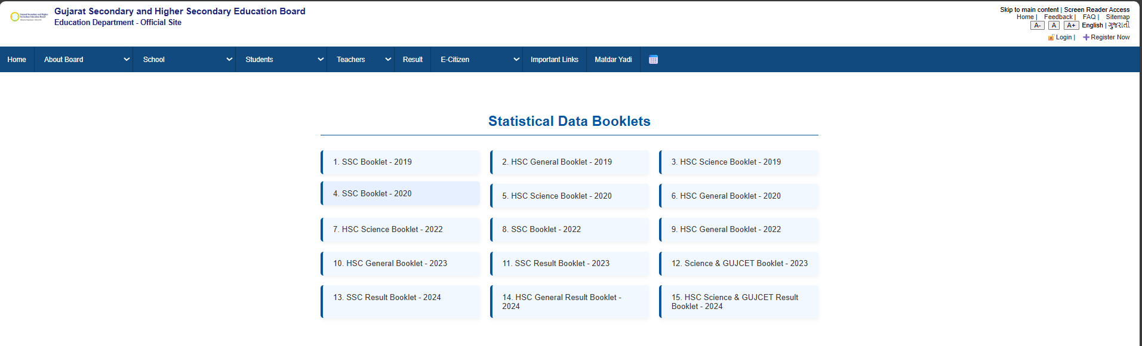    Figure:6Statistical Data Booklets page  PROGRAM CODE :  <!DOCTYPE html>  <html lang="en">  <head>  <meta charset="UTF-8">  <meta name="viewport" content="width=device-width, initial-scale=1.0">  <title>10 question paper</title>  <link rel="stylesheet" href="index.css">  <link rel="stylesheet" href="QuestionPapers.css">  </head>  <body>  <div class="top-header">  <div class="logo-area">  <img src="headimg.png" alt="Logo" />  <h2>Gujarat Secondary and Higher Secondary Education Board<br><small>Education Department - Official Site</small></h2>  </div>  <div class="top-right">  <div>  Skip to main content | Screen Reader Access <br />  <a href="#">Home</a> |  <a href="#">Feedback</a> |  <a href="faq.html">FAQ</a> |  <a href="#">Sitemap</a>  </div>  <div class="font-size-controls">  <button>A-</button>  <button>A</button>  <button>A+</button>  <span>English</span> |  <span>ગુજરાતી</span>  </div>  <div class="login-register">  <a href="login.html">🔓Login</a> |  <a href="register.html">➕Register Now</a>  </div>  </div>  </div>  <nav>  <div class="nav-item"><a href="index.html">Home</a></div>  <div class="nav-item">  <select onchange="location = this.value;">  <option value="">About Board</option>  <option value="OrganizationStructure.html">Organization Structure</option>  <option value="Contact.html">Contact</option>  <option value="Branches.html">Branches</option>  </select>  </div>  <div class="nav-item">  <select onchange="location = this.value;">  <option value="">School</option>  <option value="StaticalData.html">Statical Data</option>  <option value="SchoolRegistration.html">School Registration</option>  <option value="NewSchoolApplication.html">New School Application</option>  <option value="NewClassApplication.html">New Class Application</option>  </select>  </div>  <div class="nav-item">  <select onchange="location = this.value;">  <option value="">Students</option>  <option value="10QuestionPaper.html">10 Question Paper</option>  <option value="12QuestionPaper.html">12 Question Papers</option>  </select>  </div>  <div class="nav-item">  <select onchange="location = this.value;">  <option value="">Teachers</option>  <option value="Teachers.html">Teacher Info</option>  </select>  </div>  <div class="nav-item">  <a href="Result.html">Result</a>  </div>  <div class="nav-item">  <select onchange="location = this.value;">  <option value="">E-Citizen</option>  <option value="right-to-information.html">Right To Information</option>  <option value="act-rules.html">Act & Rules</option>  <option value="government-resolutions.html">Govt Resolutions</option>  <option value="tenders.html">Tenders</option>  <option value="Gallery.html">Gallery</option>  <option value="circulars.html">Circulars</option>  </select>  </div>  <div class="nav-item"><a href="ImportantLinks.html">Important Links</a></div>  <div class="nav-item"><a href="matdaryadi.html">Matdar Yadi</a></div>  <div class="nav-item calendar-icon">📅</div>  </nav>  <center><h2>10 Question Paper</h2></center>  <ul>  <li>(July-2018)-01(Guj F.L)Gujarati( 10th Guj MED)</li>  <li>(July-2018)-04(English F.L) English( 10th ENG MED)</li>  <li>(July-2018)-10Social Science( 10th ENG MED )</li>  <li>(July-2018)-10Social Science( 10th Guj MED)</li>  <li>(July-2018)-10Social Science( 10th Hindi MED)</li>  <li>(July-2018)-11(E)Sc. & Tech NCERT OTHER( 10th)</li>  <li>(July-2018)-11(E)Sc. & Tech. NCERT SRT( 10th )</li>  <li>(July-2018)-11Sc & Tech( 10th Hindi MED)</li>  <li>(July-2018)-11Sc & Tech. ( 10th Guj MED )</li>  <li>(July-2018)-11Sc. & Tech( 10th ENG MED)</li>  <li>(July-2018)-12(E)Maths NCERT Other( 10th)</li>  <li>(July-2018)-12(E)Maths NCESRT SRT( 10th)</li>  <li>(July-2018)-12Maths( 10th ENG MED)</li>  <li>(July-2018)-12Maths( 10th Guj MED)</li>  <li>(July-2018)-12Maths( 10th Hindi MED)</li>  <li>(July-2018)-13(Gujarati S.L)Gujarati New Course( 10th ENG MED)</li>  <li>(July-2018)-14(Hindi S.L)HINDI( 10th Guj MED)</li>  <li>(July-2018)-16(ENGLISH S.L.)ENGLISH( 10th Guj MED)</li>  <li>(July-2018)-17SANSKRIT( 10th Guj MED)</li>  <li>(MAR-2017 )-4 English F.L-English(10th Eng Med)</li>  <li>(MAR-2017)-01(Guj F.L)Gujrati(10th Guj Med)</li>  <li>(MAR-2017)-10 Social Science(10th Eng Med)</li>  <li>(MAR-2017)-10Social Science(10th Guj Med)</li>  <li>(MAR-2017)-11 Sc. & Tech.(10th Eng Med)</li>  <li>(MAR-2017)-11Sc. & Tech.(10th Guj Med)</li>  <li>(MAR-2017)-12 Maths (10th Eng Med)</li>  <li>(MAR-2017)-12Maths(10th Guj Med)</li>  <li>(MAR-2017)-13(Guj S.L)Gujarati(10th Eng Med)</li>  <li>(MAR-2017)-14(Hindi S.L)Hindi(10th Guj Med)</li>  <li>(MAR-2017)-15(Sindhi-Arebic)(S.L)Sindhi(10th)</li>  <li>(MAR-2017)-15(Sindhi-Devnagri)(S.L)Sindhi(10th)</li>  <li>(MAR-2017)-16(English S.L)English(10th Guj Med)</li>  <li>(MAR-2017)-17 Sanskrit(10th Eng Med)</li>  <li>(MAR-2017)-17Sanskrit(10th Guj Med)</li>  <li>(MAR-2017)-19 Persian(10th Eng Med)</li>  <li>(MAR-2017)-19 Persian(10th Guj Med)</li>  <li>(MAR-2017)-2(Hindi F.L)Hindi(10th Hindi Med)</li>  <li>(MAR-2017)-20 Arabic(10th Guj Med)</li>  <li>(MAR-2017)-20 Arebic(10th Eng Med)</li>  <li>(MAR-2017)-21Urdu(10th Guj Med)</li>  <li>(MAR-2017)-3(Marathi F.L)Marathi(10th)</li>  <li>(MAR-2017)-5(Urdu F.L)Urdu(10th)</li>  <li>(MAR-2017)-6(Sindhi-Arebic)(F.L)Sindhi(10th)</li>  <li>(MAR-2017)-6(Sindhi-Devnagri)(F.L)Sindhi(10th)</li>  <li>(MAR-2017)-7(TAMIL F.L)Tamil(10th)</li>  <li>(MAR-2017)-8(Telugu F.L)Telugu(10th)</li>  <li>(MAR-2017)-9(Oriya F.L)Oriya(10th)</li>  </ul>  <footer class="last-heading"><center>  <p>Education Department | Commissionerate Mid Day Meal & Schools | Commissionerate of Higher Education</p>  <p>Gujarat Institute of Educational Technology | Director of Literacy & Continuing Education | Commissionerate of Technical Education</p>  <p>Directorate of Primary Education | National Cadet Corps | Sarva Shiksha Abhiyan</p>  <p>Gujarat Secondary and Higher Secondary Education Board | State Examination Board</p>  <p>Gujarat State Board of School Textbooks | State Board of Technical Examinations Gujarat</p>  <p>Gujarat Council of Educational Research and Training</p>  <p><a href="index.html">Home Page</a></p>  <p>Privacy Policy | Terms of Use | Disclaimer</p>  </center>  </footer>  </body>  </html>  OUTPUT:  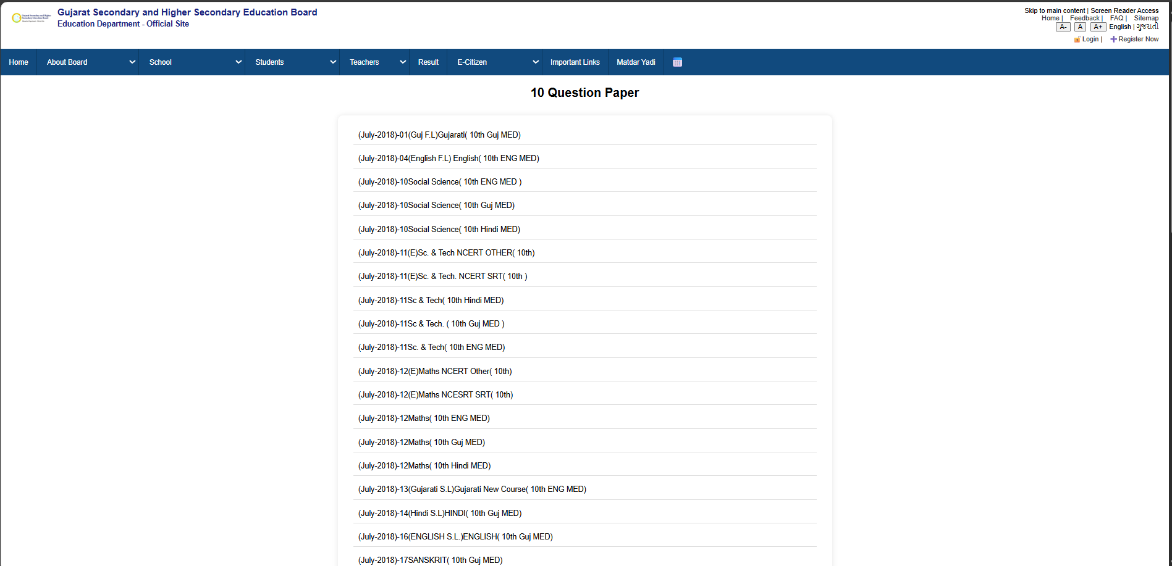  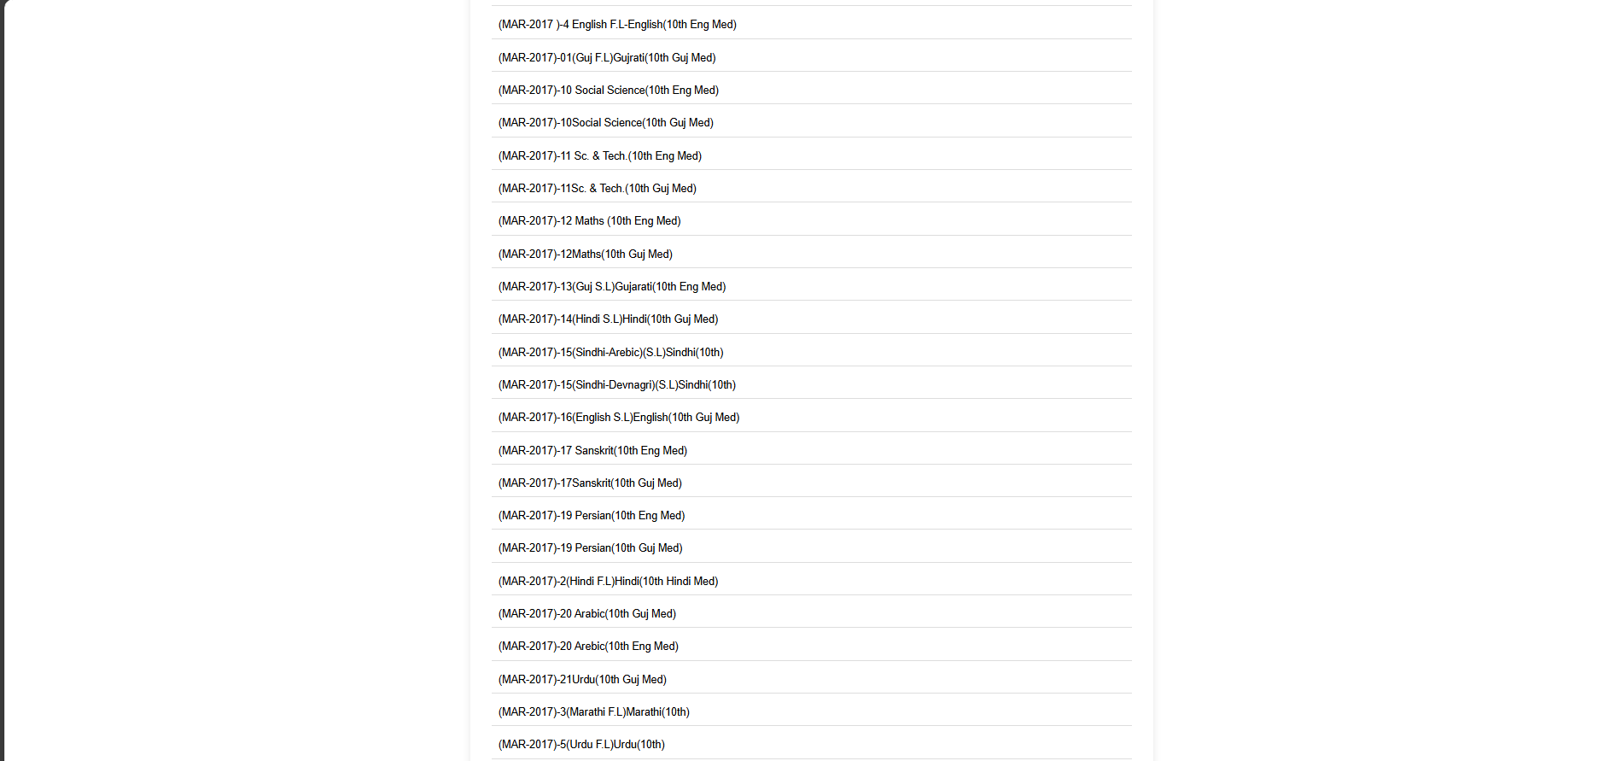    Figure:710Question paper page  PROGRAM CODE :  <!DOCTYPE html>  <html lang="en">  <head>  <meta charset="UTF-8">  <meta name="viewport" content="width=device-width, initial-scale=1.0">  <title>12 question paper</title>  <link rel="stylesheet" href="index.css">  <link rel="stylesheet" href="QuestionPapers.css">  </head>  <body>  <div class="top-header">  <div class="logo-area">  <img src="headimg.png" alt="Logo" />  <h2>Gujarat Secondary and Higher Secondary Education Board<br><small>Education Department - Official Site</small></h2>  </div>  <div class="top-right">  <div>  Skip to main content | Screen Reader Access <br />  <a href="#">Home</a> |  <a href="#">Feedback</a> |  <a href="faq.html">FAQ</a> |  <a href="#">Sitemap</a>  </div>  <div class="font-size-controls">  <button>A-</button>  <button>A</button>  <button>A+</button>  <span>English</span> |  <span>ગુજરાતી</span>  </div>  <div class="login-register">  <a href="login.html">🔓Login</a> |  <a href="register.html">➕Register Now</a>  </div>  </div>  </div>  <nav>  <div class="nav-item"><a href="index.html">Home</a></div>  <div class="nav-item">  <select onchange="location = this.value;">  <option value="">About Board</option>  <option value="OrganizationStructure.html">Organization Structure</option>  <option value="Contact.html">Contact</option>  <option value="Branches.html">Branches</option>  </select>  </div>  <div class="nav-item">  <select onchange="location = this.value;">  <option value="">School</option>  <option value="StaticalData.html">Statical Data</option>  <option value="SchoolRegistration.html">School Registration</option>  <option value="NewSchoolApplication.html">New School Application</option>  <option value="NewClassApplication.html">New Class Application</option>  </select>  </div>  <div class="nav-item">  <select onchange="location = this.value;">  <option value="">Students</option>  <option value="10QuestionPaper.html">10 Question Paper</option>  <option value="12QuestionPaper.html">12 Question Papers</option>  </select>  </div>  <div class="nav-item">  <select onchange="location = this.value;">  <option value="">Teachers</option>  <option value="Teachers.html">Teacher Info</option>  </select>  </div>  <div class="nav-item">  <a href="Result.html">Result</a>  </div>  <div class="nav-item">  <select onchange="location = this.value;">  <option value="">E-Citizen</option>  <option value="right-to-information.html">Right To Information</option>  <option value="act-rules.html">Act & Rules</option>  <option value="government-resolutions.html">Govt Resolutions</option>  <option value="tenders.html">Tenders</option>  <option value="Gallery.html">Gallery</option>  <option value="circulars.html">Circulars</option>  </select>  </div>  <div class="nav-item"><a href="ImportantLinks.html">Important Links</a></div>  <div class="nav-item"><a href="matdaryadi.html">Matdar Yadi</a></div>  <div class="nav-item calendar-icon">📅</div>  </nav>  <center><h2>12 Question Paper</h2></center>  <ul>  <li>001(G)_March2019</li>  <li>002(H)_March2019</li>  <li>003 (M)_March-2019</li>  <li>004 (U)_March-2019</li>  <li>006 (E)_March-2019</li>  <li>008 (G)_March-2019</li>  <li>009 (H)_March-2019</li>  <li>013 (E)_March-2019</li>  <li>050 (E)_March-2019</li>  <li>050 (G)_March-2019</li>  <li>050 (H)_March-2019</li>  <li>052 (E)_march-2019</li>  <li>052 (G)_March-2019</li>  <li>052 (H)_March-2019</li>  <li>054 (E)_March-2019</li>  <li>054 (G)_March-2019</li>  <li>054 (H)_March-2019</li>  <li>056 (E)_March-2019</li>  <li>056 (G)_March-2019</li>  <li>056 (H)_March-2019</li>  <li>129 (E)_March-2019</li>  <li>129 (G)_March-2019</li>  <li>129 (H)_March-2019</li>  <li>131 (GHE)_March-2019</li>  <li>331 (E)_March-2019</li>  <li>331 (G)_March-2019</li>  <li>331 (H)_March-2019</li>  <li>એકમકસોટીનાપ્રશ્નપત્રો-૨૦૨૦(STD_12_ભૌતિકવિજ્ઞાન)</li>  <li>એકમકસોટીનાપ્રશ્નપત્રો-૨૦૨૦(STD_11_ભૌતિકવિજ્ઞાન)</li>  <li>એકમકસોટીનાપ્રશ્નપત્રો-૨૦૨૦(STD_12_રસાયણવિજ્ઞાન)</li>  <li>એકમકસોટીનાપ્રશ્નપત્રો-૨૦૨૦(STD_11_રસાયણવિજ્ઞાન)</li>  <li>ચોથીએકમકસોટીનાપ્રશ્નપત્રો-૨૦૨૦(English)</li>  <li>ચોથીએકમકસોટીનાપ્રશ્નપત્રો-૨૦૨૦(Maths)</li>  <li>ચોથીએકમકસોટીનાપ્રશ્નપત્રો-૨૦૨૦(Biology)</li>  <li>5th એકમકસોટીનાપ્રશ્નપત્રો-૨૦૨૦(STD_11_052_E-રસાયણવિજ્ઞાન)</li>  <li>5th એકમકસોટીનાપ્રશ્નપત્રો-૨૦૨૦(STD_11_052_G-રસાયણવિજ્ઞાન)</li>  <li>5th એકમકસોટીનાપ્રશ્નપત્રો-૨૦૨૦(STD_11_052_H-રસાયણવિજ્ઞાન)</li>  <li>5th એકમકસોટીનાપ્રશ્નપત્રો-૨૦૨૦(STD_11_054_E-ભૌતિકવિજ્ઞાન)</li>  <li>5th એકમકસોટીનાપ્રશ્નપત્રો-૨૦૨૦(STD_11_054_G-ભૌતિકવિજ્ઞાન)</li>  <li>5th એકમકસોટીનાપ્રશ્નપત્રો-૨૦૨૦(STD_11_054_H-ભૌતિકવિજ્ઞાન)</li>  <li>5th એકમકસોટીનાપ્રશ્નપત્રો-૨૦૨૦(STD_12_052_E-રસાયણવિજ્ઞાન)</li>  <li>5th એકમકસોટીનાપ્રશ્નપત્રો-૨૦૨૦(STD_12_052_G-રસાયણવિજ્ઞાન)</li>  <li>5th એકમકસોટીનાપ્રશ્નપત્રો-૨૦૨૦(STD_12_052_H-રસાયણવિજ્ઞાન)</li>  <li>5th એકમકસોટીનાપ્રશ્નપત્રો-૨૦૨૦(STD_12_054_E-ભૌતિકવિજ્ઞાન)</li>  <li>5th એકમકસોટીનાપ્રશ્નપત્રો-૨૦૨૦(STD_12_054_G-ભૌતિકવિજ્ઞાન)</li>  <li>5th એકમકસોટીનાપ્રશ્નપત્રો-૨૦૨૦(STD_12_054_H-ભૌતિકવિજ્ઞાન)</li>  </ul>  <footer class="last-heading"><center>  <p>Education Department | Commissionerate Mid Day Meal & Schools | Commissionerate of Higher Education</p>  <p>Gujarat Institute of Educational Technology | Director of Literacy & Continuing Education | Commissionerate of Technical Education</p>  <p>Directorate of Primary Education | National Cadet Corps | Sarva Shiksha Abhiyan</p>  <p>Gujarat Secondary and Higher Secondary Education Board | State Examination Board</p>  <p>Gujarat State Board of School Textbooks | State Board of Technical Examinations Gujarat</p>  <p>Gujarat Council of Educational Research and Training</p>  <p><a href="index.html">Home Page</a></p>  <p>Privacy Policy | Terms of Use | Disclaimer</p>  </center>  </footer>  </body>  </html>  OUTPUT:  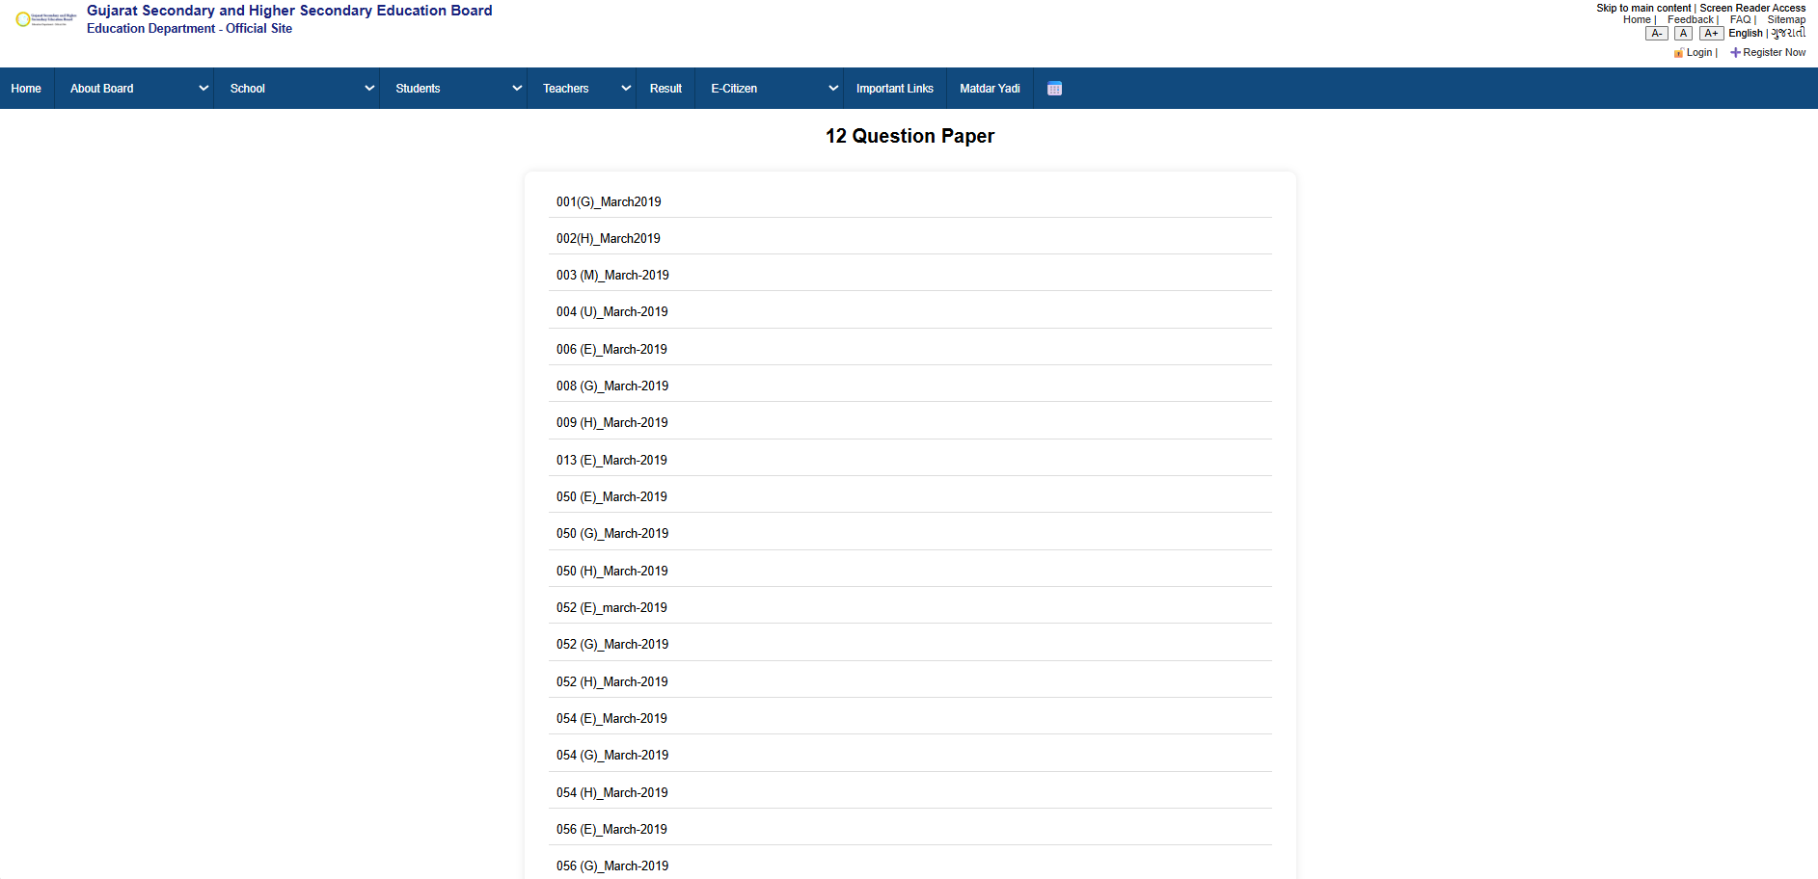  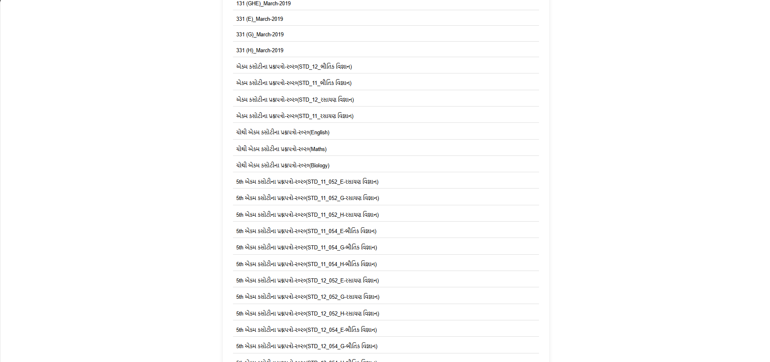    Figure:812Question paper page  PROGRAM CODE :  <!DOCTYPE html>  <html lang="en">  <head>  <meta charset="UTF-8">  <meta name="viewport" content="width=device-width, initial-scale=1.0">  <title>contact</title>  <link rel="stylesheet" href="index.css">  <style>  .contact-container {  max-width: 800px;  margin: 40px auto;  padding: 20px;  background-color: #fefefe;  box-shadow: 0 4px 12px rgba(0, 0, 0, 0.05);  border-radius: 10px;  font-family: Arial, sans-serif;  }  .contact-container h1 {  text-align: center;  font-size: 28px;  margin-bottom: 30px;  color: #0054a6;  }  .contact-card {  background-color: #f1f8ff;  border-left: 5px solid #0054a6;  padding: 20px;  margin-bottom: 20px;  border-radius: 6px;  }  .contact-card h2 {  margin-top: 0;  color: #003c7e;  }  .contact-card p {  margin: 5px 0;  font-size: 15px;  color: #333;  }  </style>  </head>  <body>  <div class="top-header">  <div class="logo-area">  <img src="headimg.png" alt="Logo" />  <h2>Gujarat Secondary and Higher Secondary Education Board<br><small>Education Department - Official Site</small></h2>  </div>  <div class="top-right">  <div>  Skip to main content | Screen Reader Access <br />  <a href="#">Home</a> |  <a href="#">Feedback</a> |  <a href="faq.html">FAQ</a> |  <a href="#">Sitemap</a>  </div>  <div class="font-size-controls">  <button>A-</button>  <button>A</button>  <button>A+</button>  <span>English</span> |  <span>ગુજરાતી</span>  </div>  <div class="login-register">  <a href="login.html">🔓Login</a> |  <a href="register.html">➕Register Now</a>  </div>  </div>  </div>  <nav>  <div class="nav-item"><a href="index.html">Home</a></div>  <div class="nav-item">  <select onchange="location = this.value;">  <option value="">About Board</option>  <option value="OrganizationStructure.html">Organization Structure</option>  <option value="Contact.html">Contact</option>  <option value="Branches.html">Branches</option>  </select>  </div>  <div class="nav-item">  <select onchange="location = this.value;">  <option value="">School</option>  <option value="StaticalData.html">Statical Data</option>  <option value="SchoolRegistration.html">School Registration</option>  <option value="NewSchoolApplication.html">New School Application</option>  <option value="NewClassApplication.html">New Class Application</option>  </select>  </div>  <div class="nav-item">  <select onchange="location = this.value;">  <option value="">Students</option>  <option value="10QuestionPaper.html">10 Question Paper</option>  <option value="12QuestionPaper.html">12 Question Papers</option>  </select>  </div>  <div class="nav-item">  <select onchange="location = this.value;">  <option value="">Teachers</option>  <option value="Teachers.html">Teacher Info</option>  </select>  </div>  <div class="nav-item">  <a href="Result.html">Result</a>  </div>  <div class="nav-item">  <select onchange="location = this.value;">  <option value="">E-Citizen</option>  <option value="right-to-information.html">Right To Information</option>  <option value="act-rules.html">Act & Rules</option>  <option value="government-resolutions.html">Govt Resolutions</option>  <option value="tenders.html">Tenders</option>  <option value="Gallery.html">Gallery</option>  <option value="circulars.html">Circulars</option>  </select>  </div>  <div class="nav-item"><a href="ImportantLinks.html">Important Links</a></div>  <div class="nav-item"><a href="matdaryadi.html">Matdar Yadi</a></div>  <div class="nav-item calendar-icon">📅</div>  </nav>  <section class="contact-container">  <h1>Contact Us</h1>  <div class="contact-card">  <h2>Address</h2>  <p>Gujarat Secondary and Higher Secondary Education Board</p>  <p>Sector 10B, Near Old Sachivalay</p>  <p>Gandhinagar-382010, Gujarat, India</p>  </div>  <div class="contact-card">  <h2>Phone</h2>  <p>07990431779</p>  </div>  <div class="contact-card">  <h2>Email</h2>  <p>meetberani78@gmail.com</p>  </div>  </section>  <footer class="last-heading"><center>  <p>Education Department | Commissionerate Mid Day Meal & Schools | Commissionerate of Higher Education</p>  <p>Gujarat Institute of Educational Technology | Director of Literacy & Continuing Education | Commissionerate of Technical Education</p>  <p>Directorate of Primary Education | National Cadet Corps | Sarva Shiksha Abhiyan</p>  <p>Gujarat Secondary and Higher Secondary Education Board | State Examination Board</p>  <p>Gujarat State Board of School Textbooks | State Board of Technical Examinations Gujarat</p>  <p>Gujarat Council of Educational Research and Training</p>  <p><a href="index.html">Home Page</a></p>  <p>Privacy Policy | Terms of Use | Disclaimer</p>  </center>  </footer>  </body>  </html>  OUTPUT:  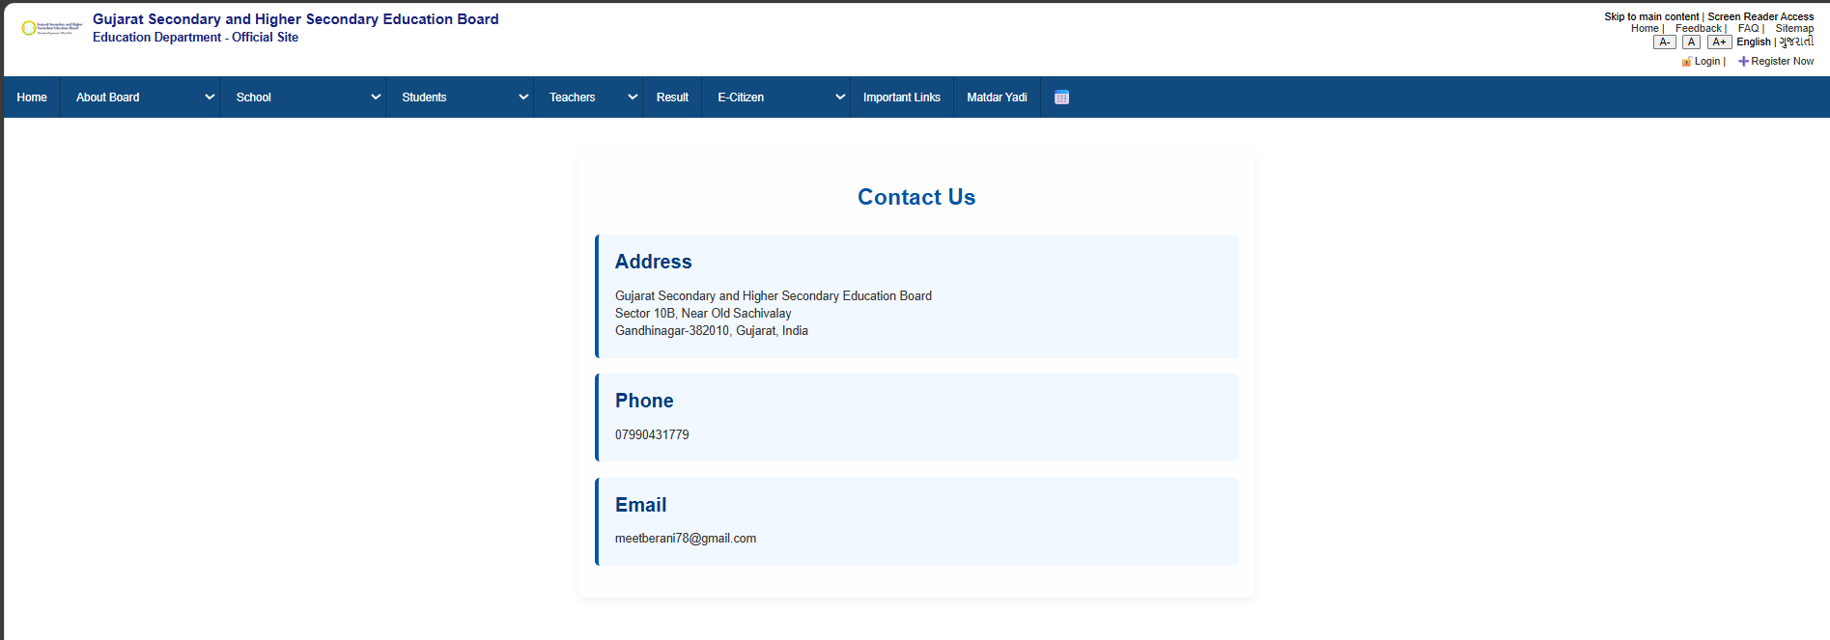    Figure:9Contact us page  PROGRAM CODE :  <!DOCTYPE html>  <html lang="en">  <head>  <meta charset="UTF-8" />  <meta name="viewport" content="width=device-width, initial-scale=1.0"/>  <title>Register</title>  <link rel="stylesheet" href="index.css" />  <style>  body {  font-family: Arial, sans-serif;  margin: 0;  padding: 0;  }  form {  width: 400px;  margin: 30px auto;  padding: 20px;  border: 1px solid #cccccc;  border-radius: 8px;  background-color: #f9f9f9;  }  form input,  form textarea,  form select {  width: 100%;  padding: 8px;  margin-top: 5px;  margin-bottom: 5px;  border: 1px solid #ccc;  border-radius: 4px;  }  form input[type="submit"] {  background-color: #0059b3;  color: white;  border: none;  cursor: pointer;  }  form input[type="submit"]:hover {  background-color: #004080;  }  .error-message {  color: red;  font-size: 13px;  margin-bottom: 10px;  display: block;  }  footer {  background-color: #eee;  padding: 20px;  font-size: 14px;  color: #333;  }  </style>  </head>  <body>  <!-- Top Header -->  <div class="top-header">  <div class="logo-area">  <img src="headimg.png" alt="Logo" />  <h2>  Gujarat Secondary and Higher Secondary Education Board<br />  <small>Education Department - Official Site</small>  </h2>  </div>  <div class="top-right">  <div>  Skip to main content | Screen Reader Access <br />  <a href="#">Home</a> |  <a href="#">Feedback</a> |  <a href="faq.html">FAQ</a> |  <a href="#">Sitemap</a>  </div>  <div class="font-size-controls">  <button>A-</button>  <button>A</button>  <button>A+</button>  <span>English</span> | <span>ગુજરાતી</span>  </div>  <div class="login-register">  <a href="login.html">🔓Login</a> |  <a href="register.html">➕Register Now</a>  </div>  </div>  </div>  <!-- Navigation -->  <nav>  <div class="nav-item"><a href="index.html">Home</a></div>  <div class="nav-item">  <select onchange="location = this.value;">  <option value="">About Board</option>  <option value="OrganizationStructure.html">Organization Structure</option>  <option value="Contact.html">Contact</option>  <option value="Branches.html">Branches</option>  </select>  </div>  <div class="nav-item">  <select onchange="location = this.value;">  <option value="">School</option>  <option value="StaticalData.html">Statical Data</option>  <option value="SchoolRegistration.html">School Registration</option>  <option value="NewSchoolApplication.html">New School Application</option>  <option value="NewClassApplication.html">New Class Application</option>  </select>  </div>  <div class="nav-item">  <select onchange="location = this.value;">  <option value="">Students</option>  <option value="10QuestionPaper.html">10 Question Paper</option>  <option value="12QuestionPaper.html">12 Question Papers</option>  </select>  </div>  <div class="nav-item">  <select onchange="location = this.value;">  <option value="">Teachers</option>  <option value="Teachers.html">Teacher Info</option>  </select>  </div>  <div class="nav-item"><a href="Result.html">Result</a></div>  <div class="nav-item">  <select onchange="location = this.value;">  <option value="">E-Citizen</option>  <option value="right-to-information.html">Right To Information</option>  <option value="act-rules.html">Act & Rules</option>  <option value="government-resolutions.html">Govt Resolutions</option>  <option value="tenders.html">Tenders</option>  <option value="Gallery.html">Gallery</option>  <option value="circulars.html">Circulars</option>  </select>  </div>  <div class="nav-item"><a href="ImportantLinks.html">Important Links</a></div>  <div class="nav-item"><a href="matdaryadi.html">Matdar Yadi</a></div>  <div class="nav-item calendar-icon">📅</div>  </nav>  <!-- Form Section -->  <form action="/submit_form" method="POST">  <h2>Student Registration Form</h2>  <label>Full Name:</label>  <input id="name" type="text" name="fullname" required />  <span class="error-message" id="name-error"></span><br />  <label>Mobile Number:</label>  <input type="tel" name="mobile" required />  <span class="error-message" id="mobile-error"></span><br />  <label>Birthdate:</label>  <input type="date" name="birthdate" required />  <span class="error-message" id="birthdate-error"></span><br />  <label>Address:</label>  <textarea name="address" rows="3" cols="30" required></textarea>  <span class="error-message" id="address-error"></span><br />  <label>School Name:</label>  <input type="text" name="school" required />  <span class="error-message" id="school-error"></span><br />  <label>Gender:</label>  <div style="display: flex; gap: 10px; margin-top: 5px; margin-bottom: 5px;">  <label><input type="radio" name="gender" value="Male" required /> Male</label>  <label><input type="radio" name="gender" value="Female" /> Female</label>  <label><input type="radio" name="gender" value="Other" /> Other</label>  </div>  <span class="error-message" id="gender-error"></span><br />  <input type="submit" value="Submit" />  </form>  <!-- Footer -->  <footer class="last-heading">  <center>  <p>Education Department | Commissionerate Mid Day Meal & Schools | Commissionerate of Higher Education</p>  <p>Gujarat Institute of Educational Technology | Director of Literacy & Continuing Education | Commissionerate of Technical Education</p>  <p>Directorate of Primary Education | National Cadet Corps | Sarva Shiksha Abhiyan</p>  <p>Gujarat Secondary and Higher Secondary Education Board | State Examination Board</p>  <p>Gujarat State Board of School Textbooks | State Board of Technical Examinations Gujarat</p>  <p>Gujarat Council of Educational Research and Training</p>  <p><a href="index.html">Home Page</a></p>  <p>Privacy Policy | Terms of Use | Disclaimer</p>  </center>  </footer>  </body>  </html>  OUTPUT:  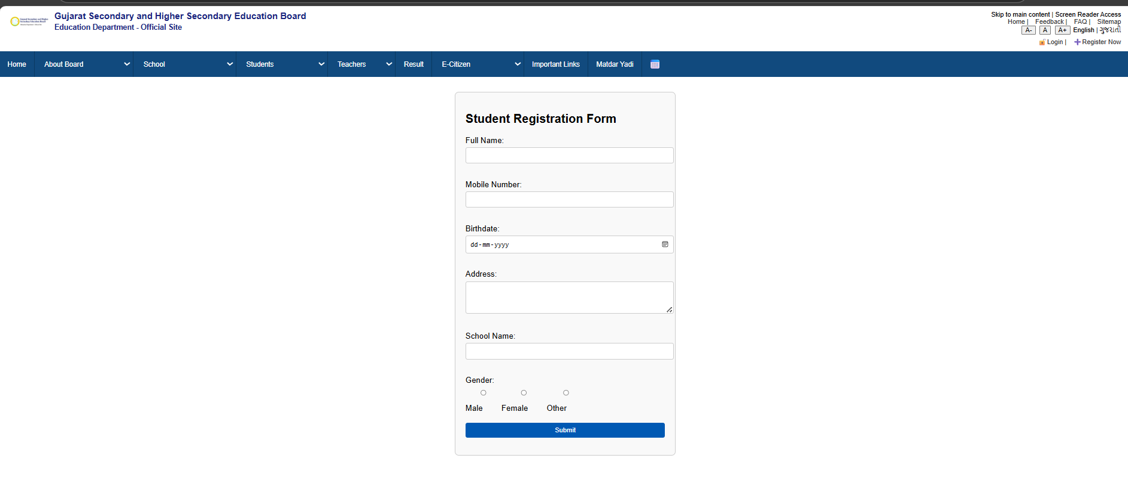    Figure:10Registration page  PROGRAM CODE :  <!DOCTYPE html>  <html lang="en">  <head>  <meta charset="UTF-8">  <meta name="viewport" content="width=device-width, initial-scale=1.0">  <title>Document</title>  <link rel="stylesheet" href="index.css">  <style>  body {  margin: 0;  padding: 0;  font-family: Arial, sans-serif;  background-color: #f3f6f9;  }  .font-size-controls button {  margin: 2px;  }  .nav-item {  margin: 0 10px;  }  form {  max-width: 400px;  background-color: white;  margin: 40px auto;  padding: 25px;  border-radius: 10px;  box-shadow: 0 0 10px rgba(0, 0, 0, 0.1);  }  form h2 {  text-align: center;  margin-bottom: 20px;  }  form input {  width: 100%;  padding: 10px;  margin: 6px 0 15px 0;  border: 1px solid #ccc;  border-radius: 4px;  }  form input[type="submit"] {  background-color: #004080;  color: white;  border: none;  cursor: pointer;  font-size: 16px;  }  form input[type="submit"]:hover {  background-color: #002b5e;  }  footer {  background-color: #eee;  text-align: center;  padding: 20px;  font-size: 14px;  color: #333;  }  </style>  </head>  <body>  <div class="top-header">  <div class="logo-area">  <img src="headimg.png" alt="Logo" />  <h2>Gujarat Secondary and Higher Secondary Education Board<br><small>Education Department - Official Site</small></h2>  </div>  <div class="top-right">  <div>  Skip to main content | Screen Reader Access <br />  <a href="#">Home</a> |  <a href="#">Feedback</a> |  <a href="faq.html">FAQ</a> |  <a href="#">Sitemap</a>  </div>  <div class="font-size-controls">  <button>A-</button>  <button>A</button>  <button>A+</button>  <span>English</span> |  <span>ગુજરાતી</span>  </div>  <div class="login-register">  <a href="login.html">🔓Login</a> |  <a href="register.html">➕Register Now</a>  </div>  </div>  </div>  <nav>  <div class="nav-item"><a href="index.html">Home</a></div>  <div class="nav-item">  <select onchange="location = this.value;">  <option value="">About Board</option>  <option value="OrganizationStructure.html">Organization Structure</option>  <option value="Contact.html">Contact</option>  <option value="Branches.html">Branches</option>  </select>  </div>  <div class="nav-item">  <select onchange="location = this.value;">  <option value="">School</option>  <option value="StaticalData.html">Statical Data</option>  <option value="SchoolRegistration.html">School Registration</option>  <option value="NewSchoolApplication.html">New School Application</option>  <option value="NewClassApplication.html">New Class Application</option>  </select>  </div>  <div class="nav-item">  <select onchange="location = this.value;">  <option value="">Students</option>  <option value="10QuestionPaper.html">10 Question Paper</option>  <option value="12QuestionPaper.html">12 Question Papers</option>  </select>  </div>  <div class="nav-item">  <select onchange="location = this.value;">  <option value="">Teachers</option>  <option value="Teachers.html">Teacher Info</option>  </select>  </div>  <div class="nav-item">  <a href="Result.html">Result</a>  </div>  <div class="nav-item">  <select onchange="location = this.value;">  <option value="">E-Citizen</option>  <option value="right-to-information.html">Right To Information</option>  <option value="act-rules.html">Act & Rules</option>  <option value="government-resolutions.html">Govt Resolutions</option>  <option value="tenders.html">Tenders</option>  <option value="Gallery.html">Gallery</option>  <option value="circulars.html">Circulars</option>  </select>  </div>  <div class="nav-item"><a href="ImportantLinks.html">Important Links</a></div>  <div class="nav-item"><a href="matdaryadi.html">Matdar Yadi</a></div>  <div class="nav-item calendar-icon">📅</div>  </nav>  <div>  <form onsubmit="return validateForm()" method="POST">  <p id="demo" ></p>  <h2>Login</h2>  <label>Mobile Number:</label><br>  <input id="name" id="mobilenumber" type="tel" name="mobile" required><br><br>  <label for="seatnumber">seat number:</label><br>  <input type="text" id="seatnumber" name="seatnumber"><br><br>  <label for="email">email:</label><br>  <input type="text" id="email" name="email"><br><br>  <label>Password:</label><br>  <input type="password" id="password" name="password" required><br><br>  <input type="submit" value="Login">  </form>  <p id="error-message" style="color: red;"></p>  <footer class="last-heading"><center>  <p>Education Department | Commissionerate Mid Day Meal & Schools | Commissionerate of Higher Education</p>  <p>Gujarat Institute of Educational Technology | Director of Literacy & Continuing Education | Commissionerate of Technical Education</p>  <p>Directorate of Primary Education | National Cadet Corps | Sarva Shiksha Abhiyan</p>  <p>Gujarat Secondary and Higher Secondary Education Board | State Examination Board</p>  <p>Gujarat State Board of School Textbooks | State Board of Technical Examinations Gujarat</p>  <p>Gujarat Council of Educational Research and Training</p>  <p><a href="index.html">Home Page</a></p>  <p>Privacy Policy | Terms of Use | Disclaimer</p>  </center>  </footer>  </body>  </html>  OUTPUT:  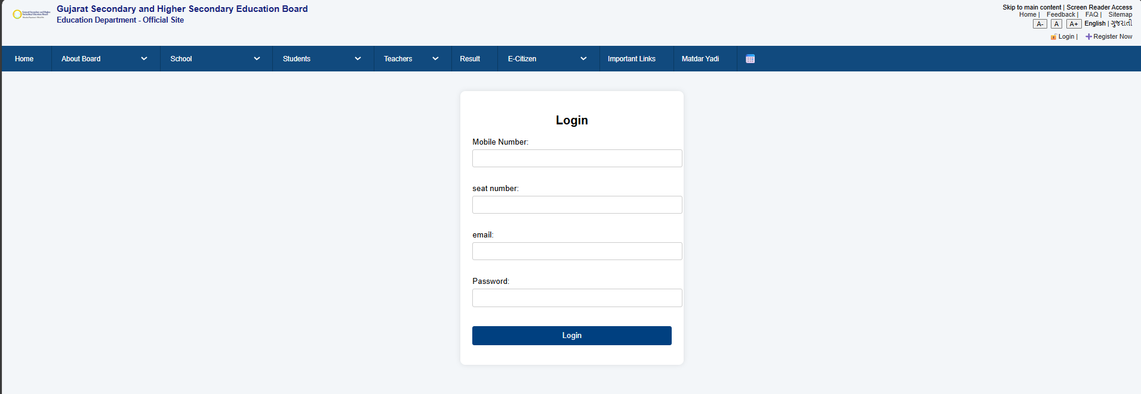    Figure:11Login page  PROGRAM CODE :  <!DOCTYPE html>  <html lang="en">  <head>  <meta charset="UTF-8">  <meta name="viewport" content="width=device-width, initial-scale=1.0">  <title>Gallery</title>  <link rel="stylesheet" href="index.css">  <style>  body {  font-family: sans-serif;  margin: 0;  background: #f5f5f5;  }  h2 {  color: #004080;  margin-top: 30px;  }  #popupOverlay, #popup {  display: none;  position: fixed;  z-index: 999;  }  #popupOverlay {  top: 0; left: 0;  width: 100%; height: 100%;  background: rgba(0,0,0,0.6);  }  #popup {  top: 50%; left: 50%;  transform: translate(-50%, -50%);  background: white;  padding: 25px;  border-radius: 10px;  box-shadow: 0 0 20px rgba(0,0,0,0.4);  z-index: 1000;  }  #popup button {  margin-top: 15px;  padding: 8px 16px;  background-color: #004080;  color: white;  border: none;  border-radius: 5px;  cursor: pointer;  }  #slider {  width: 80%;  max-width: 600px;  margin: 30px auto;  position: relative;  overflow: hidden;  border-radius: 10px;  box-shadow: 0 0 10px rgba(0,0,0,0.3);  }  .slide {  width: 100%;  display: none;  }  .slide.active {  display: block;  }  #slider button {  position: absolute;  top: 50%;  transform: translateY(-50%);  background: rgba(0,0,0,0.5);  color: white;  border: none;  font-size: 24px;  padding: 10px 15px;  cursor: pointer;  }  #prev { left: 0; }  #next { right: 0; }  .gallery-grid {  display: flex;  flex-wrap: wrap;  justify-content: center;  gap: 15px;  margin-bottom: 40px;  }  .gallery-grid img {  width: 200px;  height: 140px;  object-fit: cover;  border-radius: 10px;  transition: transform 0.3s;  }  .gallery-grid img:hover {  transform: scale(1.05);  }  #popup {  display: none;  position: fixed;  top: 30%;  left: 50%;  transform: translate(-50%, -30%);  background: white;  border: 2px solid #000;  padding: 20px;  z-index: 1000;  box-shadow: 0 0 10px rgba(0,0,0,0.3);  }  #popupOverlay {  display: none;  position: fixed;  top: 0; left: 0;  width: 100%; height: 100%;  background: rgba(0, 0, 0, 0.5);  z-index: 999;  }  /* Slider styles */  #slider {  width: 300px;  height: 200px;  overflow: hidden;  position: relative;  margin-top: 20px;  }  .slide {  width: 100%;  height: 100%;  display: none;  }  #slider button {  position: absolute;  top: 50%;  transform: translateY(-50%);  background: rgba(0,0,0,0.5);  color: white;  border: none;  font-size: 20px;  padding: 8px 12px;  cursor: pointer;  }  #prev { left: 0; }  #next { right: 0; }  </style>  </head>  <body>  <div class="top-header">  <div class="logo-area">  <img src="headimg.png" alt="Logo" />  <h2>Gujarat Secondary and Higher Secondary Education Board<br><small>Education Department - Official Site</small></h2>  </div>  <div class="top-right">  <div>  Skip to main content | Screen Reader Access <br />  <a href="#">Home</a> |  <a href="#">Feedback</a> |  <a href="faq.html">FAQ</a> |  <a href="#">Sitemap</a>  </div>  <div class="font-size-controls">  <button>A-</button>  <button>A</button>  <button>A+</button>  <span>English</span> |  <span>ગુજરાતી</span>  </div>  <div class="login-register">  <a href="login.html">🔓Login</a> |  <a href="register.html">➕Register Now</a>  </div>  </div>  </div>  <nav>  <div class="nav-item"><a href="index.html">Home</a></div>  <div class="nav-item">  <select onchange="location = this.value;">  <option value="">About Board</option>  <option value="OrganizationStructure.html">Organization Structure</option>  <option value="Contact.html">Contact</option>  <option value="Branches.html">Branches</option>  </select>  </div>  <div class="nav-item">  <select onchange="location = this.value;">  <option value="">School</option>  <option value="StaticalData.html">Statical Data</option>  <option value="SchoolRegistration.html">School Registration</option>  <option value="NewSchoolApplication.html">New School Application</option>  <option value="NewClassApplication.html">New Class Application</option>  </select>  </div>  <div class="nav-item">  <select onchange="location = this.value;">  <option value="">Students</option>  <option value="10QuestionPaper.html">10 Question Paper</option>  <option value="12QuestionPaper.html">12 Question Papers</option>  </select>  </div>  <div class="nav-item">  <select onchange="location = this.value;">  <option value="">Teachers</option>  <option value="Teachers.html">Teacher Info</option>  </select>  </div>  <div class="nav-item">  <a href="Result.html">Result</a>  </div>  <div class="nav-item">  <select onchange="location = this.value;">  <option value="">E-Citizen</option>  <option value="right-to-information.html">Right To Information</option>  <option value="act-rules.html">Act & Rules</option>  <option value="government-resolutions.html">Govt Resolutions</option>  <option value="tenders.html">Tenders</option>  <option value="Gallery.html">Gallery</option>  <option value="circulars.html">Circulars</option>  </select>  </div>  <div class="nav-item"><a href="ImportantLinks.html">Important Links</a></div>  <div class="nav-item"><a href="matdaryadi.html">Matdar Yadi</a></div>  <div class="nav-item calendar-icon">📅</div>  </nav>  <center>  <h2>📌 Important Notice</h2>  <button id="popupBtn">Open Popup</button>  <div id="popupOverlay"></div>  <div id="popup">  <p>This is a popup message. Click outside or press close to dismiss.</p>  <button id="closePopup">Close</button>  </div>  <h2>🖼️ Featured Gallery Slider</h2>  <div id="slider">  <img src="D:\web\G426180526.png" class="slide active" alt="Image 1">  <img src="D:\web\G435180504.png" class="slide" alt="Image 2">  <img src="D:\web\G624180520.png" class="slide" alt="Image 3">  <button id="prev">❮</button>  <button id="next">❯</button>  </div>  <h2>📷 All Gallery Images</h2>  <div class="gallery-grid">  <img src="D:\web\G426180526.png" alt="Gallery 1">  <img src="D:\web\G435180504.png" alt="Gallery 2">  <img src="D:\web\G624180520.png" alt="Gallery 3">  <img src="D:\web\G657180538.png" alt="Gallery 4">  <img src="D:\web\G756180453.png" alt="Gallery 5">  </div>  </center>  <!-- Footer remains unchanged -->  <!-- Paste your original footer here -->  <footer class="last-heading"><center>  <p>Education Department | Commissionerate Mid Day Meal & Schools | Commissionerate of Higher Education</p>  <p>Gujarat Institute of Educational Technology | Director of Literacy & Continuing Education | Commissionerate of Technical Education</p>  <p>Directorate of Primary Education | National Cadet Corps | Sarva Shiksha Abhiyan</p>  <p>Gujarat Secondary and Higher Secondary Education Board | State Examination Board</p>  <p>Gujarat State Board of School Textbooks | State Board of Technical Examinations Gujarat</p>  <p>Gujarat Council of Educational Research and Training</p>  <p><a href="index.html">Home Page</a></p>  <p>Privacy Policy | Terms of Use | Disclaimer</p>  </center>  </footer>  </body>  </html>  OUTPUT:  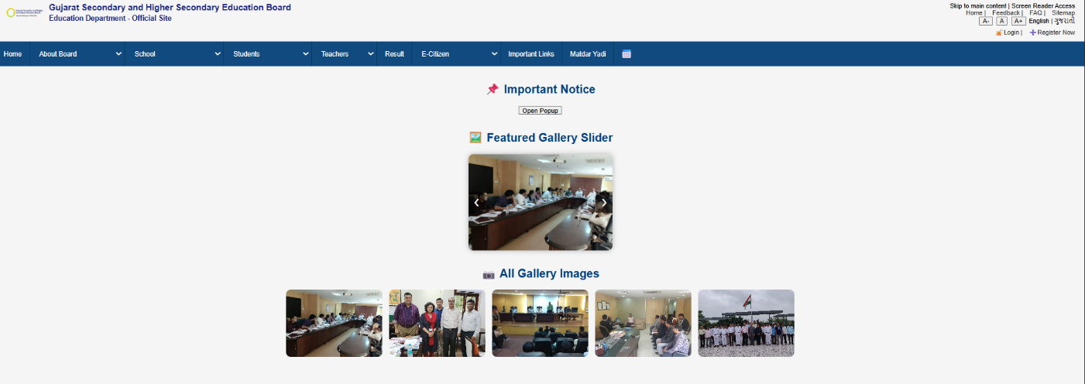    Figure:12Gallery page  PROGRAM CODE :  <!DOCTYPE html>  <html lang="en">  <head>  <meta charset="UTF-8">  <meta name="viewport" content="width=device-width, initial-scale=1.0">  <title>FAQ</title>  <link rel="stylesheet" href="index.css">  <style>  body {  font-family: Arial, sans-serif;  margin: 0;  padding: 0;  background-color: #f5f7fa;  }  .container {  display: flex;  justify-content: space-between;  padding: 30px;  }  .column {  width: 30%;  }  .left-buttons,  .right-buttons {  display: flex;  flex-direction: column;  gap: 15px;  }  .left-buttons p,  .right-buttons p {  margin: 0;  }  .button-box {  background-color: #2286c3;  color: white;  padding: 15px;  text-align: center;  font-weight: bold;  border-radius: 6px;  transition: background 0.3s;  cursor: pointer;  }  .button-box:hover {  background-color: #1769aa;  }  .center-panel {  background-color: white;  border-radius: 6px;  padding: 15px;  box-shadow: 0 2px 8px rgba(0,0,0,0.1);  }  .center-panel h3 {  margin-top: 0;  background-color: #0054a6;  color: white;  padding: 10px;  border-radius: 4px;  font-size: 18px;  }  .tabs {  display: flex;  justify-content: space-around;  margin: 15px 0;  font-weight: bold;  }  .tabs label {  cursor: pointer;  color: #0054a6;  }  .news-list {  border: 1px solid #ddd;  border-radius: 4px;  padding: 10px;  font-size: 14px;  }  .news-list option {  padding: 5px;  }  .view-all a {  color: white;  text-decoration: none;  }  .view-all {  background-color: #0054a6;  padding: 15px;  text-align: center;  font-weight: bold;  border-radius: 6px;  margin-top: 10px;  }  .view-all:hover {  background-color: #004080;  }  .partner-logos-section {  background-color: #f4f4f4;  padding: 20px 0;  text-align: center;  }  .logo-bar {  display: flex;  justify-content: center;  align-items: center;  flex-wrap: wrap;  gap: 40px;  }  .logo-bar img {  width: 117px;  max-height: 65px;  object-fit: contain;  }  .logo-bar img:hover {  transform: scale(1.05);  }  .faq-question {  cursor: pointer;  background: #f1f1f1;  padding: 10px;  margin: 5px 0;  border-left: 4px solid #0077cc;  }  .faq-answer {  display: none;  padding: 10px;  background: #fff;  border: 1px solid #ddd;  margin-bottom: 10px;  }  </style>  </head>  <body>  <div class="top-header">  <div class="logo-area">  <img src="headimg.png" alt="Logo" />  <h2>Gujarat Secondary and Higher Secondary Education Board<br><small>Education Department - Official Site</small></h2>  </div>  <div class="top-right">  <div>  Skip to main content | Screen Reader Access <br />  <a href="#">Home</a> |  <a href="#">Feedback</a> |  <a href="faq.html">FAQ</a> |  <a href="#">Sitemap</a>  </div>  <div class="font-size-controls">  <button>A-</button>  <button>A</button>  <button>A+</button>  <span>English</span> |  <span>ગુજરાતી</span>  </div>  <div class="login-register">  <a href="login.html">🔓Login</a> |  <a href="register.html">➕Register Now</a>  </div>  </div>  </div>  <nav>  <div class="nav-item"><a href="index.html">Home</a></div>  <div class="nav-item">  <select onchange="location = this.value;">  <option value="">About Board</option>  <option value="OrganizationStructure.html">Organization Structure</option>  <option value="Contact.html">Contact</option>  <option value="Branches.html">Branches</option>  </select>  </div>  <div class="nav-item">  <select onchange="location = this.value;">  <option value="">School</option>  <option value="StaticalData.html">Statical Data</option>  <option value="SchoolRegistration.html">School Registration</option>  <option value="NewSchoolApplication.html">New School Application</option>  <option value="NewClassApplication.html">New Class Application</option>  </select>  </div>  <div class="nav-item">  <select onchange="location = this.value;">  <option value="">Students</option>  <option value="10QuestionPaper.html">10 Question Paper</option>  <option value="12QuestionPaper.html">12 Question Papers</option>  </select>  </div>  <div class="nav-item">  <select onchange="location = this.value;">  <option value="">Teachers</option>  <option value="Teachers.html">Teacher Info</option>  </select>  </div>  <div class="nav-item">  <a href="Result.html">Result</a>  </div>  <div class="nav-item">  <select onchange="location = this.value;">  <option value="">E-Citizen</option>  <option value="right-to-information.html">Right To Information</option>  <option value="act-rules.html">Act & Rules</option>  <option value="government-resolutions.html">Govt Resolutions</option>  <option value="tenders.html">Tenders</option>  <option value="Gallery.html">Gallery</option>  <option value="circulars.html">Circulars</option>  </select>  </div>  <div class="nav-item"><a href="ImportantLinks.html">Important Links</a></div>  <div class="nav-item"><a href="matdaryadi.html">Matdar Yadi</a></div>  <div class="nav-item calendar-icon">📅</div>  </nav>  <div>  <h2>FAQ-this website</h2>  <div class="faq-question">➤ What is gujarat board ?</div>  <div class="faq-answer">The Gujarat Secondary and Higher Secondary Education Board  (GSEB) is the primary education board for the state of Gujarat, India.</div>  <div class="faq-question">➤ How can I join gujarat </div>  <div class="faq-answer"> register for the SSC (Class 10) or HSC (Class 12) exams through the official website, gseb.org</div>  <div class="faq-question">➤ Facing problems regarding registration or login ?</div>  <div class="faq-answer">In case you are facing any problem regarding the registration or login process, please do get in touch  with us through this form. We would be more than happy to get back to you and help in solving issues you may face while  browsing and/or participating through gujarat board, as we value your participation in gujarat board.</div>  <div class="faq-question">➤Did not find your suggestions on the platform ?</div>  <div class="faq-answer">Do not hesitate to get in touch with us with the same we will address your issue  at the earliest as we value your participation in the MyGov Platform.</div>  <div class="faq-question">➤Groups: Collaborate with Government!</div>  <div class="faq-answer">Explore & choose from an array of topics on public and national  importance on which Government and its respective agency would like to hear from you.  Make yourself part of these groups and express your valued views and proposal on these  issues. The Government would seek your active engagement and participation in addressing  issues mentioned as group topics in the portal. A citizen can only be part of 4 groups at  one particular time.</div>  <div class="faq-question">➤Any other issue ? </div>  <div class="faq-answer">Apart from the above mentioned category  if you are facing any other issue with regard to the site, please do  not hesitate to get in touch with us. Let us know about your problem with  brief description of the issue which you are facing. We would be happy to  revert back to you.  If you wish to submit your feedback or query related to any  specific content not related to gujarat board and is pertaining to  any Ministry/Department/Government body other than related togujarat board,  kindly get in touch with the concerned Ministry/Department/Government body  directly or visit their respective websites.gujarat board will not respond to such queries/issues.</div>  </div>  <footer class="last-heading"><center>  <p>Education Department | Commissionerate Mid Day Meal & Schools | Commissionerate of Higher Education</p>  <p>Gujarat Institute of Educational Technology | Director of Literacy & Continuing Education | Commissionerate of Technical Education</p>  <p>Directorate of Primary Education | National Cadet Corps | Sarva Shiksha Abhiyan</p>  <p>Gujarat Secondary and Higher Secondary Education Board | State Examination Board</p>  <p>Gujarat State Board of School Textbooks | State Board of Technical Examinations Gujarat</p>  <p>Gujarat Council of Educational Research and Training</p>  <p><a href="index.html">Home Page</a></p>  <p>Privacy Policy | Terms of Use | Disclaimer</p>  </center>  </footer>  </body>  </html>  OUTPUT:  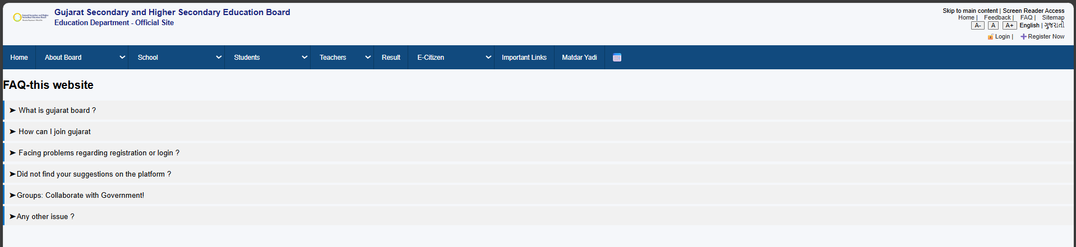    Figure:13Faq page  CONCLUSION:  The project defined the scope and structure of a student portal by creating semantic HTML layouts and a sitemap for smooth navigation (CO1). Responsive design principles using CSS Flexbox/Grid and media queries were applied to ensure usability across devices (CO2). Overall, the work improved skills in requirement analysis, wireframing, and responsive UI design, forming a strong foundation for future portal development.
3 | Problem Definition:  Create a user registration page with frontend validation using HTML5 and  JavaScript.  PROGRAM CODE :  <script>  document.addEventListener("DOMContentLoaded", function () {  const form = document.querySelector("form");  form.addEventListener("submit", function (e) {  let isValid = true;  document.querySelectorAll(".error-message").forEach(el => el.textContent = "");  const name = form.fullname.value.trim();  const mobile = form.mobile.value.trim();  const birthdate = form.birthdate.value;  const address = form.address.value.trim();  const school = form.school.value.trim();  const gender = form.gender.value;  const mobileRegex = /^[6-9]\d{9}$/;  if (name.length < 3) {  document.getElementById("name-error").textContent = "Full Name must be at least 3 characters.";  isValid = false;  }  if (!mobileRegex.test(mobile)) {  document.getElementById("mobile-error").textContent = "Enter a valid 10-digit mobile number starting with 6-9.";  isValid = false;  }  const birth = new Date(birthdate);  const today = new Date();  if (!birthdate || birth >= today) {  document.getElementById("birthdate-error").textContent = "Birthdate cannot be today or in the future.";  isValid = false;  }  if (address.length < 10) {  document.getElementById("address-error").textContent = "Address should be at least 10 characters.";  isValid = false;  }  if (school.length < 3) {  document.getElementById("school-error").textContent = "School Name must be at least 3 characters.";  isValid = false;  }  if (!gender) {  document.getElementById("gender-error").textContent = "Please select a gender.";  isValid = false;  }  if (!isValid) {  e.preventDefault();  }  });  });  </script>  OUTPUT:  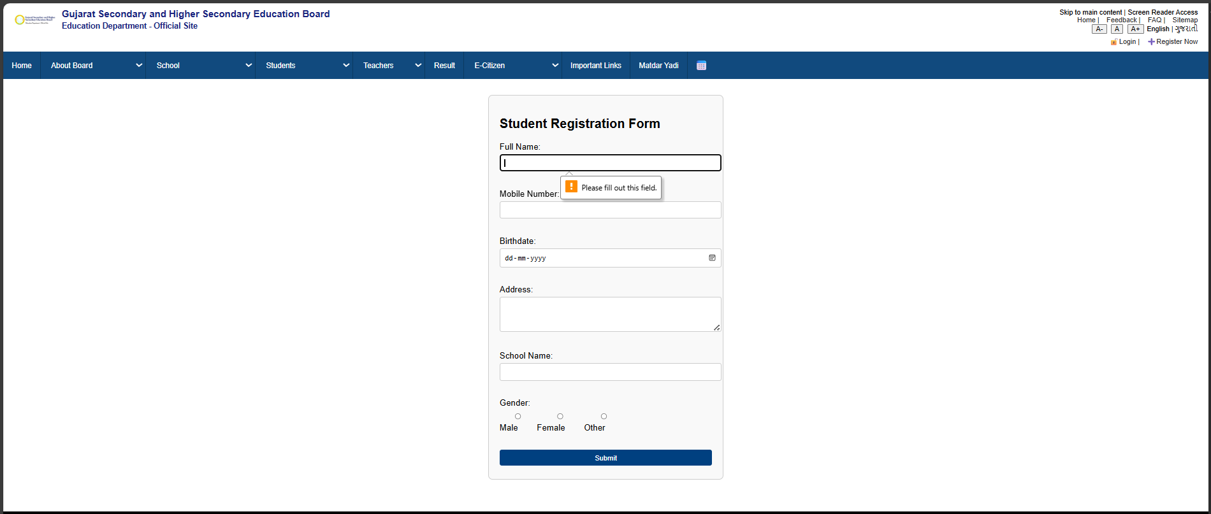  Figure:3.1Registration page  PROGRAM CODE :  <script>  function validateForm() {  const mobile = document.getElementById("name").value.trim();  const seatnumber = document.getElementById("seatnumber").value.trim();  const email = document.getElementById("email").value.trim();  const password = document.getElementById("password").value.trim();  const error = document.getElementById("error-message");  error.innerText = "";  const mobileRegex = /^[6-9]\d{9}$/;  const emailRegex = /^[^\s@]+@[^\s@]+\.[^\s@]+$/;  if (!mobileRegex.test(mobile)) {  error.innerText = "Invalid mobile number. It must be 10 digits and start with 6-9.";  return false;  }  if (seatnumber.length < 6) {  error.innerText = "Seat number must be at least 6 characters.";  return false;  }  if (!emailRegex.test(email)) {  error.innerText = "Invalid email address.";  return false;  }  if (password.length < 6) {  error.innerText = "Password must be at least 6 characters.";  return false;  }  return true;  }  </script>  OUTPUT:  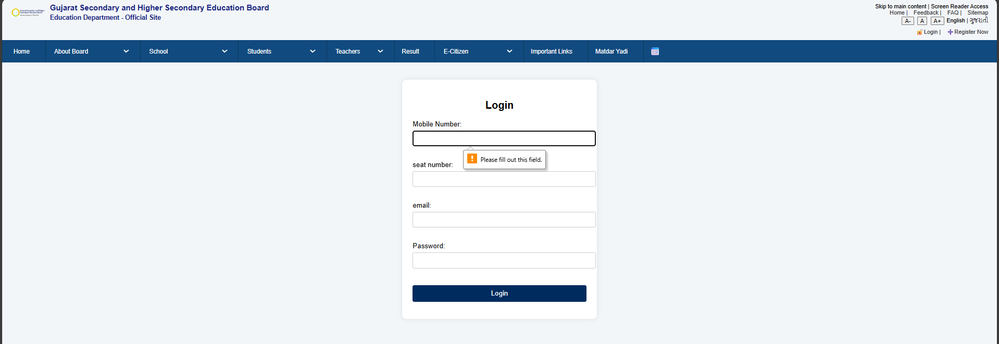    Figure:3.2Login page  CONCLUSION:  The registration page was successfully designed using HTML5 and JavaScript with effective frontend validation for required fields, input types, and error handling. Additional features like a password strength meter improved usability and security. This task enhanced skills in form design, accessibility, and validation logic, providing a practical foundation for real-world registration and data entry systems.
4 | Problem Definition:  Create dynamic content such as collapsible FAQs, popups, and sliders in portal  PROGRAM CODE :  <script>  // Popup  const popupBtn = document.getElementById("popupBtn");  const popup = document.getElementById("popup");  const popupOverlay = document.getElementById("popupOverlay");  const closePopup = document.getElementById("closePopup");  popupBtn.onclick = () => {  popup.style.display = "block";  popupOverlay.style.display = "block";  };  closePopup.onclick = popupOverlay.onclick = () => {  popup.style.display = "none";  popupOverlay.style.display = "none";  };  // Slider  let currentSlide = 0;  const slides = document.querySelectorAll(".slide");  function showSlide(index) {  slides.forEach((slide, i) => {  slide.classList.toggle("active", i === index);  });  }  document.getElementById("next").onclick = () => {  currentSlide = (currentSlide + 1) % slides.length;  showSlide(currentSlide);  };  document.getElementById("prev").onclick = () => {  currentSlide = (currentSlide - 1 + slides.length) % slides.length;  showSlide(currentSlide);  };  </script>  OUTPUT: 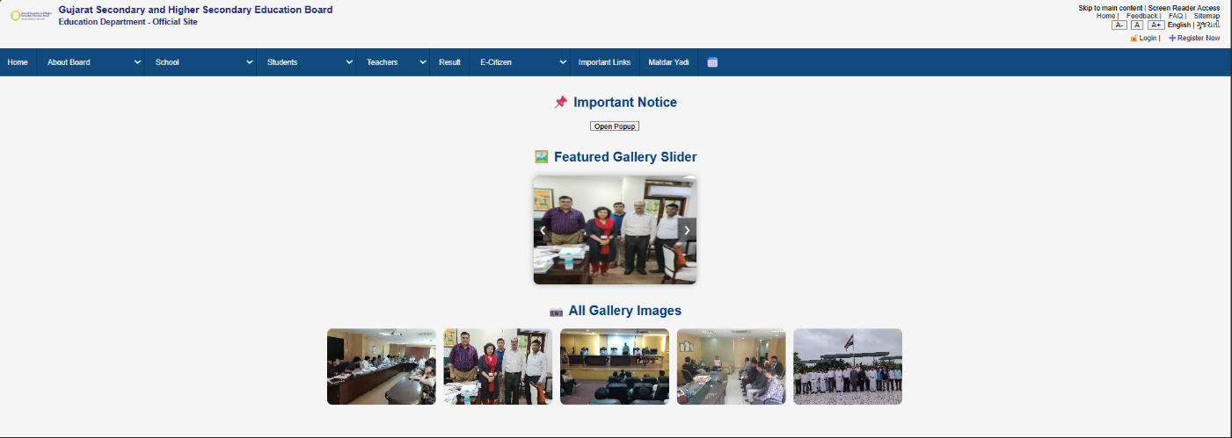    Figure:4.1Slider page  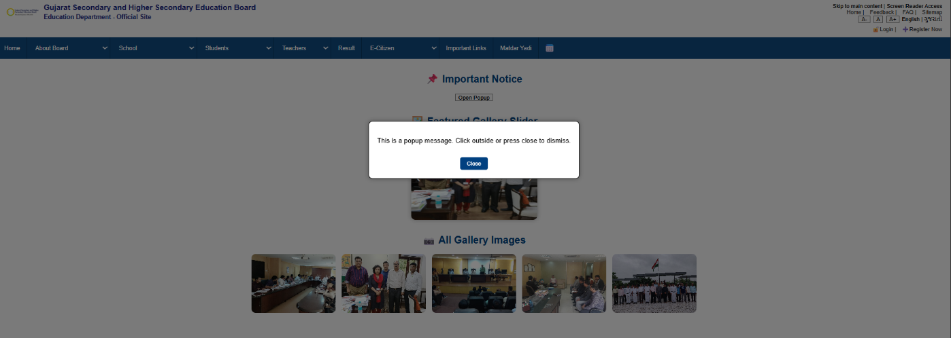  Figure:4.2Popup page  PROGRAM CODE :  <script>  document.querySelectorAll(".faq-question").forEach(q => {  q.addEventListener("click", () => {  const answer = q.nextElementSibling;  answer.style.display = answer.style.display === "block" ? "none" : "block";  });  });  </script>  OUTPUT:  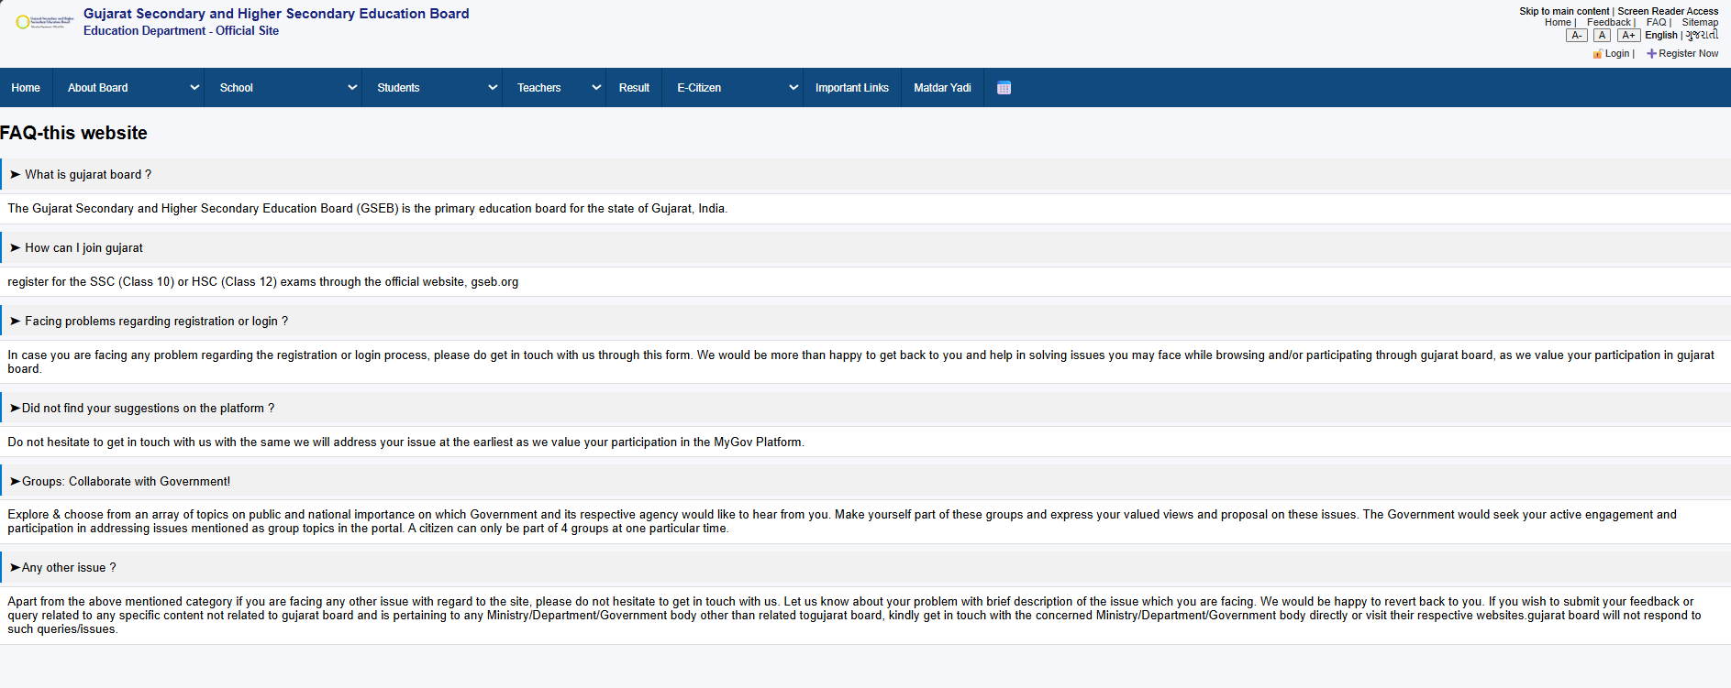    Figure:4.3Faq page  CONCLUSION:  Dynamic content such as collapsible FAQs, popups, and sliders was implemented using JavaScript DOM manipulation and event handling to improve interactivity and usability. These features enhanced the portal’s user experience by making content more engaging and accessible. The task strengthened skills in DOM selection, event-driven programming, and UI enhancement, laying the groundwork for more advanced interactive dashboards.
5 | Problem Definition:  Display events list and student profiles using object arrays and JSON parsing.  PROGRAM CODE :  <!DOCTYPE html>  <html lang="en">  <head>  <meta charset="UTF-8" />  <meta name="viewport" content="width=device-width, initial-scale=1.0"/>  <title>Events & Students</title>  </head>  <body>  <div class="section">  <h2>Event List</h2>  <div id="eventList"></div>  </div>  <div class="section">  <h2>Student Profiles</h2>  <div id="studentList"></div>  </div>  </body>  </html>  Css:  <style>  body {  font-family: Arial, sans-serif;  margin: 20px;  background-color: #f0f2f5;  }  .section {  margin-bottom: 30px;  }  .card {  border: 1px solid #ccc;  border-radius: 10px;  padding: 15px;  margin: 10px 0;  background-color: #fff;  box-shadow: 0 2px 5px rgba(0,0,0,0.05);  }  .title {  font-size: 1.2em;  margin-bottom: 5px;  font-weight: bold;  }  .student-info {  margin-left: 15px;  margin-top: 10px;  padding-left: 10px;  border-left: 3px solid #aaa;  }  .student-entry {  margin-bottom: 10px;  }  </style>  Js Code:  <script>  const eventsJSON = `  [  {"id": 1, "name": "Hackathon", "date": "2025-08-2"},  {"id": 2, "name": "CODE QUAE", "date": "2025-08-3"},  {"id": 3, "name": "STEM Quiz", "date": "2025-08-4"}  ]`;  const studentsJSON = `  [  {"name": "smit", "roll": "24DCE017", "enrolledEvents": [1,2, 3]},  {"name": "jeel", "roll": "24DCE013", "enrolledEvents": [2]},  {"name": "hit", "roll": "24DCE010", "enrolledEvents": [1, 2, 3]},  {"name": "RAJ", "roll": "24DCE019", "enrolledEvents": [1, 2]},  {"name": "POOJAN", "roll": "24DCE029", "enrolledEvents": [1, 2, 3]}  ]`;  const events = JSON.parse(eventsJSON);  const students = JSON.parse(studentsJSON);  const eventList = document.getElementById("eventList");  const studentList = document.getElementById("studentList");  function createEventCard(event) {  const div = document.createElement("div");  div.className = "card";  div.innerHTML = `  <div class="title">${event.name}</div>  <div>Date: ${event.date}</div>`;  const enrolledStudents = students.filter(student =>  student.enrolledEvents.includes(event.id)  );  const infoDiv = document.createElement("div");  infoDiv.className = "student-info";  if (enrolledStudents.length > 0) {  enrolledStudents.forEach(s => {  const entry = document.createElement("div");  entry.className = "student-entry";  entry.innerHTML = `<div><strong>Name:</strong> ${s.name}</div>  <div><strong>Roll No:</strong> ${s.roll}</div>`;  infoDiv.appendChild(entry);  });  } else {  infoDiv.textContent = "No students enrolled.";  }  div.appendChild(infoDiv);  return div;  }  function createStudentCard(student, allEvents) {  const div = document.createElement("div");  div.className = "card";  const enrolledEventNames = student.enrolledEvents.map(id => {  const match = allEvents.find(ev => ev.id === id);  return match ? match.name : "Unknown Event";  });  div.innerHTML = `  <div class="title">${student.name}</div>  <div>Roll No: ${student.roll}</div>  <div>Enrolled Events: ${enrolledEventNames.join(", ")}</div>`;  return div;  }  events.forEach(event => {  const card = createEventCard(event);  eventList.appendChild(card);  });  students.forEach(student => {  const card = createStudentCard(student, events);  studentList.appendChild(card);  });  </script>  OUTPUT: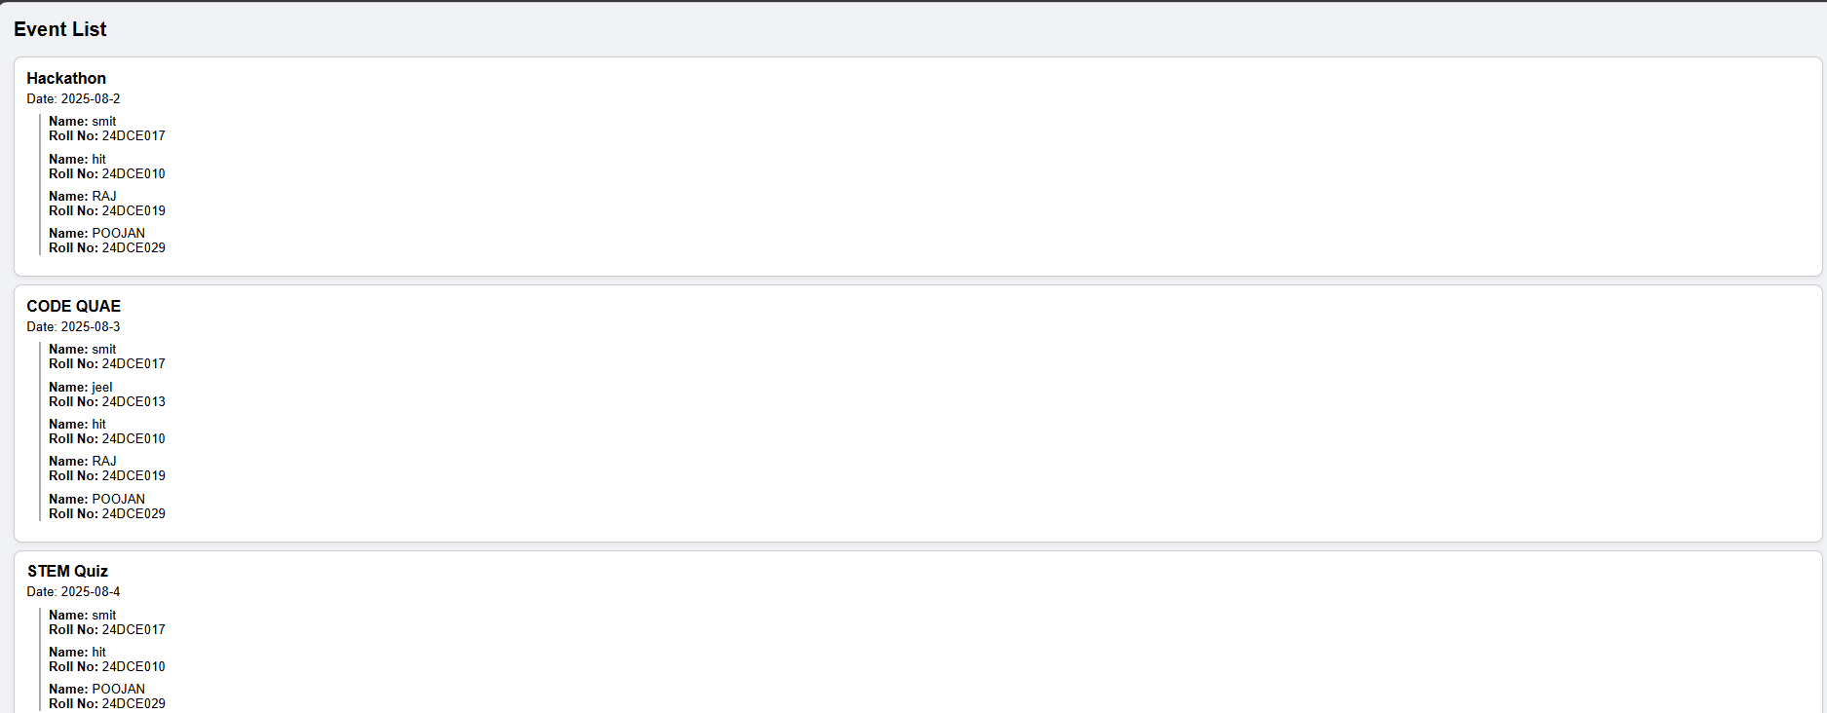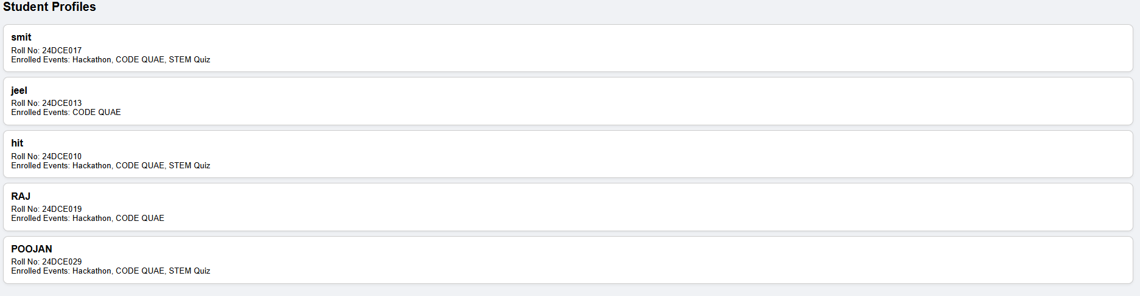
6&9 | Problem Definition:  6.Store submitted registration data in a PHP file and confirm submission.  9.Submit form data using PHP and store it in a text file  PROGRAM CODE  <?php  // Variables  $name = $mobile = $birthdate = $address = $school = $gender = "";  $nameErr = $mobileErr = $birthdateErr = $addressErr = $schoolErr = $genderErr = "";  $success = false;  // On form submission  if ($_SERVER["REQUEST_METHOD"] == "POST") {  $valid = true;  function test_input($data) {  return htmlspecialchars(stripslashes(trim($data)));  }  // Validate Name  if (empty($_POST["fullname"])) {  $nameErr = "Full Name is required";  $valid = false;  } else {  $name = test_input($_POST["fullname"]);  if (strlen($name) < 3) {  $nameErr = "Name must be at least 3 characters.";  $valid = false;  }  }  // Validate Mobile  if (empty($_POST["mobile"])) {  $mobileErr = "Mobile number is required";  $valid = false;  } else {  $mobile = test_input($_POST["mobile"]);  if (!preg_match("/^[6-9][0-9]{9}$/", $mobile)) {  $mobileErr = "Enter valid 10-digit mobile starting with 6-9.";  $valid = false;  }  }  // Validate Birthdate  if (empty($_POST["birthdate"])) {  $birthdateErr = "Birthdate is required";  $valid = false;  } else {  $birthdate = $_POST["birthdate"];  if (strtotime($birthdate) >= strtotime(date("Y-m-d"))) {  $birthdateErr = "Birthdate cannot be today or in the future.";  $valid = false;  }  }  // Validate Address  if (empty($_POST["address"])) {  $addressErr = "Address is required";  $valid = false;  } else {  $address = test_input($_POST["address"]);  if (strlen($address) < 10) {  $addressErr = "Address should be at least 10 characters.";  $valid = false;  }  }  // Validate School  if (empty($_POST["school"])) {  $schoolErr = "School name is required";  $valid = false;  } else {  $school = test_input($_POST["school"]);  if (strlen($school) < 3) {  $schoolErr = "School Name must be at least 3 characters.";  $valid = false;  }  }  // Validate Gender  if (empty($_POST["gender"])) {  $genderErr = "Please select a gender";  $valid = false;  } else {  $gender = $_POST["gender"];  }  if ($valid) {  $success = true;  // Prepare data as array  $data = [$name, $mobile, $birthdate, $address, $school, $gender];  // Open file in append mode  $file = fopen("registrations.csv", "a");  // Write data as CSV  fputcsv($file, $data);  // Close file  fclose($file);  }  }  ?>  <?php if ($success): ?>  <p class="success">✅ Registration Successful! Thank you.</p>  <?php endif; ?>  OUTPUT:  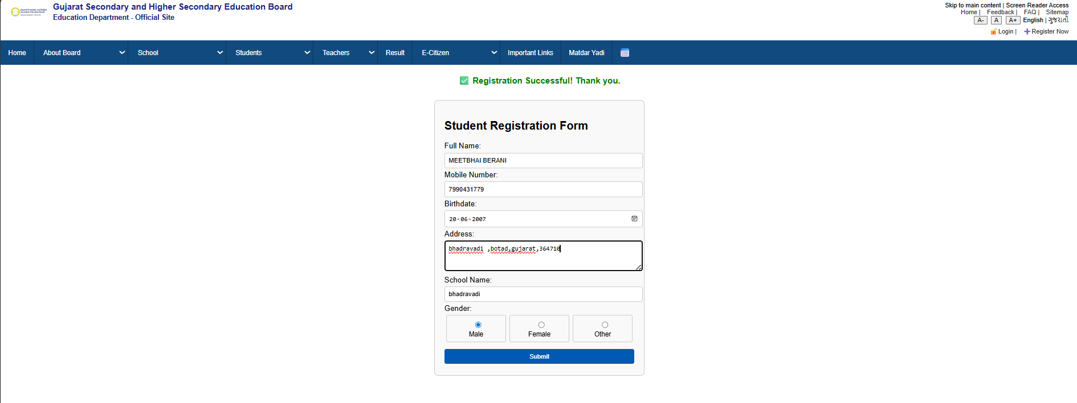  File store value:  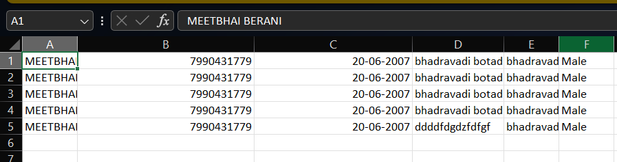  fifi
7 | Problem Definition:  Create a login/logout system with session & cookie handling  PROGRAM CODE :  Only form code:  <form action="" method="POST">  <h2>Login</h2>  <?php if($error != ""): ?>  <p style="color:red;"><?php echo $error; ?></p>  <?php endif; ?>  <label>Mobile Number:</label><br>  <input type="text" name="mobile" value="<?php echo htmlspecialchars($mobile); ?>"><br><br>  <label>Seat Number:</label><br>  <input type="text" name="seatnumber" value="<?php echo htmlspecialchars($seatnumber); ?>"><br><br>  <label>Email:</label><br>  <input type="text" name="email" value="<?php echo htmlspecialchars($email); ?>"><br><br>  <label>Password:</label><br>  <input type="password" name="password"><br><br>  <input type="submit" value="Login">  </form>  <p id="error-message" style="color: red;"></p>  Php code: <?php  session_start();  // --- Valid credentials ---  $valid_mobile = "7990431779";  $valid_email = "meetberani78@gmail.com";  $valid_seat = "B323688";  $valid_pass = "Meet@2007";  // -----------------------  $mobile = $seatnumber = $email = $password = "";  $error = "";  // Form submission  if ($_SERVER["REQUEST_METHOD"] === "POST") {  $mobile = isset($_POST['mobile']) ? trim($_POST['mobile']) : "";  $seatnumber = isset($_POST['seatnumber']) ? trim($_POST['seatnumber']) : "";  $email = isset($_POST['email']) ? trim($_POST['email']) : "";  $password = isset($_POST['password']) ? trim($_POST['password']) : "";  // PHP validation  if ($mobile === "" || $email === "" || $seatnumber === "" || $password === "") {  $error = "Please fill all fields.";  } elseif (!preg_match("/^[6-9][0-9]{9}$/", $mobile)) {  $error = "Invalid mobile number. It must be 10 digits and start with 6-9.";  } elseif (!filter_var($email, FILTER_VALIDATE_EMAIL)) {  $error = "Invalid email address.";  } elseif (strlen($seatnumber) < 3) {  $error = "Seat number seems invalid.";  } else {  // Check against valid credentials  if ($mobile === $valid_mobile && $email === $valid_email && $seatnumber === $valid_seat && $password === $valid_pass) {  // Success  $_SESSION['user'] = $mobile;  $_SESSION['email'] = $email;  $_SESSION['seatnumber'] = $seatnumber;  header("Location: dashboard.php"); // Redirect on success  // Redirect on success  exit;  } else {  $error = "Invalid login credentials. Please check mobile/email/seat number/password.";  }  }  }  ?>  Dashboard.phpcode: <?php  session_start();  // Check if user is logged in  if (!isset($_SESSION['user'])) {  header("Location: login.php");  exit;  }  // Logout logic  if (isset($_GET['logout'])) {  session_destroy();  header("Location: login.php");  exit;  }  ?>  <!DOCTYPE html>  <html lang="en">  <head>  <meta charset="UTF-8">  <meta name="viewport" content="width=device-width, initial-scale=1.0">  <title>Dashboard</title>  <style>  /* Reset & body */  body {  margin: 0;  font-family: 'Segoe UI', Tahoma, Geneva, Verdana, sans-serif;  background: linear-gradient(to right, #4facfe, #00f2fe);  min-height: 100vh;  display: flex;  flex-direction: column;  }  /* Header */  header {  background-color: rgba(0,0,0,0.8);  color: #fff;  padding: 20px;  text-align: center;  box-shadow: 0px 4px 6px rgba(0,0,0,0.2);  }  /* Card container */  .container {  flex: 1;  display: flex;  justify-content: center;  align-items: center;  padding: 20px;  }  /* Card style */  .card {  background-color: #fff;  border-radius: 15px;  padding: 30px 40px;  box-shadow: 0 10px 25px rgba(0,0,0,0.2);  text-align: center;  max-width: 400px;  width: 100%;  animation: fadeIn 1s ease;  }  /* Fade-in animation */  @keyframes fadeIn {  from {opacity: 0; transform: translateY(-20px);}  to {opacity: 1; transform: translateY(0);}  }  /* User info */  .card h2 {  margin-bottom: 20px;  color: #333;  }  .card p {  margin: 10px 0;  font-size: 16px;  color: #555;  }  /* Logout button */  .logout-btn {  display: inline-block;  margin-top: 20px;  padding: 10px 25px;  background: #ff4b2b;  color: #fff;  text-decoration: none;  border-radius: 50px;  transition: 0.3s;  }  .logout-btn:hover {  background: #ff416c;  }  /* Footer */  footer {  background-color: rgba(0,0,0,0.8);  color: #fff;  padding: 15px;  text-align: center;  font-size: 14px;  }  </style>  </head>  <body>  <header>  <h1>📚 Gujarat Secondary & Higher Secondary Education Board</h1>  <p>Welcome to your Dashboard</p>  </header>  <div class="container">  <div class="card">  <h2>Welcome, <?php echo htmlspecialchars($_SESSION['user']); ?>!</h2>  <p><strong>Email:</strong> <?php echo htmlspecialchars($_SESSION['email']); ?></p>  <p><strong>Seat Number:</strong> <?php echo htmlspecialchars($_SESSION['seatnumber']); ?></p>  <a class="logout-btn" href="dashboard.php?logout=true">Logout</a>  </div>  </div>  <footer>  &copy; <?php echo date("Y"); ?> Gujarat Secondary & Higher Secondary Education Board | All Rights Reserved  </footer>  </body>  </html>  OUTPUT:  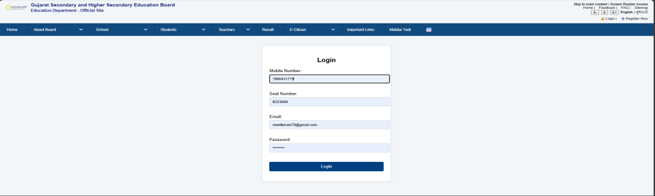    Login done:  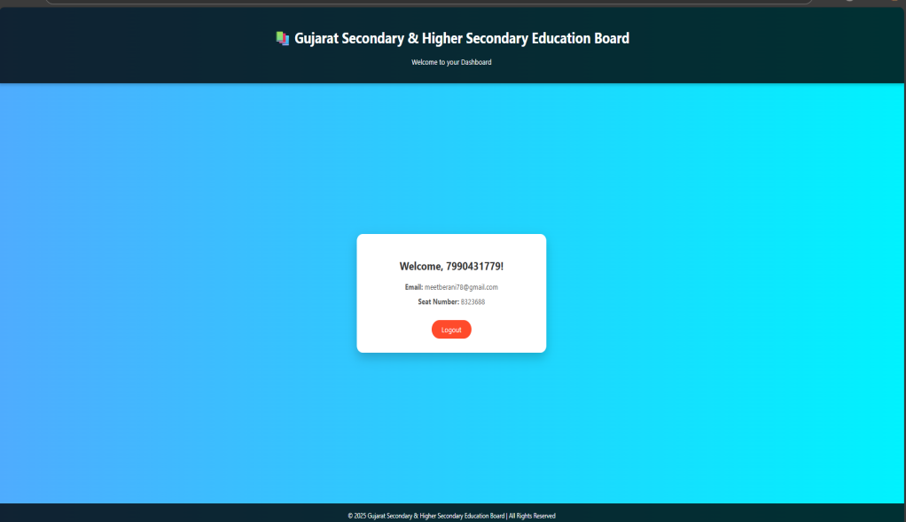
8 | Problem Definition:  Connect the portal with MySQL to store and retrieve user/event data  PROGRAM CODE : <?php  // MySQL connection  $servername = "localhost";  $username = "root"; // your MySQL username  $password = ""; // your MySQL password  $dbname = "portal_db";  // Create connection  $conn = new mysqli($servername, $username, $password, $dbname);  if ($conn->connect_error) {  die("Connection failed: " . $conn->connect_error);  }  // Variables  $name = $mobile = $birthdate = $address = $school = $gender = "";  $nameErr = $mobileErr = $birthdateErr = $addressErr = $schoolErr = $genderErr = "";  $success = false;  // On form submission  if ($_SERVER["REQUEST_METHOD"] == "POST") {  $valid = true;  function test_input($data) {  return htmlspecialchars(stripslashes(trim($data)));  }  // --- Validations ---  if (empty($_POST["fullname"])) {  $nameErr = "Full Name is required";  $valid = false;  } else {  $name = test_input($_POST["fullname"]);  if (strlen($name) < 3) {  $nameErr = "Name must be at least 3 characters.";  $valid = false;  }  }  if (empty($_POST["mobile"])) {  $mobileErr = "Mobile number is required";  $valid = false;  } else {  $mobile = test_input($_POST["mobile"]);  if (!preg_match("/^[6-9][0-9]{9}$/", $mobile)) {  $mobileErr = "Enter valid 10-digit mobile starting with 6-9.";  $valid = false;  }  }  if (empty($_POST["birthdate"])) {  $birthdateErr = "Birthdate is required";  $valid = false;  } else {  $birthdate = $_POST["birthdate"];  if (strtotime($birthdate) >= strtotime(date("Y-m-d"))) {  $birthdateErr = "Birthdate cannot be today or in the future.";  $valid = false;  }  }  if (empty($_POST["address"])) {  $addressErr = "Address is required";  $valid = false;  } else {  $address = test_input($_POST["address"]);  if (strlen($address) < 10) {  $addressErr = "Address should be at least 10 characters.";  $valid = false;  }  }  if (empty($_POST["school"])) {  $schoolErr = "School name is required";  $valid = false;  } else {  $school = test_input($_POST["school"]);  if (strlen($school) < 3) {  $schoolErr = "School Name must be at least 3 characters.";  $valid = false;  }  }  if (empty($_POST["gender"])) {  $genderErr = "Please select a gender";  $valid = false;  } else {  $gender = $_POST["gender"];  }  // --- If all validations passed ---  if ($valid) {  $success = true;  // --- Store in MySQL ---  $stmt = $conn->prepare(  "INSERT INTO students (fullname, mobile, birthdate, address, school, gender)  VALUES (?, ?, ?, ?, ?, ?)"  );  $stmt->bind_param("ssssss", $name, $mobile, $birthdate, $address, $school, $gender);  if (!$stmt->execute()) {  error_log("MySQL Error: " . $stmt->error);  echo "❌ Something went wrong. Please try again later.";  }  $stmt->close();  // --- Clear form fields ---  $name = $mobile = $birthdate = $address = $school = $gender = "";  }  }  ?>  <?php if ($success): ?>  <p class="success">✅ Registration Successful! Thank you.</p>  <?php endif; ?>  OUTPUT:      Mysql:  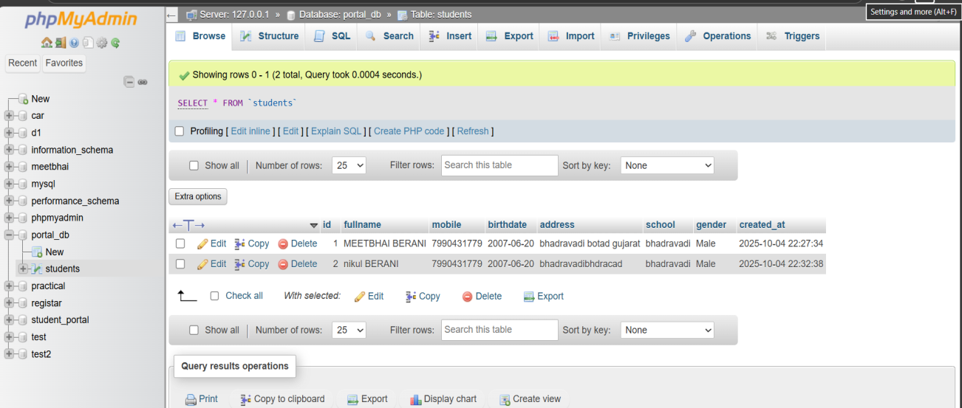
10 | Problem Definition:  Build a login system with sessions, logout, and a protected dashboard  PROGRAM CODE :  Registration user php code: <?php  // --- MySQL Connection ---  $servername = "localhost";  $username = "root"; // change if needed  $password = ""; // your MySQL password  $dbname = "student_portal"; // ✅ NEW DATABASE NAME  // Create connection  $conn = new mysqli($servername, $username, $password, $dbname);  // Check connection  if ($conn->connect_error) {  die("Connection failed: " . $conn->connect_error);  }  // Variables  $name = $mobile = $birthdate = $address = $school = $gender = $seatnumber = $password_input = "";  $nameErr = $mobileErr = $birthdateErr = $addressErr = $schoolErr = $genderErr = $seatErr = $passErr = "";  $success = false;  // --- When form submitted ---  if ($_SERVER["REQUEST_METHOD"] == "POST") {  $valid = true;  function test_input($data) {  return htmlspecialchars(stripslashes(trim($data)));  }  // Full name  if (empty($_POST["fullname"])) {  $nameErr = "Full Name is required";  $valid = false;  } else {  $name = test_input($_POST["fullname"]);  if (strlen($name) < 3) {  $nameErr = "Name must be at least 3 characters.";  $valid = false;  }  }  // Mobile  if (empty($_POST["mobile"])) {  $mobileErr = "Mobile number is required";  $valid = false;  } else {  $mobile = test_input($_POST["mobile"]);  if (!preg_match("/^[6-9][0-9]{9}$/", $mobile)) {  $mobileErr = "Enter valid 10-digit mobile starting with 6-9.";  $valid = false;  }  }  // Birthdate  if (empty($_POST["birthdate"])) {  $birthdateErr = "Birthdate is required";  $valid = false;  } else {  $birthdate = $_POST["birthdate"];  if (strtotime($birthdate) >= strtotime(date("Y-m-d"))) {  $birthdateErr = "Birthdate cannot be today or in the future.";  $valid = false;  }  }  // Address  if (empty($_POST["address"])) {  $addressErr = "Address is required";  $valid = false;  } else {  $address = test_input($_POST["address"]);  if (strlen($address) < 10) {  $addressErr = "Address should be at least 10 characters.";  $valid = false;  }  }  // School  if (empty($_POST["school"])) {  $schoolErr = "School name is required";  $valid = false;  } else {  $school = test_input($_POST["school"]);  if (strlen($school) < 3) {  $schoolErr = "School Name must be at least 3 characters.";  $valid = false;  }  }  // Gender  if (empty($_POST["gender"])) {  $genderErr = "Please select a gender";  $valid = false;  } else {  $gender = $_POST["gender"];  }  // Seat Number  if (empty($_POST["seatnumber"])) {  $seatErr = "Seat Number is required";  $valid = false;  } else {  $seatnumber = test_input($_POST["seatnumber"]);  }  // Password  if (empty($_POST["password"])) {  $passErr = "Password is required";  $valid = false;  } else {  $password_input = $_POST["password"];  if (strlen($password_input) < 6) {  $passErr = "Password must be at least 6 characters.";  $valid = false;  }  }  // --- If all valid, insert into DB ---  if ($valid) {  $stmt = $conn->prepare(  "INSERT INTO students (fullname, mobile, birthdate, address, school, gender, seatnumber, password)  VALUES (?, ?, ?, ?, ?, ?, ?, ?)"  );  $stmt->bind_param("ssssssss", $name, $mobile, $birthdate, $address, $school, $gender, $seatnumber, $password_input);  if ($stmt->execute()) {  $success = true;  $name = $mobile = $birthdate = $address = $school = $gender = $seatnumber = "";  } else {  echo "<p style='color:red;'>❌ Database error: " . $stmt->error . "</p>";  }  $stmt->close();  }  }  ?>  Login php code: <?php  session_start();  // --- Database connection ---  $servername = "localhost";  $username = "root";  $password = "";  $dbname = "student_portal"; // ✅ your database name  $conn = new mysqli($servername, $username, $password, $dbname);  if ($conn->connect_error) {  die("Connection failed: " . $conn->connect_error);  }  // --- Initialize variables ---  $seatnumber = $password_input = "";  $error = "";  // --- Handle form submission ---  if ($_SERVER["REQUEST_METHOD"] == "POST") {  $seatnumber = trim($_POST["seatnumber"]);  $password_input = trim($_POST["password"]);  if (empty($seatnumber) || empty($password_input)) {  $error = "Please fill in both fields.";  } else {  // Prepare SQL  $stmt = $conn->prepare("SELECT fullname, password FROM students WHERE seatnumber = ?");  $stmt->bind_param("s", $seatnumber);  $stmt->execute();  $stmt->store_result();  if ($stmt->num_rows > 0) {  $stmt->bind_result($fullname, $hashed_pass);  $stmt->fetch();  // Verify password  if ($password_input === $hashed_pass || password_verify($password_input, $hashed_pass)) {  $_SESSION["seatnumber"] = $seatnumber;  $_SESSION["fullname"] = $fullname;  header("Location: index.php");  exit;  } else {  $error = "Incorrect password.";  }  } else {  $error = "No user found with that seat number.";  }  $stmt->close();  }  }  $conn->close();  ?>  Home page showen data php code: <?php  session_start();  // Redirect to login if user not logged in  if (!isset($_SESSION['seatnumber'])) {  header("Location: login_user.php");  exit;  }  ?>  Logout php code: <?php  session_start();  // Clear all session data  $_SESSION = array();  // Destroy the session  session_destroy();  // Redirect to login page  header("Location: login_user.php");  exit;  ?>  OUTPUT:  Register page:  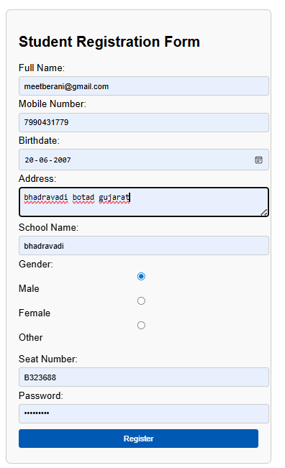  Mysql data:  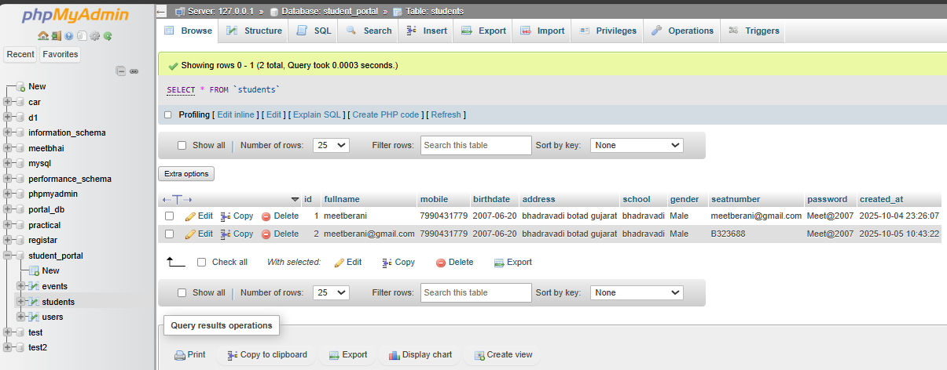  Login page:  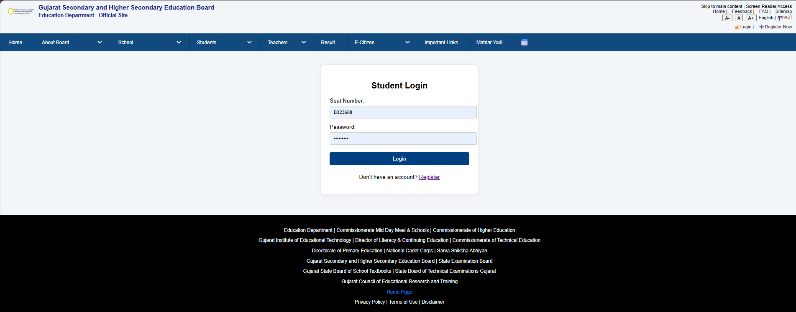  Index page :  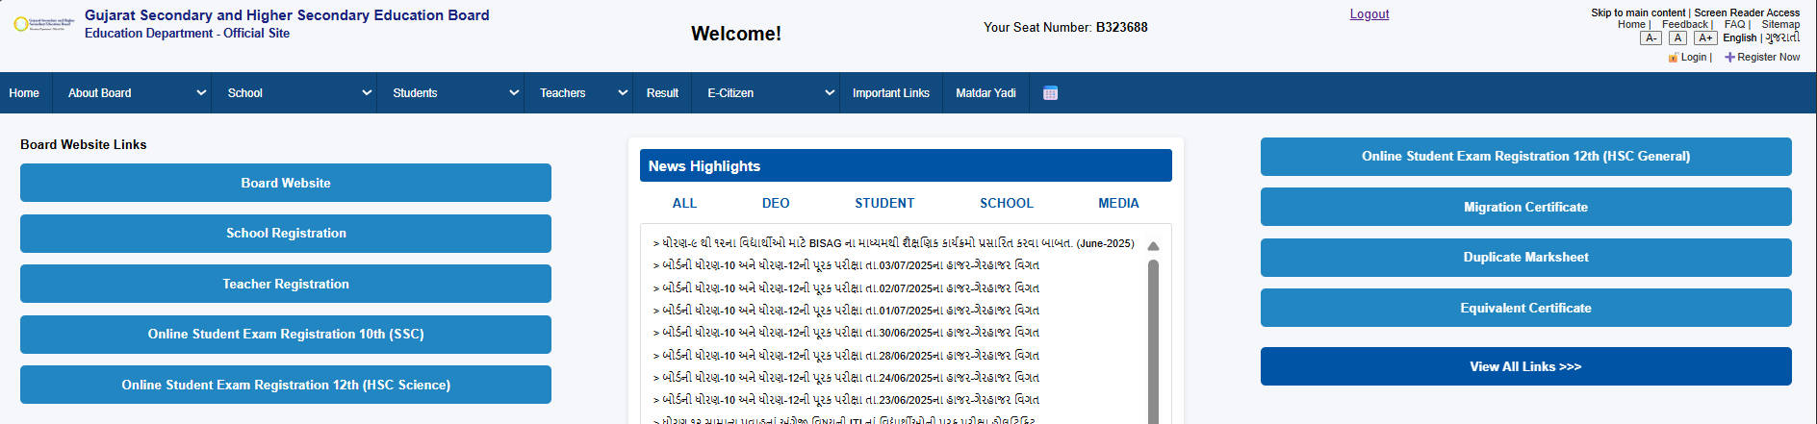
11 | Problem Definition:  Store and retrieve student data from MySQL DB  PROGRAM CODE :  View data from mysql:  <?php  $servername = "localhost";  $username = "root";  $password = "";  $dbname = "portal_db";  $conn = new mysqli($servername, $username, $password, $dbname);  if ($conn->connect_error) {  die("Connection failed: " . $conn->connect_error);  }  $sql = "SELECT * FROM students";  $result = $conn->query($sql);  echo "<h2>📋 Registered Students</h2>";  echo "<table border='1' cellpadding='8' cellspacing='0'>";  echo "<tr>  <th>ID</th>  <th>Full Name</th>  <th>Mobile</th>  <th>Birthdate</th>  <th>Address</th>  <th>School</th>  <th>Gender</th>  </tr>";  if ($result->num_rows > 0) {  while ($row = $result->fetch_assoc()) {  echo "<tr>  <td>".$row["id"]."</td>  <td>".$row["fullname"]."</td>  <td>".$row["mobile"]."</td>  <td>".$row["birthdate"]."</td>  <td>".$row["address"]."</td>  <td>".$row["school"]."</td>  <td>".$row["gender"]."</td>  </tr>";  }  } else {  echo "<tr><td colspan='7'>No records found</td></tr>";  }  echo "</table>";  $conn->close();  ?>  OUTPUT:  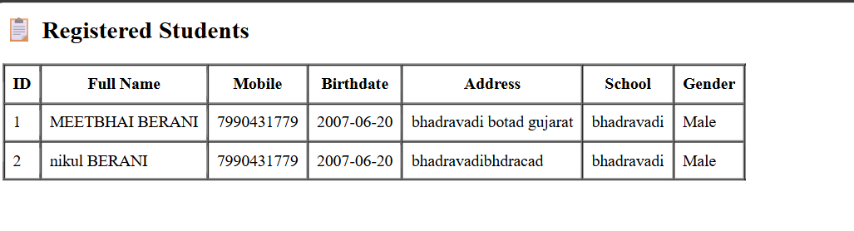
12 | Problem Definition:  Create a full CRUD for managing events with the DB  PROGRAM CODE :  <?php  include 'db_connect.php';  $message = "";  // ✅ Delete student  if (isset($_GET['delete'])) {  $id = $_GET['delete'];  $conn->query("DELETE FROM students WHERE id=$id");  $message = "🗑️ Student deleted successfully.";  }  // ✅ Update student (Edit form submitted)  if (isset($_POST['update'])) {  $id = $_POST['id'];  $fullname = $_POST['fullname'];  $mobile = $_POST['mobile'];  $birthdate = $_POST['birthdate'];  $address = $_POST['address'];  $school = $_POST['school'];  $gender = $_POST['gender'];  $seatnumber = $_POST['seatnumber'];  $stmt = $conn->prepare("UPDATE students SET fullname=?, mobile=?, birthdate=?, address=?, school=?, gender=?, seatnumber=? WHERE id=?");  $stmt->bind_param("sssssssi", $fullname, $mobile, $birthdate, $address, $school, $gender, $seatnumber, $id);  $stmt->execute();  $stmt->close();  $message = "✏️ Student updated successfully.";  }  // ✅ Fetch data for edit form (if edit button clicked)  $editData = null;  if (isset($_GET['edit'])) {  $id = $_GET['edit'];  $res = $conn->query("SELECT * FROM students WHERE id=$id");  $editData = $res->fetch_assoc();  }  // ✅ Fetch all students (for table)  $result = $conn->query("SELECT * FROM students ORDER BY id DESC");  ?>  <!DOCTYPE html>  <html lang="en">  <head>  <meta charset="UTF-8">  <title>Manage Students</title>  <style>  body { font-family: Arial; margin: 20px; }  table { border-collapse: collapse; width: 100%; }  th, td { border: 1px solid #ccc; padding: 8px; text-align: left; }  th { background-color: #f2f2f2; }  .message { color: green; font-weight: bold; }  form { margin-top: 20px; background: #f8f8f8; padding: 15px; border-radius: 6px; width: 400px; }  input, textarea { width: 100%; margin-bottom: 10px; padding: 8px; }  input[type=submit] { background-color: #0059b3; color: white; border: none; cursor: pointer; }  input[type=submit]:hover { background-color: #003d80; }  </style>  </head>  <body>  <h2>Manage Student Records</h2>  <?php if ($message): ?>  <p class="message"><?php echo $message; ?></p>  <?php endif; ?>  <!-- 📋 Table: Read + Action Buttons -->  <table>  <tr>  <th>ID</th>  <th>Full Name</th>  <th>Mobile</th>  <th>Birthdate</th>  <th>School</th>  <th>Gender</th>  <th>Seat No</th>  <th>Actions</th>  </tr>  <?php while ($row = $result->fetch_assoc()) { ?>  <tr>  <td><?php echo $row['id']; ?></td>  <td><?php echo $row['fullname']; ?></td>  <td><?php echo $row['mobile']; ?></td>  <td><?php echo $row['birthdate']; ?></td>  <td><?php echo $row['school']; ?></td>  <td><?php echo $row['gender']; ?></td>  <td><?php echo $row['seatnumber']; ?></td>  <td>  <a href="?edit=<?php echo $row['id']; ?>">✏️ Edit</a> |  <a href="?delete=<?php echo $row['id']; ?>" onclick="return confirm('Are you sure you want to delete this student?');">🗑️ Delete</a>  </td>  </tr>  <?php } ?>  </table>  <!-- ✏️ Edit Form (shows only if editing a record) -->  <?php if ($editData): ?>  <h3>Edit Student</h3>  <form method="POST">  <input type="hidden" name="id" value="<?php echo $editData['id']; ?>">  Full Name: <input type="text" name="fullname" value="<?php echo $editData['fullname']; ?>" required><br>  Mobile: <input type="text" name="mobile" value="<?php echo $editData['mobile']; ?>" required><br>  Birthdate: <input type="date" name="birthdate" value="<?php echo $editData['birthdate']; ?>" required><br>  Address: <textarea name="address" required><?php echo $editData['address']; ?></textarea><br>  School: <input type="text" name="school" value="<?php echo $editData['school']; ?>" required><br>  Gender:  <input type="radio" name="gender" value="Male" <?php if($editData['gender']=='Male') echo 'checked'; ?>> Male  <input type="radio" name="gender" value="Female" <?php if($editData['gender']=='Female') echo 'checked'; ?>> Female  <input type="radio" name="gender" value="Other" <?php if($editData['gender']=='Other') echo 'checked'; ?>> Other<br><br>  Seat Number: <input type="text" name="seatnumber" value="<?php echo $editData['seatnumber']; ?>" required><br>  <input type="submit" name="update" value="Update Student">  </form>  <?php endif; ?>  <br>  <a href="register_user.php">➕ Register New Student</a>  </body>  </html>  Output:  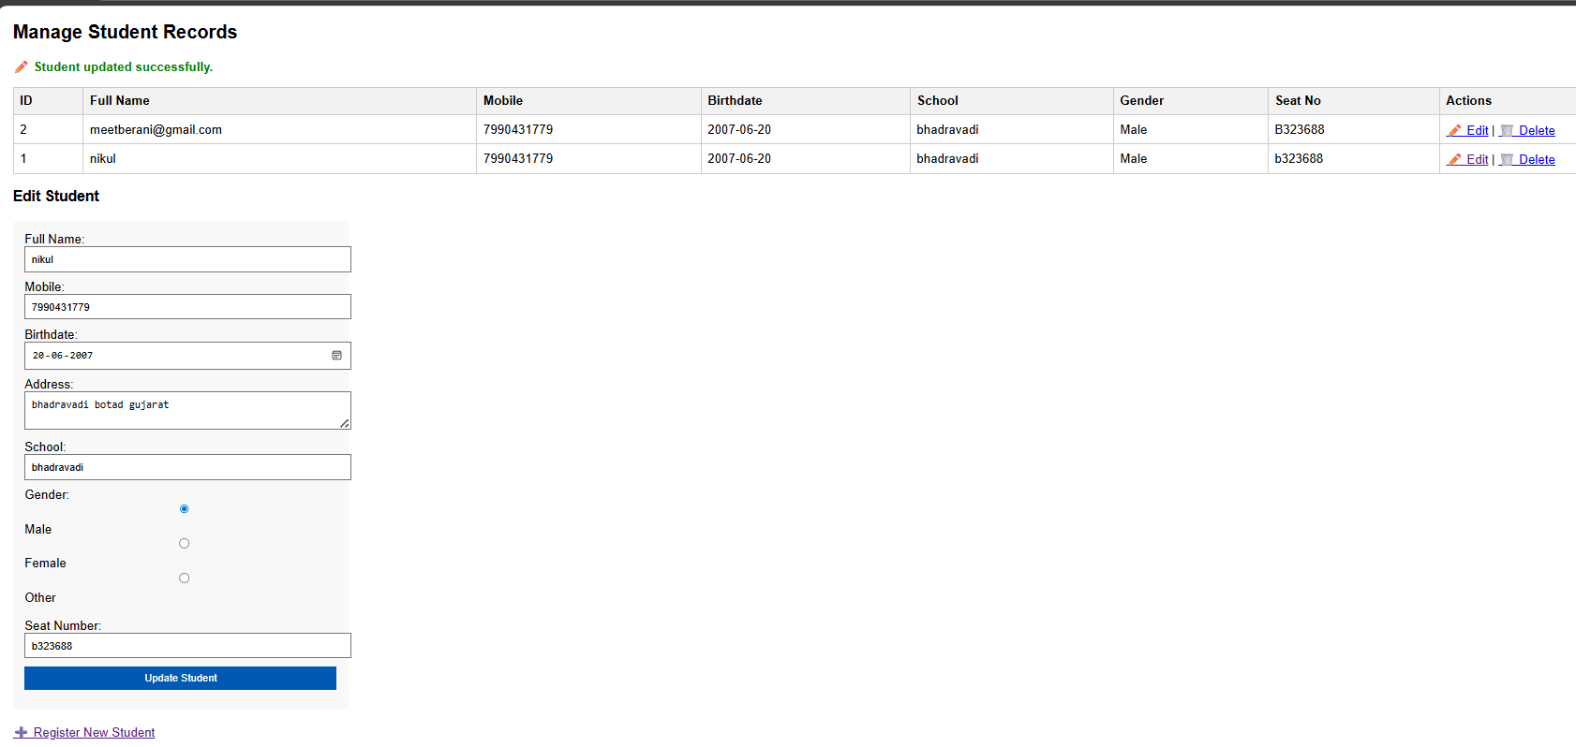
13 | Problem Definition:  Implement validation, sanitization, and password hashing  PROGRAM CODE : <?php  session_start();  require 'db.php';  $name = $mobile = $birthdate = $address = $school = $gender = $username = "";  $nameErr = $mobileErr = $birthdateErr = $addressErr = $schoolErr = $genderErr = $usernameErr = $passwordErr = "";  $success = false;  if ($_SERVER["REQUEST_METHOD"] == "POST") {  $valid = true;  // ✅ Enhanced Sanitization Function  function test_input($data) {  $data = trim($data); // Remove whitespace from both sides  $data = strip_tags($data); // Remove HTML and PHP tags  $data = htmlspecialchars($data, ENT_QUOTES, 'UTF-8'); // Convert special chars to HTML entities  $data = stripslashes($data); // Remove backslashes  return $data;  }  // Validate Full Name  if (empty($_POST["fullname"])) {  $nameErr = "Full Name is required";  $valid = false;  } else {  $name = test_input($_POST["fullname"]);  if (strlen($name) < 3) {  $nameErr = "Name must be at least 3 characters.";  $valid = false;  }  }  // Validate Mobile  if (empty($_POST["mobile"])) {  $mobileErr = "Mobile number is required";  $valid = false;  } else {  $mobile = test_input($_POST["mobile"]);  if (!preg_match("/^[6-9][0-9]{9}$/", $mobile)) {  $mobileErr = "Enter valid 10-digit mobile starting with 6-9.";  $valid = false;  }  }  // Validate Birthdate  if (empty($_POST["birthdate"])) {  $birthdateErr = "Birthdate is required";  $valid = false;  } else {  $birthdate = $_POST["birthdate"];  if (strtotime($birthdate) >= strtotime(date("Y-m-d"))) {  $birthdateErr = "Birthdate cannot be today or in the future.";  $valid = false;  }  }  // Validate Address  if (empty($_POST["address"])) {  $addressErr = "Address is required";  $valid = false;  } else {  $address = test_input($_POST["address"]);  if (strlen($address) < 10) {  $addressErr = "Address should be at least 10 characters.";  $valid = false;  }  }  // Validate School  if (empty($_POST["school"])) {  $schoolErr = "School name is required";  $valid = false;  } else {  $school = test_input($_POST["school"]);  if (strlen($school) < 3) {  $schoolErr = "School Name must be at least 3 characters.";  $valid = false;  }  }  // Validate Gender  if (empty($_POST["gender"])) {  $genderErr = "Please select a gender";  $valid = false;  } else {  $gender = test_input($_POST["gender"]);  }  // Validate Username  if (empty($_POST["username"])) {  $usernameErr = "Username is required";  $valid = false;  } else {  $username = test_input($_POST["username"]);  if (strlen($username) < 4) {  $usernameErr = "Username must be at least 4 characters.";  $valid = false;  } else {  // Check if username already exists  $stmt = $pdo->prepare("SELECT id FROM users WHERE username = ?");  $stmt->execute([$username]);  if ($stmt->rowCount() > 0) {  $usernameErr = "Username already exists.";  $valid = false;  }  }  }  // Validate Password  if (empty($_POST["password"])) {  $passwordErr = "Password is required";  $valid = false;  } else {  $password = $_POST["password"];  if (strlen($password) < 6) {  $passwordErr = "Password must be at least 6 characters.";  $valid = false;  }  }  // ✅ If all validations pass  if ($valid) {  $password_hash = password_hash($password, PASSWORD_DEFAULT);  $stmt = $pdo->prepare("INSERT INTO users (username, password, fullname, mobile, birthdate, address, school, gender) VALUES (?, ?, ?, ?, ?, ?, ?, ?)");  $stmt->execute([$username, $password_hash, $name, $mobile, $birthdate, $address, $school, $gender]);  $success = true;  // Clear form fields  $name = $mobile = $birthdate = $address = $school = $gender = $username = "";  }  }  ?>  <?php if ($success): ?>  <p class="success">✅ Registration Successful! You can now <a href="login.php">login</a>.</p>  <?php endif; ?>  Output:  Mysql strore a password in hash code:  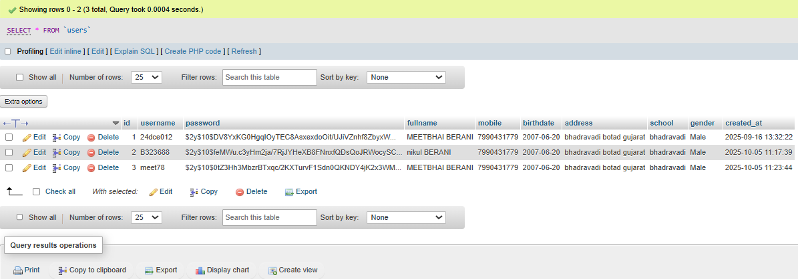
14 | Problem Definition:  Develop an admin dashboard to view/manage users  PROGRAM CODE : admin page php code:  <?php  session_start();  // ✅ Step 1: Security check  if (!isset($_SESSION['seatnumber']) || $_SESSION['role'] !== 'admin') {  header("Location: login_user.php");  exit;  }  // ✅ Step 2: Connect to database  include 'db_connect.php';  $message = "";  // ✅ Step 3: Delete student  if (isset($_GET['delete'])) {  $id = intval($_GET['delete']);  $conn->query("DELETE FROM students WHERE id = $id");  $message = "🗑️ Student deleted successfully.";  }  // ✅ Step 4: Update student  if (isset($_POST['update'])) {  $id = intval($_POST['id']);  $fullname = htmlspecialchars($_POST['fullname']);  $mobile = htmlspecialchars($_POST['mobile']);  $birthdate = htmlspecialchars($_POST['birthdate']);  $address = htmlspecialchars($_POST['address']);  $school = htmlspecialchars($_POST['school']);  $gender = htmlspecialchars($_POST['gender']);  $seatnumber = htmlspecialchars($_POST['seatnumber']);  $stmt = $conn->prepare("UPDATE students SET fullname=?, mobile=?, birthdate=?, address=?, school=?, gender=?, seatnumber=? WHERE id=?");  $stmt->bind_param("sssssssi", $fullname, $mobile, $birthdate, $address, $school, $gender, $seatnumber, $id);  $stmt->execute();  $stmt->close();  $message = "✏️ Student updated successfully.";  }  // ✅ Step 5: Fetch data for edit form  $editData = null;  if (isset($_GET['edit'])) {  $id = intval($_GET['edit']);  $res = $conn->query("SELECT * FROM students WHERE id = $id");  $editData = $res->fetch_assoc();  }  // ✅ Step 6: Fetch all students  $result = $conn->query("SELECT * FROM students ORDER BY id DESC");  ?>  Output:  Admin user mysql:  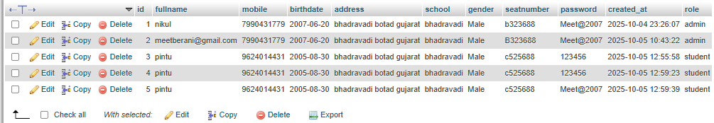  Admin page open with login:  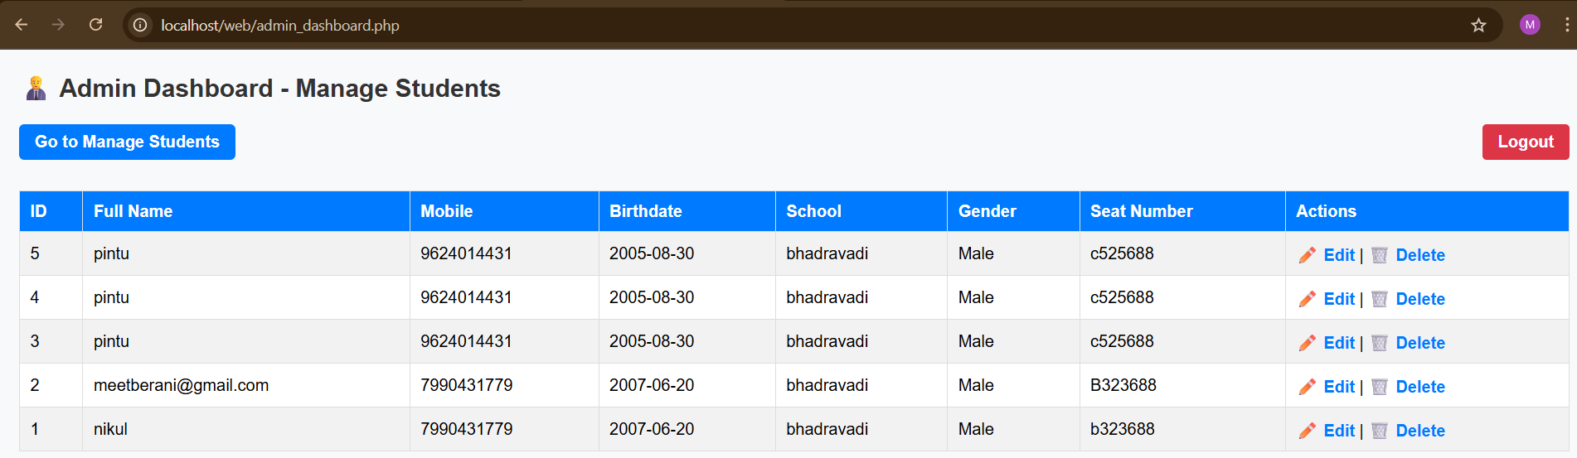
 | CONCLUSION: In this project, I created a Gujarat Board website using HTML, CSS, JavaScript, and PHP. The website provides easy access to information like results, notices, and syllabus. I learned how to connect front-end and back-end technologies to make a functional and user-friendly site. This project helped me improve my web development skills and understand how technology supports education.

