ACKNOWLEDGMENT
I would like to express my sincere gratitude to everyone who supported and guided me during my 15-day internship. This internship provided me with a valuable opportunity to gain practical knowledge and understand the professional working environment.
First of all, I would like to thank the management and team of Vortex Aziel Company for giving me the opportunity to complete my internship in their organization. I am especially thankful to my company supervisor/manager for their continuous guidance, encouragement, and support throughout the internship period. Their valuable suggestions and practical insights helped me learn many new concepts and improve my skills.
I would also like to thank the HR Department for coordinating the internship program and for providing a comfortable and supportive working environment during my training period.
I am deeply grateful to the Head/Principal of G.K.C.K. Bosamia College for allowing me to participate in this internship program as part of my academic curriculum. I would also like to sincerely thank my faculty guide/supervisor for their guidance, motivation, and valuable advice while preparing this internship report.
Finally, I would like to thank my friends and family members for their encouragement, moral support, and help throughout this internship period.
This internship has been a great learning experience for me, and I am thankful to everyone who directly or indirectly contributed to the successful completion of this internship.

INDEX
SR NO. | TITLE | PAGE NO.
1 | Introduction | 3
2 | Company profile | 5
3 | Internship Objectives | 7
4 | Roles and Responsibilities | 9
5 | Projects Undertaken | 13
6 | Skills Learned | 16
7 | Challenges Faced | 19
8 | Outcomes and Learning Experience | 21
9 | Conclusion | 23
10 | References | 25
11 | Appendix | 27

INTRODUCTION

Purpose of internship

The purpose of an internship is to give students practical experience in a real work environment. It helps students apply the knowledge they have learned in their studies to real-life tasks. Through an internship, students can improve their skills, learn new techniques, understand workplace culture, and gain professional experience. It also helps them build confidence and prepare for their future careers.

Another purpose of the internship is to improve communication skills, teamwork, and problem-solving abilities. It also helps students learn about workplace discipline, responsibilities, and time management.

Importance of internship in BCA course

Internship is very important for BCA students because it gives practical knowledge along with theoretical learning. It helps students understand how computer applications and software are used in real work environments.

Through internship, students can improve their technical skills like programming, web development, and database management. It also helps in developing communication skills, teamwork, and problem-solving abilities.

Objectives of training

  - To gain practical knowledge related to the BCA course.
  - To understand how theoretical concepts are applied in real work situations.
  - To improve technical skills such as programming and computer applications.
  - To develop communication, teamwork, and problem-solving

skills.

  - To understand the working environment of an organization.
  - To gain experience and prepare for future career

opportunities.
  - To learn new tools and technologies used in the IT field.
  - To improve confidence and professional behaviour.

How it will be useful in future

The internship will be very useful for my future career. It helps me gain practical knowledge and real-world experience in my field. Through this training, I learned how to apply theoretical concepts in practical situations. I also improved my technical skills, communication skills, and teamwork abilities.
This experience will help me understand the working environment of companies and prepare me for future job opportunities. Overall, the internship is an important step for building my professional career and increasing my confidence.

COMPANY PROFILE

Company Name:
Vortex Aziel Technologies Pvt. Ltd.

Location:
Vortex Aziel Technologies Pvt. Ltd. 3rd Floor, Office No.315, Nakshatra 9, Sadar Bazar, Rajkot , Gujarat, India

Industry Type:
Information Technology (IT) and Software Development

About the Company:
Vortex Aziel Technologies Pvt. Ltd. is an IT company that provides software development and digital solutions to businesses. The company focuses on creating modern and userfriendly applications and websites. It works with different clients to help them improve their business using technology.

Services / Products:
The company provides various IT services such as: Website design and development

Mobile application development Software development
UI/UX design
Technical support and maintenance

Mission:
The mission of the company is to provide high-quality and innovative technology solutions that help businesses grow and succeed.

Vision:
The vision of the company is to become a leading IT service provider by delivering reliable and advanced digital solutions.

Organizational Structure:
The company has a well-organized team structure. It includes: Project Manager
Software Developers Web Designers UI/UX Designers Testing Team Support Team

INTRNSHIP OBJEECTIVES

What you aimed to learn

The main aim of this project was to understand how an Internet Banking system works and how users can perform banking activities online. Through this project, I aimed to learn how customers can securely access their bank accounts using a login system and perform different operations such as checking account balance, transferring money, and viewing transaction history.
Another objective of this project was to gain practical knowledge about designing a user-friendly interface for an online banking system. I also aimed to learn about the importance of security, data management, and smooth user experience in banking applications. This project helped me understand how technology is used in the banking sector to make financial services faster and more convenient for users.

Skills you wanted to develop

Through this project, I wanted to develop my technical and design skills related to creating an Internet Banking system. I aimed to improve my knowledge of user interface (UI) design so that I could create a simple, clear, and user-friendly banking interface for customers. I also wanted to understand how different pages like login, account details, and transaction pages are designed and connected.

Another skill I wanted to develop was problem-solving and logical thinking while designing the banking system. This project also helped me improve my creativity, planning, and attention to detail while working on the design. By completing this project, I aimed to gain practical experience in designing digital banking platforms and understanding how online banking services are structured.

Project goals

The main goal of this project is to design an Internet Banking system that allows users to access banking services online easily and securely. The project focuses on creating a simple and user-friendly interface where users can log in to their account and perform basic banking activities without visiting the bank.
Another goal of this project is to understand how online banking platforms are structured and how different features such as account details, balance checking, and money transfer can be organized in a digital system. This project also aims to improve knowledge of UI/UX design and show how technology can make banking services faster, more convenient, and accessible for users.

ROLES AND RESPONSIBILITIES

Daily task

Day 1: Introduction to the project and understanding the concept of Internet Banking and Prompt Engineering.

Day 2: Research about Internet Banking systems and their main features such as login, balance check, and fund transfer.

Day 3: Study of Prompt Engineering and how prompts are used to generate useful responses from AI tools.

Day 4: Planning the structure of the Internet Banking project and deciding the main modules.

Day 5: Writing prompts to generate ideas for the Internet Banking system design.

Day 6: Creating prompts to generate content for different banking pages like login, dashboard, and account details.

Day 7: Designing the basic layout of the Internet Banking interface.

Day 8: Using prompts to improve UI/UX ideas and user experience for the banking system.

Day 9: Generating prompts for features such as transaction history and fund transfer.

Day 10: Testing different prompts to get better results for project content and design.

Day 11: Organizing the generated content and designs for the Internet Banking project.

Day 12: Making improvements in prompts to get clearer and more accurate outputs.

Day 13: Preparing the final design and documentation for the project.

Day 14: Reviewing the whole project and checking if all features and prompts are properly explained.

Day 15: Final presentation and submission of the Internet Banking project.

Tools / Software Used

  - ChatGPT – Used for prompt engineering to generate ideas, content, and guidance for designing the Internet Banking system.
  - Google Chrome – Used as a web browser to research information and test design ideas.

  - Microsoft Word – Used for preparing project documentation and writing the internship/project report.

These tools helped in planning, designing, and documenting the Internet Banking project effectively. They also supported the prompt engineering process and improved the overall design and presentation of the project.

Team Involvement

During this project, team members worked together to complete different parts of the Internet Banking system. Each member contributed by sharing ideas, researching information, and helping in designing the project. The teamwork helped in dividing the tasks such as research, prompt creation, design planning, and documentation, which made the project easier to complete.
The team also supported each other by discussing improvements and solving problems during the project work. Through this collaboration, everyone was able to learn new concepts related to prompt engineering and Internet Banking systems. Working as a team improved communication skills and helped in completing the project successfully within the given time.

Meeting or Client Interaction

During the project, regular meetings were conducted to discuss the progress and plan the next steps. In these meetings,

the project objectives, design ideas, and prompt engineering techniques were discussed. Guidance and feedback were provided to improve the Internet Banking project and make the design more effective and user-friendly.
Team Meeting
Discuss Project
Requirements
Client Interaction
Update Work
Receive
Feedback
The meetings also helped in solving problems and clarifying doubts related to the project. Suggestions were given on how to improve the prompts, organize the project structure, and present the final work properly. These interactions helped in understanding the project requirements better and ensured that the work was completed successfully.

PROJECTS UNDERTAKEN

Project Title:
Internet Banking

Problem Statement:

In today’s digital world, many banking services are shifting to online platforms to make financial activities faster and more convenient. However, designing a clear and user-friendly Internet Banking system can be challenging because it must allow users to perform different tasks such as checking account balance, viewing transaction history, and transferring money easily while maintaining security.
The main problem addressed in this project is how to design an effective Internet Banking interface using prompt engineering techniques. The project focuses on generating useful ideas, content, and design guidance through prompts to create a simple and well-structured Internet Banking system that improves user experience and supports easy access to online banking services.

Methodology:

The methodology of this project involves a systematic approach to designing an Internet Banking system using prompt engineering. First, research was conducted to

understand the basic features and working of Internet Banking systems. Information about common banking services such as user login, account details, balance checking, and fund transfer was collected to plan the structure of the project.

Tools Used:

Several tools and technologies were used during the development of the Internet banking project:
- Python Programming Language – Used to implement the main system logic
- Prompt Engineering – Used to generate prompts for solving coding issues
- Code Editor (VS Code) – Used for writing and editing program files
- Images Folder – Used to store product images (m1.jpg, a1.jpg, mo1.jpg, etc.)
- Web Browser – Used for testing the system interface

Your Contribution:

In this project, I contributed to researching and understanding the concept of Internet Banking and prompt engineering. I created different prompts to generate ideas and useful content for designing the Internet Banking system. I also worked on organizing the project structure and planning the main features of the system.

I was also responsible for designing the user interface of the Internet Banking pages and preparing the project documentation. Through my contribution, the project was developed in a structured and user-friendly way, helping to clearly present the concept and design of the Internet Banking system.

Outcome / Result:

The outcome of this project is the successful design and development of an Internet Banking system using prompt engineering techniques. The project helped in creating a clear structure of online banking features such as login, account details, balance checking, and transaction options in a user- friendly way.
Through this project, valuable knowledge about prompt engineering, UI design, and the working of Internet Banking systems was gained. It also improved skills in research, problem-solving, and project planning. Overall, the project provided practical experience in using AI tools and design methods to develop a digital banking concept.

SKILL LEARNED
Through this project, I learned several important skills related to prompt engineering and digital banking system design. I developed the ability to create effective prompts to generate useful information and ideas using AI tools.

Technical Skills

Software / Tools:
  - Python – Used as the main programming language to develop the Internet Banking system and implement different banking operations.
  - ChatGPT – Used for prompt engineering to generate code ideas, logic, and explanations for the project.
  - Windsurf AI – Used as an AI coding assistant to help write, understand, and improve Python code.
  - Visual Studio Code – Used as the code editor to write, run, and manage the Python program.
  - Google Chrome – Used for researching information and learning about Internet Banking features.

Programming Languages:
Python – Used as the main programming language to develop the Internet Banking system and implement features such as account creation, balance checking, and money transfer.

SQL – Used for managing and storing banking data such as user details, account information, and transaction records in the database.
HTML (Basic) – Used for understanding basic structure if any interface or web-based component is included in the project.

Industry-Specific Tools:
ChatGPT – Used for prompt engineering to generate code ideas, explanations, and project guidance.
Windsurf AI – Used as an AI coding assistant to support Python coding and improve development efficiency.
Visual Studio Code – Used as the development environment for writing and running Python programs.
GitHub – Used for storing and managing the project code and version control.

Soft Skills

Communication:
Developed effective communication skills while discussing project ideas, sharing progress updates, and explaining the concepts of Internet Banking and prompt engineering. It also helped in clearly presenting the project work and understanding feedback for improvements.

Teamwork:
Developed teamwork skills by collaborating with others during the project, sharing ideas, and supporting each other in

completing different tasks. Working together helped in solving problems more effectively and completing the project within the given time.

Time Management:
Improved time management skills by planning daily tasks and completing each stage of the Internet Banking project within the given timeline. Proper scheduling helped in balancing research, coding, and documentation effectively.

Problem-Solving:
Developed problem-solving skills by identifying issues during the development of the Internet Banking project and finding appropriate solutions. It helped in improving logical thinking and resolving coding or project-related challenges effectively.
Improved problem-solving ability by identifying issues in the project and finding suitable solutions during coding and development.

CHALLENGES FACED

Difficulties Encountered
During the internship, I faced several challenges while working on the project. At the beginning, it was difficult to understand the project requirements and how to apply theoretical knowledge in a practical environment. I also faced some problems while learning new tools and technologies that were required for the project.
Another difficulty was managing the project tasks within the given time. Sometimes technical issues occurred while designing and implementing the project, which made the process slow and required extra effort to solve.

How You Solved Them
To overcome these challenges, I tried to learn the tools and concepts step by step. I referred to online tutorials, documentation, and practice exercises to improve my understanding. Whenever I faced a problem, I analyzed the issue carefully and tried different solutions.
I also took guidance from my mentor and discussed problems with team members. With continuous practice and proper time management, I was able to complete the tasks and improve my skills during the internship.

Lessons Learned
Through these challenges, I learned the importance of patience and continuous learning in the technical field. I realized that problems are a normal part of the development process and they help us gain better knowledge and experience.
This internship also taught me how to work independently, manage time effectively, and improve problem- solving skills. These lessons will help me in my future academic projects and professional career.

OUTCOMES & LEARNING EXPERIENCE

Practical Exposure Gained
During the internship, I gained practical exposure to real- world project development. I learned how to apply theoretical concepts in practical situations while working on the project. It helped me understand the complete process of designing and developing a project step by step.
Through this internship, I also gained experience in using different tools and technologies related to my project. Working on real tasks improved my confidence and helped me understand how professional work is done in the industry.

Industry Knowledge
The internship helped me understand how the IT industry works and how projects are managed in a professional environment. I learned about the importance of planning, teamwork, and proper communication during project development.
I also understood how companies focus on user requirements, design quality, and efficient solutions while developing any software or application. This experience gave me a clear idea about the standards followed in the industry.

How It Connects with Classroom Learning
The internship helped me connect my classroom learning with practical work. The concepts that I studied in my academic

courses were useful while working on the project during the internship.
This experience helped me understand the real-life application of those concepts. It also improved my technical knowledge and made my learning more meaningful and practical.

CONCLUSION

Overall Experience Summary
The internship was a very valuable and meaningful experience for me. It gave me an opportunity to learn how real projects are developed in a professional environment. During this internship, I worked on my project and understood the complete development process such as planning, designing, and implementation. This experience helped me improve both my technical and practical knowledge.
Apart from technical learning, I also improved my confidence and ability to work independently. I learned how to handle responsibilities and complete tasks in an organized way. The internship helped me understand the importance of dedication, discipline, and continuous learning in the professional world.

How It Helped Career Growth
This internship played an important role in shaping my career goals. It helped me gain practical knowledge that cannot always be learned only from classroom studies. I understood how technology and design are used in real projects and how professionals work together to achieve a common goal.
Through this experience, I developed important skills such as communication, teamwork, time management, and
problem-solving. These skills are very important for building a successful career in the IT and design field. The internship also motivated me to explore more opportunities and improve my
abilities in the future.

Future Improvements
In the future, I would like to improve my technical knowledge and learn more advanced tools and technologies related to my field. I also plan to work on more projects to gain deeper practical experience.
Continuous learning and practice will help me become more skilled and confident. This internship has motivated me to keep improving and achieve better opportunities in my career.
I also aim to improve my problem-solving ability and project management skills. By gaining more experience and continuously learning, I hope to achieve better opportunities and grow professionally in my chosen field.

REFERNCES

Websites
During the internship and project development, I referred to different websites to understand concepts, tools, and technical solutions. These websites helped me learn new techniques and improve my knowledge related to the project. They also provided tutorials and examples that made it easier to solve problems during development.

  - W3Schools – https://www.w3schools.com
  - GeeksforGeeks – https://www.geeksforgeeks.org
  - Stack Overflow – https://stackoverflow.com
  - Python Official Website – https://www.python.org
  - Google Developers – https://developers.google.com

Company Materials
During the internship, various company materials were provided to help understand the work environment and project requirements. These materials included project guidelines, documentation, and instructions related to the tasks assigned during the internship.
The company materials helped in understanding the workflow, project structure, and expectations from the interns. They also provided useful information about how projects are planned and completed in a professional environment, which helped improve my knowledge and work quality.

Manuals
The manuals provided during the internship helped in understanding how to use different tools and technologies required for the project. These manuals contained step-by-step instructions, guidelines, and useful information about the features and functions of the software used during development.
By referring to these manuals, it became easier to understand the working process of the tools and complete the project tasks efficiently. The manuals also helped in solving small technical issues and improving the overall quality of the work.

Any Other
Apart from the above resources, other helpful materials such as online tutorials, video lectures, and practice examples were also used during the internship. These resources helped in gaining a better understanding of the project and improving technical knowledge.
In addition, discussions with team members and guidance from seniors also provided valuable insights. These experiences helped in solving problems, learning new techniques, and completing the project successfully.

APPENDIX

Screenshot
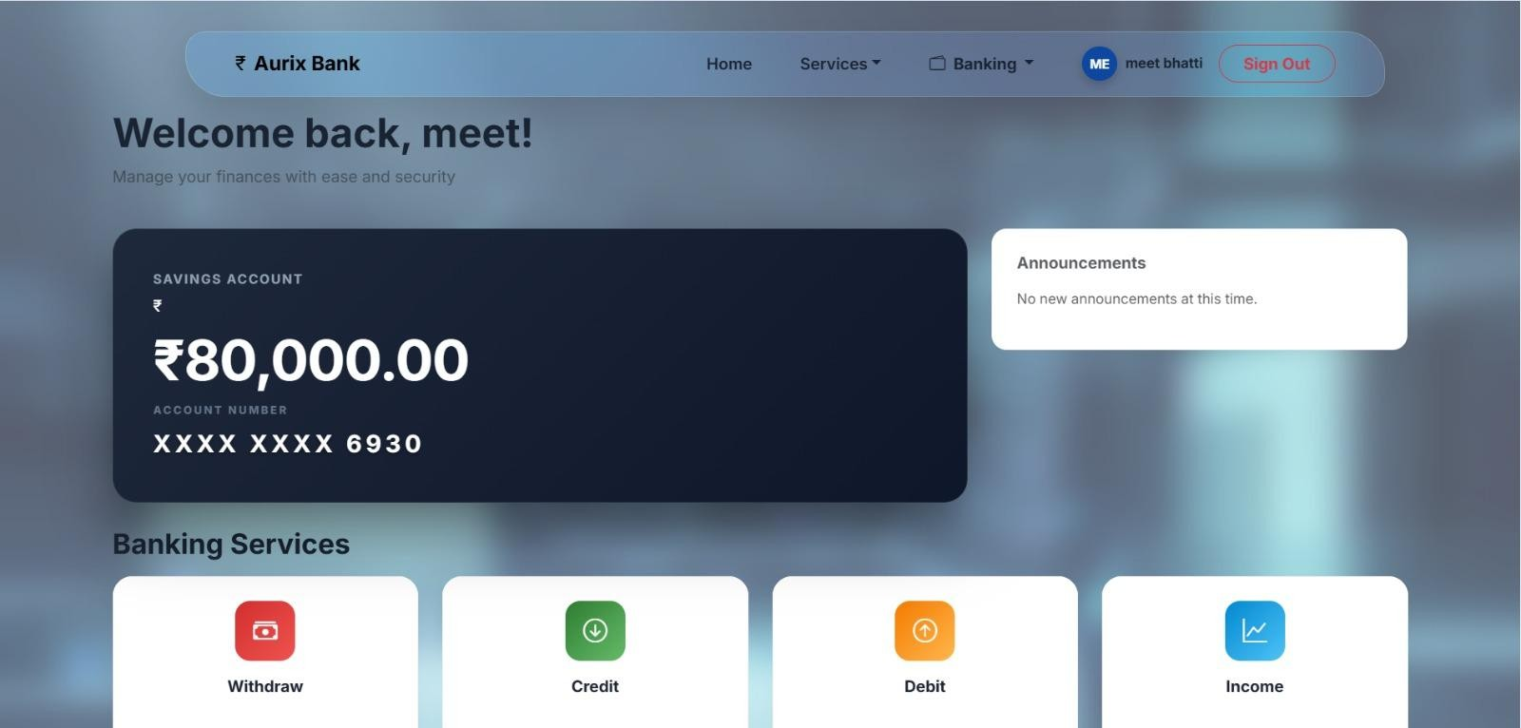

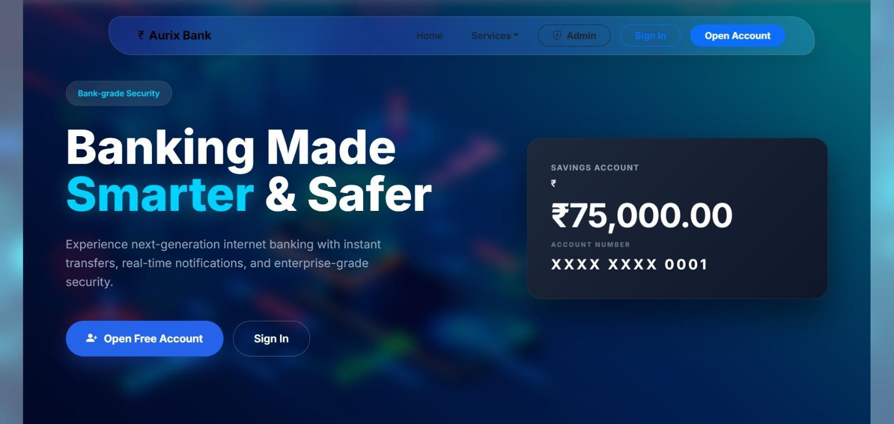
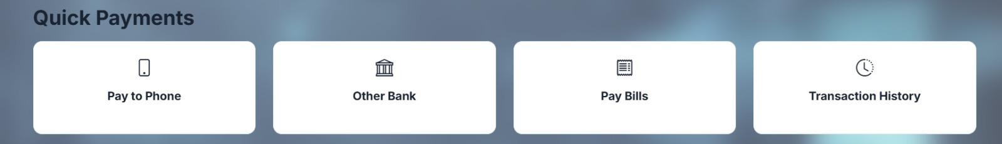

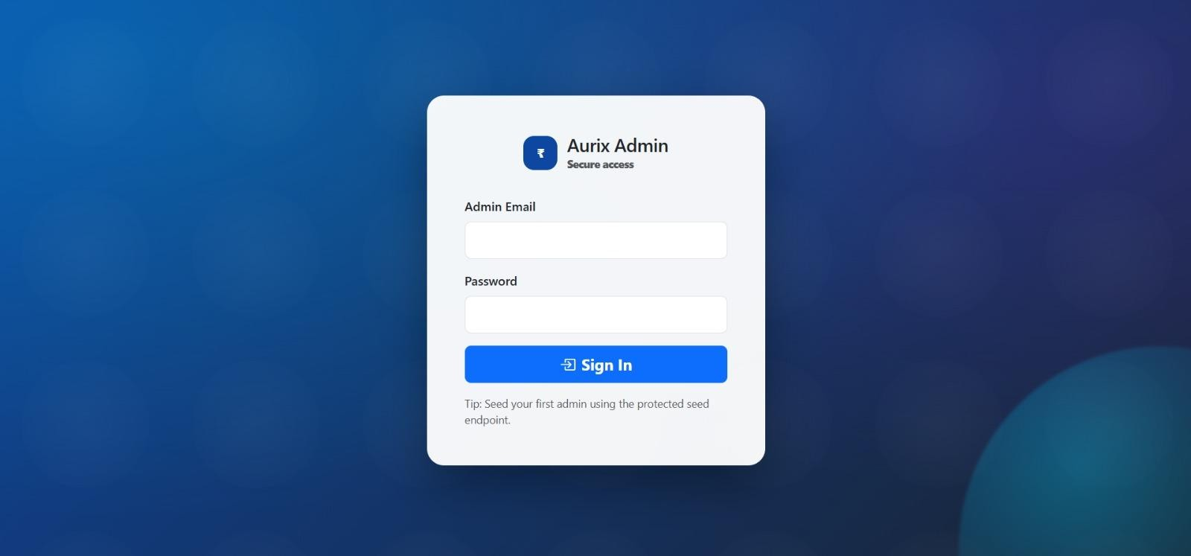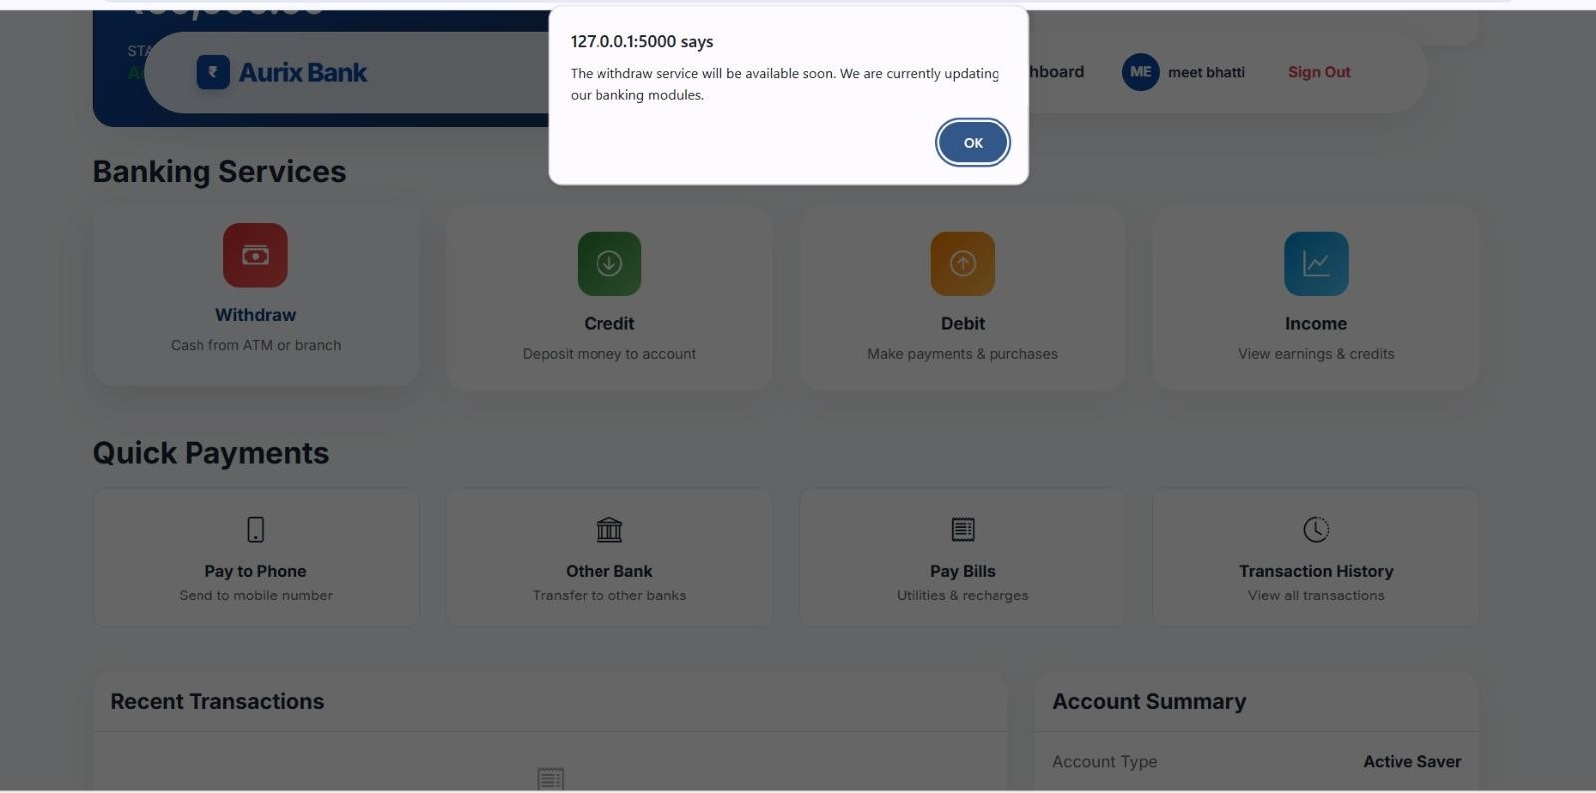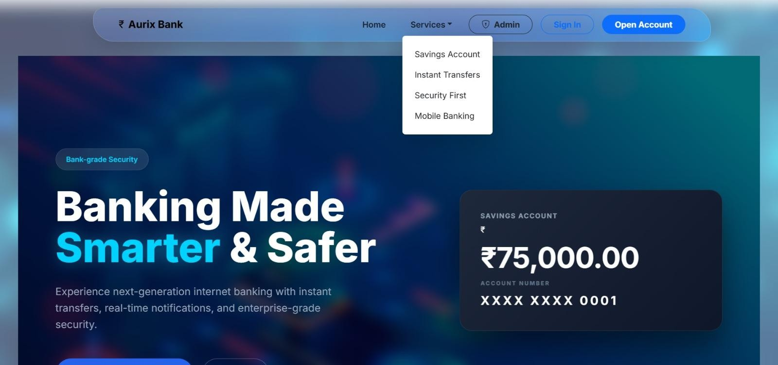

- Charts
  - Skill Improvement Chart
Chart Title
4.5
4
3.5
3
2.5
2
1.5
1
0.5
0
ython Programming Prompt Engineering Problem Solving
Communication Time Management
Before Project After Project Column1

  - Tools / Software Used Chart
Usage %

Python ChatGPT Windsurf AI Visual Studio Code Google Chrome

  - Challenges Faced Chart
Column3 Column2 Level
4.5
4
3.5
3
2 2.5
0.5 1 1.5
0
Understanding Prompt Engineering
Debugging Python Code
Managing Project Time
Learning New Tools
Chart Title

  - Learning Outcome Chart
Percentage

Python Programming Prompt Engineering Problem Solving Research Skills Documentation

- Attendance sheet

Date | What Work Done… | Hours
16/2/26 | Introduction to the project and  understanding the concept of Internet Banking. | 8 hours
17/2/26 | Research about online banking  systems and their main features. | 8 hours
18/2/26 | Learning the basics of Python programming required for the  project. | 8 hours
19/2/26 | Understanding the concept of  Prompt Engineering and its applications. | 8 hours
20/2/26 | Planning the structure and modules  of the Internet Banking system. | 8 hours
21/2/26 | Writing prompts to generate ideas  and logic for the banking system. | 8 hours
22/2/26 | Holiday | _
23/2/26 | Developing basic Python code for  user account creation. | 8 hours
24/2/26 | Implementing login functionality in  the Internet Banking system. | 8 hours
25/2/26 | Adding features like checking account  balance. | 8 hours
26/2/26 | Developing the money transfer  functionality. | 8 hours

27/2/26 | Working on transaction history and  data handling. | 8 hours
28/2/26 | Testing the Python code and fixing  errors. | 8 hours
01/3/26 | Holiday | _
02/3/26 | Improving prompts to generate  better outputs and code suggestions. | 8 hours
03/3/26 | Holiday | _
04/3/26 | Holiday | _
05/3/26 | Reviewing the project structure and  making necessary improvements. | 8 hours
06/3/26 | Preparing documentation and  organizing project files. | 8 hours
07/3/26 | Final review of the Internet Banking project and preparing for project  submission. | 8 hours

