**Batch: A4 Roll No.:16010121075**

**Experiment / assignment / tutorial No.4**

**Grade: AA / AB / BB / BC / CC / CD /DD**

**Signature of the Staff In-charge with date**

|  |
| --- |
| **TITLE :** To study and implement Non Restoring method of division |

**AIM :** The basis of algorithm is based on paper and pencil approach and the operation involve repetitive shifting with addition and subtraction. So the main aim is to depict the usual process in the form of an algorithm.

**______________________________________________________________________**

**Expected OUTCOME of Experiment: (Mention CO/CO’s attained here)**

**_____________________________________**

**Books/ Journals/ Websites referred:**

1. Carl Hamacher, Zvonko Vranesic and Safwat Zaky, “Computer Organization”, Fifth Edition, TataMcGraw-Hill.
2. William Stallings, “Computer Organization and Architecture: Designing for Performance”, Eighth Edition, Pearson.

**3**. Dr. M. Usha, T. S. Srikanth, “Computer System Architecture and Organization”, First Edition, Wiley-India.

**_____________________________________________________________________**

**Pre Lab/ Prior Concepts:**

The Non Restoring algorithm works with any combination of positive and negative numbers.

**Flowchart for Non Restoring of Division:**

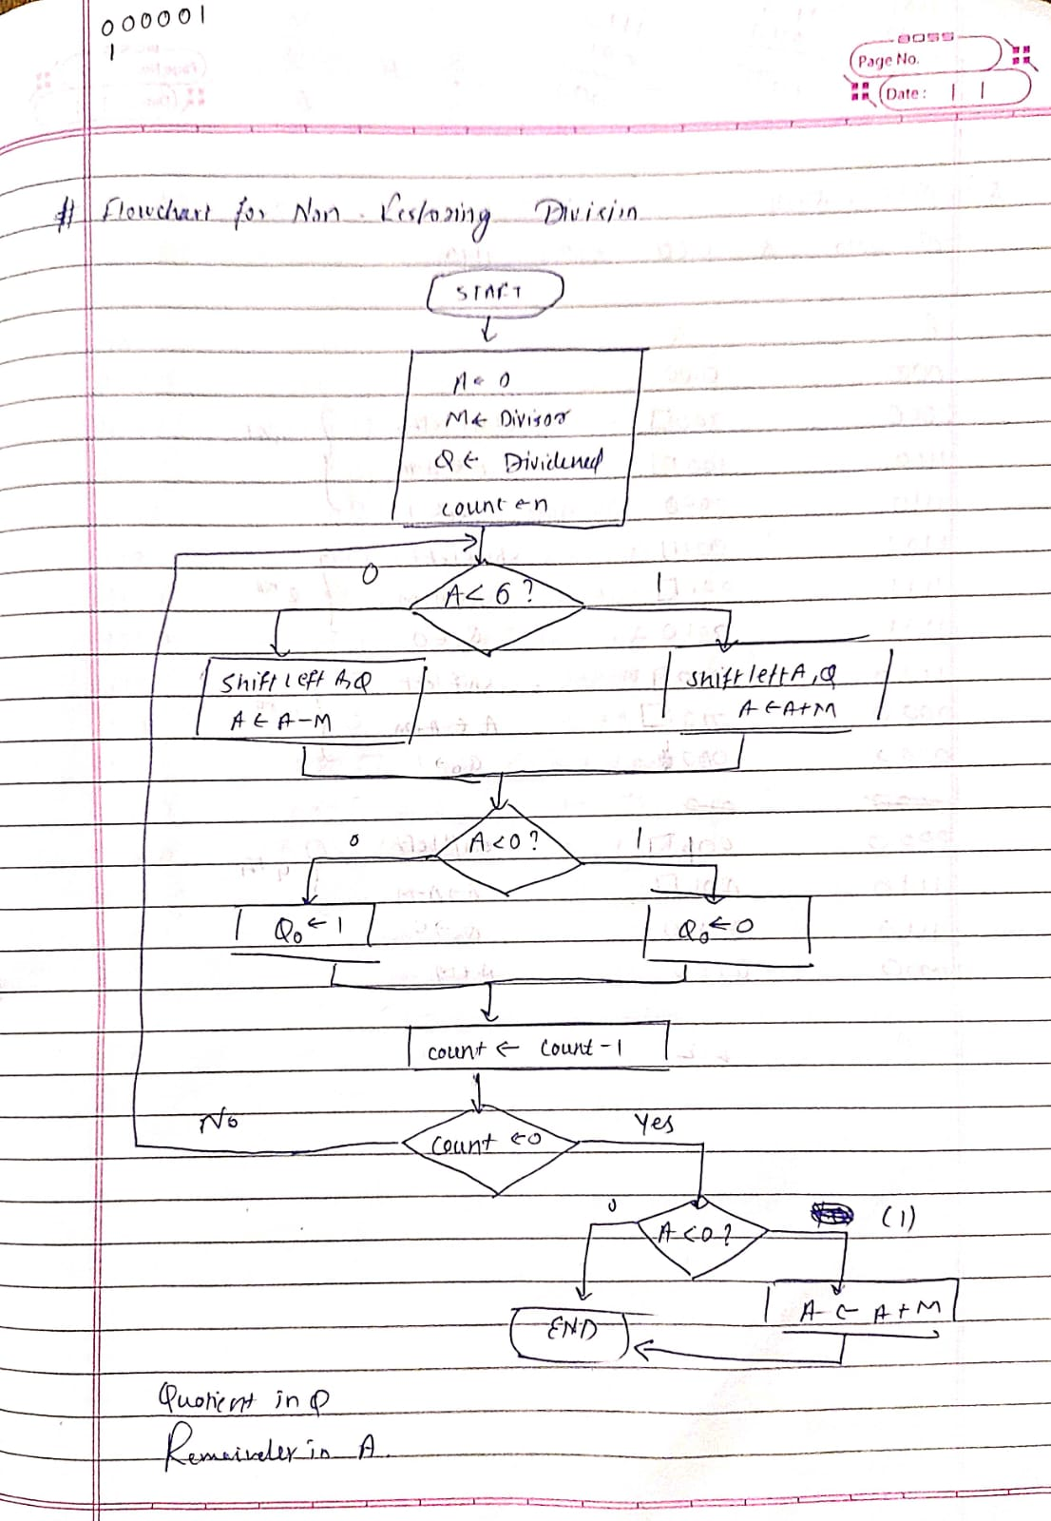

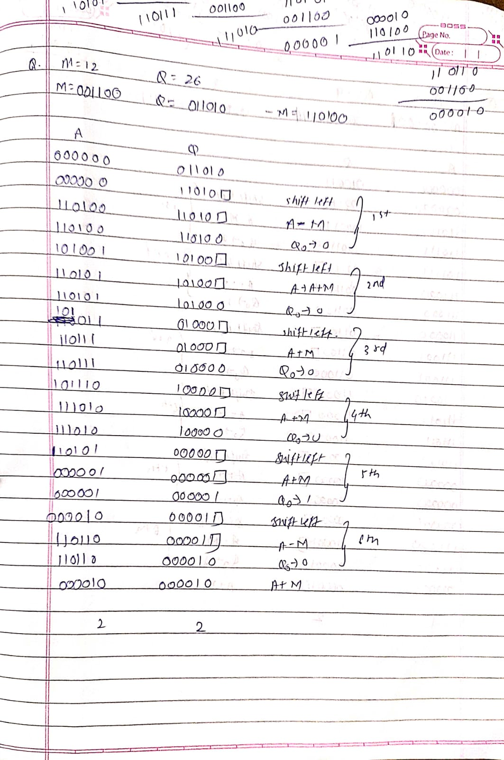**Example:**

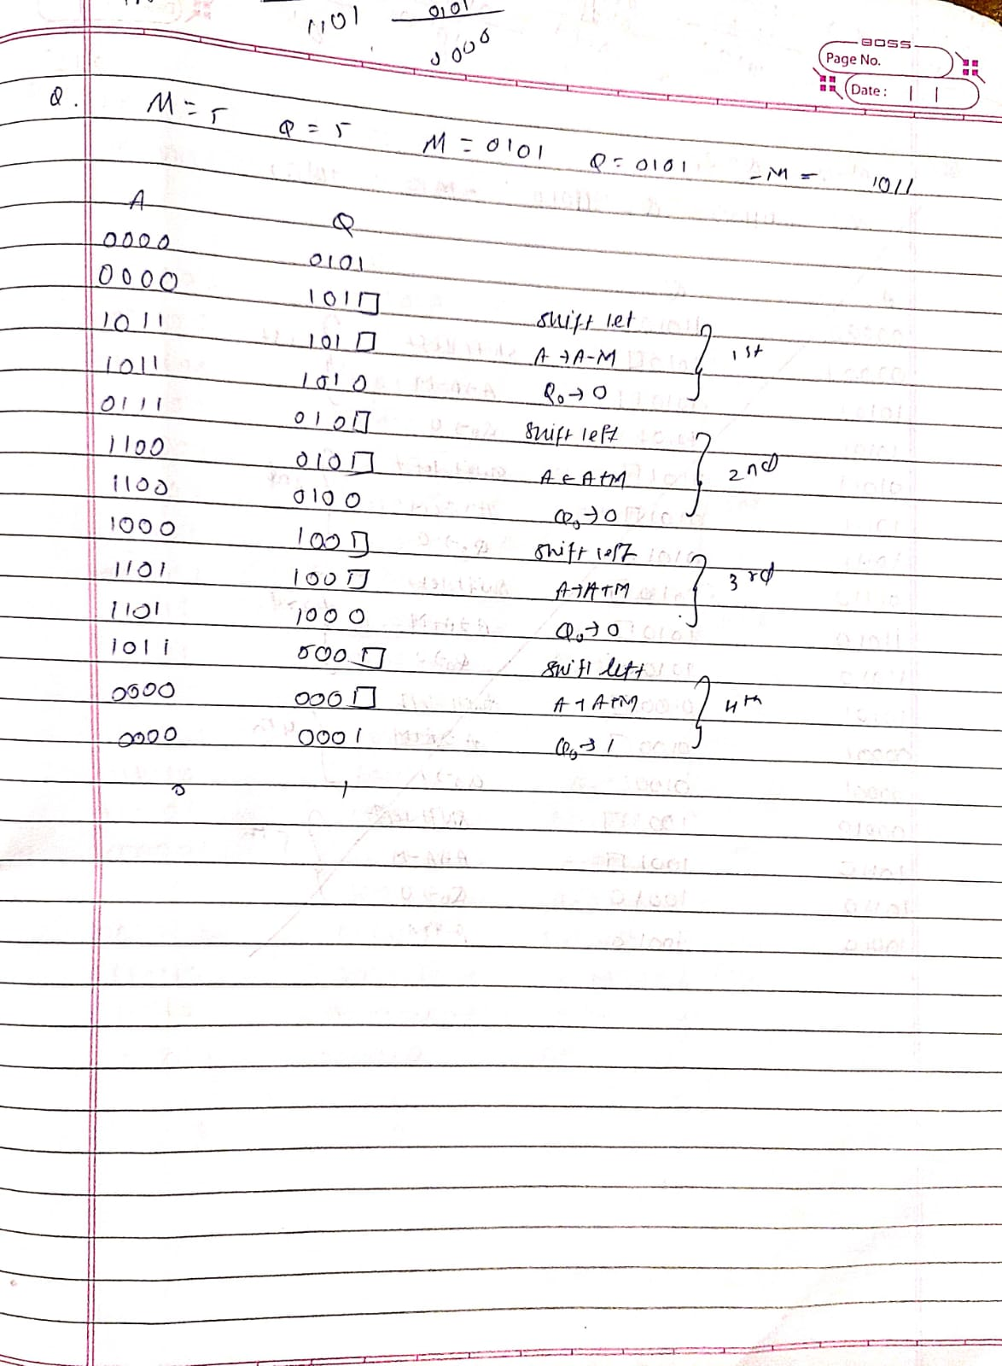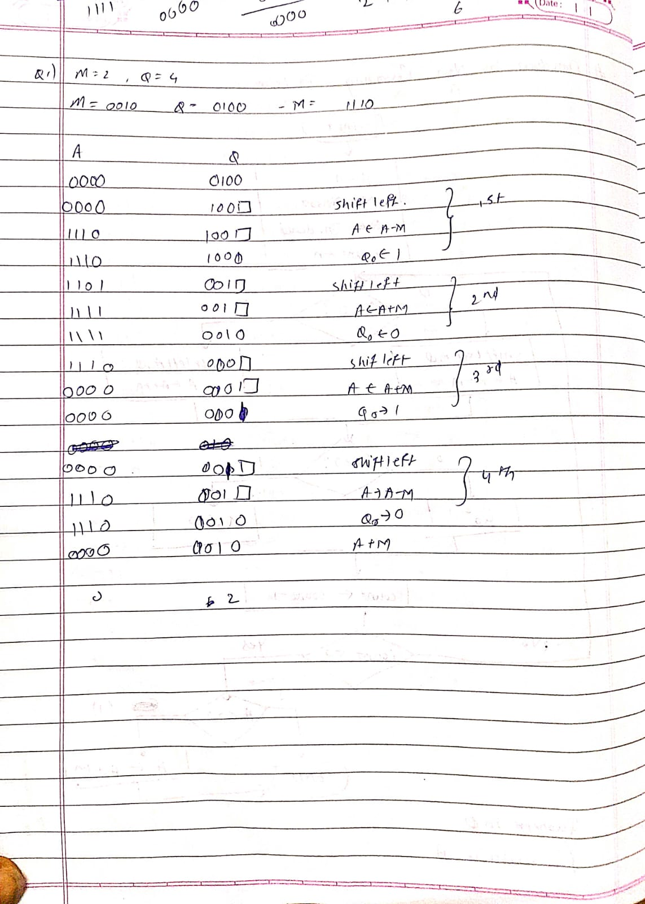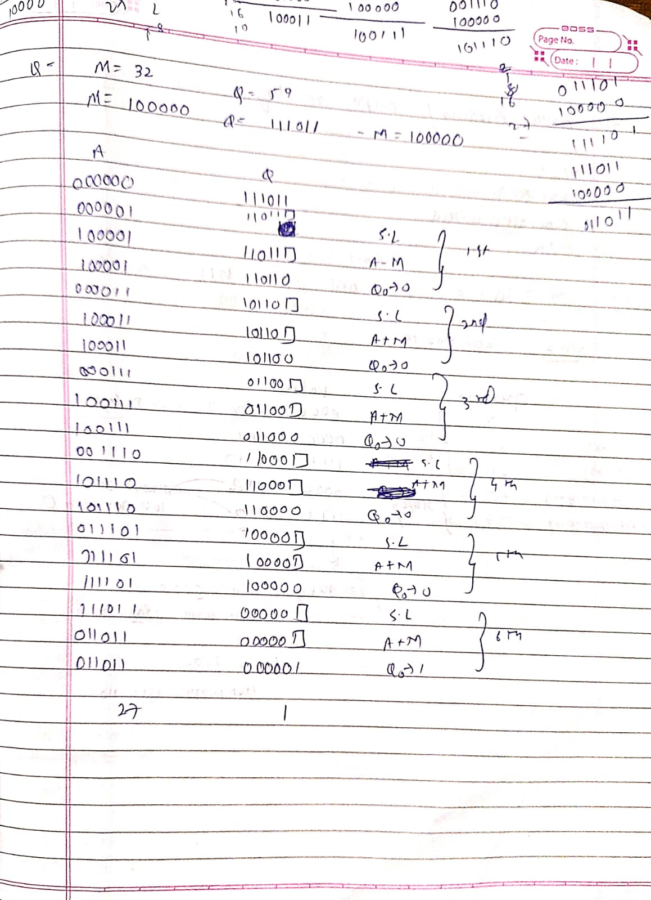

Implementation:

#include <math.h>

#include <stdio.h>

//NON RESTORING DIVISION

int main()

{

int a[50],a1[50],b[50],d=0,i,j;

int n1,n2, c, k1,k2,n,k,quo=0,rem=0;

printf("Enter the number of bits\n");

scanf("%d",&n);

printf("Enter the divisor and dividend\n");

scanf("%d %d", &n1,&n2);

for (c = n-1; c >= 0; c--)//converting the 2 nos to binary

{

k1 = n1 >> c;

if (k1 & 1)

a[n-1-c]=1;// M

else

a[n-1-c]=0;

k2 = n2 >> c;

if (k2 & 1)

b[2*n-1-c]=1;// Q

else

b[2*n-1-c]=0;

}

for(i=0;i<n;i++)//making complement

{

if(a[i]==0)

a1[i]=1;

else

a1[i]=0;

}

a1[n-1]+=1;//twos complement ie -M

if(a1[n-1]==2)

{

for(i=n-1;i>0;i--)

{

if(a1[i]==2)

{

a1[i-1]+=1;

a1[i]=0;

}

}

}

if(a1[0]==2)

a1[0]=0;

for( i=0;i<n;i++)// putting A in the same array as Q

{

b[i]=0;

}

printf("A\tQ\tPROCESS\n");

for(i=0;i<2*n;i++)

{

if(i==n)

printf("\t");

printf("%d",b[i]);

}

printf("\n");

for(k=0;k<n;k++)//n iterations

{

for(j=0;j<2*n-1;j++)//left shift

{

b[j]=b[j+1];

}

for(i=0;i<2*n -1;i++)

{

if(i==n)

printf("\t");

printf("%d",b[i]);

}printf("_");

printf("\tLEFT SHIFT\n");

if(b[0]==0)

{

for(i=n-1;i>=0;i--)//A=A-M

{

b[i]+=a1[i];

if(i!=0)

{

if(b[i]==2)

{

b[i-1]+=1;

b[i]=0;

}

if(b[i]==3)

{

b[i-1]+=1;

b[i]=1;

}

// printf("%d",b[i]);

}

}

if(b[0]==2)

b[0]=0;

if(b[0]==3)

b[0]=1;

for(i=0;i<2*n -1;i++)

{

if(i==n)

printf("\t");

printf("%d",b[i]);

}printf("_");

printf("\tA-M\n");

}

else

{

for(j=n-1;j>=0;j--)//A=A+M

{

b[j]+=a[j];

if(j!=0)

{

if(b[j]==2)

{

b[j-1]+=1;

b[j]=0;

}

if(b[j]==3)

{

b[j-1]+=1;

b[j]=1;

}

}

if(b[0]==2)

b[0]=0;

if(b[0]==3)

b[0]=1;

}

for(i=0;i<2*n -1;i++)

{

if(i==n)

printf("\t");

printf("%d",b[i]);

}printf("_");

printf("\tA+M\n");

}

if(b[0]==0)//A==0?

{

b[2*n-1]=1;

for(i=0;i<2*n ;i++)

{

if(i==n)

printf("\t");

printf("%d",b[i]);

}

printf("\tQ0=1\n");

}

if(b[0]==1)//A==1?

{

b[2*n-1]=0;

for(i=0;i<2*n ;i++)

{

if(i==n)

printf("\t");

printf("%d",b[i]);

}

printf("\tQ0=0\n");

}

}}

Output:

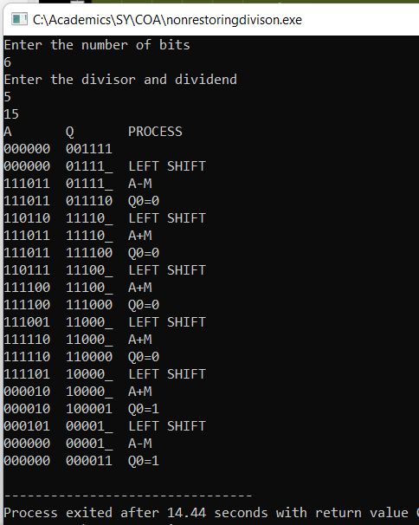

**Conclusion:**

**Non restoring divison was implemented successfully.**

**Post Lab Descriptive Questions**

1. **What are the advantages of non restoring division over restoring division?**

The advantage of using non-restoring arithmetic over the standard restoring division is that a test subtraction is not required; the sign bit determines whether an addition or subtraction is used.

**Date: _____________ Signature of faculty in-charge**