**Batch: A3**

**Roll No.: 16010121051**

**Experiment / assignment / tutorial No. 9**

**Grade: AA / AB / BB / BC / CC / CD /DD**

**Signature of the Staff In-charge with date**

**TITLE:** Implement simple addition, subtraction, multiplication and division instructions using TASM.

**AIM:** Implement simple addition, subtraction, multiplication and division instructions using TASM.

# Expected OUTCOME of Experiment: (Mentions the CO/CO’s attained)

Understand the Central processing unit with addressing modes and working of control unit in depth.

# Books/ Journals/ Websites referred:

1. **Microprocessor architecture and applications with 8085: By Ramesh Gaonkar (Penram International Publication).**

# 8086/8088 family: Design Programming and Interfacing: By John Uffenbeck (Pearson Education).

**Pre Lab/ Prior Concepts:**

# Assembler directives: These are statements that direct the assembler to do something

**Definition:**

# Types of Assembler Directives:

**ASSUME Directive** - The ASSUME directive is used to tell the assembler that the name of the logical segment should be used for a specified segment. The 8086 works directly with only 4 physical segments: a Code segment, a data segment, a stack segment, and an extra segment.

# Example:

**ASUME CS:CODE** ;This tells the assembler that the logical segment named CODE contains the instruction statements for the program and should be treated as a code segment.

**ASUME DS:DATA** ;This tells the assembler that for any instruction which refers to a data in the data segment, data will found in the logical segment DATA

# Start:

It is entry point of the program. without this program won’t run.

**END** - END directive is placed after the last statement of a program to tell the assembler that this is the end of the program module. The assembler will ignore any statement after an END directive. Carriage return is required after the END directive.

**ENDS** - This ENDS directive is used with name ofthe segment to indicate the end of that logic segment.

# Example:

**CODE SEGMENT** ;

Hear it Start the logic

;segment containing code

; Some instructions statements to perform the logical

;operation

**CODE ENDS** ;End of segment named as;CODE

# Arithmetic instruction set: ADD instruction:

**Syntax: ADD destination,source**

|  |  |  |  |  |
| --- | --- | --- | --- | --- |
| **Mnemonic** | **Meaning** | **Format** | **Operation** | **Flags** |
| **Affected** |
| ADD | Addition | ADD D, S | (S) + (D)→(D) | All |
| Carry→(CF) |
| ADC | Add with | ADC D, S | (S) + (D) +(CF) | All |
| carry | → (D) |
|  | Carry→(CF) |

|  |  |  |  |  |
| --- | --- | --- | --- | --- |
| **SUB instruction:**  **Mnemonic** | **Meaning** | **Format** | **Operation** | **Flags Affected** |
| SUB | Subtract | SUB D, S | (D) - (S)→(D) | All |
| Borrow→(CF) |

|  |  |  |  |  |
| --- | --- | --- | --- | --- |
|  |  |  |  |  |
| SBB | Subtract with | SBB D, S | (D) - (S) –(CF)→(D) | All |
| borrow |

# MUL instruction:

**Syntax: MUL source**

|  |  |  |  |
| --- | --- | --- | --- |
| **Multiplication** | **Multiplicand** | **Operand** | **Result** |
| **(MUL or IMUL)** | **(Multiplier)** |
| Byte * Byte | AL | Register or | AX |
| Memory |
| Word * Word | AX | Register or memory | DX :AX |

# DIV instruction:

|  |  |  |  |
| --- | --- | --- | --- |
| **(DIV or IDIV)** |  | **(Divisor)** |  |
| Word / Byte | AX | Register or memory | AL : AH |
| Dword / Word | DX:AX | Register or memory | AX : DX |

**The steps to execute a program in TASM are ASSEMBLING AND EXECUTING THE ROGRAM**

# Writing an Assembly Language Program

Assembly level programs generally abbreviated as ALP are written in text editor EDIT.

Type *EDIT* in front of the command prompt **(C:\TASM\BIN)** to open an untitled text file.

*EDIT<file name>*

After typing the program save the file with appropriate file name with an extension *.ASM*

Ex:Add.ASM

# Assembling an Assembly Language Program

To assumble an ALP we needed executable file called MASM.EXE. Only if this file is in current working directory we can assemble the program. The command is

*TASM<filename.ASM>*

If the program is free from all syntactical errors, this command will give the **OBJEC**T file.In case of errors it list out the number of errors, warnings and kind of error.

# Note: No object file is created until all errors are rectified.

1. **Linking**

After successful assembling of the program we have to link it to get

# Executable file.

The command is

*TLINK<File name.OBJ>*

This command results in <*Filename.exe>*which can be executed in front of the command prompt.

# Executing the Program

Open the program in debugger by the command(note only exe files can be open)by the command.

*<Filename.exe>*

This will open the program in debugger screen where in you can view the assemble code with the CS and IP values at the left most side and the machine code. Register content,memory content also be viewed using ***TD***option of the debugger & to execute the program in single steps(F7)

# Algorithm for adding the two 8-bit numbers:

* 1. Define a data segment and then define the two numbers on which the operation is to be performed in two memory locations(a, b)(as we can’t take input while running the code in assembly language)
  2. Also define another memory location(c) to store the final answer of the two values on which the operation is to be performed
  3. Then move the contents of data to AL
  4. Move the contents of AL to DS
  5. Move the first value(a) to AL
  6. Move the second value(b) to BL
  7. Then add both of them using ADD AL, BL wherein the memory gets stored in AL
  8. Then move the value of the modified AL to c to store the answer
  9. Then perform MOV ah,4ch and then int 21h to interrupt the code
  10. Type “code ends” to end the execution of the code.

# Algorithm for subtracting the two 8 bit numbers:

1. Define a data segment and then define the two numbers on which the operation is to be performed in two memory locations(a, b)(as we can’t take input while running the code in assembly language)
2. Also define another memory location(c) to store the final answer of the two values on which the operation is to be performed
3. Then move the contents of data to AL
4. Move the contents of AL to DS
5. Move the first value(a) to AL
6. Move the second value(b) to BL
7. Then subtract both of them using SUB AL, BL wherein the memory gets stored in AL
8. Then move the value of the modified AL to c to store the answer
9. Then perform MOV ah,4ch and then int 21h to interrupt the code
10. Type “code ends” to end the execution of the code.

# Algorithm for multiplying the two 8 bit numbers:

1. Define a data segment and then define the two numbers on which the operation is to be performed in two memory locations(a, b)(as we can’t take input while running the code in assembly language)
2. Also define another memory location(c) to store the final answer of the two values on which the operation is to be performed
3. Then move the contents of data to AL
4. Move the contents of AL to DS
5. Move the first value(a) to AL
6. Move the second value(b) to BL
7. Then multiply both of them using MUL BL wherein the memory gets stored in AL
8. Then move the value of the modified AL to c to store the answer
9. Then perform MOV ah,4ch and then int 21h to interrupt the code
10. Type “code ends” to end the execution of the code.

# Algorithm for dividing the two 8-bit numbers:

1. Define a data segment and then define the two numbers on which the operation is to be performed in two memory locations(a, b)(as we can’t take input while running the code in assembly language)
2. Also define another memory location(c) to store the final answer of the two values on which the operation is to be performed
3. Then move the contents of data to AL
4. Move the contents of AL to DS
5. Move the first value(a) to AL
6. Move the second value(b) to BL
7. Then divide both of them using DIV BL wherein the memory gets stored in AL
8. Then move the value of the modified AL to c to store the answer
9. Then perform MOV ah,4ch and then int 21h to interrupt the code
10. Type “code ends” to end the execution of the code.

# Code:

data segment a db 08h

b db 04h

c db ? d db ? e db ? f db ?

data ends code segment

assume cs:code, ds:data start:

MOV AX, data MOV DS, AX MOV AL, a MOV BL, b ADD AL, BL MOV c, AL MOV AL, a MOV BL, b SUB AL, BL MOV d, AL MOV AL, a MOV BL, b MUL BL MOV e, AL MOV AL, a MOV BL, b DIV BL

MOV f, AL

MOV ah, 4ch int 21h

code ends end start end

# Output:

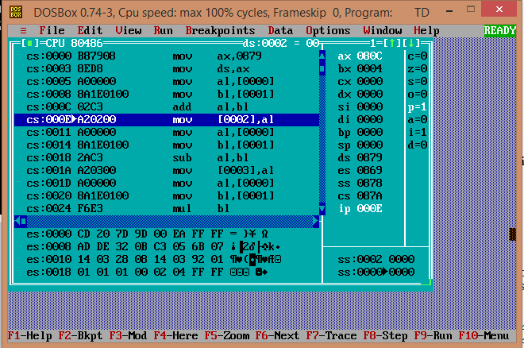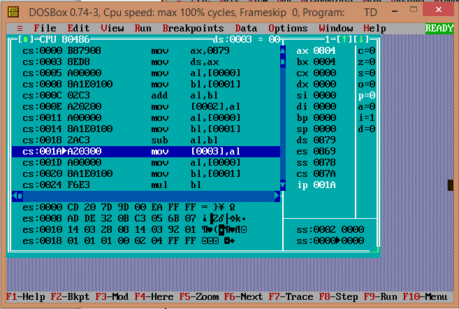

**1.**

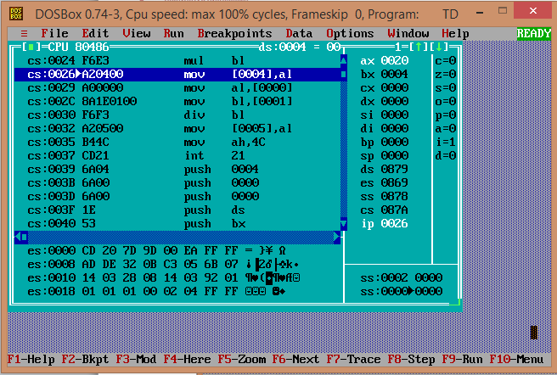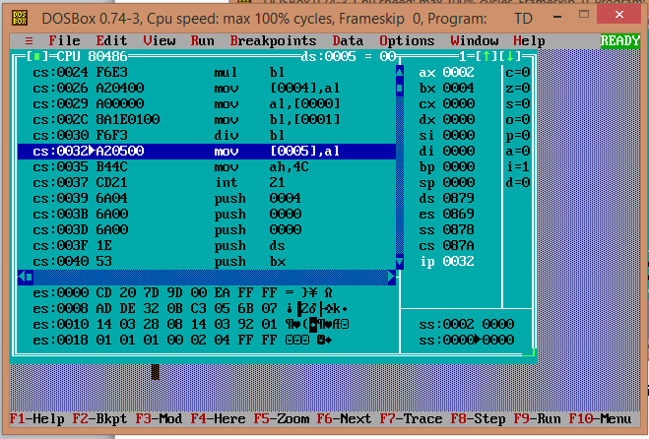

# Post Lab Descriptive Questions (Add questions from examination point view) Explain instructions ADC and SBB with example

**Answer:**

***Adding and Subtracting in Multiple Registers:***

Numbers larger than the register size on your processor can be added and subtracted with the ADC (Add with Carry) and SBB (Subtract with Borrow) instructions.

These instructions work as follows:

ADC Dest, Source ; Dest = Dest + Source + Carry Flag SBB Dest, Source ; Dest = Dest - Source - Carry Flag

If the operations prior to an ADC or SBB instruction do not set the carry flag, these instructions are identical to ADD and SUB. While operating on large values in more than one register, ADD and SUB are used for the least significant part of the number and ADC or SBB for the most significant part.

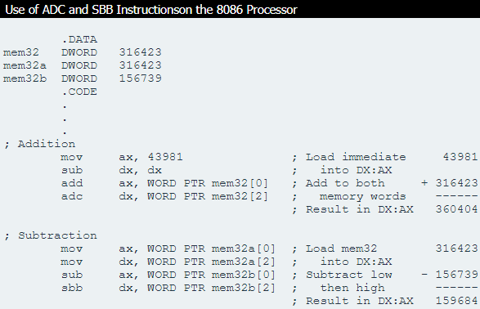

# Date: 21/11/2022 Signature of faculty in-charge