**Batch: A3 Roll. No.: 16010121051**

**Experiment:**

**Grade: AA / AB / BB / BC / CC / CD /DD**

|  |
| --- |
| **Title:**  Implementation of sorting algorithms |

**Objective:** To understand various searching methods

**Expected Outcome of Experiment:**

|  |  |
| --- | --- |
| **CO** | **Outcome** |
| **CO3** | Demonstrate sorting and searching methods. |

**Websites/books referred:**

**1. Geekforgeeks**

**2. Stackoverflow**

**3. Javatpoint**

**4. Lecture PPT**

**_____________________________________________________________________**

**Abstract**: -

*(Define sorting as a concept, )*

*Sorting is a technique that is implemented to arrange the data in a specific order. Sorting is*

*required to ensure that the data which we use is in a particular order so that we can easily*

*retrieve the required piece of information from the pile of data.*

**Related Theory:** *(Explain stable sort, in place sort, number of passes in a sorting algo)*

A Stable Sort is one which preserves the original order of input set, where the

comparison algorithm does not distinguish between two or more items. A Stable Sort

will guarantee that the original order of data having the same rank is preserved in the

output.

A sorting algorithm is said to be stable if two objects with equal keys appear in the same

order in sorted output as they appear in the input array to be sorted. Some Sorting

Algorithms are stable by nature, such as Bubble Sort, Insertion Sort, Merge Sort, Count

Sort etc.

An in-place algorithm is an algorithm that does not need an extra space and produces an

output in the same memory that contains the data by transforming the input ‘in-place’.

However, a small constant extra space used for variables is allowed.

In Place: Bubble sort, Selection Sort, Insertion Sort, Heapsort.

Not In-Place: Merge Sort. Note that merge sort requires O(n) extra space.

Number of passes in a sorting algo is the number of iterations in the loop required to

sort an array completely. A sorting algorithm goes through a list of data a number of

times, comparing two items that are side by side to see which is out of order. It will keep

going through the list of data until all the data is sorted into order. Each time the algorithm

goes through the list it is called a 'pass'.

Quicksort uses extra space for recursive function calls. It is called in-place according to

broad definition as extra space required is not used to manipulate input, but only for

recursive calls.

**Assigned Sorting Algorithm:** *(Bubble/insertion/counting)*

a) Insertion sort

Step 1 - Start

Step 2 - If the element is the first element, assume that it is already sorted. Return 1.

Step 3 - Pick the next element and store it separately in a key.

Step 4 - Now, compare the key with all elements in the sorted array.

Step 5 - If the element in the sorted array is smaller than the current element, then

move to the next element. Else, shift greater elements in the array towards the right.

Step 6 - Insert the value.

Step 7 - Repeat until the array is sorted.

Step 8 - Stop

b) Counting sort:

Step 1: Start

Step 2: Call the function using countsort(array, size)

Step 3: The value of Max is the largest element in array and initialize the count array

with all zeros

Step 4: For j ← 0 to size, find the total count of each unique element and

Step 5: Store the count at jth index in the count array

Step 6: For i ← 1 to max, find the cumulative sum and store it in count array itself

Step 7: For j ← size down to 1, restore the elements to array

Step 8: Decrease count of each element restored by 1 Step

9: Stop

**Code and output screenshots for assigned sorting algorithm:**

**#include <bits/stdc++.h>**

**using namespace std;**

**void insertionSort(int arr[], int n)**

**{**

**int i, key, j;**

**for (i = 1; i < n; i++)**

**{**

**key = arr[i];**

**j = i - 1;**

**while (j >= 0 && arr[j] > key)**

**{**

**arr[j + 1] = arr[j];**

**j = j - 1;**

**}**

**arr[j + 1] = key;**

**}**

**}**

**void printArray(int arr1[], int n)**

**{**

**int i;**

**for (i = 0; i < n; i++)**

**cout << arr1[i] << " ";**

**cout << endl;**

**}**

**void countSort(int a[], int n)**

**{**

**int output[n+1];**

**int max = a[0];**

**for(int i = 1; i<n; i++)**

**if(a[i] > max)**

**max = a[i];**

**int count[max+1];**

**for (int i = 0; i <= max; ++i)**

**count[i] = 0;**

**for (int i = 0; i < n; i++)**

**count[a[i]]++;**

**for(int i = 1; i<=max; i++)**

**count[i] += count[i-1];**

**for (int i = n - 1; i >= 0; i--)**

**{**

**output[count[a[i]] - 1] = a[i];**

**count[a[i]]--;**

**}**

**for(int i = 0; i<n; i++)**

**{**

**a[i] = output[i];**

**}**

**}**

**int main()**

**{**

**int arr[25],arr1[25];**

**int no,no1;**

**int element;**

**cout<<"\nEnter the number of elements in the array:\n";**

**cin>>no;**

**no1=no;**

**int i;**

**for(i=0;i<no;i++)**

**{**

**cout<<"\nEnter the element:";**

**cin>>element;**

**arr[i]=element;**

**}**

**for(i=0;i<no;i++)**

**{**

**arr1[i]=arr[i];**

**}**

**int option;**

**do**

**{**

**cout<<"\n\tMain Menu:\n";**

**cout<<"\t1.Insertion Sort\n";**

**cout<<"\t2.Counting sort\n";**

**cout<<"\t3.Exit";**

**cout<<"\nEnter the option:";**

**cin>>option;**

**switch(option)**

**{**

**case 1:**

**insertionSort(arr, no);**

**printArray(arr, no);**

**break;**

**case 2:**

**countSort(arr1,no1);**

**printArray(arr1,no1);**

**break;**

**case 3:**

**break;**

**}**

**}**

**while(option!=3);**

**return 0;**

**}**

**Output:**

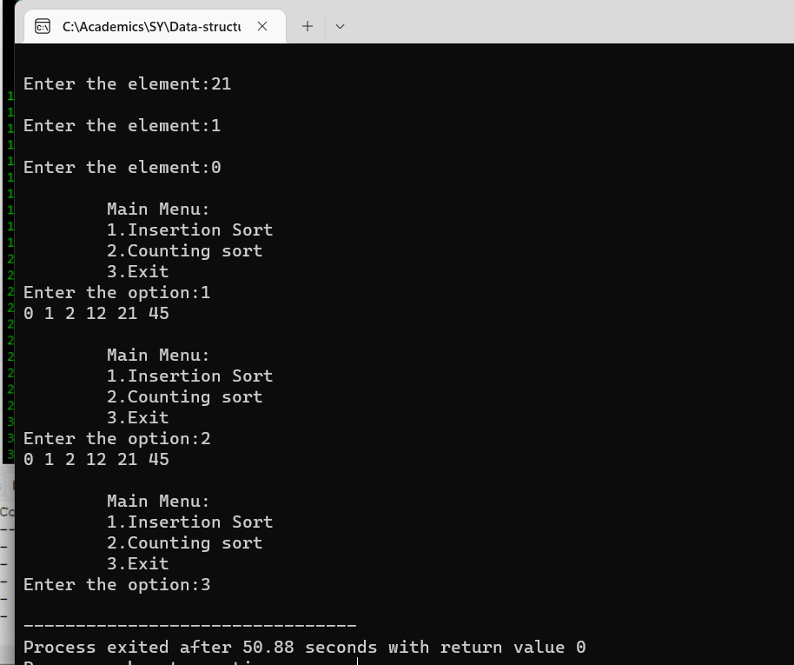

**Conclusion: -**

**With the help of the above experiment, the various sorting algorithms have**

**been successfully understood and implemented**

**Post lab questions-**

1. **Compare and contrast various sorting algorithms.**

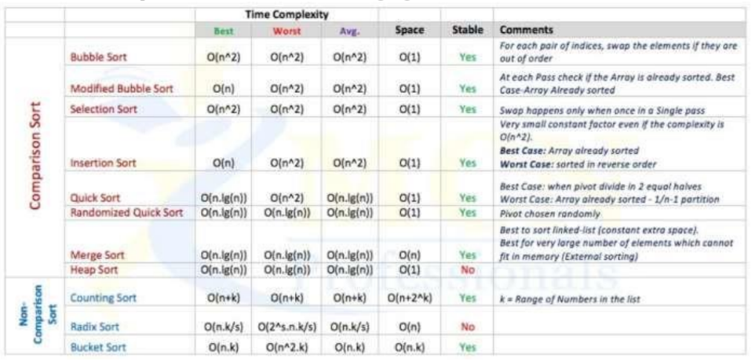

1. **Comment on the input (sorted in ascending order/descending order/random) and time required for execution of sorting algorithm.**

For count sort

Input can be random

Let, N=Number of elements in given array K=maximum

value present in given array.

Therefore, Time Complexity = O(N+K)

In all cases time complexity will be O(N+K) as the range of for loops does not

changes.

For Insertion sort

Input can be random

Time Complexity= O (n^2) in all cases, where n is the number of elements in the

array