**Batch: A3 Roll. No.: 16010121051**

**Experiment:**

**Grade: AA / AB / BB / BC / CC / CD /DD**

|  |
| --- |
| **Title:**  Using virtual labs to understand the data structures |

**Objective:** Use of virtual labs to understand the concepts and theory with examples and verify the same with practice questions.

**Expected Outcome of Experiment:**

|  |  |
| --- | --- |
| **CO** | **Outcome** |
| **CO1** | Explain the different data structures used in problem solving |
| **CO2** | Apply linear and non-linear data structure in application development |
| **CO3** | Demonstrate sorting and searching methods. |

**Websites/books referred:**

**1.**

**2.**

**3.**

Abstract: the virtual lab experiments help in understanding how various data structures work. They also emphasize on some important applications of various data structures and enable students to get familiarized with how certain applications can benefit from the choice of data structures.

Assigned data structure: *(Teacher would assign one of the following to one student)*

1. Stack - <https://ds1-iiith.vlabs.ac.in/exp/stacks-queues/stacks/stackdemo.html>
2. Infix and postfix - https://ds1-iiith.vlabs.ac.in/exp/infix-postfix/evaluation-of-postfix-expressions/postfix_eval.html
3. Queue - <https://ds1-iiith.vlabs.ac.in/exp/stacks-queues/stacks/stackdemo.html>
4. Bubble sort - <https://ds1-iiith.vlabs.ac.in/exp/bubble-sort/bubble-sort/bsexercise.html>
5. Graph DFS - <https://ds1-iiith.vlabs.ac.in/exp/depth-first-search/index.html>
6. Graph BFS - <https://ds1-iiith.vlabs.ac.in/exp/breadth-first-search/index.html>
7. Binary search tree - <https://ds1-iiith.vlabs.ac.in/exp/binary-search-trees/bst-insert/bstInsert.html>
8. Hash tables - <https://ds1-iiith.vlabs.ac.in/exp/hash-tables/quadratic-probing/qp_practice.html>
9. Linked list - https://ds1-iiith.vlabs.ac.in/exp/linked-list/singly-linked-list/sllpractice.html

**Aim / learning objective of the assigned expt:**

**To implement and test bubble sort on vlab.**

**Concept and algorithm of the application/activity followed:**

**Bubble sort.**

**Demo execution screenshots:**

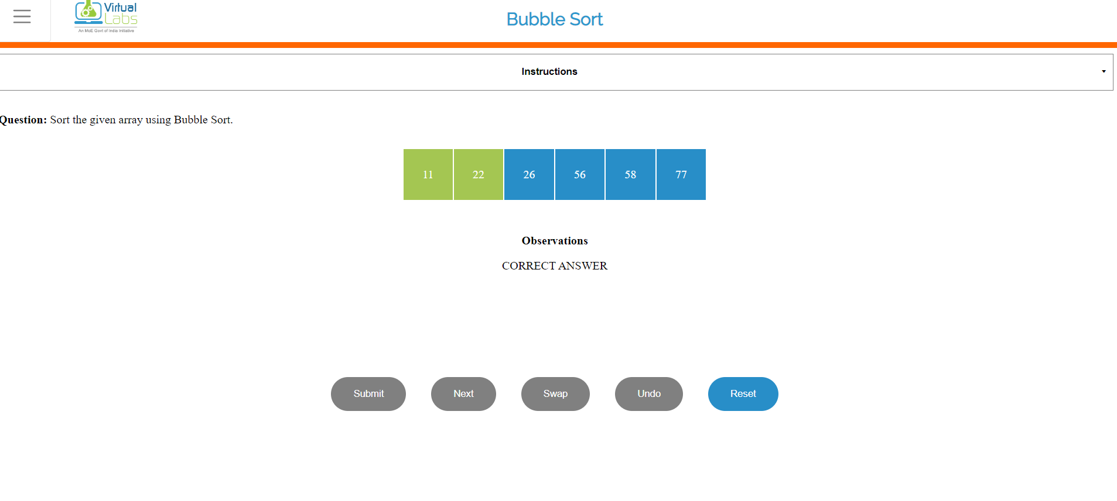

**Practice problem screenshots:**

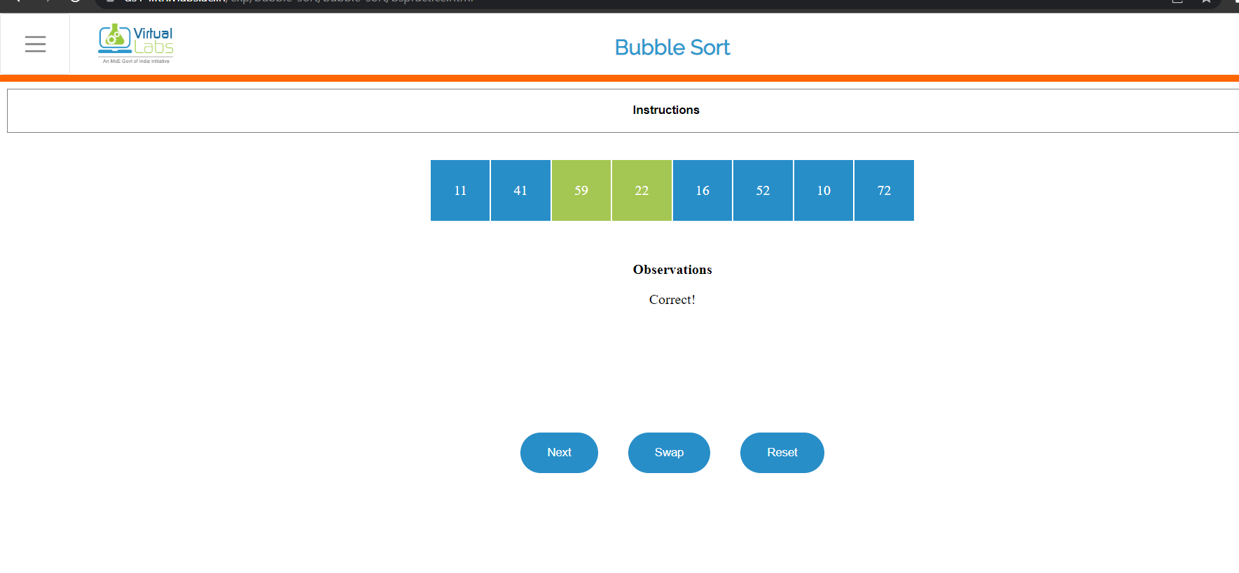

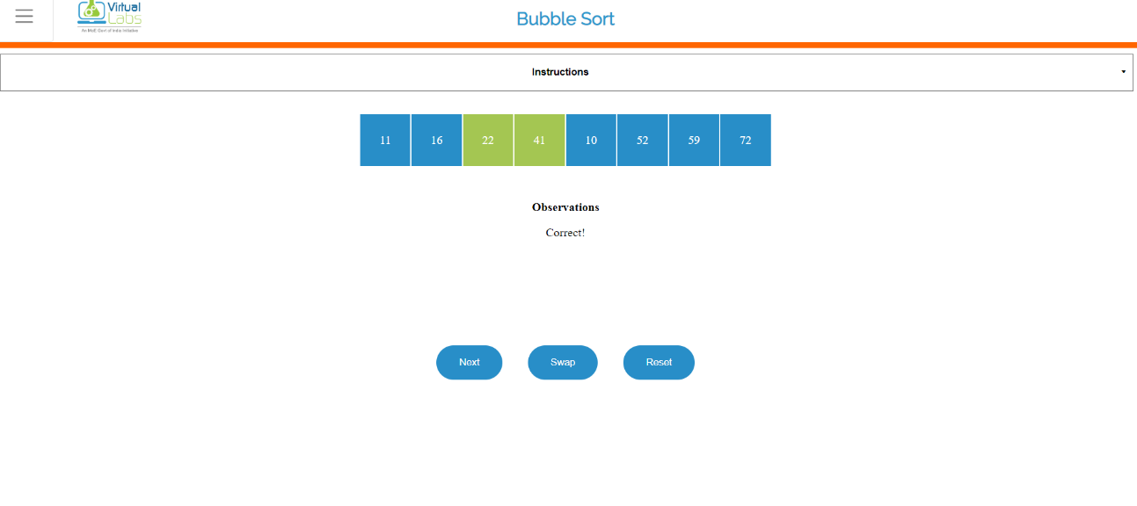

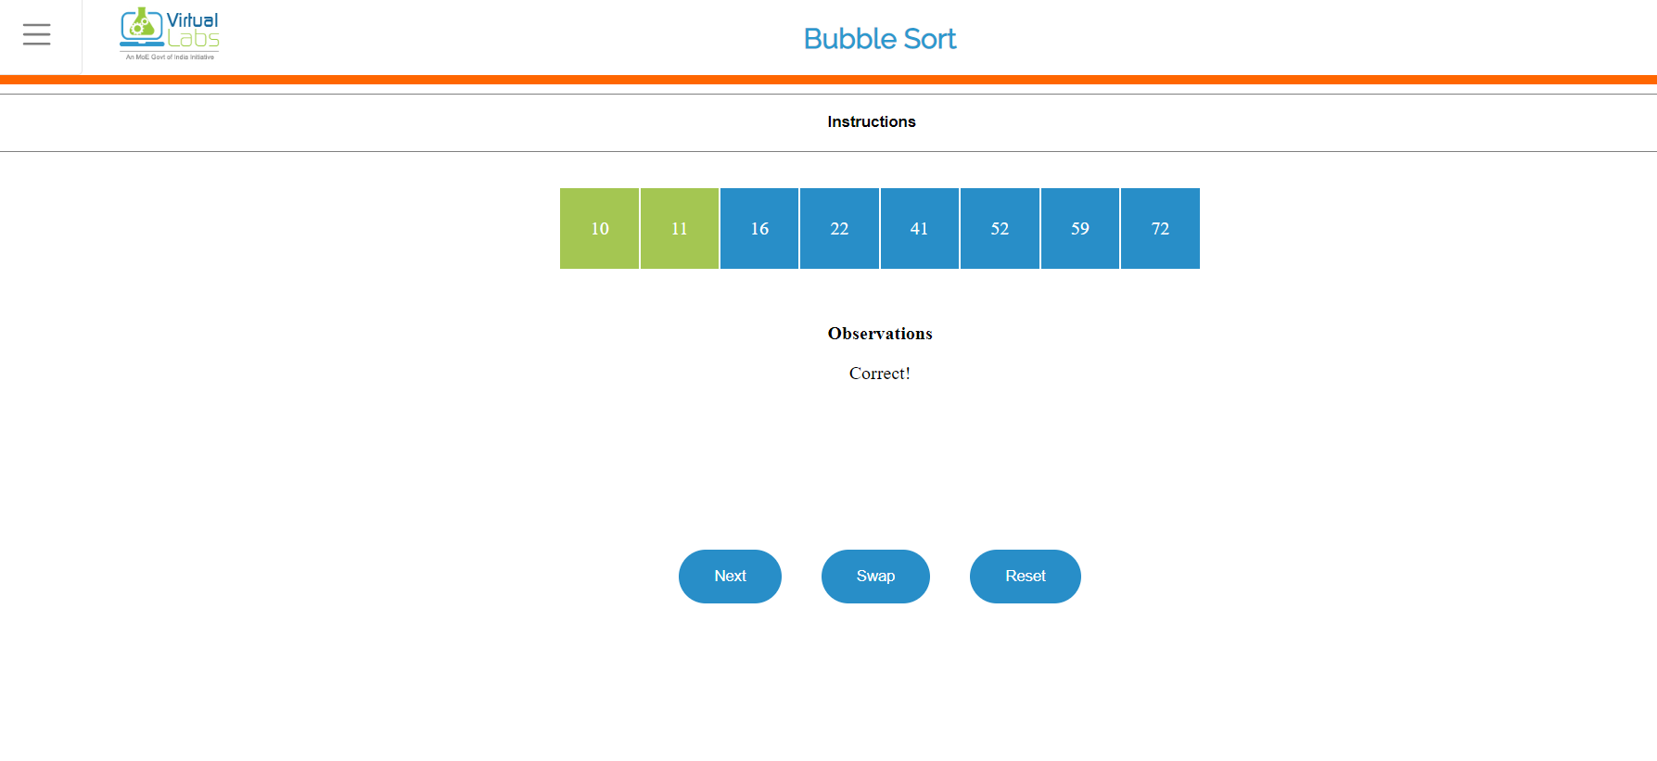

**Quiz screenshots:**

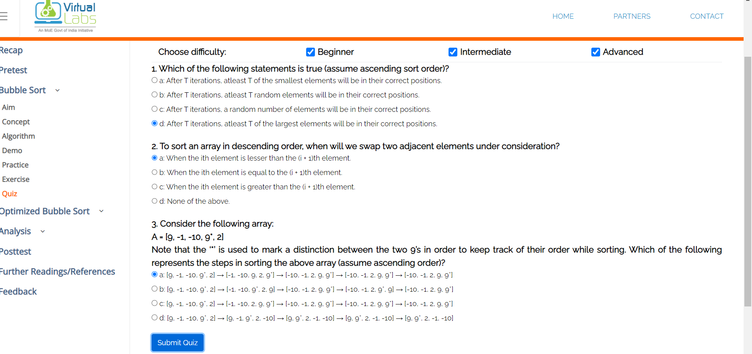

**Conclusion and your take away after performing the virtual lab experiment: -**

**Implemented bubble sort successfully with help of great ui and options by vlab.**