**Batch: A3 Roll. No.: 16010121051**

**Experiment:**

**Grade: AA / AB / BB / BC / CC / CD /DD**

|  |
| --- |
| **Title:**  Implementation of Graph - insertion, search and traversal |

**Objective:** To understand graph as data structure and methods of traversing Graph

**Expected Outcome of Experiment:**

|  |  |
| --- | --- |
| **CO** | **Outcome** |
| **CO2** | Apply linear and non-linear data structure in application development |

**Websites/books referred:**

**_____________________________________________________________________**

**Abstract**: - (Definition of Graph, types of graphs, and difference and similarity between graph & tree)

**Graph:**

**Types of Graph:**

1. Null Graph

A graph is known as null graph if there are no edges in the graph.

2. Trivial Graph

Graph having only a single vertex, it is the smallest graph possible.

3. Undirected Graph

A graph in which edges do not have any direction. That is the nodes are

unordered pairs in the definition of every edge.

4. Directed Graph

A graph in which edge has direction. That is the nodes are ordered pairs in

the definition of every edge.

5. Connected Graph

The graph in which from one node we can visit any other node in the

graph is known as a connected graph.

6. Disconnected Graph

The graph in which at least one node is not reachable from a node is

known as a disconnected graph.

7. Regular Graph

The graph in which the degree of every vertex is equal to the other vertices

of the graph.

Let the degree of each vertex be K then the graph is called K-regular.

8. Complete Graph

The graph in which from each node there is an edge to each other node.

9. Cycle Graph

The graph in which the graph is a cycle in itself, the degree of each vertex

is 2.

10. Cyclic Graph

A graph containing at least one cycle is known as a Cyclic graph.

11. Directed Acyclic Graph

A Directed Graph that does not contain any cycle.

12. Bipartite graph

A graph in which vertex can be divided into two sets such that vertex in

each set does not contain any edge between them.

**Difference between graph and tree:**

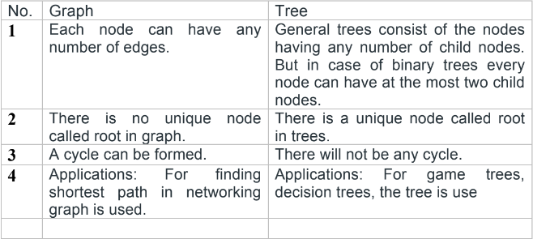

**Similarity between graph and tree:**

Both graph are non linear data structures consisting of nodes and

vertices/edges.

Every node in both graph and tree has at least one data variable and a pointer.

.

**Algorithm for DFS/BFS:**

**DFS**

**• Mark all the visited array elements as false.**

**• Call DFS for first node.**

**• Mark the node as visited and print it**

**• Iterate through adjacency list (node) and if they are not visited then recursively**

**call dfs for them.**

**• End**

**BFS**

**• Mark all the visited array elements as false.**

**• Call BFS for first node.**

**• Mark the node as visited and print it**

**• Iterate through adjacency list (node), if then they are not visited then mark them**

**true and add then to the queue.**

**• If queue has elements the remove the top one and call BFS for that node.**

**• End.**

**Code and output screenshots:**

**#include <stdio.h>**

**#include<stdlib.h>**

**int visit[20]={0};**

**int v[20]={0};**

**typedef struct node{**

**int data;**

**struct node *prev;**

**struct node *link;**

**}node;**

**typedef struct queue{**

**struct node *rr;**

**struct node *fr;**

**}que;**

**int dequeue(que *q){**

**node *temp;**

**if(q->rr!=NULL){**

**temp=q->rr;**

**int d=temp->data;**

**q->rr=temp->prev;**

**if(q->rr!=NULL)**

**q->rr->link=NULL;**

**else**

**q->fr=NULL;**

**return d;**

**}**

**return 0;**

**}**

**void enqueue(int ch,que *q ){**

**node *nnode;**

**nnode=(node*)malloc(sizeof(node));**

**nnode->data=ch;**

**nnode->link=NULL;**

**nnode->prev=NULL;**

**if(q->fr==NULL){**

**q->fr=nnode;**

**q->rr=nnode;**

**}**

**else{**

**nnode->link=q->fr;**

**q->fr->prev=nnode;**

**q->fr=nnode;**

**}**

**}**

**void display(que *q){**

**node *temp;**

**temp=q->fr;**

**while(temp!=NULL){**

**printf(" %c",temp->data);**

**temp=temp->link;**

**}**

**}**

**void dfs(int t,int a[20][20],int n){**

**int i,j;**

**printf("%d->",t);**

**visit[t-1]=1;**

**for(i=0;i<n;i++){**

**if(a[t-1][i]==1 && visit[i]==0){**

**dfs(i+1,a,n);**

**}**

**}**

**}**

**void bfs(int t,int a[20][20],int n,que *q){**

**int i,j;**

**printf("%d->",t);**

**int temp;**

**enqueue(t,q);**

**v[t-1]=1;**

**while(q->fr!=NULL){**

**temp=dequeue(q);**

**for(i=0;i<n;i++){**

**if(a[temp-1][i]==1 && v[i]==0){**

**enqueue(i+1,q);**

**printf("%d->",i+1);**

**v[i]=1;**

**}**

**}**

**}**

**}**

**int main(void) {**

**printf("Enter number of vertices:\n");**

**int n,i,j,e,p,q;**

**scanf("%d",&n);**

**int a[20][20];**

**for(i=0;i<n;i++){**

**visit[i]=0;**

**for(j=0;j<n;j++) {**

**a[i][j]=0;**

**}**

**}**

**printf("Enter number of edges:\n");**

**scanf("%d",&e);**

**printf("\nEnter 1 for undirected graph and 0 for directed graph:");**

**int t;**

**scanf("%d",&t);**

**for(i=0;i<e;i++){**

**printf("Enter edge vertex(p,q):\n");**

**scanf("%d%d",&p,&q);**

**a[p-1][q-1]=1;**

**if(t==1)**

**a[q-1][p-1]=1;**

**}**

**for(i=0;i<n;i++){**

**for(j=0;j<n;j++){**

**printf("%d ",a[i][j]);**

**}**

**printf("\n");**

**}**

**printf("Enter Element from where you want to start dfs and bfs:");**

**int d;**

**scanf("%d",&d);**

**printf("\n DFS:\n");**

**dfs(d,a,n);**

**que q1;**

**q1.fr=q1.rr=NULL;**

**printf("\n BFS:\n");**

**bfs(d,a,n,&q1);**

**return 0;**

**}**

**Output:**

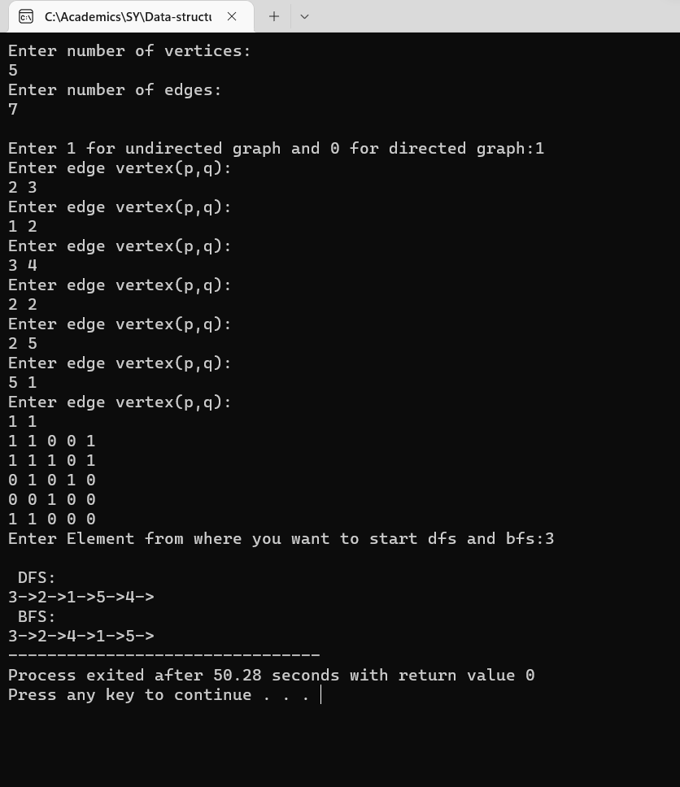

**Post lab questions-**

1. **Differentiate between BFS and DFS.**

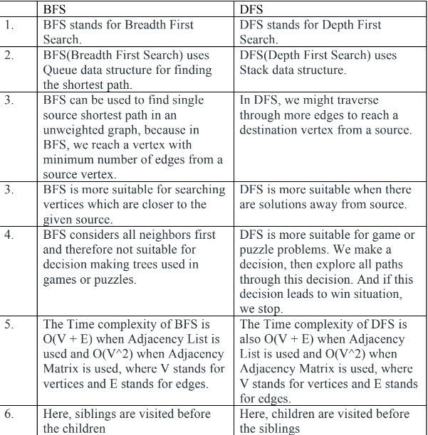

1. **Give sequence of the nodes visited as per BFS and DFS strategy for following example. Source- Arad, Destination- Bucharest (Traversal would stop after destination is reached)**

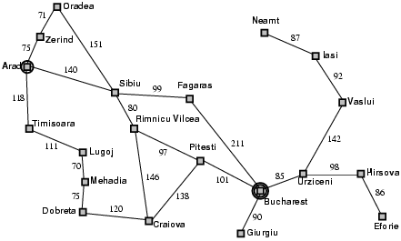

BFS – Arad->Zerind -> Sibiu -> Timisoara -> Oradea ->Fagaras -> Rimnicu Vilcea ->

Lugoj -> Bucharest

DFS - Arad->Zerind->Oradea->Sibiu->Fagaras->Bucharest

**Conclusion: -**

In this experiment we learnt about two types of traversals in a graph and

implemented them.