**Roll No. 16010121051**

**Batch No. A3**

**Name: Meet Gala**

**Experiment No. 10**

**Title: Analysis of IR spectrum**

Aim: To analyze the IR spectrum.

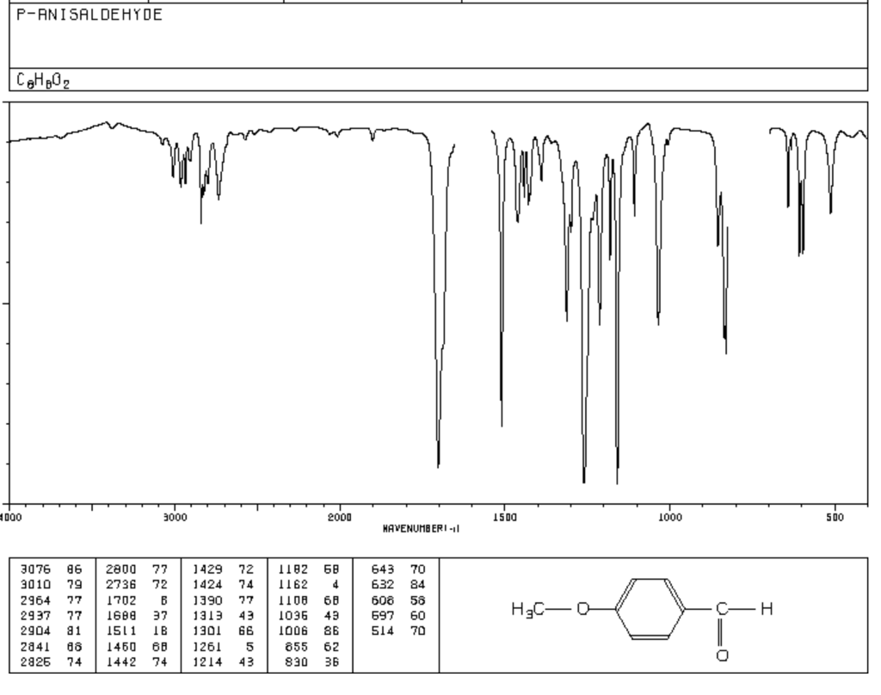

**Result:** Important IR frequencies of above compound are

|  |  |  |  |
| --- | --- | --- | --- |
| **IR frequency**  **(cm-1)** | **Functional Group** | **IR frequency**  **(cm-1)** | **Functional Group** |
| 3076-3010 | Aromatic C-H | 1511, 1600 | Aromatic C=C |
| 2937-2904 | Alkyl C-H | 1108, 1036 | Ether C-O |
| 2841, 2736 | Aldehyde C-H | 1460, 1390 | Alkane C-H (bending) |
| 1688 | Aldehyde C=O |  |  |

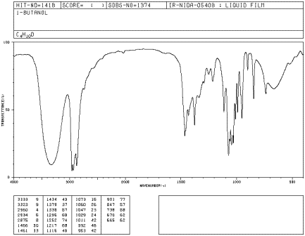

**CH3-CH2-CH2-CH2-OH**

**Observations:**

Total number of IR Peaks: 3N-6

= (3 x 15)-6 = 39

-O-H: a broad peak at 3353 cm-1 correspond to -OH group.

i) COOH: no C=O peak hence COOH absent

ii) Phenol: no Ar C-H and C=C peaks hence phenol absent

iii) Alcohol: aliphatic C-H peaks present hence it is alcohol

Aliphatic C-H Stretch: 2875, 2930, 2960 cm-1 corresponds to aliphatic CH

Aliphatic C-H bend: peaks at 1430 and 1461 cm-1 bending vibrations

C-O: 1075 and 1116 cm-1 are alcohol C-O stretch

**Result:** Important IR frequencies of above compound are

|  |  |  |  |
| --- | --- | --- | --- |
| IR frequency  (Cm-1) | Functional Group | IR frequency | Functional Group |
| 3353 | -OH (Alcoholic) | 1075 & 1116 | Alcohol C-O |
| 2875, 2930, 2960 | Aliphatic CH |  |  |

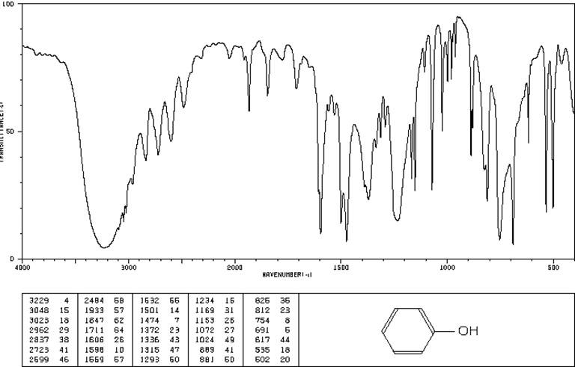

**Observations:**

Total number of IR Peaks: 3N - 5

= (3 x 13) - 5 = 34

-O-H Stretch, H-bonded: a broad peak at 3229 cm-1 correspond to -OH group.

Aromatic C-H Stretch: 3048, 3023 cm-1 corresponds to aromatic C-H

Aromatic C=C Stretch: peaks at 1501,1632 cm-1 bending vibrations

C-O: 1072 cm-1 are alcohol C-O stretch.

**Result:** Important IR frequencies of above compound are

|  |  |  |  |
| --- | --- | --- | --- |
| IR frequency  (cm-1) | Functional Group | IR frequency | Functional Group |
| 3229 | -O-H Stretch, H-bonded | 1501,1632 | Aromatic C=C Stretch |
| 3048, 3023 | Aromatic C-H Stretch | 1072 | C-O |

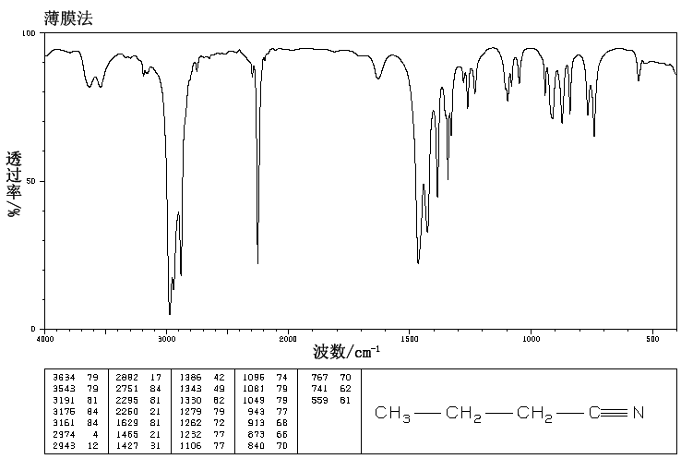

**Observations:**

Total number of IR Peaks: 3N - 6

= (3 x 12) - 6 = 30

C ≡ N: There is a sharp curve along the graph at 2260 cm-1 indicating the presence of the same.

Alkane C – H Stretch: There are sharp cuts in it the graph at 2974, 2943 cm-1.

-C-H Bending: Even, there are sharp cuts in the graph at 1386, 1343, 1350 cm-1, indicating the presence of Alkanes.

**Result:** Important IR frequencies of above compound are

|  |  |  |  |
| --- | --- | --- | --- |
| IR frequency  (cm-1) | Functional Group | IR frequency | Functional Group |
| 2260 | C ≡ N | 1386, 1343, 1350 | Alkanes -C-H Bending |
| 2974, 2943 | Alkane C – H Stretch |  |  |