|  |  |  |  |
| --- | --- | --- | --- |
| **Course Name:** | **Elements of Electrical and Electronics Engineering** | **Semester:** | **I** |
| **Date of Submission:** | **05 / 02/ 2022** | **Batch No:** | **A3** |
| **Faculty Name:** |  | **Roll No:** | **16010121051** |
| **Faculty Sign & Date:** |  | **Grade/Marks:** | **/ 20** |

**Internal assessment (IA-2)**

**Subject: EEEE Semester-1/2 Academic Year: 2021-22**

Case Study on Electricity Consumption of Home

1. **What is electrical power and energy? What are their units?**

Ans: Electric power:

Electric power is the rate at which work is done or energy is transformed in an electrical circuit. **The SI unit** **of power is the watt, one joule per second**.

1 Watt (W) = 1 Joule / Second (J/s)

$P = IV = I^{2}R= \frac{V^{2}}{R}$

Where **V** is Volts, **I** is Current & ***R*** is the Electrical Resistance.

Electric Energy:

Electrical energy is energy derived as a result of movement of electrically charged particles. When used loosely, electrical energy refers to energy that has been converted from electric potential energy.

**SI unit of electrical energy is Joule.**

1 Joule = 1 Volt x 1 Ampere x 1 Second

1. **What is 1-unit electrical energy?**

Ans: Unit Electricity is the amount of electrical energy consumed by a load of 1 kW power rating in 1 hour. It is basically measurement unit of electrical energy consumption in Joule.

1 Unit Electricity = 1 kWh

= 1 kW x 1 Hour = 1000 W x 3600 seconds = 3.6×106 Joule

1. **Estimate the electricity consumption of your home for two months (units/month) November and December 2021. (Following table is applicable as per actuals)**

**NOVEMBER 2021**

|  |  |  |  |  |  |  |
| --- | --- | --- | --- | --- | --- | --- |
| Sr.  No. | Appliances | Power Rating (watts/appliance) (a) | No of appliances (b) | Utilization in Hours per day  (c) | Energy in Wh/1000  (units)/day  (d=axbxc)/1000 | Energy units/month dx30 |
| 1 | Lights | 35  30  8 | 1  1  1 | 7  5  2.5 | 0.245  0.15  0.02 | 7.35  4.5  0.6 |
| 2 | Fans | 50 | 1  1 | 10  8 | 0.5  0.4 | 15  12 |
| 3 | Washing  Machine | 550 | 1 | 0.75 | 0.412 | 12.3 |
| 4 | Mixer | 500 | 1 | 0.1 | 0.05 | 1.5 |
| 5 | Electric Iron | 800 | 1 | 0.2 | 0.16 | 4.8 |
| 6 | Television | 50 | 1 | 3 | 0.15 | 4.5 |
| 7 | Refrigerator | 90 | 1 | 24 | 2.16 | 64 |
| 8 | Laptop | 150 | 1 | 1 | 0.15 | 4.5 |
| Total energy (Units/month) | | | | | | **131.05** |

**DECEMBER 2021**

|  |  |  |  |  |  |  |
| --- | --- | --- | --- | --- | --- | --- |
| Sr.  No. | Appliances | Power Rating (watts/appliance) (a) | No of appliances (b) | Utilization in Hours per day  (c) | Energy in Wh/1000  (units)/day  (d=axbxc)/1000 | Energy units/month dx30 |
| 1 | Lights | 35  30  8 | 1  1  1 | 7  5  2.5 | 0.245  0.15  0.02 | 7.35  4.5  0.6 |
| 2 | Fans | 50 | 1  1 | 7  5 | 0.35  0.25 | 10.5  7.5 |
| 3 | Washing  Machine | 550 | 1 | 0.75 | 0.412 | 12.3 |
| 4 | Mixer | 500 | 1 | 0.1 | 0.05 | 1.5 |
| 5 | Electric Iron | 800 | 1 | 0.2 | 0.16 | 4.8 |
| 6 | Television | 50 | 1 | 3 | 0.15 | 4.5 |
| 7 | Refrigerator | 90 | 1 | 22 | 1.9 | 58.9 |
| 8 | Laptop | 150 | 1 | 1 | 0.15 | 4.5 |
| Total energy (Units/month) | | | | | | **126.25** |

**Plot a bar Graph showing appliances on x-axis and energy (units/month/appliance) on Y –axis. Draw the graph for both the months (Use can Microsoft Excel to plot graphs)**

1. **Compare actual electricity units and bill (Rupees) with your estimation (Use electricity bill of recent month of your home. Attach copy of the same with assignment)**

November 2021:

|  |  |  |  |
| --- | --- | --- | --- |
| Energy consumption | Energy  units/month | Billing Rate  Rs/Unit | Total  (Rs)(without tax) |
| Estimated | 131.05 | 0-100 : 3.44  101-300 : 7.34  301-500 : 10.36  >500 : 11.82 | 540 |
| Actual | 108 | 0-100 : 3.44  101-300 : 7.34  301-500 : 10.36  >500 : 11.82 | 402.72 |

December 2021:

|  |  |  |  |
| --- | --- | --- | --- |
| Energy consumption | Energy  units/month | Billing Rate  Rs/Unit | Total  (Rs)(without tax) |
| Estimated | 126.25 | 0-100 : 3.44  101-300 : 7.34  301-500 : 10.36  >500 : 11.82 | 536.675 |
| Actual | 113 | 0-100 : 3.44  101-300 : 7.34  301-500 : 10.36  >500 : 11.82 | 439.42 |

November 2021:

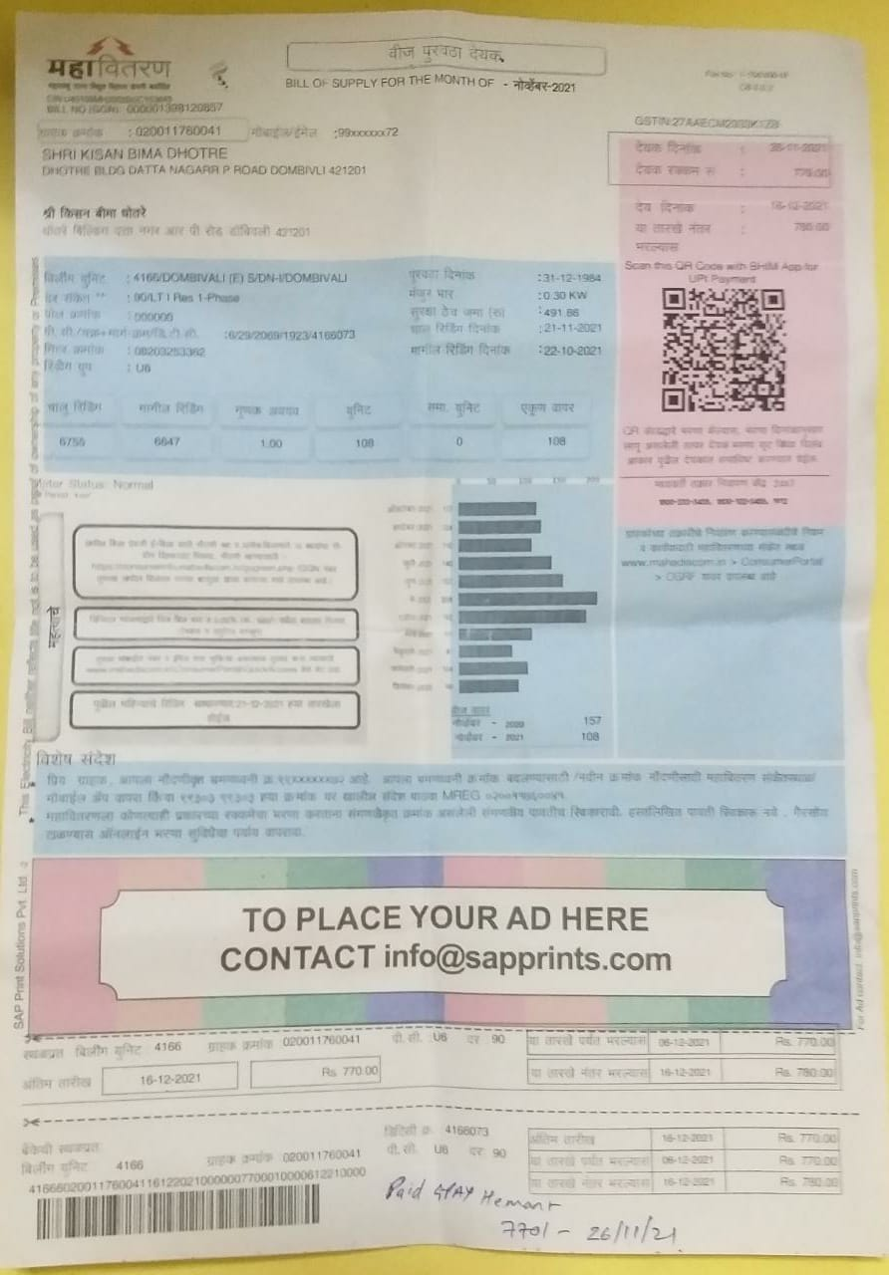

December 2021: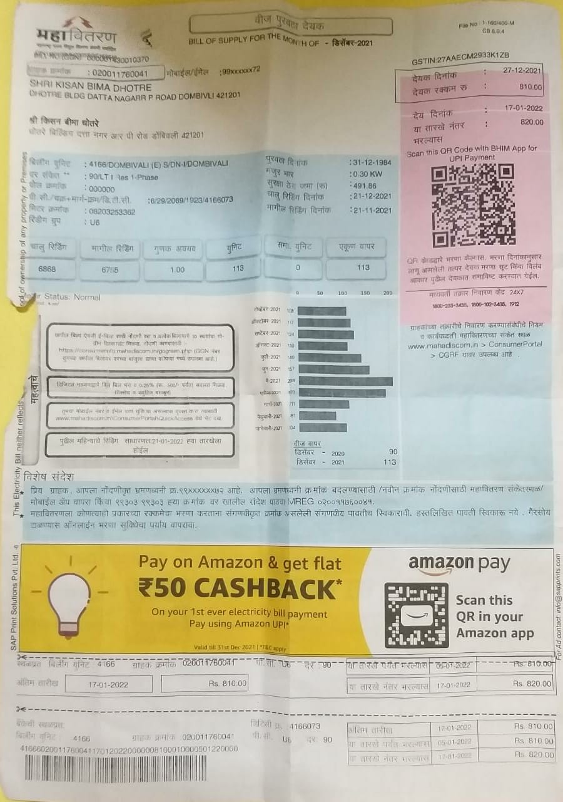

1. **How you can reduce electrical energy consumption of your home? Alternative methods**

**e.g. use of energy efficient light, use of Gas water heater instead of electric water heater etc.**

Ans: Here are 11 ways to start conserving energy yourself:

1. Make Your Refrigerator More Efficient: Setting Your Refrigerator’s Temperature Controls to As Close To 37 Degrees to Reduce the Energy.
2. Install A Programmable Thermostat to Save Energy.
3. Install Solar-Powered Landscape Lighting.
4. Replace your light bulbs By CFL Or LED, They Use Much Less Power and Provide Better Luminosity.
5. Install Automatic Light Sensors or Timed Sensors on Outdoor Lighting.
6. Unplug Electronic Devices When Not in Use.
7. Buy 5-Star Energy Rated Appliances, They Might Be Costly but Use a Lot Less Energy as Compared to Its Lower Rated Counterparts.
8. Install Energy Efficient Windows.
9. Add Insulation to Hot Water Lines & The Water Heater.
10. Use Low-Flow Faucets and Showerheads.
11. Use Cold Water While Taking Showers.
12. **Estimation of electrical energy consumption after alternate methods suggested in step-5.**

**NOVEMBER 2021**

|  |  |  |  |  |  |  |
| --- | --- | --- | --- | --- | --- | --- |
| Sr.  No. | Appliances | Power Rating (watts/appliance) (a) | No of appliances (b) | Utilization in Hours per day  (c) | Energy in Wh/1000  (units)/day  (d=axbxc)/1000 | Energy units/month dx30 |
| 1 | LED Lights | 20  20  4 | 1  1  1 | 7  5  2.5 | 0.14  0.1  0.01 | 4.2  3  0.3 |
| 2 | Fans | 35 | 1  1 | 10  8 | 0.35  0.28 | 10.5  8.4 |
| 3 | Washing  Machine | 300 | 1 | 0.75 | 0.225 | 6.75 |
| 4 | Mixer | 380 | 1 | 0.1 | 0.038 | 1.14 |
| 5 | High Rated Electric Iron | 700 | 1 | 0.2 | 0.14 | 4.2 |
| 6 | Television | 40 | 1 | 3 | 0.12 | 3.6 |
| 7 | 5 – Star Refrigerator | 75 | 1 | 24 | 1.8 | 54 |
| 8 | Laptop | 150 | 1 | 1 | 0.15 | 4.5 |
| Total energy (Units/month) | | | | | | **100.59** |

**December 2021**

|  |  |  |  |  |  |  |
| --- | --- | --- | --- | --- | --- | --- |
| Sr.  No. | Appliances | Power Rating (watts/appliance) (a) | No of appliances (b) | Utilization in Hours per day  (c) | Energy in Wh/1000  (units)/day  (d=axbxc)/1000 | Energy units/month dx30 |
| 1 | LED Lights | 20  20  4 | 1  1  1 | 7  5  2.5 | 0.14  0.1  0.01 | 4.2  3  0.3 |
| 2 | Fans | 35 | 1  1 | 7  5 | 0.24  0.175 | 7.2  5.25 |
| 3 | Washing  Machine | 300 | 1 | 0.75 | 0.225 | 6.75 |
| 4 | Mixer | 380 | 1 | 0.1 | 0.038 | 1.14 |
| 5 | High Rated Electric Iron | 700 | 1 | 0.2 | 0.14 | 4.2 |
| 6 | Television | 40 | 1 | 3 | 0.12 | 3.6 |
| 7 | 5 – Star Refrigerator | 75 | 1 | 22 | 1.6 |  |
| 8 | Laptop | 150 | 1 | 1 | 0.15 | 4.5 |
| Total energy (Units/month) | | | | | | **96.24** |

v

**Plot the bar graph showing the comparison of consumption of months with alternate methods suggested**

**November 2021**

**December 2021**

1. **Energy saving units/month and expenses in Rs/month (after implementation of alternative method suggested in step 5 and 6)**

Ans:

NOVEMBER

|  |  |  |  |
| --- | --- | --- | --- |
| Energy consumption | Energy  units/month | Billing Rate  Rs/Unit | Total (Rs)(without tax) |
| Estimated | 131.05 | 0-100 : 3.44  101-300 : 7.34  301-500 : 10.36  >500 : 11.82 | 540 |
| Alternate | 100.59 | 0-100 : 3.44  101-300 : 7.34  301-500 : 10.36  >500 : 11.82 | 348.33 |
| Actual | 108 | 0-100 : 3.44  101-300 : 7.34  301-500 : 10.36  >500 : 11.82 | 402.72 |

Energy saved per month =108-100.59 = 7.41 units

INR saved = 402.72 – 348.33 = 54.39 Rs.

DECEMBER

|  |  |  |  |
| --- | --- | --- | --- |
| Energy consumption | Energy  units/month | Billing Rate  Rs/Unit | Total (without tax)(Rs) |
| Estimated | 126.25 | 0-100 : 3.44  101-300 : 7.34  301-500 : 10.36  >500 : 11.82 | 536.675 |
| Alternate | 96.24 | 0-100 : 3.44  101-300 : 7.34  301-500 : 10.36  >500 : 11.82 | 331.065 |
| Actual | 113 | 0-100 : 3.44  101-300 : 7.34  301-500 : 10.36  >500 : 11.82 | 439.42 |

Energy saved per month == 113- 96.24 = 16.76 units.

INR saved == 439..42-331.065 = 108.355 Rs.

|  |
| --- |
| **Signature of faculty in-charge with Date:** |